Electrochemical processes in magnetic field
Bulgarian Chemical Communications, Volume 40, Number 3 (pp. 190–197) 2008
© 2008 Bulgarian Academy of Sciences, Union of Chemists in Bulgaria
T. M. Peev
* E-mail: to_peev@yahoo.com
Mladost 2, Block 204-1, 1799 Sofia, Bulgaria
Received October 4, 2007, Revised January 24, 2008
Some experimental results with respect to the influence of low magnetic field on the electrochemical processes are summarized in the proposed paper. They are related to: corrosion processes at static conditions in electrolytic medium (mine water, industrial waste H₂S-containing water, sea water, 3% NaCl solution), interaction of steel with 2N H₂SO₄, galvanic cells and electrolysis of CuSO₄ solution.
The results obtained show that the magnetic field may:
- change the mechanism and the rate of the corrosion processes;
- accelerate the rudimentary stage formation and have no influence on the rate of their growth;
- accelerate the corrosion about by 10% in 3% NaCl solution;
- have an inhibiting action by interaction of the steel with 2N H₂SO₄;
- influence the electrochemical deposition and anodic dissolution, if the preliminary covered steel plate with copper is used for electrode;
- reduce the electrode potential.
Key words: magnetic field, corrosion, electrolysis, galvanic cell, Mössbauer spectra.

INTRODUCTION
The magnetochemistry studies the dependences between the magnetic properties and chemical structure, as well as the influence of the magnetic fields on the kinetics and mechanism of chemical reactions. The interest to the chemical processes has a long history. The earliest investigation, cited in [1], dates as far back as 1847. It refers to water and cooper electrolysis and notice able effect has not been reported. A number a experimental results with respect to the influence of the magnetic field on the chemical kinetics are summarized in [1–8]. For example, about thousand publications are cited in [1, 7]. A number of effects such as polarization electrons, magnetic isotope effect, as well as the development of the theory of the effect of magnetic fields on the radical reactions, shed light upon the role of magnetism in chemical kinetics [3, 4].
Magnetic fields could affect also some compli-cated processes such as corrosion. For example the corrosion of the steel edge begins from a point on the surface with a maximum gradient of the magnetic field [9]. Magnetic field influences the formation of magnetite in electromagnetic water treatment apparatus [10, 11]. The role of magnetic field as a protector of the solubility of mild steel in sulphuric acid medium was studied in [12].

Some of our published [13–17] and unpublished results about the influence of low magnetic fields on chemical and electrochemical processes are exposed in the present paper. They refer to corrosion in static conditions with mine water [13], industrial separa-tion water from oil atmospheric distillation [14], sea water and model solution [15], 3% NaCl solution [18], interaction of steel with 2N H₂SO₄ [16], galvanic elements [17] and unpublished, and electrolysis of CuSO₄ solutions (unpublished).
EXPERIMENTAL
Corrosion
Steel-3 coupons (50×50×1 mm or 30×30×1 mm) were completely immersed into corrosion medium in glass vessels. The vessels were hermetically closed and kept at room temperature. Parallel expe-riments in presence and in absence of a magnetic field were compared. The corrosion conditions are summarized in Table 1. The detailed information about the experiments is described in [13–15].
Electrochemical experiments with mild steel and 3% NaCl solution were performed in three-electrode cell and magnetic field 0.128 T [16]. Such electro-lyte is used for modelling sea water corrosion.
Table 1. Conditions of samples preparation.
Corrosion medium |  |  |  | Time,  days | Magnet induction,  T
Water species | Basic composition,  in bracket, mg/dm³ | pH | Volume, cm³ | Time,  days | Magnet induction,  T
Mine | Fe³⁺ (36), Cu²⁺ (0.038), Ca²⁺ (120), Mg²⁺ (26), SO₄^{2–} (88), Cl– (144) | 6.5 | 500 | 160 | C-magnet  0.04
Waste | H₂S (117),  Cl– (traces) | 6 | 400 | 86 | C, 0.04; 0.09  cylindrical 0.05
Sea | From Bourgas bay |  | 650 | 337 | C, 0.04; 0.09
Interaction of steel with sulphuric acid
Cylinders (l = 95 mm and ø = 4 mm) of mild steel St 37 were immersed into open tubes for 16 days. At two ends of the cylinders, cooper rings were placed. Parallel experiments without and with two magnets with magnetic induction 0.128 T were compared [17].
Galvanic cell
Two types of galvanic cells in absence and presence of magnetic field (two magnets 0.128 T) were studied. The first sell is
Cu|1N CuSO₄.5H₂O||Sea water|Steel C1010 (1)
which are shown in Fig. 1. The electrodes are made of electrolytic cooper and steel with sizes 45×11×3 mm and 77×9×1.5 mm respectively.
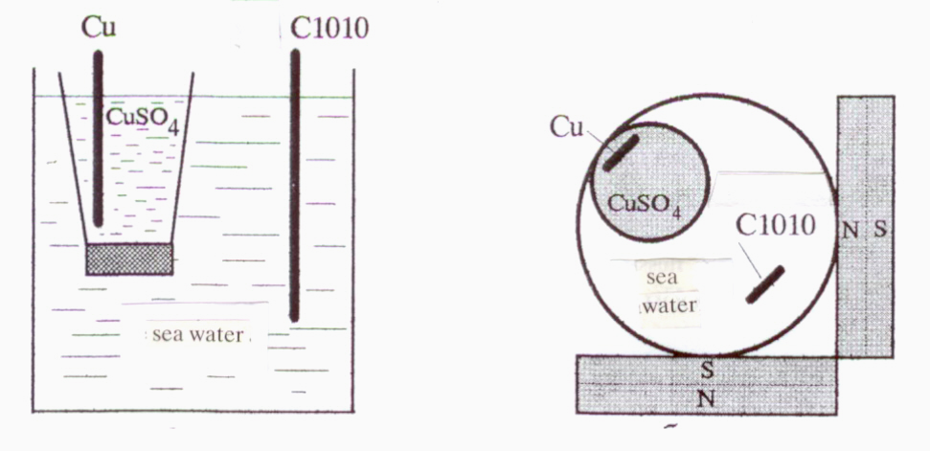
Fig. 1. Scheme of galvanic cell and orientation of the cell in the magnetic field.
The second cell is
Cu|0.1–2N CuSO₄|Steel C1010. (2)
The cathode and anode used are the same as above but the size is 77×9×1 mm. The experiments show low value of generated voltage. For this reason, normal Weston element (E_{VE} = 1.0188 V) was used in a series connection. The generated voltage was measured by a digital voltmeter
RFT G-121-010 (Germany).
Electrolysis
Two series of experiments were carried out.
First series: Massive or gauze technical copper anode (63×39×4 mm) and electrolytic copper cathode (63×13.5×1 mm), duration 1 h, current 20 mA, voltage 1.02–1.48 V. Electrolytic cell – glass vessel, immersed part of electrodes 29 cm², distance between electrodes 35 mm.
The second series of experiments is in two versions. First version: copper anode and steel 3 cathode with electrodeposited cooper, distance 15 mm, current 20–50 mA, voltage 0.8–1.44 V, time from 30 min to 1 h. Cathode electrodepositing was studied. Second version: copper cathode and steel anode with electrodeposited cooper. Anodic electro-lytic dissolution was studied. Solution for coulo-meter was used as electrolyte.
Kinetic data
The corrosion rates were determined by a weight index K or volumetric hydrogen index K_{(H)}, calcul-ated by the formulas
T. M. Peev: Electrochemical processes in magnetic field
K = ΔP/(S.t), g·m^{–2}·h^{–1}
and
K_{(H)} = V/(S.t), cm³(H₂)·cm^{–2}·h^{–1}, (3)
where: ΔP is the weight loss of the samples, g; V – volume of separated hydrogen, cm³; S – sample surface area, m² or cm², t – time, h.
Mössbauer experiments
Mössbauer spectra were recorded by the method described elsewhere [15, 17].
RESULTS AND DISCUSSION
Corrosion
During the times marked in Table 1, the plate surfaces corroded. Then the plates were taken out, washed and dried. The rusts were completely scraped off. The precipitates in the glass vessel were filtrated and dried. The rust from samples indivi-dually or together with precipitates were pressed into tablets with polyvinyl alcohol. The Mössbauer spectra were measured on the tablets at room temperature (R) and liquid nitrogen temperature (N).
Mössbauer spectra of some samples studied in [13] are shown in Fig. 2. From spectra 1R and 1N, it is seen that in absence of magnetic field the rust contains γ-FeOOH, α-FeOOH, Fe₃O₄, γ-Fe₂O₃ and α-Fe₂O₃. The corrosion processes mechanism may by given by the Hiller’s scheme [19]

Fe → Fe²⁺ → Fe(OH)₂ → γ-FeOOH
↓ ↑
→→ Fe³⁺ →→
γ-FeOOH → Fe₃O₄ → γ-Fe₂O₃
↓ ↓
α-FeOOH →→→ α-Fe₂O₃ (4)
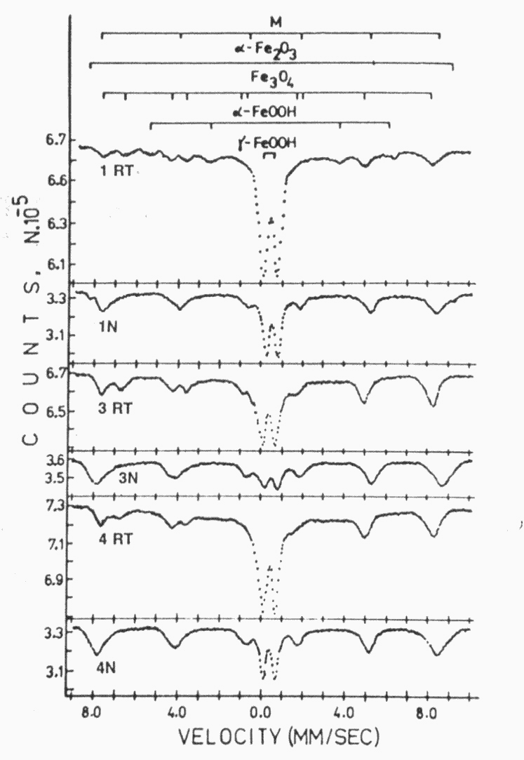
Fig. 2. Mössbauer spectra of rust samples in mine water scraped from the surfaces, measured at room (R) and liquid nitrogen (N) temperature. 1 – in the absence of a magnetic field, and 3 – external surface and 4 – internal surface in the presence of a magnetic field.
The marked components in (4) are absent in the samples in magnetic field. Spectra 3 and 4, measured at R and N, show that these samples consist only of γ-FeOOH, Fe_{3–x}O₄ and γ-Fe₂O₃. Therefore, the rust composition depends on the presence of magnetic field, which promotes the reaction
2γ-FeOOH + Fe(OH)₂ → Fe₃O₄ + 2H₂O, (5)
but the following phase transitions
γ-FeOOH → α-FeOOH → αFe₂O₃ (6)
and
γ-Fe₂O₃ → α-Fe₂O₃ (7)
do not occur. Reaction (5) increases the percentage of Fe₃O₄ and γ-Fe₂O₃. For this reason, the partial spectral area of the magnetic (MSA) and para-magnetic (PMSA) components are, respectively MSA:PMSA = 0.64:1 for spectrum 1R and 1.17:1 for 1N, 1.22:1 for 3R and 3.16:1 for 3N, 1.04:1 for 4R and 2.33:1 for 4N.
The second series of the experiments were realized in the case of waste water from separator of petrol-water from atmospheric oil distillation as corrosion medium [14]. The designations of the samples and some experimental conditions are described in Table 1 and in the text of Fig. 3.
T. M. Peev: Electrochemical processes in magnetic field
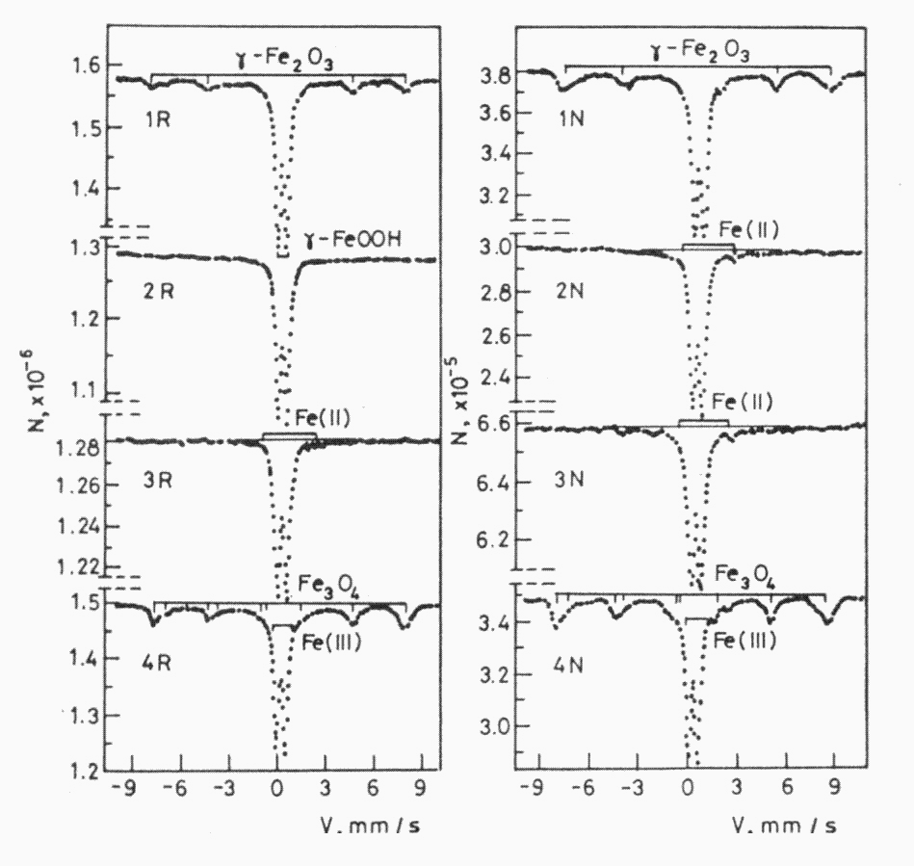
Fig. 3. Mössbauer spectra of waste water samples
at room (R) and liquid nitrogen (N) temperature.
1 – in the absence of a magnetic field; 2- and 3 – in the presence of a magnetic field of 0.04 T and 0.09 T, respectively; 4 – cylinder magnet 0.05 T.
Fe₃O₄, γ-Fe₂O₃ and γ-FeOOH were determined from spectra 1R and 1N. Analogous composition, probably including Fe(OH)₂ and hydrolysis products of Fe₂(SO₄)₃ shows spectra 4R and 4N on the same figure.
The spectra of samples 2 and 3 at both tempe-ratures are substantially different from those of sample 1. The quadruple doublet with parameters isomer shift δ = 1.09 mm/s and quadruple splitting
Δ = 3.04 mm/s in spectra 2N and 3N is from Fe(OH)₂ according to literature data [20]. The second doublet with δ = 0.38 mm/s and Δ = 1.33 mm/s coincides with hydrolysis products [21]. Spectrum 3R in velocity interval 3–4.5 mm/s indicates the presence of an unresolved hyperfine structure which differs from the spectrum in the absence of magnetic field. The conservation of air dried Fe(OH)₂ can be explained by covering of the particles with surface layer of magnetite carried out by reaction (5) and by the reaction
Fe(OH)₂ + 1/6O₂ → 1/3Fe₃O₄ + H₂O. (8)
The absence of crystal phase of Fe₃O₄ and
γ-Fe₂O₃ in the samples with C-magnet is another fact established. The magnetic field accelerates formation of rudimentary crystals, but it does not affect the rate of their growth. A similar statement is made in [22].
The experiments with waste water and mine water show changes in the mechanism of the corrosion processes in the presence of magnetic field. This interaction is not synonymous. Some stages are not present in mine water. In H₂S-containing water new products were observed.
The preparation of ultra-dispersed iron oxides was observed also in experiments with sea water [15]. Mössbauer analyses of the samples from the plate surfaces together with precipitates were carried out on the basis of the spectra in Fig. 4.

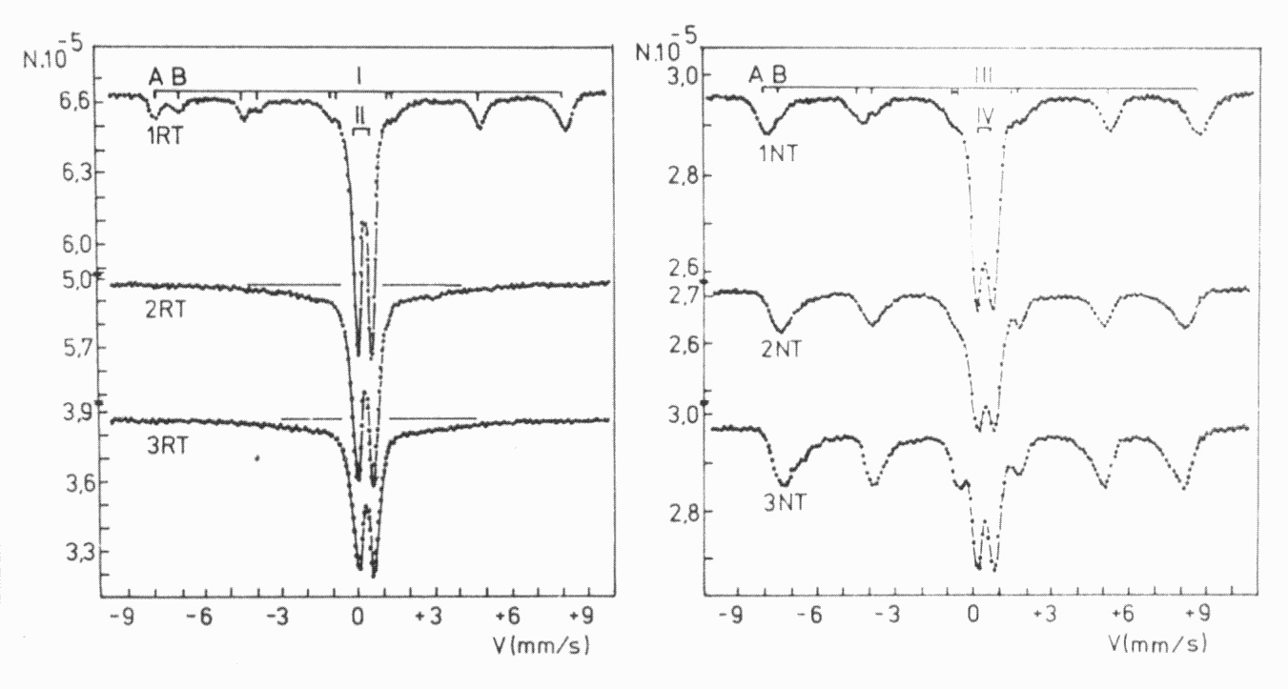
Fig. 4. Mössbauer spectra of the corrosion products formed in sea water. 1 – in the absence of a magnetic field,
2- and 3- in the presence of a magnetic field 0.04 T and 0.09 T, respectively.

There is similarity between the spectra in Fig. 3 and Fig. 4. Fe₃O₄, γ-FeOOH and γ-Fe₂O₃ were identified with sea water in the absence of magnetic field (spectrum 1R). At the same time the spectra of samples with magnet 2R and 3R represented quad-ruple doublets and unresolved HFS under the line N∞.
All spectra measured at liquid nitrogen tempera-ture consist of quadruple doublet of γ-FeOOH, HFS of Fe₃O₄ and γ-Fe₂O₃. The internal magnetic fields, caused by ferrous and ferric ions on magnetite spectra, are as follows:
 | Sample 1N | Sample 2N (0.04T) | Sample 3N (0.09T)
Ferric ions | 511 kOe | 480 kOe | 476 kOe
Ferrous ions | 490 kOe | 461 kOe | 426 kOe
MC:PMC (NT) | 1.04 : 1 | 1.38 : 1 | 2.09 : 1
The data give evidence for a two-way effect of the magnetic field: decrease in the particles size (lowering of the H_{eff}-values) and increase in the amounts of magnetic components as the magnetic field intensity increases (the spectral areas). Reaction (5) is promoted.
Other experiments were carried out with 3% NaCl solution [16]. This solution is used for model-ling corrosion in sea water. A mild steel plate is used for electrode in three-electrode cell. Rectan-gular magnet 0.128 T was put by the side of sell. Parallel experiments with and without magnetic field were compared.
T. M. Peev: Electrochemical processes in magnetic field
Gravimetric measurements (weight index of corrosion), estimated by formula (3) are K = 0.098 and K = 0.110 g·m^{–2}·h^{–1} in absence and presence of magnetic field, respectively. The magnetic field increases the corrosion rate by about 11%. In conformity with our investigation with galvanic cell by Scheme (1), the increase in the corrosion rate is caused by a shift of the steel electrode potential towards more negative values in magnetic field.
The compositions of the precipitates together with substances separated from the electrode surface were determined on the basis of Mössbauer spectra (Fig. 5). The samples were kept in the corrosion medium in hermetically closed vessels before measurements. All spectra are on the wet samples. The compositions are as follows: Fe(OH)₂ or mixture of Fe(OH)₂ and Fe(OH)_{2-x}Cl_{x}, and β-FeOOH in absence of magnetic field, and γ-FeOOH and
Fe_{3-x}O₄ in presence of magnetic field. The compo-sition established assumes that the magnetic field accelerates hydrolysis and oxidation processes such as:
Fe(OH)⁻ → Green Rust → γ-FeOOH, (9)
Fe(OH)₂ → Fe(OH)₃ → FeOOH + H₂O, (10)
and reaction (5).
The magnet attracts the magnetite particles and assists a revealing of new surfaces. The corrosion rate increases.
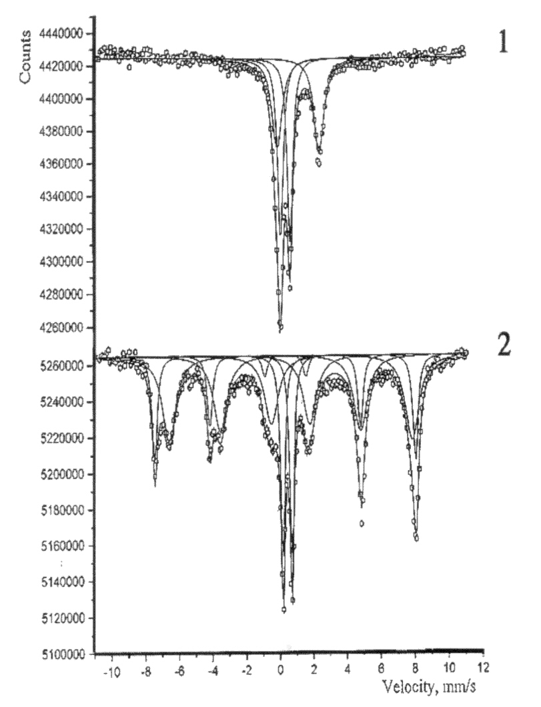
Fig. 5. Room temperature Mössbauer spectra of separated products in Steel 3/3% NaCl solution. 1 – in the absence and 2 – in the presence of magnetic field 0.128 T.
Interaction between steel and sulphuric acid
The known reaction
Fe + H₂SO₄ → FeSO₄ + H₂↑. (11)
was studied in [17]. The reaction runs to the full acid consumption. The calculated volumetric hydrogen index in the presence and in absence of magnetic field is K_{(H)} = 0.42 cm³(H₂)·cm^{–2}·h^{–1} and K_{(H)} = 0.33 cm³(H₂)·cm^{–2}·h^{–1}, respectively. This is about 20% inhibitor effect of the magnetic field.
Visual differences were observed 16 days after the beginning of the experiments. For example: without magnet – conical green crystals around copper rings, yellow solution, smoothly black holding on the steel surface: with magnet – separated growths green crystals over all cylinder surface. They are absent around the rings, green solution, black holding with dendrite growths on the steel surface.
The differences show that the oxidation Fe²⁺ → Fe³⁺, crystallization of ferrous sulphate and forma-tion of deposits over the cylinder surface are different. The yellow solution and large amount of the green crystals give evidence for higher rate of interaction in absence of magnetic field. This agrees with kinetic data. In the case of anodic dissolving of iron in the vicinity of copper rings suggest zones of local saturation and formation of local crystal.
T. M. Peev: Electrochemical processes in magnetic field
The analysis of solid phases is indicated on the bar-diagrams in Fig. 6. Steel (a), FeSO₄.7H₂O (b), Fe(OH)SO₄ (e) and Fe₃C were identified. The spectral areas of the carbide component in the samples in presence and in absence of magnetic field are 13 and 52%, respectively. Since the carbide is a solid residue after dissolving, it entails higher corrosion rate in absence of a magnetic field. This fact corresponds to the statement about the protector role of the magnetic field [12].
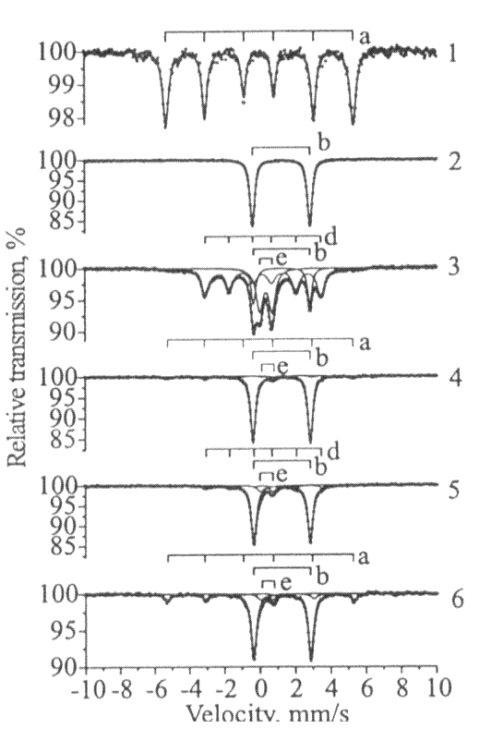
Fig. 6. Room temperature Mössbauer spectra on the experiments Steel 37/2N H₂SO₄. 1 – steel, 2 – green crystals, 3 – precipitate without magnetic field,
4 – surface without magnetic field, 5 – precipitate
in the magnetic field 0.128 T, 6 – surface in a magnetic field. Legend: a – steel, b – FeSO₄.H₂O, e – Fe(OH)SO₄, d - Ө-Fe₃C.
The possible explanation is given in [17] and is based on the ideas of triplet-singlet rephasing [4].
Galvanic cell
A galvanic cell shown in Fig. 1 and scheme (1) was studied. The time dependences of generated voltage without and with magnetic field are given in Fig. 7. The figure shows that the generated voltage of the cell is higher in magnetic field. For example, at the point of maximum a difference about 3.63% is calculated (0.7664 V with and 0.7513 V without magnet).
The weight corrosion indexes are K = 0.0115 and K = 0.0120 g·cm^{–2}·day^{–1} with and without magnet, respectively, i.e. it is 4.16% higher with magnet.
For the investigated galvanic cell of scheme (2), the generated voltage E is the difference between voltage of the combination Weston element (E_{VE}) and the experimental cell (E_{C}):
E = E_{C} – E_{VE} = E_{C} – 1.0188 V. (12)
The concentration dependence E = ƒ(C) is shown in Fig. 8. It is seen that E of galvanic cell in magnetic field have higher values, and near 2N CuSO₄ concentration the values overlap. From computer fitting of the experimental results for the dependence E = ƒ(C), the following expression has been obtained
$E=\frac{E_{1}−E_{2}}{1+\text{exp}\left(\frac{C−C_{o}}{A}\right)}+E_{2}$ (13)
The empirical constants in (13) are as follows:
Constant | Without magnet | With magnet
E₁ | 0.587 ± 0.266 | 0.594 ± 0.036
E₂ | 0.030 ± 0.018 | 0.038 ± 0 025
C₀ | 0.681 ± 0.018 | 0.684 ± 0.019
A | 0.056 ± 0.012 | 0.058 ± 0 016
χ² | 0.001 | 0.002
σ | 0.05 | 0.05
Electrolysis
The results obtained show that the magnetic field has no influence on the electrolysis with two copper electrodes. If, however, steel plate covered with cooper is used for cathode, the amount of deposited copper increases from 2.2 to 20% for different expe-riments. Moreover X-ray diffraction data (Fig. 9) show that in magnetic field only cooper was deposited. In absence of magnetic field, the deposits contain Cu and Cu₂O. If steel plate covered with copper is used for anode, electrodessolution effects decrease by the same percentages.
T. M. Peev: Electrochemical processes in magnetic field
We propose the following explanation. The deposition or the dissolution are connected with the following equilibrium electrode reactions:
Cu ↔ Cu⁺ + e, Cu ↔ Cu²⁺ + 2e
and
Cu⁺ ↔ Cu²⁺ + e. (12)
Hydrogen and oxygen were not separated.
For acceleration, respectively delay of the processes the magnetization of steel plate and Hall effect are significant. The paramagnetic ions (Cu²⁺) are concentrated, while diamagnetic ions (Cu⁺) are diffused from boundary surface in magnetic field. The equilibrium moves in a direction favourable for deposition or dissolution. Besides, the magnetic field may act on the ion mobility.
The Hall effect created additional electric field and electron surplus. So, it also influences the equi-librium electrode reaction. Those effects may explain the apparent non-observance of the first Faraday law – the same operating electric current through the electrolysis cell, but different metal deposits.
This dispersion of Cu⁺-ions causes the absence of Cu₂O in the diffractogram of the sample in magnetic field.

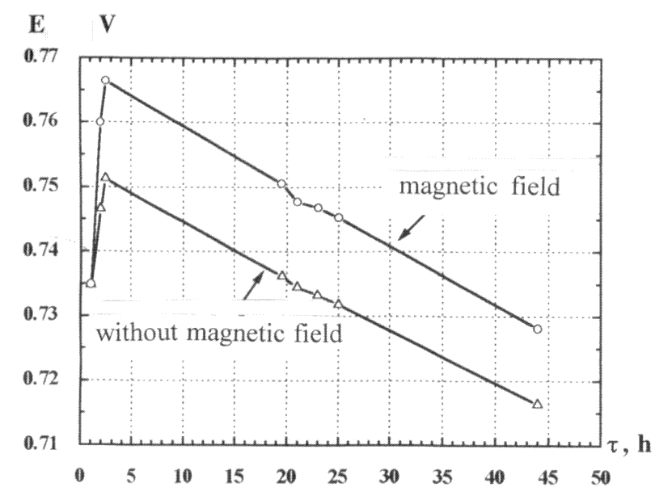 | 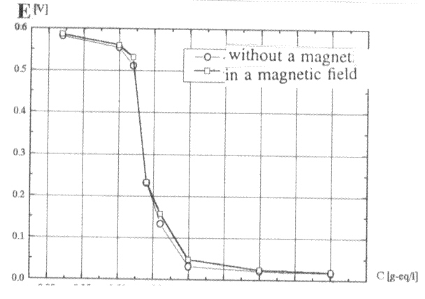
Fig. 7. Time dependence of the generated voltage with and without magnetic field. | Fig. 8. Concentration dependence of the generated voltage.
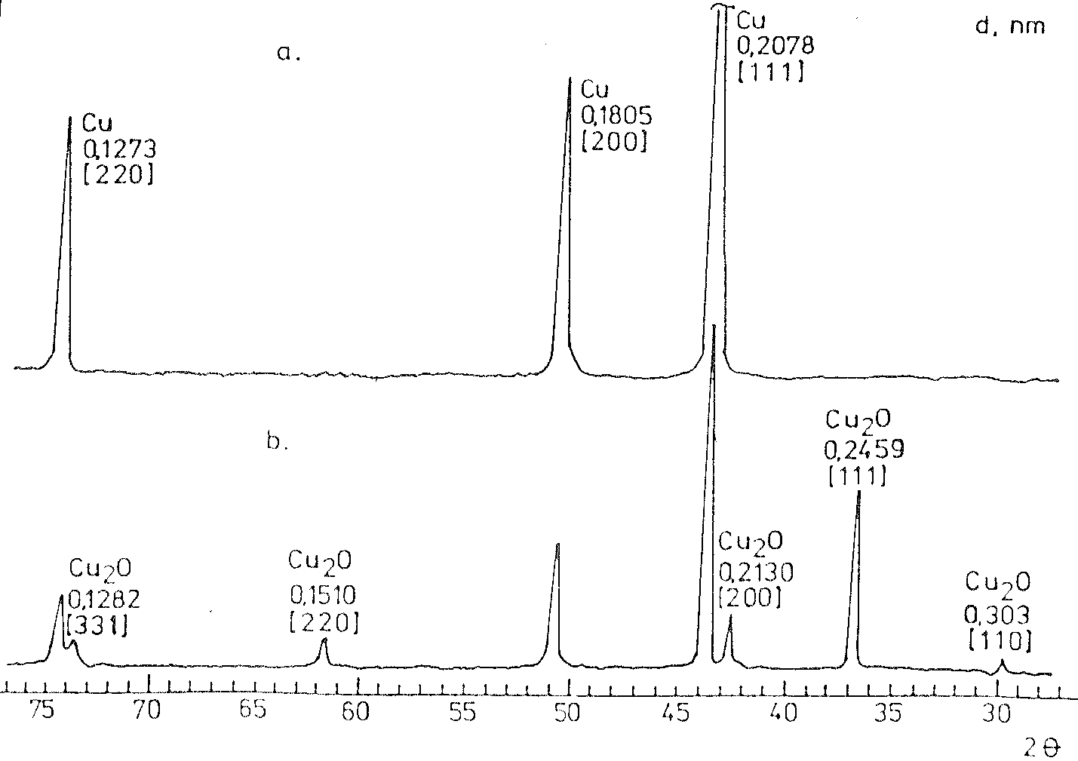
Fig. 9. Diffractogrames of the electrolytic deposited copper. A – in the magnetic field, b – without magnetic field.

CONCLUSIONS
The influence of the magnetic field on steel corrosion in the experiments described above may be summarized as follows:
- Change of the corrosion processes mechanism, leading to the elimination of some stages or creation of others. Thus, the formation of α-FeOOH and α-Fe₂O₃ in mine water is blocked. However, in hydrogen sulphide containing waste water, the obtaining of sulphate and hydrolysis is predominant;
- The formation of ferromagnetic components was favorable. The MC:PMC relation increases almost in all cases;
- Dependence on the plates orientation in nonhomogeneous magnetic field. For example, the comparison of the experiments with sea water with C-magnet and cylindrical magnet;
- Influence of the corrosion medium. This can explain the discrepencies between the results with C-magnet and mine, sea and waste water;
- Influence on the increase in the probability of formation of rudimentary crystals, but no influence on the rate of their growth;
As regards the interaction of steel with sulphuric acid, the early established fact for inhibiting action of the magnetic field has been confirmed. What is specific in our experiments are the copper rings, giving rise to contact potentials. In our opinion, the contact potential causes local saturation and liberates ferrous sulphate as conic crystals. Here the magnetic field eliminates these contact potentials. Therefore, the liberation of the crystals occurs on all the cylindrical surfaces.
The magnetic field acts on the rate and mecha-nism of the electrode processes in galvanic cells. The generated voltage increases by about 1.8%. The conditionally named “steel electrode” becomes about 3.6% more negative. The empirical equation for the dependence E = ƒ(C) has been deducted for some cases.
T. M. Peev: Electrochemical processes in magnetic field
The magnetic field does not affect the electrolysis with copper electrodes. If, however, a steel plate covered with copper is used for cathode, the amount of electrodeposited copper increases. The anodic dissolution of such anode decreases. A qualitative explanation on the bases of diamagne-tism and paramagnetism of copper ions and Hall effect has been proposed.
REFERENCES
- P. Selwood, Chem. Rev., 38, 21 (1946).
- P. W. Selwood, Magnetochemistry, Interscience Inc. New York, New York, 1956.
- P. Atkins, Chem. Britain, 26, 214 (1976).
- A. L. Buchachenko, In: Physical Chemistry – Contemporary Problems, Y. M. Kolotyrkin (ed.), Khimya, Moscow, 1980, p. 4 (in Russian).
- R. Z. Sagdeev, K. M. Salihov, Yu. M. Molin, Uspekhi Khimii, 46, 576 (1977) (in Russian).
- V. T. Kalinnikov, Yu. V. Rakitin, Introduction in Magnetochemistry, Nauka, Moscow, 1984, (in Russian).
- U. E. Steiner, T. Ulrih, Chem. Rev., 89, 51 (1989).
- D. R. Mekhandjiev, S. A. Angelov, Magnetoche-mistry in Solid State, Nauka i Izkustvo, Sofia, 1979 (in Bulgarian).
- S. Yamaguchi, Z. Anorg. Allgem. Chem., 305, 116 (1959).
- S. S. Dushkin, P. N. Evstatov, Magnetic Water Preparation in Chemical Enterprises, Khimya, Moscow, 1986 (in Russian).
- A. N. Kirgintsev, V. M. Sokolov, J. Prikl. Khimii, 38, 1172 (1965) (in Russian).
- U. Srivastava, N. Nigam, British Corr. J., 23, 1972 (1988).
- T. Peev, B. Mandjukova, I. Mandjukov, Corrosion (NACE), 43, 739 (1987).
- T. Peev, A. I. Akala, V. Rousanov, J. Radioanal. Nucl. Chem. Lett., 137, 397 (1989).
- T. Peev, B. Mandjukova, I. Mandjukov, V. Rusanov, Werkst. Korros., 42, 90 (1991).
- T. Peev, Khimia (Bulgaria), 16, 286 (2007).
- T. Peev, I. Leshev, I. Mitov, in: Nanoscience & Nanotechnology’02. Nanostructired Materials Appli-cation and Innovation Transfer, E. Balabanova, I. Dragieva (eds.), Heron Press, Sofia, 2002, p. 155.
- T. Peev, S. Gjiev, A. Pavlova, in: Proc. Nat. Sci. Session Bulg. Electrochem. Soc, Sofia, Bulgaria, 1996, p. 135.
T. M. Peev: Electrochemical processes in magnetic field
- J. H. Hiller, Werkst. Korros., 17, 943 (1966).
- J. L. Mackey, R. L. Collins. J. Inorg. Nucl. Chem., 29, 655 (1967).
- S. Music, A. Vertes, G. W. Simmons, I. Czako-Nagy, H. Leidheiser, Jr., J. Colloid Interface Sci., 85, 2560 (1982).
- L. A. Kulskii, S. S. Dushkin, Magnetic Field and Water Preparation Processes, Naukova Dumka, Kiev, 1988, p. 25 (in Russian).

EЛЕКТРОХИМИЧНИ ПРОЦЕСИ В МАГНИТНО ПОЛЕ
Т. М. Пеев
ж. к. Младост-2, бл. 204-1, 1799 София
Постъпила на 4 октомври 2007 г., Преработена на 24 януари 2008 г.
(Резюмe)
Представени са публикувани и непубликувани резултати относно влиянието на слаби полета върху електрохимични процеси. Те се отнасят до: корозионни процеси в среда на електролити (руднични води, сeпарационни сяроводород съдържащи води, морска вода и 3% разтвор на натриев хлорид), взаимодействие на стомана в сярна киселина, галванични елементи и електролиза на разтвор на меден сулфат.
Получените резултати показват, че магнитното поле:
- променя механизма и скоростта на корозионните процеси;
- ускорява зародишообразуването, но не влияе върху кристалния растеж;
- ускорява с около 10% корозията в 3% разтвор на натриев хлорид;
- има инхибиращ ефект върху взаимодействието на стомана със сярна киселина;
- влияе върху електролитното отлагане върху катод и разтваряне на анод от предварително покрита с електролитна мед стоманена пластина;
- променя електродния потенциал.

