Amperometric biosensors
Bulgarian Chemical Communications, Volume 40, Number 3 (pp. 204–210) 2008
* E-mail: monimarti@abv.bg
© 2008 Bulgarian Academy of Sciences, Union of Chemists in Bulgaria
S. M. Hristov
Institute of Electrochemistry and Energy Systems, Bulgarian Academy of Science,
Acad. G. Bonchev St., Block 10, 1113 Sofia, Bulgaria
Received November 16, 2007, Revised January 31, 2008
A unique feature of biosensors is the incorporation of a biological sensitive element with signal transformer, thus forming a very sensitive system. The advantages of the electrochemical biosensors are their compactness, simplicity, possibility for miniaturization, specificity, selectivity, etc.
Greater attention is focused on the most actively developed amperometric biosensors – their principle of operation, methods of investigation, construction and practical applications. A review of the generally used enzymes-oxidases is made – mechanism of operation, methods for immobilizing, applications. Experimental amperometric biosensors, based on enzyme gas-diffusion electrodes for detection of glucose, lactate and phenols are presented.
Key words: biosensor, amperometric detection, enzymes-oxidases, enzyme gas-diffusion electrodes.

Sensors and biosensors
Sensorics represents a scientific-technical field treating sensors’ general operation principles, con-struction, application and market. Its modernity and interdisciplinarity are determined by the interaction with other scientific fields such as physics and technology of semi-conducting materials, microelec-tronics, physical chemistry, materials’ science, informatics, computer science and many others.
There are scores of thousands different types of sensors. Their production is an independent branch of the world electronic industry. Contemporary sensors encompass all existing natural impacts of the Earth, soil, water, atmosphere and Space and a significant part of them is used for improvement and safety of human life and actions. Many effects from chemistry, physics and biology could be used for preparing sensors [1, 2].
Some of the most important and specific sensors’ parameters are: sensitivity, linearity, dividing ability, reproducibility, noise-resistance, selectivity, quick rate and many others of less importance [3]. Some of the sensors have already excelled over our senses by all of the listed parameters. However, human senses remain unattainable by a couple of signi-ficant parameters: construction compactness, com-plexity of the actions and economy in energy consumption. The biological compatibility problem still remains an issue. Probably in the near and not so near future organic sensors will acquire similar abilities.
Biosensors are analytical devices containing a biological sensitive element closely connected or incorporated to transformers of its reactions [4]. Biosensors development has been determined by the potential sensitive elements and transformers, which can be used in the devices construction. Very often enzymes are used as a biological component, how-ever whole organisms, tissues, cells, organellies, membranes, enzyme components, receptors, anti-bodies, nucleus acids and others are also applied. Transformers could be amperometric, potentio-metric, conductometric, impedimetric, optical, calorimetric, acoustic, mechanical, chemical, etc. (Fig. 1). Not all possible combinations of these elements are used in real-life biosensors.
POTENTIOMETRIC
AMPEROMETRIC
CONDUCTOMETRIC
IMPEDIMETRIC
COLORIMETRIC
OPTICAL
CHEMICAL
TRANSFORMERS
BIOLOGICAL COMPONENT
ENZYMES
TISSUES
CELLS
RECEPTORS
MEMBRANES
ANTIBODIES
NUCLEIC ACIDS
BIOSENSORS
Fig. 1. Biosensors – biological sensitive elements and transformers.
Rodriguez-Mozaz et al. [5] reflect the advances and describe the trends in biosensors for environ-mental applications. This overview also addresses the support provided by public institutions for biosensor research in USA, Japan and, especially, in Europe. Future prospects of biosensor technology, with special emphasis on the development of new sensing elements, are foreseen. The review [6] covers recent approaches in design and development of biosensors applied for analysis of real samples of medical, environmental or industrial relevance.
Although various novel methods for analysis are constantly introduced, the electrochemical and more specifically – the amperometric ones remain the most applicable alternative to the traditional set of methods for biochemical analysis. The electro-chemical biosensor usually consists of an enzyme electrode, reference electrodes and a measuring cell. The enzyme electrode represents a bioelectroche-mical device which is sensitive to the concentration of a given substance – substrate, and uses enzyme-catalytic reactions concurrent to the electrode process. In biochemistry substrate denotes the substance with which a given enzyme reacts selectively (and to which it is assigned).
Most processes in biochemistry have cyclic character. Consequently, most enzyme-catalytic reactions are also cyclic in nature. In Fig. 2 the general scheme of such a process is presented. Effector (F) is the substance with which the enzyme (E) interacts. Usually it is a substrate which decomposes to product (P), but it can also be an inhibitor or an activator, which lower or increase, respectively, the catalytic activity of the enzyme. The first part of the enzyme-effector process is the complex-forming stage which is also called a detec-tion stage. As a second part comes the chemical transformation [8]. The enzyme and the effector should be structurally (by size and form) and energy complementary. There is a “crypt” (hole) in the enzyme molecule with which the effector is to interact – i.e. a detection center. The catalytic center is located close to it or inside it.
The high specificity and activity of enzymes combined with electrochemical systems’ possibili-ties build the major advantage of enzyme electrodes. The concept for enzyme electrode and for biosensor in general was developed by L. Clark in 1962 [9]. He announced it at a Symposium of the New York Academy of Sciences. Clark developed two types of amperometric electrodes for glucose detection by the glucose oxidase enzyme: one based on measuring the oxygen concentration and the other – based on the oxidation of H₂O₂. “The main merit of the enzyme electrode approach is its simplicity”, said Clark.

Р
F
Е
EF
EP
F
Catalytic
center
Detection
center
Fig. 2. General scheme of the enzyme action.
Amperometric enzyme electrodes
A significant progress has been achieved in the last two decades in the application of amperometric methods for deeper understanding of the properties and role of biologically important substances. This regards some low molecular substances as quinones, catheholamines, purines, flavins, tiols and disul-phides, and similarly proteins, for instance cyto-chromes, feredoxines and flavoproteins [10]. All these substances participate in biologically significant oxidation-reduction reactions. Electro-chemical biosensors are used for analysis of various chemical substrates (such as glucose, cholesterol, lactate, alcohols and many others) in aqueous solu-tions, aimed against environmental pollution and also for clinical and biotechnological applications [11–13]. Amperometric biosensors can find wide potential applications in the detection of sulphur dioxide, methane, carbon dioxide, formaldehyde, phenols, etc. [14].
S. M. Hristov: Amperometric biosensors
Judging by the number of publications and patents as well as the serially produced analyzers, the amperometric biosensors represent the most largely developed sector in the area of biospecific electrodes. Amperometric detection finds wide application in the biological media analysis. At optimum conditions the method enables determining the substrate concentrations to 10^{–8}–10^{–9} М. The operation principle of amperometric sensors is determination of the gradient in the concentration of the electroactive product from the enzyme reaction.
The amperometric enzyme electrodes are based on the current’s dependence on the concentration flow in a diffusion limited potentiostatic mode:
I = n.F.A.D.c.d^{–1}, where I is the current, n – number of transferred electrons during the process, F – the Faraday’s constant, A – electrode area, D – diffu-sion coefficient, c – substrate concentration and d – thickness of the diffusion membrane.
An important advantage of the amperometric biosensors is the significant simplification of the set of measuring apparatuses: they are gathered in a block dialyzer, an enzyme reactor and an electro-chemical detector. Reactions which are catalyzed by enzymes – oxidases are primarily used. This is related to the easy electrochemical detection of О₂ and Н₂О₂. If during the change of the detected substance molecules the obtained product is with a concentration which is difficult to measure, then it can be obtained with the help of a subsequent enzyme reaction. Similar consecutive reactions are often used in detection of complex ethers, oligo-saccharides and amides. Other types of consecutive reactions based on recycling of the investigated molecules in order to “increase” product quantity or eliminate the influence of hampering substances can also be applied in amperometric sensors [15].
Amperometric biosensors are characterized by quite low currents which allow simplifying of their electronic scheme via combining the reference and secondary electrodes in one counter electrode – for e.g., a Ag/AgCl reference electrode could play this role. The two-electrode configuration enables installing the working and the counter electrode in an immediate proximity to one another and thus the required sample size could be decreased [16].
As was already mentioned enzymes – oxidases are primarily used in the investigated amperometric biosensors. Participation of oxygen into the catalyzed by the enzymes biochemical reaction is character-istic for this class of enzymes. The reaction scheme is based on the running of two catalytic reactions:
Biocatalytic reaction:
substrate + O₂ → product + H₂O₂
Electrochemical reaction:
H₂O₂ → O₂ + 2H⁺ + 2e–
During the biocatalytic reaction enzyme oxida-tion of the substrate occurs. H₂O₂ is obtained as by-product during the reaction. Due to the fact that for most enzymes direct electrons transfer between the enzyme and the electrode is not observed, it is not possible to obtain directly an electric signal from the biosensor. The amperometric signal occurs during the electrochemical oxidation of the generated in the enzyme reaction H₂O₂ upon a catalytic electrode at an appropriate potential. Due to the consecutive bio-catalytic and electrochemical reactions an electric signal is generated by the enzyme electrode and it is proportional to the substrate concentration.
The investigation and characterization of ampe-rometric enzyme electrodes are usually implemented by two types of measurements – polarization and concentration ones. Polarization dependences (the so-called voltamperometric characteristics) deter-mine the working potential of the electrode.
S. M. Hristov: Amperometric biosensors
Stationary current dependence on the substrate concentration at constant potential is determined by the concentration dependences (the so-called cali-bration curves). A sample calibration curve is presented in Fig. 3a. In case of diffusion-control electrode processes, the stationary current is propor-tional to the diffusion flow of the substrate towards the electrode surface (1).
I = n.F.A.D.C.d^{–1} (1)
Fig. 3. Steady-state current as a function of the substate concentration (a) and as a function of the sensitivity of the enzyme electrode (b).
For kinetic control of the processes the enzyme-catalytic reaction is the rate-determining step. The current dependence on the substrate concentration is described by the Michaelis–Menten equation (2).
$I\text{}=\text{}\frac{I_{\text{max}}^{\text{app}}}{1+\frac{K_{M}^{\text{app}}}{C}}$ (2)
In one of the linearizations of this equation, described by Eadie–Hofstee (3), the current is proportional to the electrode sensitivity.
$I=\text{}I_{\text{max}}^{\text{app}}\text{}−\text{}K_{M}^{\text{app}}\text{.}\left(\frac{I}{C_{S}}\right)$ (3)
Sensitivity represents the relation of the station-nary current to the substrate concentration at which it was produced. The proportionality constant is K_{M}^{app} – imaginary Michaelis constant. Fig. 3b presents the results of Fig. 3а in Eadie–Hofstee coordinates. For substrate concentrations with linear calibration curve the sensitivity of the electrode is constant. In this range a diffusion control of the electrode processes is performed. Higher concen-trations result in transfer to the other declined linear part of the Eadie–Hofstee dependence which indi-cates an enzyme-kinetic control of the electrode processes. The imaginary Michaelis constant can be determined by the slope of the linear dependence [17, 18].
The other very crucial and important problem at investigating and developing enzyme electrodes is the enzyme immobilization. Generally this can be defined as “holding” of the enzyme upon the electrode or in its immediate proximity. Electrodes with immobilized enzymes, i.e. electrodes in which the enzyme is inserted into the device design, are closer to application in practice. Some of the requirements to the immobilizing methods are reli-ability, purity of the biological component, preven-tion of side reactions and others. Generally, physical (adsorption, insertion in gel or polymer, etc.) or chemical (covalent bonding, netting, etc) immobili-zation methods or a combination of these types are used.
Carbon electrode materials offer huge possibi-lities for immediate enzyme immobilizing upon the electrode surface. They have good adsorption char-acteristics and possess various oxygen-containing surface groups or the option of generating such groups comparatively easy.
Various methods for stable and reproductive immobilization of the enzyme on the carbon elec-trode surface are used and tested. Physical adsorp-tion is a simple immobilization method in which high enzyme loading is achieved by physical adsorption of the enzyme on a planar electrode surface. The immobilization by covalent attachment is achieved through the formation of permanent linkages between the enzyme and the immobi-lization material. Highly sensitive and stable enzyme electrodes have been prepared by cross-linking entrapment. It is possible to combine cross-linking with other immobilization techniques to produce very reliable amperometric sensors.
Experimental
Our team has constructed and investigated an experimental amperometrical biosensors for detec-tion of glucose, lactate, ethanol and volatile phenols [19–21]. We use enzymes glucose oxidase (GOD), lactate oxidase (LOD), alcohol oxidase (AOD) and tyrosinase (TYR).
The detection of glucose [22], L-lactate [23] and ethanol has important practical application since their content in blood, food products or media has significance for medicine and food industry. The following aspects are pursued in medicine:
S. M. Hristov: Amperometric biosensors
- analysis of the glucose content in physiological liquids, for prevention and control of diabetes mellitus and in the development of artificial pancreas;
- constant monitoring of the lactate content in blood during surgical operations as a criterion for oxygen supply to tissues when curing traumas (specifically sport ones) and hemorrhages;
- the precise measurement of ethanol in blood and urine is of special importance in clinical and judicial medicine.
Quick and sensitive methods, which will simplify the time-consuming and expensive labora-tory operations, are needed in food industry for control of the food quality and the running of fermentation processes.
The enzyme gas-diffusion electrode combines an air gas-diffusion electrode with an enzyme immo-bilized into its catalytic surface. The electrodes used in the current work are based on the new type of enzyme gas-diffusion electrode [24]. The electrode comprises two layers: a porous, highly hydrophobic, electrically conductive gas-supplying layer, made from a special PTFE-containing carbon material and a thin catalytic layer from CoTMPP pyrolyzed at 700ºC in Ar [25]. This catalyst is very active towards the electrochemical oxidation of H₂O₂. For better fixing of the enzyme mixture upon the electrode surface an aqueous-alcohol solution of Nafion is applied as connecting film.
The enzyme electrode is placed in a conic plastic tube in such a way that the enzyme/catalytic layer is on the top of the tube and is in contact with the electrolyte (Fig. 4). The opposite side of the plastic tube is in contact with the open air. During opera-tion, the dissolved substrate is transported to the immobilized enzyme in gas phase from the atmo-spheric air through the free from electrolyte hydrophobic pores.
In Fig. 5a calibration curves of the glucose oxidase gas-diffusion electrode are presented for the cases when air is supplied from the gas side of the electrode, when pure oxygen and when Ar is blown to the gas side of the electrode. The steady-state current is up to 5 times lower when Ar is blown to the gas side of the electrode. The values of the steady-state current from Fig. 5a are presented in Fig. 5b as a function of the sensitivity of the glucose electrode (Eadie-Hofstee plot). From the slope of the curves the apparent Michaelis constant K_{M}^{app} of the process is estimated. When air is available from the gas side K_{M}^{app} is 20.7 mM, when pure O₂ - K_{M}^{app} is higher (26.7 mM), and when Ar is blown the value of K_{M}^{app} is about 10 times lower (2.0 mM). It can be concluded that the enzymatic reaction is strongly influenced by the concentration of O₂ in the reaction zone.
ELECTROLYTE
ENZYME
LAYER
CATALYST LAYER
GAS –SUPPLYING
LAYER
SUBSTRATE
AIR
О₂
Fig. 4. Scheme of the electrochemical cell.
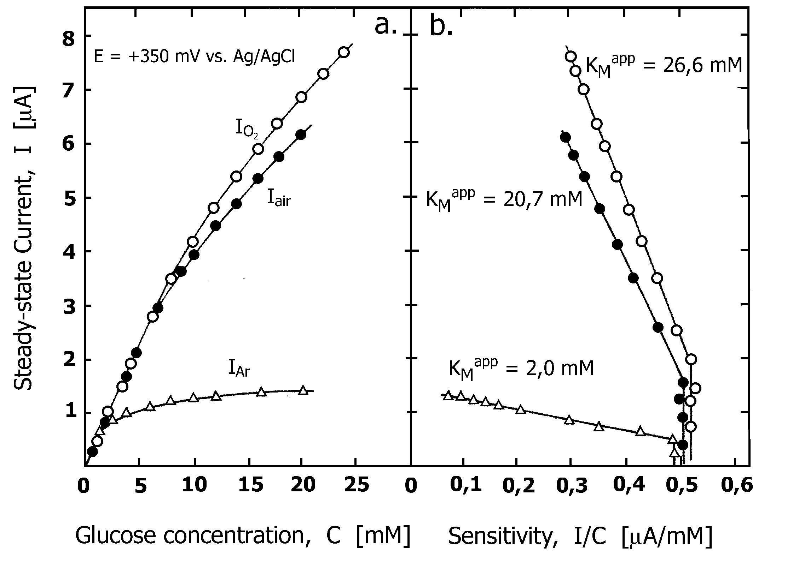
Fig. 5. Concentration dependences (a) and the corres-ponding Eadie–Hofstee plots (b) of the glucose oxidase electrode for three different modes of oxygen supply.
Fig. 6a shows calibration curves of the lactate oxidase electrode when air, pure oxygen or argon is blown to the gas side of the electrode. In the case of the lactate electrode similar results are received. The apparent Michaelis constants obtained from the corresponding Eadie–Hofstee plots (Fig. 6b) are: K_{M}^{app} = 2.5 mM (air), K_{M}^{app} = 0.44 mM (Ar),
K_{M}^{app} = 4.1 mM (O₂). From the presented calibra-tion curves of glucose oxidase (Fig. 5a) and lactate oxidase (Fig. 6a) electrodes it is clear that the linear portion of the dependences is larger when air (or pure oxygen) is available to the gas side of the electrode.
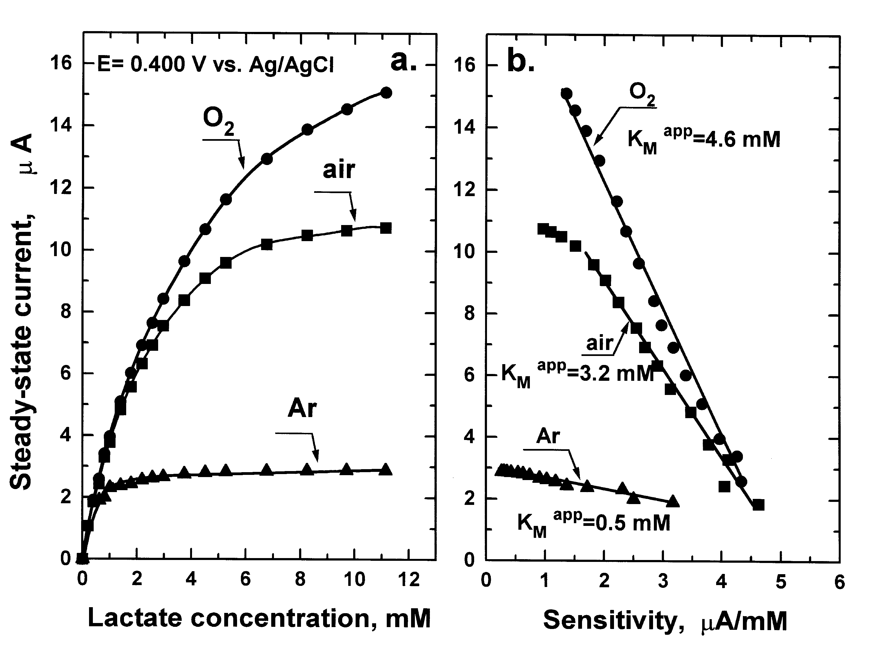
Fig. 6. Calibration curves (a) and Eadie-Hofstee plots
(b) of the lactate oxidase gas-diffusion electrode.
Biosensor for determination of alcohol (ethanol or methanol) concentration in water solution and of alcoholic vapour in the atmospheric air is described, based on the electrode with an enzyme alcohol oxidase [20].
S. M. Hristov: Amperometric biosensors
Phenol compounds are among the major pollu-tants of the environment. They can also be found in wastewaters and various industrial wastes: from coke furnaces, in fats refining, from petrol refineries, from the plastic industry, from aniline dying chemical-pharmaceutical plants and many others. Probably the most serious phenol pollution results from various manufactures of the paper industry. Volatile phenols are more toxic and with stronger smell, which results in their very low permissible concentrations. Phenol affects the human organism as a strong nervous poison [26].
All of the above said justifies the exceptionally low permissible exposure limits of phenol, which are the following:
- in the working zone air of production halls – 0.005 mg/l or 5×10^{–8} М [26]
- in populated places atmospheric air – 0.00001 mg/l or 10^{–10} М [27]
- in the water for household needs – 0.001 mg/l or 10^{–8} М [28].
An experimental electrochemical biosensor for phenol detection in liquid and gas phase has been constructed and investigated by our team. An enzyme gas-diffusion electrode with enzyme tyro-sinase has been developed by us and applied in biosensor for detection of volatile phenols in solu-tions, gas mixtures and the atmosphere.
The enzyme tyrosinase catalyzes phenols oxida-tion through hydroxylation with oxygen to catechol and subsequent dehydrogenation to the respective quinones compounds (1, 2). The electrochemical reduction of the product о-quinone is used as indicating reaction (3):
Phenol + O₂ $\vec{\text{tyro}\text{sin}\text{ase}}$ Catechol (1)
Catechol + O₂ $\vec{\text{tyro}\text{sin}\text{ase}}$ o-quinone (2)
o-quinone + 2H⁺ + 2e– Catechol (3)
The participation of the obtained catechol in the enzymatic reaction (2) leads to cycling of the process, resulting in the so-called “effect of amplification”.
In case of phenol detection in solutions the enzyme gas-diffusion electrode is mounted in the electrochemical cell in a way providing contact between its enzyme layer and the electrolyte. The opposite end of the working electrode is out of the cell and is in contact with the air. For gas mixture investigations the enzyme electrode is installed on a plastic holder with imbedded chlorinated silver wire serving as reference and counter electrode. The sensor is put in the space above the solution, where the saturated phenol vapors prevail in equilibrium with a pre-set concentration of phenol solution.
The calibration curve of tyrosinase electrode is presented in Fig. 7. The steady-state current depend-ence on the phenol concentration is displayed in a double logarithmic scale and encompasses the low concentrations below 1 μМ. It is important to under-line the fact that amperometric signal is observed at exceptionally low phenol concentration –0.4 nМ. The dependence is linear throughout the whole displayed concentration range from 0.4 nM to 1 μМ phenol. The backgroud current is 2 nA at potential 0.00 V vs. Ag/AgCl. The detectable minimum is in the nanomolar range – 5.5 nМ phenol.
Fig. 7. Calibration curve of the tyrosinase sensor in the concentration range 10^{–10}–10^{–6} M phenol.
The high sensitivity of the tyrosinase gas-diffusion electrode and its ability to detect phenol concentrations lower than permissible exposure limits make it advantageous not only in comparison to the known analytical methods for phenol detection but also to the typical reported data in literature about enzyme electrodes with tyrosinase.
Different variants and biosensor prototypes were developed and used in the investigations. With the aim to optimize and miniaturize the biosensors a number of prototypes with various sizes, shape and design were constructed and tested (Fig. 8). The proposed experimental biosensors could be improved and further developed to detect other substances using respective enzymes and thus the biosensors could find practical applications.
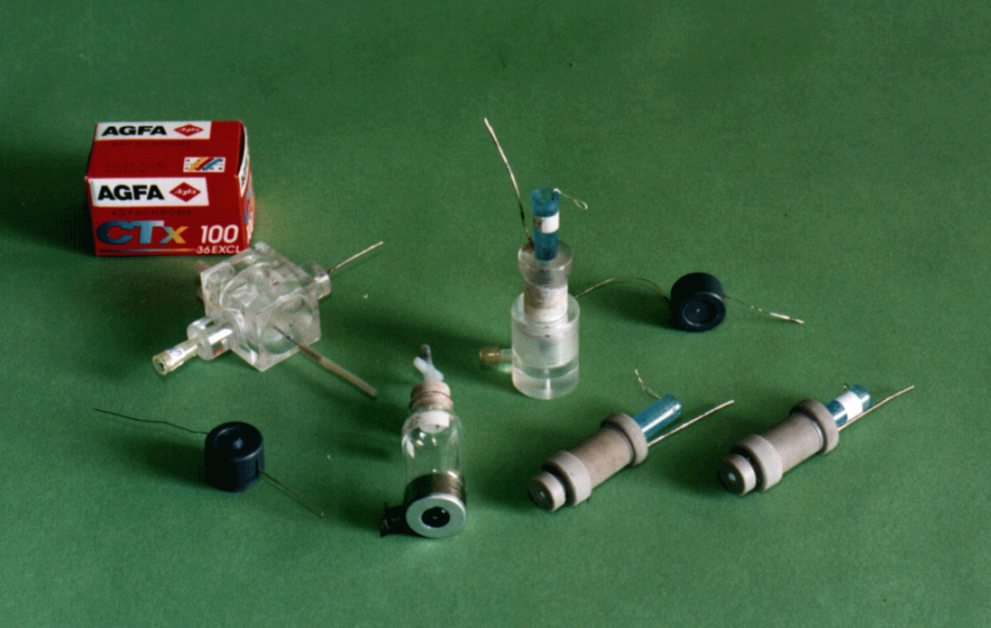
Fig. 8. Different experimental prototypes.
Conclusions
Amperometric biosensors for detection of hundreds of substances, including substrates, co-factors, prosthetic groups, enzymes, antibodies, inhibitors, activators and many others are described in patents and publications. The amperometric biosensors for detection of substrates are reliable and highly specific devices. They reach their optimum economic effect of operation when used in automatic jet devices or for jet-injection analysis. The linear range of concentration dependences for these devices usually encompasses from 2 to 4 magnitudes of concentration with detection limits of about 1 μM. Sensitivity can be increased by substrate recycling which enables the use of highly diluted samples or decreasing the sample volume below 1 μl. Thus, new possibilities for conducting measurements in the picomolar range, i. e. in the range of contents characteristic for hormones and antigens, are opened up. Future progress in this area includes combining biocatalysts with microelec-tronic elements, which transform and increase the amperometric signal.
S. M. Hristov: Amperometric biosensors
References
- J. Gardner, Microsensors, Wiley, Chichester, UK, 1994.
- S. Sze (ed), Semiconductor Sensors, John Wiley &Sons, New York, 1994.
- J. Fraden, Handbook of Modern Sensors, American Institute of Physics, New York, 1993.
- A. Turner, I. Karube, G. Wilson (eds), Biosensors: Fundamentals and Application, Oxford University Press, New York, 1987.
- S. Rodriguez-Mozaz, M. Lopez de Alda, M. Marco, D. Barcelo, Talanta, 65, 291 (2005).
- J. Castillo, S. Gaspar, S. Leth, M. Niculescu, A. Mortari, I. Bontidean, V. Soukharev, S. Dorneanu, A. Ryabov, E. Csöregi, Sens. Actuators B, 102, 179 (2004).
- K. Markov, H. Nikolov (eds), Reference Book of Biotechnology, Dr. Petar Beron, Sofia, 1988 (in Bulgarian).
- D. Kolev, Enzymes, Nauka i Tehnika, Sofia, 1976 (in Bulgarian).
- L. Clark Jr., C. Lyons, Ann. N.Y. Acad. Sci., 102, 29, (1962).
- G. Dryhurst, K. Kadish, F. Scheller, R. Renneberg, Biological Electrochemistry, Academic Press, New York, 1982.
- F. Scheller, F. Schubert, Biosensoren, Akademie Verlag, Berlin, 1989.
- A. Azevedo, D. Prazeres, J. Cabral, L. Fonseca, Biosens. Bioelectron., 21, 235, (2005).
- M. Boujtita, J. Hart, R. Pittson, Biosens. Bioelectron., 15, 257, (2000).
- S. Sullivan, S. Lafis, M. Karayannis, M. Dennison, J. Hall, S. Saini, A. Turner, B. Hobbs, W. Aston, Proc. 3rd Europ. Workshop Biosensors for Environmental Monitoring, 15–17 February, 1995, Florence, Italy,
p. 175–179.
- G. Wilson, Y. Hu, Chem. Rev., 100, 2693 (2000).
- M. Delvaux, A. Walcarius, S. Demoustier-Champaqne, Biosens. Bioelectron., 20, 1587 (2005).
- A. Lehninger, Biochemistry, The Molecular Basis of Cell Structure and Function, The Johns Hopkins University Inc., New York, 1972.
- D. Voet, J. Voet, Biochemistry, John Wiley&Sons, New York, 1990.
- R. Boukoureshtlieva, PhD Thesis, Inst. Electrochem. Energy Systems, Bulg. Acad. Sci., Sofia, 2004.
- A. Kaisheva, I. Iliev, S. Hristov, R. Kazareva, N. Tzonkov, EUROSENSORS XI, 21–24 September, 1997, Warsaw, vol. 2, p. 723–726.
- S. Hristov, PhD Thesis, Inst. Electrochem. Energy Systems, Bulg. Acad. Sci., Sofia, 2004.
- R. Evans, C. Banks, R. Compton, Analyst, 129-5, 428 (2004).
- E. Iwuoha, A. Rock, M. Smyth, Electroanalysis, 11, 367 (1999).
- I. Iliev, A. Kaisheva, F. Scheller, D. Pfeiffer, Electroanalysis, 7, 542, (1995).
- A. Kaisheva, I. Iliev, S. Gamburtzev, J. Power Sources, 13, 181, (1984).
S. M. Hristov: Amperometric biosensors
- N. Lazarev (ed), Harmful Compounds in the Industry, Organic Compounds, Khimia, Moscow, 1965, p. 386 (in Russian).
- Instruction of the Ministry of Environment and Water of Bulgaria, State Gazette, 8, 2002.
- J. Lurje, Analytical Chemistry of the Industrial Waters, Khimia, Moscow, 1984 (in Russian).

Амперометрични биосензори
С. М. Христов
Институт по електрохимия и енергийни системи, Българска академия на науките,
ул. „Акад. Г. Бончев“ бл. 10, София 1113
Постъпила на 16 ноември 2007 г., Преработена на 31 януари 2008 г.
(Резюме)
Уникална отличителна черта на биосензорите е интегрирането на биологичен елемент с преобразувател на сигнала, което дава една чувствителна система, строго специфична по отношение на изследвания обект. Предимствата на електрохимичните биосензори са тяхната компактност, простота, възможност за миниатю-ризация, специфичност, селективност и др.
По-детайлно са разгледани най-разработваните амперометрични биосензори – принципът им на действие, методите за изследване, конструиране и практическо приложение. Направен е преглед на най-често използ-ваните ензими-оксидази – механизъм на действие, методи за имобилизиране, приложения. Представени са и експериментални амперометрични биосензори, базирани на ензимни газодифузионни електроди, за детектиране на глюкоза, лактат и феноли.

