Synthesis and characterization of novel electrodeposited catalytic materials
for hydrogen evolution reaction
Bulgarian Chemical Communications, Volume 40, Number 3 (pp. 211–218) 2008
© 2008 Bulgarian Academy of Sciences, Union of Chemists in Bulgaria

R. Rashkov*
* E-mail: rasho@ipc.bas.bg
Acad. R. Kaischew Institute of Physical Chemistr , Bulgarian Academy of Sciences,
Acad. G. Bonchev St., block 11, 1113 Sofia, Bulgaria
Received October 30, 2007, Revised February 1, 2008
Novel electrodeposited materials as NiMoW, NiCoMnB, CoMnVB, CoVB, CoNiMoW and NiCoMoW are reviewed. The electrolytes and electrolytic conditions for obtaining of these deposits were presented. Morphology and component distribution in the composites was observed by SEM and EDX analyses. The electrocatalytic activity for HER in different medium was estimated by polarization curves. The best electrocatalytic results for HER were shown by CoNiMoW and NiMoW systems.
Key words: Ni- and Co-based electrodeposits, multilayers, composite, hydrogen evolution.

Introduction
There is a huge number of investigations on the hydrogen evolution reaction (HER) due to its tech-nological importance. The activity of the cathodic material possessing low hydrogen evolution over-potentials is one of the most important characteristic of the electrodes. Ni and Ni-based alloys have been extensively studied for HER [1–31] due to their good electrocatalytic properties and corrosion stability in alkaline solutions. It is proposed that the high catalytic activity is caused by an increased amount of amorphous phase surrounding the Ni crystals [6, 9], i.e. the crystal size is correlated to the catalytic activity of hydrogen evolution in alkaline solutions. The presence of TiO₂ particles in amorphous Ni-P layers [11, 14] and incorporated Ti particles in Ni deposit [13] lead to an increase of the hydrogen evolution rate in comparison with conven-tional Ni and Ni-P deposits. Also, the increase in activity occurring after heating of Ni-P + TiO₂ + Ti layers is related to TiO₂ reduction and formation of nonstoichiometric Ti oxides [15]. In order to improve the catalytic properties of nickel electrodes, W [16, 17] and Mo [18–27] are co-deposited with Ni. Other materials characterized by better catalytic behaviour are Co and Ni-Co based composites [28–30]. Both composites and alloys of transition metals based on Ni and Co possess higher electrocatalytic activity for HER than pure metals. This pheno-menon corresponds not only to the increase of surface roughness but to the electronic structure of materials. The electron transfer occurs from the less electronegative metal to the more electronegative one, and then the excess electrons are located near the more electronegative element providing preferable sites for HER [31].
The aim of this work is to make a review of own novel electrosynthesized Ni- and Co-based materials suitable as catalysts for HER.
Electrodeposition of Ni based systems
Codeposited TiO_{x} particles
The interest in electrodeposition of tungsten with nickel is increasing due to the technological properties of the obtained materials such as hardness [32, 33], corrosion resistance [34, 35], activity as hydrogen electrodes [16, 17], etc. The initial treatment of the substrate strongly influences the deposit characteristics. For example, thin electro-deposited Ni-W films on nanomodified carbon fibre showed more developed surface and better electro-catalytic activity compared to that of pristine carbon fibres [16]. As it was mentioned above, composite layers obtained by electrolytic codeposition of nickel and titanium powder from an electrolyte containing Ti powder suspension [36, 37] exhibited higher electrochemical activity for HER [13–15] compared with that of nickel coatings. Their high activity in this process was attributed to the developed electrode surface due to incorporation of Ti powder into the nickel matrix as well as to the presence of nonstoichiometric titanium oxides and intermetallic Ni-Ti compounds. Therefore, it can be expected that nonstoichiometric titanium oxides codeposited with NiW layer will influence the composite property.
Electrolytes and electrodeposition conditions. Deposition of Ni-W layer on copper plate with geometric area 2 cm² and carbon fibers (Fig. 1) was carried out under potentiostatic conditions (E = –1.2 V and 1.0 V versus SCE) in a solution containing nickel sulphamate (Ni²⁺ 16 g/l), sodium citrate 90 g/l and Na₂WO₄.2H₂O 30 g/l. The pH of the electrolyte was 7 and the temperature 60ºC [32]. 10 g/l nonstoichiometric Ti oxides (Ebonex) of Atraverda Ltd. (TiO_{x} particles, x = 2n–1/n, where n in Ti_{n}O_{2n–1} is ∞, 10, 9, 8, 7, 6, 5, 4), were added and maintained in suspension by optimum stirring at 150 min^{–1}. For the electrochemical measurements in 0.5 M H₂SO₄ solution a conventional three-electrode cell (platinum electrode as a counter and SCE as a reference) was used with EG&G PAR – Versastatt, SoftCorr 352.
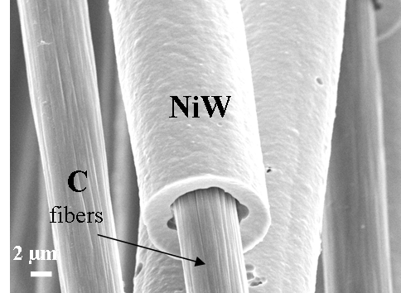
Fig. 1. NiW deposited layer on carbon fibers.
Characterization in acid medium. The corrosion behaviour of Ni-based composites with and without nonstoichiometric Ti oxide particles was studied by
polarization curves. The deposits containing embedded TiO_{x} particles (Fig. 2) exhibited better corrosion behaviour [35] as the others properties retain persistent. This fact was connected with the structure of the deposits, the presence of deep cracks (Fig. 2a) as well as the amount of sorbed hydrogen.
The electrocatalytic properties of the composites were investigated by electrochemical impedance spectroscopy (EIS). The results from EIS showed that NiW + TiO_{x} layers on modified carbon fibre electrodes (Fig. 3a) [38] possess the highest electro-catalytic activity for HER compared with NiW + TiO_{x} layers on pristine carbon fiber electrodes (Fig. 3b) [38] and NiW layers on oxidized carbon fiber electrodes. This behaviour may be attributed not only to the developed electrode surface caused by the presence of nonstoichiometric titanium oxides followed by secondary crystallization of NiW layers on their surface (Fig. 2b), but also to the nature of the interaction between the composite and modified carbon fibres [38].
Codeposition of Mo
Electrolytes and electrodeposition conditions. Two types of electrolytes were used: neutral – containing nickel sulphamate (Ni²⁺ 16 g/l), C₆H₅Na₃O₇.2H₂O 90 g/l, Na₂WO₄.2H₂O 30 g/l and Na₂MoO₄.2H₂O 7.5 g/l; and a second one – NiMoW alkaline electrolyte containing Ni sulphamate (Ni²⁺ 32 g/l), C₆H₅Na₃O₇.2H₂O 72g/l, Na₂WO₄.2H₂O 24g/l, Na₂MoO₄ 6g/l, NH₄OH about 20 ml to adjust pH. The pH of the neutral electrolyte was 7 and temperature 60ºС, and pH 9 and temperature 50ºС for the alkaline electrolyte, respectively. The deposits from both electrolytes obtained under potentiostatic conditions (–1.0 V and –1.1 V versus SCE) were characterized with good adhesion and smoothness.
R. Rashkov: Synthesis and characterization of novel electrodeposited catalytic materials…

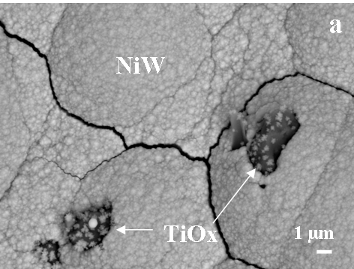 | 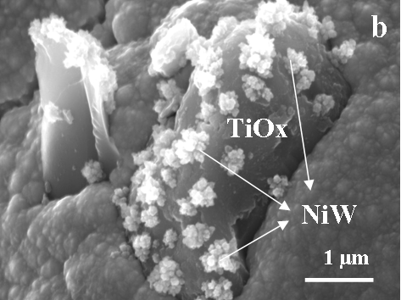
Fig. 2. Embedded TiO_{x} particles on NiW deposit: a) cracks; b) secondary crystallization on the TiO_{x} particle surface.

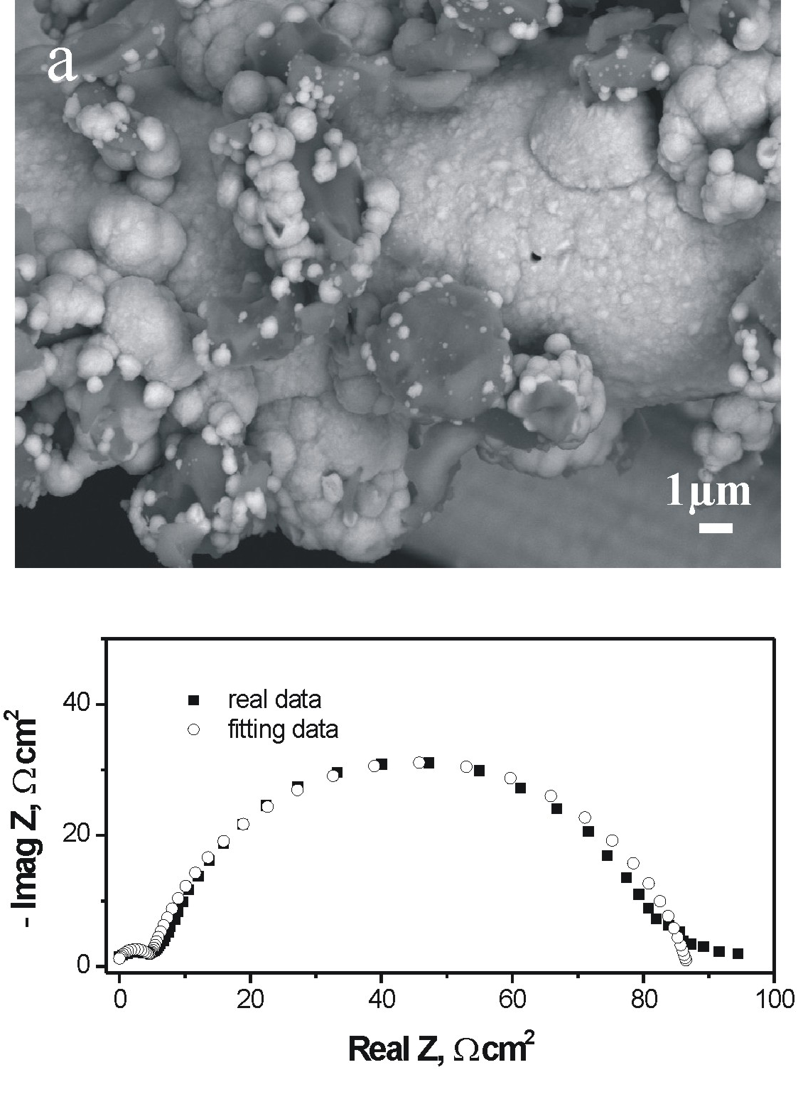 | 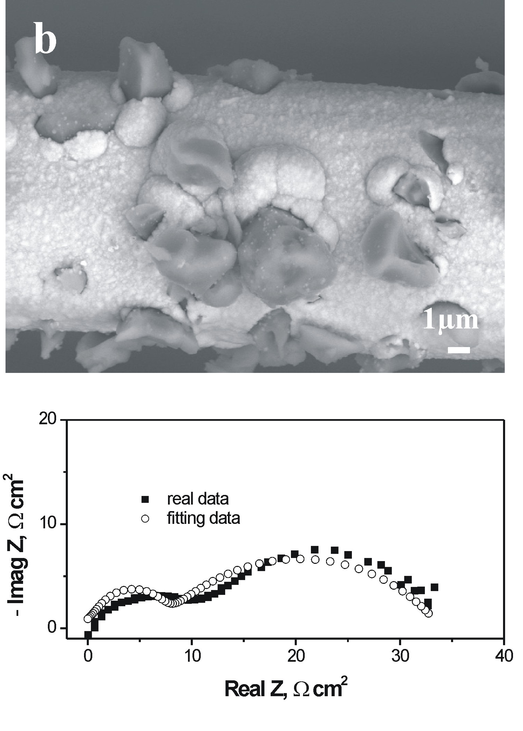
Fig. 3. NiW + TiOx layers on carbon fibres and EIS measurements [38]: a) modified carbon fibre; b) pristine carbon fibre.

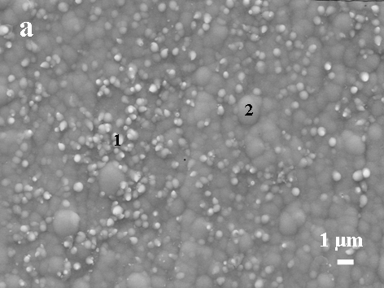 | 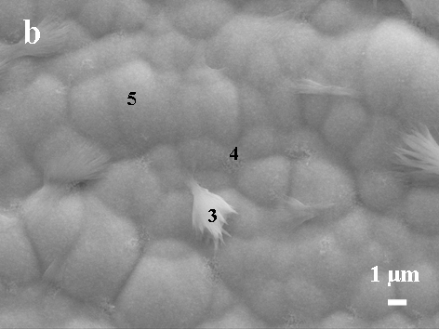
Fig. 4. NiMoW deposits from: a) neutral electrolyte; b) alkaline electrolyte.

Morphology and composition studies. Both deposits from neutral and alkaline electrolyte possessed globular morphology (Fig. 4). The compositions of the layers are presented in Table 1. Globular formations rich of oxygen (white balls, spectrum (Sp 1)) on the surface of deposit from neutral electrolyte were observed (Fig. 4a). Sodium-oxide rich species (Sp 3) appeared on the surface of the deposit obtained from alkaline solution probably due to the electrolyte components (Fig. 4b). Our previous studies on the polarization curves in strongly alkaline solution for HER showed better electrocatalytic activity of NiMoW layers obtained from alkaline electrolyte than those obtained from neutral one in spite of the bigger amount of Mo in the deposit. Thus, our next studies were continued with deposits obtained from alkaline electrolyte.
R. Rashkov: Synthesis and characterization of novel electrodeposited catalytic materials…
Table 1. The composition of NiMoW deposits obtained from neutral and alkaline electrolyte (in weight per cent).
Neutral electrolyte
Sp | O,  % | Ni,  % | Mo,  % | W,  % | Na,  %
1 | 12 | 41 | 36 | 11 | -
2 | 6 | 47 | 36 | 11 | -
Alkaline electrolyte
 | О | Ni | Mo | W | Na
3 | 11 | 58 | 17 | 4 | 10
4 | 8 | 66 | 18 | 5 | 2
5 | 5 | 67 | 22 | 6 | -
Electrodeposition of Co based systems
CoMnB system
A non-conventional growth of cobalt-manganese layers deposited from electrolytes with low cobalt content was observed [39–41]. Independently on the substrate, the typical shape of the multilayered
Co-Mn-B dendrite was kept, where successive growth fronts were observed, the light ones being rich of cobalt, and the dark ones – rich of oxygen, boron and manganese. Such multilayers were obtained from complex electrolyte containing 5 g/l Co²⁺, 5 g/l Mn²⁺ and 35 g/l boric acid. Cobalt electrode was used as an anode. Deposition was performed under potentiostatic conditions at –1.5 and –1.8 V (vs. SCE) on Ni-foam (RECEMAT Int. [42]), with geometric area 1 cm². The real electrochemically active area of the electrodes was calculated from curves, obtained by cyclic voltam-metry in 6 M KOH electrolyte (using the Randles-Sevcik equation). The reproducible voltammograms (Fig. 5) show well defined and invariant anodic and cathodic (I_{kp}) peaks, corresponding to the formation and reduction of Co(OH)₂, were compared with those obtained from fresh polished and determined surface (S) of Co plate.
Growth of multi-layered dendrite formations, comprising successive layers with very high Co or O content, was observed at high deposition poten-tials. The obtained systems contain huge amounts of incorporated hydrogen for cobalt deposits, ca. 4200 ppm [43]. The dependence of hydrogen content remaining after thermal treatments at different temperatures suggested the presence of two types of bonded hydrogen. Based on the experimental data of the components in the different zones, and especially about the ratio between them, suggestions were made about the nature of the BMnO layers. It was assumed that these were borate or metaborate compounds, which were adsorbed onto and then grew together with the subsequent cobalt layers. It was postulated that the presence of such layers was directly related to the absorption of considerable amounts of hydrogen in the deposits [44]. Such electrodeposited nanocomposite Co-Mn-B multi-layers on Ni-foam were investigated as catalysts for HER [30] and hydrolysis of NaBH₄ in alkaline solution [45]. It was established that the estimated value of activation energy (~55 kJ·mol^{–1}) for the tested catalysts was lower than the reported one for Co-B (~65 kJ·mol^{–1}) [46] and close to that reported for Ru-catalyst (56 kJ·mol^{–1}) [47].
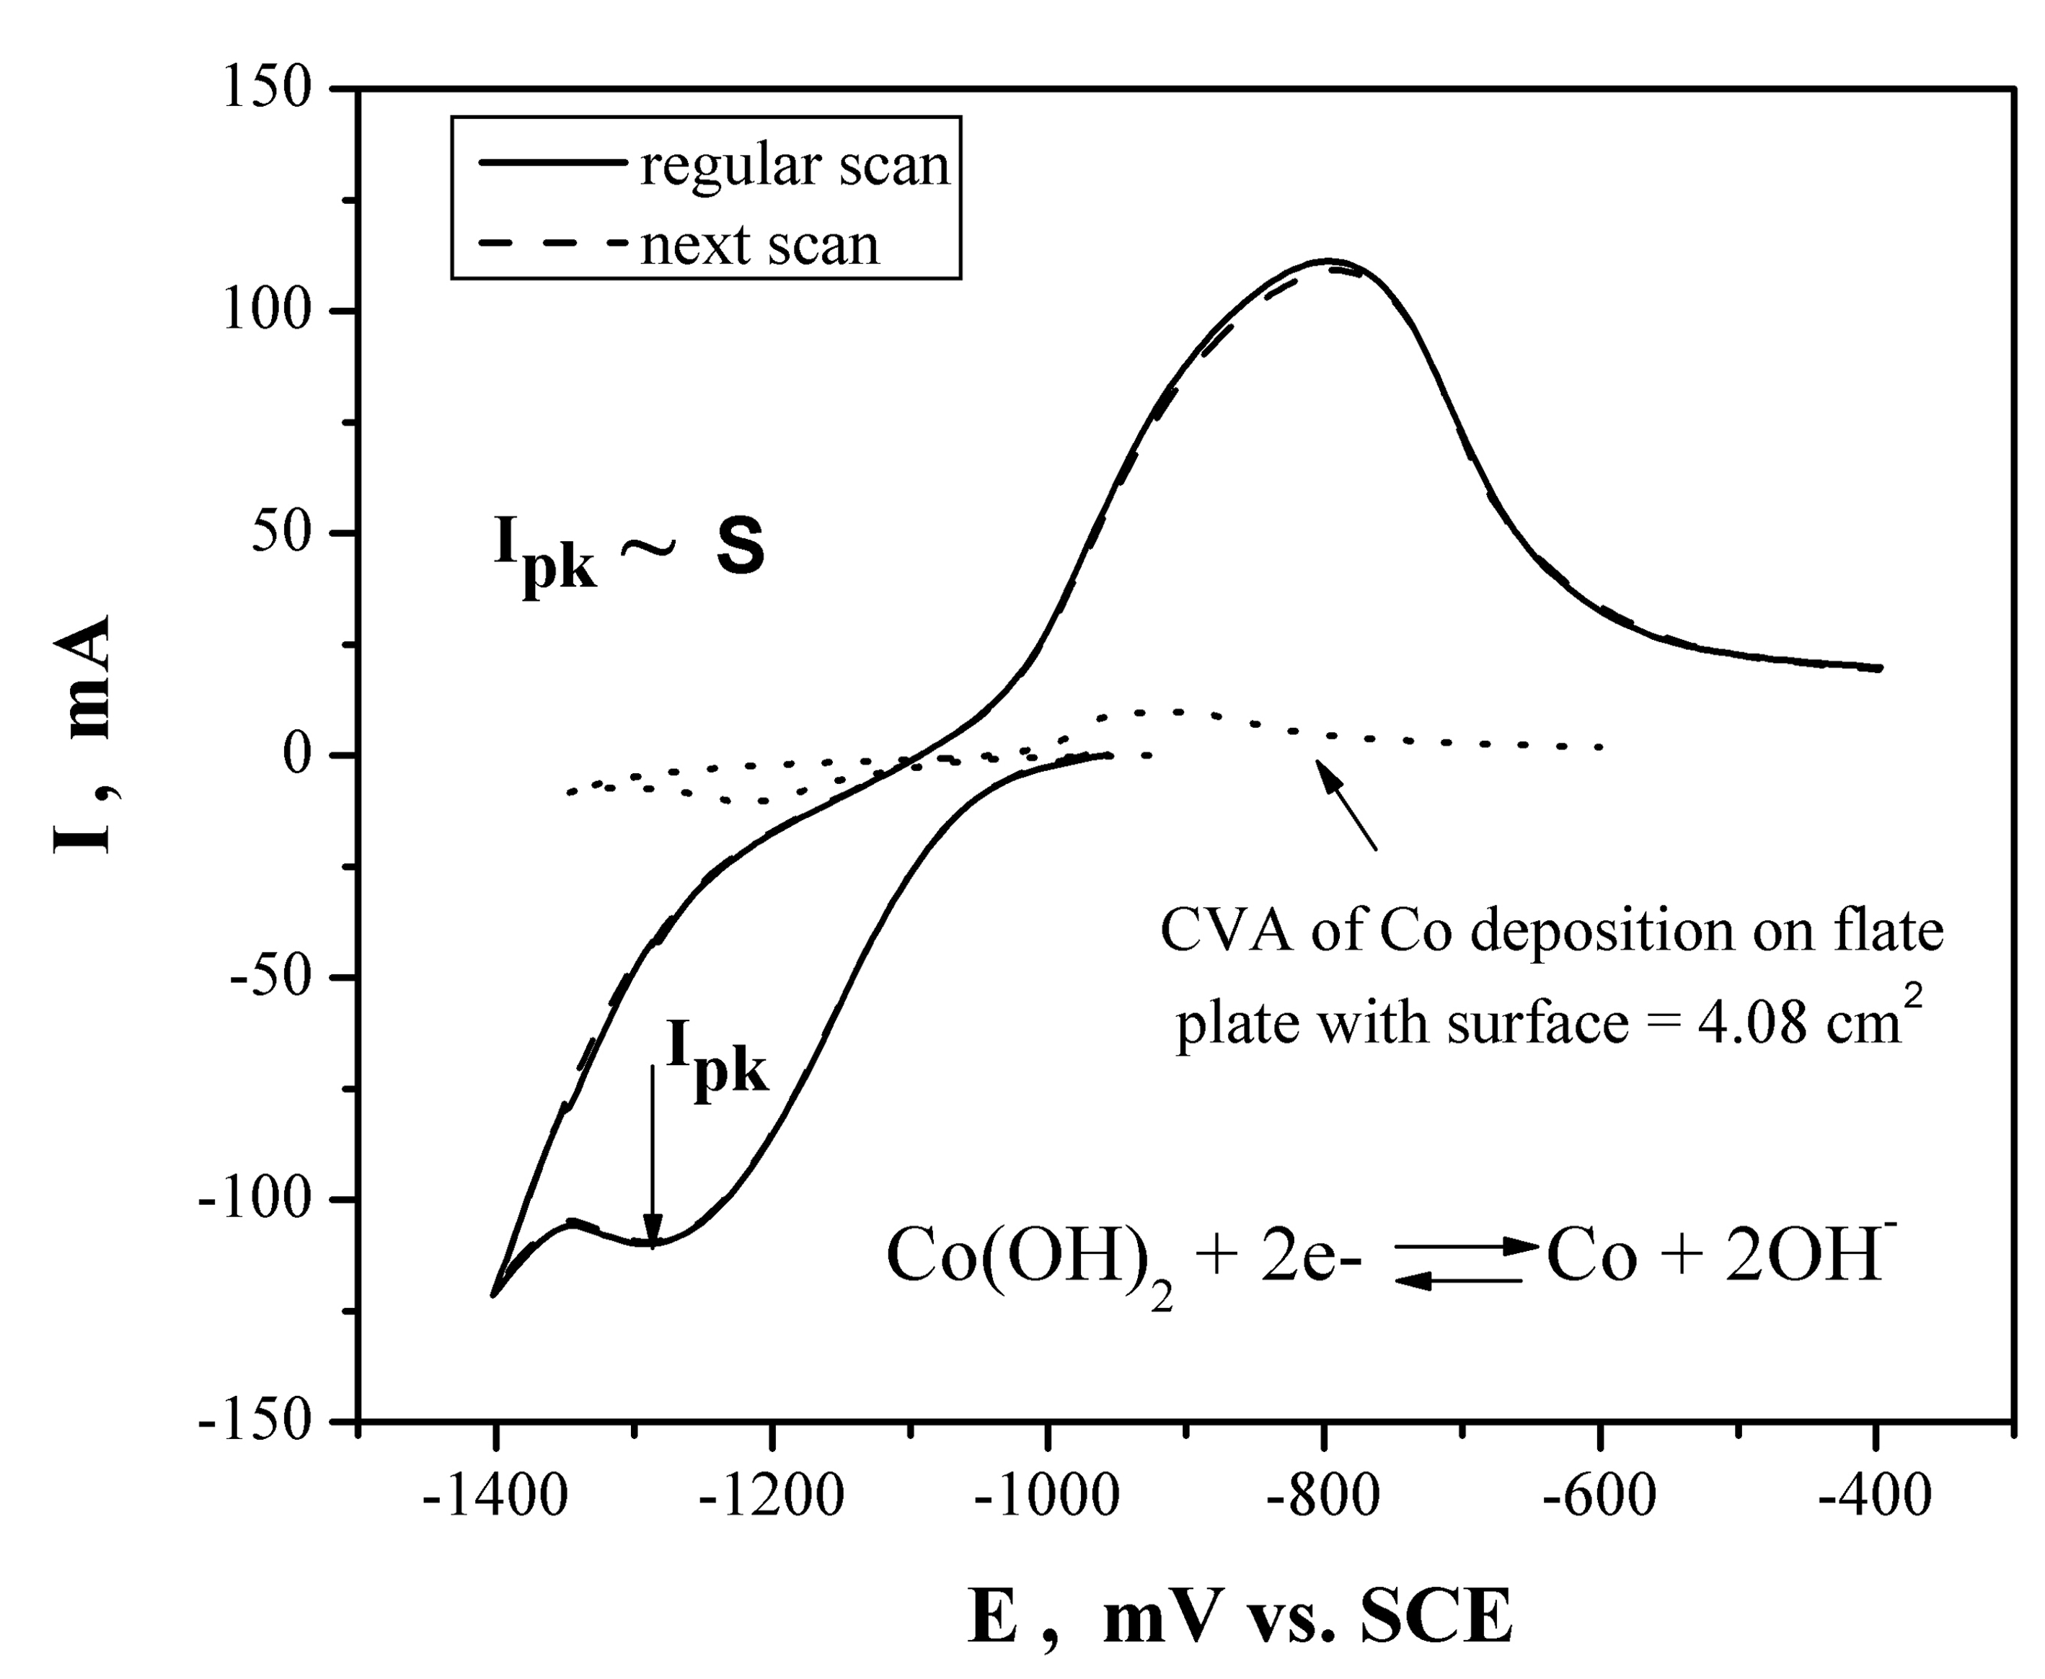
Fig. 5. Reproducible voltammograms of Co electrodes in 6 M KOH.
CoNiMnB system
Sulphamate nickel (3 or 5 g/l) was added using the electrolyte described in 3.1. Thus, the concen-tration relation between nickel and cobalt was 3:3 g/l or 5:5 g/l.
R. Rashkov: Synthesis and characterization of novel electrodeposited catalytic materials…
The formation of successive light, comprising cobalt and nickel layers, and dark fronts, containing considerable amounts of oxygen and manganese, were observed by scanning electron microscopy (SEM), Fig. 6. The addition of nickel maintains typical multilayered Co-Mn-B growth. The morpho-logy depends on concentration and electrolysis conditions.
The electrocatalytic activity of newly synthe-sized CoNiMnB electrodeposits for direct boro-hydride electroxidation was examined. Electrodes, prepared by electrodeposition from complex sulphamate electrolytes on Ni-foam at different potentials, were anodically polarized and the corres-ponding polarization curves were plotted. Simul-taneously, the rate of generated due to borohydride
hydrolysis hydrogen was monitored at each current loading. The values of overpotentials at given current densities were estimated and compared with those previously obtained with CoMnB electrodes [48].
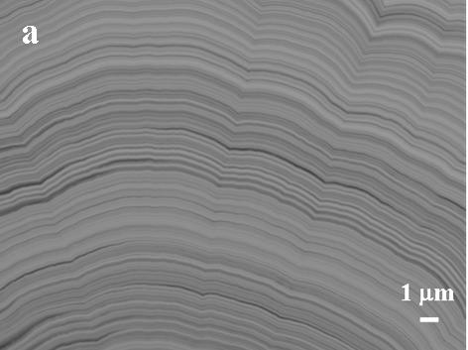
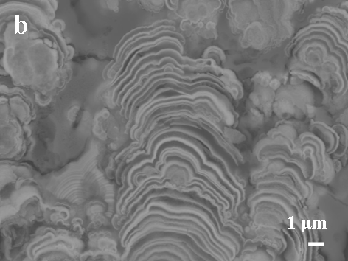
Fig. 6. Cross-section of CoNiMnB composites obtained under potentiostatic conditions: a) E = –1.5 V vs. SCE with concentration relation between Ni and Co are 5:5 g/l; b) E = –1.8V vs. SCE with concentration relation between Ni and Co are 3:3 g/l.
Table 2. The composition of V containing deposits (in weight per cent).
CoMnVB
 | B,  % | O,  % | S,  % | V,  % | Mn,  % |  | Co,  %
6 | 11 | 21 |  | 24 | 15 |  | 29
7 | 18 | 39 | 0.2 | 31.8 | 8 |  | 3
CoVB
 |  | O | S | V |  |  |  | Co
8 |  | 38 | 0.3 | 50.7 |  | - |  | 11
CoVMnB and CoVB system
Based on CoMnB electrolyte, vanadium was added as 0.5 g/l or 5 g/l VCl₃. The deposits were characterized by a huge number of cracks, worse adhesion with substrate (copper plate) than CoMnB layers. Different morphology and vanadium content were observed (Fig. 7) depending on the electrolyte. EDX analyzes showed reach of V–O zones (Sp 7) with different morphology. Decreasing of manga-nese amount in the composite increased the vanadium content, too, Table 2.
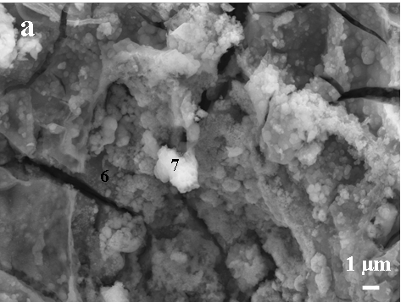
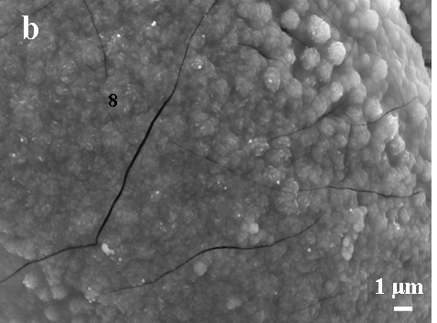
Fig. 7. Vanadium codeposition with Co-based composites: a) CoVMnB; b) CoVB.
Electrodeposition of quaternary Co and Ni based systems
Ni and its selected binary and ternary alloys with copper and cobalt over the last 10–15 years were reviewed [49]. The influence of various bath composition, pH, current density and potential conditions as well as the mechanism of electro-deposition and hydrogen evolution during electro-chemical processes were considered [20, 49]. In order to improve the electrocatalytic characteristics of this type of systems, quaternary Co-Ni based composites were synthesized.
R. Rashkov: Synthesis and characterization of novel electrodeposited catalytic materials…
Electrolytes and electrodeposition conditions:
CoNiMoW deposits on copper plate were produced from electrolyte containing 16 g/l Ni²⁺, 16 g/l Co²⁺ (or 3 g/l Co²⁺ for NiCoMoW deposits), C₆H₅Na₃O₇.2H₂O 72 g/l, Na₂MoO₄.2H₂O 6 g/l, Na₂WO₄.2H₂O 24 g/l and NH₄OH to adjust pH to 10.5. The deposition was carried out under galvano-static conditions and temperature 50ºC by stirring at 200 min^{–1}. The Pt-Ti mash was used as anode and SCE – as reference electrode.
Morphology and composition studies
The influence of Co concentration and current density on the distribution of components in composites is presented in Table 3. Decreasing the initial concentration of Co about five times in the electrolyte (from 16 to 3 g/l) decreases its amount about twenty times in the deposit thus obtaining Ni-rich composites (NiCoMoW) as the contents of W remain nearly the same. On the other hand, the increase of current density also decreases Co amount. This fact can be explained by anomalous codeposition of iron group metals [49, 50], where the less noble metal has a stronger influence on the deposition behaviour of the partner ion. The phenomena were observed clearly on SEM images (Fig. 8). The same electrodeposition conditions but with different Co concentration in the electrolyte generated totally different morphology. The pyramidal nickel surface structures in Fig. 8a (with less amount of Co – NiCoMoW,) proceeded to small grain formations on the reach of Co composite (CoNiMoW) surface, Fig. 8b.
Table 3. Element content and thickness of the deposit d in Co and Ni based composites obtained under different galvanostatic conditions.
Current density | Composites | d, μm | Ni, % | Co, % | W, % | Mo, %
50 mA/ cm² | NiCoMoW | 9.7 | 69.0 | 11.8 | 3.2 | 16.0
70 mA/ cm² | NiCoMoW | 13.3 | 74.1 | 7.7 | 3.8 | 14.4
80 mA/cm² | CoNiMoW | 1.8 | 8.8 | 78.8 | 3.6 | 8.8
90 mA/cm² | CoNiMoW | 3.0 | 11.6 | 76.1 | 3.8 | 8.5
90 mA/cm² | NiCoMoW | 12.2 | 83.0 | 4.2 | 2.6 | 10.2
100 mA/cm² | CoNiMoW | 3.1 | 12.8 | 77.9 | 1.4 | 7.9
110 mA/cm² | CoNiMoW | 3.8 | 21.3 | 67.2 | 2.5 | 9.0
120 mA/cm² | CoNiMoW | 5.6 | 23.7 | 63.7 | 3.2 | 9.4
Polarization curves
The deposited electrodes with geometric surface 2 cm² were tested for HER in 6 M KOH. The experiments were carried out under galvanostatic steady-state conditions. Before starting the measure-ments, the electrode surface was polarized for 30 min by applying a relatively high (200 mA) cathodic current. Then the current was lowered to 5 mA. The reproducible polarization curves are presented in Fig. 9. The results showed that CoNiMoW and NiMoW systems possess the lowest polarization for HER compared with others, i.e. the highest electro-catalytic activity.
R. Rashkov: Synthesis and characterization of novel electrodeposited catalytic materials…
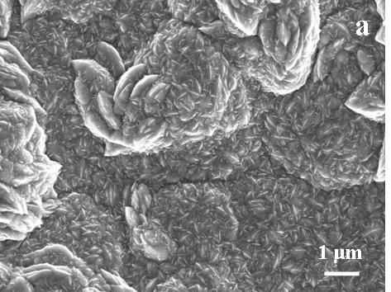
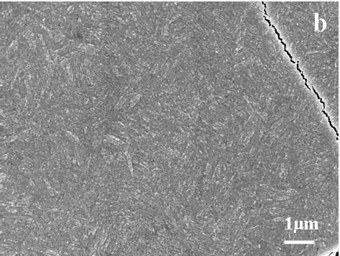
Fig. 8. Ni- and Co-based composites: a) NiCoMoW;
b) CoNiMoW.
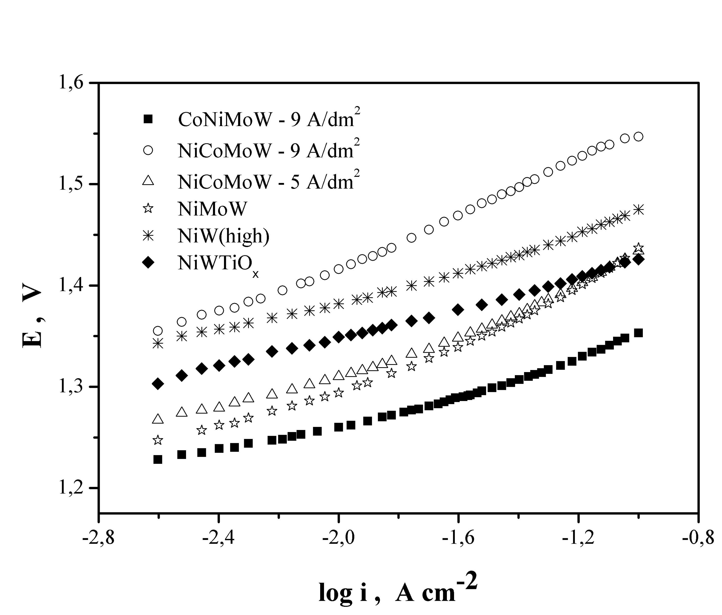
Fig. 9. Polarization curves of Ni- and Co-based materials.
Conclusion
New types of electrolytes for electrodeposition of ternary and quaternary Co- and Ni-based composites were developed. The influence of the component concentrations and electrolyte conditions on the morphology was studied. The best electrocatalytic behaviour for HER was shown by CoNiMoW and NiMoW systems. Their additional corrosion studies in different media might lead to direct application for hydrogen production and fuel cell technology.
Acknowledgments: The authors express their gratitude to the Bulgarian National Fund “Scientific Researches” (project D-01-368) for the financial support for carrying out these investigations. This work is partially supported by the Deutsche Forschungsgemeinschaft (DFG) within a joint research project between the Institute of Physical Chemistry at Bulgarian Academy of Sciences, Bulgaria and the Forschungsinstitut fűr Edelmetalle und Metallchemie, Germany.
REFERENCES
- S. A. S. Machado, L. A. Avaca, Electrochem. Acta, 39, 1385 (1994).
- L. Vračar, B. E. Conway, J. Electroanal. Chem., 277, 253 (1990).
- K. Lohrberg, P. Kohl, Electrochim. Acta, 29, 1557 (1984).
- A. Rami, A. Lasia, J. Appl. Electrochem., 22, 376 (1992).
- L. Chen, A. Lasia, J. Electrochem. Soc., 140, 2464 (1993).
- I. Paseka, Electrochim. Acta, 38, 2449 (1993).
- R. K. Shervedani, A. Lasia, J. Electrochem. Soc., 144, 511 (1997).
- C. Hitz, A. Lasia, J. Electroanal. Chem., 500, 213 (2001).
- T. Burchardt, V. Hansen, T. Våland, Electrochim. Acta, 46, 2761 (2001).
- E. Daftsis, N. Pagalos, A. Jannakoudakis, P. Jannakoudakis, E. Theodoridou, R. Rashkov, M. Loukaytsheva, N. Atanassov, J. Electrochem. Soc., 150, C787 (2003).
- D. Gierlotka, E. Rówiński, A. Budniok, E. Łągiewka, J. Appl. Electrochem., 27, 1349 (1997).
- C. Hitz, A. Lasia, J. Electroanal. Chem., 532, 133 (2002).
- J. Panek, A. Serek, A. Budniok, E. Rówiński, E. Łągiewka, Int. J. Hydrogen Energy, 28, 169 (2003).
- B. Łosiewicz, A. Budniok, E. Rówiński, E. Łągiewka, A. Lasia, Int. J. Hydrogen Energy, 29, 145 (2004)
- B. Łosiewicz, A. Budniok, E. Rówiński, E. Łągiewka, A. Lasia, J. Appl. Electrochem., 34, 507 (2004).
- R. Rashkov, N. Atanassov, A. Jannakoudakis, P. Jannakoudakis, E. Theodoridou, J. Electrochem. Soc., 153, C152 (2006).
- V. Marinović, J. Stevanović, B. Jugović, M. Maksimović, J. Appl. Electrochem., 36, 1005 (2006).
- D. E. Brown, M. N. Mahmood, M. C. M. Man, A. K. Turner, Electrochim. Acta, 29, 1551 (1984).
- I. A. Raj, K. I. Vasu, J. Appl. Electrochem., 20, 32 (1990).
- I. A. Raj, K. I. Vasu, J. Appl. Electrochem., 22, 471 (1992).
- C. Fan, D. L. Piron, P. Paradis, Electrochim. Acta, 39, 2715 (1994).
- C. Fan, D. L. Piron, A. Sleb, P. Paradis, J. Electrochem. Soc., 141, 382 (1994).
- B. Y. Zeng, S. Yao, H. Guo, Plat. Surf. Finish., 82, 64 (1995).
- E. B. Castro, M. J. de Giz, E. R. Gonzalez, J. R. Vilche, Electrochim. Acta, 42, 951 (1997).
- R. K. Shervedani, A. Lasia, J. Electrochem. Soc., 145, 2219 (1998).
- J. M. Jakšić, M. V. Vojnović, N. V. Krstajić, Electrochim. Acta, 45, 4151 (2000).
- M. M. Jaksic, Int. J. Hydrogen Energy, 26, 559 (2001).
- M. Enyo, in: Comprehensive Treatise of Electro-chemistry, B. E. Conway, J. O’M. Bockris, E. Yeager, S. U. M. Khan, R. E. White (eds), vol. 7, Plenum Press, NewYork and London, 1983, p. 241.
R. Rashkov: Synthesis and characterization of novel electrodeposited catalytic materials…
- G. Wu, N. Li, Ch. S. Dai, D. R. Zhou, Mat. Chem. Phys., 83, 307 (2004).
- R. Rashkov, G. Hodjaoglu, N. Atanassov, A. Zielonka, in: Nanostructured Materials in Electroplating (Proc. Int. Workshop, 26–29 March, Sandanski, Bulgaria, 2006), D. Stoychev, E. Valova, I. Krastev, N. Atanassov (eds.), Sv. Kliment Ohridski University Press, Sofia, 2006, p. 190.
- H. Ezaki, M. Morinaga, S. Watanabe, Electrochim. Acta, 38, 557 (1993).
- N. Atanassov, M. Bratoeva, Trans. Met. Finish., 76, 39 (1998).
- L. Huang, J. X. Dong, F. Z. Yang, S. K. Xu, S. M. Zhou, Trans. Met. Finish., 77, 185 (1999).
- F. Z. Yang, Y. F. Guo, L. Huang, S. K. Xu, S. M. Zhou, Chin. J. Chem., 22, 228 (2004).
- M. Arnaudova, R. Rashkov, V. Bachvarov, N. Atanassov, A. Zielonka, in: Nanostructured Materials in Electroplating (Proc. Int. Workshop, 26-29 March, Sandanski, Bulgaria, 2006), D. Stoychev, E. Valova, I. Krastev, N. Atanassov (eds), Sv. Kliment Ohridski University Press, Sofia, 2006, p. 194.
- B. Łosiewicz, A. Stępień, D. Gierlotka, A. Budniok, Thin Solid Films, 349, 43 (1999).
- A. Serek, A. Budniok, Curr. Appl. Phys., 2, 193 (2002).
- R. Rashkov, M. Arnaudova, N. Atanassov, A. Zielonka, P. Jannakoudakis, E. Theodoridou, J. Appl. Electrochem., submitted.
- M. Nikolova, N. Atanassov, M. Baumgärtner, A. Zielonka, Metalloberfläche, 53, 26 (1999).
- M. Nikolova, N. Atanassov, J. Fischer-Bühner, A. Zielonka, Trans. Inst. Met. Finish., 78, 147 (2000).
- N. Atanassov, M. Nikolova, A. Zielonka, Trans. Inst. Met. Finish., 79, 99 (2001).
- RECEMAT, “RECEMAT Metal Foam: Extremely Porous Material; RECEMAT Metal Foam: Flame Arresters” RECEMAT International, 2002; http://www.recemat.com.
- N. Atanassov, M. Manolova, R. Rashkov, A. Zielonka, Trans. IMF, 85, 94 (2007).
- N. Atanassov, M. Manolova, R. Rashkov, A. Zielonka, J. Appl. Electrochem., in press
- M. Mitov, R. Rashkov, N. Atanassov, A. Zielonka, J. Mater. Sci., 42, 3367 (2007).
- S. U. Jeong, R. K. Kim, E. A. Cho, H.-J. Kim, S.-W. Nam, I.-H. Oh, S.-A. Honh, S. H. Kim, J. Power Sources, 144, 129 (2005).
- S. C. Amendola, S. L. Sharp-Goldman, M. S. Janjua, N. C. Spencer, M. T. Kelly, P. J. Petillo, M. Binder, Int. J. Hydrogen Energy, 25, 969 (2000).
- M. Mitov, G. Hristov, E. Hristova, R. Rashkov, M. Arnaudova, A. Zielonka, Environ. Chem. Lett., (2007) (in press).
R. Rashkov: Synthesis and characterization of novel electrodeposited catalytic materials…
- R. Oriňàkovà, A. Turoňovà, D. Kladekovà, M. Gàlovà, R. M. Smith, J. Appl. Electrochem., 36, 957 (2006).
- N. Zech, E. J. Podlaha, D. Landolt, J. Electrochem. Soc., 146, 2886 (1999).

СИНТЕЗ И ОХАРАКТЕРИЗИРАНЕ НА ЕЛЕКТРОХИМИЧНО ОТЛОЖЕНИ НОВИ МАТЕРИАЛИ КАТАЛИЗИРАЩИ ОТДЕЛЯНЕТО НА ВОДОРОД
Р. Рашков
Институт по физикохимия „Акад. Р. Каишев“, Българска академия на науките,
ул. „Акад. Г. Бончев“ бл. 11, 1113 София
Постъпила на 30 октомври 2007 г., Преработена на 1 февруари 2008 г.
(Резюме)
В настоящата работа е направен преглед на електрохимично получени собствени материали както и синтез на нови покрития от NiMoW, NiCoMnB, CoMnVB, CoVB, CoNiMoW и NiCoMoW при вариращи условия на електролизния процес. Наблюдавана е морфологията както на повърхността така и на напречни шлифове на изброените системи. Каталитичните характеристики по отношение реакцията на отделяне на водород в силно алкална среда са оценени от поляризационни зависимости. Най-добри резултати за тази реакция показват системите NiMoW и CoNiMoW. Тези материали биха могли да намерят приложение като електрокатализатори не само при производството на водород, но и в технологиите на горивните елементи.

