Modified carbon matrix – high energy anode for lithium ion battery
Bulgarian Chemical Communications, Volume 40, Number 3 (pp. 219–226) 2008
© 2008 Bulgarian Academy of Sciences, Union of Chemists in Bulgaria
A. V. Trifonova*
* E-mail: trifonova@bas.bg
Institute of Electrochemistry and Energy Systems, Bulgarian Academy of Sciences,
Acad. G. Bonchev St., block 10, 1113 Sofia, Bulgaria
Received October 22, 2007, Revised January 27, 2008
The recent commercial applications for packaged electrical power emphasize the need for high performance Li-ion battery systems and require the development of new alternative electrode materials, especially negative, which exceed the capabilities of conventional ones in terms of energy density. Graphites are the standard materials used as anode in lithium-ion systems. They have good compatibility with most electrolyte solvents and stable capacity over several hundreds of cycles but it is limited of 372 Ah/kg and rather low compared to the increasingly investigated lithium inserting metals and alloys (such as Al, Sn, Si, SnSb). Based on these facts, different modifications of graphite such as mild oxidation, coating by polymers and other kinds of carbon, composite formation, etc. are also the research activities focus of many scientific groups.
This paper will provide an overview about different graphite modification methods. The concepts for the creation of lithium storage hosts with improved cycling performance will be highlighted.
Keywords: carbon matrix, modification methods, high-energy anodes, Li-ion batteries

Introduction
The energy density of lithium-ion batteries is determined by the lithium storage capacity of the cathode and anode materials. Carbonaceous mate-rials and lithium transition metal oxides (LiMeO_{2,} Me = Co, Ni, Mn) are currently used as anode and cathode materials in commercial lithium-ion batte-ries. The electrolyte is usually an aprotic organic solution, a solid or gel-type polymer electrolyte. The electrochemistry of the cell involves the transfer of Li⁺ cations between the insertion electrodes with different electrochemical potentials [1]. Therefore, such a system is called lithium-ion cell (Fig. 1). The reaction at the electrodes and the overall cell reaction are as follows:
Positive electrode:
LiMeO₂ ↔ Li_{1-x}MeO₂ + x Li⁺ + x e– (1)
Negative electrode:
C_{n} + x Li⁺ + x e– ↔ Li_{x}C_{n} (2)
Overall reaction:
LiMeO₂ + C_{n} ↔ Li_{x}C_{n} + Li_{1–x}MeO_{2 ,} (3)
The lithiated carbon/graphite materials are thermodynamically not stable combined with the organic electrolytes used. Fortunately, the degrada-tion products of the electrolyte components, which are formed during the first lithium intercalation into the graphite, build up a protective layer on the surface of the electrode. This layer is called "Solid Electrolyte Interphase (SEI)" and should inhibit all further reactions once formed [2]. The layer is electrically insulating but remains permeable for lithium-ions.
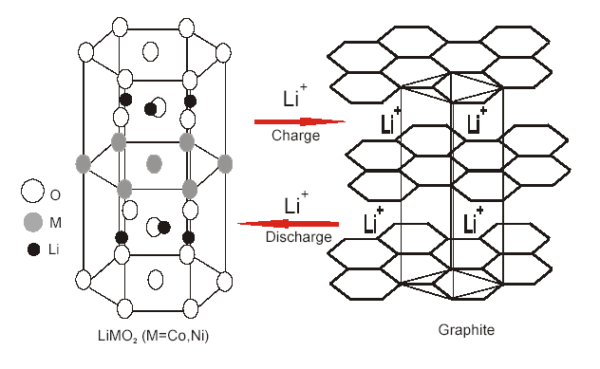
Fig. 1. Function scheme of a lithium-ion cell with a graphite-based anode.
The behaviour of graphite and related carbon-based materials is strongly dependent on their micro-structure; hence thermal and mechanical treatments play an important role in determining the thermo-dynamic and kinetic properties. Materials with more graphitic structure have more negative potential, whereas those with less well-organized structures, which operate in much wider potential ranges, result in a lower cell voltage that is dependent on the state-of-charge. Another important observation is the loss of capacity during the first charge-discharge cycle due to irreversible lithium absorption into the structure. This has the distinct disadvantage that it requires an additional amount of lithium to be initially present in the cell. Nevertheless, lithiated carbons are the state-of-art anode materials for rechargeable lithium batteries.
Graphite and other carbon-based anode materials: theoretical background in consideration
of experimental results
Crystal structure
Graphite is known to occur in two modifications, the hexagonal and the rhombohedral one. The hexa-gonal form, often called alpha graphite, is defined by a stacking of the graphite planes in the order of ABAB. The rhombohedral graphite, beta modifi-cation, shows a plane sequence of ABCABC [3], figure 2.
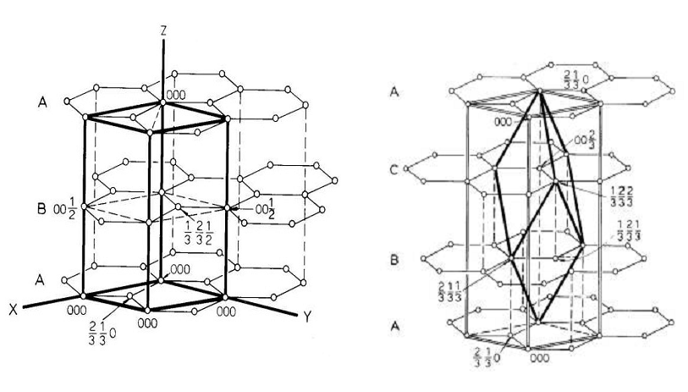
Fig. 2. Ideal graphite crystal structures with the corresponding unit cells; left hexagonal, right rhombohedral [4].
The two modifications apart from their crystal structure show identical physical properties. Normally, the two modifications are found together, some natural graphites are reported to contain up to 30% of the beta form [4].
The ratio of both phases depends on the different processing techniques applied. Heat treatments revert the material into the thermodynamically more stable alpha form, while mechanical treatments like milling; shearing or ultra sonic preparation enlarges the content of the beta modification [3, 4].
Effects of the rhombohedral phase on the materials electrochemical properties
Soon after the invention of graphite-made anodes correlations between the materials electrochemical properties and the rhombohedral phase were reported. High rhombohedral contents were observed to cause unusual high reversible capacities. The grain boun-daries were postulated to store additional lithium-ions and should therefore enhance the capacity [4].
A. V. Trifonova: Modified carbon matrix – high energy anode for lithium ion battery
More important is the graphites increased resistance against co-intercalation of solvents by the rhombohedral content. Guerin and co-workers [5] after intense studies found out that the rhombohedral stacking of the graphite layers is always accom-panied by structural defects. These defects created during the formation of the beta phase (not the phase itself) are hindering the entry of solvent molecules [6]. Battery graphites with high contents of rhombohedral phase additionally showed much better SEI formation properties than an all-hexa-gonal reference sample [7].
Beside graphite also hard and soft carbons have been investigated as host materials for lithium-ions. The intercalation characteristic of the materials is illustrated in Fig. 3. The usable capacity of the materials, especially of the hard carbons, can differ in a wide range depending on the starting material and the processing applied, and that of soft carbons ranges from about 185 mAh/g to 230 mAh/g.
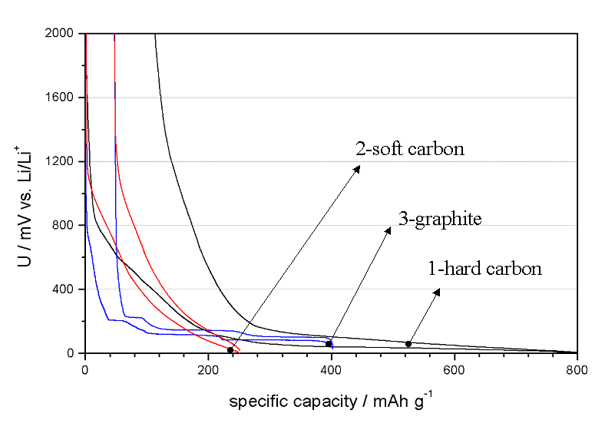
Fig. 3. Charge-discharge curves of: hard carbon (1),
soft carbon (2) and graphite(3).
Due to the imperfect structure the materials intercalation/de-intercalation characteristic is similar to the charging/discharging curve of a capacitor. The usable potential decreases continuously with the discharge capacity, limiting the systems usability for applications depending on a constant voltage supply. Hard carbons are reported from 600 to more than 1000 mAh/g (high capacity carbon), however, the low potential during charging implies problems due to metallic lithium deposits. Additionally to the problems mentioned, hard and soft carbons exhibit a high irreversible capacity in the first charging/dis-charging step. The potential curve of graphite is dominated by the intercalation plateaus caused by the layered structure of the material (Figs. 3 and 4). The usable potential remains high even when more than 90% of the lithium is deintercalated. The theoretical capacity of graphite, calculated for the discharged material, is 372 mAh/g, corresponding to a stoichiometry of LiC₆. The graphite layers are expanded only slightly by the lithium-ions inter-calated; volume changes of about 10% have been reported [2].

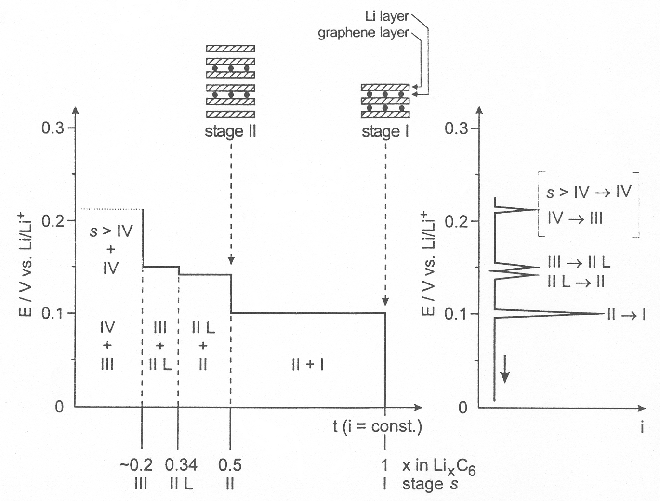
Fig. 4. Stage formation during lithium intercalation into graphite.

Worth mentioning are "Mesocarbon Microbeads (MCMB)", a special form of carbons developed by Osaka Gas in 1994 (Fig. 5). Their electro-chemical characteristic is similar to that of graphite; however, the usable capacity is a bit lower.
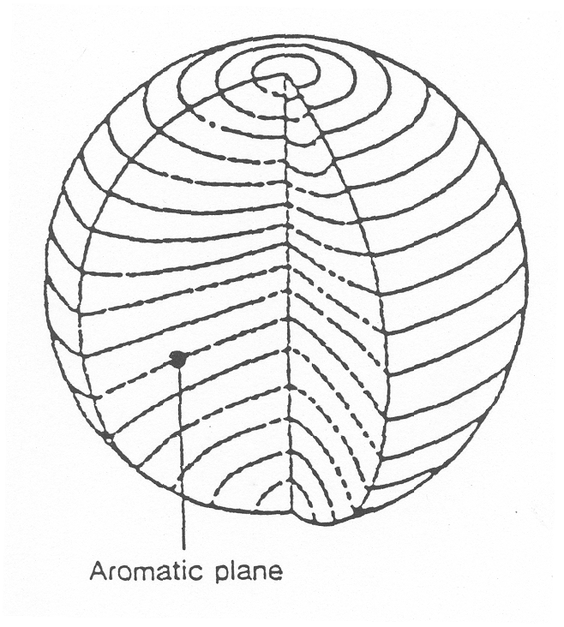
Fig. 5. Sketch drawing of the structure of MCMB.
A big advantage of MCMB is their good resistance against co-intercalation of solvents, a phenomenon especially, but not only, occurring in propylene carbonate-based electrolytes during the first charging step. The solvent co-intercalation inhibiting effect of MCMB is attributed to its entangled layers similar to those of a hard carbon. Graphites and the related types of MCMB are the most frequently used anode materials today.
A. V. Trifonova: Modified carbon matrix – high energy anode for lithium ion battery
Structural versus surface chemistry effects
The question is which of both is (more) deter-mining the materials electrochemical behaviour. The surface of carbonaceous materials contains nume-rous chemical complexes that are formed during preparation and post-treatment. The surface com-plexes are typically chemisorbed oxygen functio-nalities such as carbonyl, carboxyl, lactones, quinone, and phenol groups. These groups exhibit different thermal stabilities. From this viewpoint, the surface modification of different graphites is difficult and highly specific to the type of graphite. Spahr et al. showed that heating graphite under argon to more than 1200°C influences the material’s electrochemical properties negatively [8]. The effect was attributed to a change of the materials surface chemistry as the rhombohedral phase was observed not to change below 1300°C. This assumption is only partly correct; heat treatments do not affect only the surface chemistry but also the materials structure. As described above, the material is reverted to the hexagonal modification whereby the defect structure is rearranging much earlier than the stacking of the graphite layers. Guerin et al. could show that the defects are vanishing already from 1000°C on, while the rhombohedral phase remains stable much longer [6]. Considering the approach described, it is not possible to separate the effects of the surface chemistry groups and those of the mate-rials structure in the proposed way. The both influ-ence the overall electrochemical behaviour of graphite.
Modifications of graphite: discussion based on different practical results
The used graphite materials can be distinguished in natural and artificial ones; also MCMB is often classified as a graphite subtype. The electrochemical properties of the materials are widely influenced by the manufacturing and conditions applied. The raw material and the heat treatment process are deter-mining the structural order, the processing technique (milling and classifying) is among other influencing the resulting particle size distribution, the defect structure and the specific surface. The modification attempts exceeding the normal graphite manufac-turing techniques can be distinguished as follows∗:
Mild oxidation of graphite
It was first reported by Peled et al. [9] and Takamura et al. [10, 11] that mild oxidation with air at 550–600ºC of artificial graphite could modify its electrochemical performance. It can remove reactive sites and/or defects in graphitic materials resulting in an improvement of the surface structure, the formation of a dense layer of oxides acting as an efficient passivating film, and the creation of nano-channels/micro-pores for storage sites and passages for lithium. As a result, the electrochemical perfor-mance, including coulombic efficiency in the first cycle, reversible capacity and cycling behaviour, is improved. Many gases have been investigated since, and gas treatments can be considered as own field of research, which can be used to change the graphites surface chemistry significantly. Gas treatments do not only change the surface chemistry, but also affect the morphology of the graphite particles [12]. Up to a certain point this is desirable as evolving small holes and cracks eases the kinetic of the lithium intercalation into the graphite (Fig. 6). However longer treatment periods cause irreversible damage at the particles structure, capacity fading follows [13, 14].
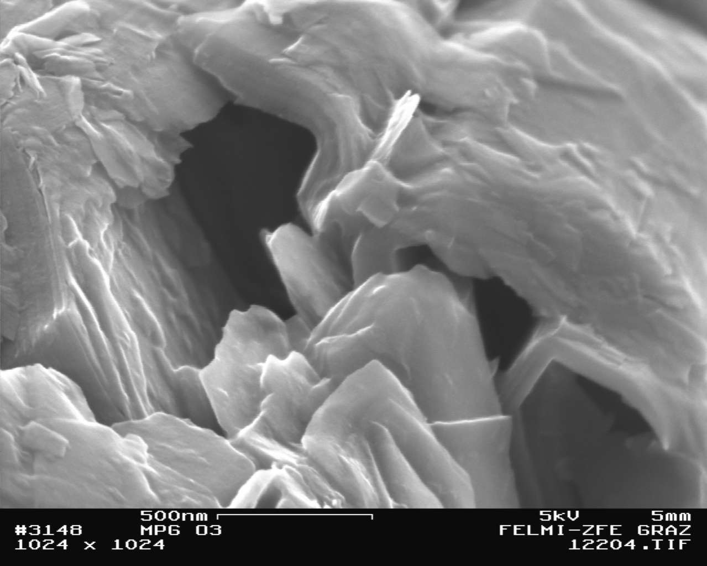
Fig. 6. Ozone-treated graphite: small pores and caverns are visible [13].
For the aim of graphite modifications, the non-catalytic reactions of graphite with different nitrogen oxides are of interest. While the different studies agree in the point that all NO_{x} molecules have higher reaction rates than O₂, there is only a poor correlation between all experimental kinetic data. The anisotropy of the graphite surfaces causes magnitude higher reactivities of the prismatic side atoms. The graphite gasification reactions are dominated by edge site etch reactions. Beside these, the c-attack or basal plane atom abstraction causes the formation of very reactive small pits. Depending on the reaction temperature the pits are found to appear in very different shapes. Beside monolayer pits also multilayer pits have been observed, which are accredited to defects in the underlying crystal structure. The contribution of the basal plane pit formation to the overall reaction increases with higher temperatures [14–17].
Surface coatings by polymers and other kinds of carbon
The term coating is very general and covers a wide range of ideas applied on electrochemically used materials. Often there are several effects achievable by coatings.
A. V. Trifonova: Modified carbon matrix – high energy anode for lithium ion battery
Coating by polymers such as polythiophene [18], polypyrrole [19], and polyanilin [20] lead to less irreversible capacity loss and better cycling stability [21]. Furthermore, there might be no need any more for fluorine-containing binder [22] and conductive additives in the composite electrodes.
Reversible electrochemical intercalation is impos-sible with graphitized carbons in LiClO₄/PC∗ (pro-pylene carbonate) because rapid electrolyte decom-position and exfoliation of the crystallite structure occur. On the other hand, this electrolyte is acceptable for intercalation of Li-ions into non-graphitized carbons such as petroleum coke, which however has a lower capacity than graphite, amount-ing to about 180 mAh/g. Consequently, improving the electrochemical performance of graphitic carbons for PC-based electrolytes by coating with other kinds of carbons has become a focus. The coated natural graphite as example shows much better electrochemical performance than “bare” natural graphite in both PC- and EC-based electrolytes [23]. Carbon coating can prevent the exposure of graphite or of a graphitic carbon core to electrolytes, and results in reduced electrolyte decomposition and exfoliation of graphene sheets, higher coulombic efficiency in the first cycle and good cycling behaviour [24–26].
Some other methods for modification: chemical vapour deposition of metal particles; irradiation by electron beam; doping with heteroatoms and mild milling
A third class of coating substances, beside polymers and carbons (resp. pyrolysed polymers), are metal-organic compounds. Kim et al. made some experiments using aluminum esters [26]. Phosphate esters [27] are widely investigated, while they can be used as coating chemicals directly. Tita-nium compounds have been described as coatings for different types of materials, not only carbon-aceous – unfortunately mainly in the form of patents. Mostly coatings with pure metal layers respectively TiO₂ have been intended [28, 29]. The conversion of the titanium ester, coupled on the graphite’s surface to a more stable, oxide-like compound, should be performed by a heat treatment step under an inert gas atmosphere. This post-treatment is often considered as one of the key steps of a successful coating process. Coatings with metal-organic compounds are the least investigated so far, and therefore remain most interesting. Contrary to the evaporated metal films that are more or less covering the whole surface of the substrate, the silanes [30] investigated were found to favour the prismatic sides of the graphite particles very exclusively (Fig. 7). From this it can be assumed that coatings based on metal-organic and related compounds are depending on the chemical coupling with the graphites surface groups of the prismatic planes.
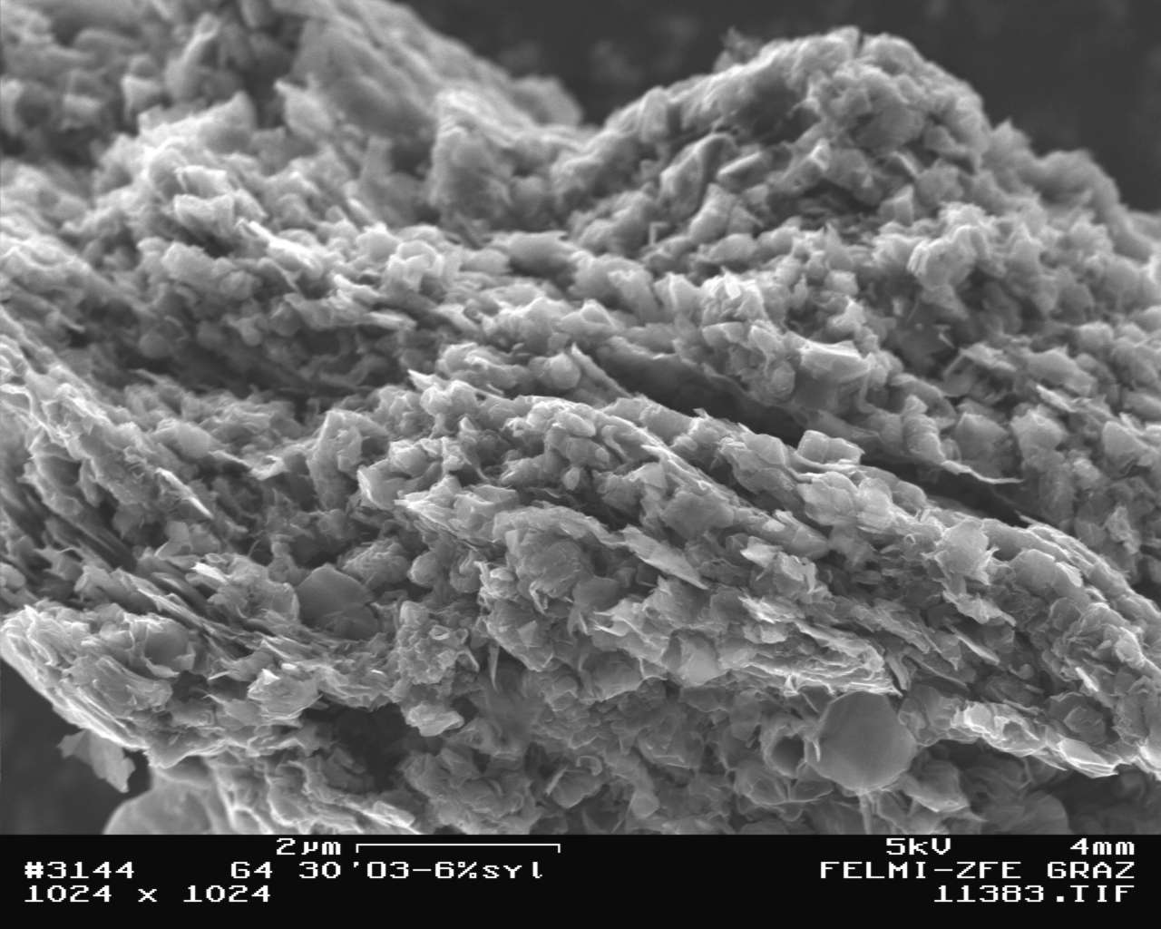
Fig. 7. Prismatic plane of a graphite particle after being ozonised and then coated with a silane [14].
The metal deposition on carbon can also be considered as subtype of surface coatings. Takamura et al. showed that covering the fibers with vacuum evaporated metal films can enhance the intercalation kinetic of lithium into carbon fibres [31]. Guo et al. could prove that nano-scale copper particles on the graphites surface are also enhancing the lithium kinetics, i.e., improving the high rate performance [32]. The work was additionally of interest as the copper also improved the performance in PC-rich electrolyte combinations.
For the application in lithium-ion systems doped carbon and graphite materials have been tested. Most promising are the results using boron. Nitrogen, sulphur, silicon and phosphor were tested, too [33]. A good summary of the knowledge about boron-doped graphites was given by Endo et al. [34]. Boron was shown to shift the electrochemical voltage profiles of therewith-doped materials at about 40 mV to higher potentials. The boron acting as electron acceptor explained the shift in potential. Lee et al. showed that the discharge capacity of boron-doped graphites is a function of the boron content [35]. Its amount, which can be incorporated in the graphite lattice, seems to be identical with the maximum of its solid solubility in graphite – 2.5% – found by C. E. Lowell [36]. Beside graphites also carbon fibre materials, carbon nanotubes and MCMB have been modified by boron doping. Especially the boron-doped carbon fibres showed good results [37].
A. V. Trifonova: Modified carbon matrix – high energy anode for lithium ion battery
Other modification method such as irradiation by electron beam leads to an increased reversible capacity in combination with a reduction of the amount of binder, which is necessary, and structural changes during cycling [38]. Furthermore, the mild milling can be a good method to improve the reversible capacity in the first cycle [39].
Composite formation with metals and metal oxides
Relatively new approaches include composite materials that have to combine the dimensional stability of the graphite matrix with the high capacity material, and thus trying to achieve an improved host with stable desired electrochemical performance. Metals, metal oxides and alloys can cover active sites at edge planes of graphitic carbon resulting in a decrease of electrolyte decomposition, gas evolution, exfoliation and absorption of water in the presence of high humidity [40, 41]. Increased conductivity, reversible capacity and improved high rate capability are also observed [42]. The specific extent of all effects depends on the species of metals, oxides or alloys and the preparation process. Some examples are:
(i) A 10% Ni-coating increases the initial charge-discharge coulomb efficiency of SFG 75 graphite from 59 to 84% and the reversible capacity by 30–40 mAh/g (Fig. 8) [43];
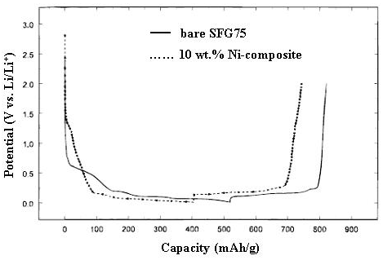
Fig. 8. Initial charge-discharge profiles of bare graphite- SFG75 – solid line and composite with 10% Ni - dot line, ch/dch-rate: C/8 [from ref. 43].
(ii) Composite of potato-type graphite with Sn has 38% higher discharge capacity, compared with output power (fig. 9) [42];
Fig. 9. Lithium insertion capacities vs. cycle number for bare potato-type graphite and Sn-graphite composites [from ref. 42].
(iii) In the case of composites of SnSb alloy (ratio below 30 wt. %) and MCMB, the aggregation of nanosized alloy particles is alleviated, and its cycling behaviour is improved with a high stable capacity up to 420 mAh/g (Fig. 10) [44].
Fig. 10. Cyclic performance for the series of MCMB/SnSb materials in 1M LiPF₆/EC-DEC (1:1, v/v) and current density = 0.2 mA/cm². Sample CNSS2 contains 26% alloy [from ref. 44].
Other kinds of metals such as Zn and Al [45] can also be coated onto the surface of graphite. The effects are similar to the above-mentioned ones. The results obtained lead to the assumption that there is a critical metal, respectively alloy ratio up to which good results can be achieved.
Conclusions
The electrochemical properties of graphite and carbon-based materials are widely influenced by the manufacture conditions applied and are strongly dependent on their microstructure and surface che-mistry. Because of the limited theoretical capacity of raw materials, new modification approaches are needed to improve their overall electrochemical performance. The overview about different modify-cation methods, such as mild oxidation, coating by polymers and other kinds of carbon, composite formation, etc. was provided. It was found that the electrochemical behaviour improvement strongly depends on the allocation of supporting particles (chemical coupling with the graphites surface groups) together with the kind (microstructure) of used carbon matrix and synthesis method conditions. There is a critical ratio of supporting agents up to which good results can be achieved.
A. V. Trifonova: Modified carbon matrix – high energy anode for lithium ion battery
Acknowledgments: Dr. Trifonova would like to acknowledge the financial support of NATO via EAP.RIG.982531
References
- R. Dahn, A. K. Sleigh, H. Shi, B. M. Way, W. J. Weydanz, J. N. Reimers, Q. Zhong, U. von Sacken, in: Lithium Batteries, Vol. 5, G. Pistoia (ed.), Elsevier, Amsterdam, London, New York, Tokyo, 1994, p. 1.
- M. Winter, J. O. Besenhard, in: Handbook of Battery Materials, J. O. Besenhard (ed.), Wiley-VCh, Weinheim, Germany, 1999, p. 383.
- O. Vohler, G. Collin, F. von Sturm, E. Wege, Ullmann’s Encyclopedia of Industrial Chemistry, 7th Ed., Electronic Release, 2005.
- H. Huang, W. Liu, E. Kelder, J. Schoonman, Solid State Ionics, 110, 173 (1998).
- K. Guerin, A. Fevrier-Bouvier, J. Electrochem. Soc., 146, 3660 (1999).
- S. Flandrois, K. Guerin, Mol. Cryst. Liquid Cryst., 340, 493 (2000).
- W. Kohs, J. Doninger, I. Barsukov, J. Besenhard, J. Power Sources, 119, 528 (2003).
- M. E. Spahr, H. Wilhelm, T. Palladino, N. Dupont-Pavlovsky, D. Goers, F. Joho, P. Novak, J. Power Sources, 119-121, 543 (2003).
- E. Peled, C. Menachem, A. Melman, J Electrochem. Soc., 143, L4 (1996).
- T. Takamura, M. Kikuchi, Y. Ikezawa, Proc. Electrochem. Soc., 94-28, 213 (1995).
- M. Kikuchi, T. Takamura, J. Electroanal. Chem., 396, 451 (1995).
- H. Buqa, P. Golob, J. O. Besenhard, J. Power Sources, 97–98, 122 (2001).
- H. Buqa, M. Alvarez, J. Besenhard, M. Winter, J. Power Sources, 97, 126 (2001).
- Y. H. Li, G. V. Rudolph, Chem. Eng. Sci., 53, 1 (1998).
- X. Chu, L. D. Schmidt, Ind. Eng. Chem. Res., 32, 1359 (1993).
- N. Chen, R. T. Yang, R. S. Goldman, J. Catal., 180, 245 (1998).
- J. Yang, E. Sanchez-Cortezon, R. Schlögl, Carbon, 38, 2029 (2000).
- S. Kuwabata, H. Yoneyama, J. Electrochem. Soc., 145, 1415 (1998).
- B. Veeraraghavan, B. Haran, B. Popov, J. Power Sources, 109, 377 (2002).
- M. Gaberscek, M. Bele, R. Dominko, J. Power Sources, 97, 67 (2001).
- Q. Pan, K. K. Guo, L. Z. Wang, S. B. Fang, Solid State Ionics, 149, 193 (2002).
- J. Drofenik, R. Dominko, S. Pejovnik, J. Power Sources, 94, 97 (2001).
- M. Yoshio, K. Fukuda, Y. Adachi, J. Electrochem. Soc., 147, 1245 (2000).
- S. Yoon, H. Kim, S. M. Oh, J. Power Sources, 94, 68 (2001).
- H. Wang, M. Yoshio, Z. Ogumi, J. Electrochem. Soc., 149, A499 (2002).
- S.-S. Kim, Y. Kadoma, Y. Uchimoto, M. Wakihara, Electrochem. Solid-State Lett., 4, A109 (2001).
- S.-S. Kim, Y. Kadoma, M. Wakihara, Electrochemistry, 69, 830 (2001).
- J. J. Park, H. J. Kwon, J. H. Yun, J. W. Soo, JP 2003123757, Japan Kokai Tokkyo Koho (2003).
- K.-S. Yun, B.-W. Cho, W.-I. Cho, H.-S. Kim, U.-S. Kim, S.-C. Nam, Y.-S. Yoon, US patent application, US 2003039890 (2003).
A. V. Trifonova: Modified carbon matrix – high energy anode for lithium ion battery
- M. Schmidt, A. Kuehner, D. Petigk, EU patent,
EP 1162682 (2001).
- T. Takamura, C. Yamada, K. Sekine, J. Power Sources, 81, 368 (1999).
- X. Guo, K. Tokuwasu, T. Kasuh, J. Power Sources, 92, 187 (2001).
- M. Winter, K.-C. Moeller, J. O. Besenhard, in: Lithium Batteries, G.-A. Nazri, G. Pistoia (eds.), Elsevier, Amsterdam, 1994, p. 51.
- M. Endo, C. Kim, K. Nishimura, K. Miyashita, Carbon, 38, 183 (2000).
- Y. Lee, D.-Y. Han, A. J. Woo, D. Lee, Y. K. Kim, Carbon, 40, 403 (2002).
- C. E. Lowell, J. Am. Ceram. Soc., 50, 142 (1967).
- N. Takami, T. Ohsaki, M. Yamamoto, J. Electrochem. Soc., 149, A9 (2002).
- E. Endo, S. Yamada, H. Imoto, K. Sekai, J. Power Sources, 93, 215 (2001).
- C. Natarajan, H. Fujimoto, K. Tokumitsu, J. Power Sources, 92, 187 (2001).
- Y. P. Wu, C. Wan, E. Tsuchida, Electrochem. Commun., 2, 626 (2000).
- Y. P. Wu, C. Jiang, C. Wan, R. Holze, J. Power Sources, 112, 255 (2002).
- A. Trifonova, M. Winter, J. Besenhard, J. Power Sources, 174, 800 (2007).
- P. Yu, J. A. Ritter, B. N. Popov, .J. Electrochem. Soc., 147, 1280 (2000).
- L. H. Shi, H. Li, Z. X. Wang, L. Q. Chen; J. Mater. Chem., 11, 1502 (2001).
- S. Kim, Y. Kadoma, H. Ikuta, Y. Uchimoto, M. Wakihara, Electrochem. Solid-State Lett., 4, A109 (2001).

Модифицирана въглеродна матрица – високоенергиен анод
за литиево-йонна батерия
Ат. В. Трифонова
Институт по електрохимия и енергийни системи, Българска академия на науките,
ул. „Акад. Г. Бончев“, бл. 10, 1113 София
Постъпила на 22 октомври 2007 г., Преработена на 27 януари 2008 г.
(Резюме)
Новите пазарни приложения на компактни и мобилни източници на енергия налагат необходимостта от разработване на нови литиево-йонни системи с високи специфични характеристики. Това довежда до търсене на алтернативни електродни материали, и по-специално аноди, които надвишават електрохимичните показа-тели на конвеционално използваните досега графити.
Графитите имат добра съвместимост с голям брой електролити и добра циклируемост, но техният специ-фичен обратим капацитет е ограничен до 372 Ah/kg и значително по-нисък в сравнение с този, на изследваните в последно време метали и сплави (като Al, Sn, Si, SnSb), съхраняващи литий.
Базирайки се на тези факти, различни методи за модификация на графити, като например умерено оксиди-ране, покриване с полимери, структуриране на композитни материали и други, са обект на изследване от много научни колективи.
Тази публикация представя обзор на различни методи за модифициране на графитови материали. Особено внимание се отделя на някои концепции за създаване на модифицарана въглеродна матрица за съхраняване на литий с подобрени електрохимични параметри.

 ∗ The classification is maybe not accurately in all points.
 ∗∗ The electrolyte in commercial Li-ion batteries contains LiPF₆ and solvent mixtures of cyclic and linear carbonates.

