Influence of calcination of stainless steel OC4004 covered with alumina or ceria carrier layers on their passive state in different acid media
Bulgarian Chemical Communications, Volume 40, Number 3 (pp. 227–232) 2008
© 2008 Bulgarian Academy of Sciences, Union of Chemists in Bulgaria
D. Guergova¹, E. Stoyanova¹, D. Stoychev¹*, G. Atanasova², I. Avramova², P. Stefanov²
* To whom all correspondence should be sent:
E-mail: stoychev@ipchp.ipc.bas.bg
¹ Rostislaw Kaischew Institute of Physical Chemistry, Bulgarian Academy of Sciences, 1113 Sofia, Bulgaria
² Institute of General and Inorganic Chemistry, Bulgarian Academy of Sciences, 1113 Sofia, Bulgaria
Received November 12, 2007, Revised February 8, 2008
A comparative investigation has been carried out on the corrosion behaviour of thermally treated stainless steel (SS) OC4004 covered with Al₂O₃ or Ce₂O₃-CeO₂ layers (systems Al₂O₃/SS_{(t.t.)} and Ce₂O₃-CeO₂/SS_{(t.t.)}) electrodeposited on in solutions of 0.1 N HNO₃ and 0.1 N H₂SO₄. It has been established that in NO₃– containing medium SS_{(t.t.)} tends to self-passivation. The thermal treatment of the system Al₂O₃/SS eliminates the protective effect of the electrodeposited Al₂O₃ layer in the corrosion media investigated due to its mechanical cracking and the formation of galvanic Al₂O₃/Fe pairs. Electrodeposited ceria strongly enhances the corrosion resistance of the system Ce₂O₃-CeO₂/SS both before and after thermal treatment. The protective effect of the Ce₂O₃-CeO₂ layers is found to be due to the enrichment of Cr in the passive film provoked by these layers as well as to effective cathodes causing a shift of the steady state potential in the system Ce₂O₃-CeO₂/SS_{(t.t.)} in a positive direction.
Key words: stainless steel, electrodeposited Al₂O₃ and Ce₂O₃-CeO₂, corrosion protection.

INTRODUCTION
The use of stainless steels in high temperature regimes and aggressive media can lead to a decrease in their corrosion resistance due to the formation and prevailing dissolution of the appearing chro-mium carbides. Such conditions arise, e.g., during the preparation (calcination) and exploitation of catalytic steel converters for neutralization of NO_{x}, CO, hydrocarbons, etc. evolving from engines and power plants, etc. It is important to characterize their anode (corrosion) behaviour in aggressive media the more so as there may be mixture of nitric, sulphur and/or oxides in the converters, depending on the nature of the chemical compounds to be puri-fied. Interacting with the evolving water vapour, these oxides may produce relatively high acid concentration. In this connection, the occurrence of a corrosion attack on the steel substrates is quite probable. As a result, negative effects may be observed in two directions: (i) strength characteris-tics deterioration of the steel construction and (ii) formation of chemical compounds in addition to the catalytically active ones, which being present as oxides, hydroxides etc. can decreased the catalytic effect of the catalysts and, in the most unfavourable case, act as catalytic poisons. In this connection, it is important to investigate the temperature effect on the corrosion behaviour of construction stainless steels used in converters and in this respect the role of additionally deposited aluminium or cerium oxides coatings.
The purpose of the present work was to invest-tigate the effect of thermal treatment on the corro-sion behaviour of stainless steel OC4004 covered with electrodeposited Al₂O₃ or Ce₂O₃-CeO₂ in strongly aggressive nitric or sulphuric acid media.
EXPERIMENTAL
The test specimens (10×10 mm) used in this study were prepared from a sheet of OC 4004 type stainless steel (SS) with a thickness of 50 μm. The composition of the steel in wt.% was: 20.0% Cr, 5.0% Al, 0.02% C, and balanced Fe.
The Al₂O₃ and Ce₂O₃-CeO₂ layers were depo-sited electrochemically on the specimens from non-aqueous electrolytes, whose compositions and regimes are described in [1–3]. The thickness of the deposited layers was ~1 μm. The layers were invest-tigated after calcinations (thermal treatment) at 450ºC for 2 h in air.
The chemical composition and the oxidation state of the elements on the surfaces being formed (heat-treated and/or subjected to anodic polariza-tion) were studied using X-ray photoelectron spec-troscopy (XPS) after a preliminary 5 min bombard-ment of the surfaces with Ar⁺. The XPS studies were performed in an Escalab II system (England) with Al K_{α} radiation (hν = 1486.6 eV) and total instrumental resolution of ~1 eV. The vacuum in the chamber was 10^{–7} Pa. The binding energy (BE) was referred to the C1s line (of adventitious carbon) at 285.0 eV. The element concentrations were evalu-ated based on the integrated peak areas after a Shirley-type linear background subtraction using theoretical Scofield’s photoionization cross-sections.
The morphology and structure of the layers were examined by scanning electron microscopy, using a JEOL JSM 6390 electron microscope (Japan), equipped with an ultrahigh resolution scanning system in a regime of secondary electron image (SEI). The accelerating voltage was 25 kV, I ~ 65 μA. The pressure was of the order of 10^{–6} Torr.
The electrochemical behaviour of the samples was studied in 0.1 N HNO₃ or 0.1 N H₂SO₄ as corrosion media with a standard three-electrode thermostated cell (100 ml volume) at 25ºC. A counter electrode, representing a platinum plate (10×10×0.6 mm), and a mercury sulphate reference electrode (E_{Hg/Hg2SO4} = +0.642 V vs SHE) were used. All poten-tials in the text are related to MSE. The anodic and cathodic polarization curves were obtained using a 273 EG&G potentiostat/galvanostat (Germany), with a potential sweeping rate of 10 mV/s within a potential range from −1.150 to + 1.500 V.
The steady-state corrosion potential (E_{st}) of the samples under investigation was also determined by direct measurement after immersing the samples in 0.1 N HNO₃ or 0.1 N H₂SO₄. The following two values of E were determined: E₁ is the potential value, found immediately after the immersion of the samples in the acid; E_{st} is established after a sufficiently long time interval (from a few minutes to several decades of minutes until the moment,
when the steady-state corrosion potential change does not exceed 1–3 mV for 5 min).
RESULTS AND DISCUSSION
Figure 1 shows potentiodynamic polarization curves for a thermally treated SS sample in 0.1 N HNO₃ (Fig. 1a) and 0.1 N H₂SO₄ (Fig. 1b).
D. Guergova et al.: Influence of calcination of SS OC4004 covered with alumina
The anodic behaviour of the steel in 0.1 N HNO₃ is characterized by a region of passive state in the potential zone − 0.750 V to + 0.500 V and by cur-rents of complete passivation (i_{pass} at E_{c.p}. = +0.500 V) from about 5.8×10⁻⁶ to about 4.1×10⁻⁵ A·cm⁻². In the cathode region, at the potential where hydrogen evolution begins, the curve maximum is shifted in a positive direction – from −1.0 V to −0.750 V (at the I, II and III scan – see the insert in Fig. 1a). This effect, which is indicative of a decrease in over-potential of the reaction of hydrogen evolution, is a result of enrichment of the oxide film in several valency states of chromium and the complete disap-pearance of metal chromium from the surface layer [4, 5].
Simultaneously, at E = ~ +0.900 V (see the insert in Fig. 1a), an anodic peak appears which is characteristic of steels with a high chromium content in acid media. This peak is associated with oxidation of Cr³⁺ to Cr⁶⁺ (formation of anions of chromic acid) according to equation 2Cr³⁺ + 7H₂O = Cr₂O₇²⁻ + 14H⁺ + 6e⁻ [6]. After repeated polariza-tion in anodic direction this peak splits, which indicates the appearance of valency states differing from Cr⁶⁺.

Fig. 1. (a) Potentiodynamic E-lgi curves (i-E curves of scans 1–3, inserted figure) of SS after thermal treatment
in 0.1 N HNO₃; (b) in 0.1 N H₂SO₄.

In contrast to the oxidizing affect in 0.1 N HNO₃, in 0.1 N H₂SO₄ an increase in i_{pass} from 1.4×10⁻⁵ with the first scan to 5.6×10⁻⁵ A·cm⁻² with the third scan is observed. In addition, critical currents of passivation appear in the anodic polarization curves after the second scan at E = ~ −0.800 V (see the insert in Fig. 1b). Their appearance is associated with the concentration increase, according to Eqn. Fe − 3e⁻ → Fe³⁺ [7], of iron in the passive film after the thermal treatment. The changes in shape of the anodic polarization curves (Fig. 1b) are analogous to those found in 0.1 N HNO₃: when E = ~ +0.900 V, peaks characterizing the oxidation of Cr³⁺ to higher valencies appear.
Comparison of the steady state corrosion potentials for heat-treated steel in 0.1 N HNO₃ and 0.1 N H₂SO₄ determined experimentally during the study of the dependences E−τ (Fig. 2a) shows a difference of about 1 V in their values (in nitric acid E_{st} = +0.113 V and in sulphuric acid E_{st} = −0.976 V). We assume that this result is due to the oxidative effect of NO₃–. The proceeding of reactions (1) and (2) with potentials of about +0.950 V, vs. NHE (~ +0.280 V vs, Hg/Hg₂SO₄) according to [6–8] is thermodynamically possible:
D. Guergova et al.: Influence of calcination of SS OC4004 covered with alumina
NO₃– + 3H⁺ + 2e– → HNO₂ + H₂O
Eº_{H} = +0.940 V vs. NHE (1)
NO₃– + 4H⁺ + 3e– → NO + H₂O
Eº_{H} = +0.960 V vs. NHE (2)
The proceeding of these reactions results in a strongly positive corrosion potential of the medium,
which determines the stable passive state of SS_{(t.t.)}. Due to this, occurrence of a hydrogen-depolarizing reaction, i.e. conjugated reaction of metal oxidation similar to those occurring in 0.1 N H₂SO₄, is impossible. This specific character of the processes observed in 0.1 N HNO₃ leads to an increase (about 3 times) of the surface concentration of Cr, while the surface concentration of Al drops by about 45% with respect to its values in the passive film of SS not subjected to heat-treatment (Table 1). The changes in surface concentrations of the elements correspond to the surface morphology changes of SS_{(t.t.)} in the two corrosion media (Fig. 3). Obviously, the chemical composition change of the SS surface film resulting from the heating, leads to a change in corrosion behaviour of the steel, which, in the case of 0.1 N HNO₃, is also stabilized by the oxidative effect of the corrosion medium, while in H₂SO₄ such an effect is not observed.
Table 1. Element distribution (in at.%) on the surface layers of SS and thermally treated samples of SS, Al₂O₃/SS, Ce₂O₃-CeO₂/SS after anode polarization in 0.1 N HNO₃ and 0.1 N H₂SO₄ at a potential of +0.500 V.
Samples | in 0.1 N HNO₃ at E_{c.p}. = +0.500 V
Samples | O,  at. % | Fe,  at. % | Cr,  at. % | Al,  at. % | Ce, at. %
SS | 62.0 | 1.7 | 3.1 | 33.2 | -
SS (t.t.) | 67.7 | 2.7 | 9.4 | 20.2 | -
Al₂O₃ /SS (t.t.) | 59.3 | 1.3 | 0.8 | 38.6 | -
Ce₂O₃-CeO₂/SS(t.t.) | 61.3 | 7.0 | 8.8 | 17.0 | 5.9
 | in 0.1 N H₂SO₄ at E_{c.p}.= +0.500 V
SS (t.t.) | 62.8 | 2.3 | 6.1 | 28.8 | -
Ce₂O₃-CeO₂/SS(t.t.) | 60.0 | 0.9 | 6.7 | 30.8 | 1.6

Fig. 2. Open circuit stationary potential (E_{st}) vs. time for: (a) SS_{(t.t.)}; (b) Ce₂O₃-CeO₂/SS_{(t.t.)} in different acid media.

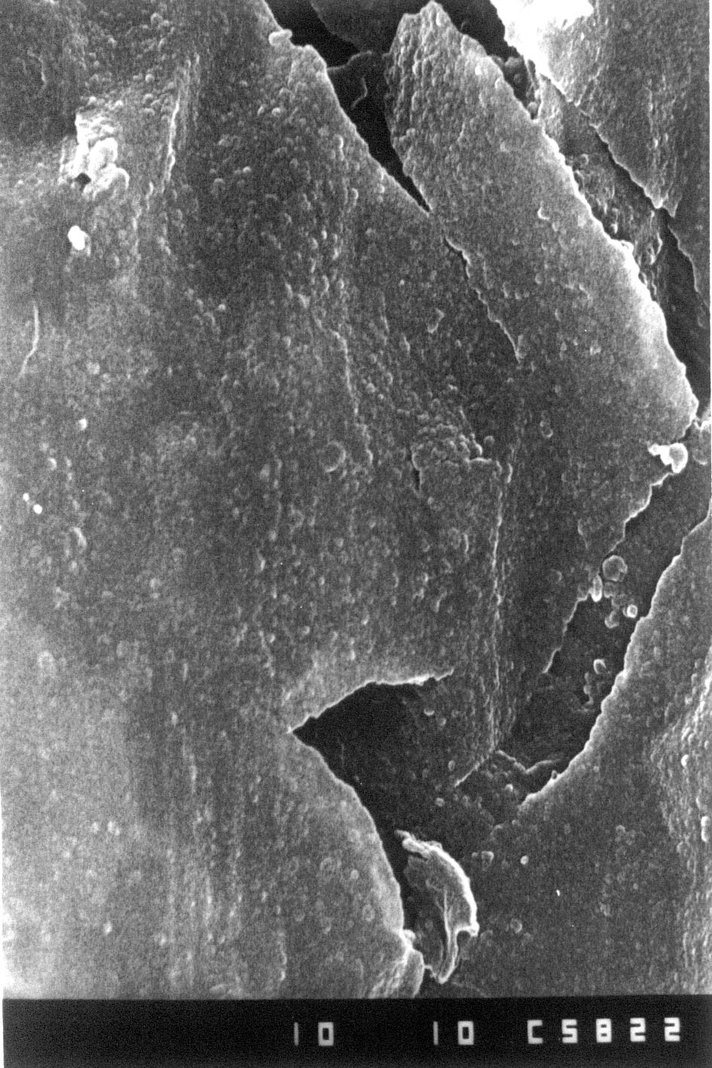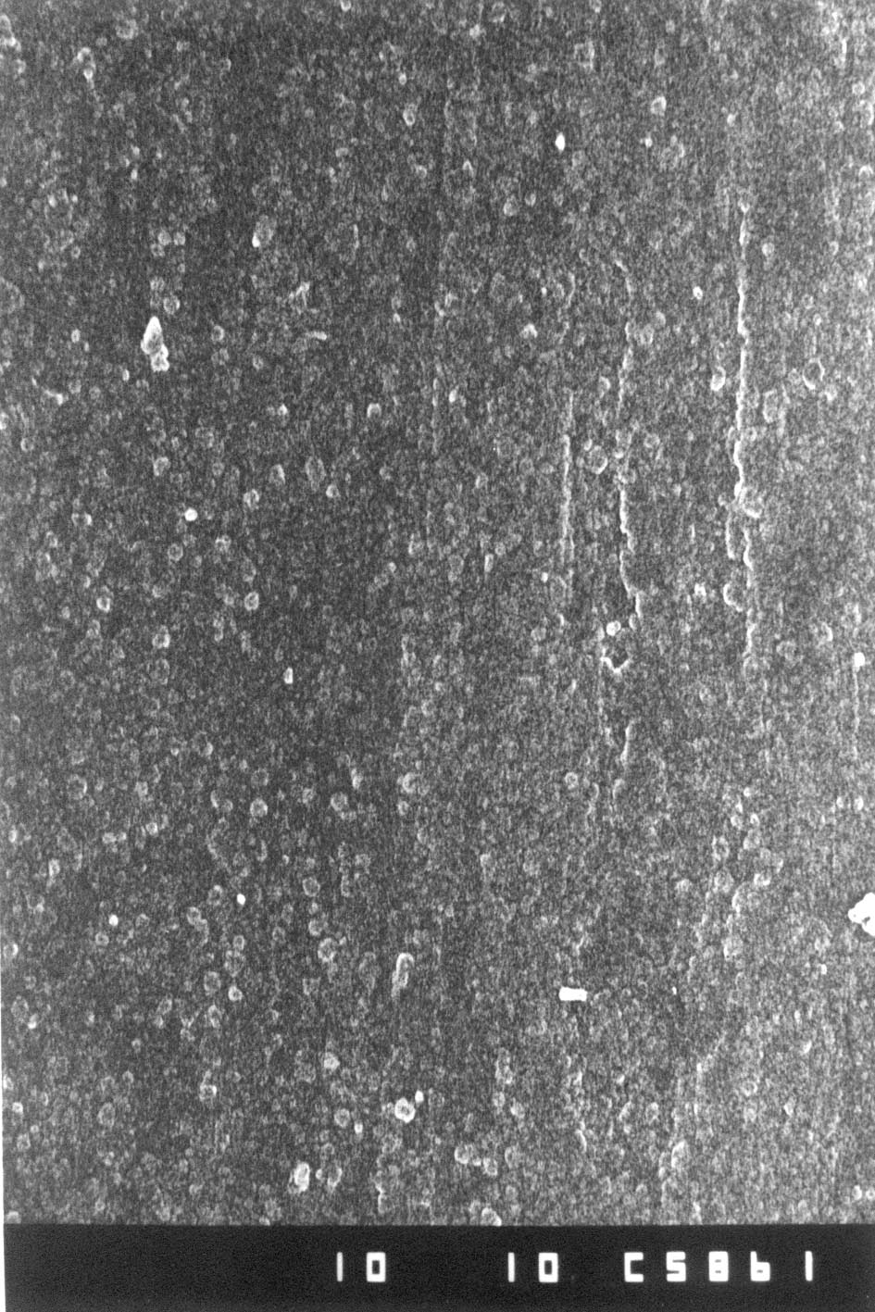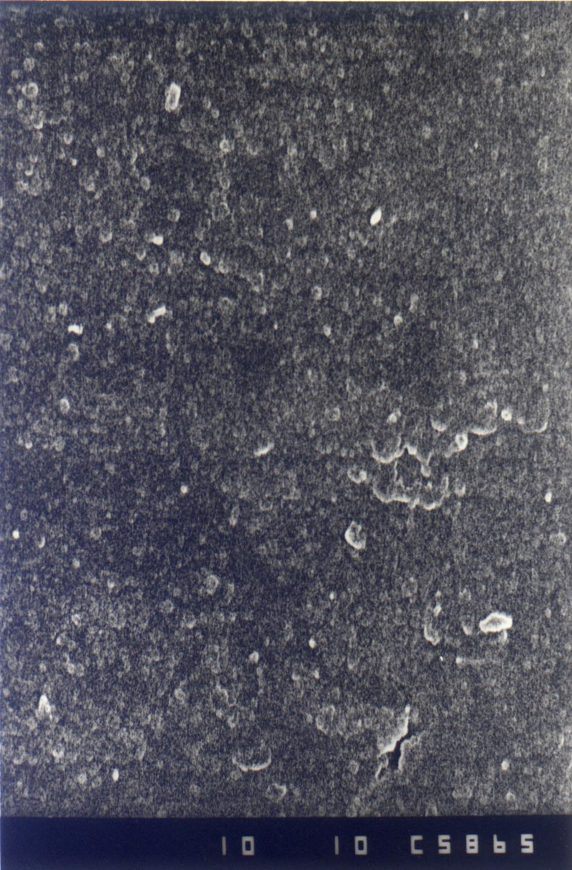
1 μm
c
1 μm
a
1 μm
b
Fig. 3. SEM micrographs of the surface after thermal treatment of: (a) SS; (b) SS in 0.1 N HNO₃ at E_{st} = +0.113 V;
(c) SS in 0.1 N H₂SO₄ at E_{st} = −0.976 V.

In the absence of external polarization (open circuit), oxidation of Fe (Fe = Fe²⁺ + 2e–) proceeds in sulphuric acid at –0.976 V on the significantly increased (due to cracking of the passive film on SS) number of local anodic regions of the electrode surface. As a result of the anodic process of Fe self- dissolution, its surface concentration decreases from 7.2 at.% to 1.3 at.% (Table 2).
Table 2. Element distribution (in at.%) on the surface layers of SS, SS_{(t.t.)}, respectively Ce₂O₃-CeO₂/SS_{(t.t.)} without corrosion treatment and at open circuit in 0.1 N H₂SO₄.
Samples | O,  at. % | Fe,  at. % | Cr,  at. % | Al,  at. % | Ce,  at. %
SS | 58.3 | 3.1 | 3.4 | 35.2 | -
SS (t.t.) | 64.9 | 7.2 | 7.0 | 20.9 | -
Ce₂O₃-CeO₂/SS(t.t.) | 68.9 | 0.0 | 3.6 | 6.8 | 20.7
 | at open circuit potential (E_{st})
SS (t.t.) | 65.4 | 1.3 | 6.4 | 26.9 | -
Ce₂O₃-CeO₂/SS(t.t.) | 81.4 | 6.4 | 3.3 | 7.4 | 1.5
The application of anodic polarization (E_{c.p.} = +0.500 V) results in formation of a passive film containing Fe³⁺, Cr³⁺ and Al³⁺, most probably as an Al³⁺-containing spinel of the type Fe²⁺(Fe³⁺, Cr³⁺)₂O₄ [7]. In this case, a Cr³⁺:Fe³⁺ ratio of about 3 is attained.
Comparison of the data from XPS analyses on the concentration change of the elements in the surface film shows that in 0.1 N H₂SO₄, changes in the concentrations of Cr and Fe, i.e. the Cr/Fe ratio, appear with both E_{st} and E_{c.p.}. The values registered are 5.1 for an open circuit and 2.7 for E_{c.p.} = +0.500 V. Irrespective of the enhanced Cr content in the surface film, the steady state corrosion potential of SS_{(t.t.)} is strongly shifted in the negative direction, as a result of which the steel demonstrates corrosion with hydrogen depolarization. Our opinion is that this is due to the significant cracking as a result of the thermal treatment.
Figure 4 shows the potentiodynamic curves for the systems Al₂O₃/SS and Ce₂O₃-CeO₂/SS after heat treatment in 0.1 N HNO₃ (Fig. 4a) and 0.1 N H₂SO₄ (Fig. 1b). Comparison of the E_{corr} values determined by the intersecting point of the anodic and cathodic polarization curves for the system Al₂O₃/SS(t.t.) with the E_{st} values measured on the E−τ curves of the real corrosion process shows, after attaining a steady-state value of the corrosion potential, a strong shift of E_{st} in negative direction, i.e. from E_{corr} = −0.714 V to E_{st} = −0.755 V in 0.1 N HNO₃ and from E_{corr} = −0.860 V to E_{st} = −0.972 V in 0.1 N H₂SO₄. The SEM data are in agreement with these results (Fig. 5), which means that, as a result of heating, the Al₂O₃ film has cracked and the steel substrate has partially lost its coating, this leading to the appearance of microgalvanic Al₂O₃/Fe pairs. This unfavourable effect is responsible for the more negative E_{st} values found (Figs. 4a and 4b) for the Al₂O₃/SS system in both corrosion media.
D. Guergova et al.: Influence of calcination of SS OC4004 covered with alumina
Figure 4 also shows the potentiodynamic curves for the system Ce₂O₃-CeO₂/SS after thermal treat-ment in 0.1 N HNO₃ (Fig. 4a) and in 0.1 N H₂SO₄ (Fig. 4b). Comparison of these data with the steady-state corrosion potentials of the heat-treated system Ce₂O₃-CeO₂/SS (Fig. 2b) and SS_{(t.t.)} (Fig. 2a) shows their shift in the positive direction by about 150 mV in 0.1 N HNO₃ and 1 V in 0.1 N H₂SO₄. Hence, the cerium oxides film formed on steel substrates considerably improves their corrosion resistance in sulphuric acid medium, the corrosion process being shifted (E_{st}) from the zone of mixed control (water reduction and metal oxidation) to the zone of stable passivity (Figs. 1b and 4b).

Fig. 4. Potentiodynamic E-lgi curves for the systems Al₂O₃/SS and Ce₂O₃-CeO₂/SS after thermal treatment: (a) in 0.1 N HNO₃; (b) in 0.1 N H₂SO₄.

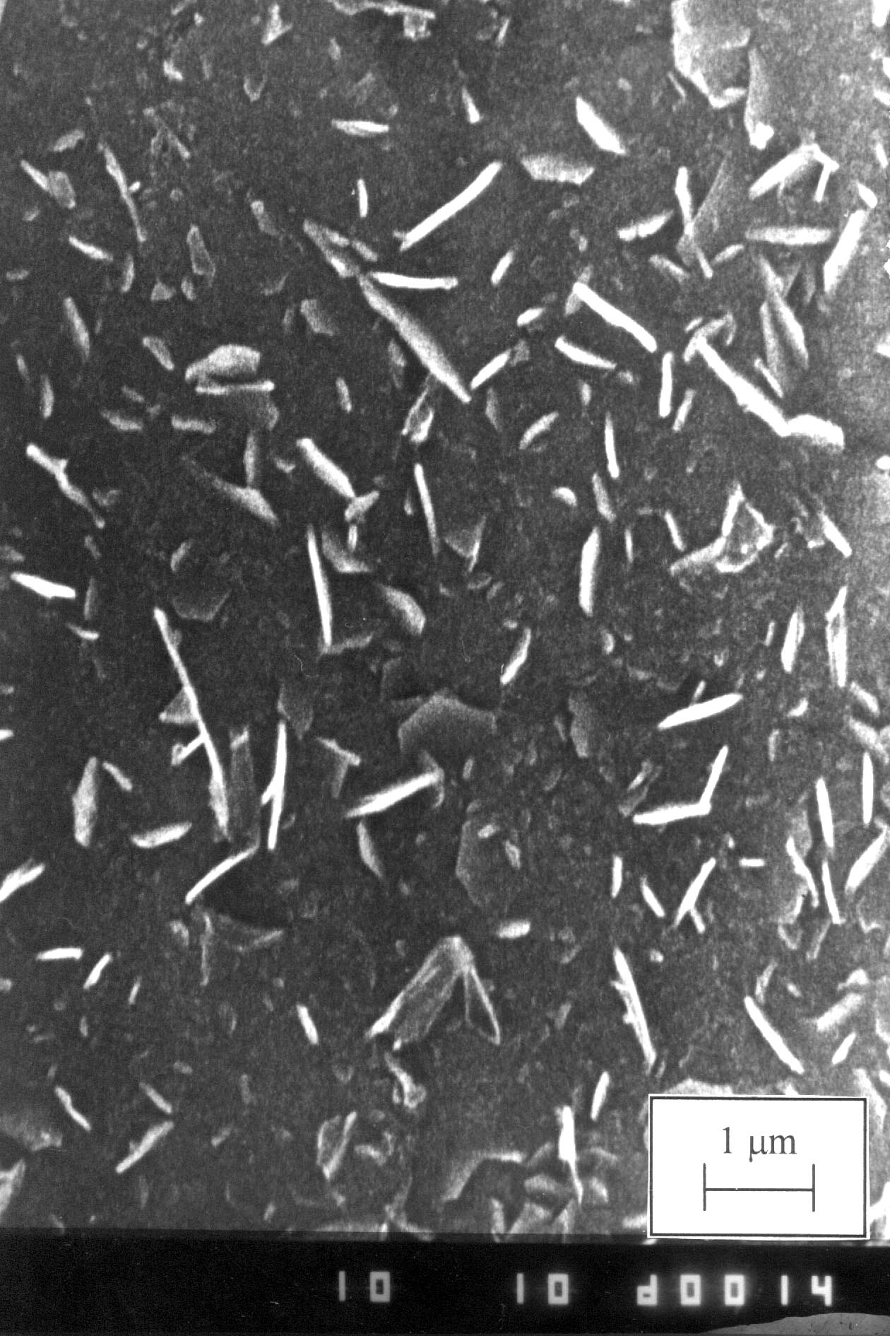
Fig. 5. SEM micrographs of Al₂O₃/SS after thermal treatment.
The results obtained permit concluding that in 0.1 N HNO₃, Ce₂O₃-CeO₂ has an additive protective effect along with that of the medium component NO₃–. In 0.1 N H₂SO₄ the cerium oxide layers char-acterized by E = ~ +1.7 V [9] act as effective cathodes ensuring the restoration of the steel passive state as a result of the shift of E_{st} = −0.976 V for SS_{(t.t.)} to E_{st} = +0.211 V for the system Ce₂O₃-CeO₂/SS_{(t.t.)}.
XPS analyses on the element distribution in the surface oxide film of the thermally treated system Ce₂O₃-CeO₂/SS showed Cr₂O₃, Al₂O₃ and Ce₂O₃-CeO₂ as the main film components (Tables 1 and 2). As is evident, after polarizing the system in 0.1 N HNO₃ and 0.1 N H₂SO₄ at E_{c.p.} = +0.500 V for 5 min and after immersing the samples in 0.1 N H₂SO₄ for 80 min, the circuit being open, the surface film composition shows considerable changes: (i) The decrease in Ce₂O₃-CeO₂ concentration is much smaller as compared to samples not subjected to thermal treatment [5], due to the transformation of Ce₂O₃ into CeO₂ which does not dissolve in acids [10]; (ii) In the zone of passivity (E_{c.p.} = +0.500 V) the concentration of Cr₂O₃ increases in both 0.1 N HNO₃ and 0.1 N H₂SO₄; (iii) In 0.1 N H₂SO₄ the concentration of Cr₂O₃ does practically not change in the presence of real corrosion (open circuit); (iv) The concentration of Al₂O₃ and iron oxides increases.
The concentration change of the elements in the passive film is most probably due to the processes of its modification under the effect of the corrosion medium and the effective cathode coverage of ceria.
CONCLUSIONS
It has been established that in a corrosion medium containing NO₃–, the heat treatment of stainless steel OC4004 leads to self-passivation.
D. Guergova et al.: Influence of calcination of SS OC4004 covered with alumina
Thermal treatment of the system Al₂O₃/SS has been shown to eliminate the protective effect of electrodeposited alumina layer in the corrosion media investigated due to its mechanical cracking and the formation of galvanic Al₂O₃/Fe pairs.
Electrodeposited cerium oxides strongly increase the corrosion resistance of the system Ce₂O₃-CeO₂/SS both before and after thermal treatment. This effect is found to be due to the change (increase) in Cr concentration in the modified protective passive film on the surface, i.e. to the Cr/Fe ratio change in this film. This chemical composition change of the surface film is enhanced by thermal treatment. This change leads to a significant shift of E_{st} of the systems in the positive direction up to a value of +0.211 V in sulphuric acid media. These potentials determine the occurrence of the corrosion process under the conditions of stable passivity of the steel. In cases when the passive state of the systems is disturbed, the steel surface parts covered with Ce₂O₃-CeO₂ will begin to act as effective cathodes restoring the passive state.
In addition to the positive role of the enhanced Cr concentration in the surface layer, there will be processes of internal anode polarization due to the electrodeposited Ce₂O₃-CeO₂ layer with its highly positive redox potential. These processes will preserve/restore the passive state of the system under the conditions of real corrosion.
Acknowledgements: The electrochemical measure-ments have been performed by means of scientific equipment donated to Prof. A. Milchev (Inst. Phys. Chem., Bulg. Acad. Sci.) by the Alexander von Humboldt Foundation, Germany.
REFERENCES
- D. Stoychev, P. Stefanov, D. Nikolova, A. Aleksandrova, G. Atanasova, Ts. Marinova, Surf. Coat. Technol., 180-181, 441 (2004).
D. Guergova et al.: Influence of calcination of SS OC4004 covered with alumina
- P. Stefanov, D. Stoychev, A. Aleksandrova, D.
Nicolova, G. Atanasova, Ts. Marinova, Appl. Surf. Sci., 235, 80 (2004).
- P. Stefanov, G. Atanasova, D. Stoychev, I. Valov, Ts. Marinova, Physical Chemistry 2002 (Proc. 6th Int. Conf. Fund. Appl. Aspects Phys. Chem., A. Terlecka-Baricevic (ed.), September, 2002, Belgrade, Yugoslavia), Vol. I, p. 198.
- Gmelins, Handbuch der Anorganischen Chemie, Vol. 52, Verlag Chemie, GmbH, Weinheim/Bergstrasse, Deutschland, 1963, p. 449.
- D. Nikolova, E. Stoyanova, D. Stoychev, P. Stefanov, T. Marinova, Surf. Coat. Technol., 201, 1559 (2006).
- N. D. Tomashov, G. P. Chernova, Teoria korozii, Metallurgia, Moskow, 1993 (in Russian).
- U. R. Evans, The Corrosion and Oxidation of Metals: Scientific Principles and Practical Applications, Edward Arnold Ltd., London, 1962.
- A. M. Suhotina, Handbook of Electrochemistry, Khimia, Leningrad, 1981 (in Russian).
- Handbook of Chemistry Vol. III, B. P. Nikolskii (ed.), Khimia, Leningrad, 1964, p. 756 (in Russion),
- N. S. Ahmetov, General and Inorganic Chemistry, Visshaya Shkola, Moscow, 1988 (in Russian).

Влияние на термичната обработка на електроотложени алуминиев и цериев оксиди върху пасивното състояние на неръждаема стомана OC4004
в кисели среди
Д. Гергова¹, Eм. Стоянова¹, Д. Стойчев¹*, Г. Атанасова², Ив. Аврамова², П. Стефанов²
¹ Институт по физикохимия „Акад. Ростислав Каишев“, Българска академия на науките, София 1113,
² Институт по обща и неорганична химия, Българска академия на науките, София 1113
Постъпила на 12 ноември 2007 г., Преработена на 8 февруари 2008 г.
(Резюме)
Проведено е сравнително изследване на корозионното поведение на термообработена неръждаема стомана (SS) OC4004 и на електроотложени върху нея Al₂O₃ и Ce₂O₃-CeO₂ слоеве (системите Al₂O₃/SS_{(t.t.)}, Ce₂O₃-CeO₂/SS) в разтвори на 0.1 N HNO₃ и 0.1 N H₂SO₄. Установено е, че в корозионна среда, съдържаща NO₃–, SS_{(t.t.)} проявява склонност към самопасивация. Термообработката на системата Al₂O₃/SS елиминира защитното действие на електроотложения Al₂O₃ слой в изучените корозионни среди, вследствие механичното им напукване и формирането на галванични двойки Al₂O₃/Fe. Електроотложените цериеви оксиди повишават силно корозионната устойчивост на системата Ce₂O₃-CeO₂/SS както преди, така и след термообработка. Установено е, че защитният ефект на Ce₂O₃-CeO₂ слоевете се дължи на предизвиканото от тях повишаване на повърхностната концентрация на Cr в пасивния филм, както и на действието им като ефективни катоди, обуславящи силно отместване на стационарения потенциал на системата Ce₂O₃-CeO₂/SS_{(t.t.)} в положителна посока.

