Corrosion and electrochemical investigations of low-alloyed and austenitic stainless steel used in the steam generators of Kozloduy nuclear power plant
Bulgarian Chemical Communications, Volume 40, Number 3 (pp. 281–285) 2008
© 2008 Bulgarian Academy of Sciences, Union of Chemists in Bulgaria
G. M. Raichevski¹, N. D. Tsvetkova¹, N. S. Boshkov¹*, R. G. Raicheff²,
K. Minkova³, I. Topalova³, L. Lutov⁴
* To whom all correspondence should be sent:
E-mail: NBoshkov@ipc.bas.bg
¹ Institute of Physical Chemistry, Bulgarian Academy of Sciences, Acad. G. Bonchev St, Block 11, 1113 Sofia, Bulgaria
² Institute of Electrochemistry and Energy Systems, Bulgarian Academy of Sciences,
Acad. G. Bonchev St, Block 10, 1113 Sofia, Bulgaria
³ Kozloduy Nuclear Power Plant, Kozloduy
⁴ University of Sofia, Department of Chemistry, J. Bourchier Blvd. 1, 1164 Sofia, Bulgaria
Received October 31, 2007, Revised January 22, 2008
The corrosion behavior of austenitic stainless steel 18Cr10NiTi used for pipe bundles in the steam generators (SG) of WWER reactor in Kozloduy nuclear power plant (NPP) as well as of construction low-alloyed steel (Cr, Ni, Mn and Si – 6% total) is investigated under model operation conditions – temperature of 220ºC, pressure of 150 atm. and the water-chemical regime used in the second contour. A specially constructed autoclave and electrochemical polarization technique in combination with scanning electron microscopy (SEM), X-ray photoelectron (XPS) and Moessbayer spectroscopy are used.
The corrosion and electrochemical parameters of both kinds of steels are obtained. It is demonstrated that the corrosion processes on the austenitic steel differ in the uniform distribution of corrosion damages and stable passive state. Additionally, the rate of general corrosion of the austenitic steel is much lower compared to that of the low-alloyed steel.
The chemical and phase composition of the layer of corrosion products, formed on the surface of the pipe bundle during the exploitation of the Energy Block 3 (EB 3) of NPP, is determined using XPS and Moessbayer analysis. It is established that the main components of the layer are magnetite Fe₃O₄ (about 90%), γ-FeOOH and small amounts of CuO and ZnO. The results confirm that the corrosion products have formed a uniform and compact protective film on the pipe surface.
Key words: corrosion products, stainless steel, XPS analysis, Moessbayer spectroscopy, SEM.

Introduction
The horizontal steam generators (SG) used in Energy Block 3 of Kozloduy nuclear power plant (NPP) work at extreme loading during their exploit-tation life – high temperature and pressure as well as corrosion and erosion provoked processes. This fact predetermines the need of careful corrosion moni-toring and preserving a special water-chemical regime. The evaluation of selected important electrochemical corrosion parameters could ensure a realistic foundation for a precise prognosis and trouble-free operation of this equipment in NPP.
Some previous investigations with stainless steels under model conditions were carried out using a specially designed autoclave unit for electro-chemical measurements [1]. The aim was to clarify the reasons for the deleterious effect of corrosion-active trace amount of lead in the loop. Such types of steels are distinguished with some excellent pro-perties compared to the low-alloyed ones; however, they could be negatively influenced by some specific ions (phosphates, chlorates, etc.) under appropriate conditions [2, 3]. As a result, this might lead to failure processes concerning the equipment in NPP and can predetermine the demolition of the plant itself. The negative effects of various impu-rities in the water (heavy metal cations and some anions) on the corrosion behaviour of stainless steels are thoroughly studied by some authors [4–6].
The aim of the present work is to investigate the electrochemical corrosion behaviour of austenitic stainless steel 18Cr10NiTi used for pipe bundles in SG of NPP under model operation conditions of the secondary circuit. The results, obtained by the pola-rization technique, are compared with the corrosion behaviour of low-alloyed steel containing Cr, Ni, Mn and Si. The surface film of corrosion products, formed on 18Cr10NiTi during the exploitation of SG, is evaluated using XPS and Moessbauer spec-troscopy analyses. SEM images complete the invest-tigation giving more information about the surface morphology of both steel types.
Experimental
Two different sample types of size 1×1 cm (working area of 2 cm²) are investigated:
- low-alloyed steel (LASt) 38GN2MFA (Cr, Ni, Mn and Si – 6% total) used as construction steel;
- austenitic stainless steel (ASSt) 18Cr10NiTi used for pipe bundles in the SG of EB 3 of NPP.
Corrosion medium and corrosion treatment
A model corrosion medium (MCM) with the following composition (hydrazine – 25 μg/l; Cl– ions – 40 μg/l и Cu²⁺ ions – 2.5 μg/l) is used for the investi-gations. Additionally, the pH value is corrected up to 8.7 with 25% NH₃-solution. The water used for the experiments is demineralized and finely cleaned in ionic-exchange columns equipped unit.
G. M. Raichevski et al.: Corrosion and electrochemical investigations of low-alloyed and austenitic stainless steel
The electrochemical and corrosion investigations are carried out in two different directions:
- at 35ºC in a glass cell using a “VersaStat” (PAR) unit, three-electrode cell with Luggin’s capillary (volume of 0,25 l), platinum plate as a counter electrode and saturated calomel electrode (SCE) as a reference electrode.
- at high temperature (220ºC) and pressure (150 atm.) in a specially constructed autoclave system (internal volume of 1.5 l) with the aim to ensure experimental conditions close to these in NPP. A specially constructed electrochemical cell made of Teflon with a volume of 0.25 l, as well as platinum for the counter electrode and AgCl/KCl reference electrode are also used in this case.
Sample characterization
A scanning electron microscope JEOL JSM-5300, Japan is used for investigation of the morpho-logy changes on the surfaces of ASSt and LASt samples after the treatment in the model corrosion medium. Moessbayer analyser (“Wissel”) is used for more precise characterization of the type and quantity of the compounds of iron. This element has high sensi-tivity in regard to the resonance adsorption toward the beams of the radiation source (⁵⁷Co isotope). The XPS measurements are carried out on an ESCALAB MkII (VG Scientific) electron spectro-meter at base pressure of 5×10^{–10} mbar in the analysis chamber. The photoelectrons were excited using Mg Kα X-ray source (E = 1253.6 eV). The energy scale is corrected with respect to the C1s peak maximum at 285 eV.
Results and discussion
Potentiodynamic polarization (PD) curves
The PD curves, obtained for both steel types in MCM at two different temperatures (potential sweep rate of 1 mV/s), are demonstrated in Fig. 1. In Table 1 some of the corresponding electrochemical para-meters of LASt are compared to those of ASSt, the corrosion behavior of the latter being also com-pletely investigated under different aggressive conditions as presented elsewhere [7].
Table 1. Electrochemical and corrosion parameters of ASSt and LASt samples in MCM under various environ-mental conditions: corrosion potential (Ecorr), corrosion current (Icorr), passive current (Ipass) and width of the passive range (ΔEpass).
Sample | T,  ºC | Ecorr,  mV | Icorr,  μA/cm² | Ipass,  μA/cm² | ΔEpass,  mV
LASt | 35 | –280 | 6.2 | - | -
LASt | 220 | –280 | 17.8 | - | -
ASSt | 35 | 90 | 0.5 | 0.6 | 950
ASSt | 220 | 15 | 3.0 | 4.2 | 920
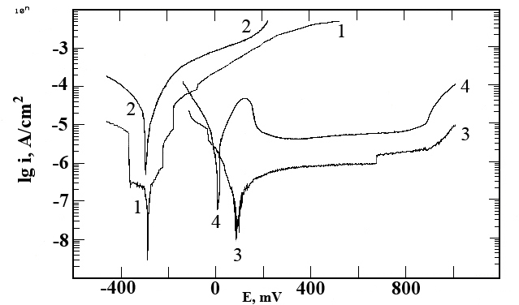
Fig. 1. Potentiodynamic polarization curves E – logI in MCM of: 1 - LASt at 35ºC; 2 - LASt at 220ºC;
3 - ASSt at 35ºC; 4 - ASSt at 220ºC.
The main experimental results from Fig. 1 and Table 1 can be summarized as follows:
- The low-alloyed steel 38GN2MFA (curves 1 and 2) demonstrates more negative E_{corr} compared to that of ASSt (with approximately 200 mV and more) and higher corrosion current as well. Passive state is not registered at both investigated tempe-ratures. In the anodic branch of PD (where intensive dissolution occurs) three short areas are established, where the process becomes slow. Nevertheless, the corrosion rate remains in general relatively high, especially at 220ºC.
- The corrosion rate of 18Cr10NiTi steel is very low (up to 3 μA/cm²) even at elevated temperature (220ºC), i.e. the corrosion resistance of the pipe material under the model operation conditions of the secondary circuit is high (cf. curves 3 and 4). It should also be noted that the data are obtained with samples in an active surface state. In this case, they are without layer of corrosion products that is formed in the course of real and prolonged exploita-tion of the pipe bundle. Thus, the actual corrosion rate of the steel pipes under operation conditions of the steam generator should be much lower [7].
- The stainless steel shows more “noble” E_{corr} compared to that of LASt. It demonstrates a stable passive state in the model solution at both tem-peratures (35 and 220ºC) as well as a wide passive range (about 900 mV) and low passive current intensity (0.6–4.2 μA/cm²). These observations are an additional indication of high corrosion resistance of the steel under conditions close to those of real exploitation of the secondary circuit of WWER.
SEM investigations
The SEM observations of 18Cr10NiTi samples after 24 h exposure to MCM in the autoclave (4 h at 220ºC and 20 h cooling down to ambient tempera-
ture) are presented in Fig. 2. The results are obtained after preliminary preparation of the steel samples – rinsing with distilled water and drying with hot air. Relatively uniform corrosion damages distribution and formation of a thin protective film on the steel surface can be registered. This observation confirms the expectation that the ASSt sample is very resistant to the exploitation conditions used in NPP.
G. M. Raichevski et al.: Corrosion and electrochemical investigations of low-alloyed and austenitic stainless steel
The SEM observations of LASt sample are demonstrated in Fig. 3. In this case the sample images are made at potential values different from those in the case of ASSt sample due to the fact that the length of both curves also differs. However, the LASt-curve itself is theoretically divided in almost equal sections (having in mind the potential shift in positive direction) and the samples are pulled out of the autoclave at selected potential values.

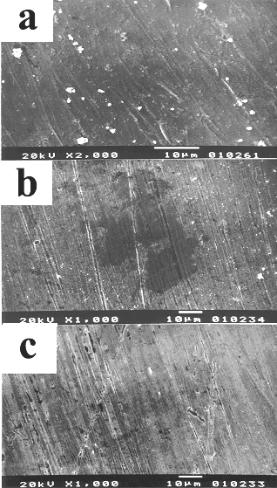 | 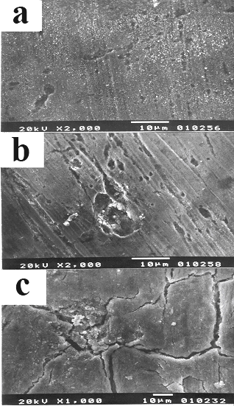
Fig. 2. SEM images of the surface morphology of ASSt sample after 24 h immersion in MCM: a - at Ecorr;  b - at 550 mV; c - at 950 mV. | Fig. 3. SEM images of the surface morphology of LASt sample after 24 h immersion in MCM: a - at Ecorr;  b - at –200 mV; c - at 200 mV.

Moessbayer investigations
The Moessbayer analysis (Fig. 4) of the surface film of corrosion products collected from 10 characteristic spots on the pipes of the steam gene-rator during shut-down procedure, shows that the film consists predominantly of magnetite Fe₃O₄ (about 90%) and γ-FeOOH. As it is well known, the magnetite has low solubility and it is highly resistive product, even under aggressive water conditions. This suggests that the corrosion products on the bundle surfaces may form a layer with highly protective properties. The latter will impede the penetration of the corrosion processes in depth protecting the metal tubes. The composition of the surface film leads also to the conclusion that the water chemistry regime is well observed during the prolonged operation of the unit.
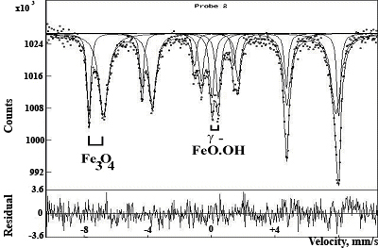
Fig. 4. Moessbayer spectrum of the corrosion products on the surface of ASSt sample.
In general, the presence of hydrazine at experi-mental temperature of approximately 200–250ºC, pH value of 7 and higher as well as under the conditions of low oxygen content in the medium can contribute to the transformation of some iron compounds (e.g. Fe₂O₃ and Fe(OH)₃) into magne-tite. As it was discussed above, the latter is characterized with very good adhesion to the steel substrate and thus, it can produce a compact and stable protective film.
G. M. Raichevski et al.: Corrosion and electrochemical investigations of low-alloyed and austenitic stainless steel
XPS investigations
The results obtained by the XPS investigations for ASSt sample are presented in Fig. 5 and Table 2. It can be concluded that the main component on the steel surface is magnetite (confirmed by the Fe and O signal values) and relative small amounts of ZnO and CuO (the latter two XPS spectra are not presented), these appearing as a result of the additional treatment of the cooling water in the steam generators.
In general, the XPS spectra confirm the con-clusions from the Moessbauer investigations and the results from the potentiodynamic polarization curves. They demonstrate additionally the highly protective properties of the corrosion products obtained on the ASSt sample surface.
A
B
Fig. 5. XPS spectra of the corrosion products on the surface of ASSt sample.
Table 2. Corrosion products on pipe bundle surfaces determined by XPS analysis.
Element signal | O1s | Fe2p | Cu2p | Zn2p
Binding energy,eV | 530.3 | 710.2 | 932.5 | 1021.8
At. % | 56 | 31.4 | 9.6 | 3
Conclusion
Under model conditions and cooling water com-position studied, the corrosion current for austenitic stainless steel 18Cr10NiTi is much lower compared to that of the low-alloyed steel 38GN2MFA. The current intensity value of 3 μA/cm² yields an average corrosion rate of 0.035 mm/year for the steam generator pipe bundles. Taking into account that under real operation conditions in NPP and prolonged exploitation of the steam generators, a protective film, composed mainly of magnetite, is readily formed on the pipe surfaces, the actual corrosion rate becoming much lower. The presence of a layer of the corrosion products is confirmed using Moessbayer spectroscopy and XPS investiga-tions, which are in agreement with the results, obtained by the electro-chemical polarization tech-nique and SEM.
Thus, it could be concluded that the average decrease of the pipe thickness after 20-year exploita-tion period of the SG unit does not exceed 10–15% of the original thickness. This conclusion, together with the well established composition of the surface film (predominantly magnetite), and the uniformity of the corrosion, suggests a considerable additional exploitation resource of the steam generator pipes.
In order to confirm with certainty the above conclusion additional studies are required, espe-cially investigations on crevice and pitting corrosion at the contact zones of the pipes and supporting grid under operation conditions of secondary circuit of WWER.
G. M. Raichevski et al.: Corrosion and electrochemical investigations of low-alloyed and austenitic stainless steel
REFERENCES
- O. Blajiev, L. Lyutov, N. Zaharieva, I. Kirilova, G. Raichevski, Trans. Bulg. Nucl. Soc., 8, 1, 61 (2003).
- R. Raicheff, J. Marcheva, in: Proc. 11th Int. Corros. Congr., ICC Publ., Florence, 1990, Vol. 1, p. 1365.
- J. Marcheva, R. Raicheff, S. Nikolov, Tz. Haladzova, J. Radioanal. Nucl. Chem. Letters, 212, 5, 382 (1996).
- K. Yankova, K. Dinov, Trans. Bulg. Nucl. Soc., 1, 1, 72 (1996).
- O. Blajiev, N. Zaharieva, G. Raichevski, K. Dinov, Trans. Bulg. Nucl. Soc., 2, 46 (1997).
- D. Macdonald, A. Eghan, Z. Srklarska-Smialowska, Corrosion, 41, 474 (1985).
- G. Raichevski, N. Boshkov, R. Raicheff, N. Tsvetkova, K. Minkova, I. Topalova, L. Lutov, in: Proc. 1st Int. Conf. Corrosion and Material Protection, EFC Event No. 294, Ed. SVUOM, Prague, 2007.

КОРОЗИОННИ И ЕЛЕКТРОХИМИЧНИ ИЗСЛЕДВАНИЯ НА НИСКОЛЕГИРАНИ И АУСТЕНИТНИ НЕРЪЖДАЕМИ СТОМАНИ ИЗПОЛЗВАНИ В ПАРОГЕНЕРАТОРИТЕ
НА АЕЦ „Козлодуй“
Г. М. Райчевски¹, Н. Д. Цветкова¹, Н. С. Божков¹*, Р. Г. Райчев²,
K. Mинкова³, Ин. Топалова³, Л. Лютов⁴
¹ Институт по физикохимия, Българска академия на науките, ул. „Акад. Г. Бончев“, бл. 11, 1113 София
² Институт по електрохимия и енергийни системи, Българска академия на науките,
ул. „Акад. Г. Бончев “, бл. 10, 1113 София
³ АЕЦ „Kозлодуй“, Kозлодуй
⁴ Софийски университет, Химически факултет, бул. „Дж. Баучър“ №. 1, 1164 София
Постъпила на 31 октомври 2007 г., Преработена на 22 януари 2008 г.
(Резюме)
Изследвано е корозионното поведение на аустенитна неръждаема стомана Х18Н10Т, използвана в тръбните снопове на парогенераторите на реакторите ВВЕР в АЕЦ „Козлодуй”, при моделни условия на изпитване – температура 220ºC, налягане 150 атм. и водохимичен режим на втори контур. Получените резултати са сравнени с тези за нисколегирана стомана (НЛС), съдържаща Cr, Ni, Mn и Si – общо 6%. Двата типа стомани са тествани в специално конструиран за целта автоклав, като са използвани следните методики: електрохимична поляризация, сканираща електронна микроскопия (SEM), рентгеноструктурен анализ и Мьосбауерова спектро-скопия.
В резултат от проведените изследвания са установени корозионните и електрохимични параметри на двете стомани. Показано е, че корозионните процеси при аустенитната Х18Н10Т стомана се отличават с равномерно разпределение на поразените зони, както и с поява на пасивна област в процеса на анодна поляризация. Освен това, скоростта на нейната обща корозия е много по-ниска по отношение на образците от НЛС.
Химичният и фазов състав на слоя от корозионни продукти, формиран на повърхността на тръбния сноп по време на експлоатацията на трети блок на АЕЦ е определено с помощта на рентгеноструктурен анализ и Мьосбауерова спектроскопия. Установено е, че основните компоненти в слоя са магнетит (Fe₃O₄ - около 90%), γ-FeOOH и малки количества от меден (CuO) и цинков (ZnO) оксиди. Резултатите от SEM потвърждават образуването на равномерен и плътен защитен филм на повърхността на тръбите.

