Sulphide oxidation on electrodeposited Ni-Mo-W catalysts
Bulgarian Chemical Communications, Volume 40, Number 3 (pp. 291–294) 2008
© 2008 Bulgarian Academy of Sciences, Union of Chemists in Bulgaria
E. Hristova¹, M. Mitov^{1,3}*, R. Rashkov², M. Arnaudova², A. Popov³
* To whom all correspondence should be sent:
E-mail: mitovmario@mail.bg
¹ Department of Chemistry, South-West University, Blagoevgrad, Bulgaria
² Institute of Physical Chemistry, Bulgarian Academy of Sciences, Acad. G. Bonchev St., Block 11, 1113 Sofia, Bulgaria
³ Institute of Electrochemistry and Energy Systems, Bulgarian Academy of Sciences, Acad. G. Bonchev St., Block 10, 1113 Sofia, Bulgaria
Received November 5, 2007, Revised February 12, 2008
In this study, the catalytic activity of novel Ni-Mo-W electrodeposits for sulphide oxidation in alkaline media has been investigated. The studies were performed by obtaining partial anodic and cathodic polarization curves with alkaline sodium sulphide and sodium hydroxide electrolytes, respectively, and applying the additivity principle, proposed by Wagner and Traud, for reaction rate determination. In addition, long-term catalytic tests were carried out in static reactor and the process kinetics was registered by UV- spectroscopy determination of sulphide concentration decrease. Based on the comparative results from the both experiments, the electrochemical method is proposed as an express preliminary test for catalytic activity evaluation.
Key words: sulphide oxidation, catalysis, catalytic activity, electrochemistry, electrodeposited Ni-Mo-W catalysts.

Introduction
Lots of chemical productions – oil-refining, metallurgy, etc., are connected with the formation of sulphur-containing compounds. Usually, they are unwanted products as most of the sulphur com-pounds are strong poisons for the catalysts, used in various chemical technologies.
Ni-W, Ni-Mo and Ni-Mo-W systems are among the best catalysts for hydrodesulphurization processes of various organic compounds and petroleum products [1–5]. It is assigned that their high catalytic activity is due to the formation of surface sulphur compounds with some of the catalyst components.
Besides organic sulphur, inorganic sulphur com-pounds, mainly dissolved sulphides, also cause serious problems connected with contamination of workplace atmospheres, aqueous basins, etc. Following the new legislations for environmental protection, the needs for development of more effective methods for sulphide purification are constantly increasing. One of the perspective methods in this direction is the catalyzed oxidation of sulphides to sulphur:
S^{2–} + 1/2O₂ + H₂O  Sº + 2OH–
Since Wagner and Traud [6] formulated the so-called additivity principle, the kinetics of many redox reactions [7], including sulphide oxidation [8], has been examined by means of electrochemical methods.
In this study, we aimed at developing a method for express evaluation of activity of a series of novel catalysts for sulphide oxidation reaction. For this purpose, newly synthesized Ni-Mo-W electrodepo-sits were tested as a model catalyst system. Partial anodic and cathodic polarization curves, corres-ponding respectively to sulphide electrooxidation and oxygen electroreduction, were obtained and the reaction rate of catalyzed sulphide oxidation was estimated by applying the additivity principle. Parallel long-term catalytic studies by using the same catalysts were also performed. Experimental results, obtained by both methods, were compared and discussed.
Experimental
Composite Ni-Mo-W coatings were obtained by electrodeposition on Ni-foam (Recemat RCM-Ni-2733.03) from electrolyte containing C₆H₅Na₃O₇.2H₂O – 72 g/l, Na₂WO₄.2H₂O – 24 g/l, Na₂MoO₄ – 6 g/l, NH₄OH – 20 ml. The electrolysis was carried out at a potential –1.0 V (vs. SCE) and temperature 50ºC for 30 minutes.
Button-shaped electrodes with geometric area 5 cm² were prepared by pressing electrodeposited samples on hydrophobized carbon, as described in [9]. The obtained Ni-Mo-W electrodes were used in both electrochemical and catalytic experiments.
The electrochemical studies were performed in a specially constructed three-electrode electroche-mical cell (Fig. 1) with a working volume 500 ml.
Stepwise cathodic and anodic polarization at galvanostatic conditions were subsequently carried out with tested electrodes in 0.25 mol/l NaOH and 0.1 mol/l Na₂S + 0.25 mol/l NaOH solutions, respectively. Large area stainless steel plate was used as a counter electrode. All potentials were measured against Hg/HgO reference electrode. The polarization experiments were carried out by using PJT 35-2 potentiostat-galvanostat (Radiometer-Tacussel) with IMT 101 electrochemical interface and Volta Master 2 software.
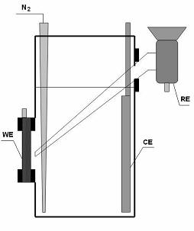
Fig. 1. Scheme of three-electrode cell, used for electrochemical experiments as well as catalytic tests: WE – working electrode, CE – counter electrode,
RE – reference electrode.
The same cell was used as a static reactor for implementation of catalytic tests. The catalyst was immersed into alkaline solution of sodium sulphide (0.1 mol/l Na₂S + 0.25 mol/l NaOH) and the sulphide ions concentration was monitored with time. The sulphide concentration was determined by means of UV-spectrophotometry [10], using an Agilent UV-Vis-NIR HP 8453 spectrophotometer.
Results and Discussion
The morphology of the composite Ni-Mo-W electrodeposits on Ni foam is seen in Fig. 2. The elemental distribution, obtained by EDS analysis, is Ni – 77%, Mo – 17%, W– 4% and O – 2%. Usually, from this type of electrolyte, but in the absence of molybdenum, the tungsten is deposited to 30–40% [11, 12]. Obviously, the presence of molybdenum drastically lowers the competitive co-deposition of tungsten, decreasing significantly its content in the composite. Despite of the large amount of Mo, however, big cracks are observed on the typical globular and smooth morphology of deposits.
In electrochemical studies, the tested button-shaped electrode was assembled as shown in Fig.1. The hydrophobic side of the electrode was exposed to the air and its hydrophilic side, containing the catalyst layer, was immersed into the electrolyte.
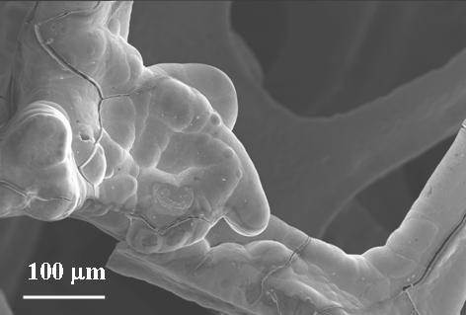
Fig. 2. SEM image of NiMoW deposit on nickel foam.
The polarization experiments were performed in two stages. At the first stage, the tested electrode was connected as a cathode and 0.25 mol/l NaOH solution was used as a working electrolyte. The electrochemical cell was opened to the atmosphere. After attaining stationary value of open circuit potential, E_{oc}, polarization curves were taken in a galvanostatic mode.
E. Hristova et al.: Sulphide oxidation on electrodeposited Ni-Mo-W catalysts
At the second stage, the working electrolyte was changed with 0.1 mol/l Na₂S + 0.25 mol/l NaOH and the stationary value of E_{oc} was measured. After that, the opened to the atmosphere hydrophobic side of the working electrode was isolated and the cell was hermetically closed. The electrolyte was purged with pure nitrogen for 1 hour and then, the working electrode was polarized anodically at different currents.
In both stages, polarization was repeated until reproducible polarization curves were obtained. Reproducible cathodic and anodic polarization curves, obtained as described above, are plotted together in Fig. 3.
According to the additivity principle [3], the values of mixed potential, E_{mix}, and mixed current, I_{mix}, were determined from their crossing point. The obtained mixed potential value, E_{mix}, is very close to the measured at open to the air cell open circuit potential E_{oc} = –285 mV (vs. Hg/HgO). This result is an indication of most probable electrochemical reaction mechanism on the catalysts under study.
By using the Faraday’s law, reaction rate of 0.43 mmol/l·h was estimated from the obtained value of I_{mix}.
As it was pointed out, UV spectrophotometry was used for monitoring sulphide concentration during catalytic experiments. For determination of proper sulphide concentration range, at which accurate analyzing can be done, various dilutions (10, 100, 250, 1250 folds) of the stock solution (0.1 mol/l Na₂S + 0.25 mol/l NaOH) were performed and the spectra of the obtained solutions were taken. The best well-shaped characteristic peaks at 229 nm were obtained with 250 folds diluted solutions, as seen from Fig. 4.
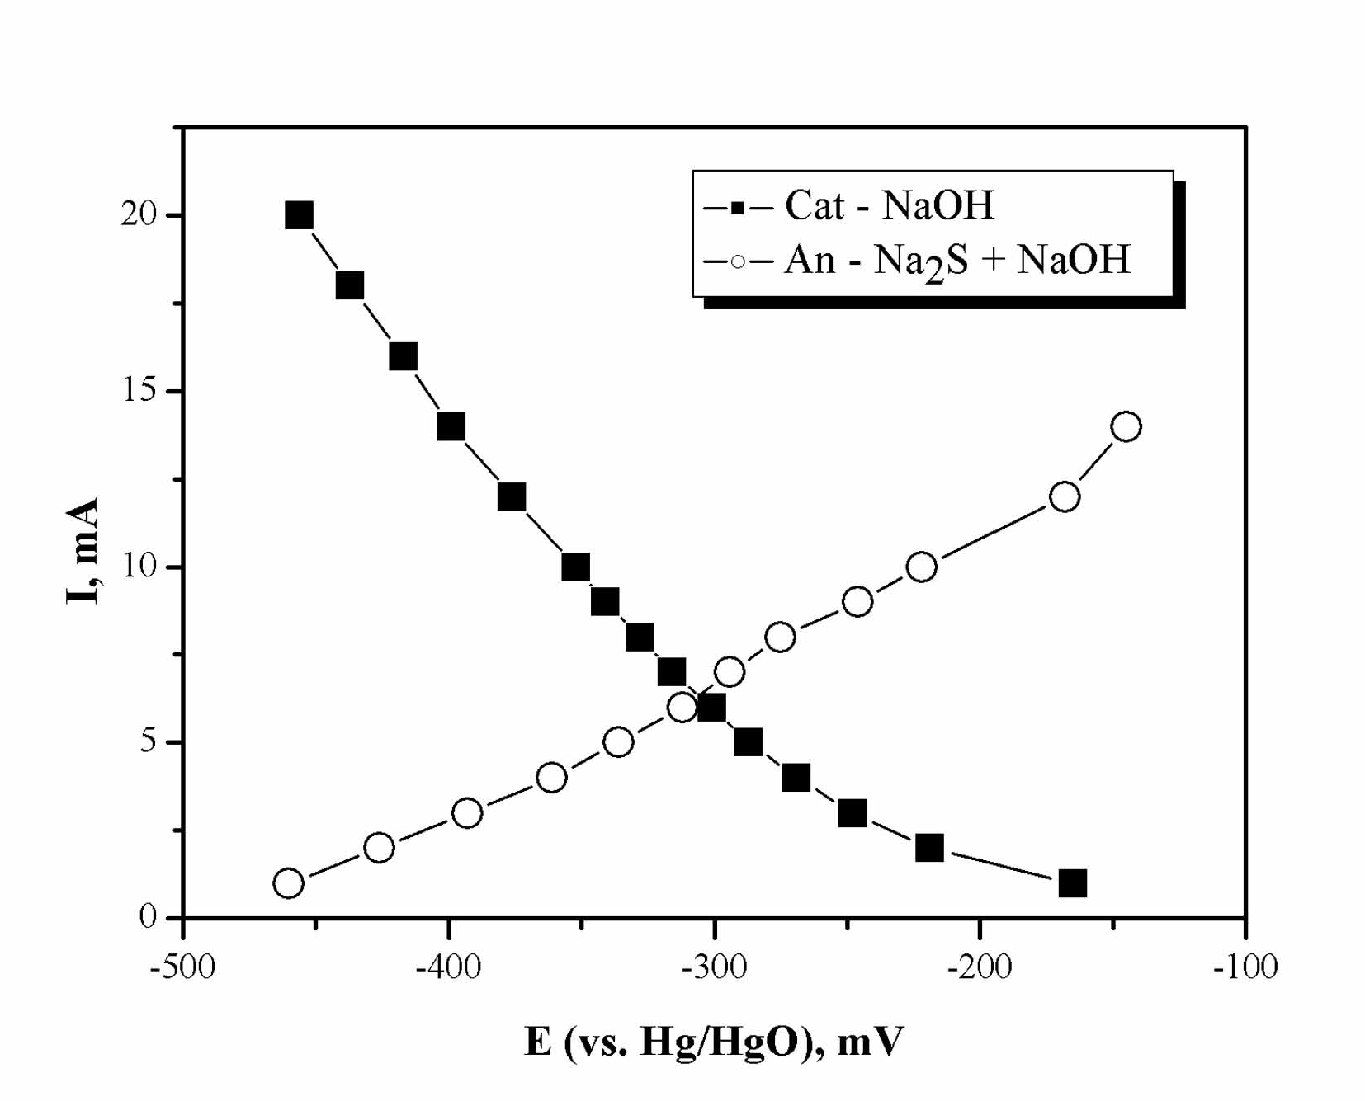
Fig. 3. Cathodic and anodic polarization curves obtained with Ni-Mo-W electrode in 0.25 mol/l NaOH and 0.1 mol/l Na₂S + 0.25 mol/l NaOH electrolyte, respectively.
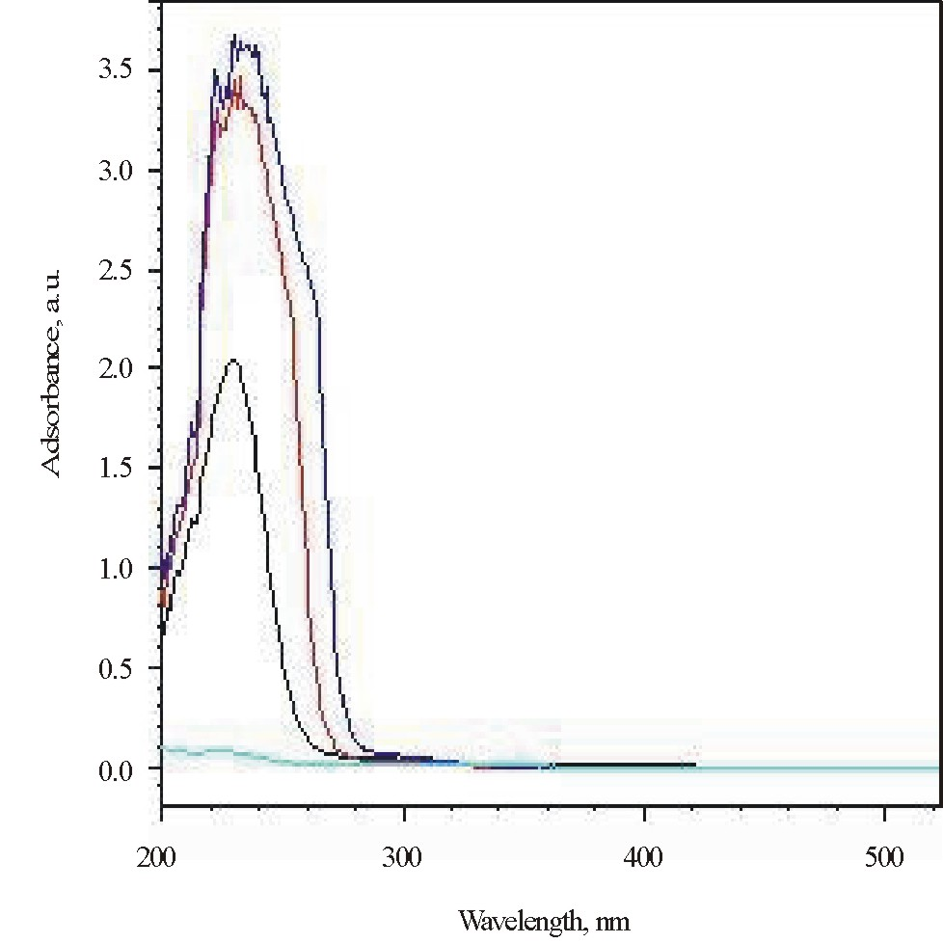
Fig. 4. UV spectra of n-folds diluted 0.1 mol/l Na₂S + 0.25 mol/l NaOH stock solution (n = 10, 100, 250, 1250).
A linear dependence of absorbance versus sulphide concentration was obtained in the concen-tration range 1×10^{–4} – 4×10^{–4} mol/l (Fig. 4).
This plot was used as a calibration curve for sulphide determination in the next catalytic studies.
During long-term catalytic tests, samples of 2 ml were taken from the working solution at different times and diluted to 500 ml. UV-spectra of diluted samples were measured and their concentrations were estimated from the calibration curve (Fig. 4). The sulphide concentration in the working solution at a specified time was obtained by recalculation of obtained values, taking into account the dilution.
E. Hristova et al.: Sulphide oxidation on electrodeposited Ni-Mo-W catalysts
The change of sulphide concentration with time during the catalytic experiment is presented in Fig. 6.
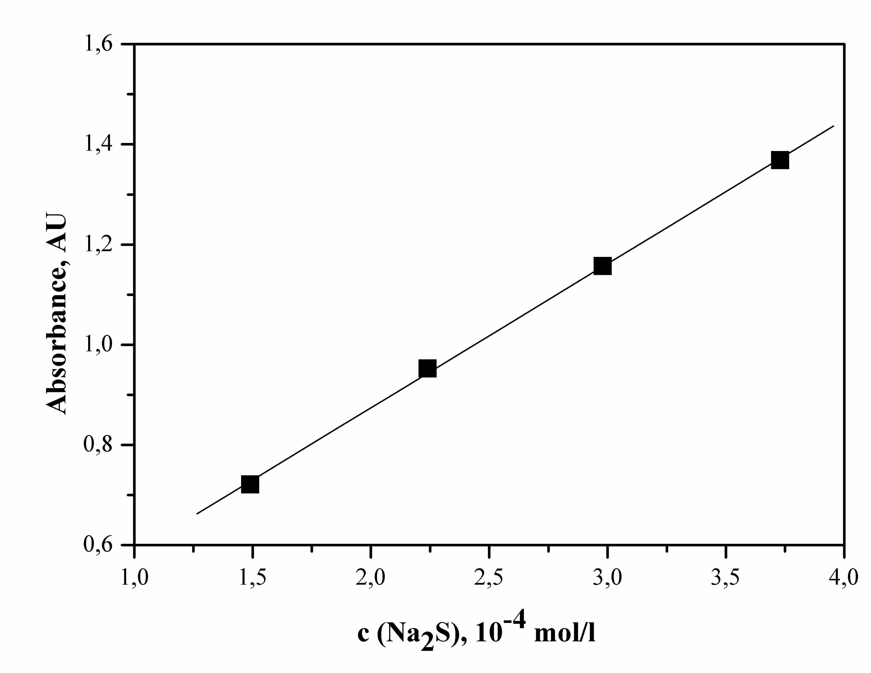
Fig. 5. Dependence of absorbance versus sulphide ion concentration.
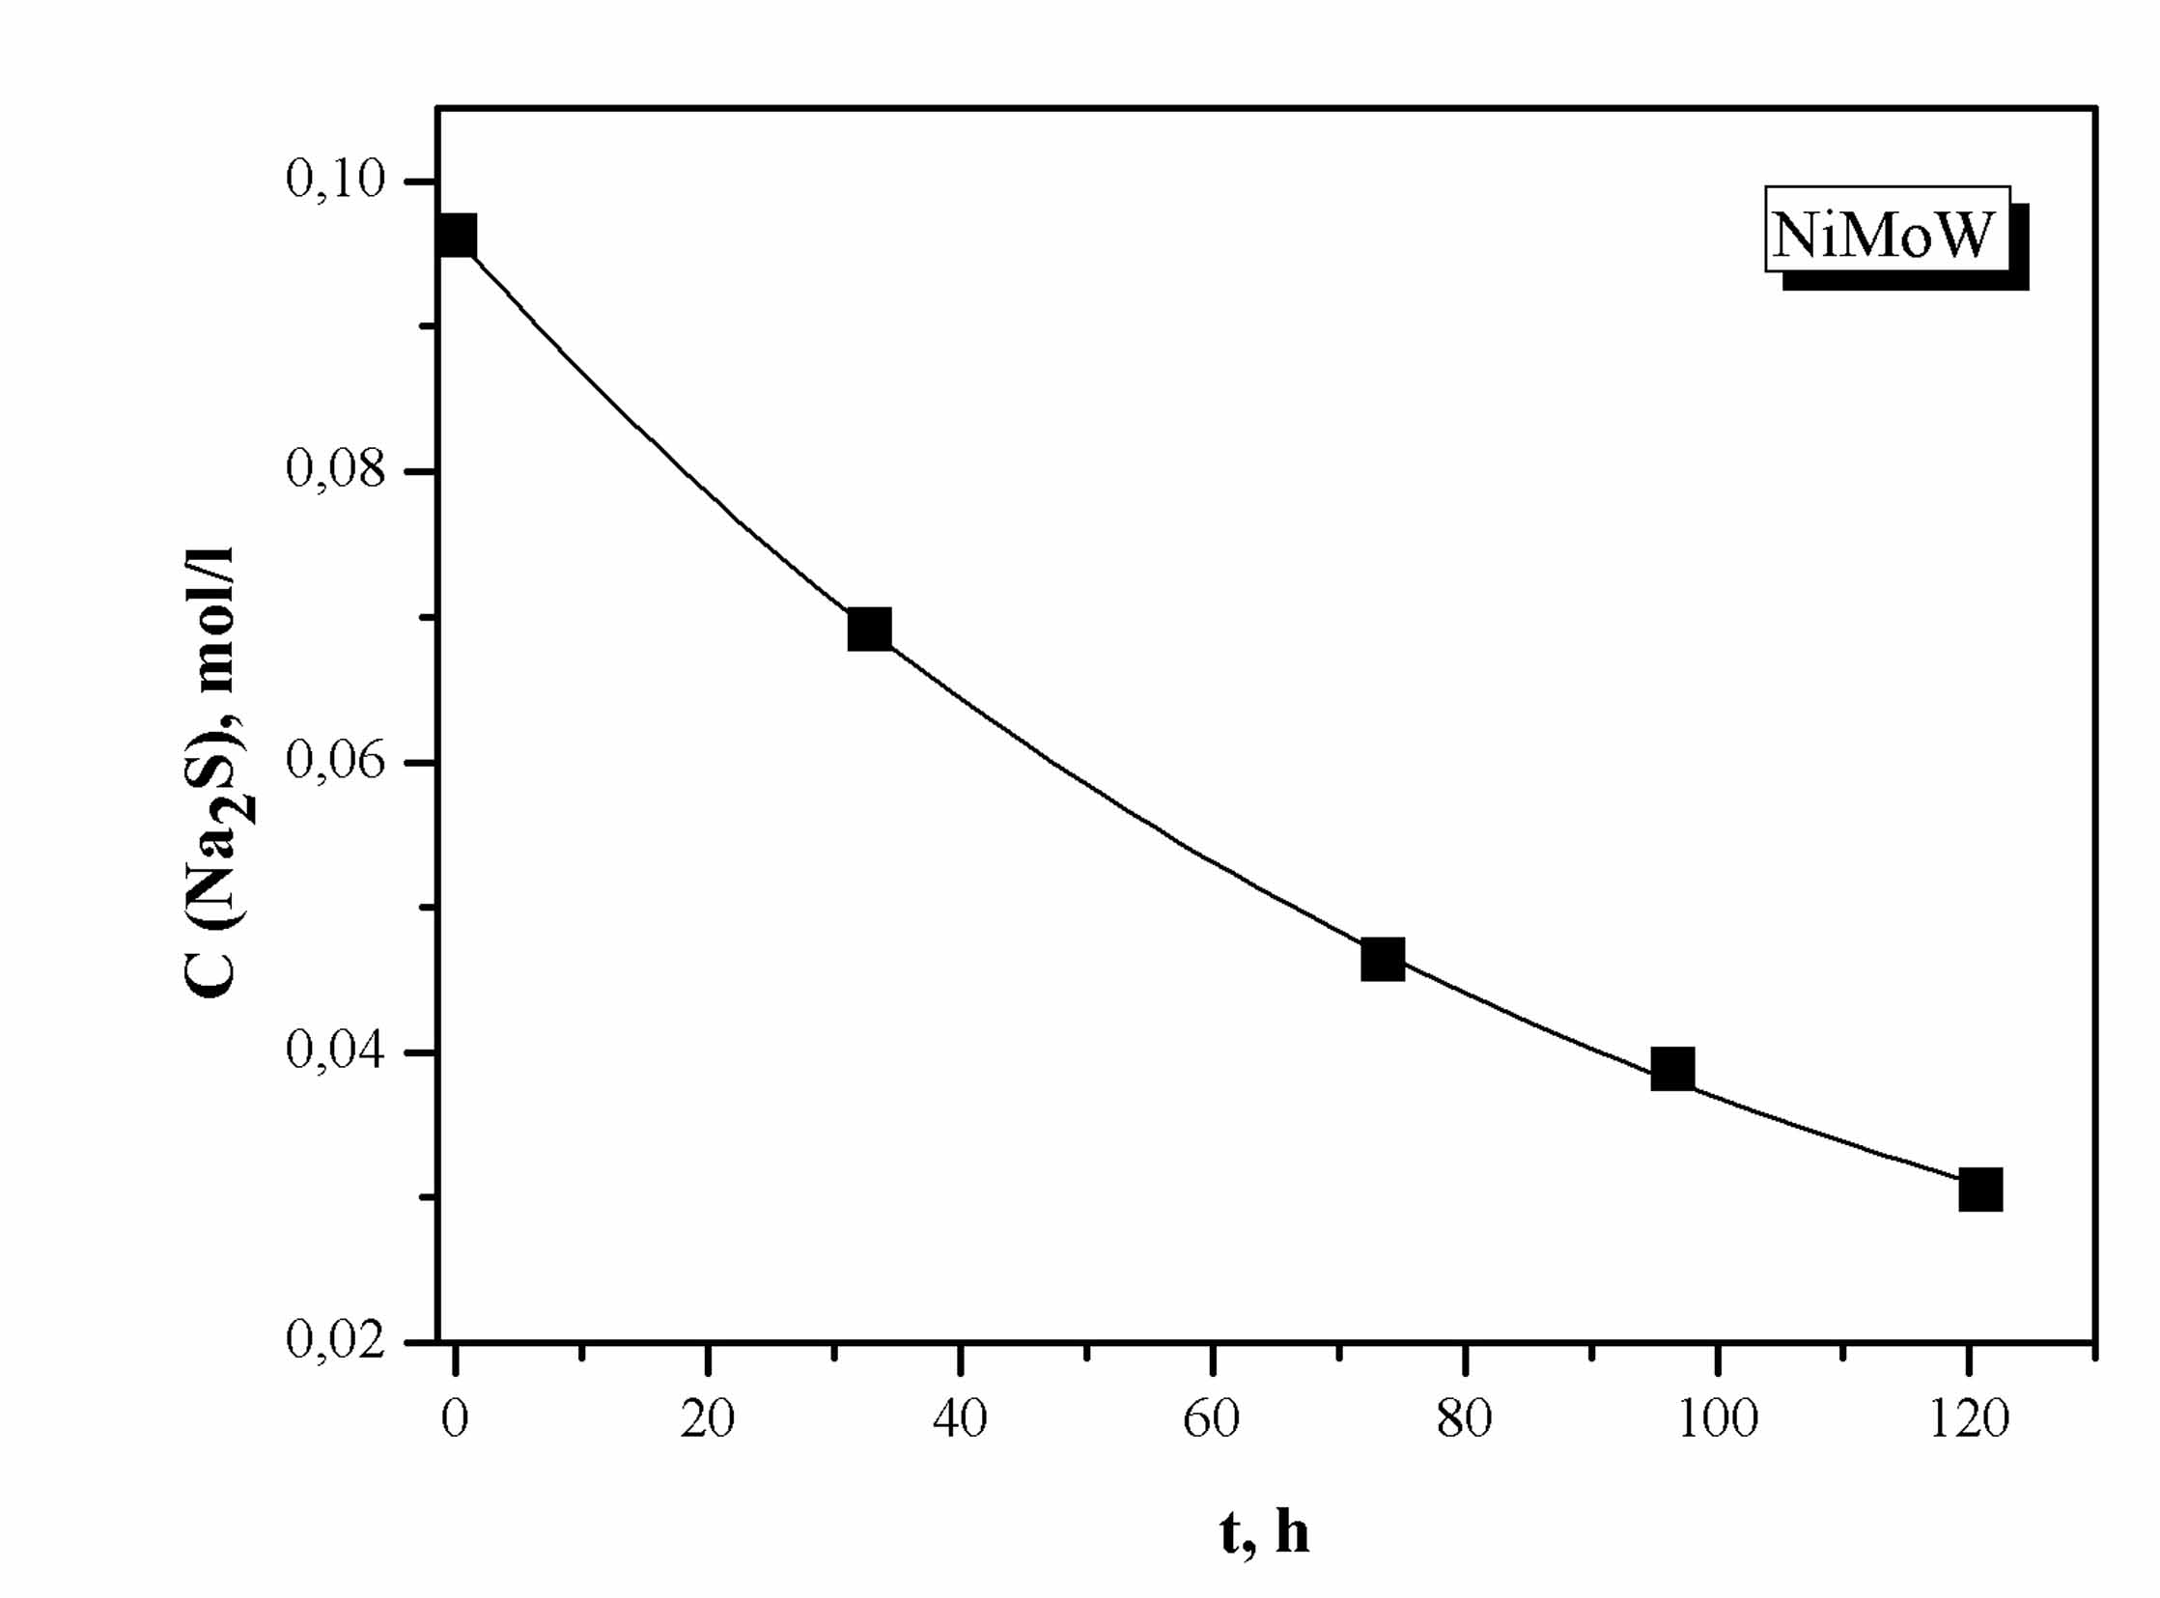
Fig. 6. Change of sulphide concentration with time.
Half decrease of initial sulphide concentration is observed after about 70 hours. The estimated mean reaction rate is 0.54 mmol/l·h, which is comparable with the one obtained from electrochemical experiments.
Conclusions
Novel Ni-Mo-W electrodeposits were examined as a model catalyst for oxidation of sulphides to sulphur in alkaline solutions by means of two experimental methods – electrochemical method, based on the additivity principle of Wagner and Traud, and long-term catalytic tests in a static reactor. The estimated values of the reaction rate, obtained by both methods, are comparable. However, it should be pointed out that the electro-chemical experiments are several times shorter and do not require additional analysis, contrary to the case of catalytic tests. This reveals the principle possibility for application of the proposed electro-chemical method as an express test for catalytic activity determination of a series of materials for this and other reactions, proceeding through electro-chemical mechanism.
Further investigations with other novel electro-deposits as potential catalysts for purification of waste waters from sulphides will be carried out.
E. Hristova et al.: Sulphide oxidation on electrodeposited Ni-Mo-W catalysts
References
- K. Coulier, Hydrotreating Model Catalysts: From Characterization to Kinetics, Technische Universiteit Eindhoven, Eindhoven, 2001.
- G. Kishan, L. Coulier, V. H. J. de Beer, J. A. R. van Veen, J. W. Niemantsverdriet, Chem. Commun., 1103 (2000).
- R. Huirache-Acuna, M. A. Albiter, J. Espino, C. Ornelas, G. Alonso-Nunez, F. Paraguay-Delgado, J. L. Rico, R. Martınez-Sanchez, Appl. Catal. A: General, 304, 124 (2006).
- H. Nava, J. Espino, G. Berhault, G. Alonso-Nunez, Appl. Catal. A: General, 302, 177 (2006).
- H. Nava, F. Pedraza, G. Alonso, Catal. Lett., 99, 65 (2005).
- C. Wagner, W. Traud, Z. Electrochem. Angew. Physik. Chem., 44, 391 (1938).
- M. Spiro, P. Fraund, J. Electroanal. Chem., 144, 293 (1983).
- I. Mitov, A. Andreev, I. Nikolov, K. Petrov, in: Reports of the National Scientific Session of Bulgarian Electrochemical Society, V. Bostanov, N. Atanassov (eds), Bulg. Electrochem. Soc., Sofia, 1996, p. 141.
- J. Milusheva, A. Kaisheva, R. Rashkov, N. Atanassov, in: Nanostructured Materials in Electroplating, D. Stoychev, E. Valova, I. Krastev, N. Atanassov (eds), St. Kliment Ohridski University Press, Sofia, 2006, p. 203.
- M. Mitov, K. Lekova, Ann. Shumen Univ. (in press).
- R. Rashkov, N. Atanassov, A. Jannakoudakis, P. Jannakoudakis, E. Theodoridou, J. Electrochem. Soc. 153, C152 (2006).
- M. Arnaudova, R. Rashkov, V. Bachvarov, N. Atanassov, A. Zielonka, in: Proc. Int. Workshop “Nanostructured Materials in Electroplating”, D. Stoychev, E. Valova, I. Krastev, N. Atanassov (eds.) St. Kliment Ohridski University Press, Sandanski, 2006, p.194.

ОКИСЛЕНИЕ НА СУЛФИДИ ВЪРХУ ЕЛЕКТРООТЛОЖЕНИ Ni-Mo-W КАТАЛИЗАТОРИ
Ел. Христова¹, М. Митов^{1,3}*, Р. Рашков², М. Арнаудова², Ал. Попов³
¹ Катедра „Химия“, Югозападен университет, Благоевград
² Институт по физикохимия, Българска академия на науките, ул. „Акад. Г. Бончев“, бл. 11, 1113 София
³ Институт по електрохимия и енергийни системи, Българска академия на науките,
ул. „Акад. Г. Бончев“, бл. 10, 1113 София
Постъпила на 5 ноември 2007 г., Преработена на 12 февруари 2008 г.
(Резюме)
В настоящата работа е изследвана каталитичната активност на новосинтезирани Ni-Mo-W електроотложени покрития по отношение окислението на сулфиди в алкални среди. За определяне на реакционната скорост е приложен адитивния принцип, предложен от Вагнер и Трауд, основаващ се на снемане на парциални анодни и катодни поляризационни криви, съответно в разтвори на алкализиран натриев сулфид и натриева основа. Паралелно са проведени продължителни каталитични тестове в статичен реактор, като кинетиката на процеса е проследена по определеното чрез УВ спектроскопски метод намаление на концентрацията на сулфидните йони. Въз основа на съпоставимите резултати, получени по двата метода, електрохимичният метод е предложен като експресен предварителен тест за оценка на каталитичната активност.

