Electrochemical corrosion behaviour of silica hybrid sol-gel coatings
Bulgarian Chemical Communications, Volume 40, Number 3 (pp. 295–299) 2008
© 2008 Bulgarian Academy of Sciences, Union of Chemists in Bulgaria
R. G. Raicheff ¹*, G. E. Chernev², V. G. Zaprianova², D. I. Ivanova²,
P. R. Djambaski², B. I. Samuneva², I. M. Miranda Salvado³
* To whom all correspondence should be sent:
E-mail: raicheff@bas.bg
¹ Institute of Electrochemistry and Energy Systems, Bulgarian Academy of Sciences, Sofia 1113, Bulgaria
² University of Chemical Technology and Metallurgy, Sofia 1756, Bulgaria
³ University of Aveiro, CICECO, 3810-193 Aveiro, Portugal
Received December 2, 2007, Revised February 12, 2008
The aim of the present work is to produce hybrid inorganic-organic nanostructured sol-gel coatings and to study their structure and corrosion resistance. The coatings were synthesized by sol-gel technology at room temperature using vinyltrimethoxysilane (VTMS) as silicon precursor and methylmethacrylate (MMA) or hydroxyethylmethacrylate (HEMA) as organic materials in different proportions. The coatings were deposited on mill steel substrates and thermally treated at 25 and 200ºC. The composition and the structure of the hybrids were characterized by FTIRS, XRD, BET-analysis, EDS, SEM and AFM. The presence of strong chemical bonds (Si–C, Si–O–C, Si–CH₃) between inorganic and organic parts of the hybrid materials, which are in amorphous state was proved. The size of nanounits and their aggregates as well as the surface roughness of the samples were also determined. The corrosion resistance of the coatings was studied using electrochemical potential-sweep technique and a model corrosive medium of 0.5 M Na₂SO₄ solution. It has been shown that the coating affects both partial corrosion reactions, but it decreases more strongly the anodic metal dissolution, thus decreasing the corrosion rate of the steel substrate more than an order of magnitude. The presence of a chemical bond of the coating with iron from the substrate is also established, which is in accordance with the good adhesion of this type of coating. The results of the present study suggest a possible application of the obtained hybrid materials as transparent coatings with good protective properties.
Key words: sol-gel, silica hybrids, nanostructure, corrosion resistant coatings.

INTRODUCTION
Over the last decades a great attention has been paid to the sol-gel chemistry, mainly because of its well-known advantages such as low synthesis tem-perature, high homogeneity and purity of obtained materials and proved possibility for producing new materials with appropriate physical and chemical properties [1–5].
H. Schmidt (Germany) and G. Weeks (USA) were the first published independently papers on creation of new family hybrid materials containing both organic and inorganic components [6, 7]. Because the hybrids are designed at a molecular and low molecular level, ranging from a few angstroms to a few nanometers in the structure is observed.
The sol-gel hybrid new materials were success-fully prepared by intimately mixing of organic and inorganic components combining desirable proper-ties of polymers (elasticity, hydrophobicity) with those of inorganic solids (hardness, thermal stabi-lity, chemical resistance). Furthermore, new unique properties coming in the hybrids from the synergy of both components are commonly observed [8–10].
Silica hybrid materials attracted much interest since they may be formed as nanocomposites and these materials were developed mainly by taking advantage of the mild chemical conditions of the sol-gel processes. The most popular precursors used for the synthesis of silicate hybrid nanocomposite materials assuring SiO₂ introduction are: TEOS, TMOS, ETMS, MTES, VTES, MTMS and THEOS. As an organic part olygomers or polymers, aggre-gates or particles as PEG, PEO, PVA, HEMA, PMMA, polystyrene, collagen and others could be used. One of the most interesting and important problems for studying hybrid nanocomposite mate-rials is their structure analysis as well as the processes of aggregation and development of self-assembled structures [11–14]. Up to now the infor-mation about these structures and the processes occurring during their formation is largely missing. For synthesis of hybrid materials the choice of the type and quantity of precursors as well as of organic components is also of importance.
The sol-gel method provides a low-temperature route to preparation of environmentally friendly hybrid coatings, which are readily applied to most metallic substrates. The hybrid sol-gel coatings possess several advantages over the inorganic coatings in regard to their improved adhesion to metallic substrates, hydrophobicity, low permeabi-lity, elasticity and crack-free surface layers. The preparation of coatings by dipping of the substrates in the sol-gel solutions is one of the most simple and well-established methods to produce homogeneous coatings with uniform thickness. The interest in development of hybrid inorganic-organic coatings has greatly increased and the subject of investiga-tions has been directed mostly to the structural chemistry and studies on their physical and chemi-cal properties, and potential applications [15–19].
Nanostructured silica hybrid coatings based on self-assembled nanophase particles were synthe-sized and studied for long term protection of aircraft aluminum alloys against atmospheric corrosion [20–22]. The corrosion resistance of stainless steel, zinc-plated steel and aluminum alloys was greatly improved by using silica-PMMA hybrid coatings prepared at 200ºC [23]. Silica hybrid coatings were obtained and investigated for corrosion protection of orthopedic metallic prostheses [24] and for conser-vation of art items [25].
The aim of the present work is to produce hybrid inorganic-organic nanostructured coatings by sol-gel technology and to study their eelectrochemical corrosion behaviour.
EXPERIMENTAL
Coating systems
The coating materials were synthesized by sol-gel technology at room temperature using vinyltri-metoxysilane (VTMS) as silicon precursor and methylmethacrylate (MMA) or hydroxyethylmeth-acrylate (HEMA) as organic materials in different proportions (5–20%). The coatings were deposited on mill steel substrates by dipping at controlled rate of 15 cm/min. The obtained layers were transparent, homogeneous with thickness 5–8 μm. Then they were dried at 25ºC for 24 h and thermally treated at 50 and 200ºC for 24 h in an electric furnace in air atmosphere.
As a model corrosive medium 0.5 M Na₂SO₄ solution at 25ºC was used.
Experimental techniques
The potential sweep technique (Princeton Corro-sion Measurement System, PAR 263A potentiostat with Soft Corr III package) was applied for electro-chemical and corrosion measurements. For investi-gation of the structure and surface morphology of the synthesized hybrids the following methods were used: FT-IR (IR- MATSON 7000 FTIR spectro-meter), XRD (X-ray PW1730/10 diffractometer, in the 2θ range of 50–80º, Cu-Kα radiation), BET Analysis (Gemini 2370 V5.00), EDS (RONTEC EDS System) and AFM (NanoScope Tapping Mode TM).
RESULTS AND DISCUSSION
The results from the XRD-analysis (Fig. 1) prove that all hybrids obtained have basically an amor-phous structure. The type of the XRD patterns, however, indicates that some processes of ordering have taken place. It is also established that the dif-fraction pattern intensity increases with increase in the organic component content.
R. G. Raicheff et al.: Electrochemical corrosion behaviour of silica hybrid sol-gel coatings
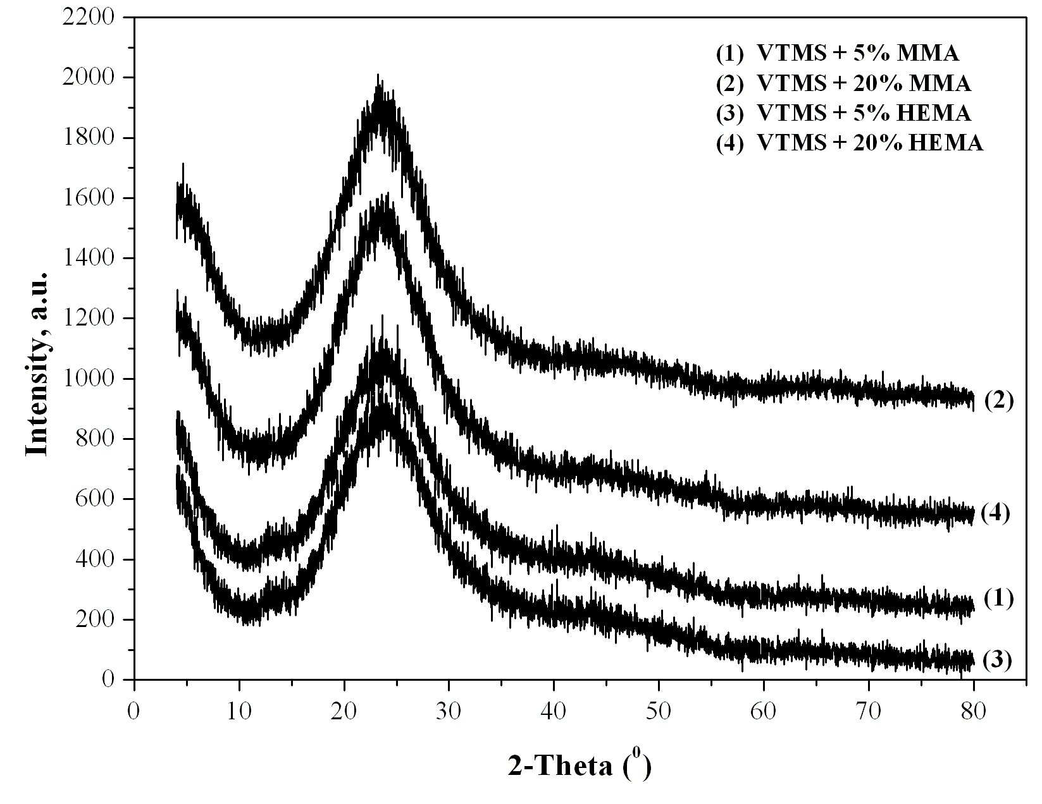
Fig. 1. XRD paterns of silica (VTMS) hybrids containing HEMA and MMA.
The FT-IR spectra of the synthesized inorganic-organic hybrids (Fig. 2) show that for all samples, bands at 1080, 790 and 480 cm^{–1} are observed, which are assigned to ν_{as}, ν_{s} and δ of Si–O–Si vibra-tions. At the same time the band at 1080 cm^{–1} can be related to the presence of Si–O–C, C–O–C and Si–C bonds. The band at 960 cm^{–1} is due to stretching of Si–OH vibration. The band at 1439 cm^{–1} is assigned to C–O–H vibrations. The characteristic bands at around 3450 and 1620 cm^{–1} assigned to H–O–H vibration can also be detected. The absorption band at 2975, 1255, 880 and 694 cm^{–1}, due to the presence of Si–O–R (CH₃ and C₂H₅) and Si–C bonds, have been also observed. These facts directly prove the presence of strong chemical bonds between inorganic and organic parts of the hybrids. The EDS analysis proved the presence of Si, O and C elements in all hybrid samples studied.
From the data of BET analysis, it is established that the surface area is in the range from 327 to 340 m²/g for the samples with 5% MMA or HEMA and from 64 to 71 m²/g – for the samples with 20% MMA or HEMA. More detailed information on the nanostructure and surface morphology of the matrices is obtained from the AFM studies. The presence of a heterogeneous structure with well-defined nano-units is observed. The average size of the nanoparticles on the sample surface is about 5–15 nm (Fig. 3a–d). The AFM micrographs show the topography of the synthesized hybrids with the height distribution profiles of the surface roughness. The latter depends obviously on the type and quan-tity of the organic components. With the increase in their content, the surface roughness decreases.
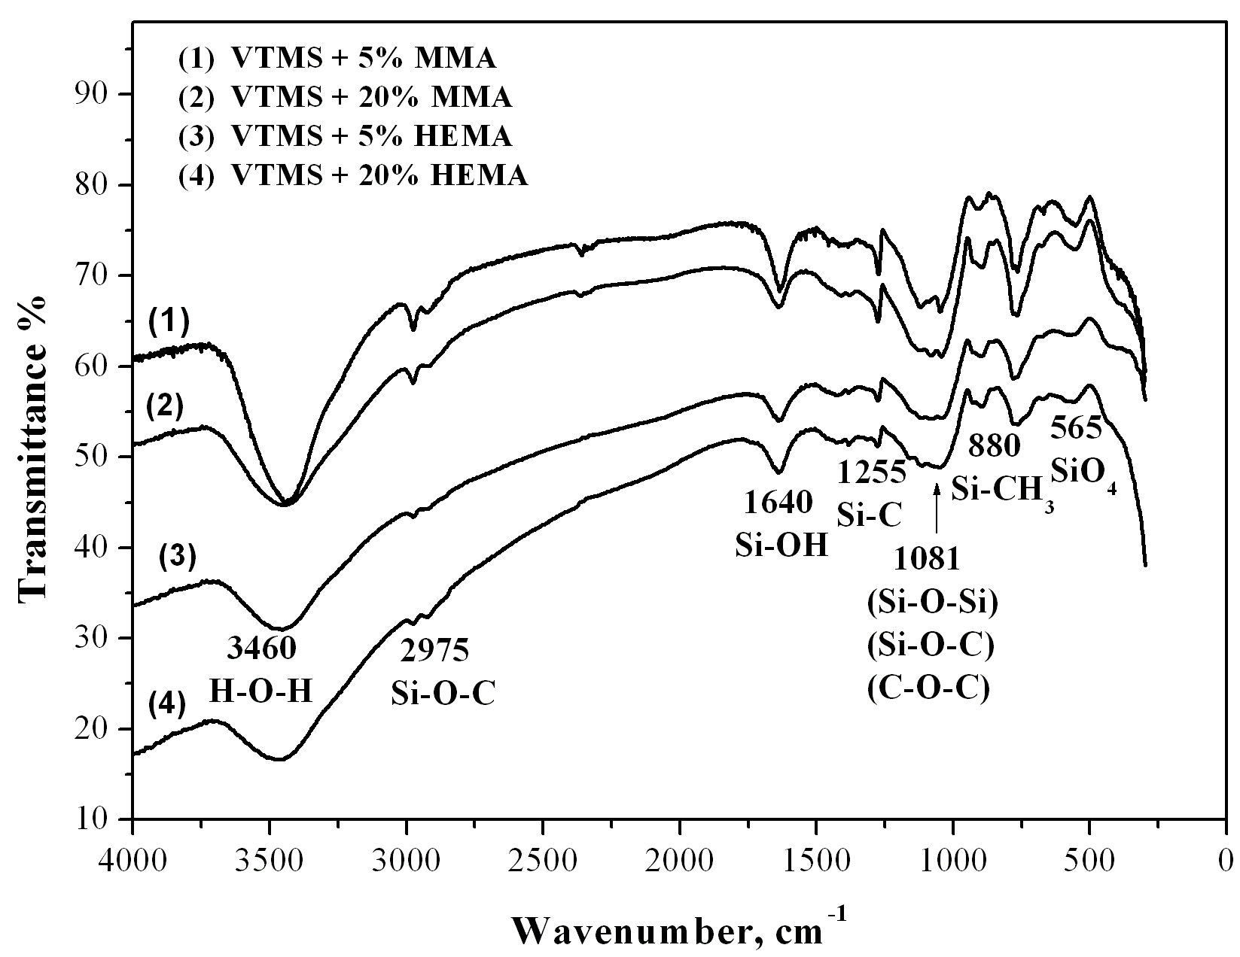
Fig. 2. FT-IR spectra of silica (VTMS) hybrids containing HEMA and MMA.
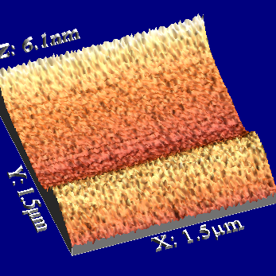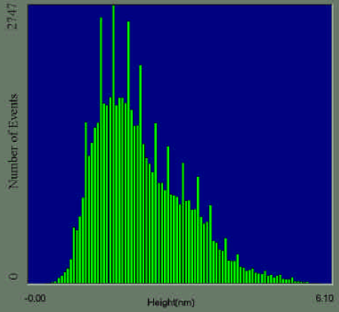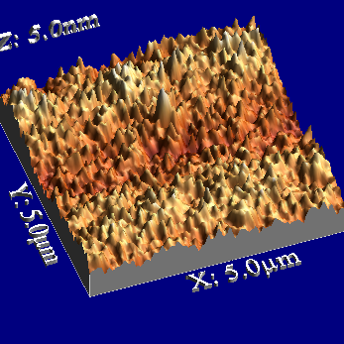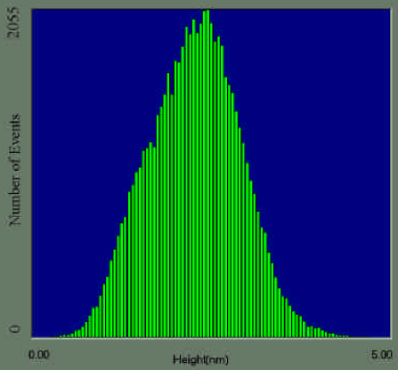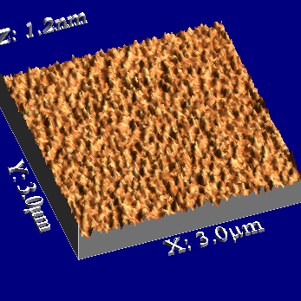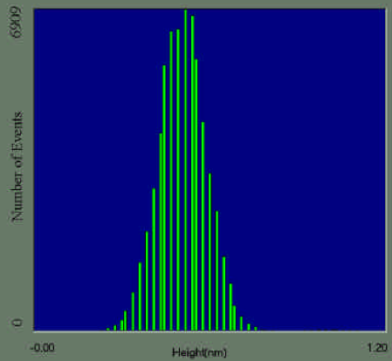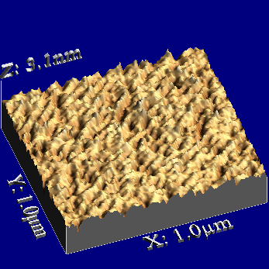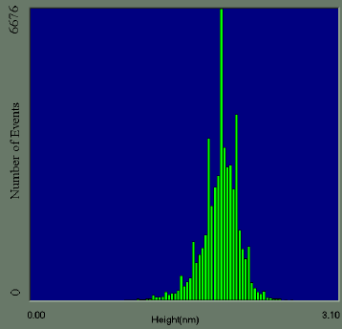
a
b
c
d
Fig. 3. AFM images height distribution profile of surface roughness of silica (VTMS) hybrids containing: (a) 5% HEMA; (b) 20% HEMA; (c) 5% MMA; (d) 20% MMA.
The electrochemical measurements show that the silica hybrid coatings with both organic materials (MMA or MA) affect both partial corrosion reactions, but it decreases more strongly the anodic metal dissolution reaction, thus shifting the corrosion potential in positive direction and decreasing the corrosion rate of the steel substrate more than an order of magnitude (Figs. 4 and 5). Those effects, however, are more strongly expressed for coatings containing MMA as organic material (Fig. 5). It is established that the temperature of thermal treatment of the coated samples affects the corrosion resistance of the coatings, obviously due to additional densification of the hybrid structure, but the effect is rather mild (cf. Table 1 and Fig. 6).
R. G. Raicheff et al.: Electrochemical corrosion behaviour of silica hybrid sol-gel coatings
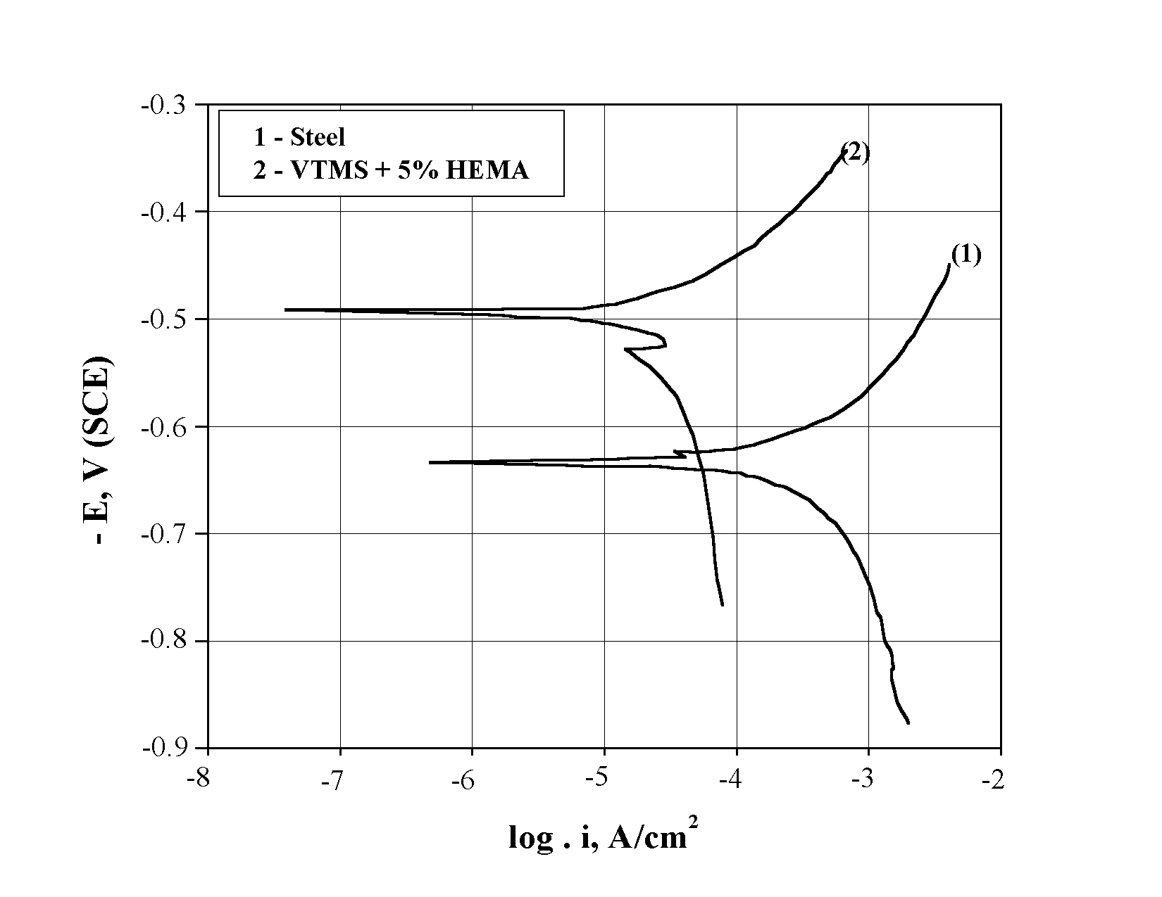
Fig. 4. Potentiodynamic polarization curves of mild steel substrate (1) and steel with hybrid coatings containing VTMS + 5% HEMA (2) treated at 50ºC/24 h, in 0.5 M Na₂SO₄.
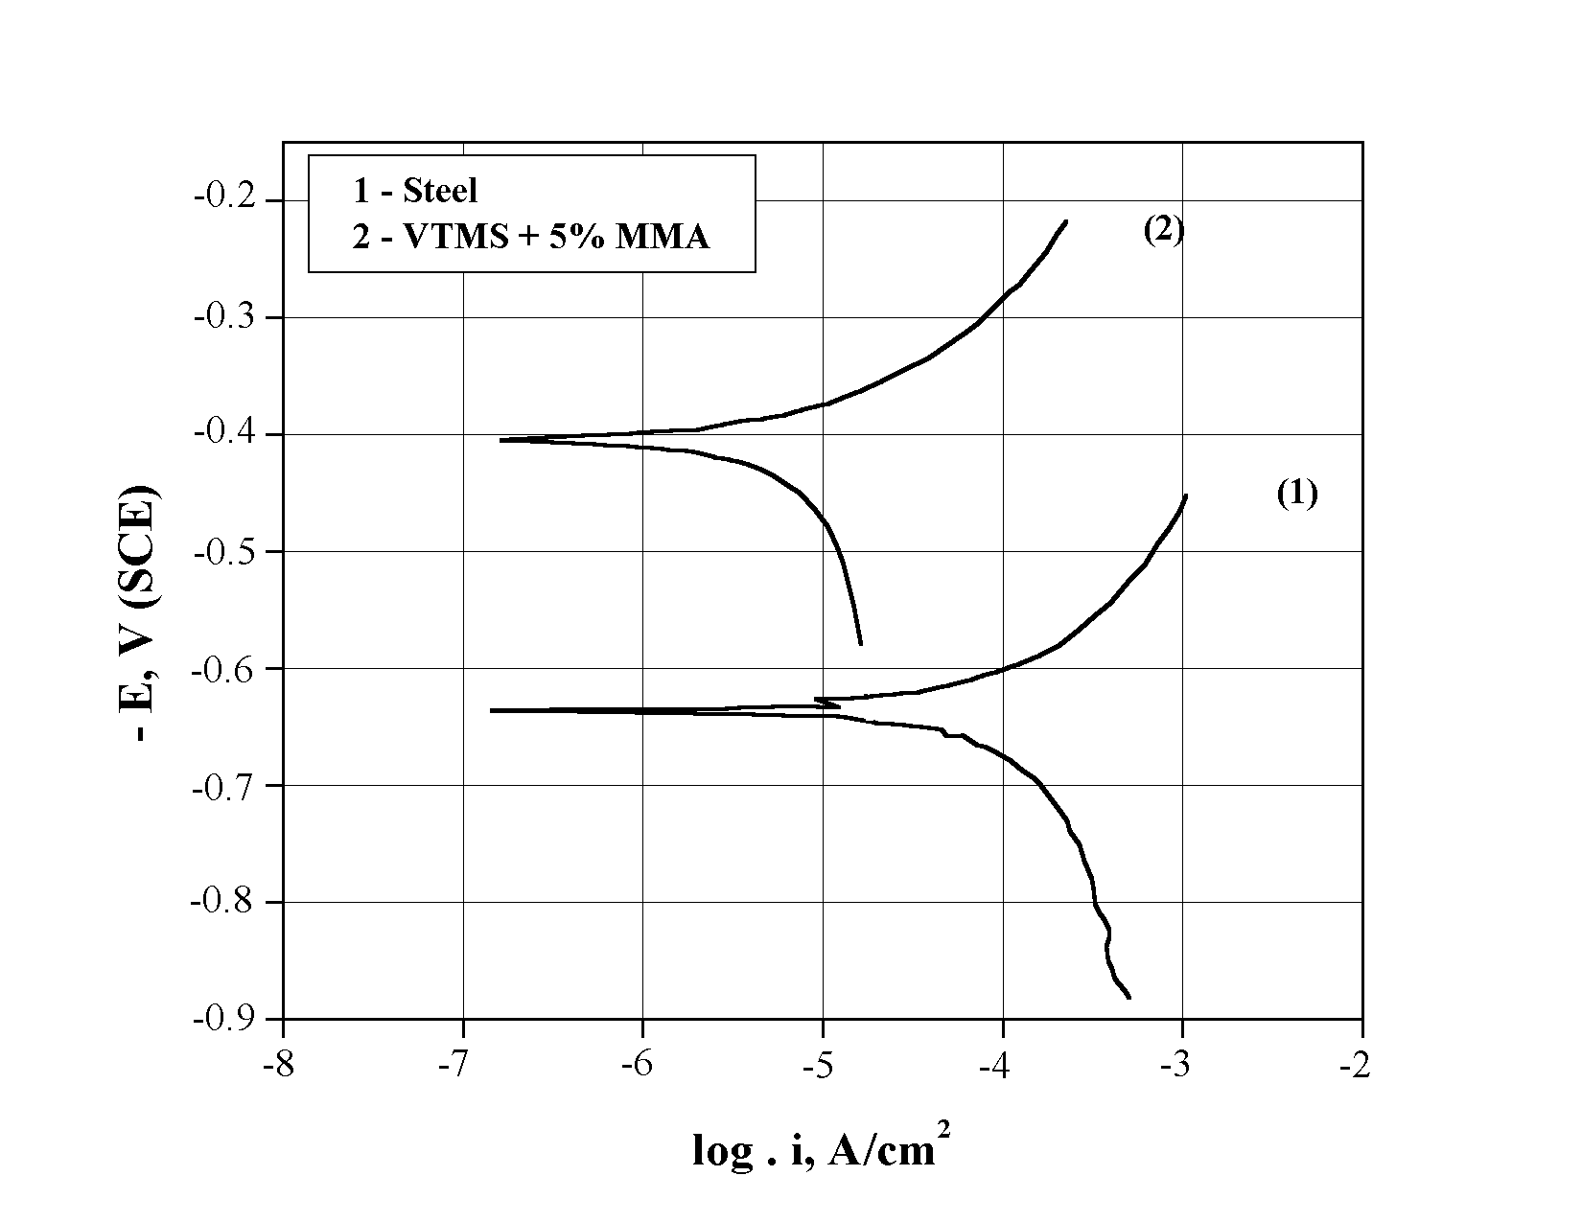
Fig. 5. Potentiodynamic polarization curves of mild steel substrate (1) and steel with hybrid coatings containing VTMS + 5% MMA (2) treated at 50ºC/24 h, in 0.5 M Na₂SO₄.
Table 1. Electrochemical corrosion parameters: corrosion potential (E_{corr}) and corrosion current density of the steel and steel samples with hybrid coatings.
Samples | Temperature  of treatment | E_{corr}  V, SCE | i_{corr}  μA/cm²
steel | - | –0.615 | 250
Steel/VTMS+5%HEMA | 50ºC | –0.480 | 45
Steel/VTMS+5%HEMA | 200ºC | –0.370 | 15
Steel/VTMS+5%MMA | 50ºC | –0.415 | 35
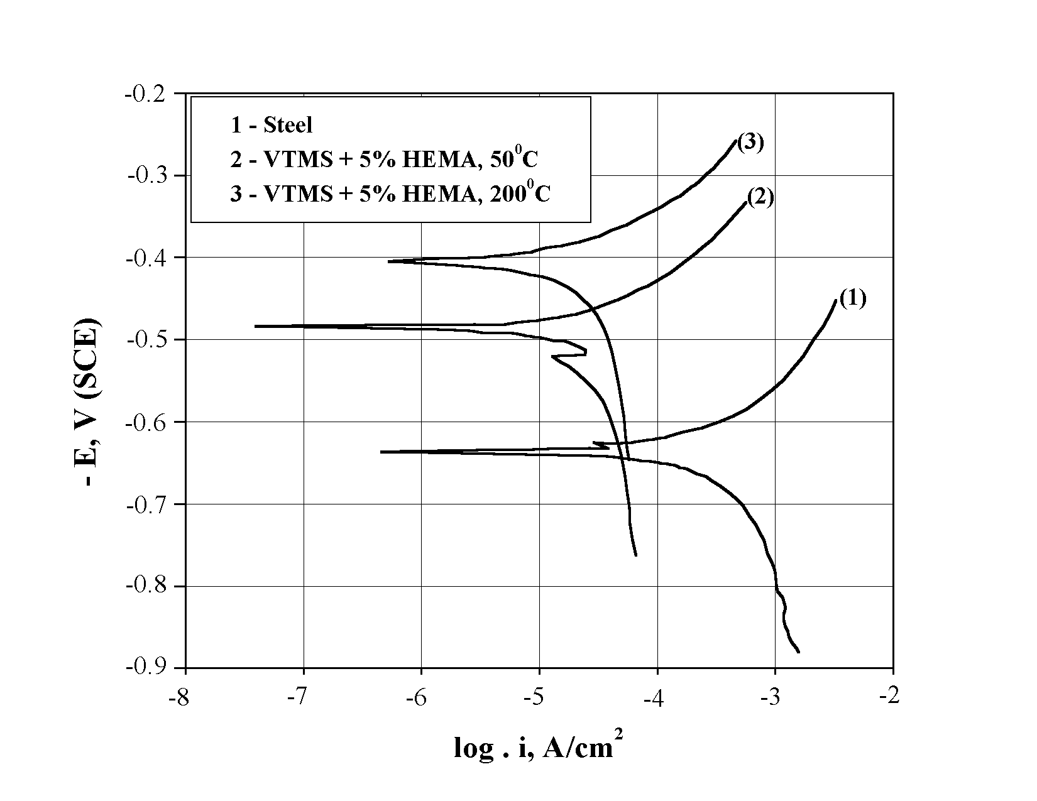
Fig. 6. Potentiodynamic polarization curves of mild steel substrate (1) and steel with hybrid coatings containing VTMS + 5% HEMA treated at 50ºC/24 h (2) and 200ºC/24 h (3), in 0.5 M Na₂SO₄.
The presence of a chemical bond of the hybrid coating with the iron from the substrate is also established, which is in accordance with the good adhesion and properties of the coating.
CONCLUSION
Silica hybrid inorganic-organic nanostructured coatings were obtained by sol-gel technology using vinyltrimethoxysilane (VTMS) as silicon precursor and methylmethacrylate (MMA) or hydroxyethyl-methacrylate (HEMA) as organic materials.The composition and structure of the hybrid coatings were characterized and their corrosion resistance investigated. The results from the present study suggest possible application of the obtained hybrid materials as transparent coatings with good adhesion and protective properties.
R. G. Raicheff et al.: Electrochemical corrosion behaviour of silica hybrid sol-gel coatings

Acknowledgements: The financial support of the Bulgarian National Science Fund under contract №VU-TN-102 is gratefully acknowledged.
REFERENCES
- H. Dislich, J. Non-Cryst. Solids, 73, 5991 (1985).
- S. Sakka, T. Yoko, Struct. Bond., 77, 90 (1992).
- M. Guglielmi, J. Sol-Gel Sci. Technol., 8, 443 (1997).
- A. Morales, A. Duran, J. Sol-Gel Sci. Technol., 8, 451 (1997).
- M. Guglielmi, J. Sol-Gel Sci. Technol., 8, 443 (1997)
- H. Schmidt, J. Non-Cryst. Solids, 73, 681 (1985).
- G. L. Wilkes, B. Otter, H. Huang, Polymer Prep., 26, 300 (1985).
- J. D. Mackenzie, J. Sol-Gel Sci. Technol., 2, 81 (1994).
- J. D. Mackenzie, E. P. Bescher, J. Sol-Gel Sci. Technol., 19, 251 (2000).
- C. Sanchez, B. Julian, P. Belleville, M. Popall, J. Mater. Chem., 15, 3559 (2005).
- F. Ribot, C. Sanchez, Comm. Inorg. Chem., 20, 327 (1999).
- R. M. Laine, J. Mater. Chem., 15, 3725 (2005).
- R. Castro-Rodrigez, A. I. Oliva, V. Sosa, F. Cabalero-Briqnes, J. L. Pena, Appl. Surf. Sci., 161, 340 (2000).
- K. H. Haas, K. Rose, Rev. Adv. Mater. Sci., 5, 47 (2003).
- K. Kuroaka, T. Ueda, M. Sato, T. Okamoto, T. Yazawa, J. Mater. Sci., 40, 3577 (2005).
- T. Ogashi, Y. Chujo, Compos. Interface, 11, 539 (2005).
- C. Garcia, A. Duran, R. Moreno, J. Sol-Gel Sci. Technol., 34, 211 (2005).
- B. Samuneva, E. Kadiyska, P. Djambaski, E. Dobreva, I. Bojadjieva, L. Kabaivanova, I. M. M. Salvado, M. H. V. Fernandes, Glastech. Ber. Glass Sci. Technol., 434 (2002).
- G. Chernev, B. Samuneva, P. Djambaski, L. Kabaivanova, I. M. Salvado, M. H. V. Fernandes, Glass Technol., 46, 175 (2005).
- N. Voevodin, V. Balbishev, M. Khobaib and M. Donley, Prog. Org. Coating., 47, 416 (2003).
- M. Khobaib, L. Reynolds and M. Donley, Surf. Coating Technol., 140, 16 (2001).
- V. Balbishev, K. Anderson, A. Sinsawat, B. Farmer and M. Donley, Prog. Org. Coating., 47, 337 (2003).
- S. Ono, H. Tsuge, Y. Nishi, S.I. Hirano, J. Sol-Gel Sci. Technol., 29, 147 (2004).
- J. Gallardo, P. Galliano, A. Duran, J. Sol-Gel Sci. Technol., 21, 65 (2001).
- E. Bescher, J. D. Mackenzie, J. Sol-Gel Sci. Technol., 26, 1223 (2003).

КОРОЗИОННО-ЕЛЕКТРОХИМИЧНИ ОТНАСЯНИЯ НА ЗОЛ-ГЕЛНИ ХИБРИДНИ ПОКРИТИЯ
Р. Райчев¹*, Г. Чернев², В. Запрянова², Д. Иванова², П. Джамбазки², Б. Самунева²,
Из. М. Миранда Салвадо³
¹ Институт по електрохимия и енергийни системи, Българска академия на науките, 1113 София
² Химикотехнологичен и металургичен университет, бул. „Климент Охридски“ № 8, 1756 София
³ Университет на Авейро, 3810-193 Авейро, Португалия
Постъпила на 2 декември 2007 г., Преработена на 12 февруари 2008 г.
(Резюме)
Целта на настоящата работа е да се получат хибридни неорганично-органични наноструктурирани покрития и да се изследва тяхната структура и корозионна устойчивост. Покритията бяха синтезирани чрез зол-гелна технология при стайна температура, използвайки винилтриметоксисилан (VTMS) като силициев прекурсор и метилметакрилат (ММА) като органичен материал в различни съотношения. Покритията бяха отложени върху образци от нисковъглеродна стомана и термично третирани при 25 и 200ºC. Съставът и структурата на покритията бяха охарактеризирани с помощта на FTIRS, XRD, BET, EDS, SEM, AFM и други методи. Потвърдено бе наличието на силни химически връзки (Si–C, Si–O–C) между органичната и неорганична част на хибридния материал, който е в аморфно състояние. Размерът на наночастиците и на техните агрегати, както и повърхностната грапавост на различните хибридни покрития са също оценени.
Корозионната устойчивост на покритията бе изследвана с помощта на потенциодинамична поляризационна техника и моделна корозионна среда от 0.5 M Na₂SO₄. Показано бе, че покритието оказва влияние и на двете парциални корозионни реакции, но понижава значително по-силно скоростта на анодната реакция на разтаряне на метал, при което скоростта на корозия на стоманената основа намалява над един порядъка. Установено е наличието на химическа връзка между покритието и желязото от основата, което е в съгласие с добрата адхезия на покритията. Резултати от настоящото изследване са указание за възможно приложение на получените хибридни материали като прозрачни защитни покрития.

