Electrooxidation of alkaline borohydrides on metal hydride electrodes
Bulgarian Chemical Communications, Volume 40, Number 3 (pp. 306–309) 2008
© 2008 Bulgarian Academy of Sciences, Union of Chemists in Bulgaria
G. Hristov¹, M. Mitov^{1,3}*, R. Rashkov², S. Hristov³, A. Popov³
* To whom all correspondence should be sent:
E-mail: mitovmario@mail.bg
¹ Department of Chemistry, South-West University, Blagoevgrad, Bulgaria,
² Institute of Physical Chemistry, Bulgarian Academy of Sciences, 1113 Sofia, Bulgaria
³ Institute of Electrochemistry and Energy Systems, Bulgarian Academy of Sciences, 1113 Sofia, Bulgaria
Received October 26, 2007, Revised February 14, 2008
In this paper, commercial AB₅ metal hydride alloy has been investigated as an anode material for borohydride electrooxidation. Polarization and discharge characteristics in stabilized sodium borohydride solutions as well as in strong base electrolyte have been obtained by means of electrochemical methods. The results have been analyzed and compared with those of previously studied nanocomposite electrodeposits.
Key words: metal hydrides, alloys, alkaline borohydrides, electrooxidation, direct borohydride fuel cell.

Introduction
The rapidly rising energy consumption requires new strategies and technologies for energy produc-tion. Except the problem with exhausting fossil fuel resources, the existing energy system suffers from another big obstacle – huge emissions of CO₂ and other “greenhouse” gases, which cause the already announced global warming of the planet.
One of the most popular concepts for the future energy system is based on the use of hydrogen and/or hydrogen-rich compounds as main energy carriers as well as zero- or low-emission fuels [1–3].
Complex hydrides such as alkaline borohydrides (M^{I}BH₄) are recently under intensive research and development [4-6]. Except high hydrogen content, they possess important advantages such as good solubility in water, high stability in basic solutions and electrooxidation with participation of big number of electrons via one of the following reactions:
BH₄–+ 8OH– → BO₂– + 6H₂O +8e–
or
BH₄–+ 4OH– → BO₂–+2H₂O + 2H₂ + 4e–
In addition, the electrode potentials of the above reactions are more negative than that of hydrogen reaction in alkaline media, and also the formed borates are environmentally safe and can be regene-rated.
However, most of the appropriate electro-catalysts possess some catalytic activity for the borohydride hydrolysis reaction:
BH₄– + 2H₂O → BO₂– + 4H₂
For the purposes of direct borohydride fuel cell applications, the upper reaction decreases the efficiency of a fuel use. The efforts for minimization of this effect are mainly in two directions – to use electrocatalysts, on which the hydrolysis does not occur or its rate is negligible [7], or to find proper inhibitors for borohydride hydrolysis [8], which do not impede its electrooxidation.
A possible way to lower the hydrolysis effect is the use of metal hydride alloys as anode materials. In such manner, a part of generated hydrogen could be absorbed and stored into the electrode as a “secondary” fuel.
The present paper is aimed at studying the electrooxidation of base-stabilized sodium boro-hydride solutions on the commercially available AB₅ metal hydride alloy. The results are compared with those obtained on recently studied nano-composite electrodeposits.
Experimental
Commercial mischmetal-based AB₅ alloy (Trei-bacher Industrie AG) was studied as a potential anode material for borohydride electrooxidation.
Button shaped electrodes with diameter 10 mm were produced as follows: a weighed amount (about 100 mg) of the powdered AB₅ alloy was mixed with PTFE paste (Carl Roth GmbH+Co), the obtained mixture was piled on nickel foam (RCM-Ni-4753.016, Recemat Inc.) and then hot-pressed under 200 kg/cm² at 280ºC.
A set of electrochemical methods has been used for characterization of electrode performance in borohydride solutions. Initially, the electrodes were polarized anodically in base-stabilized sodium boro-hydride solutions (1.0–1.3 M NaBH₄/6 M KOH) at different currents and the corresponding polarization curves were plotted. In other set of experiments, the electrodes were immersed in borohydride-con-taining solutions and then, a galvanostatic discharge in 6 M KOH was carried out. The discharge capa-city values, corresponding to the amount of ab-sorbed hydrogen, were estimated from the obtained discharge times. Finally, long-term discharge procedure at constant currents was carried out with the same electrodes in stabilized borohydride elec-trolytes (1.3 M NaBH₄/6 M KOH) and the resultant discharge curves were compared with those obtained in potassium hydroxide electrolyte.
All electrochemical experiments were carried out in a specially constructed hermetic water-jacketed three-electrode cell with an outlet for generated gases – Fig.1:
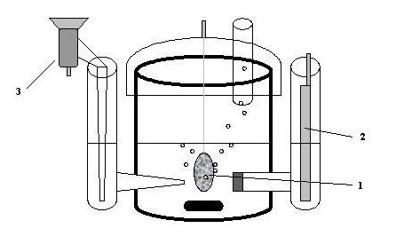
Fig. 1. Experimental three-electrode cell: 1 – working electrode, 2 – counter electrode, 3 – reference electrode.
The studies were performed using PJT 35-2 potentiostat-galvanostat (Radiometer Tacussel) with IMT 101 electrochemical interface and Volta Master 2 software.
Results and discussion
For getting an initial impression about the electrochemical behaviour of AB₅ electrodes in stabilized borohydride electrolytes and to quantify the range of current densities, at which the anodic process takes place with low overpotentials, polari-zation measurements under galvanostatic conditions have been carried out. Typical polarization curve, obtained with studied electrodes in stabilized boro-hydride solution, is presented in Fig. 2.
At all studied borohydride concentrations, the polarization curves start at more negative open circuit potentials (OCP) than the equilibrium poten-tial of hydrogen reaction in strong alkaline electro-lytes (-0.926 V vs. Hg/HgO). In addition, the OCP shifts to more negative values when increasing borohydride concentration [9]. These results are evident proof for the borohydride participation in the electrochemical reaction.
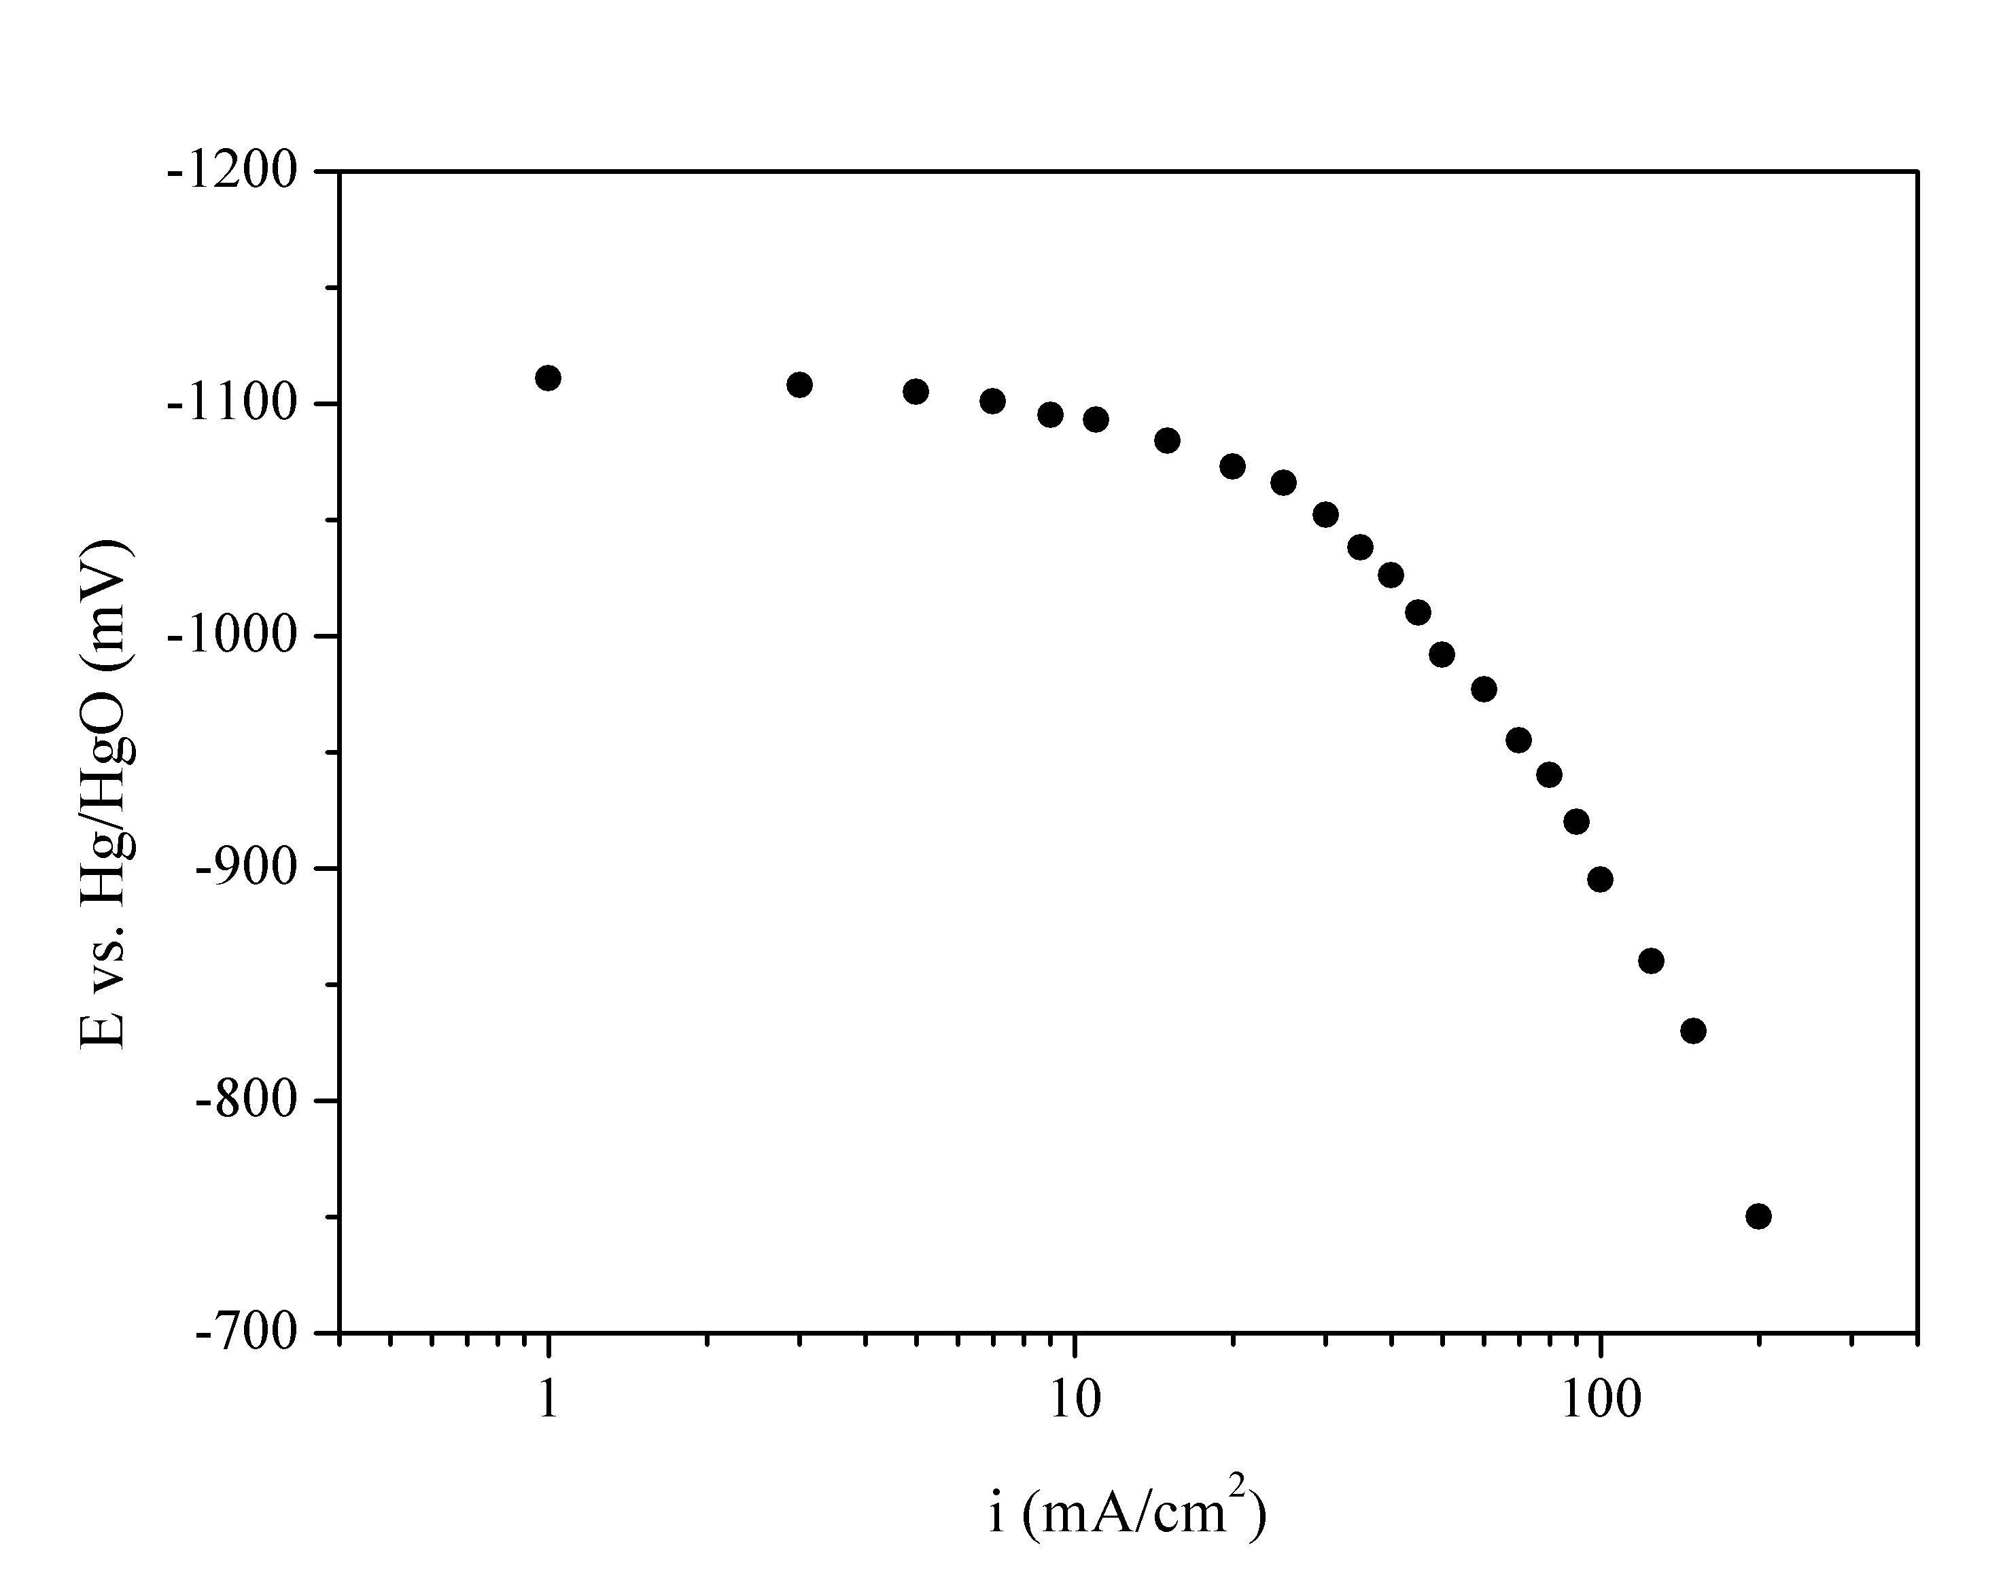
Fig. 2. Polarization curve of borohydride electrooxidation on AB₅ metal hydride electrode in 1.3 М NaBH₄/6 M KOH electrolyte.
Relatively small overpotentials (fewer than 100 mV) have been obtained with the studied electrodes up to 50 mA/cm² current loadings.
G. Hristov et al.: Electrooxidation of alkaline borohydrides on metal hydride electrodes
Noticeable hydrogen release due to the borohydride hydrolysis was observed immediately after immersion of AB₅-electrodes into the electro-lyte. However, the rate of hydrogen generation on these electrodes is quite lower in comparison with the cases of previously studied CoMnB and CoNiMnB electrocatalysts [10, 11] (see Table 1) and it reduces additionally at increasing the current density.
The hydrogen storage capability of the studied AB₅ electrodes as a result of their overnight immersion in sodium borohydride solution was verified by taking discharge curves in 6M KOH electrolyte – Fig. 3:
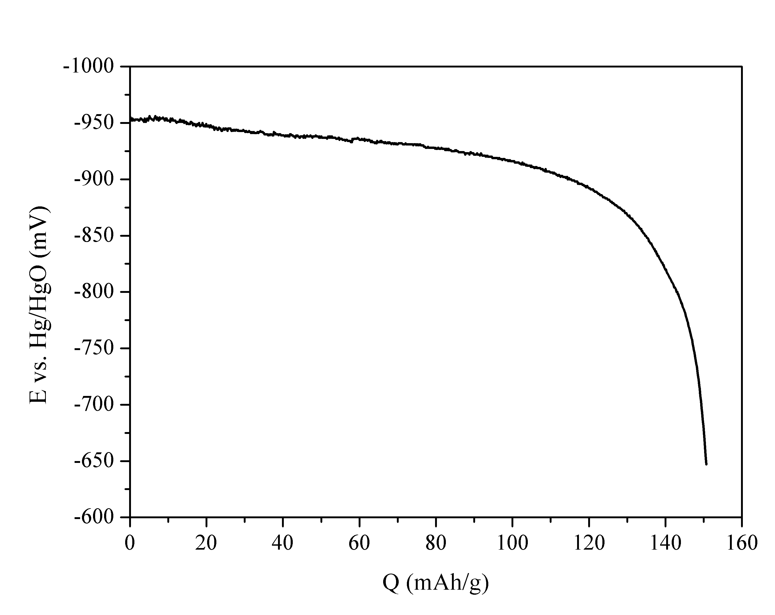
Fig. 3. Discharge curve obtained with AB₅ in 6 M KOH (I_{disch}.= 5 mA) after pre-treatment in sodium borohydride.
The pattern of these curves is typical for the metal hydride electrodes, used in the rechargeable Ni-MH batteries. The estimated capacity values are of the same magnitude as those, which are usually obtained with the same electrodes during their electrochemical charge/discharge activation. This result may be assigned to a formation of ternary metal hydride as a result of preliminary electrode immersion in borohydride solution. It was proven [12] that this hydride has the same composition as the one formed during electrochemical charge. This means that the treatment with sodium borohydride solution could be used as a pre-activation procedure for this type of electrodes.
Very long plateaus at more negative potentials than the characteristic ones for metal hydride electrodes in strong alkaline solutions are observed on the discharge curves, obtained in stabilized borohydride electrolytes – Fig. 4.
G. Hristov et al.: Electrooxidation of alkaline borohydrides on metal hydride electrodes
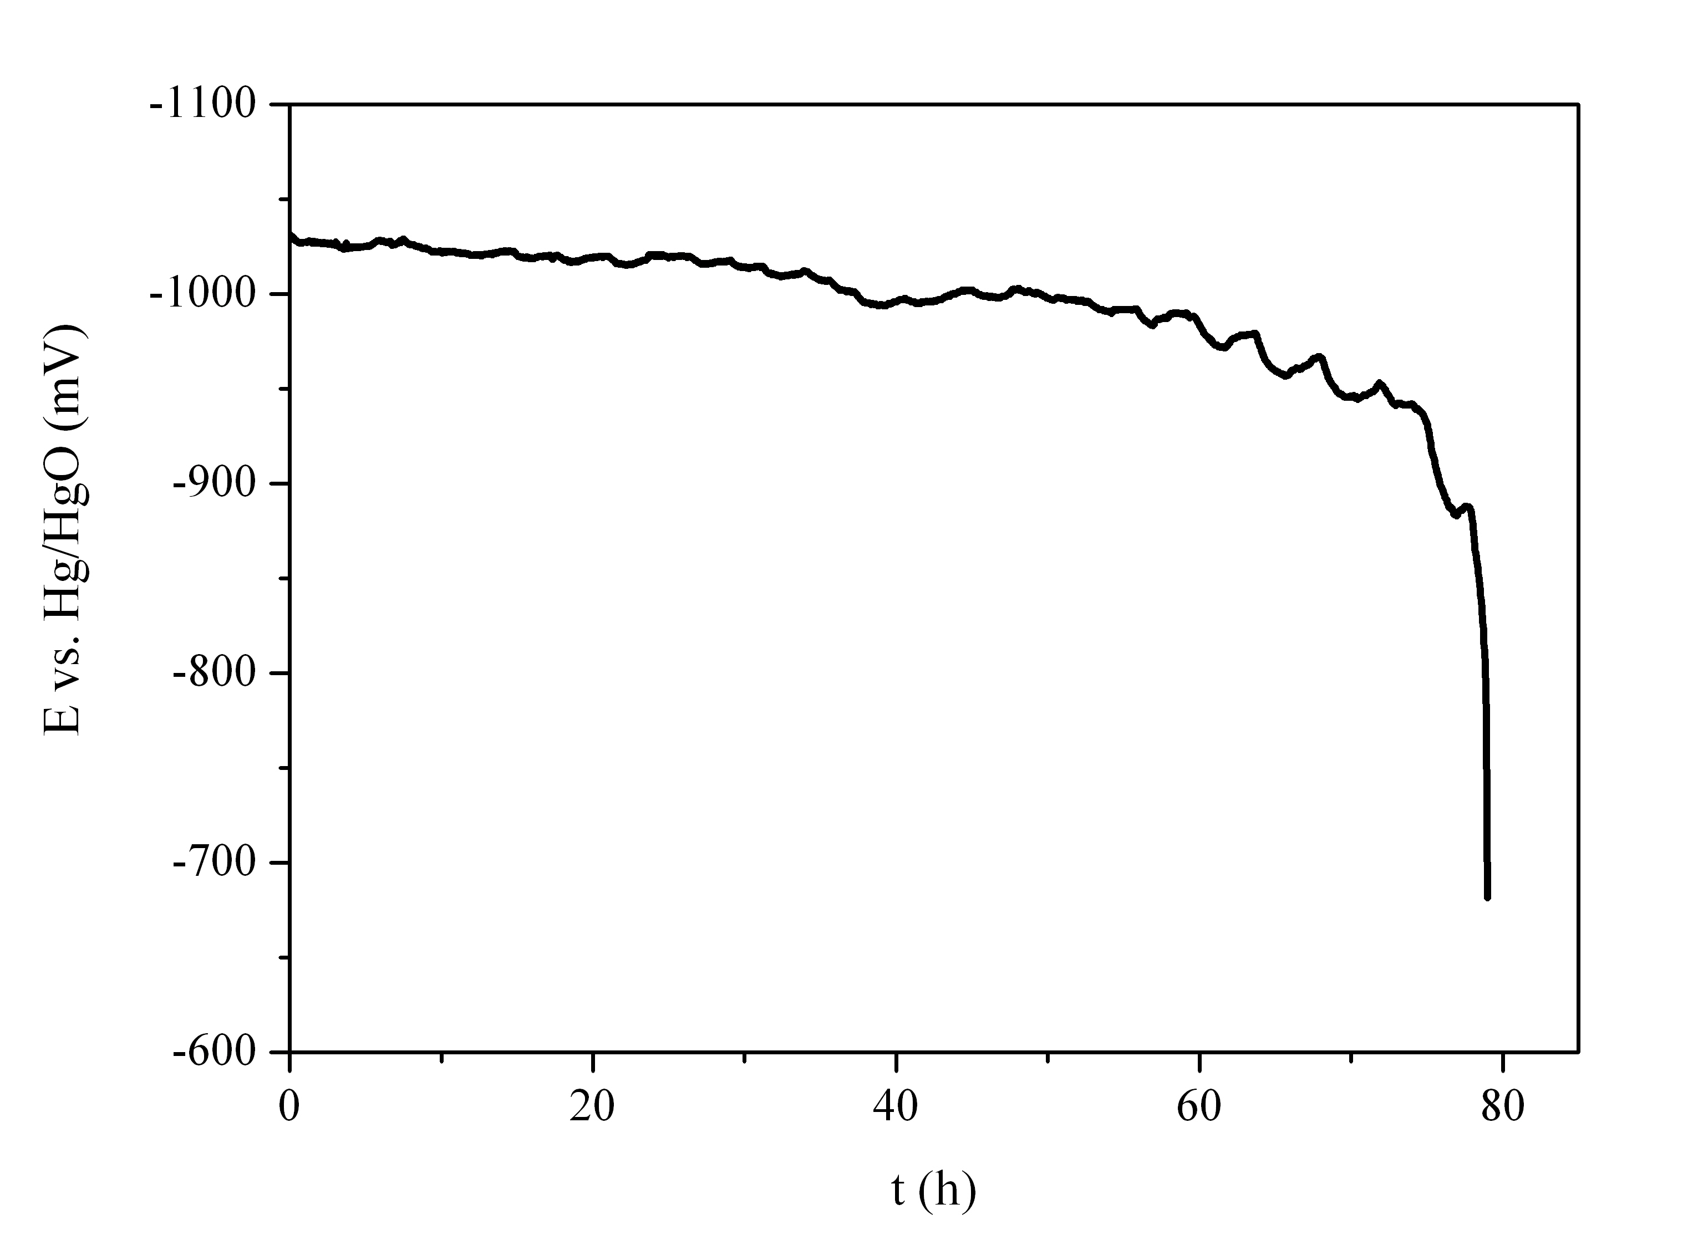
Fig. 4. Discharge curve obtained with AB₅ electrode in 30 ml 1.3 M NaBH₄/6M KOH electrolyte (I_{disch}.= 20 mA).
Their magnitude and range of potentials can be related mainly to the electrooxidation of dissolved borohydride. However, at the end of discharge the process is probably associated with the electro-chemical hydrogen desorption.
Characteristics, obtained with studied AB₅ metal hydride electrodes by means of polarization and discharge experiments are summarized in Table 1 and compared with those of best-performed nano-composite electrodeposits, recently investigated by us [11]. In addition, data for hydrogen release rate on these materials are also presented [9, 11].
At the same borohydride concentration, the OCP of AB₅ electrodes are less negative than those of electrodeposited ones and closer to the equilibrium potential of hydrogen reaction. Taking into account the strong hydrogen absorption ability of this elec-trode material, it may be supposed that the OCP is a mixed potential of two reactions – borohydride elec-
trooxidation and electrochemical hydrogen absorp-tion/desorption. The higher capacity values during discharge in 6 M KOH electrolyte as well as the several times smaller amounts of generated hydro-gen in borohydride solutions obtained with former electrodes are additional proofs for the significant role of hydrogen absorption reaction in the overall electrode performance.
Table 1. Characteristics of borohydride electrooxidation on AB₅ metal hydride and CoNiMnB electrodeposited electrodes, obtained by means of polarization and dis-charge experiments in 1.3 M NaBH₄/6 M KOH electrolyte.
Electrode material | OCP,  (vs. Hg/HgO),  mV | η,  (i = 50 mA/cm²), mV | τ_{disch.},  (I_{disch}. = 20 mA),  h | k,  (I = 20 mA)  ml H₂/min
AB₅ | -1113 | 120 | 75 | 0.9
CoNiMnB | -1190 | 40 | 30 | 5.7
In spite of higher overpotentials estimated from polarization curves, much longer discharge times in borohydride electrolytes were obtained with the studied AB₅ than with the electrodeposited elec-trodes. Probably, the main reason for this is the faster exhaustion of borohydride fuel in the latter case due to the higher rate of its hydrolysis on this type of nanocomposites (see Table 1).
Further experiments with investigated AB₅ metal hydride electrodes in a specially constructed fuel cell are in a progress.
Conclusions
The electrooxidation of sodium borohydride on AB₅-type metal hydride electrodes takes place with relatively small overpotentials (less than 100 mV) up to 50 mA/cm² current densities. In addition, the rate of hydrogen release due to borohydride hydro-lysis is almost negligible and the amount of the absorbed into the electrodes hydrogen is comparable with that obtainable by electrochemical charging. At the same current loadings, the discharge times in stabilized borohydride electrolyte obtained with the investigated AB₅ electrodes are several times longer than those with previously examined composite electrocatalysts.
Based on the overall performance, it may be concluded that the studied AB₅ alloy is a proper alternative for application as anode material in Direct Borohydride Fuel Cells.
Acknowledgements: The authors would like to thank National Science Fund of Bulgaria for the financial support through the Contract D01-386, Program “New Technologies in the Energetics”.
References
- P. Hoffman, Tomorrow’s Energy: Hydrogen, Fuel Cells, and the Prospects for a Cleaner Planet, MIT Press, Cambridge, MA, 2001.
- J. Rifkin, The Hydrogen Economy: The Creation of the Worldwide Energy Web and the Redistribution of Power on Earth, Penguin Group, New York, 2002.
- J. Bockris, Int. J. Hydrogen Energy, 27, 731 (2002).
G. Hristov et al.: Electrooxidation of alkaline borohydrides on metal hydride electrodes
- D. Nikbin, J. McEntee, Fuel Cell Rev., 3, 19 (2006).
- C. Ponce de Leon, F. C. Walsh, A. Rose, J. B. Lakemana, D. J. Browning, R. W. Reeve, J. Power Sources, 164, 441 (2007).
- S. C. Amendola, S. L. Sharp-Goldman, M. S. Janjua, N. C. Spencer, M. T. Kelly, P. J. Petillo, M. Binder,
Int. J. Hydrogen Energy, 25, 969 (2000).
- M. H. Atwan, C. L. B. Macdonald, D. O. Northwood, E. L. Gyenge, J. Power Sources, 158, 36 (2006).
- E. Gyenge, Electrochim. Acta, 49, 965 (2004).
- Y. Petrov, M. Mitov, A. Popov, Bulg. Chem. Comm., 38, 217 (2006).
- M. Mitov, R. Rashkov, N. Atanassov, A. Zielonka, J. Mat. Sci,. 42, 3367 (2007).
- M. Mitov, G. Hristov, E. Hristova, R. Rashkov, M. Arnaudova, A. Zielonka, Environ. Chem. Lett. (submitted)
- S. Bliznakov, M. Mitov, Y. Petrov, E. Lefterova, S. Vassilev, A. Popov, in: Nanoscience & Nanotech-nology, vol. 4, E. Balabanova, I. Dragieva (Eds.), Heron Press, Sofia, 2004, p. 139.

ЕЛЕКТРООКИСЛЕНИЕ НА АЛКАЛНИ БОРХИДРИДИ ВЪРХУ МЕТАЛ ХИДРИДНИ ЕЛЕКТРОДИ
Г. Христов¹, М. Митов^{1,3}*, Р. Рашков², С. Христов³, А. Попов³
¹ Катедра Химия, Югозападен университет, Благоевград,
² Институт по физикохимия, Българска академия на науките, 1113 София
³ Институт по електрохимия и енергийни системи, Българска академия на науките, 1113 София
Постъпила на 26 октомври 2007 г., Преработена на 14 февруари 2008 г.
(Резюме)
В настоящата работа е изследвана комерсиална AB₅ метал хидридна сплав като аноден материал за електроокисление на борхидриди. Чрез набор от електрохимични методи са снети поляризационни и разрядни характеристики в стабилизирани разтвори на натриев борхидрид, както и в концентриран алкален електролит. Получените резултати са анализирани и сравнени с тези от предишно изследвани нанокомпозитни електро-отложени покрития.

