Comparison of stress-corrosion cracking susceptibility of mild and low alloy steels in phosphate environments
Bulgarian Chemical Communications, Volume 40, Number 3 (pp. 318–322) 2008
© 2008 Bulgarian Academy of Sciences, Union of Chemists in Bulgaria
Y. S. Marcheva¹*, R. G. Raicheff²
* To whom all correspondence should be sent:
E-mail: ysm@tu-sofia.bg
¹ Technical University of Sofia, Department of Chemistry, Sofia, Bulgaria
² Institute of Electrochemistry and Energy Systems, Bulgarian Academy of Sciences, 1113 Sofia, Bulgaria
Received October 9, 2007, Revised January 2, 2008
Comparison between anodic behaviour and susceptibility to stress-corrosion cracking (SCC) in phosphate solutions (NaH₂PO₄, pH = 4) of two kinds of construction steels – low carbon (0.17% С) and low-alloy (2.0% Сr) steels has been carried out using the potentiodynamic polarization method with slow and fast potential sweep rates (10 and 300 mV/min) as well as slow strain rate techniques. It has been established, that both steels undergo active to passive state transition in phosphate medium, more clearly expressed for the low-carbon steel. For this steel, the susceptibility toward SCC is much higher than that of the low-alloy steel. The occurrence of SCC depends strongly on the potential and it is expressed only within a narrow range of potentials for both steels: –0.3–0.0 V (SCE) for the low-carbon and –0.1+0.3 V (SCE) for the low-alloyed steel. The SCC susceptibility decreases strongly with the increase of temperature and lowering solution concentration. The most severe SCC extent has been registered in 1 N NaH₂PO₄ solutions at 20°С. It is also shown that under SCC conditions a surface film, containing iron phosphates, is formed on both kinds of steels. The conditions of SCC correspond well to the regions of active-passive state transition in the polarization curves for both materials and are in good agreement with the regions, predicted by the potentiodynamic polarization method with slow and fast potential sweep rates. On the basis of the results obtained, a conclusion is drown for the higher mechano-corrosion stability of the low-alloy steel, compared to that of the low-carbon steel.
Key words: Stress-corrosion cracking, anodic behaviour, phosphate solutions, low-carbon steel, low-alloy steel.

Introduction
A survey of failure cases and analyses [1] show that the share of carbon and low-alloy steels in the stress-corrosion cracking (SCC) cases is 24%. It is well known today, that this type of steels undergoes SCC in hydroxide, nitrate and carbonate solutions. Some works on susceptibility to SCC of these mate-rials and Armco iron in phosphate media were published as well [2–7].
SCC takes usually place in alloys in passive state and within some ranges of potentials. For carbon steels this region is close to the critical potential of passivation, where the passive film is not very stable [8]. Parkins proposed a simple method for pre-dicting this potential range using a potentiodynamic polarization method with fast and slow potential sweep rates [3, 9, 10].
In our previous works, the detailed investigations concerning the effect of pH, solution concentration and temperature on SCC [11–13] as well as the film composition under SCC conditions [14] of mild and low-alloyed with Cr steels in phosphate media were represented. Taking into account that the low-alloyed steels are used as an alternative material for replacing the low-carbon ones, it is important to compare their SCC behaviour. The aim of the presented work was to make a comparison of SCC susceptibility and electrochemical behaviour of low-carbon and low-alloy (2% Cr) steels in phosphate environment.
Experimental
Materials and solutions: The studies were carried out with samples of:
- mild construction steel of the following com-position (wt.%): C 0.17; Cr 0.06; Mn 0.36; Si 0.016;
S 0.029; P 0.01; Ni 0.06 and Cu 0.11. The mecha-nical parameters of the steel (produced as hot-rolled bars) were: ultimate tensile strength σ_{B} = 440.0 MPa and yield strength σ_{S} = 354.7 MPa.
- low-alloy steel of the following composition (%): C 0.066; Cr 1.89; Mn 0.61; Si 0.23; S 0.034;
P 0.015; Ni 0.066; Cu 0.15 and Al 0.08. The mechanical parameters of the steel (produced as hot-rolled sheets) were: ultimate tensile strength σ_{B} = 392.0 MPa and yield strength σ_{S} = 261.7 MPa.
Orthophosphate solution having pH = 4, prepared of NaH₂PO₄.H₂O (p.a.) with small amounts of H₃PO₄ (p.a.) or NaOH (р.а.) for рН adjustment, was used as a corrosion medium.
Polarization studies on non-stressed electrode
Disk sample-electrodes (working area of 1 cm²) installed on a special Teflon holder, three-compart-ment electrochemical cell and conventional experi-mental procedure were used for the polarization measurements [11, 12]. The potentiodynamic polari-zation method with fast (300 mV/min) and slow (10 mV/min) potential sweep rate was applied for assessment of the approximate potential range for cracking [10–13]. The potentials were measured and reported against saturated calomel electrode (SCE).
SCC tests
The measurements were made using the slow strain rate technique in situ (strain rate 2.34×10^{–5}
s^{–1}) under potentiostatic conditions at different potentials. Tensile testing specimens were: for the mild steel – cylindrical specimens of 180 mm overall length, 10 mm diameter and 3 mm reduced gauge diameter, and for the low-alloy steel - sheet specimens 3 mm thick, 170 mm overall length and 3 mm reduced gauge width.
Y. S. Marcheva and R. G. Raicheff: Stress-corrosion cracking susceptibility of mild and low alloy steels
The electrochemical cell, the tensile testing apparatus and the experimental procedure were described elsewhere [15, 16]. The susceptibility to SCC was evaluated by comparison of the mecha-nical parameters (tensile strength σ_{В} and reduction in the specimen cross-sectional area RA) at fracture in the corrosion medium and inert atmosphere.
Results and discussions
Fig. 1 and Fig. 2 show typical potentiodynamic polarization curves (10 mV/min) of mild and low-alloy steels in phosphate solutions at concentrations 0.05–2 M NaH₂PO₄, pH = 4, 20°C. As it can be seen, both kinds of steels undergo active to passive state transition. The maximum in the active state (the critical potential) shifts in positive direction while the width of the passive region is reduced upon lowering solution concentration, more strongly expressed for the low-alloy steel. At low concen-trations (0.05 M for the low-carbon and 0.1 M for the low-alloy steel) the steels are in an active state within the whole potential range. In more concen-trated solutions, the polarization curves show “double peak”, i.e. a region of “primary passivity” at potentials more negative than the potential of deep passivity, clearly expressed for the low-carbon steel. Upon increasing the temperature, this region for both kinds of steels shrinks and shifts to more negative potentials.
According to Kolotyrkin [17] the region of “primary passivity” for iron in phosphate media is related to formation of a surface film, composed of two layers. The first one is thin, protective, created by adsorption of phosphate ions and their interaction with iron atoms from the metal surface. The second (external) layer is formed as a result of a secondary chemical reaction between iron and phosphate ions, composed of Fe₃(PO₄)₂.8H₂O, without any pro-tective properties. The presence of a phosphate layer in the region of active to passive state transition was proved by our Mössbauer study of surface films, formed on the steels in phosphate solutions [12].
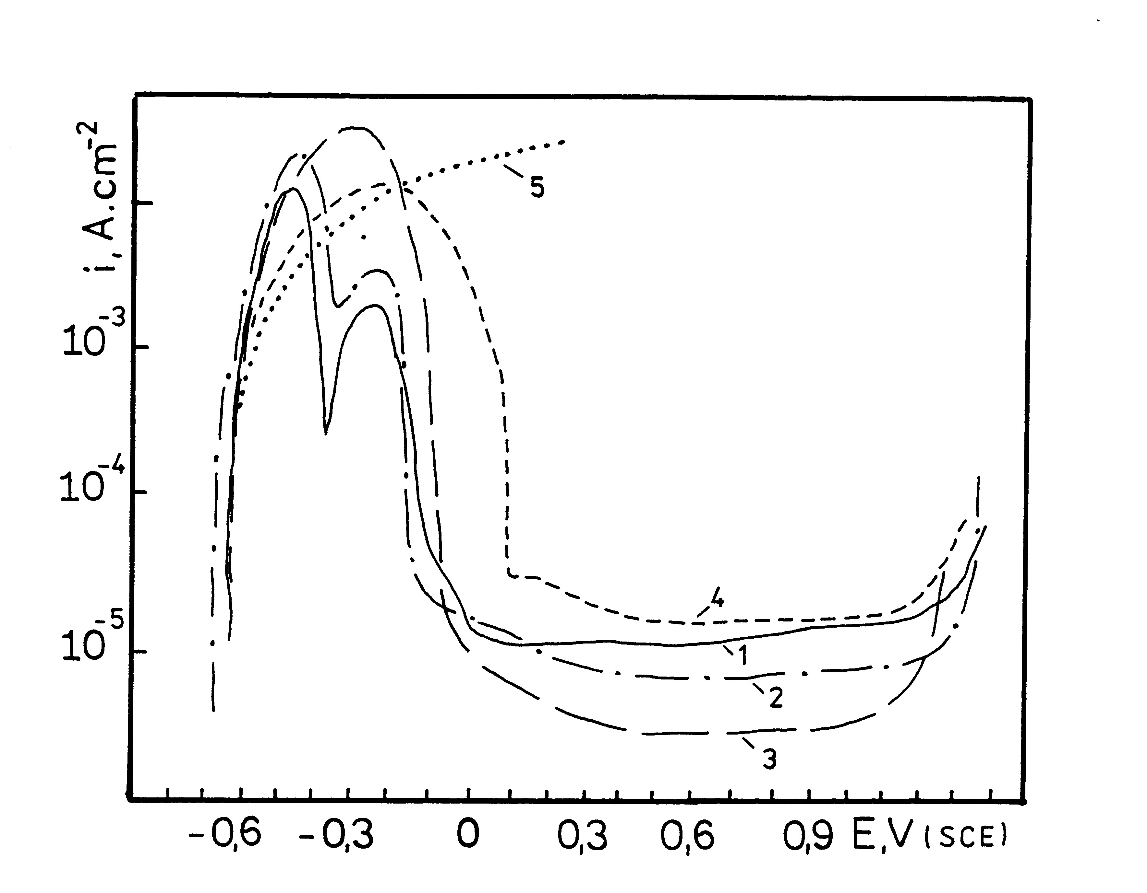
Fig. 1. Potentiodynamic polarization curves (10 mV/min) of low-carbon steel in solution of NaH₂PO₄, рН = 4, 20°С with concentrations (g-eqv/l): 2.0 (1); 1.0 (2);
0.5 (3); 0.1 (4) and 0.05 (5).
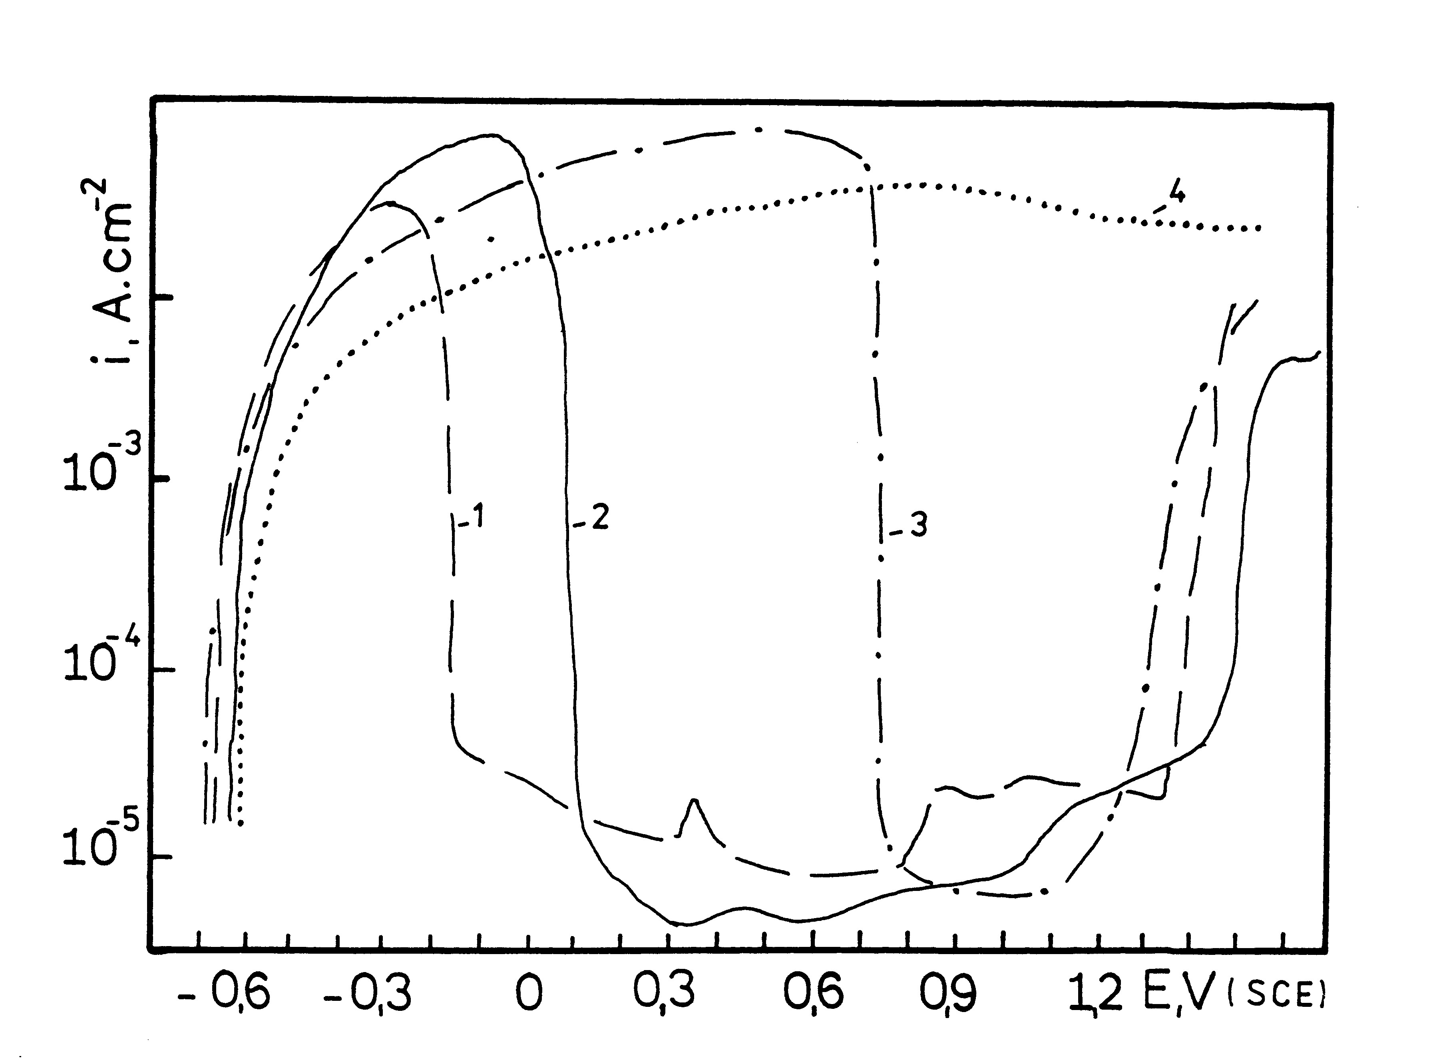
Fig. 2. Potentiodynamic polarization curves (10 mV/min) of low-alloy steel in solution of NaH₂PO₄, рН = 4, 20°С with concentrations (g-eqv/l): 2.0 (1); 1.0 (2); 0.5 (3)
and 0.1 (4).
The differences in the polarization curves of the two kinds of steels can be explained by the different steel composition. Probably, the lower carbon con-tent and the presence of chromium in the low-alloy steel affect the process of film formation on the metal surface and its properties.
The potentiodynamic polarization curves with fast (f) and slow (s) sweep rate under the most severe SCC conditions for both kinds of steels: 1 N NaH₂PO₄, pH = 4, 20°C as well as the ratio of current densities i_{f}/i_{s} are represented in Fig. 3 and Fig. 4. As it is known, the idea of this method is to determine the range of potentials with high metal activity (in the absence of film, high rate) and low metal activity (in the presence of a film, low rate) and in this way to define the region of most favorable electrochemical conditions for SCC development [10–12].
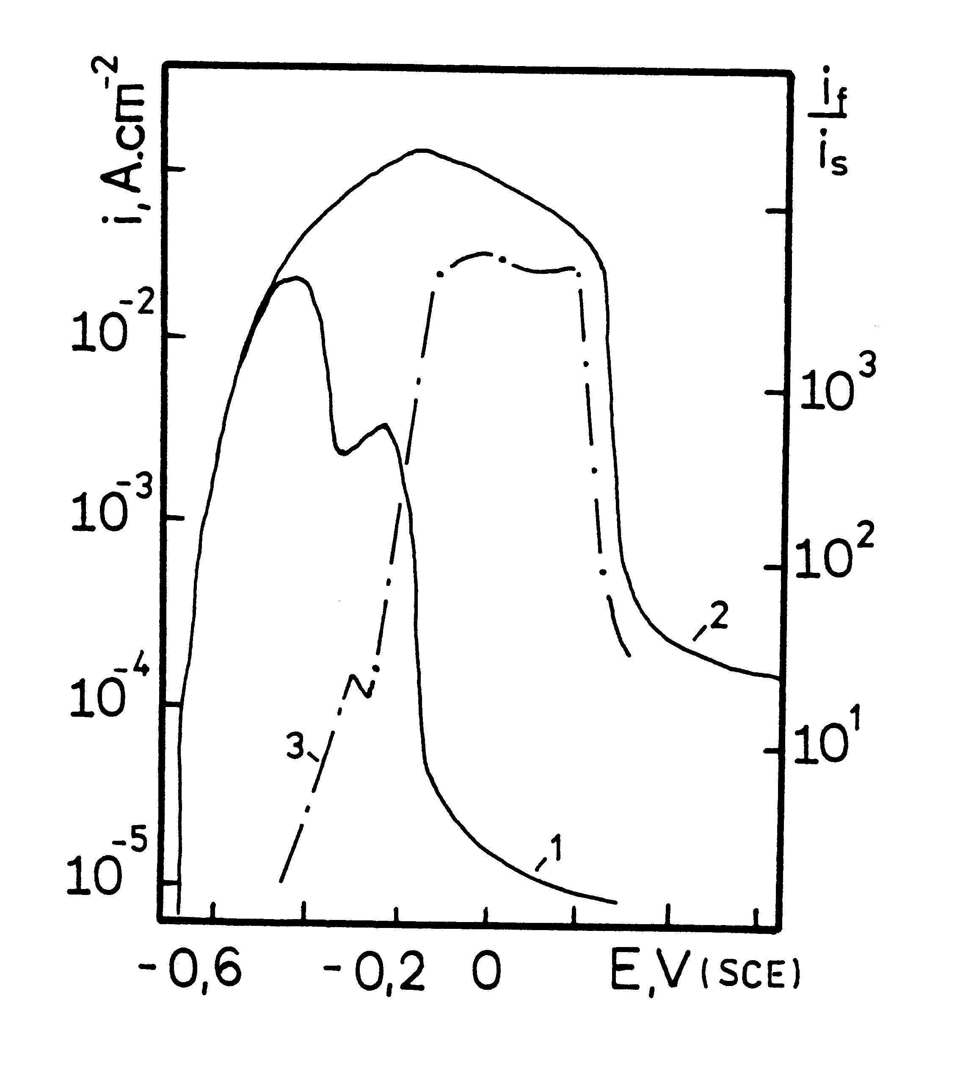
Fig. 3. Potentiodynamic polarization curves with 10 mV/min (1) and 300 mV/min (2) sweep rate,
and i_{f} /i_{s} ratio (3) for low-carbon steel in 1 N NaH₂PO₄.
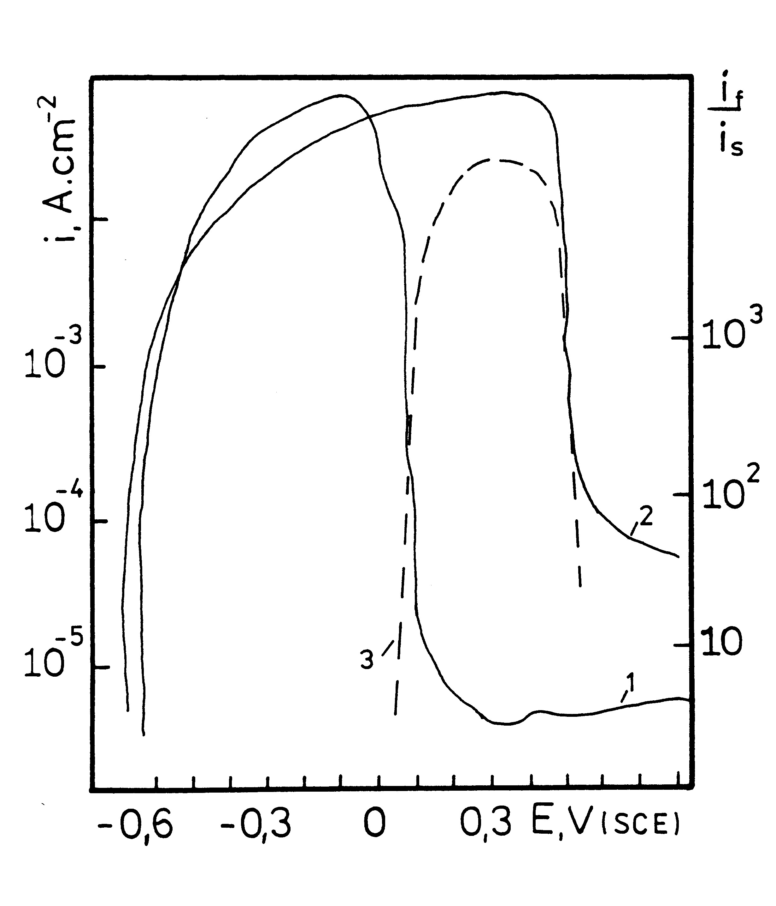
Fig. 4. Potentiodynamic polarization curves with 10 mV/min (1) and 300 mV/min (2) sweep rate and i_{f} /i_{s} ratio (3) for low-alloy steel in 1 N NaH₂PO₄.
Using this method the electrochemical conditions for SCC for both kinds of steels were defined and verified by slow strain rate SCC test. Fig. 5 and Fig. 6 show that the reduction of steel tensile strength σ_{В} can be observed actually in the area, predicted by the polarization curves. In support of this result comes also the dependence of the relative reduction in the specimen cross-sectional area at fracture RA% on the potential. For low carbon steel in all solution concentrations (0.1–2 g-eqv/l) the tensile strength of the steel σ_{В} decreases (compared to this one in air) in the potential range –0.3–0.0 V(SCE) (Fig. 5) corresponding to the zone of active-passive state transition of the metal in the range of rising current ratio i_{f}/i_{s}. The susceptibility to SCC however strongly depends on the phosphate concentration in the solution. The most severe cracking is registered in 1 M solution, where the tensile strength at poten-tial about –0.15V is reduced more than 2.5 times compared to the tensile strength in air. The reduc-tion of σ_{В} in 2 M and 0.1 M solutions is only about 10%, as it was expected in view of the change of i_{f}/i_{s} ratio. These results are confirmed also by the rela-tionship between the reduction in specimen cross-sectional area RA% and potential (Fig. 5). It was also established that SCC susceptibility decreases with the increase of temperature.
Y. S. Marcheva and R. G. Raicheff: Stress-corrosion cracking susceptibility of mild and low alloy steels
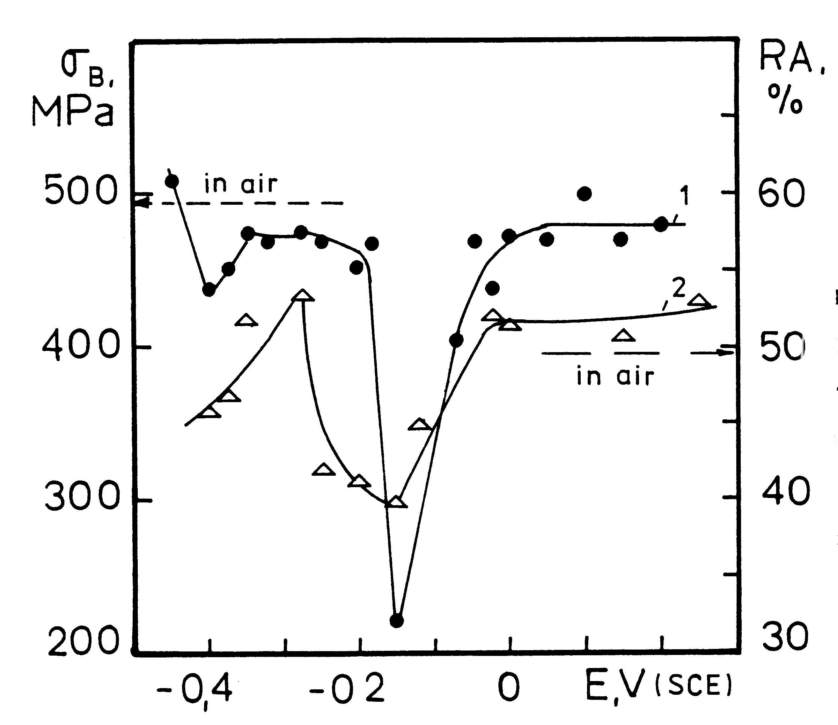
Fig. 5. Dependence of tensile strength σ_{В} (1) and of the reduction in area RA (2) on the potential for the low-carbon steel in 1 N NaH₂PO₄, рН = 4.
The SCC susceptibility of the low-alloy steel is much lower in comparison to that of the low-carbon steel (Fig. 6). The most severe decreasing of the tensile strength σ_{В} (15%) is registered in 1 N solutions at 20°С in the zone of active-passive state transition of the metal (–0.1+0.3 V) in the range of rising current ratio i_{f}/i_{s}. Like SCC of mild steel, the SCC of low-alloy steel is very weak at higher temperatures and lower solution concentrations.
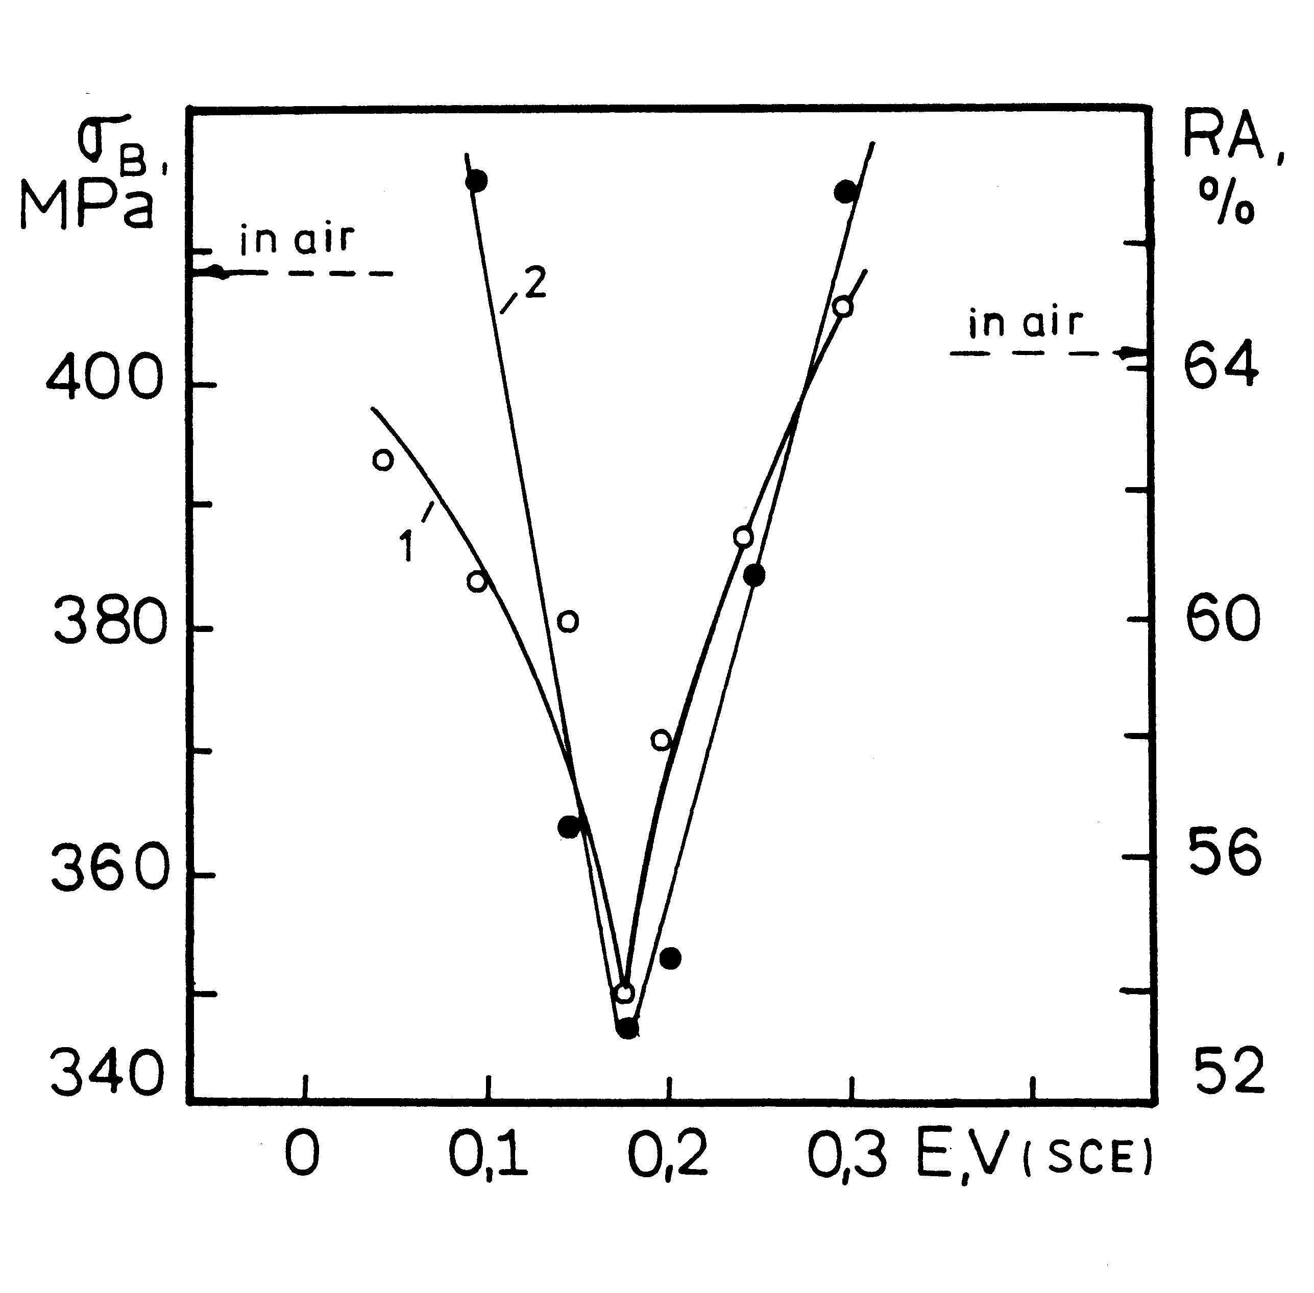
Fig. 6. Dependence of tensile strength σ_{В} (1) and of the reduction in area RA (2) on the potential for the low-alloy steel in 1 N NaH₂PO₄, рН = 4.
The lower SCC susceptibility of the low-alloy steel compared with the low-carbon steel can be explained by the differences in the steel structure and composition.
The steel composition and especially the carbon distribution in the steels are very important in respect to homogeneity and protective properties of the surface films. The mild steel has a ferrite structure with well defined grain boundaries and more strongly expressed carbon segregation (carbon content 0.17%) along the grain boundaries compared to the low-alloy steel. The carbon segregation facilitates the formation of a film on the grain boundaries with weak protective properties and lower mechanical strength compared to the film, formed on the metal grain itself [4, 5] and thus, it creates favourable conditions for breakdown of the film and highly localized corrosion attack under stress, i.e. for SCC. The intergranular paths of cracking, registered by SEM and metallographic observations [11, 12], are obviously related to the detrimental effect of carbon segregations on the properties of the passive film. The carbon content in the low-alloy steel is lower (0.07%), which leads to lower carbon segregation and formation of more uniform film with better protective properties (facilitated also by the presence of Cr), resulting in lower susceptibility to SCC of this type of steel.
Y. S. Marcheva and R. G. Raicheff: Stress-corrosion cracking susceptibility of mild and low alloy steels
Conclusions
The main results of the comparison of SCC susceptibility of low-carbon and low-alloy with Cr steels are as follows:
- In phosphate environment both kinds of steels undergo active-passive state transition, more strongly expressed for the low-carbon steel. There is a region of “primary passivity” in the polarization curve for this steel, missing in case of the low-alloy steel.
- Both kinds of steels undergo SCC in solutions of NaH₂PO₄ (рН = 4) however the SCC suscepti-bility of the mild steel is higher (reduction of the tensile strength about 2.5 times for the low-carbon and only 15% for the low-alloy steel).
- The SCC susceptibility is strongly dependent on the potential and it occurs in a relatively narrow potential range: for the mild steel this range is –0.3
–0.0 V and for low-alloy steel it is –0.1+0.3 V.
- The SCC susceptibility of both kinds of steels depends strongly on temperature and solution concentration. It diminished with increasing the temperature and lowering solution concentration. For both kinds of steels the most severe SCC is registered in 1 N solutions at 20°C.
- The SCC conditions for both kinds of steels, determined by SCC tests, correspond well with the region of active-passive state transition and are in a good agreement to the regions, predicted by the potentiodynamic polarization method with slow and fast potential sweep rates.
- SCC of both kinds of steels is related to the presence of phosphates in the surface film.
- The low-alloy steel has higher mechano-corrosion stability compared to that of the low-carbon steel studied.
REFERENCES
- K. Komai, Int. J. Fatigue, 20, 145 (1998).
- W. R. Middleton, Brit. Corros. J., 8, 62 (1973).
- R. N. Parkins, N.Y.H. Holroyd, R. R. Fessler, Corrosion, 34, 253 (1978).
- J. Flis, Corros. Sci., 19 (1979) 151; ibid, 25, 317 (1985).
- J. Flis, Corrosion, 40, 232 (1984).
- N. R. Smart, P. M. Scott, R. P. M. Procter, Corros. Sci., 30, 877 (1990).
- S. Srikanth, K. Gopalakrishna, S. K. Das, B. Ravikumar, Eng. Failure Anal., 10, 491 (2003)
- D. Landolt, Corrosion et chimie de surfaces des métaux, Рress Politechniques et Universitaires Romandes, 1993, p. 447.
- J. M. Sutcliffe, R. R. Fessler, W. K. Boyd, R. N. Parkins, Corrosion, 28, 313 (1972).
- R. N. Parkins, Corros. Sci., 20,147 (1980).
- R. Raicheff, J. Marcheva, L. Fachikov, in: Proc. 10th Int. Congr. Met. Corros., Oxford & IBH Publ., Madras, India, 1987, vol. 3, p. 2133.
- R. Raicheff, J. Marcheva, in: Proc. 11th Int. Corros Congr., Associazione Ital. Di Metall. Publ., Florence, Italy, 1990, vol. 1, p. 1365.
- R. Raicheff, J. Marcheva, L. Maldonado, in: Proc. 10th Int. Metallurgy and Materials Congress, M. Doruk C. H. Gur, K. Sesen (eds)., Chamber of Met. Eng. Publ., Istanbul, Turkey, 2000, vol. 2, p. 997.
- J. Marcheva, R. Raicheff, S. Nikolov, Tz. Haladzowa, J. Radioanal. Nucl. Chem., Lett., 212, 383 (1996).
- L. Fachikov, R. Raicheff, D. Panchovski, Metalurgia, 41, 17 (1986) (in Bulgarian).
- L. Fachikov, R. Raicheff, Industrial Laboratory, 55, 16 (1989) (in Russian).
- I. M. Kolotyrkin, M. D. Kononova, G. M. Florianovich, Zashtita Metallov, 10, 369 (1974) (in Russian).

СРАВНЕНИЕ НА СКЛОННОСТТА КЪМ КОРОЗИОННО НАПУКВАНЕ НА НИСКОВЪГЛЕРОДНА И НИСКОЛЕГИРАНА СТОМАНИ ВЪВ ФОСФАТНИ СРЕДИ
Y. S. Marcheva and R. G. Raicheff: Stress-corrosion cracking susceptibility of mild and low alloy steels
Й. Марчева¹*, Р. Райчев²
¹ Технически университет, Катедра „Химия“, бул. „Климент Охридски“ № 8, София 1756
² Институт по електрохимия и енергийни системи, Българска академия на науките, София 1113
Постъпила на 9 октомври 2007 г., Преработена на 2 януари 2008 г.
(Резюме)
Посредством метода на потенциодинамичните поляризационни криви с ниска и висока скорост на изменение на потенциала (10 и 300 mV/min), както и на метода на динамично деформиране на образците in situ с ниска скорост на деформация, е направена сравнителна оценка на анодното поведение и склонността към корозионно напукване (КН) във фосфатни среди на два вида стомани: нисковъглеродна (0.17% С) и нисколегирана (0.07% С, 2.0% Сr). Установено е, че и двете стомани проявяват склонност към КН в разтвори на NaH₂PO₄ (рН 4), която е по-силно изразена за нисковъглеродната стомана (намаление на границата на якост на материала в средата 2.5 пъти за нисковъглеродната и само 15% за нисколегираната стомана). Корозионното напукване зависи силно от потенциала и се проявява в тясна област от потенциали и за двете стомани: –0.3–0.0 V (SCE) за нисковъглеродната и –0.1+0.3 V (SCE) за нисколегираната стомана. Склонността към КН намалява силно с повишаване на температурата и разреждането на разтвора. Условията за КН, определени чрез корозионно-механичните изпитания, съответстват на областите на активно-пасивен преход на стоманите и са в добро съответствие с областите за КН, прогнозирани от поляризационните криви. Установено е, че развитието на КН и за двата вида стомани е свързано с присъствие на фосфати в повърхностния филм. Направено е заключение за по-високата корозионно-механична устойчивост на нисколегираната в сравнение с обикновената нисковълеродна стомана.

