Mathematical modelling of electrolysis processes
Bulgarian Chemical Communications, Volume 40, Number 3 (pp. 323–329) 2008
© 2008 Bulgarian Academy of Sciences, Union of Chemists in Bulgaria
L. N. Petkov, I. D. Dardanova*
* To whom all correspondence should be sent:
E-mail: i_dardanova@abv.bg
University of Chemical Technology and Metallurgy, 8 Kliment Ohridski Blvd., Sofia 1756, Bulgaria
Received October 30, 2007, Revised January 28, 2008
The paper presents the optimization of sodium hypochlorite electrochemical production processes and zinc electroextraction by mathematical modeling method. On the basis of the model equations the values of the following parameters are defined – current density, components concentrations, duration for which there are maximum current efficiencies, minimum voltage and specific energy consumption. It is shown that the current efficiency maxima – ~70% for the platinized titanium anodes Pt/Ti – correspond to current densities 7.5 A·dm^{–2}, and for the cobalt-oxide anodes CoO_{X}/Ti – 75% to current densities 2.5 A·dm^{–2}. The highest values of the conversion coefficients (2.54%) are at low sodium chloride concentrations ~25 g·dm^{–3}. In case of increase in current densities up to 10 A·dm^{–2}, the conversion coefficient could grow to 6%, but this leads to a considerable increase of energy consumption – 25 W·g^{–1}.
In zinc electroextraction the lowest voltage ~ 3.1 V is at current densities i = 200–300 A·m^{–2} and space between the opposite electrodes of 20–30 mm.
Key words: mathematical model, relation coefficient, binary oxides, electrosynthesis, electroextraction.

Introduction
Sodium hypochlorite finds application as an antiseptic for the treatment of waste waters and aggressive solutions [1–3], in discolouration of pigment production wastes [4], etc.
The electrochemical method of its production has found application due to the advantages it possesses – clean product, low labour and chemicals consump-tions, facilitated possibilities of automation and control. The method is based on the electrolysis of sodium chloride solutions; the hypochlorite produc-tion is a result of the interaction between the evolved on the anode and undergone hydrolysis chlorine and the formed on the cathode alkaline metal base.
Characteristic features of the considered process are the secondary reactions of chlorate formation and oxygen release, which lead to current efficiency decrease and specific electric energy consumption increase.
The reaction of sodium chlorate formation proceeds at more negative potentials than those of chlorine ions oxidation.
ClO– – 4e + 2H₂O → ClO₃– + 4H⁺ (1)
Moreover, chlorate is obtained also in the solu-tion volume as a result of the oxidation effect of the hypochlorous acid formed during chlorine hydro-lysis:
2HCl + NaClO → NaClO₃ + HCl (2)
The oxygen evolution, on its part, at pH values at which the process goes ~ 5.5–7.5 is a result of the oxidation of water molecules.
H₂O – 2e → 2H⁺ +1/2O₂ (3)
The occurrence of these reactions results in a decrease of the process current efficiency and increase in the electric energy consumption.
The optimization of these parameters appears currently the main problem of the sodium hypo-chlorite electrolysis; the correct selection of the electrolysis conditions – charge salt concentration, current densities, duration, the type of the anode material are the main factors in this respect .
Yang et al. [4, 5] investigate the production of sodium hypochlorite on the basis of Ru-Pt binary oxide anodes [(Ru-Pt)O_{x}], prepared by thermal method on titanium substrate.
At a current density 300–500 mА·cm^{–2} and chlorine ion concentration of 0.5–1.0 mol·dm^{–3} there are achieved current efficiency 80 – 85% and energy yield 120 – 140 g·kWh^{–1}.
Kupovich et al. [6] investigate ferro-oxide tita-nium anodes containing mainly magnetite Fe₃O₄, small quantities of hematite Fe₂O₃ and wustit FeO. The authors find out that the active mass retains stability in chlorine environment for 9 000–10 000 hours: modification by CoO (up to 35%), on its part, significantly improves the anode electrocatalytic properties.
A research on the sodium hypochlorite electro-synthesis on spinel coated electrodes is described in [7]. There are studied anodes – spinels of general formula AB₂O₄, where А is cobalt and В – cobalt, iron, chromium, aluminum. The experiments are performed at current densities 170–290 mА·сm^{–2} and sodium chloride concentration – 150 g·dm^{–3}. The authors find out that current efficiencies depend on the type of the spinel metal, decreasing in the sequence Al-Fe-Co-Cr.
Yang [8] proves the possibility to use Ru–Sn binary oxides [(Ru+Sn)O₂] in the hypochlorite pro-duction by hydrolysis. The introduction of tin oxide in the anode active mass increases the overvoltage of oxygen О₂ release and raises the current effi-ciency; in the current density range 100–150 mА·сm^{–2} and sodium chlorite concentration 0.5 m·dm^{–3} the presence of SnO₂ to 20% increases current efficiency from 85 to 90–95 %.
Kraft et al. [9, 10] carry out comparative investi-gations of platinum anodes and iridium oxide coated titanium ones/IrO₂/. It is found out that in diluted chloride solutions hydrolysis (250–1000 mg·dm^{–3}) the rate of hypochlorite formation on titanium-iridium oxide anode is higher compared to that on platinum; at current density 15 mA·cm^{–2} the current efficiencies are 75 and 50%, respectively.
Sorokendia et al. [11] examine the NaClO elec-trolysis on palladium alloyed manganese dioxide anodes. The authors find out that in case of palla-dium oxide PdO content 1–2.5 mol.%, the current efficiencies have values about 85%, which are close to the current efficiencies of palladium oxide anodes ~ 90%.
In a number of publications there are studied the possibilities to optimize the process by using membranes. Publication [12] considers an inorganic membrane on the base of zirconium oxide/ZrO₂/. It is proved that the final product does not contain chlorates.
As a result of that, higher current efficiencies reaching 77% with sodium chloride concentration 25 g·dm^{–3} and current density 6 mА·сm^{–2} are achieved on the used cobalt oxide/Co₃O₄/ anodes. Publications [13–16] also report about usage of membranes.
Zinc, together with aluminum and copper, is one of the widely used non-ferrous metals. Major method of its production is electroextraction due to which metal of high purity running up to 99.99% is obtained. The electrolysis is performed by insoluble anodes (lead alloyed with 1% silver), but in contrast to sodium hypochlorite production it is referred to the so-called electrochemical processes with metal release. The hydrogen evolution is a basic secondary reaction; it is favoured by the circumstance that the used electrolytes contain sulphuric acid up to 100 g·dm^{–3}. The problems related to current efficiency and specific energy consumption present interest taking into account the large scale character of the electrolysis. They depend on the current density, components concentrations, the temperature and hydrodynamics. Some publications [17, 18] inform that every current density has a corresponding sulphuric acid concentration for which the process energy consumption is minimal.
Many authors use the mathematical modeling method in the electrolysis process optimization [19–23]. As it is well known, the mathematical models represent exact quantitative correlations between the input and output parameters of a system. Their development allows to calculate the values of the individual quantities in advance, to define their maximum or minimum values, to apply flexible approach in respect to the processes, etc.
L. N. Petkov and I. D. Dardanova: Mathematical modelling of electrolysis processes
The authors of publications [24–26] have shown the possibilities to apply models in the optimization of sodium hypochlorite electrochemical production process and zinc electroextraction. The present paper is a continuation of the researches in this aspect, its main purpose being development of mathematical model equations which connect current efficiencies and energy consumption with the electrolysis con-ditions – current density, duration, components con-centrations, type of anode material.
Experimental
In the NaClO production, the used anodes (dimensions 50×40×1 mm) were graphite, CoO_{x},
Pt-Ti and on the cathode – steel. The initial solu-tions were prepared of NaCl p.a. The electrolysis was carried out in a cell of volume 0.5 l without a diaphragm. The determination of the active chlorine quantity was performed by iodometry, by titration with 0.1 N Na₂S₂0₃ solution in acidic environment. The temperature was maintained by a thermostat UTU-2 and for constant current intensity – poten-tiostat-galvanostat Tacussel 30-01.
The process quantitative characteristics were calculated on the basis of the Faraday’s laws.
In the studies of zinc electroextraction process a PVC cell (0.5 dm³) was used, which has rectangular shape permitting variation of the distance between the cathode and anode from 10 to 100 mm. The Zn concentration was 65 g·dm^{–3}. In the cell there are positioned three electrodes (dimensions 20×25×1 mm), 2 anodes (alloy, lead with 1% antimony) and 1 cathode (aluminum), respectively.
Voltage measurement was performed by means of a precise electron voltmeter 1AB105.
The processing of the results and development of mathematical models were performed by adequate computer program.
Results and Discussion
Figure 1 presents the diagram of the electro-chemical process in mathematical modeling. In the Figure X and Y are independent factors – current density, electrolyte concentration – initial substance (time), and Z₁ and Z₂ – the functions or dependent factors – current efficiency and specific energy consumption (voltage).
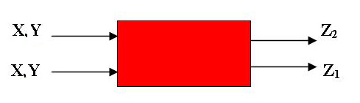
Fig. 1. Diagram of electrochemical system:
X, Y – independent factors; Z₁, Z₂ – dependent factors;
On the basis of preliminary experiments that show a non-linear character of the dependences between the individual factors for describing the dependences between Z₁ = f(X, Y) and Z₂ = f(X, Y), a model on the base of second degree polynomial is chosen.
$Z_{i}=b_{0i}+b_{1i}X+b_{2i}Y+b_{\text{12}}X\text{.}Y+b_{\text{11}i}X^{2}+b_{\text{22}i}Y^{2}$ $i=1\text{.}2$ (4)
and for finding the model coefficients b_{i} (i = 0, 1, 2) D – optimum composition plan.
Dependence of sodium hypochlorite current efficiency on the electrolysis time and sodium chloride concentration
The boundaries of independent factors X /time, h/ and Y /NaCl concentration, C g·dm^{–3}/ variation in the development of the mathematical model are chosen as follows:
0.5 h ≤ X ≤ 2 h, 25 g·dm^{–3} ≤ Y ≤ 150 g·dm^{–3}
Table 1 presents the experiment plan (D - optimum plan).
The model obtained as a result of its fulfillment could be presented by the following equation.
CE = 30.87034 – 0.5835.τ + 0.6481.C –
– 2.τ² – 0.0017.C² – 0.0283.τ.C (5)
where CE, % is current efficiency /dependent factor Z/.
The model correlation coefficient r runs to 0.99, which proves its adequacy.
L. N. Petkov and I. D. Dardanova: Mathematical modelling of electrolysis processes
In Fig. 2, where the model is presented in graphic form, it is seen that current efficiencies grow with the increase in the chloride concentration and maximum values of 70–72% are observed at a concentration range of 100–150 g·dm^{–3}.
Table 1. Plan of experiment: X, time (h); Y, concen-tration of NaCl (g·dm^{–3}); Z, current efficiency (%).
X, τ, (h) | Y, C_{NaCl} , g·dm^{–3} | Z, CE, %
0.5 | 25 | 44
1 | 25 | 42
1.5 | 25 | 41
2 | 25 | 35
0.5 | 50 | 58
1 | 50 | 54
1.5 | 50 | 51
2 | 50 | 49
0.5 | 100 | 77
1 | 100 | 76
1.5 | 100 | 67
2 | 100 | 62
0.5 | 250 | 81
1 | 250 | 78
1.5 | 250 | 69
2 | 250 | 64
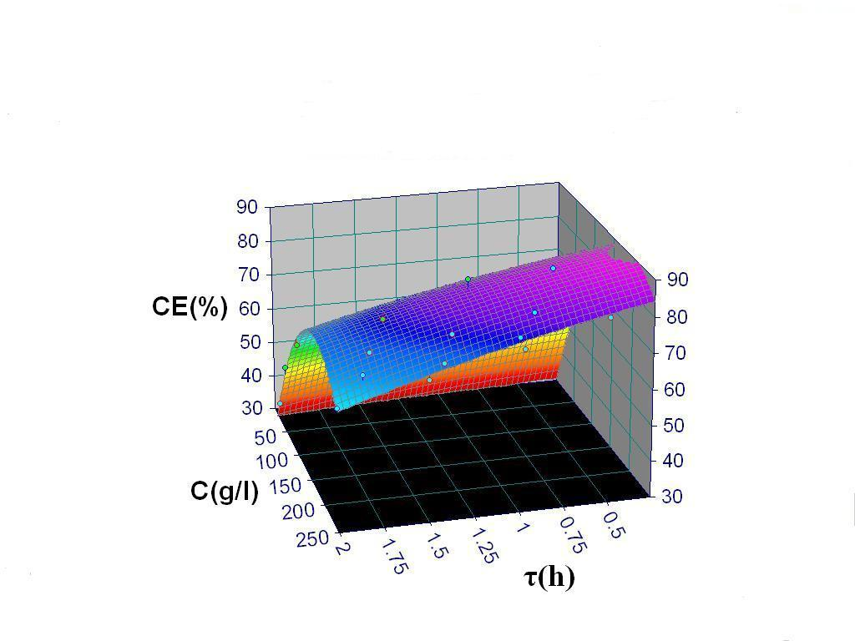
Fig. 2. Dependence of current efficiency СЕ (%) on time τ (h) and NaCl concentration, C (g·dm^{–3}). Current density i = 2.5 A·dm^{–2}; anode – graphite.
The fact observed could be explained by accele-ration of the chlorine ions oxidation process on account of O₂ release reaction. As mentioned above, O₂ release as a result of water oxidation appears one of the secondary reactions in the hypochlorite production.
The current efficiency increase leads to pro-duction of greater hypochlorite quantities. However, as seen in Table 2, with the increase in sodium chloride concentration the conversion coefficient decreases for similar electrolysis time ~ 2 hours.
Thus for instance, in case of chloride concen-tration change in the range of 25–100 g·dm^{–3} the coefficient value decreases nearly 2.5 times. On the basis of these data, a conclusion could be made that in sodium hypochlorite electrosynthesis the optimum concentrations of the charge salt, sodium chloride, are those in the range of 50–100 g·dm^{–3}.
Table 2. Effect of concentration of NaCl.
Concentration  of NaCl,  g·dm^{–3} | Active chlorine, mg | Current efficiency,  % | Coefficient of conversion,  %
5 | 0.6 | 40 | 2.54
50 | 0.78 | 52 | 1.56
100 | 1.06 | 70 | 1.09
150 | 1.08 | 72 | 1.06
Dependence of specific energy consumption on current density and time
In the development of the model, on the base of preliminary experiments, the following variation range boundaries of the independent factors X (time, τ) and Y (current density i, A·dm^{–2}) are assumed.
0.5 h ≤ X ≤ 2 h, 2.5 A·dm^{–2} ≤ Y ≤ 10 A·dm^{–2}
As a result of the experiment plan realization, the following equation is obtained for the dependence of the output factor Z – specific energy consumption /W, Wh·g^{–1}/ from the input X and Y – current density i and time t:
W = 0.4620 – 3.3597.τ + 2.5333.i + 0.85.τ² –
– 0.13717949.i² + 0.85112426.τ.i (6)
The calculated correlation coefficient is 0.98, which shows the adequacy of the obtained model.
Figure 3 presents the dependence in a graphic form.
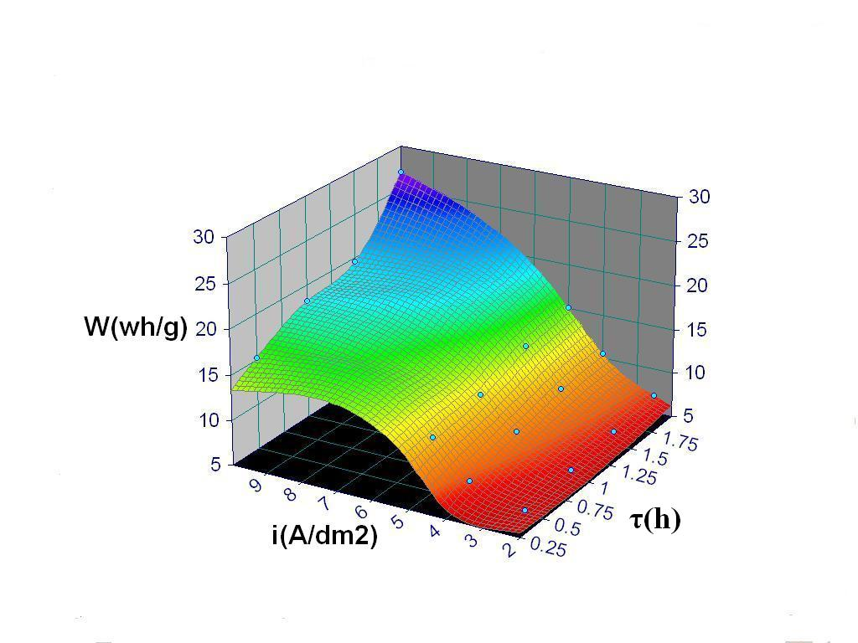
Fig. 3. Dependence of specific energy consumption W (Wh·g^{–1}) on time τ (h) and current density i (A·dm^{–2} ); NaCl concentration – 500 g·dm^{–3}, anode – graphite.
It is seen in the Figure, that at high current densities with the advance of the process time maximum values of energy consumption are observed ~ 27 Wh·g^{–1}.
L. N. Petkov and I. D. Dardanova: Mathematical modelling of electrolysis processes
The specific energy consumption depends on the electrolysis cell voltage U and the current effi-ciency, W = U/q.Ψ (ψ – current efficiency, q – elec-trochemical equivalent). The subsequent results show that the current efficiency variations with the current density have a maximum, which could be explained by the voltage increase at current density (respect-ively the intensity) increase.
Table 3 presents the values of different para-meters at current density variations in the range of 2.5–10 A·dm^{–2}.
Table 3. Effect of current density.
Current density  A·dm^{–2} | Energy consumption,Wh·g⁻¹ | Active chlorine, g | Coefficient of conversion, % | Energy yield,  g_{ClO–}·Wh.^{–1}
2.5 | 7.0 | 1.5 | 3 | 0.21
4.0 | 10 | 1.7 | 3.4 | 0.17
5.0 | 15 | 1.8 | 3.7 | 0.12
10.0 | 27 | 3.0 | 6.0 | 0.11
As seen in case of greater energy consumption higher quantities of sodium hypochlorite are pro-duced and the conversion coefficient has higher values ~6%. However, there is observed a signify-cant, about 2 times, decrease in the energy yield – g_{NaClO}·Wh^{–1}.
On the basis of the obtained results, a conclusion could be made that the optimum current densities are 4.0–5.0 A·dm^{–2} for which the energy consump-tion grows to a lower degree while the sodium chloride conversion degree and energy yield have acceptable values.
Dependence of the current efficiency on the current density and time for different anode materials
Mathematical models are worked out considering the quantitative correlations between the current efficiency, current density and electrolysis time in the NaClO production on platinized titanium anode/Pt/Ti/and anode of cobalt oxide thermally laid on titanium substrate/CoO_{x}/Ti/.
For the variations of the independent factors X /time t, hours/ and Y /current density I, A·dm^{–2}/ the following ranges are assumed:
For Pt/Ti
0 h ≤ X ≤ 2 h, 5.0 A·dm^{–2} ≤ Y ≤ 15 A·dm^{–2}
For CoO_{x}/Ti
0 h ≤ X ≤ 2 h, 1.0 A·dm^{–2} ≤ Y ≤ 7.5 A·dm^{–2}
The obtained models can be presented by the following equations:
CE₁ = 69.4525 – 19.4017.τ + 1.5812.i –
– 2.875.τ² – 0.1131.i² – 0.2251τ.i (7)
CE₂ = 61.1625 – 4.88.τ + 4.6339.i –
– 2.125.τ² – 0.4906.i² – 2.31.τ.i (8)
where, CE₁, CE₂ are the specific energy consump-tion, for anode Pt-Ti and anode CoO_{x}-Ti, respect-ively.
The calculated correlation coefficients values are 0.98 and 0.96, respectively, which proves their adequacy.
Figures 4 and 5 present the models in a graphic form.
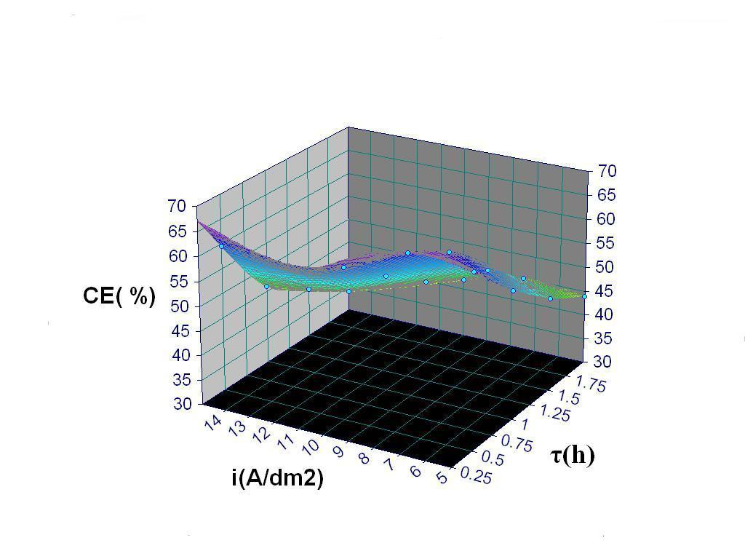
Fig. 4. Dependence of current efficiency (СЕ %) on time τ (h) and current density i (A·dm^{–2}); NaCl concentration – 50 g·dm^{–3}, anode – Pt – Ti;
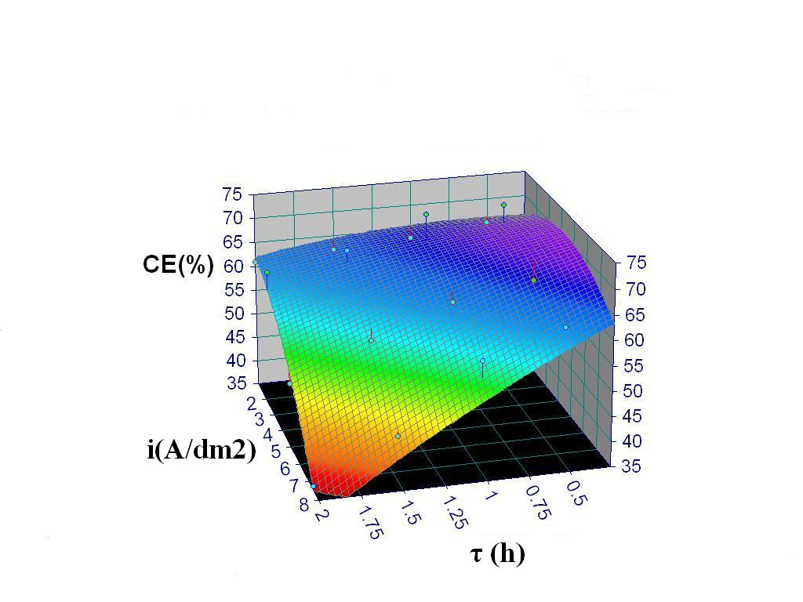
Fig. 5. Dependence of current efficiency (СЕ %) on time τ (h) and current density i (A·dm^{–2}); NaCl concentration – 50 g·dm^{–3}, anode – CoO_{x} – Ti;
In Figures 4 and 5 it is seen that the current effi-ciency values have their maximum at the density variations in the examined ranges. For the Pt/Ti anodes the current efficiency maximum (66–70%) is at current density 7.5 A·dm^{–2} and for the cobalt oxide anode CoO_{x}/Ti (70–72% ) – at 2.5 A·dm^{–2}. The presence of current efficiency maximum is characteristic for insoluble anodes and shows that the hypochlorite production process passes through a diffusion limitation stage. The higher current densities of the Pt/Ti anode maxima are due to the fact that the over voltage of oxygen О₂ release on the CoO_{x}/Ti anode exceeds that on the Pt/Ti; as it is known platinum is one of the metals on which oxygen is released with greatest difficulties. The current efficiency maxima on graphite, in accord-ance with the performed in the present work expe-riments, have approximately the same values as on the CoO_{x}/Ti anode, 70–72%, but a lower current density, 1 A·dm^{–2}, corresponds to them. This fact shows the advantages of the platinized titanium Pt/Ti and the cobalt oxide titanium CoO_{x}/Ti anodes over the graphite ones, which in addition have short operation life time because of their intensive wear during exploitation.
Dependence between voltage and inter-electrode space at different current densities in zinc electroextraction
In the electroextraction process optimization by mathematical modeling as input parameters there are chosen X – current density i, A·dm^{–2} and Y – inter-electrode space d, mm. For output parameter Z we chose the voltage U, V. The variation ranges of the independent parameters are the following:
L. N. Petkov and I. D. Dardanova: Mathematical modelling of electrolysis processes
250 A·m^{–2} ≤ X ≤ 1000 A·m^{–2},
20 mm ≤ Y ≤ 80 mm
On the base of the realization of the optimum plan, a model equation with the following form is worked out:
U = 2.4013 + 0.0021.i + 0.0041.d –
– 1.2275.i² – 1.5625.d² + 2.7688i.d (9)
The model correlation coefficient is 0.99.
It is seen in Fig. 6, presenting the model in a graphic form, that the function has its minimum at current density of i = 200 A·dm^{–2} and inter-electrode space 20–30 mm. The voltage values for the speci-fied minimum amounts to ~ 3.1 V.
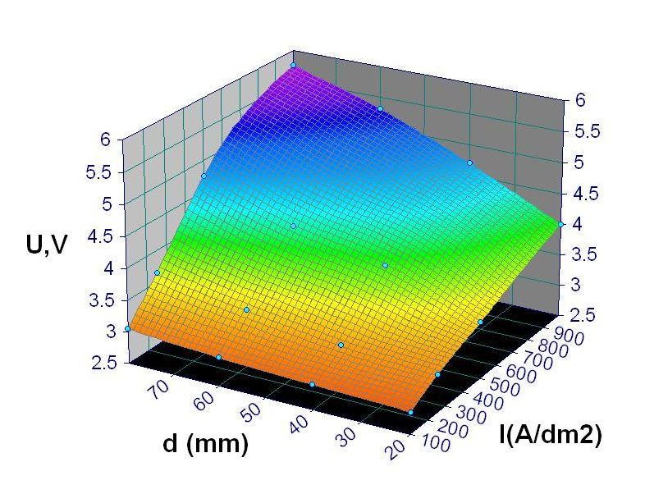
Fig. 6. Dependence of voltage U (V) on current density i (A·dm^{–2}) and inter-electrode space d (mm) in zinc electroextraction. Solution composition: Zn 6.5 g·dm^{–3}; H₂SO₄ 100 g·dm^{–3}; t = 40°C;
Table 4 presents the distribution of the voltage constituents at i = 500 A·dm^{–2} and inter-electrode space 20 mm. [18].As seen in the Table, the anode and cathode potentials carry the greatest relative weight as well as the voltage drop in the electrolyte – 23.5%, 56.1% and 13%, respectively.
As far as the inter-electrode space does not affect the cathode and anode over voltage the dependence of the total voltage is obviously due to the drop increase in the electrolyte that is defined by the formula ∆U_{electolyte} = i.l/κ.i, where i – current density, κ – specific electric conductivity, l – inter electrode space;
Table 4. Distribution of voltage constituents in zinc electrolysis.
Voltage constituents | V | %
Cathode potential | 0.82 | 23.5
Anode potential | 1.96 | 56.1
Ohm drop in the electrolyte | 0.45 | 13.0
Ohm drop in conductors of I type | 0.295 | 6.4
total | 3.525 | 100
However, the current density increase increases both the electrode current over voltage and the solution ohmic drop.
L. N. Petkov and I. D. Dardanova: Mathematical modelling of electrolysis processes
Conclusion
The developed mathematical models, which connect the parameters of NaClO production process and zinc electroextraction, provide possi-bility to find the conditions for which the current efficiency, voltage and electric energy consumption have optimum values. The high correlation coeffi-cient values ≥ 0.96 prove their adequacy.
Reference
- M. E. H. Bergmann, A. S. Koparal, J. Appl. Electrochem., 35, 1321 (2005).
- N. Krstajic, V. Nikic, N. Spasojevic, J. Appl. Electrochem., 21, 637 (1991).
- F. Mogyorody, J. Appl. Electrochem., 36, 635 (2006).
- C.-C. Yang, C.-H. Lee, T.- C. Wen, J. Appl. Electrochem., 30, 1043 (2000).
- C.-C. Hu, C.-H. Lee, T.- C. Wen, J. Appl. Electrochem., 26, 72 (1996).
- F. V. Kupovich, A. M. Virnik, V. I. Eberil, Russ. J. Electrochem., 37, 907 (2001).
- V. I. Liubushkin, V. A. Smirnov, E. T. Liubushkina,
Electrokhimiya, 17, 828 (1981).
- C.-H. Yang, Can. J. Chem. Eng., 77, 1161 (1999).
- A. Kraft, M. Stadelmann, M. Blaschke, D. Kreysig, B.Sandt, F. Schroder, J. Appl. Electrochem., 29, 861 (1999).
- A. Kraft, M. Blaschke, D. Kreysig, B. Sandt, F. Schroder, J. Rennau, J. Appl. Electrochem, 29, 895 (1999).
- V. S. Sorokendia, R. U. Bondar, O. G. Klushina, Yu. G. Olesov, Electrokhimiya, 27, 1133 (1991).
- S. Yu. Bashtan, V. V. Goncharuk, R. D. Chebotareva, V. M. Linkov, Russ. J. Electrochem., 37, 782 (2001).
- C. Yu. Bashtan, V. V. Gorcharuk, R. D. Chebotareva, Khimia i Tekhnologia Vody, 23, 364 (2001) (in Russian).
- S. Yoshitsugu, M. Koji, S. Shigeki, EP Patent 0 826 794 794 A1 (1998 ).
- Nakajima, US Patent 01 34687 A1 (2002).
- N. Krstajic, V. Nikic, N. Spasojevic, J. Appl. Electrochem., 21, 637 (1991).
- Industrial Electrochemistry, N. T. Kudryavtsev (ed.), Khimiya, Moscow, 1975, p. 265-276 ( in Russian ).
- Industrial Electrochemistry, A. P. Tomilov (ed.), Khimiya, Moscow, 1984, p. 420 (in Russian).
- L. I. Heifets, A. B. Goldberg, Elektrokhimia, 25, 3 (1989).
- G. Martens, Ch. Tenner, Chemische Technologie, 37, 196 (1985).
- D. Pilone, G. H. Kelsall, Proc. Electrochem. Soc., Vol. 18 (Electrochemistry in Mineral and Metal Processing VI), 2003, p. 260–271.
- M. Anka, M. C. Leonard, T. Cezar, Rev. Chim., 53, 595 (2002).
- V. Fila, K. Bouzek, J. Appl. Electrochem, 33, 675 (2003).
- L. Petkov, Sv. Kamenova, K. Boshnakov, J. UCTM (Sofia), 35, 109 (2000).
- L. Petkov, T. Todorov, I. Dardanova, K. Boshnakov, in: Proc. 7th Int. Sci. Tech. Conf., Kouty nad Desnou, Czech Republic, 2006, p. 98.
- L. Petkov, I. Dardanova, in: Proc. 16th Int. Conf. Process Control, Strebske Pleso, Slovakia, 2007, p. 065 – 4.

МАТЕМАТИЧЕСКО МОДЕЛИРАНЕ НА ЕЛЕКТРОЛИЗНИ ПРОЦЕСИ
Л. Н. Петков, Ив. Д. Дарданова*
Химикотехнологичен и металургичен университет, бул. „Климент Охридски“ №8, 1756 София
Постъпила на 30 октомври 2007 г., Преработена на 28 януари 2008 г.
(Резюме)
Проведена е оптимизация на процесите на електрохимично получаване на натриев хипохлорит и електро-екстракция на цинк по метода на математическо моделиране. На базата на уравненията на моделите са установени стойностите на параметрите – плътност на тока, концентрация на компонентите, времетраене, при които са налице максимални добиви по ток, минимално напрежение и специфичен разход на енергия. Показано е, че максимумите на добива по ток ~ 70% за анодите от платиниран титан Pt-Ti съответстват на плътности на тока 7.5 A·dm^{–2}, а за кобалтово-оксидните аноди CoO_{x}-Ti, 75%, на плътности на тока 2.5 A·dm^{–2}. Най-високи стойности на коефициентите на превръщане (2.54%) са налице при ниски концентрации на натриев хлорид ~ 25 g·dm^{–3}. При увеличаването на плътностите на тока до 10 A·dm^{–2} коефициентът на конверсия може да нарасне до 6%, но това води до значително нарастване на разхода на енергия – 25 Wh·g^{–1}.
При електроекстракцията на цинк най-ниско напрежение ~3.1 V е налице при плътности на тока
i = 200–300 A·m^{–2} и разстояние между разноименните електроди 20–30 mm.

