Study of anodic films on niobium by scanning electron microscopy
Bulgarian Chemical Communications, Volume 40, Number 3 (pp. 261–266) 2008
© 2008 Bulgarian Academy of Sciences, Union of Chemists in Bulgaria
B. Tz. Tzvetkov*, M. S. Bojinov, A. A. Girginov
* To whom all correspondence should be sent:
E-mail: boggy.bg@gmail.com
Department of Physical Chemistry, University of Chemical Technology and Metallurgy,
8 Kliment Ohridski Blvd., 1756 Sofia, Bulgaria
Received November 1, 2007; Revised January 21, 2008
The influence of HF concentration and potential on the processes of anodic oxidation of Nb in acid media was studied by chronoamperometry and scanning electron microscopy. During the first stage of the process a compact barrier film is formed. On top of this film, a porous overlayer starts to form, then the nanopores grow into nanotubes. At the point of “saturation” 3D secondary flower-shaped structures begin to form. These “flowers” gradually spread all over the surface and “pile up” into an irregular multilayer film.
The rates of the process of porous overlayer formation and subsequent growth of nanotube arrays increase considerably with applied potential, as well as with the HF concentration. Changing sulphuric acid to phosphoric in the electrolyte alters significantly these processes so that the growth of the nanotubes follows a different mechanism and at “saturation” point, no secondary 3D structures are formed.
An attempt to rationalise the mechanism of nanotube growth is made by using the conceptual views of the mixed-conduction model (MCM) and recent ideas for porous film formation on valve metals. In the next stage of this investi-gation the qualitative microscopic picture will be combined with additional electrochemical results to develop a quanti-tative model of the consecutive stages of the processes of growth and recrystallization of the nanoporous films on Nb.
Key words: niobium, nanotubes, SEM, valve metals

Introduction
Recently valve metals have offered promises as cost-effective sources of ordered oxide nanotubes [1]. Their major applications, due to the well developed and easily controllable specific surface, are in the field of catalysis [2, 3], photo elements and gas sensors [4–9]. Specifically the application of niobium oxide is generally as catalyst in organic synthesis and promoter/ activator to other catalysts (Ru, Rh, Pt, Re, Ni, Cr, W etc.) [10] as well as capacitor, replacing the rare and more expensive tantalum [11, 12].
Even though Nb is proved to reproducibly form an oxide nanotube layer [1, 13] in particular media, containing HF, quantitative data on the process rate and controlling factors are still scarce. In our previous works [14, 15] the general and local electrochemical behaviour of the porous niobium oxide layer in solutions with different HF concen-trations, potential up to 10V and in the presence of sulphate and phosphate ions was studied by means of chronoamperometry, electrochemical impedance spectroscopy (EIS) and local EIS (LEIS). The objective of the present work is to study the evolution of the surface by means of SEM in relation with extended electrochemical data over a wide range of potentials (up to 100V).
Experimental
The working electrode material was pure Nb (99.9%, Goodfellow), manufactured in the form of rod. The working electrodes were mechanically abraded with emery paper up to grade 2000. For the SEM investigation, this pretreatment was followed by polishing with diamond paste up to 0.5 μm. After the anodization, disks of about 1mm width were cut, including the exposed surface. The electrolytes were prepared from reagent grade H₂SO₄, H₃PO₄ and HF and bidistilled water. Current vs. time curves were registered by personal computer connected to a laboratory made high voltage potentiostat/galvano-stat via an analog-to-digital converter card. A conventional electrolytic cell featuring a Pt counter electrode and a saturated calomel reference electrode was employed. SEM observations were carried out on a JEOL microscope.
Results
Chronoamperometry
Fig. 1 shows the current vs. time curves of Nb measured in 1 M H₂SO₄ + 0.5% HF in the potential range 20 to 60 V. The curves are similar to those reported previously by us and other authors for H₂SO₄ and H₃PO₄ solutions containing HF [1, 13] and depict the formation of barrier layer (till the minimum of the curves, about 15 min), subsequent growth of the nanoporous overlayer (the current increase and stabilisation, till about 2h) and then a change in the slope, which probably indicates an alteration in the formation process.
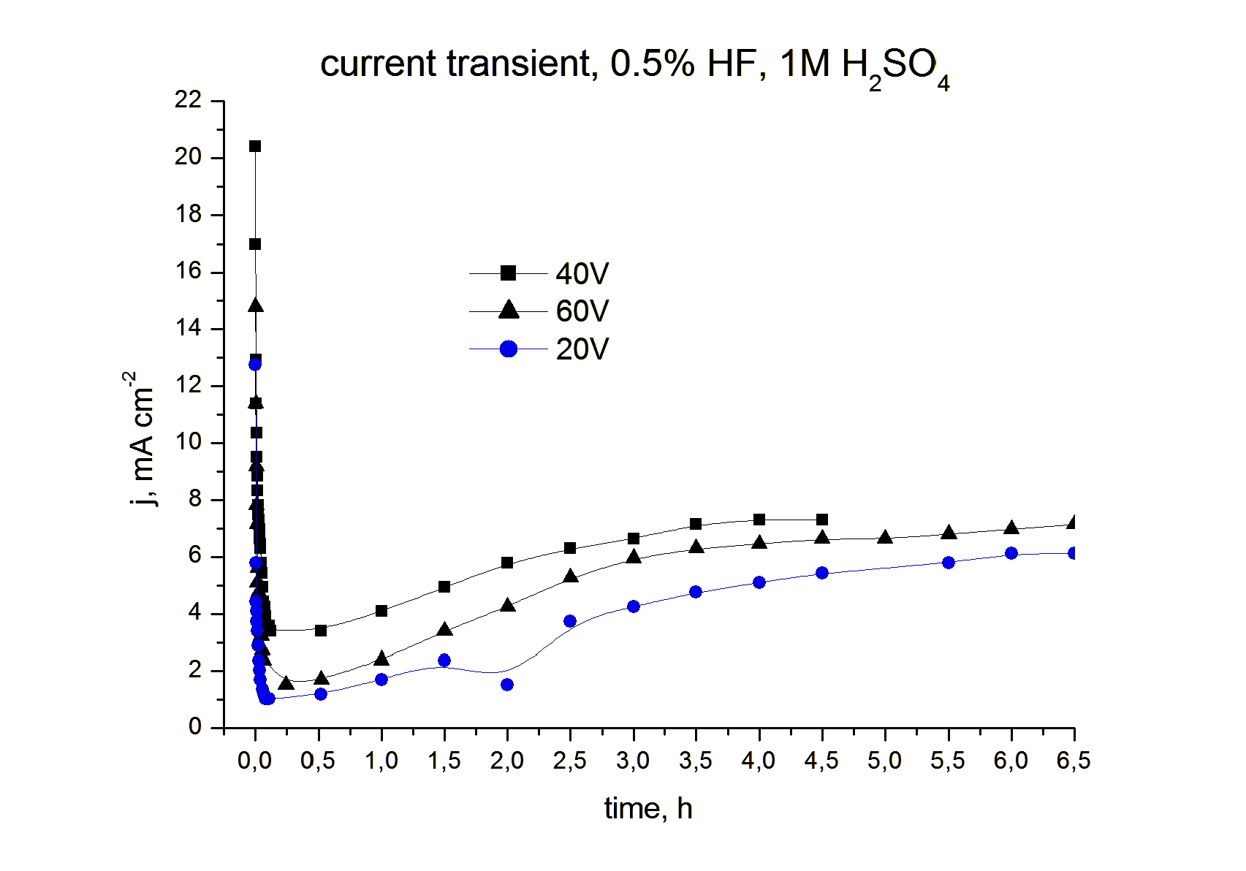
Fig. 1. Current vs. time curves of Nb in 0.5% HF,
1 M H₂SO₄.
SEM
As mentioned in the previous section, the anodi-zation of Nb in sulphuric-fluoride acid media begins with formation of a compact barrier layer within the first 0.25 h. Subsequently, the growth of the porous nanostructured overlayer initiates (the initial rise of the current) as observed on Fig. 2a. Then the nano-pores grow into nanotubes (Fig. 2b) up to about 2 h. At this moment, the process reaches its point of “saturation” and secondary 3D structures begin to form (Fig. 2c). This process is already infinite, whereas the “flowers” initially spread out all over the surface and then “pile up” into multiple irregular
layers (Fig. 3c, the experiments were carried out up to 8 hours). It is noteworthy that the secondary 3D structures, or the so called “flowers” are different formations from the previously reported “cones” [16, 17] (in pure HF acid) and “sunflowers” [18] (in H₃PO₄ at potential close to breakdown).
The study of the influence of HF concentration and potential on the rate of the nanotube formation process proved the previous reported correlations [14, 15]. If Fig. 3b, 2b and 3c that show the top view of anodized Nb in 1 M H₂SO₄ + 0.5% HF for 2h at respectively 20, 40 and 60 V, are compared, it becomes obvious that the nanotube diameters at 20 V (Fig. 3b) are smaller than at 40 V (Fig. 2b). At 60 V in the same electrolyte for the same time there is a typical view of a completely “oversaturated” oxide layer of secondary structures. The relationship between the rate of the porous oxide layer growth and HF concentration in the electrolyte is somewhat analogous. On the micrograph of the oxide film formed in 0.2% HF at 40 V for 2 h (Fig. 3a), resembles more the top view for the anodic layer in 0.5% HF for 1 h (Fig. 2a) than that grown in the same electrolyte and potential for 2 h (Fig. 2b). Experiments in 1% HF have also been carried out but the layers for time periods over 1h were already “oversaturated” with specific shape of the “flowers” for this highly aggressive medium.
B. Tz. Tzvetkov et al.: Study of anodic films on niobium by scanning electron microscopy
In electrolytes, containing H₃PO₄ instead of H₂SO₄, the mechanism of porous layer formation is quite different and the layers grown at 40V, 1 M H₃PO₄ + 0.5% HF, for more than 1h look like quite similar. This may be due to the higher rate of the film formation and the specific manner of over-saturation in this particular case. The difference of niobium behaviour in H₃PO₄ and H₂SO₄ could be attributed to PO₄^{3–} adsorption on the surface or incorporation in the oxide layer as the pore forma-tion is more strongly dependent on the H₃PO₄ con-centration in the electrolyte [1] unlike H₂SO₄ [15].

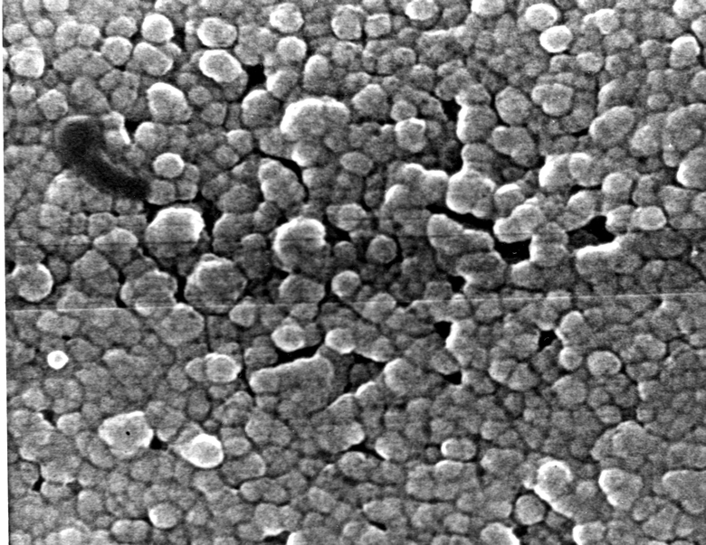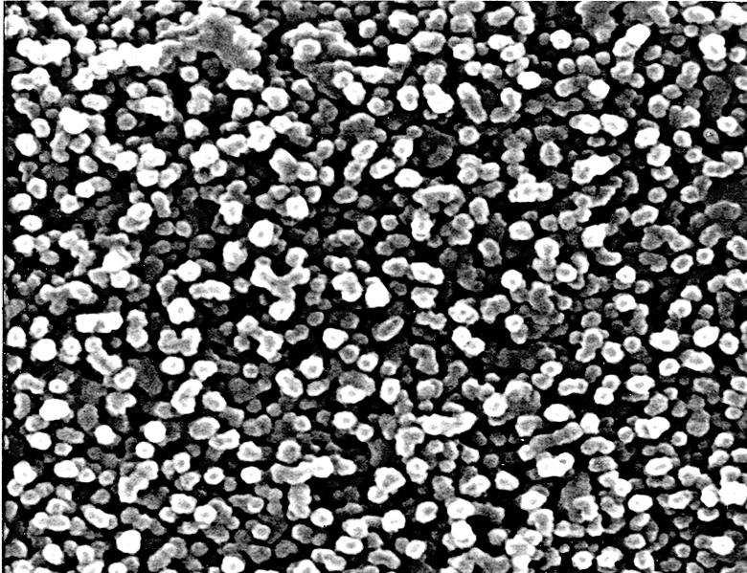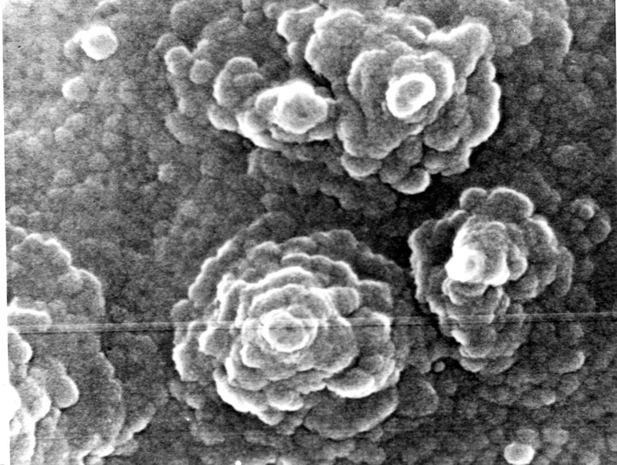
a
b
c
1h 2h 3h
Fig. 2. SEM micrographs of anodized Nb at 40 V in 1 M H2SO4+0.5% HF at different times. Magnification 5×104.
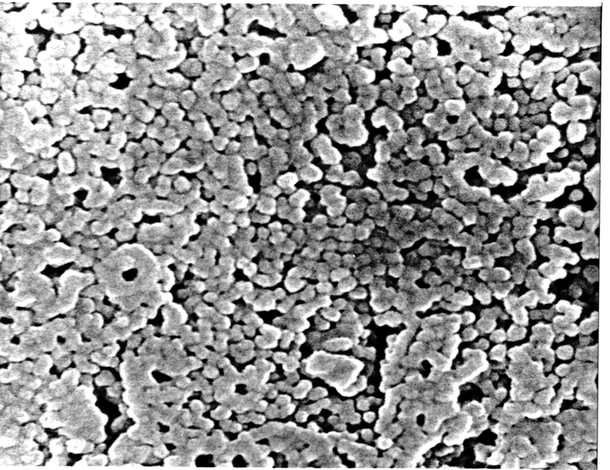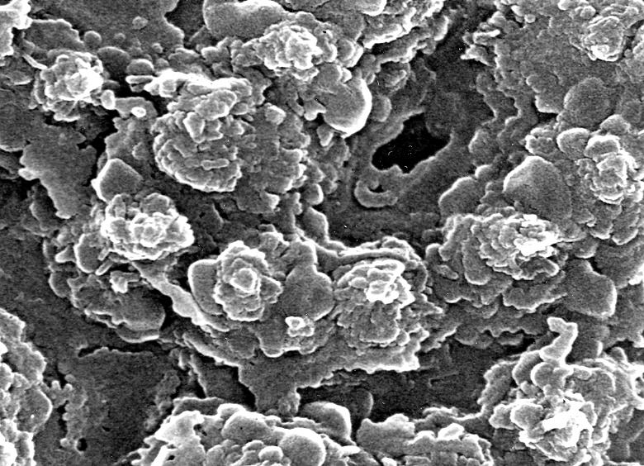
a
b
c
Fig. 3. SEM micrographs of anodized Nb at 2 h and different potentials,
in 1 M H₂SO₄ + x% HF. Magnification 5×10⁴ a) 40 V, 0.2% HF; b) 20 V, 0.5% HF; c) 60 V, 0.5% HF.

Discussion
Very recently, Raja et al. [19] presented a view to the mechanism of the oxide nanotube growth on Ti in which the regularity of the pore formation is ascribed to the perturbation of the surface strain energy and homogeneous F⁻ adsorption on the film surface unlike other anions like Br⁻ which adsorb locally and produce deep, irregular pits. According to this model the process is divided into the following stages: i) formation of a compact barrier film during the first few seconds of anodization; ii) thickening of barrier layer and subsequent micro-fissuring, normally referred as formation of ‘easy paths’; iii) secondary porous oxide nucleation through these ‘easy paths’, subject to perturbation in the balance between the surface energy acting as a stabilizing force and the increase in strain energy due to electrostriction, electrostatic and recrystal-lization stresses trying to destabilize the surface; iv) coverage of the pore sublayer over the entire surface and growth into nanotubes; v) pore separation to form individual, self-ordered nanotubes. The disso-lution process produces oxygen vacancies which accumulate into the nanotube walls and, as ions with similar sign, they will repel each other to acquire regular distribution until they rich point of satura-tion when a separation of the walls takes place.
On the other hand, K. Yasuda et al. [20] propose that the initiation of the pores is owed to the micro-breakdowns resulted from the layer dissolution and the near-breakdown electric field strength [21]. Additionally a pH gradient is postulated to be established between pore top and bottom which enables the autocatalytic increase of the dissolution process at the bottom. Subsequently, an ordered, linear shape is supposed to be obtained from worm-like initial structure due to the larger oxidation area available around the deeper pores which grow to the detriment of the small ones.
In our previous work, a first attempt to include the porous sublayer into the model of the niobium anodic layer was made [14]. Now we try to develop this schematic of the process into more detailed view of the mechanism.
According to the MCM [22], the processes of the barrier film growth could be described by the scheme shown in Fig. 4.
B. Tz. Tzvetkov et al.: Study of anodic films on niobium by scanning electron microscopy
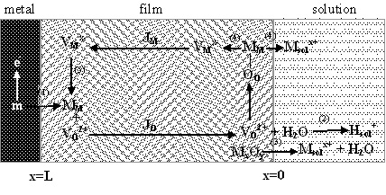
Fig. 4. Schematic representation of the processes in the barrier layer of the oxide film according to MCM.
In our case the processes can be described by the following equations:
Film growth (J_{O}):
Direct oxide film dissolution:
Niobium dissolution through the film (J_{M}):
It is widely accepted [21, 23] that the transport of the oxygen vacancies (J_{O}) supports the film growth. Niobium atoms from the underlying metal (Nb_{m}) move into the film producing oxygen vacancies, which migrate to the film/solution interface where they interact with the water molecules (1 and 2) to form oxygen positions (O_{O}). Barrier film growth is balanced by dissolution (reaction (3)) to achieve a constant thickness of this layer at a given potential. On the other hand, niobium dissolution through the film proceeds by the transport of the metal vacan-cies (J_{M}) where the niobium in niobium position (Nb_{Nb}) at the film/solution interface dissolves generating a niobium vacancy. The vacancy in turn migrates to the metal/film interface where it submerges into the underlying metal.
Combining the idea of Raja et al. [19] for the perturbation of surface tension which favours film dissolution, we could speculate that at the film/solution interface, the entire surface is divided into two types: zones of dissolution and zones of growth as the perturbation of the surface stress is supposed regular. We could suggest that there are two reactions, competing for the zones of growth – equation and the following one (Fig. 5):
where (Nb₂O₅)_{pore} is the niobium oxide in the pore walls.

x=0
Nb_{Nb}
Nb_{pore}
V_{Nb}⁵⁻
V_{O}²⁺
H₂O
void
H⁺_{sol}
J_{O}
HF₂⁻
Nb_{Nb}
[NbF₆]_{sol}⁻
film
solution
Fig. 5. Schematic of the pore formation during the Nb anodization.
According to Cattarin et al. [24], in high acid media (pH<3) as necessary for niobium oxide dissolution, the fluoride anions are mainly in the form of HF₂–. The latter interact with niobium atoms at the surface to form a stable soluble complex ([NbF₆]⁻_{sol}) and generate niobium vacancy, as described by reaction .
It is obvious from the schematic (Fig. 4) that it is less probable that the oxygen vacancies reach the top of the pore walls, Eqn. (growing areas), than the bottom of the holes, so the growth would proceed preferably by Eqn. . Thus, both oxygen and niobium vacancies take part in the film formation and dissolution processes at the film surface. As the ionic conduction in anodic layers on Nb is owed rather to J_{O} than to J_{M}, according to the Surface Charge Approach [23, 25], the increased amount of the V_{Nb}^{5–} generated during metal disso-lution will be accumulated at the film/solution interface, forming a surface charge which attracts the oxygen vacancies.
There the two types of defects could combine with each other. There are two possible reactions for this process:
where Null represents the perfect lattice as a whole and is a vacancy pair [26].
The first reaction represents the recombination of the two types of vacancies to leave ideal lattice which is unlike since the MCM does not assume interstitial atoms. The second possible option is that they rest combined in an empty pair, which we could visualise as a void, i.e. a local recess of the layer at its interface with the electrolyte. This is one possible explanation of how the pores initiate and grow into the barrier layer.
B. Tz. Tzvetkov et al.: Study of anodic films on niobium by scanning electron microscopy
If we include in this picture the surface stress perturbation to define the zones of vacancy recom-bination into voids in a regular manner, organized pore arrays can form as a result of pore nucleation. Subsequently, the mechanism of pore growth into nanotubes of K. Yasuda et al. [20] could be well applicable. Within the frames of this mechanism, pore growth initially proceeds in a wormlike manner, establishing a pH-gradient between the top and the bottom of the pore. In the next step, a natural selective mechanism owed to the greater oxidation area around the deeper pores helps the self-organization process to form well-ordered and well-shaped nanotube arrays.
Conclusions
The processes of anodic porous oxide film formation on niobium have been studied by means of chronoamperometric measurements and SEM. In agreement with these two methods there have been found three stages of the film growth:
A compact barrier film is formed during the first 0.25 h, resulting in a steep drop of the current;
Due to metal dissolution through the film and the lower rate of transport of niobium vacancies, they form a surface charge, which attracts the oxygen vacancies from the metal/film interface to form voids at particular sites on the surface determined by the perturbation of the surface tension. Thus the pores nucleate regularly (the tension perturbation is assumed to be regular);
Porous sublayer grow until about 2 h, related with corresponding rise of the current curve, begin-ning in wormlike pores which grow into ordered nanotubes by natural selection mechanism;
Formation of secondary 3D structures, re-sembling flowers, after some point of “saturation” of nanotube formation, which first spread all over the surface and then form irregular multilayer “pilling-up”.
In the next stage of this investigation the quali-tative microscopic view presented above will be combined with additional electrochemical results such as pore filling to attempt to model quanti-tatively the consecutive stages of the processes of growth and recrystallization of the nanoporous oxide films on Nb.
B. Tz. Tzvetkov et al.: Study of anodic films on niobium by scanning electron microscopy
References
- J. Choi, J. Lim, S. Lee, J. Chang, K. Kim, M. Cho, Electrochim. Acta, 51, 5502 (2006)
- G. Hutchings, S. Taylor, Cat. Today, 49, 105 (1999).
- P. Barczuk, H. Tsuchiya, J. Macak, P. Schmuki, D. Szymanska, O. Makowski, K. Miecznikowski, P. Kulesza, Electrochem. Solid-State Lett., 9, E13 (2006)
- O. Varghese, D. Gong, M. Paulose, K. Ong, E. Dickey, C. Grimes, Adv. Mater. Commun., 15, 624 (2003).
- O. Varghese, D. Gong, M. Paulose, K. Ong, C. Grimes, Sensor Actuator B, 93, 338 (2003).
- O. Varghese, C. Grimes, J. Nanosci. Nanotech., 3, 277 (2003)
- E. Dickey, O. Verghese, K. Ong, D. Gong, M. Paulose, C. Grimes, Sensors, 2, 91 (2002).
- А. Zuruzi, A. Kalmakov, N. MacDonald, M. Moskovits, Appl. Phys. Lett., 88, 102904 (2006).
- G. Mor, M. Carvalho, О. Varghese, М. Pishko, C. Grimes, J. Mater. Res., 19, 628 (2004).
- I. Nowak, M. Ziolek, Chem. Rev., 99, 3603 (1999).
- http://powerelectronics.com/mag/Ken%20Yi%20March%202003.pdf
- http://www.nec-tokin.com/english/product/cap/topics/0107_qa.html
- I. Sieber, H. Hildebrand, A. Friedrich, P. Schmuki, Electrochem. Commun., 7, 97 (2005).
- B. Tzvetkov, M. Bojinov, A. Girginov, Nanoscience and Nanotechnology, vol. 6, E. Balabanova, I. Dragieva (Eds.), Heron Press, Sofia, 2006, p. 86.
- R. Karlinsey, Electrochem. Commun, 7, 1190 (2005)
- J. Zhao, X. Wang, R. Xu, Y. Mi, Y. Lia, Electrochem. Solid-State Lett., 10, C31 (2007).
- K. Nagahara, M. Sakairi, H. Takahashi, K. Matsumoto, K. Takayama, Y. Oda, Electrochim. Acta, 52, 2134 (2007)
- K. S. Raja, M. Misra, K. Paramguru, Electrochim. Acta, 51, 154 (2005)
- K. Yasuda, J. Macak, S. Berger, A. Ghicov, P. Schmuki, J. Electrochem. Soc., 154, C472 (2007)
- C. Chao, L. Lin, D. Macdonald, J. Electrochem. Soc., 128, 1187 (1981)
- M. Bojinov, G. Fabricius, P. Kinnunen, T. Laitinen, K. Makela, T. Saario, G. Sundholm, J. Electroanal. Chem., 504, 29 (2001)
- M. Bojinov, S. Cattarin, M. Musiani, B. Tribollet, Electrochim. Acta, 48, 4107 (2003)
- S. Cattarin, M. Musiani, B. Tribollet, J. Electrochem. Soc., 149, B457 (2002)
- M. Bojinov, Electrochim. Acta, 42,3489 (1997).
- D. D. Macdonald, J. Electrochem. Soc, 139, 3434 (1992).

Изследване на анодни филми върху ниобий със сканираща електронна микроскопия
Б. Цветков*, М. Божинов, Ас. Гиргинов
Катедра „Физикохимия“, Химикотехнологичен и металургичен университет,
бул. „Кл. Охридски“ № 8, 1756 София
Постъпила на 1 ноември 2007 г.; Преработена на 21 януари 2008 г.
(Резюме)
Посредством хроноамперометрия и сканираща електронна микроскопия бе изучено влиянието на концентрацията на HF и потенциала върху процесите на анодно окисление на ниобий в кисели среди. В първия етап на процеса се образува плътен бариерен слой, върху който започва образуването на порьозен подслой. С времето порите израстват в нанотръбички докато не достигнат точка на „пресищане“. В този момент започва формирането на тримерни структури, наподобяващи цветове. Тези „цветове“ постепенно обхващат цялата повърхност и започват да се натрупват. С нарастване на потенциала, както и на съдържанието на HF, повърхностните процеси на образуване на порьозния слой и впоследствие на масивите от нанотръбички значително се ускоряват. Заместването на сярната киселина с фосфорна води до съществено видоизменение на тези процеси, като израстването на нанотръбичките протича по различен механизъм, а при локално пресищане не се получават вторични тримерни структури. Направен е опит да се илюстрира механизма на израстване на нанотръбичките на основата на модела на смесена проводимост и нови идеи за порообразуване. В следващия етап на изследванията, чрез комбиниране на електрохимичните и микроскопски техники, ще бъде направен опит за моделиране на последователните стадии на процесите на нарастване и рекристализация на нанопорьозни филми върху ниобий.

