Solid-state IR-LD spectroscopy of L-tryptophan-containing dipeptides
L-tryptophyl-L-methionine (H-Trp-Met-OH), L-methionyl-L-tryptophan
(H-Met-Trp-OH) and glycyl-L-tryptophan dihydrate (H-Gly-Trp-OH.2H₂O)
Bulgarian Chemical Communications, Volume 40, Number 4 (pp. 456–463) 2008
© 2008 Bulgarian Academy of Sciences, Union of Chemists in Bulgaria
B. B. Koleva
* E-mail: BKoleva@chem.uni-sofia.bg
St. Kliment Ohridsky Sofia University, Faculty of Chemistry, 1, J. Bourchier, Blv., 1164 Sofia, Bulgaria
Dedicated to Academician Ivan Juchnovski on the occasion of his 70th birthday
Received January 2, 2008, Revised January 11, 2008
IR-spectroscopic and structural elucidation of L-tryptophan-containing dipeptides L-tryptophyl-L-methionine (H-Trp-Met-OH), L-methionyl-L-tryptophan (H-Met-Trp-OH) and glycyl-L-tryptophan dihydrate (H-Gly-Trp-OH.2H₂O) by means of solid-state linear dichroic IR- (IR-LD) spectroscopy of orientated colloid suspensions in nematic host is performed. A correlation structure-spectroscopic property of the latter compound is done, comparing IR-LD and known single crystal X-ray diffraction data. Quantum chemical ab initio and DFT calculations of H-Trp-Met-OH/H₂O and
H-Met-Trp-OH/H₂O systems support is made in addition to the IR-LD spectroscopic analysis.
Key words: L-tryptophyl-L-methionine (H-Trp-Met-OH), L-methionyl-L-tryptophan (H-Met-Trp-OH), glycyl-L-tryp-tophan dehydrate, solid-state linear polarized IR spectroscopy, quantum chemical calculations.

Introduction
Tryptophan-containing peptides are intensively studied during the last years, due to their possibility to recognize and cleave DNA at apurinic sites [1]. On the other side the aromatic interactions in tryp-tophan-containing peptides have been also studied [2]. A series of small peptides has been structurally investigated by single crystal X-ray diffraction [2]. As a part of systematic spectroscopic and structural elucidation of small peptides, their salts and metal complexes have been studied [3–15] by means of solid-state IR-LD spectroscopy of orientated colloids in nematic mesophase [16–19], herein included _{L}-tryptophane containing dipeptides as L-tryptophyl-L-methionine (H-Trp-Met-OH) and L-methionyl-_{L}-tryptophan (H-Met-Trp-OH) (Scheme 1). The conclusions about the structures of the above stated dipeptides are supported by the additionally performed IR-LD characterization of glycyl-L-tryptophan dihydrate (H-Gly-Trp-OH.2H₂O), shown in Scheme 1. The crystal structure of H-Gly-Trp-OH.2H₂O has been determined by single crystal
X-ray diffraction [20], thus allowing a comparison between spectroscopic and structural data, i.e. correlation between structure-optical properties.
Scheme 1. Chemical diagram of dipeptides H-Trp-Met-OH, H-Met-Trp-OH and H-Gly-Trp-OH.2H₂O.
Experimental
Both peptides are “Bachem” (Switzerland) products. The H-Gly-Trp-OH.2H₂O is obtained by the procedure described in [20]. The purity of the studied compound was proved by mass spectro-metry (ESI) and ¹H-NMR.
The IR-spectra were measured on a THERMO NICOLET 6700 FTIR-spectrometer (4000–400
cm^{–1}, 1 cm^{–1} resolution, 200 scans) equipped with a Specac wire-grid polarizer. The non-polarized solid-state IR spectra were recorded using KBr disk
technique. The orientated samples were obtained as a colloid suspension in a nematic host (ZLI 1695, Merck), using the method described in [16–19]. The application of colloid suspensions in nematic liquid crystal host allows IR-spectroscopic and structural elucidation of embedded solid particles, which was demonstrated in series of papers dealing with characterization of inorganic compounds and glasses [21], organic and coordination compounds (see Refs. 3–19). It has been found out [19] that a partial orientation (15–20%) of suspended particles (Scheme 2), adequate for the recording of reasonable linearly polarized IR-spectra is achieved, when 5 ± 1% by weight of the given solid com-pound, with particle size within the limits 0.3–0.9 μm, is mixed with a nematic liquid crystal substance (ZLI 1695, ZLI 1538 or MLC 6815) suitable for IR spectroscopy and the obtained slightly viscous suspension is phase pressed between two KBr-plates. They are roughened in one direction prior to use with fine sandpaper (C800) (size 5 μm). The KBr-plates and pressed suspension are moved repeatedly with 3 μm/s for 100 times. The optimal cell thickness is 100 μm. The validation of this orientation solid-state method in regard to accuracy and precision, the influence of the liquid crystal medium on peak positions and integral absorbances of the guest molecule bands have been represented [17,18]. The reological model, the nature and balance of the forces in the nematic liquid crystal suspension system, the mathematical model, and morphology of the suspended particles are discussed [19].
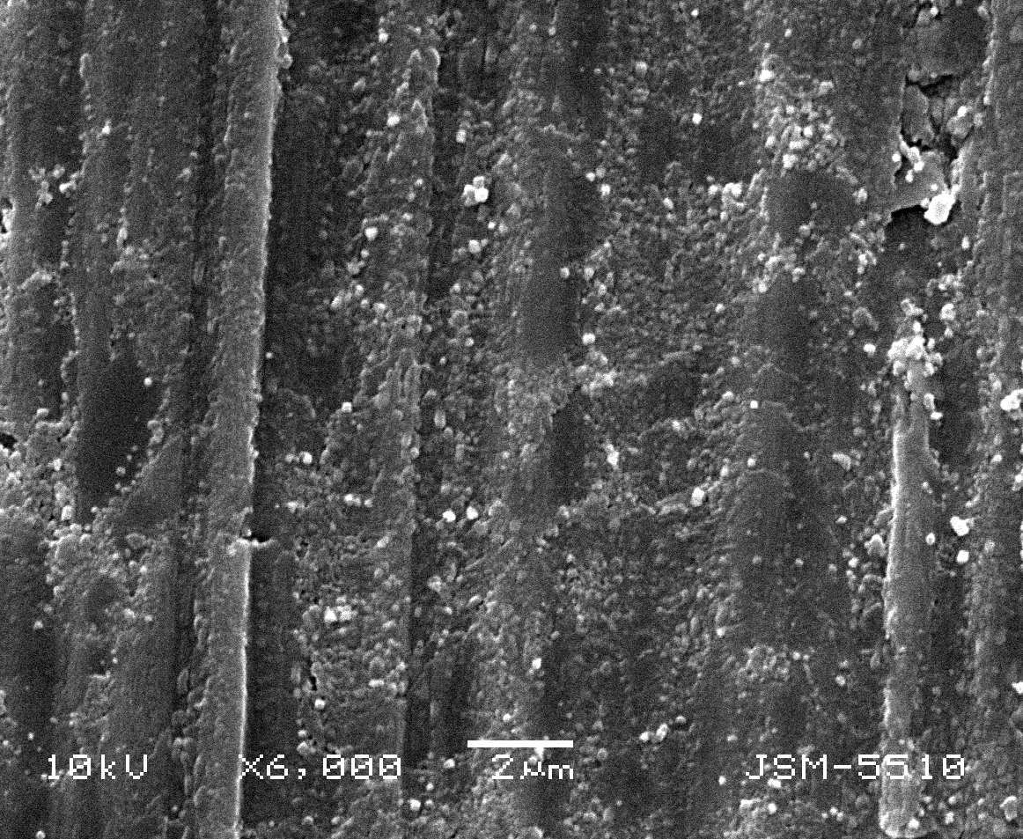
Scheme 2. Electron microscopic data of the colloid suspension in nematic host.
The interpretation of the non-polarized and polarized infrared spectra includes determination of the position (ν_{i}) and integral absorbances (A_{i}) for each i-peak by deconvolution and curve fitting at a 50:50% ratio of Lorentzian to Gaussian peak func-tions. Usually χ² factor varies within 0.00013–0.00008 (in our case 1.2×10^{–5}–2.3×10^{–4}) and 2000 iterations [17, 18]. The mean values of two treat-ments were compared by the Student t-test. The experimental IR-spectral patterns were acquired and processed by means of the GRAMS/AI 7.01 IR spectroscopy (Thermo Galactic, USA) and the STATISTICA for Windows 5.0 (StatSoft, Inc., Tulsa, OK, USA) program packages.
Spectroscopic and structural results by orienta-tion technique presented here were obtained using the known “reducing-difference procedure” designated as “stepwise reduction” for polarized IR-spectra interpretation. This method was initially suggested by Thulstrup and Eggers for the inter-pretation of polarized UV-spectra [22]. The proce-dure involves consecutive elimination of the spectral bands of a given polarization by subtracting the perpendicular spectrum multiplied by a coefficient from the parallel one. This procedure was extended by Spanget-Larsen [23] and by Korte and Lampen [24] to include samples orientated in stretched polyethylene and in nematic solution, respectively. A systematic analysis of this approach and its application to IR-band assignment according to their symmetry appurtenance was developed by Jordanov and co-workers [25–28] for polarized IR-LD spectra in nematic liquid crystal solution. The method con-sists of subtraction of the perpendicular spectrum, (IR⊥, resulting from a 90° angle between the pola-rized light beam electric vector and the orientation of the sample) from the parallel one (IR||) obtained with a co-linear mutual orientation. The recorded difference (IR||-IR⊥) spectrum divides the corres-ponding parallel (A||) and perpendicular (A⊥) inte-grated absorbencies of each band into positive values originating from transition moments, which form average angles with the orientation direction (n) between 0° and 54.7° (magic angle), and nega-tive ones corresponding to transition moments between 54.7° and 90°. In the reducing-difference procedure, the perpendicular spectrum multiplied by the parameter c, is subtracted from the parallel one and c is varied until at least one band or a set of bands is eliminated. The simultaneous disappear-ance of these bands in the obtained reduced IR-LD spectrum (IR||-cIR⊥) indicates co-linearity of the corresponding transition moments, thus yielding information regarding the mutual disposition of the molecular fragments.
B. B. Koleva: Solid-state IR-LD spectroscopy of L-tryptophan-containing dipeptides
The optimization of the structures of the peptides in the systems peptide/H₂O was carried out by DFT calculations (B3LYP) at 6-31+G** basis set using the Gaussian 98 and Dalton 2.0 program packages [29, 30]. The visualization of the output files is done by ChemCraft 5.0 [31]. The methodology for exploring the conformational energy landscape described in [32, 33] was used in our case too. The scheme first creates all possible conformers by rotating around the flexible bonds according to a set of suitable step sizes and then employs a hierarchy of increasingly more accurate electronic structure methods. For every structure the stationary points found on the molecule potential energy hyper-surfaces were characterized using standard ana-lytical harmonic vibrational analysis. The absence of imaginary frequencies, as well as of negative eigen-values of the second-derivative matrix, confirmed that the stationary points correspond to minima of the potential energy hyper-surfaces. The calcula-tions of vibrational frequencies and infrared inten-sities were checked to establish which kind of performed calculations agrees best with the experi-mental data.
Results and discussion
The non-polarized IR-spectra of the dipeptides are depicted in Figs. 1.1A and 1.1B. The IR-characteristic band assignment is listed in Table 1. The NH stretching vibration (ν_{NH}) is observed within 3326–3446 cm^{–1} range. The indole stretching ν_{NH(In)}, usually observed as a strong band [8, 9, 15, 34–36] is obtained within 3409–3424 cm^{–1}. In all cases the asymmetric and symmetric stretching vibrations of NH₃⁺ group (ν^{as}_{NH3+} and ν^{s}_{NH3+}) are observed as a broad band within wide 3200–2000
cm^{–1} ranges with highest frequency sub maxima about 3200 cm^{–1}. The IR-spectroscopic region 1800–1450 cm^{–1} is characterized with overlapping absorption bands of bending NH₃⁺, Amide I (ν_{C=O}), ν^{as}_{COO–}, δ_{NH} (Amide II) and indole in-plane (i.p.) vibrations (Table 1). In 800–400 cm^{–1} region are described and assigned to the out-of-plane (o.p.) bending vibrations of indole ring, bending vibra-tions of COO–-group and Amide IV-VI vibrations. The last ones are observed usually within the regions γ_{NH} (Amide V) 735 ± 60 cm^{–1}, δ_{C=O} (Amide IV) 695 ± 75 cm^{–1} and γ_{C=O} (Amide VI) 600 ± 70 cm^{–1}, respectively [37]. Usually the indole o.p. mode about 740 cm^{–1} is characterized by strongest intensity within the discussed IR-spectroscopic region [8, 9, 15, 34–36]. Other characteristic IR-bands of latter structural fragment correlated well with the data for previously studied tryptophan containing peptides [8, 9, 15] and of L-tryptophan [34–36]. The IR-spectroscopic patterns are prelimi-naryly deconvoluted and curve fitted with a view to determine the band positions and integral absorb-ances. As reference procedure a second derivative analysis is also applied. The IR-characteristic bands of COO–-fragment are assigned as well by an independent way, studying the IR-characteristics of corresponding protonated forms of the peptides.
B. B. Koleva: Solid-state IR-LD spectroscopy of L-tryptophan-containing dipeptides

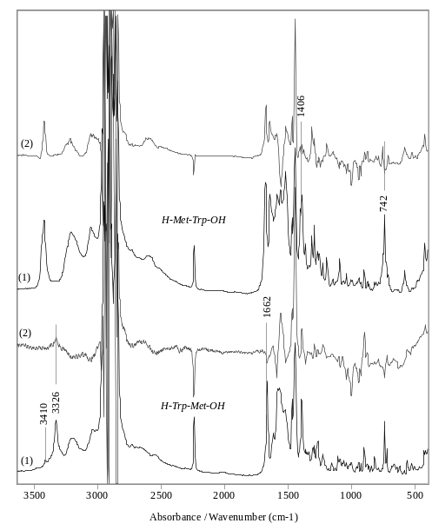 | 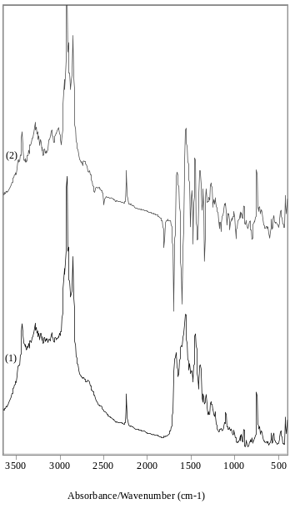
A | B
Fig. 1. Non-polarized IR (1) and difference IR-LD (2) spectra of H-Trp-Met-OH, H-Met-Trp-OH (A)
and H-Gly-Trp-OH.2H₂O (B).
Table 1. IR-characteristic bands of L-tryptophyl-L-methionine (H-Trp-Met-OH), L-methionyl-L-tryptophan (H-Met-Trp-OH) and glycyl-L-tryptophan dihydrate (H-Gly-Trp-OH.2H₂O) in solid-state.
Assignment | H-Trp-Met-OH  ν, cm^{–1} | H-Met-Trp-OH  ν, cm^{–1} | H-Gly-Trp-OH.2H₂O  ν, cm^{–1}
ν_{NH} | 3326 | 3446 | 3430
ν_{NH(In)} | 3409 | 3424 | 3419
ν_{OH(H2O)} | - | - | 3280
ν^{as}_{NH3+}, ν^{s}_{NH3+} Sub. maximum | 3190 | 3208 | 3210
δ_{NH3+} | 1675 | 1685 | 1689
ν_{C=O} (Amide I) | 1662 | 1675 | 1673
δ^{as}_{NH3+} | 1623 | 1643 | 1617
Indole i.p. | 1612, 1469, 1265 | 1615, 1465, 1265 | 1610, 1465, 1265
ν^{as}_{COO-} | 1581 | 1615 | 1563
δ_{NH} (Amide II) | 1521 | 1508 | 1540
ν^{s}_{COO-} | 1396 | 1406 | 1395
ν_{C-N}/δ_{NH} (Amide III) | 1257 | 1260 | 1255
ν_{N-C} | 1000 | 1008 | 1010
Indole o.p. | 738, 424 | 742, 420 | 750, 424
ν_{S-C(H3)} | 721 | 723 | 718
δ_{COO–} | 684 | 661 | 696
ρ_{COO–} | 505 | 484 | 468
γ_{NH} (Amide V) | 651 | 665 | 474
δ_{C=O} (Amide IV) | 580 | 640 | 576
γ_{C=O} (Amide VI) | 526 | 560 | 553

The assignment given in Table 1 is experi-mentally proved by the possibilities of the IR-LD spectroscopy of orientated colloid suspensions stated below. Moreover, for the dipeptides L-tryptophyl-L-methionine (H-Trp-Met-OH) and L-methionyl-L-tryptophan (H-Met-Trp-OH) crystallographic data are not available.
Similar to other peptide systems [3–15] a signi-ficant degree of macro-orientation of suspended particles is obtained [17–19], thus resulting in a reasonable interpretation of the polarized IR-spectra.
B. B. Koleva: Solid-state IR-LD spectroscopy of L-tryptophan-containing dipeptides
In the IR-spectrum H-Trp-Met-OH the ν_{NH(In)} stretching vibration typical for indole ring is low intensive band (Table 1), which can be explained with the participation of the NH_{In} group in inter-molecular interactions in solid-state. The intensive band at 1662 cm^{–1} (ν_{C=O,} Amide I) stretching vibra-tion and the corresponding ν_{NH} one are eliminated in difference IR-LD spectrum (Fig. 1A.2), indicating a co-linear orientation of the transition moments. The last result supposed a trans-configuration of the O=C–NH fragment. The low-intensive bands at 1675 cm^{–1} and 1623 cm^{–1} are assigned as δ^{as}_{NH3+} and δ^{s}_{NH3+}, while the intensive band at 1581 cm^{–1} – to ν^{as}_{COO–}. The discussed bands are overlapped with the low-intensive maxima in the 1600–1450 cm^{–1}, typical for in-plane vibrations of indole ring (Table 1). Only the band at 1469 cm^{–1} is well defined. Its elimination leads to a disappearance of the band at 721 cm^{–1}, typical for ν_{S–C(H3)} of L-methyonyl-side chain [6, 7, 10, 38–40]. This fact supposed a co-linear disposition of both transition moments (Scheme 3). The elimination of the intensive band at 740 cm^{–1} (out-of-plane mode of indole ring) with the band of ν^{as}_{COO–} (1581 cm^{–1}) at equal dichroic ratio also indicates a collinear orientation of the corres-ponding transition moments, which is realized in the frame of the proposed structure of H-Trp-Met-OH, shown in Scheme 3. The intensive band at 1396 cm^{–1} belongs to ν^{s}_{COO–}. The experimentally proposed structure of the dipeptide correlated well with the theoretically approximated model of the system dipeptide/water. A torsion angle of 179.3(6)º of the O=C–NH group indicates a transoide-configuration of the fragment (see IR-LD spectroscopic analysis). On the other side the indole o.p. modes are co-linear to ν^{as}_{COO–} closing an angle of 3.2(6)º. The corres-ponding value of 2.1(2)º between the indole i.p. and ν_{S–C(H3)} transition moments also correlated well with the predicted structure (Scheme 3).
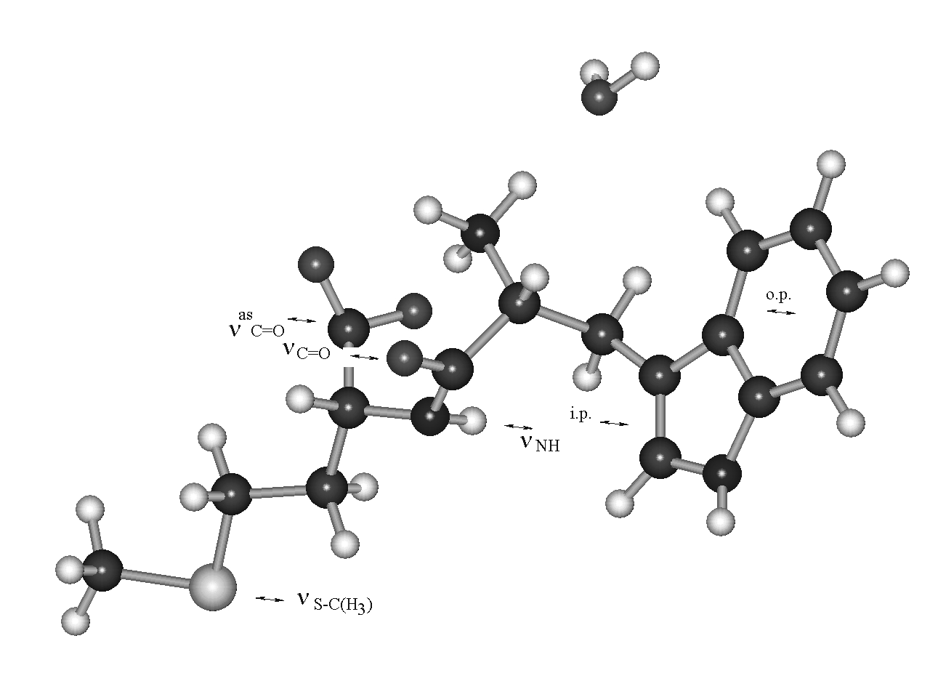
Scheme 3. Most stable conformer of the H-Trp-Met-OH peptide/water system with E_{rel} of 0.2 kJ/mol; Directions of the selected transition moments.
The difference IR-LD spectrum of H-Met-Trp-OH (Fig. 1A.2) is characterized by eliminated bands at 1406 cm^{–1} (ν^{s}_{COO–}) and 742 cm^{–1} (o.p. mode of indole ring), thus assuming a collinear orientation of their transition moments. In contrast to H-Trp-Met-OH, in this case the NH-stretching region is characterized by pairs of bands at 3446 cm^{–1} and 3424 cm^{–1} (ν_{NH} and ν_{NH(In)}) stretching vibrations. The consequent eliminations of these bands result in a disappearance of the maxima at 1685 cm^{–1} (δ^{as}_{NH3+}) and 1675 cm^{–1} (Amide I) (Figs. 2.2 and 2.3). This result can be observed when the HN–C=O amide fragment possesses cisoide-configuration. The band at 723 cm^{–1} (ν_{S–C(H3)}) is eliminated with the bands of ν_{NH}, proposing a co-linearity of these transition moments as well. The predicted geometry of the dipeptide is supported by the theoretical structure with E_{rel} of 0.7 kJ/mol, where a dihedral angle of 8.6(1)º of HN–C=O fragment is obtained. On the
other side the transition moments of ν_{NH} and ν_{S-C(H3)} close an angle of 2.6(2)º, indicating their co-linearity. The calculated angle between the transi-tion moments of ν_{NH(In)} and Amide I of 5.2(1)º, is in accordance with the obtained elimination of last two bands at different dichroic ratio (Figs. 2.2 and 2.3). In the frame of the optimized electronic structure of H-Met-Trp-OH the o.p. mode of indole and ν^{s}_{COO–} close an angle of 7.8(3)º. These data also support the experimentally proposed structure of the dipeptide. An experimental evidence of the cisoide-configu-ration of the amide fragment in this dipeptide follows from the obtained cyclic dipeptide in strongly acidic medium, in contrast to H-Trp-Met-OH, where a hydrochloride salt is obtained. Similar results have been observed in the case of other tryptophan-containing dipeptides, where the cyclic product has been characterized spectroscopically [20].

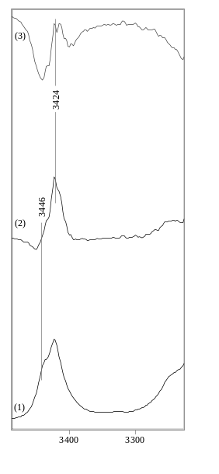 | 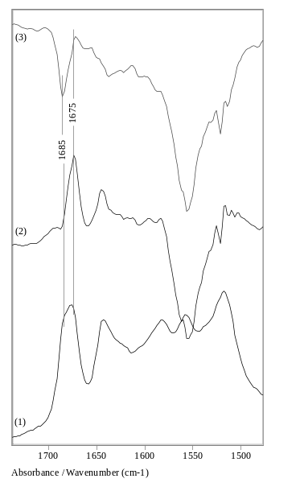
Fig. 2. Non-polarized IR (1) and reduced IR-LD spectra of H-Met-Trp-OH after elimination of the bands
at 3446 cm^{–1} (2) and 3424 cm^{–1} (3).

The characterization of the dipeptide H-Gly-Trp-OH.2H₂O is carried out, comparing the IR-spec-troscopic data and the known crystalline structure [20]. H-Gly-Trp-OH.2H₂O crystallizes in P2₁ space group and the unit cell contains two peptide mole-cules, perpendicularly orientated (Scheme 4). The amide HN–C=O fragment is flat trans-configurated with a dihedral angle of 177.4(9)º [20]. For this reason the elimination of the bands of ν_{NH} and ν_{C=O} (Amide I) at equal dichroic ratio is observed (Fig. 3A.2). The transition moments of indole o.p. modes of the two molecules close an angle of 64.6(4)º, while those of the amide fragment – 68.6(2)º, res-pectively (Scheme 4). It is valid for o.p. vibrations of amide fragment. In all cases the consequent elimination of the bands at 750 cm^{–1} or 553 cm^{–1} leads to disappearance of the maxima at 424 cm^{–1} and 474 cm^{–1}, respectively. In all cases the obser-vation of second peaks of the same symmetry class are observed. As for example the bands at 754 cm^{–1} and 750 cm^{–1} are eliminated at different dichroic ratio (Fig. 3B.2). The phenomenon has been described in a series of papers on the IR-band assignment, by means of the method represented here, describing the systems crystallizing in dif-ferent space groups and containing non-equivalent molecules in the unit cell [10, 11].
B. B. Koleva: Solid-state IR-LD spectroscopy of L-tryptophan-containing dipeptides
Acknowledgements: The author wishes to thank Prof. T. Kolev (Institute of Organic Chemistry with Centre of Phytochemistry, Bulgarian Academy of Sciences) for the possibility to use Gaussian 98 program and Prof. T. Spassov (St. Kliment Ohridski Sofia University) for the electron microscopic data.
B. B. Koleva: Solid-state IR-LD spectroscopy of L-tryptophan-containing dipeptides

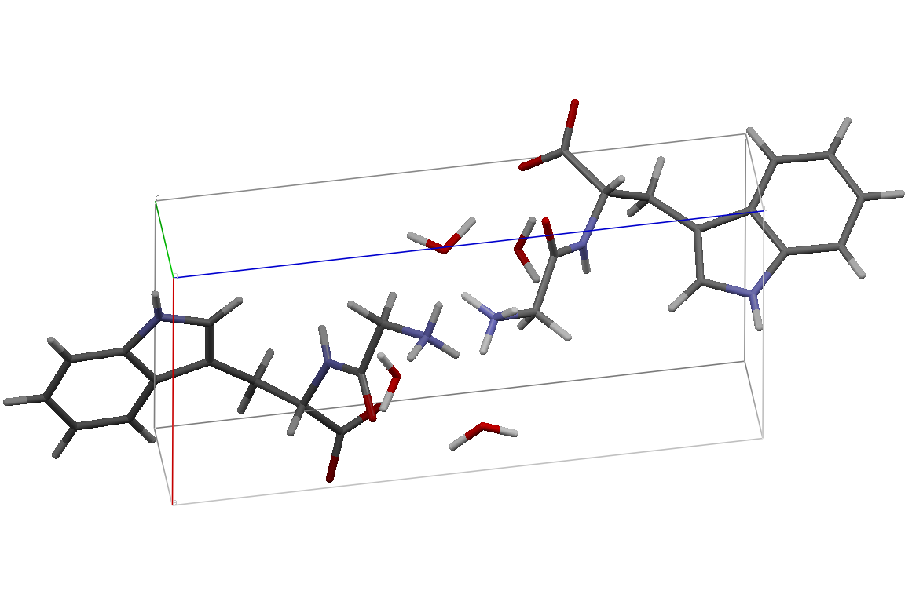 | 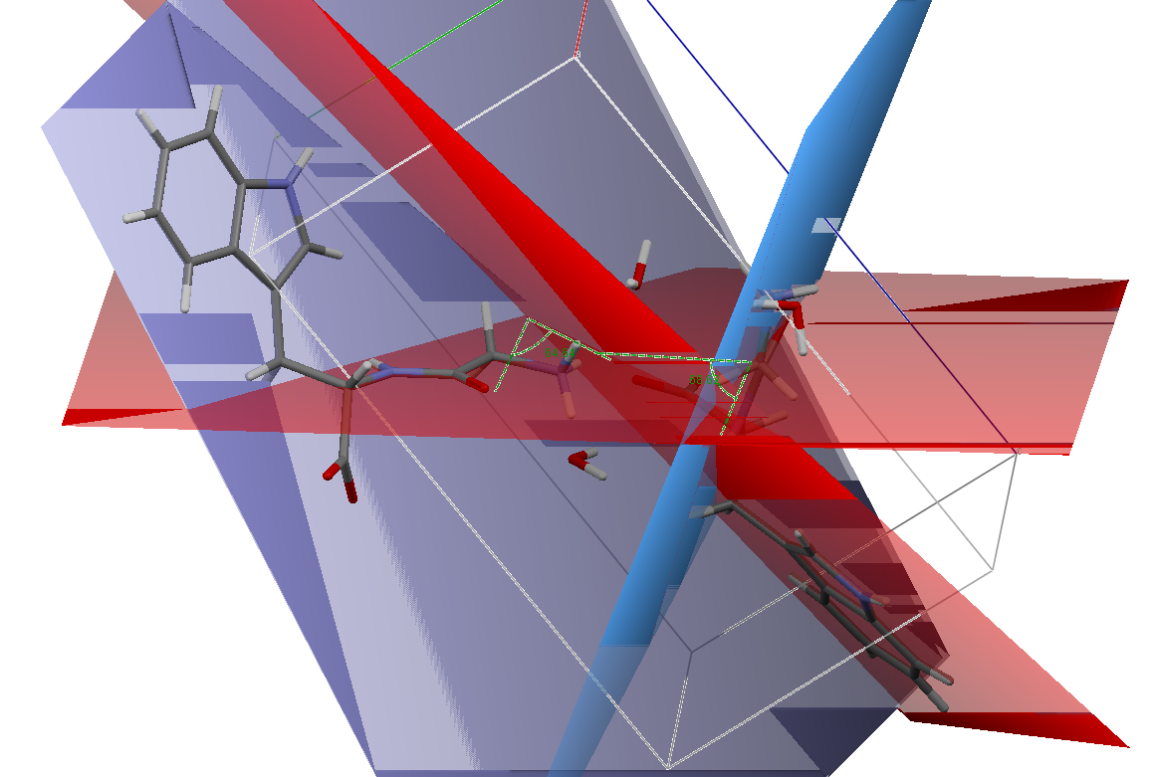
Scheme 4. Unit cell of H-Gly-Trp-OH.2H₂O.

A |  | B
Fig. 3. A: Non-polarized IR (1) and reduced IR-LD (2) spectra of H-Gly-Trp-OH.2H₂O after the elimination of the band at 1673 cm^{–1}; B: Curve-fitted (χ² = 1.2×10^{–5}) IR (1) and reduced IR-LD (2) spectra of H-Gly-Trp-OH.2H₂O after the elimination of the band at 754 cm^{–1}.

References
- 1. T. Behmoaras, J.-J. Toulmé, C. Hélène, Nature, 292, 858 (1981).
- 2. A. Sengupta, R. Mahalaksmhi, N. Shamala, P. Balaram, J. Pept. Res., 65, 113 (2005).
- 3. B. B. Ivanova, M. Mitewa, J. Coord. Chem., 57, 217 (2004).
- 4. B. B. Ivanova, M. G. Arnaudov, Prot. Pept. Lett., 13, 889 (2006).
- B. B. Ivanova, J. Mol. Struct., 782, 122 (2006).
- B. B. Ivanova, M. G. Arnaudov, Spectrochim. Acta, 65A, 56 (2006).
- B. B. Ivanova, M. G. Arnaudov, St. Todorov, W. S. Sheldrick, H. Mayer-Figge, Struct. Chem., 17, 49 (2006).
- B. B. Ivanova, Spectrochim. Acta, 64A, 931 (2006).
- B. B. Ivanova, Spectrochim. Acta. Part A, (2007) in press. DOI: http://dx.doi.org/10.1016/ j.saa.2007.09.005.
- B. B. Ivanova, T. Kolev, S. Y. Zareva, Biopolymers, 82, 587 (2006).
- B. B. Koleva, T. M. Kolev, M. Spiteller, Biopolymers, 83, 498 (2006).
- B. B. Ivanova, J. Coord. Chem., 58(7), 587 (2005).
- T. Kolev. B. B. Ivanova, S. Y. Zareva, J. Coord. Chem., 60, 109 (2007).
- B. B. Koleva, Ts. Kolev, S. Y. Zareva, M. Spiteller, J. Mol. Struct., 831, 165 (2007).
- B. B. Koleva, Ts. Kolev, M. Spiteller, Inorg. Chim. Acta, 360, 2224 (2007).
- B. B. Ivanova, M. G. Arnaudov, P. R. Bontchev, Spectrochim. Acta, 60, 855 (2004).
- B. B. Ivanova, D. L. Tsalev, M. G. Arnaudov, Talanta, 69, 822 (2006).
- B. B. Ivanova, V. D. Simeonov, M. G. Arnaudov, D. L. Tsalev, Spectrochim. Acta, 67A, 66 (2007).
- B. B. Koleva, T. Kolev, V. Simeonov, T. Spassov, M. Spiteller, Colloids Surf. (2007) submitted.
- T. J. Emge, A. Agrawal, J. P. Dalessio, G. Dukovic, J. A. Inghrim, K. Janjua, M. Macaluso, L. L. Robertson, T. J. Stiglic, Y. Volovik, M. M. Georgiadis, Acta Crystallogr., C56, e469 (2000).
- Ts. Kolev, B. Koleva, B. Shivachev, Inorg. Chim. Acta, (2007) in press. doi:10.1016/j.ica.2007.10.030
- E. W. Thulstrup, J. H. Eggers, Chem. Phys. Lett., 1, 690 (1996).
- J. Spanget-Larsen, SPIE, 1575, 404 (1992).
- E. H. Korte, P. Lampen, Private communications, 1988.
- B. Jordanov, R. Nentchovska, B. Schrader, J. Mol. Struct., 297, 401 (1993).
B. B. Koleva: Solid-state IR-LD spectroscopy of L-tryptophan-containing dipeptides
- B. Jordanov, B. Schrader, J. Mol. Struct., 347, 389 (1995).
- M. Belhakem, B. Jordanov, J. Mol. Striuct., 218, 309 (1990).
- M. Rogojerov, D. Kolev, B. Jordanov, J. Mol. Striuct., 349, 447 (1995).
- M. J. Frisch, G. W. Trucks, H. B. Schlegel, G. E. Scuseria, M. A. Robb, J. R. Cheeseman, V. G. Zakrzewski, J. A. Montgomery Jr., R. E. Stratmann, J. C. Burant, S. Dapprich, J. M. Millam, A. D. Daniels, K. N. Kudin, M. C. Strain, Ö. Farkas, J. Tomasi, V. Barone, M. Cossi, R. Cammi, B. Mennucci, C. Pomelli, C. Adamo, S. Clifford, J. Ochterski, G. A. Petersson, P. Y. Ayala, Q. Cui, K. Morokuma, P. Salvador, J. J. Dannenberg, D. K. Malick, A. D. Rabuck, K. Raghavachari, J. B. Foresman, J. Cioslowski, J. V. Ortiz, A. G. Baboul, B. B. Stefanov, G. Liu, A. Liashenko, P. Piskorz, I. Komáromi, R. Gomperts, R. L. Martin, D. J. Fox, T. Keith, M. A. Al-Laham, C. Y. Peng, A. Nanayakkara, M. Challacombe, P. M. W. Gill, B. Johnson, W. Chen, M. W. Wong, J. L. Andres, C. Gonzalez, M. Head-Gordon, E. S. Replogle, J. A. Pople, Gaussian 98, Gaussian, Inc., Pittsburgh, PA (1998).
- "DALTON, a molecular electronic structure program, Release 2.0 (2005), http://www.kjemi.uio.no/ software/dalton/dalton.html "
- G. A. Zhurko, D. A. Zhurko, ChemCraft: Tool for Treatment of Chemical Data, Lite version build 08 (2005).
- D. Toroz, T. Van Mourik, Molec. Phys., 105, 209 (2007).
- D. Toroz, T. Van Mourik, Molec. Phys., 104, 559 (2006).
- X. Cao, G. Fischer, J. Phys. Chem. A 103, 9995 (1999).
- C. Snoek, R. T. Kroemer, M. R. Hockridgea, J. P. Simons, Phys. Chem. Chem. Phys., 3, 1819 (2001).
- B. C. Dian, A. Longarte, T. S. Zwiera, J. Chem. Phys., 118, 6 (2003).
- N. Roeges, A Guide to the Complete Interpretation of Infrared Spectra of Organic Structures, J. Wiley, N.Y. (1993).
- X. Cao, G. Fischer, J. Phys. Chem. A, 106, 41 (2002).
- D. T. Rosa, J. A. K.Bauer, M. J. Baldwin, Inorg. Chem., 40, 1606 (2001).
- B. B. Koleva, Vibr. Spectrosc., 44, 30 (2007).

Твърдотелна линейно-дихроична ИЧ спектроскопия на L-триптофан-съдържащи дипептиди L-триптофил-L-метионин (H-Trp-Met-OH), L-метионил-L-триптофан (H-Met-Trp-OH) и глицил-L-триптофан дихидрат (H-Gly-Trp-OH.2H₂O)
Б. Б. Колева
Софийски университет „Св. Климент Охридски“, Химически факултет,
Катедра „Аналитична химия“, бул. „Дж. Баучер“ № 1, 1164 София
Посветена на акад. Иван Юхновски по повод на 70-та му годишнина
Постъпила на 2 януари 2008 г., Преработена на 11 януари 2008 г.
(Резюме)
С помощта на линейно-дихроичния ИЧ-спектрален анализ на ориентирани проби в твърдо състояние като суспензии в нематичен течен кристал бе проведено ИЧ-спектрално и структурно охарактеризиране на L-трип-тофан-съдържащите дипептиди L-триптофил-L-метионин (H-Trp-Met-OH), L-метионил-L-триптофан (H-Met-Trp-OH) и глицил-L-триптофан дихидрат (H-Gly-Trp-OH.2H₂O). Зависимостта структура–спектрални свойства бе изследвана чрез сравнителен анализ на данните от ИЧ спектроскопия с тези, получени чрез рентгенова дифракция от монокристален образец на H-Gly-Trp-OH.2H₂O. В допълнение са представени резултати от квантово-химични пресмятания на ab initio и ТФП нива на теория за системите дипептид/H₂O.

