A theoretical investigation on the structure, electronic spectra and nonlinear optical properties of pyridinium-betaines of squaric acid
© 2008 Bulgarian Academy of Sciences, Union of Chemists in Bulgaria
Bulgarian Chemical Communications, Volume 40, Number 4 (pp. 498–504) 2008
B. A. Stamboliyska*, D. Y. Yancheva, Ts. M. Kolev
* To whom all correspondence should be sent:
E-mail: bs@orgchm.bas.bg
Department of Structural Organic Analysis, Institute of Organic Chemistry with Centre of Phytochemistry,
Bulgarian Academy of Sciences, Acad. G. Bonchev St., Block 9, 1113 Sofia, Bulgaria
Dedicated to Academician Ivan Juchnovski on the occasion of his 70th birthday
Received January 17, 2008; Revised January 29, 2008
A theoretical investigation is carried out to estimate the structure and properties of six pyridinium-betaines of squaric acid and the dependence of their nonlinear optical (NLO) response on the structural modification. The ground-state geometries of all studied pyridinium-betaines of squaric acid were optimized at the HF/6-311G(d,p) level of theory. The vertical singlet transition energies were computed at the CIS and at the TD-DFT level by using the optimized geometries. The electron charge distributions, the vibrational and electronic spectra were analyzed in order to describe the charge transfer in the molecules and the related electronic transitions. The molecular NLO properties were discussed in terms of electron structure parameters and estimated based on the two-level model. The best performance was found for acceptor substituted pyridinium-betaines of squaric acid.
Key words: Organic NLO materials, UV-Vis, quantum chemical calculations, molecular structure.

INTRODUCTION
The nonlinear optics (NLO) has been a field of intensive research over the last two decades due to the great prospect for developing of new electronic devices and communication technologies based on NLO-effects such as optical frequency doubling, electro-optical modulation, optical rectification, self-focusing, and photorefractivity [1–4]. For the realization of the different optical functions new highly-effective materials should be applied and the organic materials offer many advantages such as great variety, flexible structure, lower cost and easier fabrication for example [5–12].
In the search for strategies aimed at rational design of new organic NLO materials, a number of theoretical models for evaluation of the molecular hyperpolarizabilities have been defined [1–4]. The most widely applied one, the so-called “two-level model”, describes the first molecular hyperpola-rizability (β) in electron structure terms. It is sug-gested that β could be optimized via synthesis of NLO-phores exhibiting excited states close in energy to the ground states, large oscillator strengths for the corresponding electron transition, and as a result of the transition – a large difference between the dipole moments in ground state and in excited state. In the framework of the two-level model, the π-conjugated molecules with strong donor and acceptor groups seem to be the most promising candidates for NLO applications. The electron structure affects also the transparency, the thermal stability and some other features of the material, important from technical point of view.
Optical (UV-vis) and electro-optical absorption measurement (EOAM) techniques allow experi-mental determination of the electron structure para-meters involved in the two-level model [13, 14]. On the other hand, the experimental measurements are often hampered by practical limitations, so it may be of practical use if the same characteristics could be estimated based on structural parameters determined directly by quantum-chemical methods. By eluci-dating the microscopic structure – NLO property relationship the computational evaluations may be used to model the NLO-activity of the molecules.
In the present paper, we represent a detailed computational analysis of the NLO properties of six pyridinium-betaines of squaric acid. For our pur-poses, we analyzed the ground state and excited state structures, vibrational spectra, electronic transi-tions and molecular NLO properties and we compared the obtained data to the corresponding experimental values. The dependence of the elec-tronic parameters involved in the two-level model on structural modification in the elucidated mole-cules has also been studied.
COMPUTATIONAL DETAILS
The ground-state geometries of all studied pyri-dinium-betaines of squaric acid were optimized at the HF level of theory by employing the 6-311G(d,p) basis set. The vertical singlet transition energies were computed at the CIS (configuration interaction singles) and at the TD-DFT (time-dependent density functional theory) level by using the optimized geometries. The geometries of the lowest singlet excited state were also optimized at the CIS level. The nature of the stationary point was analyzed by vibrational frequency calculation both in the ground state and in the excited state. To estimate the dipole moments in the excited state we have performed the population analysis using the CI density. All calculations were performed using GAUSSIAN 98 suite of programs [15]. It is well known that linear scaling is needed for the CIS transition energies to compare the energies with the corresponding experimental data. A factor of 0.72 has been found to be satisfactory ([16] and references therein]), and we have used the same scaling factor in this case also.
RESULT AND DISCUSSION
Molecular geometry and electronic charge distribution in ground state
The bond lengths in the ground state computed at HF level for all studied molecules are plotted in Scheme 1 along with the atomic numbering. In the cases of molecules with C_{2v} symmetry only one of the equal bond lengths is shown in Scheme 1 for simplicity.
B. A. Stamboliyska et al.: A theoretical investigation on the structure, electronic spectra and…

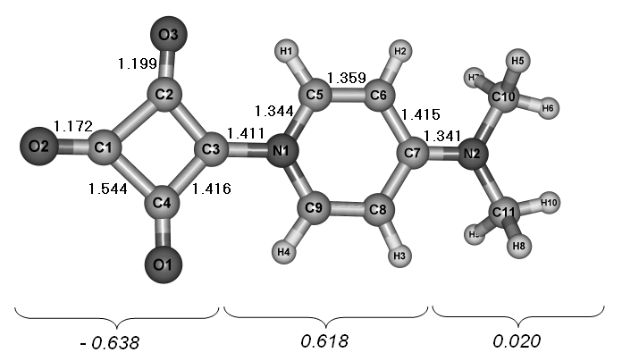 | 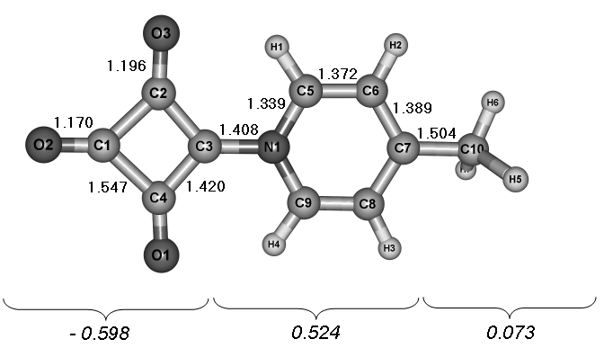
a | b
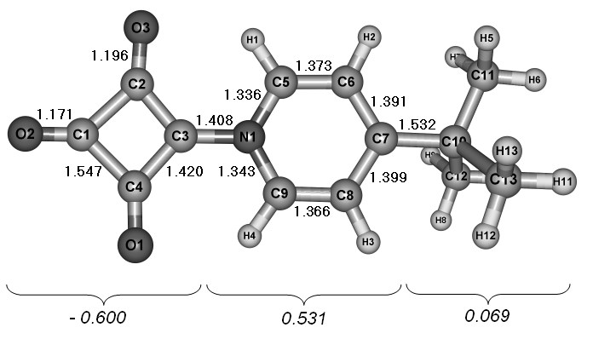 | 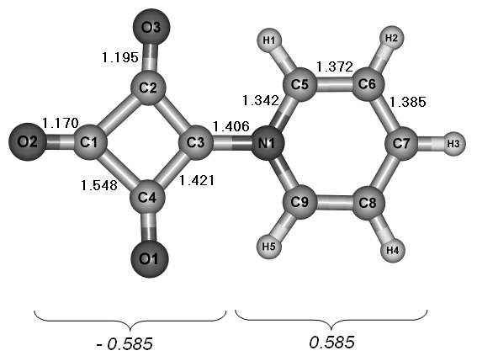
c | d
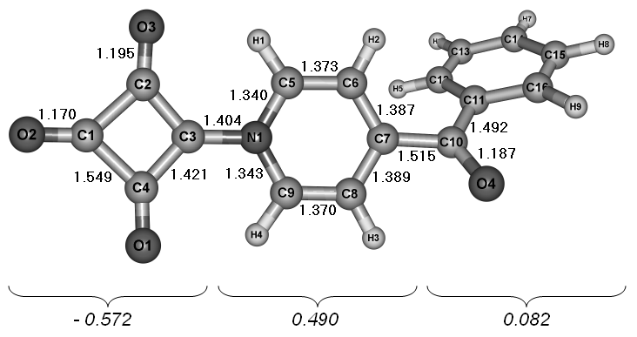 | 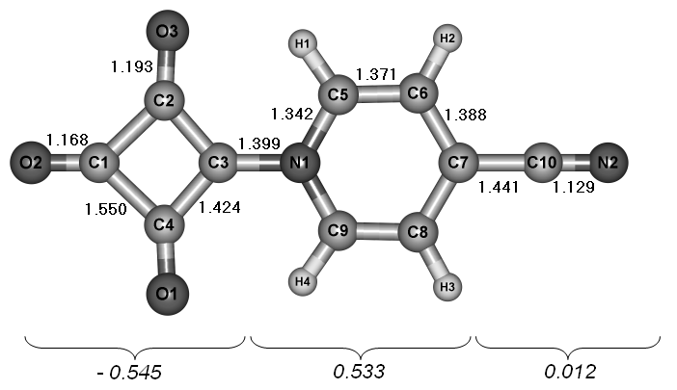
e | f
Scheme 1. Theoretical (HF/6-311G**) bond lengths in the ground state (Å) and NBO charges
over fragments of the studied pyridinium-betaines of squaric acid.

All the theoretically found bond lengths and angles are in a very good agreement with the X-ray refinement values from previous crystallographic studies [17–19]. The ground state geometry of the squaric and pyridinium ring is almost constant within the elucidated series and the calculated inter-atomic distances vary within very narrow ranges. For all structures, the C₁–O₂ bond is predicted to be nearly double in character, which is in accordance with the single crystal data, and its bond length has an average value around 1.170 Å. As a result of the negative charge delocalization the remaining two squarate carbonyl groups C₂–O₃ and C₄–O₁ have identical bond lengths within the range 1.193–1.199 Å. For the same reason, two of the C–C bonds in the squaric ring (C₂–C₃ and C₃–C₄) are considerably shorter.
The heterocycle has partially quinoidal character, most clearly expressed in the 4-dimethylamino derivative. In comparison to the other structures, the latter has the shortest C₅–C₆ and C₈–C₉ bonds and respectively the longest C₆–C₇ and C₇–C₈ bonds. The interatomic distance between the squaric and pyridinium fragment is found to be sensitive to the substitution and it shows variation of 0.012 Å within the elucidated series, gradually decreasing in the order:
4-N(CH₃)₂ > 4-CH₃ ~ 4-C(CH₃)₃ > H > 4-COC₆H₅ > > 4-CN.
The bigger part of the molecule is virtually flat including the carbonyl groups, the squaric ring and the heterocycle, and in some cases – even the non-hydrogen atoms of the substituents, which is an indication of the strong conjugation between the fragments. It is known from the X-ray diffraction studies that the squaric and pyridinium ring in 4-sustituted pyridinium-betaines of squaric acid show negligible deviation from the planarity [17–19], whereas in 2- and 3-substituted derivatives the dihedral angle between their two planes differs significantly i.e. the conjugation is strongly decreased by substitution at 2- and 3-position [20].
B. A. Stamboliyska et al.: A theoretical investigation on the structure, electronic spectra and…
The NBO model was chosen for calculation of the atomic charges of the studied species. In order to illustrate the charge transfer (CT) in the ground state, the calculated charges were summarized over fragments as shown in Scheme 1. The molecules were regarded as constituted of three fragments – cyclobutenedione moiety (acceptor part), pyridinium ring (donor part) and substituent. The substituent is expected to increase or decrease the donor properties of the pyridinium ring by its own electron releasing or withdrawing ability and thus to influence the CT in the molecule. Following this approach, the most favourable degree of conjugation could be achieved by varying the substituent nature.
The excellent acceptor properties of the squaric fragment are revealed by the complete localization of the negative charge on the fragment, even in the presence of cyano or benzoyl group in the pyridi-nium ring.
The electron deficiency in the heterocycle is decreasing in the order: 4-N(CH₃)₂ > 4-C(CH₃)₃ ~
~ 4-CH₃ > 4-COC₆H₅. As it could be seen from the values depicted in Scheme 1, longer alkyl chains as substituents do not contribute significantly to the increase in the positive charge on the pyridinium ring.
Given the strong conjugation and the aromatic character of the system, not surprisingly the substi-tuents releasing or withdrawing electrons through mesomeric effects influence to a greater extent the CT than those acting through inductive effects. To summarize, the introduction of a donor substituent leads to a larger displacement of the electron density from the heterocycle to the squarate fragment.
Vibrational spectra
B. A. Stamboliyska et al.: A theoretical investigation on the structure, electronic spectra and…
In accordance with the minor structural differ-ences found in the ground state geometry, the vibrational spectra of the studied species closely resemble one another. The most characteristic IR region (2000–800 cm^{–1}) is represented in Figure 1 with experimental and theoretical IR bands of selected pyridinium-betaines of squaric acid.
Fig. 1. Solid state experimental (left) and theoretical (right) IR spectra of selected pyridinium-betaines
of squaric acid: (1) 4-CN; (2) H; (3) 4-CH₃;
The quantum-chemical calculations predict accu-rately the frequency range and the intensity of the characteristic vibrational modes [21–23]. In general the most intensive bands in the vibrational spectra of the pyridinium-betaines of squaric acid are between 1800 and 1615 cm^{–1}, and they correspond to stretching vibrations of the carbonyl groups of the squaric ring. The band for stretching vibration of the formal double bond C₁–O₂ is observed at the highest frequency in this region and it is followed by the symmetric ν^{s}(CO) and antisymmetric ν^{as} (CO) stretching vibrations of C₂–O₃ and C₄–O₁. In the case of carbonyl substitution in the pyridinium ring, as for example in the 4-benzoyl compound, an additional band appears in the same spectral region. The stretching vibration ν(C₃–N₁) is found in the experimental spectra at ca. 1420 cm^{–1} (theoretically predicted at ca. 1400 cm^{–1}) and its frequency is higher than the value observed for other similar pyridinium-betaines [24] due to the partially quino-idal character of this bond.
Molecular geometry in excited state
The unsubstituted, the dimethylamino- and the cyano-substituted derivatives best exemplify the differences caused by the substitution in the pyri-dinium ring and hence these three compounds have been used for description of the structural changes observed in excited state. Selected computed struc-tural parameters in excited state are shown in Scheme 2. All bond lengths vary within larger ranges than in ground state and the geometry of the squaric and pyridinium fragments are much more affected by the presence of donor and acceptor groups.
There is a general trend toward lengthening of the C₁–O₂ bond, but to a different extent depending on the substituent. On the other hand, in all cases C₂–O₃ and C₄–O₁ bonds become shorter by 0.011 Å resulting in a completely new geometry of the cyclobutenedione moiety with one single and two double carbonyl bonds. In the case of the 4-cyano
derivative equal bond lengths are observed for the three squaric C–O groups. The C–C bond distances in the squaric ring show a similar tendency, but they are less pronounced and the overall geometry of the cycle is preserved.
A notable difference is observed regarding the bond length of C₃–N₁ not only compared with the ground state, but between the species studied in excited state as well. In comparison with the ground state, the bond has decreased its length, but again to a much different degree in the three cases. The largest decrease is found for the 4-cyano compound, where it is shorter by 0.054 Å.
The pyridinium cycle also undergoes a structural modification, although not so dramatically expressed as in the above-discussed cases. The quinoidal character of the latter fragment is less expressed in excited state in the 4-dimethylamino compounds and more expressed in the 4-cyano pyridinium-betaine of squaric acid. It is interesting to note that the bond distances between the pyridinium ring and the substituents are also affected – in opposite directions. Same fact has been established for other pyridinium dertivatives as well [25–27].
B. A. Stamboliyska et al.: A theoretical investigation on the structure, electronic spectra and…
Thus, the excited state geometry shows major differences compared to the ground state one, but it is not possible to describe them as purely aromatic and quiniod-like as it is defined typically in long-chain push-pull NLO-phores. The changes depend specifically on the donor and acceptor groups and cannot be generalized; however, it is quite evident that the substituent influence is particularly strong in the excited state.

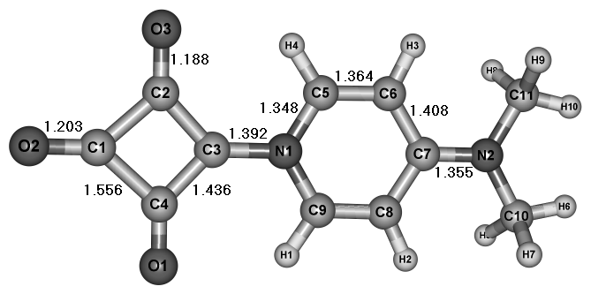 | 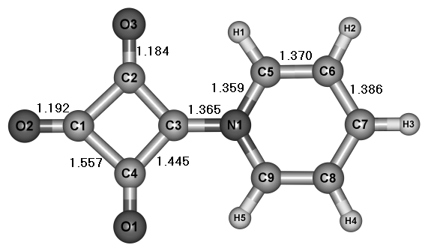
a | b
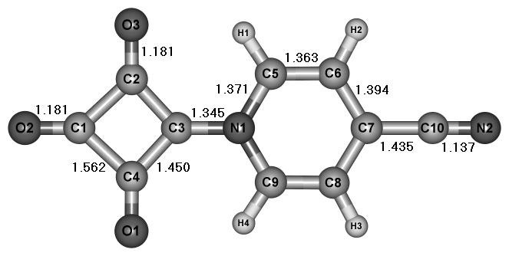
c
Scheme 2. Theoretical (CIS/6-311G**) bond lengths (Å) in the excited state
of selected pyridinium-betaines of squaric acid.

Electronic spectra, dipole moments in ground and excited state and nonlinear optical properties
The electron charge distribution over fragments indicates that a strongly polarized system is present with negative and positive moieties of the molecule in immediate vicinity without any linking chain between them. So, although it is very useful in many cases, here it is impossible to determine the bond length alternation (BLA) and the c² parameter cannot be used for description of the ground state polarization and for showing the relationship between the electron distribution and the ground-state properties. For that reason, the NLO behaviour and the degree of the CT will be estimated based on dipole moments in ground and excited state (μ_{g} and μ_{e}) and the difference between them (Δμ = μ_{e} – μ_{g}), energy of the electronic transition (ΔE), and oscillator strength of the electronic transition (f). These are the parameters involved in the two-level model: β ~ Δμ.f²/ΔE², according to which large molecular hyperpolarizabilities β are related to a dominant CT excitation from the donor to the acceptor part of the molecule [1–4].
Consequently, the first step in our quantum-chemical evaluation of the NLO properties was to investigate the electronic transitions of the species studied. We used TD-DFT and CIS methods to calculate ΔE and f, and in order to find which one of the methods gives better description of the optical properties of the compounds, we compared the obtained theoretical data to experimental EOAM values in nonpolar solvent 1,4-dioxane [28]. A summary of the calculation results and the corres-ponding experimental parameters is represented in Table 1. Excitation to the first excited state gives rise to an intense absorption in the visible region characterized by transition energy predicted by the CIS method between 3.30 and 2.74 eV, and 3.17–2.83 by TD-DFT respectively. There is a progress-
sive decrease in ΔE, expressed in a considerable bathochromic shift, when the the donor substituents in the pyridinium ring are replaced by acceptor groups. The calculated ΔE values reproduce quite accurately the experementally observed values, although the solvent effects were not considered in the theoretical evaluation.
Upon varying the substitution nature, the ground-state dipole moments significantly change decreasing more than twice from the most donating (17.8 D for 4-N(CH₃)₂) to the most electron withdrawing group (7.5 D for 4-CN). According to the two-level model, a large difference between the dipoles in the ground and excited state is a sign of large β. Hence, we determined the excited state dipole moments of the six compounds – for all the compounds a negative difference was found as a result of their less polar structure in excited state. The two acceptor substi-tuted derivatives show the largest difference between the dipole moments in the ground and excited state. Experimentally the decrease of the dipole moments upon excitation was characterized by solvatochromic elucidation of the CT band [29]. Altough the CIS and the TD-DFT calculations overestimated the ground and excited state dipole moments, the variation of μ_{g} and Δµ values are in good agreement with the experimentally determined values.
B. A. Stamboliyska et al.: A theoretical investigation on the structure, electronic spectra and…
As it was given above according to the two-level model, higher β values should be expected based on larger Δµ and f and smaller ΔE. The difference between the dipole moments in the ground and excited state and the oscillator strengths of the CT transition are predicted by both computational methods as being highest for the acceptor substi-tuted compounds. These two compounds exhibit the lowest-wavelength CT transitions as well and subsequently they should be expected to show the highest first molecular hyperpolarizability within the series.

Table 1. Theoretically calculated dipole moments in the ground and excited states (μ_{g} and μ_{e}), difference between the ground and excited state dipole moments (Δμ), energy of the electronic transition (ΔE), oscillator strength of the electronic transition (f), and the corresponding experimental parameters [25].
Substituent | CIS |  |  |  |  | TD-DFT |  | Experiment
Substituent | µ_{g},  D | µ_{e},  D | Δµ,  D | E,  eV | f | E,  eV | f | µ_{g},  D | µ_{e},  D | Δµ,  D | E,  eV | µ_{ge},  D
4-N(CH₃)₂ | 17.8 | 14.2 | –2.8 | 3.30 | 0.85 | 3.17 | 0.51 | 12.5 | 11.3 | –1.2 | 3.33 | 6.8
4-CH₃ | 13.5 | 10.3 | –3.2 | 3.13 | 0.63 | 3.14 | 0.41 | 10.0 | 5.4 | –4.6 | 3.32 | 5.2
4-C(CH₃)₃ | 14.1 | 10.6 | –3.4 | 3.14 | 0.69 | 3.14 | 0.46 | 10.1 | 5.7 | –4.4 | 3.31 | 5.0
H | 12.4 | 9.2 | –3.2 | 3.09 | 0.57 | 3.15 | 0.37 | 9.7 | 4.9 | –4.8 | 3.16 | 4.8
4-COC₆H₅ | 12.6 | 8.2 | –4.4 | 2.83 | 0.81 | 2.83 | 0.55 | 8.9 | 1.2 | –7.7 | 2.95 | 5.8
4-CN | 7.5 | 3.3 | –4.2 | 2.74 | 0.78 | 2.93 | 0.52 | 6.1 | 0.9 | –5.2 | 2.81 | 5.2

CONCLUSION
A theoretical study on the molecular NLO effi-ciency of a series of squaric acid based chromo-phores was carried out. The molecular NLO pro-perties depend strongly on the nature of the substi-tuents. The theoretical methods used reproduce accurately the experimentally observed ΔE values and the variation of μ_{g} and Δµ, although the solvent effects were not considered in the theoretical evaluation. On the basis of the established electronic structure, the large difference between the dipole moments in the ground and excited state and the intensive low-lying absorption maxima in the visible UV region best performance should be expected for the acceptor substituted chromophores.
Acknowledgements: The financial support by the Bulgarian National Science Fund (Contract X-1510) is gratefully acknowledged.
B. A. Stamboliyska et al.: A theoretical investigation on the structure, electronic spectra and…
REFERENCES
- J. Wolff, R. Wortmann, Adv. Phys. Org. Chem., 32, 121 (1999).
- H. Nalwa, S. Miyata, in: Nonlinear Optics of Organic Molecules and Polymers, H. Nalwa, S. Miyata (Eds.), CRC Press. Inc., Boca Ratton, 1997, Ch. 4.
- H. S. Nalwa, T. Watanabe, S. Miyata, Opt. Mater., 2, 73 (1993).
- B. Champagne, D. Bishop, Adv. Chem. Phys., 126, 41 (2003).
- D. F. Aeton, Science, 253, 281 (1991).
- S. Gilmour, R. A. Montgomery, S. R. Marder, L.-T. Cheng, A. K.-Y. Jen, Y. Cai, J. W. Perry, L. R. Dalton, Chem. Mater., 6, 1603 (1994).
- D. M. Burland, R. D. Miller, C. A. Walsh, Chem. Rev., 94, 31 (1994).
- T. J. Marks, M. A. Ratner, Angew. Chem. Int. Ed., 34, 155 (1995).
- W. Lin, S. Yitzchaik, A. Malik, M. K. Durbin, A. G. Richter, G. K. Wong, P. Dutta, T. J. Marks, Angew. Chem. Int. Ed., 34, 1497 (1995).
- T. Yamashiki, S. Fukuda, K. Tsuda, T. Gotoh, Appl. Phys. Lett., 83, 605 (2003).
- X. Zheng, S. Wu, R. Sobolewski, R. Adam, M. Mikulics, P. Kordoš, M. Siegel, Appl. Phys. Lett., 82, 2383 (2003).
- M. Sliwa, S. Letard, I. Malfant, M. Nierlich, P. G. Lacroix, T. Asahi, H. Masuhara, P. Yu, K. Nakatani, Chem. Mater., 17, 4727 (2005).
- W. Liptay, in: Excited States, Dipole Moments and Polarizabilities of Molecules in Excited Electronic States, E. C. Lim (ed.), vol. 1, Academic Press, New York, 1974, p.129.
- R. Wortmann, K. Elich, S. Lebus, W. Liptay, P. Borowicz, A. Grabowska, J. Chem. Phys., 96, 9724 (1992).
- M. J. Frisch, G. W. Trucks, H. B. Schlegel, G. E. Scuseria, M. A. Robb, J. R. Cheeseman, V. G. Zakrzewski, J. A. Montgomery, Jr., R. E. Stratmann, J. C. Burant, S. Dapprich, J. M. Millam, A. D. Daniels, K. N. Kudin, M. C. Strain, O. Farkas, J. Tomasi, V. Barone, M. Cossi, R. Cammi, B. Mennucci, C. Pomelli, C. Adamo, S. Clifford, J. Ochterski, G. A. Petersson, P. Y. Ayala, Q. Cui, K. Morokuma, D. K. Malick, A. D. Rabuck, K. Raghavachari, J. B. Foresman, J. Cioslowski, J. V. Ortiz, A. G. Baboul, B. B. Stefanov, G. Liu, A. Liashenko, P. Piskorz, I. Komaromi, R. Gomperts, R. L. Martin, D. J. Fox, T. Keith, M. A. Al-Laham, C. Y. Peng, A. Nanayak-kara, C. Gonzalez, M. Challacombe, P. M. W. Gill, B. Johnson, W. Chen, M. W. Wong, J. L. Andres, C. Gonzalez, M. Head-Gordon, E. S. Replogle, J. A. Pople, Gaussian 98, Revision A.7, Gaussian, Inc., Pittsburgh PA, 1998.
- A. M. K. Shuhla, J. Leszczynski, J. Phys. Chem. A, 107, 5538 (2003).
- T. Kolev, D. Yancheva, D. C. Kleb, M. Schurmann, H. Preut, P. Bleckmann, Z. Krist. NCS, 216, 65 (2001).
- T. Kolev, D. Yancheva, M. Schurmann, D. C. Kleb, H. Preut, M. Spiteller, Acta Cryst., E58, o1267 (2002).
- T. Kolev, D. Yancheva, B. Shivachev, R. Petrova, Acta Cryst., E63, o3259 (2007).
- I. Uçar, A. Bulut, O. Yeşilel, M. Odabaşoglu, O. Büyükgüngör, Acta Cryst., C61, o148 (2005).
- T. M. Kolev, D. Y. Yancheva, B. A. Stamboliyska, Spectrochim. Acta, 59, 1805 (2003).
- T. M. Kolev, B. A. Stamboliyska, D. Y. Yancheva, V. Enchev, J. Mol. Struct., 191, 241 (2004).
- T. Kolev, B. Stamboliyska, D. Yancheva, Chem. Phys., 324, 489 (2006).
- M. Szafran, J. Koput, J. Mol. Struct., 381, 157 (1996).
- Y. Yang, B. Champagne, J. Phys. Chem., 107A, 3942 (2003).
- T. Kolev, B. B. Koleva, M. Spiteller, W. S. Sheldrick, H. Mayer-Figge, J. Phys. Chem., 111A, 10084 (2007).
- B. B. Koleva, T. Kolev, R. W. Seidel, H. Mayer-Figge, M. Spiteller, W. S. Sheldrick, J. Phys. Chem. A, (2008) in press.
- T. Kolev, D. Yancheva, B. Stamboliyska, M. Dimitrov, R. Wortmann, Chem. Phys., 348, 45 (2008).
- T. Kolev, D. Yancheva, S. Stoyanov, Adv. Funct. Mater., 14, 799 (2004).

Теоретично изследване на структурата, електронните спектри и нелинейните оптични свойства на пиридин-бетаините
на квадратната киселина
Б. А. Стамболийска*, Д. Я. Янчева, Ц. М. Колев
Лаборатория „Структурен органичен анализ“, Институт по органична химия с център по фитохимия,
Българска академия на науките, ул. „Акад. Г. Бончев“, бл. 9, 1113 София
Посветена на акад. Иван Юхновски по повод на 70-та му годишнина
Постъпила на 17 януари 2008 г.; Преработена на 30 януари 2008 г.
(Резюме)
Строежът и свойствата на шест пиридин-бетаини на квадратната киселина и зависимостта на техните нелинейно-оптични характеристики от структурните промени са изследвани посредством теоретичен анализ. Структурите на всички изследвани пиридин-бетаини са оптимизирани на HF/6-311G(d,p) ниво на теория. Синглетната енергия на прехода е пресметната на нива CIS и TD-DFT. Разпределението на заряда, вибрационните и електронни спектри са анализирани за да се опишат преноса на заряд в молекулата и свързаните с това енергии на прехода. Молекулните нелинейно-оптични свойства са определени на базата на „модела на две нива“ като е установено, че те са най-добри при акцепторно-заместените пиридин-бетаини на квадратната киселина.

