Preparation of novel chitosan-containing micro- and nanofibrous materials
by electrospinning
Bulgarian Chemical Communications, Volume 40, Number 4 (pp. 469–476) 2008
© 2008 Bulgarian Academy of Sciences, Union of Chemists in Bulgaria
M. G. Spasova, D. P. Paneva, N. E. Manolova, I. B. Rashkov*
* To whom all correspondence should be sent:
E-mail: rashkov@polymer.bas.bg
Laboratory of Bioactive Polymers, Institute of Polymers, Bulgarian Academy of Sciences, 1113 Sofia, Bulgaria
Dedicated to Academician Ivan Juchnoэski on the occasion of his 70th birthday
Received January, 4, 2008; Revised January 16, 2008
Electrospinning is an efficient and versatile technique for fabrication of nanofibres. This article presents a condensed overview of this technique, with emphasis on chitosan-based nanofibrous materials. For the first time two easily feasible and efficient approaches for preparation of micro- and nanofibrous materials containing the natural polymer chitosan were proposed. The first approach relied upon electrospinning of chitosan and a non-ionogenic polymer mixed solutions. The mean diameters of the nanofibres were in the range of 40–290 nm. The second approach consisted of coating of electrospun poly(L-lactide) or poly(L-lactide)/poly(ethylene glycol) nanofibrous mats with chitosan. Particular potential applications of these novel materials in the biomedical field such as drug delivery systems and wound dressings were evaluated.
Key words: chitosan, electrospinning, nanofibres, drug delivery, wound healing.

Introduction
Polymer fibres are applied in a wide variety of industrial fields [1]. Electrospinning is a cutting edge technique that allows producing continuous polymer fibres with submicron diameters. While the con-ventional techniques like spinning from melt or solution provide fibres with diameters in the range of 5–500 μm, the electrospinning allows producing polymer fibres with diameters in the nanoscale range. Because of their inherent large specific surface area and the small pore size in nanofibrous materials, the electrospun mats may find a variety of applications, e.g. in military protective clothing and filter appli-cations, for non-traumatic wound dressings, in drug delivery carriers, as tubular shapes for blood vessels and nerve regeneration, 3D-scaffolds for bone and cartilage regeneration, in cosmetics, in nanosensors (thermal, piezoelectric, biochemical and fluorescence optical chemical sensors), or in electronics [2]. At present the electrospinning is recognized as the most efficient technique for preparation of significant in length fibres having diameters in the micro- and nanoscale [2, 3]. Moreover, the transfer from labo-ratory to industrial scale can be easily achieved. In the recent years, the electrospinning process gains particularly increasing interest as illustrated in Figure 1, which shows the number of scientific publications that are focused on electrospinning per year and the publications distribution in Europe.
A
B
Fig. 1. Number of scientific publications per year (1995–2006) (A) and distribution of publications in Europe
for 2007 (B) on electrospinning (source: Science Citation Index, SCI®).
Typically, a laboratory set-up is used for electro-spinning since complete electrospinning apparatuses are not yet marketed. Schematic illustration of the electrospinning process and photographs of electro-spinning set-up are shown in Figure 2.

A | 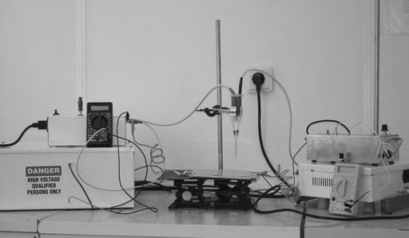 B
C | 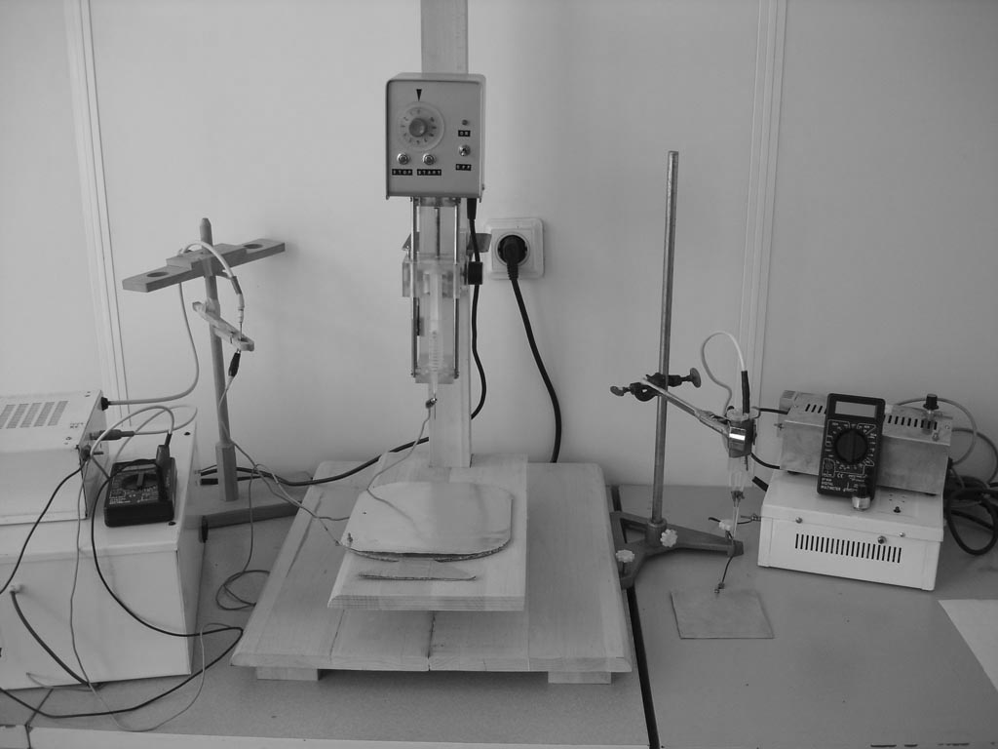 D
Fig. 2. Electrospinning set-up: A) and C) Schematic illustration; B) and D) Laboratory set-up:
The high voltage electrode is immersed in the polymer solution (A and B);
the high voltage electrode is connected to the spinneret (C and D).

The electrospinning involves the application of a strong electrostatic field to a polymer solution. The high voltage electrode is immersed in the polymer solution or connected to the spinneret. The electro-static field deforms the pendant droplet of the polymer solution at the capillary tip into a conical shape known as Taylor cone. When the applied field strength exceeds a threshold value, the electrostatic forces overcome the surface tension, and a fine charged jet is ejected to move towards a ground plate acting as a counter electrode. Due to the high viscosity of the polymer solution and the presence of entanglements, the jet remains stable and is not transformed into droplets. The solvent begins to evaporate immediately after the jet is formed. As a result, thin polymer fibres are deposited on the counter electrode.
Many parameters have an effect on the electro-spinning process. These parameters include (a) solu-tion properties such as viscosity, elasticity, conduct-ivity, and surface tension, (b) process variables such as feeding rate, hydrostatic pressure, electric poten-tial at the capillary tip, and the gap (distance bet-ween the tip and the collecting screen), and (c) ambient parameters such as solution temperature, humidity, and air velocity [2]. Despite of the great number of variables that affect the process, some models describing the electrospinning process have been put forward [4–6]. A simplified model for predicting the diameter of electrospun fibres was proposed as well [7]. Last, but not least, criteria for complex evaluation of the morphology and align-ment of electrospun polymer micro- and nanofibres were systematized [8].
More than hundred polymers have already been electrospun [2, 9]. The significant interest in electro-spinning of biocompatible and biodegradable poly-mers is mainly due to the possibility to obtain scaf-folds that mimic the extracellular matrix of native tissues and organs [10]. Nanofibrous scaffolds of aliphatic biodegradable polyesters, such as polylac-tide (PLA), polyglycolide, poly(ε-caprolactone), poly(lactide-co-glycolide), poly(L-lactide-co-capro-lactone), have been successfully electrospun [11–15]. There is also an increasing interest in use of natural polymers for preparation of nanofibrous ma-trixes. However, fabrication of nanofibres of natural polymers by electrospinning is still a challenge [2].
M. G. Spasova et al.: Preparation of novel chitosan-containing micro- and nanofibrous materials
Chitosan is regarded as the natural polymer, which is the most attracting for use in nanofibrous materials. The interest on preparation of chitosan-based polymer materials is mainly provoked by its numerous beneficial properties in terms of its poten-tial application in biomedical field [16]. Chitosan is a polysaccharide, which is typically produced by partial N-deacetylation of the abundant natural polymer chitin. Chitosan may be considered as a polyelectrolyte built of β(1→4)-linked 2-acetamido-2-deoxy-β-D-glucopyranose and 2-amino-2-deoxy-β-D-glucopyranose residues. During the past few years, particularly increased attention has been paid on the development of optimal conditions for prepa-ration of chitosan-containing nanofibres by electro-spinning [17–28]. Electrospinning has been success-fully applied to prepare nanofibrous materials with antibacterial and/or haemostatic activity [17–20, 22, 29, 30], nanofibrous scaffolds for tissue engineering [31], as well as hybrid nanofibres of biocompatible polymers and fullerenes [32, 33] or magnetic nano-particles [23].
Herein we summarize two novel approaches pro-posed by us for successful preparation of chitosan-containing micro- and nanofibrous materials apply-ing the electrospinning technique. Some possibi-lities for the application of these materials in the biomedical field have been estimated.
Experimental part
Materials
Chitosan from crab shells ($\overline{M}$v = 540 000 g/mol, deacetylation degree 80%, Sigma), poly(ethylene oxide) (PEO, $\overline{M}$v = 800 000 g/mol, Badimol® Dimitrovgrad, Bulgaria), poly(L-lactide) (PLLA, $\overline{M}$w = 152 000 g/mol, Fluka) and poly(ethylene glycol) (PEG, mol. wt. range 1 900–2 200, Fluka) were used.
Preparation and characterization of chitosan/PEO nanofibres and chitosan-coated PLLA or PLLA/PEG fibres
The electrospinning of chitosan/PEO mixed aqueous solutions in absence/presence of the model drug potassium 5-nitro-8-quinolinolate (K5N8Q) is described in details elsewhere [17]. PLLA and PLLA/PEG fibres were prepared as already described [22, 31]. The electrospinning was per-formed using the electrospinning set-up presented in Figure 2B. Chitosan-coated PLLA and PLLA/PEG mats were prepared by immersion of the mats in aqueous chitosan solution (0.05%, pH 5) followed by crosslinking of the natural polymer in glutar-aldehyde vapours [22]. The morphology of the elec-trospun mats was observed by scanning electron microscopy (SEM) and evaluated in terms of the previously reported criteria for complex evaluation of electrospun mats [8] using Image J software [34] by measuring 20 fibres from each SEM image. The
antibacterial and antimycotic activity of chito-san/PEO and (chitosan-coated) PLLA or PLLA/PEG mats was tested against Gram-negative bacteria (Escherichia coli), Gram-positive bacteria (Staphy-lococcus aureus) and the fungus Candida albicans [17, 22]. Platelet and erythrocyte adhesion were monitored by direct SEM observation of blood cells adhered on the surfaces of mats that had been in contact with whole human blood [22].
Results and discussion
M. G. Spasova et al.: Preparation of novel chitosan-containing micro- and nanofibrous materials
Preparation of chitosan/PEO nanofibres
Until 2004, all attempts to prepare chitosan-con-taining fibres by electrospinning have been unsuc-cessful [2]. Our preliminary experiments to elec-trospin chitosan alone from its aqueous solutions also failed. We assumed that the impossibility chito-san to form a continuous spinning jet (a prerequi-site for successful electrospinning of polymers) is due to its polyelectrolyte behaviour and chains rigidity in aqueous solutions. Having in mind our previous studies on the rheological behaviour of chitosan/PEO mixed solutions [35] we suggested that the adding of a non-ionogenic flexible polymer would facilitate the chitosan electrospinning. Chito-san-containing nanofibres were successfully elec-trospun from chitosan/PEO mixed solutions at a weight ratios of chitosan/PEO equal to or less than 1 [17]. SEM micrographs of the nanofibres obtained at different weight ratios chitosan/PEO are shown in Figure 3. The nanofibres electrospun from mixed solutions at a weight ratio of chitosan/PEO = 0.05–0.33 and total polymer concentration of 5% were cylindrical with mean diameters in the range of 200–250 nm. On increasing the chitosan content, the fibre diameters decreased. The nanofibres prepared at a weight ratio of 1/1 and total polymer concen-tration of 3% have significantly smaller mean dia-meter (ca. 40 nm) and bead-like defects. On further increasing the chitosan content (chitosan/PEO = 4) fibres did not spun and only ‘tailed’ beads were formed. The necessity of adding an excess of PEO to the chitosan solution (PEO in an amount higher than the equimolar one) might be attributed to the possibility of formation of a complex between PEO and chitosan resulting in an uncoiling of the PEO macromolecules and their orientation along the chitosan chains. The possibility of formation of a chitosan/PEO complex with composition close to the stoichiometric one has been previously shown [35].

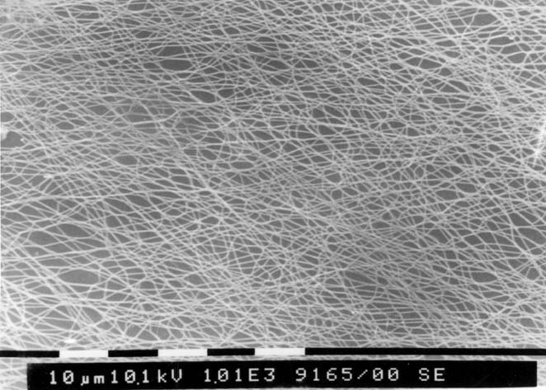 | 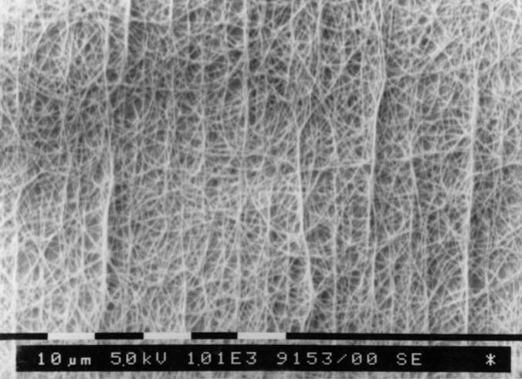
A | B
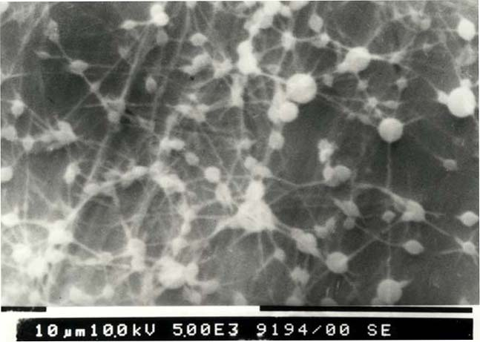 | 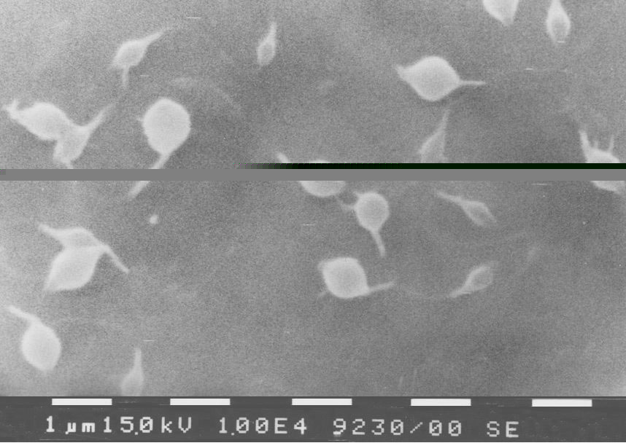
C | D
Fig. 3. SEM micrographs of nanofibres electrospun from chitosan/PEO mixed solutions obtained at applied field strength of 1 kV/cm and chitosan/PEO weight ratios: 0.18; ×1 000 (A), 0.33; ×1 000 (B) (total polymer
concentration – 5%); 1.0; ×5 000 (C), 4.0; ×10 000 (D) (total polymer concentration – 3%).
Reproduced from Spasova et al. [17] by permission of e-Polymers.

Further, the possibility to incorporate a model drug into the chitosan-containing fibres was studied. Potassium 5-nitro-8-quinolinolate (K5N8Q) was selected because of its wide-spectrum antimicrobial and antimycotic activity. Considerable decrease in the mean fibre diameter (ca. 70 nm) was observed. It was attributed to the ability of K5N8Q to form charged ions in aqueous solutions. The incorpo-ration of this model drug resulted in obtaining of nanofibres that possess antibacterial and antimycotic activity as evidenced by the performed microbio-logical tests.
The obtained results revealed the possibility natural polymers with inherent polyelectrolyte behaviour in aqueous solutions to be electrospun into nanofibres in the presence of non-ionogenic polymers with flexible chains. This approach has been confirmed by the preparation of chitosan-containing fibres in the presence of PEO [17, 24] or poly(vinyl alcohol) [25], as well as in the presence of silk fibroin using formic acid as a common solvent [26]. The use of trifluoracetic acid as a solvent has allowed the electrospinning of chitosan alone [25, 27, 28]. Applying the approach of elec-trospinning of mixed solutions of chitosan and non-ionogenic polymers allowed nanofibres containing chitosan derivatives to be obtained as well [18–21]. The solubility in aqueous medium of the obtained nanofibres however may limit some of their possible applications, especially when a contact of the nano-fibrous materials with body fluids is envisaged. The preparation of water-insoluble fibres of chitosan or its derivatives by chemical- [27], thermal- [18, 21] or photo-crosslinking [19, 20] was reported. The antibacterial activity of nanofibrous materials of quaternized derivatives of chitosan revealed the potential of these new materials to be used as wound dressings [19, 20]. Moreover, very recently the pre-paration of magnetic nanofibres by electrospinning of a chitosan derivative and magnetite nanoparticles applying the same approach was shown [23].
M. G. Spasova et al.: Preparation of novel chitosan-containing micro- and nanofibrous materials
Preparation of chitosan-coated PLLA or PLLA/PEG micro- and nanofibres
Poly(L-lactide) (PLLA) has numerous advent-ages as poly(α-hydroxy acid) for wide range of applications in the medical field and especially in implantology because of its bioresorbability and favourable physico-mechanical properties [36]. It is easily electrospun into micro- and nanofibres [11, 37]. However, the hydrophobic nature of the poly-esters induces adhesion of pathogenic microorga-nisms onto implants prepared thereof [38]. In con-sequence, formation of bacterial biofilm which can lead to implant failure is possible. Thus, incor-poration of suitable substances into the PLLA materials preventing the bacterial biofilm formation is required. One of the widely used methods of inhi-biting adhesion of pathogenic microorganisms on hydrophobic surfaces is to impart certain hydro-philicity to the material by physical or chemical incorporation of polyethylene glycol (PEG) [39]. Recently, we have shown that the incorporation of PEG up to 30% in PLLA fibres during the elec-trospinning process allows tuning the hydrophilicity of the obtained materials thus providing a con-venient tool for modulation of the cellular response [31]. The electrospun PLLA and PLLA/PEG mats are promising scaffolds for cell proliferation and for tissue regeneration. Despite the repelling effect of PEG against pathogenic microorganisms it cannot kill them. It is expected that further modification of polyester-containing materials with polymers that possess inherent antibacterial activity can allow the preparation of devices having surfaces that will not only repel the pathogenic microorganisms but will also kill them. Taking into account the antibacterial activity of chitosan [40], we have proposed a new strategy for preparation of PLLA-based fibrous materials possessing antibacterial activity [22]. It consists in electrospinning of PLLA or PLLA/PEG followed by coating of the fibres with a thin chitosan film (thickness of ca. 20 nm). Moreover, chitosan has inherent haemostatic activity [41–43]. Thus, it is expected that the combination of the beneficial properties of PLLA fibres and chitosan will lead to the design of new wound-healing fibrous devices that provide rapid cessation of bleeding and regeneration of the injured tissue.
The effect of chitosan coating and the presence of PEG in the fibres on the behaviour of PLLA and PLLA/PEG mats on contact with blood and patho-genic microorganisms were estimated using SEM analysis. Mats of PLLA did not exhibit haemostatic activity. SEM observations showed single erythro-cytes with non-altered shape on their surface (Fig. 4). Most probably, the cell adhesion resulted from their retention into the highly porous 3D structure of the PLLA mat. The triple chitosan coating on PLLA mats leads to agglutination, deformation and aggre-gation of the erythrocytes. While only single ery-throcytes were observed on the surface of PLLA/PEG mats, numerous blood cells adhered on the surface of chitosan-coated PLLA/PEG mats. These results indicate high haemostatic activity of the obtained hybrid fibrous material.
M. G. Spasova et al.: Preparation of novel chitosan-containing micro- and nanofibrous materials
Further the effect of the composition of the prepared novel hybrid materials on their behaviour in contact with S. aureus was evaluated. Some of the SEM micrographs of different nanofibrous mats are presented in Figure 5.

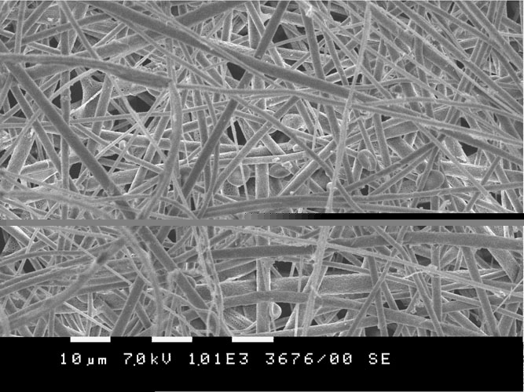
A |  |  | B
DFig. 4. SEM micrographs of PLLA (A, B) and PLLA/PEG (C, D) mats after contact with blood (1 h):
pristine (A, C) and triple-coated with chitosan (crosslinked) (B, D). Reproduced from Spasova et al. [22]
by permission of Wiley-VCH Verlag GmbH & Co. KGaA, Germany.

AC | B
C | D
Fig. 5. SEM micrographs of S. aureus cells adhered on PLLA mat: pristine (A) and triple-coated with chitosan (crosslinked) (B); PLLA/PEG (70/30) mat: pristine (C) and triple-coated with chitosan (crosslinked) (D).
Reproduced from Spasova et al. [22] by permission of Wiley-VCH Verlag GmbH & Co. KGaA, Germany.

As expected a significant number of adhered cells are observed on the PLLA mats (more than 200 cells per 100 mm²). Triple coating of PLLA mats with chitosan led to a significant decrease in the number of adhered cells to ca. 5 cells per 100 mm². The increased hydrophilicity of PEG-con-taining fibres decreased the number of adhered bacterial cells (e.g., from more than 200 cells on the PLLA mat to 26 cells on the PLLA/PEG mat). Chitosan coating also resulted in significant decrease in the number of the adhered cells on the PLLA/PEG mat; the cell number was ca. 5 cells per 100 mm², which is the same as for chitosan-coated PLLA mats. The suppressing of the pathogenic cells adhesion combined with the haemostatic properties of the chitosan-coated PLLA and PLLA/PEG mats renders them very promising for use as wound dressings.
Conclusion
It has been shown that formation of defect-free chitosan nanofibres by electrospinning of chitosan aqueous solutions is feasible when poly(ethylene oxide) is added to the spinning solution. The incor-poration of antimicrobial drug in the fibres imparts microbicidal activity of the nanofibrous materials. Novel non-woven textiles are easily prepared by coating PLLA or PLLA/PEG mats with chitosan. The chitosan-coated materials possess haemostatic and antibacterial activity, and thus are promising candidates for healing applications enabling rapid cessation of bleeding and regeneration of injured tissue.
The propounded simple and efficient approaches for preparation of chitosan-containing nanofibrous materials by electrospinning are easily extendable for other polymer systems. The electrospinning of aqueous solutions of polyelectrolytes is facilitated by incorporation of a non-ionogenic polymer. The beneficial properties of a polymer used for prepa-ration of a scaffold with tuned properties may be easily combined with the properties of a second polymer using a combination of the electrospinning and coating techniques. The potential applications of the obtained nanofibrous mats are diversified by incorporation of bioactive substances thus obtaining novel materials with tuned biological activity.
M. G. Spasova et al.: Preparation of novel chitosan-containing micro- and nanofibrous materials
Acknowledgements: Financial support from the National Fund of Scientific Research (Grant NANOBIOMAT, NT 4-01/04) is acknowledged. The authors thank Dr. N. Markova (Institute of Micro-biology, Bulgarian Academy of Sciences) and Dr. D. Danchev (Department of Haemostasis, Military Medical Academy, Sofia) for their help in pe-rforming the biological tests. The authors thank Dr. N. Malinowski (Central Laboratory of Photopro-cesses, Bulgarian Academy of Sciences) for providing the SCI data.
References:
M. G. Spasova et al.: Preparation of novel chitosan-containing micro- and nanofibrous materials
- K. H. Lee, H. Y. Kim, M. S. Khil, Y. M. Ra, D. R. Lee, Polymer, 44, 1287 (2003).
- Z.-M. Huang, Y.-Z. Zhang, M. Kotaki, S. Ramakrishna, Composites Sci. Techn., 63, 2223 (2003).
- A. Greiner, J. H.Wendorff, Angew. Chem. Int. Ed., 46, 5670 (2007).
- D. H. Reneker, A. L. Yarin, H. Fong, S. J. Koombhongse, Appl. Phys., 87, 4531 (2000).
- M. M. Hohman, M. Shin, G. Rutledge, M. P. Brenner, Phys. Fluids, 13, 2221 (2001).
- Y. M. Shin, M. M. Hohman, M. P. Brenner, G. C. Rutledge, Polymer, 42, 9955 (2001).
- G. Peev, M. Spasova, R. Mincheva, I. Rashkov, J. Theor. Appl. Mechanics, 36, 43 (2006).
- M. Spasova, R. Mincheva, D. Paneva, N. Manolova, I. Rashkov, J. Bioact. Compat. Polym., 21, 465 (2006).
- D. Li, Y. Xia, Adv. Mater., 16, 1151 (2004).
- G. L. Bowlin, K. J. Pawlowski, J. D. Stitzel, E. D. Bowland, D. G. Simpson, J. B. Fenn, G. E. D. Wnek, in: “Tissue Engineering and Biodegradable Equivalents: Scientific and Clinical Applications”, K.-U. Lewandrowski, D. L. Wise, M. J. Yaszemski, J. D. Gresser, D. J. Trantolo, D. E. Altobelli, (Eds), Marcel Dekker, Inc., N.Y., 2002, chapter 9, p. 165–178.
- M. Bognitzki, W. Czado, T. Frese, A. Schaper, M. Hellwig, M. Steinhart, A. Greiner, J. H. Wendorff, Adv. Mater., 13, 70 (2001).
- K. Kim, M.Yu, X. Zong, J. Chin, D. Fang, Y. Seo, B. Hsiao, B. Chu, M. Hadjiargyrou, Biomater., 24, 4977 (2003).
- H. Yoshimoto, Y. M. Shin, H. Terai, J. P. Vacanti, Biomater., 24, 2077 (2003).
- W. J. Li, C. T. Laurencin, E. J. Caterson, R. S. Tuan, F. K. Ko, J. Biomed. Mater. Res., 60, 613 (2002).
- X. M. Mo, C. Y. Xu, M. Kotaki, S. Ramakrishna, Biomater., 25, 1883 (2004).
- R. N. Tharanathan, F. S. Kittur, Crit. Rev. Food. Sci. Nutr., 43, 61 (2003).
- M. Spasova, N. Manolova, D. Paneva, I. Rashkov, e-Polymers, no. 056, 1 (2004).
- R. Mincheva, N. Manolova, D. Paneva, I. Rashkov, J. Bioact. Compat. Polym., 20, 419 (2005).
- M. Ignatova, K. Starbova, N. Markova, N. Manolova, I. Rashkov, Carbohydr. Res., 341, 2098 (2006).
- M. Ignatova, N. Manolova, I. Rashkov, Eur. Polym. J., 43, 1112 (2007).
- R. Mincheva, N. Manolova, I. Rashkov, Eur. Polym. J., 43, 2809 (2007).
- M. Spasova, D. Paneva, N. Manolova, Ph. Radenkov, I. Rashkov, Macromol. Biosci., 8, 153 (2008).
- R. Mincheva, O. Stoilova, H. Penchev, T. Ruskov, I. Spirov, N. Manolova, I. Rashkov, Eur. Polym. J., 44, 615 (2008).
- B. Duan, C. Dong, X. Yuan, K. Yao, J. Biomater. Sci., Polym. Ed., 15, 797 (2004).
- K. Ohkawa, D. Cha, H. Kim, A. Nishida, H. Yamamoto, Macromol. Rapid Commun., 25, 1600 (2004).
- W. H. Park, L. Jeong, D. I. Yoo, S. Hudson, Polymer, 45, 7151 (2004).
- J. D. Schiffman, C. L. Schauer, Biomacromolecules, 8, 594 (2007).
- J. D. Schiffman, C. L. Schauer, Biomacromolecules, 8, 2665 (2007).
- M. Ignatova, N Manolova, I. Rashkov, Eur. Polym. J., 43, 1609 (2007).
- M. Ignatova, N. Markova, N. Manolova, I. Rashkov, J. Biomat. Sci. Polym. Ed. 19, 373 (2008).
- M. Spasova, O. Stoilova, N. Manolova, G. Altankov, I. Rashkov, J. Bioact. Compat. Polym., 22, 62 (2007).
- O. Stoilova, C. Jérôme, C. Detrembleur, A. Mouithys-Mickalad, N. Manolova, I. Rashkov, R. Jérôme, Chem. Mater., 18, 4917 (2006).
- O. Stoilova, C. Jérôme, C. Detrembleur, A. Mouithys-Mickalad, N. Manolova, I. Rashkov, R. Jérôme, Polymer, 48, 1835 (2007).
- W. S. Rasband, Image J, U. S. Nat. Inst. Health, Bethesda, Maryland, USA, http://rsb.info.nih.gov/ij/ (1997-2006).
- A. Nikolova, N. Manolova, I. Rashkov, Polym. Bull., 41, 115 (1998).
- L. S. Nair, C. T. Laurencin, Progr. Polym. Sci. 32, 762 (2007).
- E. R. Kenawy, G. L. Bowlin, K. Mansfield, J. Layman, D. G. Simpson, E. H. Sanders, G. E. Wenk, J. Control. Rel. 81, 57 (2002).
- L. G. Harris, L. Mead, E. Muller-Oberlander, R. G. Richards, Eur. Cell. Mater., 10, 24 (2005).
- A. Razatos, T. Ong, F. Boulay, D. L. Elbert, J. A. Hubell, M. M. Sharma, G. Georgiou, Langmuir, 16, 9155 (2000).
- Y. Chung, Y. Su, C. Chen, G. Jia, H. Wang, J. Wu, J. Lin, Acta Pharmacol. Sin., 25, 932 (2004).
- H. S. Whang, W. Kirsh, Y. H. Zhu, C. Z. Yang, S. M. Hudson, J. Macromol. Sci., Polym. Rev., 45, 309 (2005).
- D. Paneva, N. Manolova, I. Rashkov, D. Danchev, J. Bioact. Compat. Polym., 20, 133 (2005).
- R. Mincheva, N. Manolova, D. Paneva, I. Rashkov, Eur. Polym. J., 42, 858 (2006).

Получаване на нови хитозан-съдържащи микро- и нановлакнести материали чрез електроовлакняване
М. Г. Спасова, Д. П. Панева, Н. Ем. Манолова, Ил. Б. Рашков*
Лаборатория „Биологично активни полимери“, Институт по полимери,
Българска академия на науките, 1113 София
Посветена на акад. Иван Юхновски по повод на 70-та му годишнина
Постъпила на 4 януари 2008 г.; Преработена на 16 януари 2008 г.
(Резюме)
Електроовлакняването е производителна и лесно осъществима техника за получаване на нанoвлакна. Тази публикация представлява обзор, посветен на този метод, като особено внимание е отделено на нановлакнести материали на основата на хитозан. За първи път са предложени два лесно осъществими подхода за получаване на микро- и нановлакнести материали, съдържащи природния полимер хитозан. Първият подход се основава на електроовлакняване на смесени разтвори на хитозан и нейоногенен полимер. Средните стойности на диаметъра на нановлакната варират между 40 и 290 nm. Вторият подход се състои в покриване на електроовлакнени нановлакнести матове от поли(L-лактид) или поли(L-лактид)/полиетиленгликол с хитозан. Оценени са потенциалните приложения на тези нови материали в областта на биомедицината и по-специално тяхното приложение като системи за доставяне на лекарствени средства и като покрития за лечение на рани.

