Solid-state polarized IR-spectroscopic study of high temperature red phase of
5-amino-2-methoxypyridine ester amide of squaric acid ethyl ester
Bulgarian Chemical Communications, Volume 40, Number 4 (pp. 477–482) 2008
© 2008 Bulgarian Academy of Sciences, Union of Chemists in Bulgaria
E. D. Cherneva¹, Ts. M. Kolev^{1,2}*
* To whom all correspondence should be sent:
E-mail: kolev@uni-plovdiv.bg
¹ Department of Structural Organic Analysis, Institute of Organic Chemistry with Centre of Phytochemistry,
Bulgarian Academy of Sciences, Acad. G. Bonchev St., Block 9, 1113 Sofia, Bulgaria
² Plovdiv University, Department of Organic Chemistry, 24 Tzar Assen St., Plovdiv 4000, Bulgaria
Dedicated to Academician Ivan Juchnovski on the occasion of his 70th birthday
Received January 6, 2008; Revised March 19, 2008
5-Amino-2-methoxypyridine ester amide of squaric acid ethyl ester is stabilized into two stable solid phases depending on the temperature. Yellow solid phase, which crystallizes at T = 298K, is characterized with noncentro-symmetric space group Cc, a pseudo-layer structure with molecules linked by moderate NH…O=C intermolecular hydrogen bonds (2.955 Å). Amorphous red solid phase is obtained as a result of phase transition at 200ºC, which structure and IR-spectroscopic elucidation is performed by means of linear-polarized IR-spectroscopy of oriented colloid suspensions in nematic mesophase.
Key words: IR-LD spectroscopy, colloid suspension, structural elucidation, high temperature solid phase.

Introduction
Electro-optical and nonlinear optical properties of organic molecules and crystals are of great interest for applications in the communication technology, owing to the tendency to replace classical electronic materials with suitable organic crystals [1–3]. In some cases squaric acid deriva-tives display a possibility to crystallize in noncen-trosymmetric space groups, meaning that such com-pounds can exhibit second order NLO properties in the bulk. This prompts us to design novel squaric acid derivatives with heterocyclic compounds.
5-Amino-2-methoxypyridine ester amide of squaric acid with second order NLO application in bulk has been synthesized, spectroscopically and structurally elucidated by means of single crystal X-ray diffract-tion, solid-state linear polarized IR-spectroscopy, UV-spectroscopy, mass spectrometry, and thermal methods [4]. At room temperature (solid phase 1, Scheme 1) the compound crystallizes in the noncen-trosymmetric space group Cc and exhibits a pseudo-layer structure with molecules linked by NH…O=C intermolecular hydrogen bonds with length of 2.955 Å and NH…O angle of 153.41º, respectively. The performed thermal analysis (Fig. 1) has been shown [4] that an initial distinct endothermic process followed by two overlapping exothermic calori-metric peaks takes place during heating. The endo-thermic peak with T_{max} = 143.5ºC has been asso-ciated with substance melting with an enthalpy of 155 J/g. The next broad exothermic DSC effect, which is partially overlapped with a second exo-thermic process, has been associated with a larger enthalpy change. The second exothermic process has ended at 200ºC, with a formation of second red solid phase 2 (Scheme 1). Using the conventional solid-state IR-spectroscopy, it has been proposed new intermolecular NH…N interactions in the last phase.
Fig. 1. DSC data of solid phase 1 [4].
In this paper we report IR-spectroscopic and structural elucidation of solid phase 2 by means of a linear-polarized IR-spectroscopy of oriented colloid suspensions in nematic liquid crystal [5–8]. For systems where is impossible to obtain suitable singe crystals for X-ray diffraction study, like the presented one, the spectroscopic method is appeared to be unique for IR-band assignment and obtaining of structural information in condense phase.
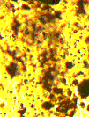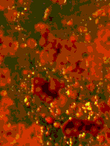
Yellow solid phase 1. Red solid phase 2.
Scheme 1. Chemical diagram of compound studied;
solid phases 1 and 2.
Experimental
Synthesis
The starting compound, 5-amino-2-methoxy-pyridin ester amide of squaric acid ethyl ester (solid phase 1) was synthesized according to the procedure described in [4]. IR and UV-Vis spectroscopy confirmed the purity of the compound. The most intensive signal in the mass spectrum is that of the peak at m/z 249.29, corresponding to the singly charged cation [C₁₂H₁₃N₂O₄]⁺ with a molecular weight of 249.24. The solid phase 2 was obtained by heating of solid phase 1 at 200ºC at Pt-crucible. It was also obtained after heating of the starting compound in glass capillary. Our attempts to receive suitable single crystals of this phase have failed due to the formation of solid phase 1 after dissolving of the solid phase 2.
E. D. Cherneva and Ts. M. Kolev: Solid-state polarized IR-spectroscopic study ….
Materials and methods
IR-spectroscopic measurements within 4000–400 cm^{–1} range were obtained on a Thermo Nicolet 6700 FT-IR spectrometer (resolution 1 cm^{–1}, 250 scans). A Specac wire-grid polarizer was used. Oriented solid samples were obtained as a colloid suspension in a nematic liquid crystal of the 4’-cyano-4’-alkylbicyclohexyl type (ZLI 1695, Merck), meso-morphic at room temperature. Its weak IR-spectrum permits recording of the guest-compound IR-bands in the whole 4000–400 cm^{–1} range. The isolated nitrile stretching IR-band at 2236 cm^{–1} serves addi-tionally as an orientation indicator. The effective orientation of the samples was achieved through the new procedure described in [5–8]. The procedure for the position (ν_{i}) and integral absorbances (A_{i}) determination for each i-peak has been carried out by deconvolution and curve-fitting procedures at 50:50% ratio of Lorentzian to Gaussian peak func-tions, γ² factors about 10^{–5} and 2000 iterations [7, 8]. The means of two treatments were compared by Student t-test. The experimental IR-spectral patterns have been acquired and processed by GRAMS/AI 7.01 IR spectroscopy (Thermo Galactic, USA) and STATISTICA for Windows 5.0 (StatSoft, Inc., Tulsa, OK, USA) program packages. The theoretical approach, experimental technique for preparing the samples, procedures for polarized IR-spectra inter-pretation and the validation of this new linear-dichroic infrared (IR-LD) orientation solid-state method for accuracy and precision have been presented. The influence of the liquid crystal medium on peak positions and integral absorbances of the guest molecule bands, the rheological model, the nature and balance of the forces in the nematic liquid crystal suspension system, and morphology of the suspended particles have been also discussed [6–8].
Spectroscopic and structural results were obtained by the orientation technique [5–8] using the known reducing-difference procedure designated as “step-wise reduction” for polarized IR-spectra interpret-tation. This method was primarily suggested by Thulstrup and Eggers for polarized UV-spectral interpretation [9]. The procedure consists in con-secutive elimination of the spectral bands of a given polarization by means of subtracting the perpen-dicular spectrum multiplied by a coefficient from the parallel one. This procedure was extended by Spanget-Larsen [10] and by Korte and Lampen [11] to samples orientated in stretched polyethylene and nematic solution, respectively. A systematic analysis of this approach and its application to IR-bands assignment according to their symmetry appur-tenance was developed by B. Jordanov and co-workers [12–15] for polarized IR-spectra in nematic liquid crystal solution. The method consists of sub-traction of the perpendicular spectrum, (IR_{s}, resulting from a 90º angle between the polarized light beam electric vector and the orientation of the sample) from the parallel one (IR_{p}) obtained with a co-linear mutual orientation. The recorded difference (IR_{p}–IR_{s}) spectrum divides the corresponding parallel (A_{p}) and perpendicular (A_{s}) integrated absorbencies of each band into positive values originating from transition moments, which form average angles with the orientation direction (n) between 0º and 54.7º (magic angle), and negative ones corresponding to transition moments between 54.7º and 90º. In the reducing-difference procedure, the perpendicular spectrum multiplied by the parameter c, is sub-tracted from the parallel one and c is varied until at least one band or sets of bands are eliminated. The simultaneous disappearance of these bands in the reduced IR-LD spectrum (IR_{p}–cIR_{s}) obtained indi-cates co-linearity of the corresponding transition moments, thus, yielding an information regarding the mutual disposition of the molecular fragments.
Solid-state ultraviolet spectra were recorded on a Tecan Safire Absorbance/Fluorescence XFluor 4 V 4.40 spectrophotometer operating between 190 and 900 nm.
Results and discussion
The non-polarized IR-spectra of both solid phases 1 and 2 are depicted in Figs. 2.1 and 2.2. Solid phase 1 is characterized by an intensive band at 3262 cm^{–1} belonging to stretching ν_{NH} mode [4]. The bands at 1798 and 1694 cm^{–1} belong to ν^{s}_{C=O(Sq)} and ν^{as}_{C=O(Sq)} vibrations of squaric acid fragment. The pyridinium in-plane (i.p.) and out-of-plane (o.p.) maxima are observed at 1608, 830, 746, 722 cm^{–1} and the broad one within 730–710 cm^{–1} region. The relatively intensive band at 777 cm^{–1} belongs to the i.p. mode of the pyridine ring. In contrast to Raman spectra [16, 17], the discussed peaks are relatively high intensive and have been used for the
purpose of IR-LD spectroscopy [4]. According to crystallographic data, the molecules in solid phase 1 are joined into infinite parallel pseudo layers (Sche-me 2) by moderate intermolecular NH…O=C_{(Sq)} hydrogen bonds of length 2.955 Å and NH…O angle of 153.41º. This result explains the relatively low frequency shifting of both ν_{NH} and ν_{C=O(Sq)} IR-bands in the corresponding spectra (Fig. 2.1).
To define the nature of the second solid phase 2, a comparison between the IR-spectrum of Solid phase 1 is carried out. In the high temperature phase (Fig. 2.2) the ν_{NH} band is absent and a broad mul-tiple maximum is observed within 3500–2500 cm^{–1}. The observed high frequency shift of 21 cm^{–1} for ν^{as}_{C=O(Sq)} of the squaric acid fragment, and the opposite shift for  γ_{C=O} of 33 cm^{–1} suggest that these are not affected by intermolecular interactions. An intensive absorption band at 1587 cm^{–1} belonging to δ_{NH} is shifted by 12 cm^{–1} in the discussed phase. The i.p. modes of pyridine ring are low affected, resulting to an observation of the IR-band shifting within 2–6 cm^{–1}. These data proposed that the high temperature phase transition leads to a formation of new red solid phase 2, where strong NH…N_{Py} intermolecular bonds are predominating (Scheme 3).
E. D. Cherneva and Ts. M. Kolev: Solid-state polarized IR-spectroscopic study ….

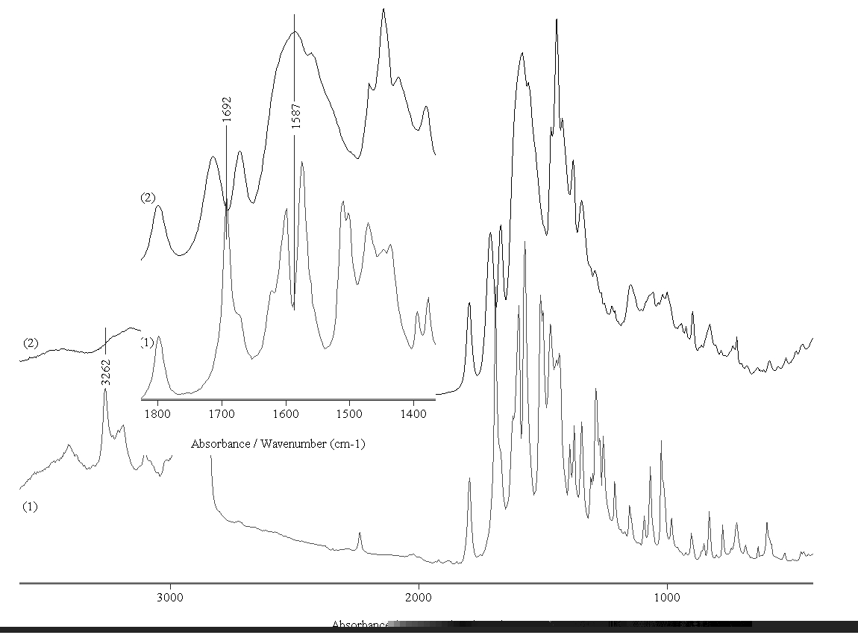
Fig. 2. Non-polarized IR-spectra of solid phase 1 (1) and 2 (2).

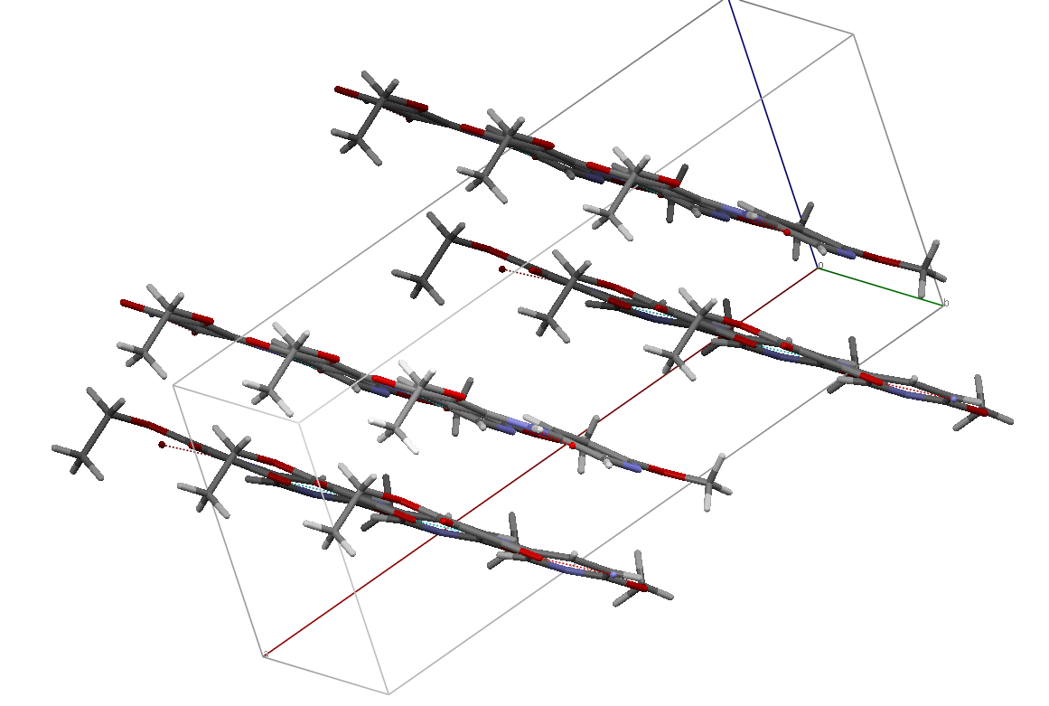
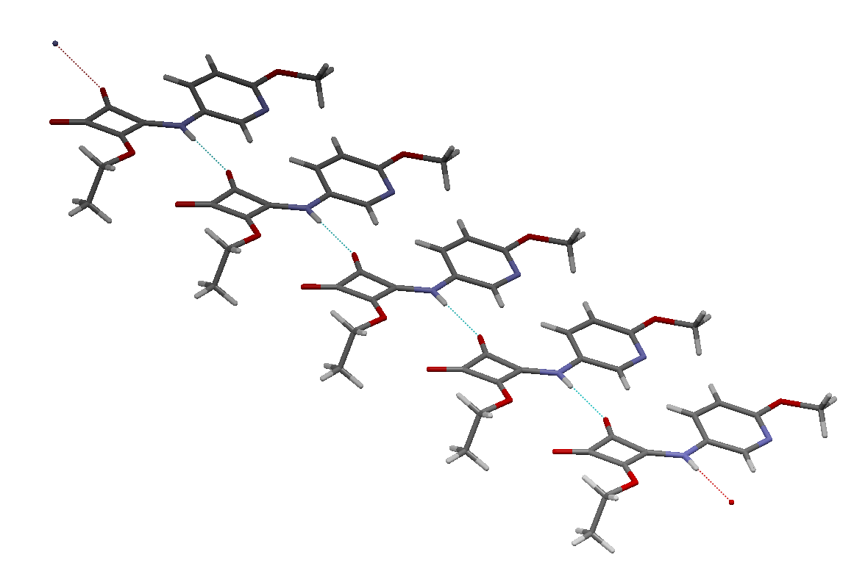
Scheme 2. Hydrogen bonding in solid phase 1.
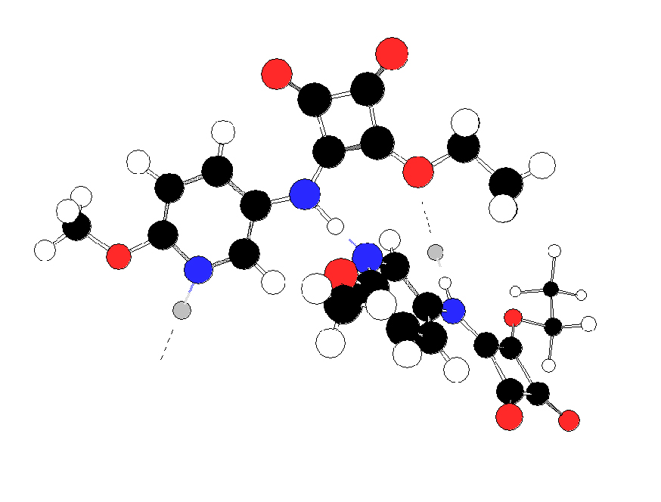
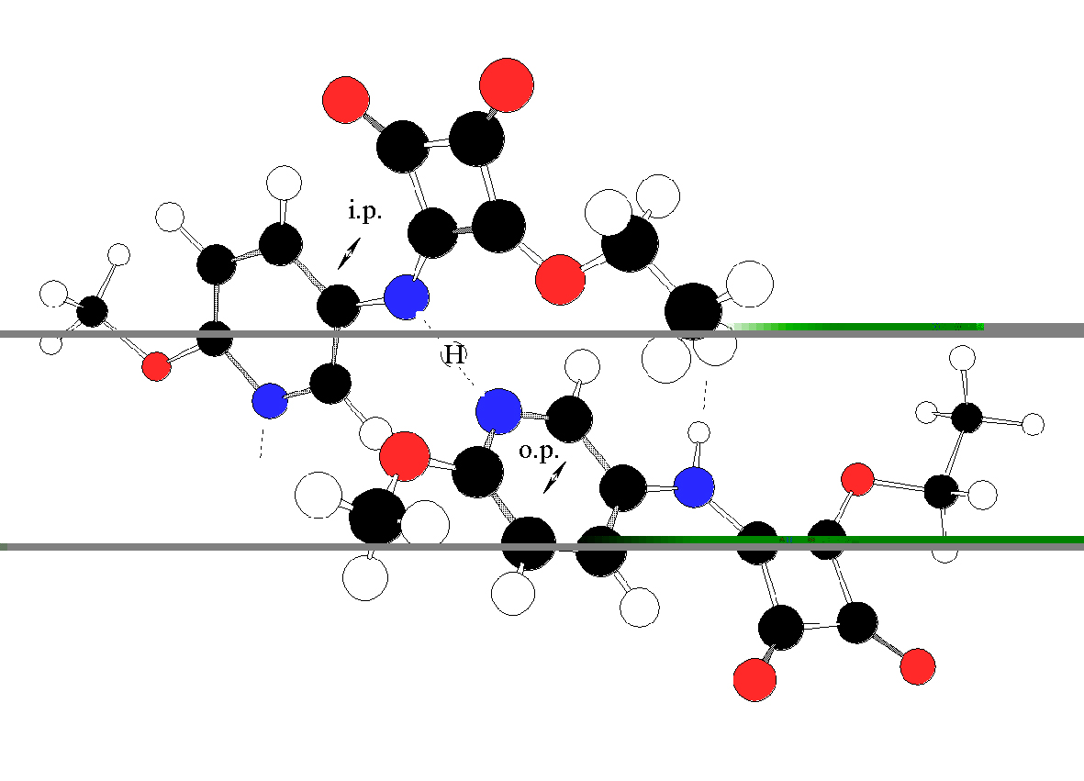
Scheme 3. Intermolecular interactions in solid phase 2.
Moreover, the absence of well-defined isolated band of ν_{NH}, typical for solid phase 1, and an obser-vation of the broad band within 3500–2500 cm^{–1} as well as the intensive broad band at 1587 cm^{–1}, typical for full or partially charged amines, proposed strong intermolecular NH…N_{Py}, which has been observed in a series of papers dealing with proto-nated heterocyclics [18–20] or in 4-aminopyri-dinium hemiperchlorate, where the NH bonds in the NH…N interaction is equalized and H- is fixed at an equal distance of both the N-atoms [21]. Additional confirmation of the last assumption follows as well from the obtained more than 100 nm batochromic sift of λ_{max} in the solid red phase, typical for push-pull systems [1–3].
The above stated vibrational assignment is expe-rimentally proved by the polarized IR-spectroscopic study. Moreover, an interesting result is obtained in addition. In contrast to solid phase 1, where the elimination of o.p. modes leads to a total vanishing of the corresponding IR-bands of same symmetry class [4], the elimination of the corresponding bands in solid phase 2 as well as the ν^{s}_{C=O(Sq)} stretching modes leads to an observation of second bands of same symmetry class. As can be seen the elimi-nation of each of the well-defined by deconvolution and curve-fitting procedures bands at 1803 and 1795 cm^{–1} leads to an observation of numbering maxi-mum (Figs. 3.2 and 3.3).
E. D. Cherneva and Ts. M. Kolev: Solid-state polarized IR-spectroscopic study ….
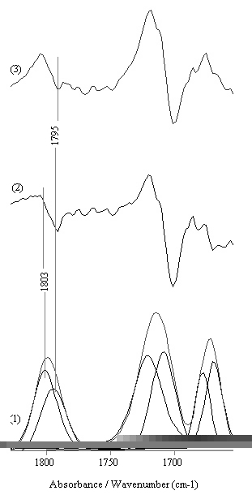
Fig. 3. Curve-fitted IR-spectrum (1) of solid phase 2
(χ² values less then 8×10^{–4}) within 1850–1650 cm^{–1} and reducing IR-LD spectra after elimination of the bands at 1803 cm^{–1} (2) and 1795 cm^{–1} (3).
On the other hand, the elimination of the bands about 1600 and 835 cm^{–1} at equal dichroic ratio in addition confirms the assumption stated above, due to in the frame of one isolated molecule is impos-sible to be eliminated IR-bands with i.p. and o.p. symmetry classes. This phenomenon has been observed in systems, where the unit cell contains mutual perpendicular oriented molecules [22, 23]. These results proposed that the second phase 2 is characterized by infinite zig-zag chains of mole-cules, connected by strong NH..N_{Py} hydrogen bonds (Scheme 3). In the frame of these chains the mole-cule of 5-amino-2-methoxypyridin ester amide of squaric acid ethyl ester is with low influenced con-formation, because of our thermal analysis, shows only a small thermal process at 94ºC with shape, indicating a second order phase transformation, explained by the liberation of a rotation around the C–N bond [4].
Conclusion
By means of linear-polarized IR-spectroscopy of oriented colloid suspensions in nematic host, the IR-spectroscopic and structural elucidation of the high temperature solid phase of 5-amino-2-methoxy-pyridine ester amide of squaric acid is preformed. In contrast to the solid phase obtained at room temperature, where a pseudo-layered structure is stabilized by intermolecular NH…O=C intermo-lecular hydrogen bonds with length of 2.955 Å [4], in the high temperature phase strong NH…N_{Py} interactions are predominant. As a result of the solid phase transition, the layered structure is distorted and infinite zig-zag chains are typical.
Acknowledgments: This work has been supported financially by the Bulgarian National Fund of Scientific Research, Contract X– 1510.
E. D. Cherneva and Ts. M. Kolev: Solid-state polarized IR-spectroscopic study ….
Reference
- D. Chemla, J. Zyss, Nonlinear Optical Properties of Organic Molecules and Crystals, Vol. 1, D. Chemla, J. Zyss (Eds), Academic Press, New York, 1987, pp. 23–187.
- H. Nalwa, T. Watanabe, S. Miyata, Nonlinear Optics of Organic Molecules and Polymers, H.S. Nalwa, S.
Miyata, (Eds.) CRC Press, Boca Raton, 1997,
pp. 89–329.
- J. J. Wolf, R. Wortmann, Adv. Phys. Org. Chem, 32 (1999) 121.
- T. Kolev, B. B. Koleva, T. Spassov, E. Cherneva, M. Spiteller, H. Mayer-Figge, W. S. Sheldrick, J. Mol. Struct., (2007), (in press), doi:10.1016/j.molstruc. 2007.05.005.
- B. B. Ivanova, M. G. Arnaudov, P. R. Bontchev, Spectrochim. Acta, 60A, 855 (2004).
- B. B. Ivanova, D. L. Tsalev, M. G. Arnaudov, Talanta, 69, 822 (2006).
- B. B. Ivanova, V. D. Simeonov, M. G. Arnaudov, D. L. Tsalev, Spectrochim Acta, 67A, 66 (2007).
- B. B. Koleva, T. Kolev, V. Simeonov, T. Spassov, M. Spiteller, J. Inclusion Phenom. Macrocyclic Chem., 61, 319 (2008).
- E. W. Thulstrup, J. H. Eggers, Chem. Phys. Lett., 1, 690 (1996).
- J. Spanget-Larsen, SPIE, 1575, 404 (1992).
- E. H. Korte, P. Lampen, Private communications (1988).
- B. Jordanov, R. Nentchovska, B. Schrader, J. Mol. Struct., 297, 401 (1993).
- B. Jordanov, B. Schrader, J. Mol. Struct, 347, 389 (1995).
- M. Belhakem, B. Jordanov, J. Mol. Striuct., 218, 309 (1990).
- M. Rogojerov, D. Kolev, B. Jordanov, J. Mol. Striuct., 349, 447 (1995).
- S. G. de Miranda, P. A. M. Vazquez, J. Braz. Chem. Soc., 13, 3 (2002).
- H. Torii, M. Tasumi, J. Mol. Struct. (Theochem), 334, 15 (1995).
- B. B. Ivanova, Spectrochim. Acta, Part A, 62, 58 (2005).
- B. B. Ivanova, M. G. Arnaudov, H. Mayer-Figge, Polyhedron, 24, 1624 (2005).
- B. B. Koleva, T. Kolev, T. Tsanev, St. Kotov, H. Mayer-Figge, R. W. Seidel, W. S. Sheldrick, J. Mol. Struct., (2007), (in press) DOI: http://dx.doi.org/ 10.1016/j.molstruc.2007.09.006
- P. Teulon, R. G. Delaplane, I. Olovsson, J. Rozière, Acta Cryst., C41, 479 (1985).
- B. B. Koleva, E. N. Trendafilova, M. G. Arnaudov, W. S. Sheldrick, H. Mayer-Figge, Trans. Met. Chem., 31, 866 (2006).
- B. B. Ivanova, H. Mayer-Figge, J. Coord. Chem., 58, 653 (2005).

Поларизационно ИЧ-спектрално изследване на високотемпературната „червена“ фаза на 5-амино-2-метоксипиридин естер амид на етиловия естер на квадратната киселина
E. Д. Чернева¹, Ц. M. Kолев^{1,2}*
¹ Институт по органична химия с център по фитохимия, Българската академия на науките,
ул. „Акад. Г. Бончев“, бл. 9, 1113 София,
² Пловдивски университет, Катедра „Органична химия“, ул. „Цар Асен“ № 24, 4000 Пловдив
Посветена на акад. Иван Юхновски по повод на 70-та му годишнина
Постъпила на 6 януари 2008 г.; Преработена на 19 март 2008 г.
(Резюме)
В наша предишна работа бе установено, че съединението 5-амино-2-метоксипиридин естер амид на етиловия естер на квадратната киселина се стабилизира в две твърди фази в зависимост от температурата. Така наречената „жълта“ фаза изкристализира при температура T = 298K и се характеризира с нецентросиметрична пространствена група Cc, а молекулите образуват псевдослоеста структура посредством междумолекулни NH…O=C водородни връзки (2.955 Å). Втората, аморфна „червена“ фаза се получава в резултат на фазов преход при температура от 200ºC. Нейното спектрално охарактеризиране бе извършено използвайки възмож-ностите на поларизационната ИЧ-спектроскопия на ориентирани колоидни суспензии в нематичен течен кристал.

