Ab initio and DFT study of the structure of metal ion complexes with
N-benzalaniline-15-crown-5
Bulgarian Chemical Communications, Volume 40, Number 4 (pp. 532–537) 2008
© 2008 Bulgarian Academy of Sciences, Union of Chemists in Bulgaria
V. Enchev^{1,}*, S. Angelova¹, N. Markova¹, I. Wawer², E. Stanoeva³, M. Mitewa³
* To whom all correspondence should be sent:
E-mail: venelin@orgchm.bas.bg
¹ Institute of Organic Chemistry with Centre of Phytochemistry, Bulgarian Academy of Sciences, 1113 Sofia, Bulgaria
² Faculty of Pharmacy, Medical University of Warsaw, Warsaw, Poland
³ Department of Chemistry, University of Sofia, 1 James Bourchier Blv., 1164 Sofia, Bulgaria
Dedicated to Academician Ivan Juchnovski on the occasion of his 70th birthday
Received January 30, 2008; Revised February 7, 2008
The structures of N-(4-benzalaniline)-15-crown-5 and N-(4’-benzalaniline)-15-crown-5 and their Li⁺, Na⁺, K⁺, Be²⁺, Mg²⁺, Ca²⁺, Sr²⁺ and Ba²⁺ complexes are optimized using ab initio and DFT methods. It was found that in all cases the M^{n+}–N distances (n = 1, 2) are longer than the average M^{n+}–O ones in the corresponding complexes and the metal–nitrogen distances in the alkali metal complexes are longer than these in alkaline earth ones. The Li⁺, Na⁺, Mg²⁺ and Ca²⁺ cations fit to cavity size of the crown while the K⁺, Sr²⁺ and Ba²⁺ cations, whose size is greater than the diameter of the macrocycle cavity, protrude from the macrocycle. In all cases the conformation of the crown ether does not change except the Be²⁺ complex, where the conformation of the macrocycle is strongly deformed.
Key words: N-benzalaniline-15-crown-5, ab initio, Li⁺, Na⁺, K⁺, Be²⁺, Mg²⁺, Ca²⁺, Sr²⁺, Ba²⁺ metal ions.

Introduction
Crown ethers are widely used as complexing agents that can capture selectively metal cations in their cavity. Their ability to bind metal cations depends on the cavity size, the nature of hetero-atoms and substituents in the macrocycle. The ability of crown ethers to selectively bind cations makes them valuable components for constructing cation-sensing molecular or supramolecular probes [1]. The effects of metal coordination on the photo-sensitive and spectral properties of crown ether complexes have been studied [2–6].
During the last decades there is a constant interest in the design of new chromo- and fluoroio-nophores incorporating a N-phenylaza macrocycle moiety due to the change of their absorption and emission properties upon complexation and thus serving as optical sensors [7–9].
It is suggested that due to conjugation between the lone electron pair of the endocyclic nitrogen atom and the aromatic system a charge transfer (CT) is realized (the chromophoric system usually being acceptor) resulting in the appearance of intense CT band in the UV-Vis spectrum [10–14]. However, the coordination capacity of the macrocycle is lowered and the corresponding stability constants are much lower than these with the parent macrocycle [11, 12]. Taking into account that the conjugation should depend on the acceptor properties of the chromo-phoric group, we have designed and synthesized new N-benzalaniline-15-crown-5 derivatives, con-taining a weak acceptor group, namely a Schiff base [15]. The obtained stability constant data confirm the supposition for the formation of relatively stable complexes [15]. The goal of this paper is to study the complexation of these new N-benzalaniline-15-crown-5 derivatives with alkali and alkaline earth metal ions. Ab initio and DFT calculations on the structure of N-(4’-benzalaniline)-15-crown-5 and N-(4-benzalaniline)-15-crown-5, and their complexes with alkaline and alkaline earth metal ions were performed and the results obtained are discussed in the present paper.
Computational details
Geometry optimization of the structure of the compounds investigated was performed by ab initio methods and by density functional theory. The ab initio calculations were carried out using the PC GAMESS version [16] of the GAMESS (US) quan-tum chemistry program package [17]. The structure optimizations for the N-(4-benzalaniline)-15-crown-5 (L1) and N-(4’-benzalaniline)-15-crown-5 (L2) (Fig. 1), and their Li⁺, Na⁺, K⁺, Be²⁺, Mg²⁺, Ca²⁺, Sr²⁺ and Ba²⁺ complexes were performed at a restricted Hartree-Fock (RHF) level without any symmetry constrains (C₁ symmetry was assumed). The mean gradient threshold was 0.0001 hartree/Bohr. The ab initio calculations were carried out with the Stewens-Basch-Krauss-Jasien effective core poten-tials (ECP) and their concomitant basis sets for all the atoms (ECP-31G) [18, 19]. The DFT geometry optimizations using Becke’s three parameter hybrid functional (B3LYP) [20] and 6-31G(d) basis set [21] were also performed. The DFT geometry optimiza-tion was carried out using the Gaussian 98 program package [22]. The Sr²⁺ and Ba²⁺ complexes with L1 have not been optimized at this level of theory because of lack of basis sets for these elements.
¹³C NMR chemical shieldings were calculated using the GIAO (gauge-including atomic orbitals) approach [23] implemented in Gaussian 03 [24] at DFT level of theory using 6-31+G(d) and 6-31+G(d,p) basis sets. In order to compare with experiment, the calculated absolute shieldings were transformed to chemical shifts using the reference compound tetra-methylsilane (TMS): δ = δ_{calc}(TMS) – δ_{calc}. Both δ_{calc}(TMS) and δ_{calc} were evaluated with the same method and basis set.
Experimental
The ¹H and ¹³C NMR spectra and 2D ¹H/¹³C heteronuclear correlations for CDCl₃ solutions were recorded on a Varian Unity Plus-500 MHz spectro-meter. Cross polarization (CP) magic angle spinning (MAS) solid state ¹³C NMR spectra were recorded on a Bruker MSL-300 instrument at 75.5 MHz. Powder samples were spun at 8.4 kHz in 4 mm ZrO₂ rotor, a contact time of 1-4 ms, a repetition time of 6 s and a spectral width of 20 kHz were used for accumulation of 500-800 scans. Chemical shifts were calibrated indirectly through the glycine CO signal recorded at 176.0 ppm relative to TMS.
V. Enchev et al.: Ab initio and DFT study of the structure of metal ion complexes
N-(4-benzalaniline)-15-crown-5 was synthesized according to a procedure described in Ref. [14].
Results and Discussion
Structure of N-(4-benzalaniline)-15-crown-5
and N-(4’-benzalaniline)-15-crown-5
The structures of several free arylazacrown ethers have been studied by X-ray diffraction and they can be found in the Cambridge Structural Data-base [25–31]. We found that the conformation of the optimized structures for N-(4-benzalaniline)-15-crown-5 (L1) and N-(4’-benzalaniline)-15-crown-5 (L2) are close to the experimentally determined ones for aza-15-crown-5.
The optimized structure of N-(4-benzalaniline)-15-crown-5, L1, is shown in Fig. 2. It is evident that the macrocycle is positioned almost perpendicularly to the other part of the molecule. The dihedral angle between the planes of both benzene rings is 30 degrees. The optimized structure of N-(4’-benz-alaniline)-15-crown-5, L2, is similar to L1.
The N-(4-benzalaniline)-15-crown-5 was studied by NMR spectroscopy in solid state and in CDCl₃ solution. The ¹³C chemical shifts in the both cases are close because of the similarity in the confor-mations of the structure investigated in solution and in solid state.
Fig. 1. N-(4-benzalaniline)-15-crown-5 (L1) and
N-(4’-benzalaniline)-15-crown-5 (L2).
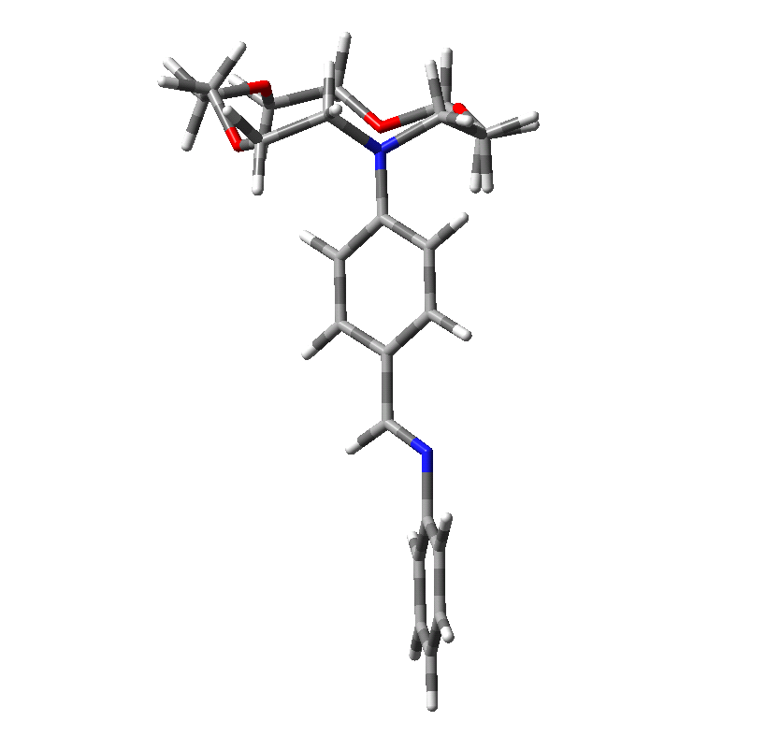
Fig. 2. B3LYP/6-31G(d) optimized structure of
N-(4-benzalaniline)-15-crown-5.
The lack of multiple resonances in the ¹³C NMR CPMAS spectrum of the solid N-(4-benzalaniline)-15-crown-5 indicates that there is one molecule in the asymmetric unit of the crystal. The resonances in the solid-state spectrum were assigned by comparing with solution data and B3LYP/6-31+G(d) and B3LYP/6-31+G(d,p) calculated chemical shifts. The experimental and calculated chemical shifts are collected in Table 1.
The broad signals appearing in the ¹³C spectrum of L1 indicate that dynamic processes involving aromatic rings are present in the spectra of the solids. The flip motion of the ring gives rise in the spectrum to the equivalence of the ortho and meta pair of CH resonances in the fast exchange limit. The C1, C4, C9 and C13 resonances are unaffected by this event, yield narrow resonances in all spectra and thus are easy to recognize. Broad resonances of C2, C7 (at 129.0 ppm) and of C3, C5 (at 120.9 ppm) in the spectrum of L1 indicate that the ring under-goes some reorientation, and these dynamics affect the NMR parameters.
Table 1. Experimental ¹³C and calculated carbon chemical shifts (ppm) of N-(4-benzalaniline)-15-crown-5. The num-bering of the atoms is given in Figure 1.
Atom | Experimental |  | Calculated
Atom | CDCl₃ | Solid state | B3LYP/  6-31+G(d) | B3LYP/  6-31+G(d,p)
C1 | 125.01 | 126.20 | 119.48 | 120.54
C2 | 129.02 | 129.00 | 124.20 | 125.30
C3 | 120.93 | 120.90 | 110.67 | 111.70
C4 | 150.18 | 150.30 | 149.49 | 151.48
C5 | 120.93 | 120.90 | 121.72 | 122.87
C7 | 129.02 | 129.00 | 123.26 | 124.33
C8 | 160.14 | 161.70 | 152.49 | 153.64
C9 | 124.15 | 122.60 | 128.31 | 130.36
C10 | 130.68 | 134.10 | 128.21 | 129.23
C11 | 130.68 | 127.00 | 122.92 | 124.03
C12 | 111.26 | 113.50 | 128.29 | 129.39
C13 | 152.75 | 153.60 | 145.94 | 147.82
C14 | 111.26 | 113.50 | 117.45 | 118.46
C16 | 52.72 | 55.00 | 57.65 | 58.08
C17 | 52.72 | 52.70 | 56.83 | 57.12
C18 | 68.28 | 66.70 | 68.96 | 69.40
C20 | 70.06 | 70.10 | 70.73 | 71.07
C21 | 70.25 | 70.10 | 72.21 | 72.61
C23 | 71.31 | 72.00 | 72.08 | 72.55
C24 | 71.31 | 72.00 | 73.71 | 74.11
C26 | 70.25 | 70.10 | 73.51 | 73.93
C27 | 70.06 | 70.10 | 72.13 | 72.60
C29 | 68.28 | 66.70 | 70.22 | 70.66
The results obtained with the two basis sets are close. The predictions of chemical shifts of atoms C3, C8, C9 and C12 are with relatively high average deviations because the dynamic processes in solu-tion and in solid state are not taken into account in calculations.
Considering the crown-ether moiety it becomes apparent that the resonances of the two methylene groups linked to the nitrogen atom appear at 52–55 ppm. In the solid state spectrum of L1 separate signals were observed, while in CDCl₃ solution only one signal at 52.72 was observed. The predicted values differ by about 1 ppm.
V. Enchev et al.: Ab initio and DFT study of the structure of metal ion complexes
Structure of N-(4-benzalaniline)-15-crown-5 and
N-(4’-benzalaniline)-15-crown-5 complexes
The geometry optimization of the complexes with the metal cations was started from the optimized conformation of the free N-(4-benzalaniline)-15-crown-5 and N-(4’-benzalaniline)-15-crown-5. We considered one mode of coordination and the type of cation was varied. The alkaline (Li⁺, Na⁺, K⁺) and alkaline earth (Be²⁺, Mg²⁺, Ca²⁺, Sr²⁺, Ba²⁺) metal ions were considered. The metal complexes of the crown ethers are studied in dry acetonitrile, because traces of water destroy the complexes (see [32] and references therein). In our computational study the influence of acetonitrile as solvent on the crown ethers and the complexes was not taken into account. The most important geometrical parameters of the studied complexes, metal-nitrogen and metal-oxygen distances, are presented in Tables 2 and 3.
The size-matching or size-selectivity effect is typical for the crown ethers and is commonly observed in their complexes with alkali and alkaline earth metal ions [34]. This effect is referred to as correspondence between the crown ether cavity size and the ion diameter of preferentially bound cations. Among the alkali cations, lithium and sodium fit best to L1 and L2 while potassium is located above the crown ether ring (the so-called “half-sandwich structure”) (Fig. 3).

Table 2. Selected ab initio and DFT calculated distances (Å) in N-(4-benzalaniline)-15-crown-5 complexes (M^{(n)+}–L1) (n = 1, 2). Available experimental data are also given.
Distances | M = Li⁺ |  | M = Na⁺ |  | M = K⁺ |  | M = Be²⁺ |  | M = Mg²⁺ |  |  | M = Ca²⁺ |  | M = Sr²⁺ | M = Ba²⁺
Distances | ECP | DFT | ECP | ECP | DFT | ECP | ECP | DFT | ECP | DFT | ECP |  | DFT | ECP | ECP
M–N15 | 2.561 | 2.437 | 2.555 (2.658)ª | 2.561 | 2.437 | 2.555 (2.658)ª | 1.808 | 1.788 | 2.208 | 2.215 | 2.467 |  | 2.498 | 2.598 | 2.867
M–O19 | 2.159 | 2.103 | 2.267 (2.330)ª | 2.159 | 2.103 | 2.267 (2.330)ª | 1.647 | 1.672 | 2.091 | 2.119 | 2.208 |  | 2.350 | 2.366 | 2.552
M–O22 | 2.248 | 2.319 | 2.369 (2.485)ª | 2.248 | 2.319 | 2.369 (2.485)ª | 1.666 | 1.668 | 2.112 | 2.110 | 2.234 |  | 2.386 | 2.420 | 2.629
M–O25 | 2.249 | 2.244 | 2.349 (2.443)ª | 2.249 | 2.244 | 2.349 (2.443)ª | 2.665 | 2.664 | 2.114 | 2.126 | 2.238 |  | 2.415 | 2.385 | 2.554
M–O28 | 2.214 | 2.176 | 2.315 (2.344)ª | 2.214 | 2.176 | 2.315 (2.344)ª | 1.667 | 1.669 | 2.099 | 2.127 | 2.222 |  | 2.377 | 2.393 | 2.596
a Ref. [33].
Table 3. Selected ab initio and DFT calculated distances (Å) in N-(4’-benzalaniline)-15-crown-5 complexes (M^{(n)+}–L2), (n = 1, 2).
Distances | M = Be²⁺ |  | M = Mg²⁺ |  | M = Ca²⁺ |  | M = Li⁺ |  | M = Na⁺ |  | M = K⁺
 | ECP | DFT | ECP | ECP | DFT | ECP | ECP | DFT | ECP | DFT | ECP | DFT
M–N15 | 1.781 | 1.790 | 2.275 | 1.781 | 1.790 | 2.275 | 2.523 | 2.441 | 2.551 | 2.472 | 3.007 | 2.921
M–O19 | 1.645 | 1.675 | 2.087 | 1.645 | 1.675 | 2.087 | 2.158 | 2.111 | 2.267 | 2.318 | 2.643 | 2.639
M–O22 | 1.651 | 1.673 | 2.105 | 1.651 | 1.673 | 2.105 | 2.255 | 2.283 | 2.370 | 2.357 | 2.753 | 2.728
M–O25 | 3.384 | 2.669 | 2.109 | 3.384 | 2.669 | 2.109 | 2.251 | 2.240 | 2.346 | 2.351 | 2.742 | 2.739
M–O28 | 1.640 | 1.672 | 2.098 | 1.640 | 1.672 | 2.098 | 2.219 | 2.195 | 2.319 | 2.318 | 2.670 | 2.674

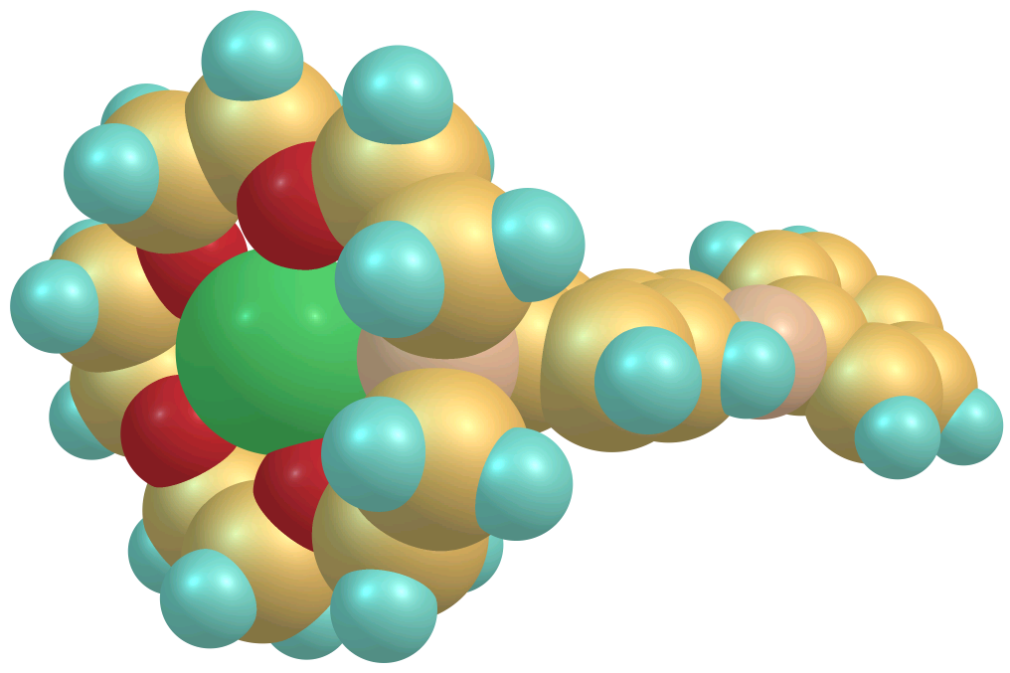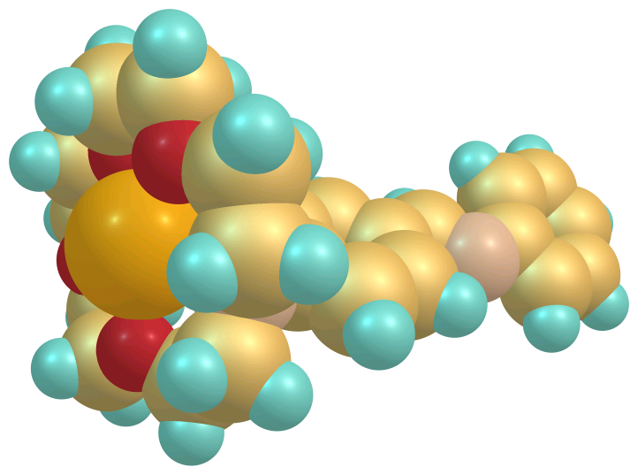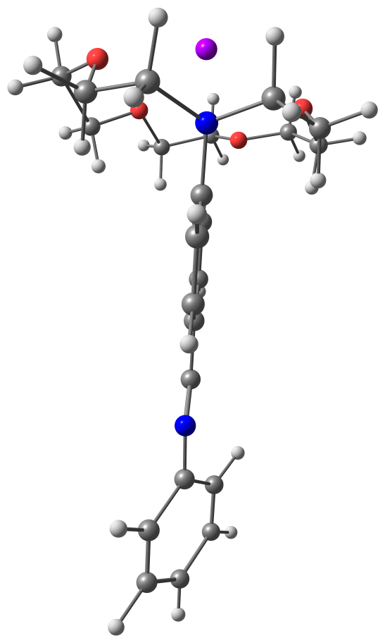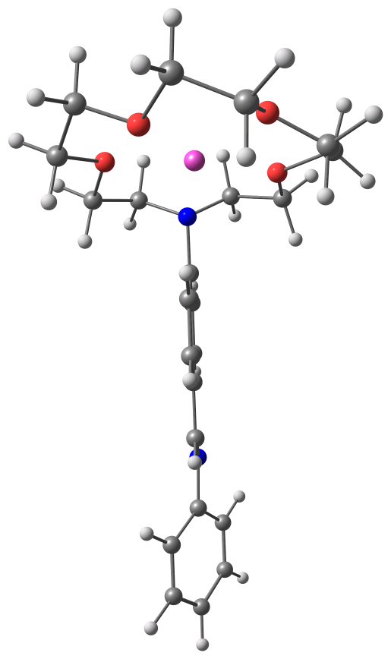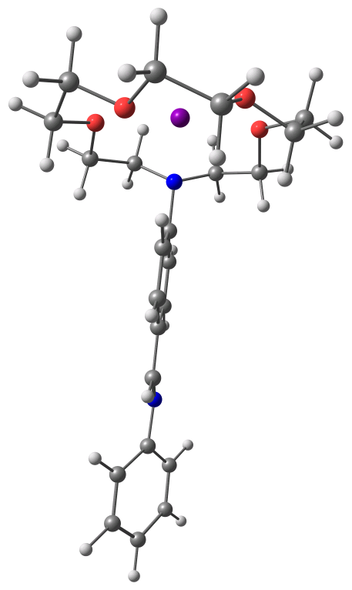
K⁺-complex
Na⁺-complex
Li⁺-complex
Fig. 3. Two projections of the B3LYP/6-31G(d) calculated structures of N-(4-benzalaniline)-15-crown-5 complexes (M⁺–L1).

Among the alkaline earth cations, magnesium fits to the cavity size of L1 and L2. Calcium is located somewhat below the crown ether ring. Strontium and barium like potassium are located above the crown ether ring. We found that for the smallest Be²⁺ cation (ion radius 0.27 Å [35]) the macrocycle conformation is changed (Fig. 4).
The calculated M^{n+}–O and M^{n+}–N distances (n = 1, 2) are given in Tables 2 and 3. As can be seen, in all cases the M^{n+}–N bonds are longer than the corresponding average M^{n+}–O bonds. These data are indicative of a weaker interaction of M^{n+} with the nitrogen lone electron pair, e.g. the coordination is realized mainly via the oxygen atoms. It should be mentioned also that in the Be²⁺ complex, one of the oxygen atoms (namely O25) practically is not
involved in coordination (Tables 2 and 3).
Conclusion
The cations, whose size is equal to the size of the macrocycle (Li⁺, Na⁺, Mg²⁺) fit to cavity size of the crown. The Ca²⁺ is situated slightly below the crown ether ring. The cations, whose size is greater than the diameter of the macrocycle cavity (K⁺, Sr²⁺, Ba²⁺) protrude from the macrocycle. The complexation does not change the conformation of the macro-cycle. However, the conformation of the crown ether ring is strongly deformed for the complex of the smallest dication (Be²⁺). The dications are stronger bound to crown ethers than the monocations. The metal–nitrogen distance in the alkali metal com-plexes are longer than these in alkaline earth ones.
V. Enchev et al.: Ab initio and DFT study of the structure of metal ion complexes

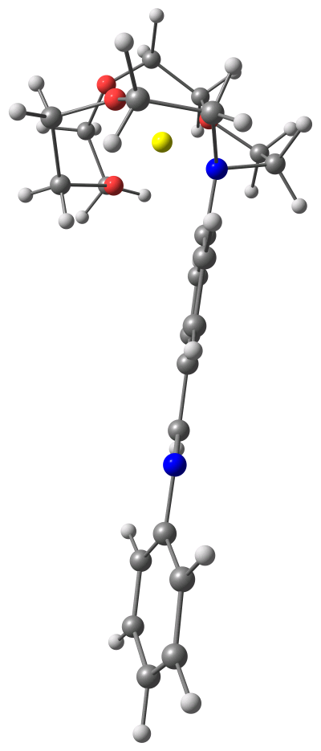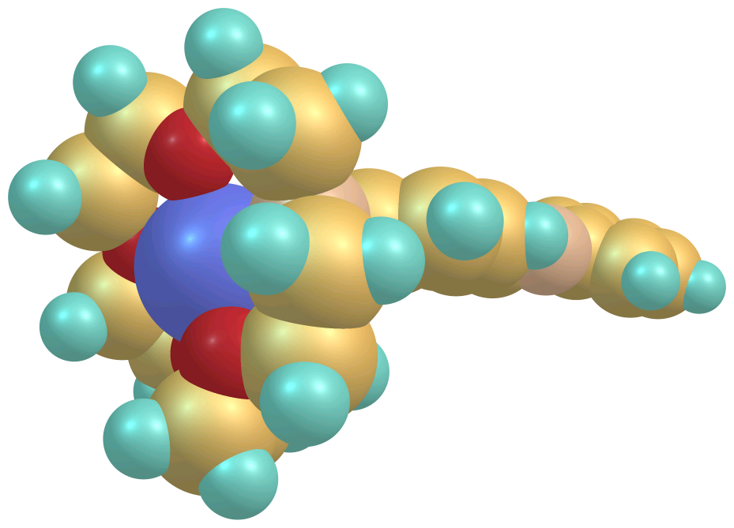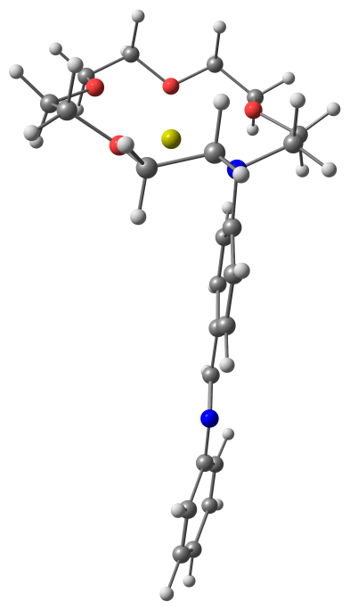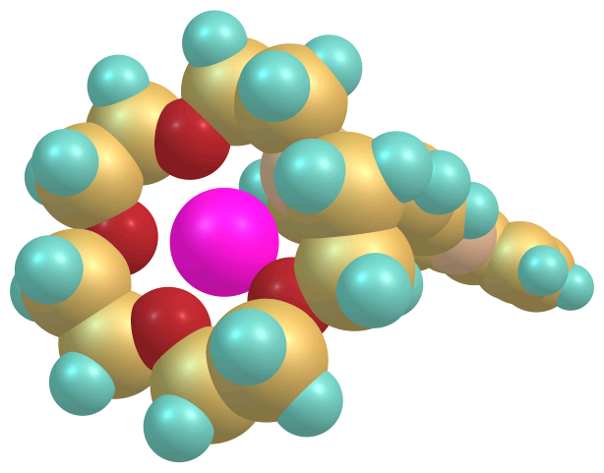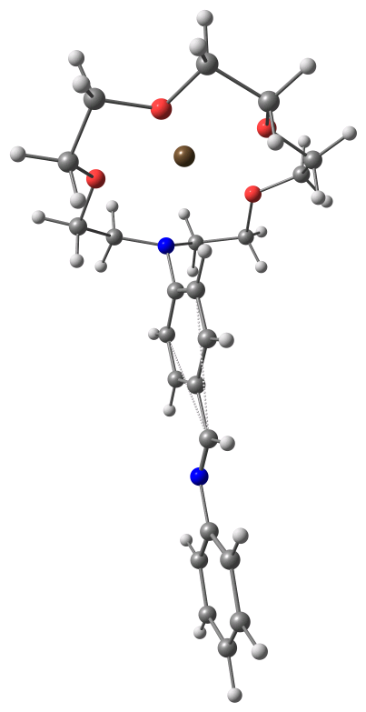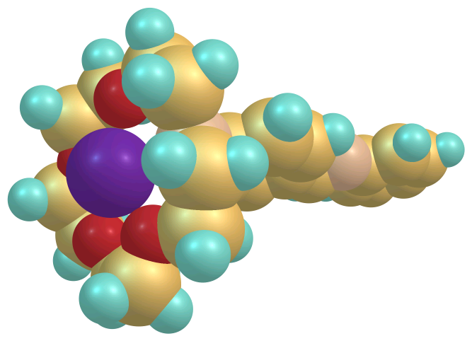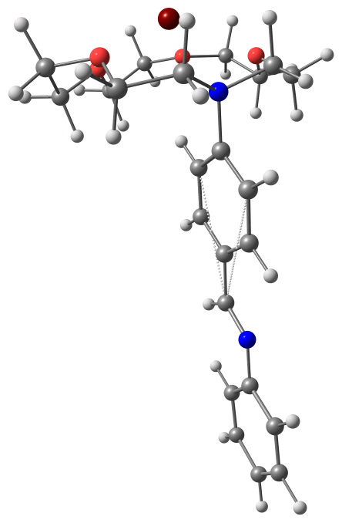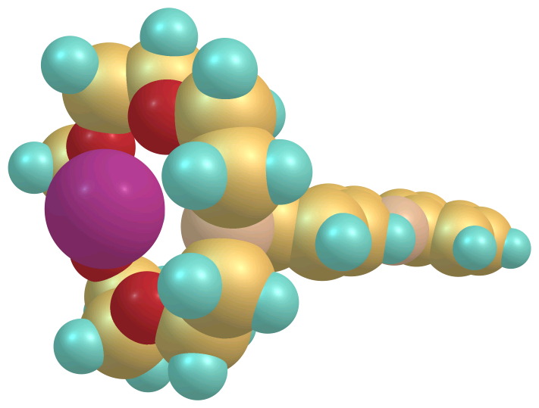
Ca²⁺-complex
Mg²⁺-complex
Be²⁺-complex
Ba²⁺-complex
Sr²⁺-complex
Fig. 4. Two projections of the calculated structures of N-(4-benzalaniline)-15-crown-5 complexes (M²⁺–L1). Be²⁺, Mg²⁺ and Ca²⁺ complexes are optimized at B3LYP/6-31G(d) level and Sr²⁺ and Ba²⁺ complexes are optimized at ECP-31G level.

REFERENCES
V. Enchev et al.: Ab initio and DFT study of the structure of metal ion complexes
- V. Balzani, A. Credi, M. Venturi, Coord. Chem. Rev. 171, 3 (1998).
- I. K. Lednev, R. E. Hester, J. N. Moore, J. Phys. Chem. A, 101, 7371 (1997).
- I. K. Lednev, T.-Q. Ye, R. E. Hester, J. N. Moore, J. Phys. Chem. A, 101, 4966 (1997).
- I. K. Lednev, R. E. Hester, J. N. Moore, J. Am. Chem. Soc., 119, 3456 (1997).
- R. Bergonzi, L. Fabrizzi, M. Licchelli, C. Mangano, Coord. Chem. Rev., 170, 31 (1998).
- L. F. Lindoy, Coord. Chem. Rev., 174, 327 (1998).
- F. Voegtle, Supramolekulare Chemie, 1st Ed., Teubner, Stuttgart, 1989, p. 82.
- B. Valeur, in: Chemosensors of Ion and Molecule Recognition, Vol. 492, NATO ASI Ser., Ser. C, J.-P. Desvergne, A. W. Czarnik (eds.), Kluwer Academic, Dordrecht, 1997, p. 195.
- A. P. de Silva, H. Q. N. Gunaratne, T. Gunnlaugsson, A. J. M. Huxley, C. P. McCoy, J. T. Rademacher, T. E. Rice, Chem. Rev., 97, 1515 (1997).
- N. Mateeva, V. Enchev, L. Antonov, T. Deligeor-giev, M. Mitewa, J. Inclusion Phenom. Mol. Recognit. Chem., 20, 323 (1995).
- A. Boila-Goeckel, W. M. F. Fabian, H. Junek, Liebigs Ann. Chem., 397 (1996).
- M. Mitewa, N, Mateeva, L. Antonov, Quim. Anal., 16, 153 (1997).
- A. Boila-Goeckel, H. Junek, J. Prakt. Chem., 341, 20 (1999)
- M. P. Vladimirova, S. D. Simova, E. Stanoeva, M. Mitewa, Dyes Pigm., 50, 157 (2001).
- L. Antonov, M. Vladimirova, E. Stanoeva, M. F. F. Fabian, L. Ballester, M. Mitewa, J. Inclus. Phenom. Macromol. Chem., 40, 23 (2001).
- A. A. Granovsky, www http://classic.chem.msu.su/ gran/gamess/index.html
- M. W. Schmidt, K. K. Baldridge, J. A. Boatz, S. T. Elbert, M. S. Gordon, J. H. Jensen, S. Koseki, N. Matsunaga, K. A. Nguyen, S. Su, T. L. Windus, M. Dupuis, J. A. Montgomery, J. Comput. Chem., 14, 1347 (1993).
- W. J. Stevens, H. Basch, M. Krauss, J. Chem. Phys., 81, 6026 (1984).
- W. J. Stevens, H. Basch, M. Krauss, P. Jasien, Can. J. Chem., 70, 612 (1992).
- A. D. Becke, J. Chem. Phys., 98, 5648 (1993).
- R. Ditchfield, W. J. Hehre, J. A. Pople, J. Chem. Phys., 54, 724 (1971).
- M. J. Frisch, G. W. Trucks, H. B. Schlegel, G. E. Scuseria, M. A. Robb, J. R. Cheeseman, V. G. Zakrzewski, J. A. Montgomery, Jr., R. E. Stratmann, J. C. Burant, S. Dapprich, J. M. Millam, A. D. Daniels, K. N. Kudin, M. C. Strain, O. Farkas, J. Tomasi, V. Barone, M. Cossi, R. Cammi, B. Mennucci, C. Pomelli, C. Adamo, S. Clifford, J. Ochterski, G. A. Petersson, P. Y. Ayala, Q. Cui, K. Morokuma, P. Salvador, J. J. Dannenberg, D. K. Malick, A. D. Rabuck, K. Raghavachari, J. B. Foresman, J. Cioslowski, J. V. Ortiz, A. G. Baboul, B. B. Stefanov, G. Liu, A. Liashenko, P. Piskorz, I. Komaromi, R. Gomperts, R. L. Martin, D. J. Fox, T. Keith, M. A. Al-Laham, C. Y. Peng, A. Nanayak-kara, M. Challacombe, P. M. W. Gill, B. Johnson, W. Chen, M. W. Wong, J. L. Andres, C. Gonzalez, M. Head-Gordon, E. S. Replogle, J. A. Pople, Gaussian 98, Revision A.11, Gaussian, Inc., Pittsburgh PA, 2001.
- R. Ditchfield, Mol. Phys., 27, 789 (1974); K. Wolinski, J. F. Hilton, P. Pulay, J. Am. Chem. Soc., 112, 8251 (1990).
- M. J. Frisch, G. W. Trucks, H. B. Schlegel, G. E. Scuseria, M. A. Robb, J. R. Cheeseman, J. A. Mont-gomery, Jr., T. Vreven, K. N. Kudin, J. C. Burant, J. M. Millam, S. S. Iyengar, J. Tomasi, V. Barone, B. Mennucci, M. Cossi, G. Scalmani, N. Rega, G. A. Petersson, H. Nakatsuji, M. Hada, M. Ehara, K. Toyota, R. Fukuda, J. Hasegawa, M. Ishida, T. Nakajima, Y. Honda, O. Kitao, H. Nakai, M. Klene, X. Li, J. E. Knox, H. P. Hratchian, J. B. Cross, C. Adamo, J. Jaramillo, R. Gomperts, R. E. Stratmann, O. Yazyev, A. J. Austin, R. Cammi, C. Pomelli, J. W. Ochterski, P. Y. Ayala, K. Morokuma, G. A. Voth, P. Salvador, J. J. Dannenberg, V. G. Zakrzewski, S. Dapprich, A. D. Daniels, M. C. Strain, O. Farkas, D. K. Malick, A. D. Rabuck, K. Raghavachari, J. B. Foresman, J. V. Ortiz, Q. Cui, A. G. Baboul, S. Clifford, J. Cioslowski, B. B. Stefanov, G. Liu, A. Liashenko, P. Piskorz, I. Komaromi, R. L. Martin, D. J. Fox, T. Keith, M. A. Al-Laham, C. Y. Peng, A. Nanayakkara, M. Challacombe, P. M. W. Gill, B. Johnson, W. Chen, M. W. Wong, C. Gonzalez, and J. A. Pople, Gaussian 03, Revision B.04, Gaussian, Inc., Pittsburgh PA, 2003.
- K. Rurack, J. L. Bricks, G. Reck, R. Radeglia, U. Resch-Genger, J. Phys. Chem. A, 104, 3087 (2000).
- T. Gunnlaugsson, H. Q. N. Gunaratne, M. Nieuwen-huyzen, J. P. Leonard, J. Chem. Soc. Perkin Trans. 1, 1954 (2002).
- M. V. Alfimov, A. V. Churakov, Y. V. Fedorov, O. A. Fedorova, S. P. Gromov, R. E. Hester, J. A. K. Howard, L. G. Kuz’mina, I. K. Lednev, J. N. Moore, J. Chem. Soc. Perkin Trans. 2, 2249 (1997).
- M. Asakawa, P. R. Ashton, S. Iqbal, J. F. Stoddart, N. D. Tinker, A. J. P. White, D. J. Williams, Chem. Commun., 483 (1996).
- J. T. Bien, M. Shang, B. D. Smith, Acta Crystallogr. Sect. C, 52, 183 (1996).
- P. D. Beer, Zheng Chen, M. G. B. Drew, A. J. Pilgrim, Inorg. Chim. Acta, 225, 137 (1994).
- F. D. Sokolov, N. G. Zabirov, V. V. Brusko, D. B. Krivolapov, I. A. Litvinov, Mendeleev Commun., 72 (2003).
- A. Ya. Freidzon, A. A. Bagatur’yants, S. P. Gromov, M. V. Alfimov, Int. J. Quant. Chem., 100, 617 (2004).
- K. Goubitz, C. A. Reiss, D. Heijdenrijk, Acta Crystall. C, 45, 1364 (1989).
- J. S. Bradshaw, R. M. Izatt, A. V. Bordunov, C. Y. Zhu, J. K. Hathaway, in: Comprehensive Supramole-cular Chemistry, Molecular Recognition: Receptors for Cationic Guests, vol. 1, G. W. Gokel (Ed.), Pergamon, Elsevier, Oxford, 1996, Chap. 2,.
- R. B. Martin, in: Metal Ions in Biological Systems, Vol. 26, H. Siegel, A. Siegel (eds.), Marcel Dekker, NY, 1990, Ch.. 1.

изследване с методите Ab initio и ТФП на структурата на комплекси
на N-бензаланилин-15-краун-5 с метални йони
V. Enchev et al.: Ab initio and DFT study of the structure of metal ion complexes
В. Енчев¹*, С. Ангелова¹, Н. Маркова¹, Ив. Вавер², Eл. Станоева³, M. Mитева³
¹ Институт по органична химия с център по фитохимия, Българска академия на науките, 1113 София
² Фармацевтичен факултет, Варшавски медицинска университет, Варшава, Полша
³ Химически факултет, Софийски университет, бул. „Джеймс Баучер“ № 1, 1164 София
Посветена на акад. Иван Юхновски по повод на 70-та му годишнина
Постъпила на 30 януари 2008 г.; Преработена на 7 февруари 2008 г.
(Резюме)
Структурите на N-(4-бензаланилин)-15-краун-5 и N-(4’-бензаланилин)-15-краун-5 и техните Li⁺, Na⁺, K⁺, Be²⁺, Mg²⁺, Ca²⁺, Sr²⁺ и Ba²⁺ комплекси са оптимизирани чрез използване на методите ab initio и ТФП. Намерено е, че във всички случаи разстоянията M^{n+}–N (n = 1, 2) са по-дълги от средните разстояния M^{n+}–O в съответните комплекси и, че разстоянията метал–азот при комплексите на алкалните метали са по-дълги от тези при алкалоземните. Li⁺, Na⁺, Mg²⁺ и Ca²⁺ катиони пасват на размера на кухината на макроцикъла, докато катионите K⁺, Sr²⁺ и Ba²⁺, чийто размер е по-голям от нейния диаметър, са извън равнината на макроцикъла. Във всички случаи конформацията на коронния етер не се променя. Изключение е комплексът с Be²⁺, при който макроцикълът е силно деформиран.

