Use of newly synthesized guar based chelating ion exchange resin
in chromatographic separation of copper from nickel ions
Bulgarian Chemical Communications, Volume 41, Number 1 (pp. 19–22) 2009
© 2009 Bulgarian Academy of Sciences, Union of Chemists in Bulgaria
S. Loonker¹, J. K. Sethia²*
* To whom all correspondence should be sent:
E-mail: jinen140579@gmail.com
Department of Chemistry, Jai Narain Vyas University, Jodhpur – 342 001 (Rajasthan), India
Received November 10, 2007; Revised May 10, 2008
Crosslinked guar functionalized with β-amino-α-methylphenethyl alcohol (AMPA) is found to be very efficient for separation of copper from nickel ions in a mixture using column chromatography. The IR spectra of the resin and the nitrogen content data support the successful incorporation of chelating agent in the guar matrix. The moisture content, bulk density, bulk volume and ion exchange capacity were determined by standard methods. Distribution coefficient data, determined at various pH for both metal ions, reveal an effective separation of Cu(II) from Ni(II) ions using the newly synthesized guar epoxy ether of β-amino-α-methylphenethyl alcohol (GEE-AMPA)
Key words: functionalized guar resin, Cu(II) and Ni(II) ions separation.

Introduction
The determination of low concentration levels of heavy metal ions in water samples from different sources received considerable attention in recent years [1–3]. In general, certain metal ions and a number of toxic elements have traditionally been determined by several atomic spectrometric methods [4–6]. A great need still exists to investigate fast, accurate, and sensitive analytical methods for separation and subsequent determination of different metal ions especially at trace levels in a wide spectrum of test samples.
Ion-exchangers and chelating resins are very often used in the removal, preconcentration and determination of various metal ions in aqueous solutions. Ion-exchange fibers are also used as drug reservoir materials for storage and controlled drug delivery [7]. The specific applications include the use of such resins in hydrometallurgical processes [8]. This area receives more attention since many metals are recovered from secondary sources, wastes and rinsing water. Resins are particularly useful in metal recovery, when the concentration of targeted ion in the solution is low and thus the treatment of large volumes of solution is inevitable.

___________________________________________________
¹ Present address: Dr. Sangeeta Loonker, "Neil", 70, Jwala Vihar, Behind Jeevan Jyoti Hospital, Jodhpur, Rajasthan, India
² Present address: Dr. Jinendra Sethia, Solvay Specialities India
Pvt. Ltd., Plot No. 3526-27, GIDC Estate, Panoli – 394116,
Dist. Bharuch, Gujarat, India
Nine heavy metal ions were simultaneously determined at μg/L levels by Cardellicchio et al. [9] in 22 minutes, using column chromatography in ground water samples. Santoyo et al. [10] deter-mined lead, copper, cadmium, cobalt, zinc and nickel ions in ground water using three ionic separation column systems including HPIC-CS2 of Dionex as a cationic column, HPIC-AS4 of Dionex as an anionic column and IonPac CS5 of Dionex as a bifunctional ion-exchange column.
In our work we have attempted the separation of Cu and Ni ions on GEE-AMPA resin synthesized in our laboratory. We have used the guar-based resin because of its abundance in the region, low cost, hydrophilic nature and flocculent action. Both ion-exchanging and chelating abilities are shown by AMPA thus giving better results in comparison to other chelating agents. AMPA is found to give good results for copper in comparison to other function-alizing agents like imino diacetic acid, anthranilic acid, p-amino benzene sulphonic acid, etc., reported by us, using various polymeric supports. Though the resin can also separate other ions on the basis of distribution coefficient values, this paper focuses on the separation of Cu and Ni only.
Experimental
Guar is procured from local industries and other AR purity grade chemicals are procured from Sarabhai M. Chemicals, Baroda.
Physical Parameters
The IR spectra of resin, recorded on Schimadzu IR 400 spectrophotometer using KBr pellets, revealed the appearance of a band at 3657 cm^{–1} (1 spike), that is assigned to ν(N–H) of R–NH–R group. Another band at 3585 cm^{–1} is ascribed to ν(–OH) of alcohol. The disappearance of peak at 3565 cm^{–1} (2 spike) shows that ΑΜPΑ has been successfully incur-porated into epoxy ether of guar.
Flame atomic absorption spectrophotometer (FAAS) model Schimadzu AA-630-12 was used for analysis of metal ions in test sample.
The resin characteristics i.e., bulk density; moisture content, nitrogen content estimation and ion exchange capacity were determined by the standard methods. The results are summarized in Table 1.
Table 1. Resin characteristics.
Resin | Moisture content,  % | Bulk density,  g/cm³ | Specific bulk volume, cm³/g | Nitrogen content,  % | Ion exchange capacity, meq/g
GEE-AMPA | 1.6 | 0.721 | 2.75 | 1.68 | 0.991

The pH titration or neutralization curve (in Fig. 1) of chelating ion exchanger is carried out to establish the character of the exchanging group. The results reveal that it is a weakly basic chelating anion exchange resin.
S. Loonker and J. K. Sethia: Use of newly synthesized guar based chelating ion exchange resin …
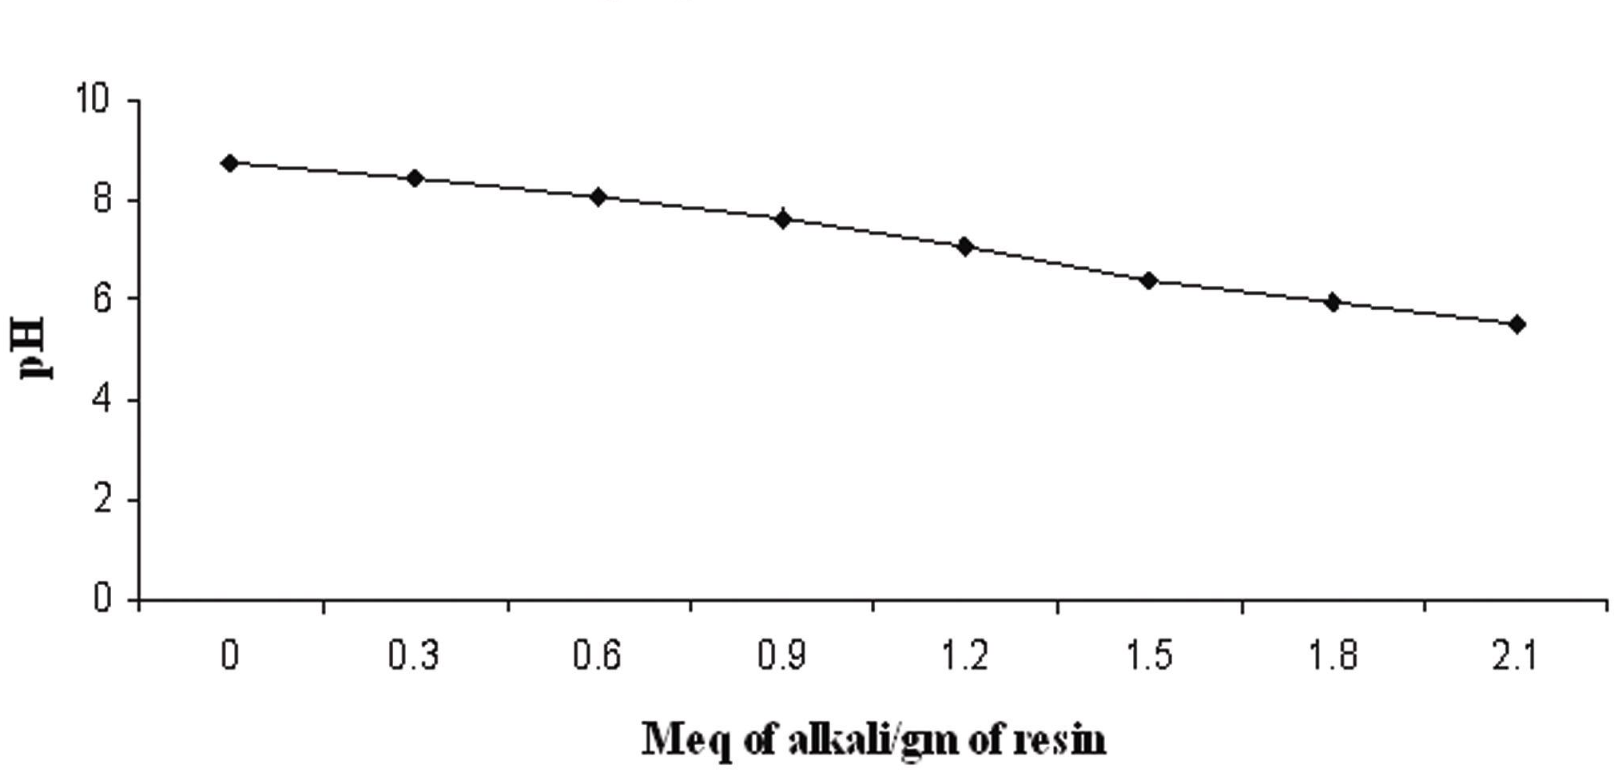
Fig. 1. pH titration curve.
Synthesis of epoxy ether of guar
Guar was first subjected to reaction with epichlorohydrin. The obtained epoxy ether is then used to synthesize GEE-AMPA. One mole of guar (486 g) was suspended in dioxane in a round bottom flask. The reaction mixture was rendered alkaline by adding 20 mL of 50% aqueous sodium hydroxide solution. The contents were magnetically stirred and refluxed at 45ºC for an hour. 1 mole (92.53 g) of epichlorohydrin was added and pH was adjusted between 9 to 10. The contents were refluxed upon constant stirring for another 4–5 hours at 45ºC. The product was filtered on a vacuum pump and washed with 80% aqueous CH₃OH + HNO₃ solution, to remove inorganic impurities and excess of alkali. The complete removal of chloride by the washing was ensured using AgNO₃ solution and removal of alkali was ensured using litmus solution. The washed product was dried in an oven at 50ºC and used for further derivatization.

Synthesis of guar epoxy ether of β-amino-α-methyl-phenethyl alcohol (GEE-AMPA)
0.01 moles of guar epoxy ether was suspended in 70% aqueous isopropyl alcohol. 10 mL of 50% aqueous sodium hydroxide solution was added to the reaction mixture under reflux upon constant stirring at 50 ± 5ºC.
0.02 moles of AMPA were added to the reaction mixture. The contents were refluxed and stirred for 5–6 hours at 55ºC on a water bath. The product was filtered off under vacuum and washed with 50% aqueous CH₃OH + HNO₃ solution to remove the inorganic impurities. The dried product was suspended in 0.1N HCl and filtered immediately. The successive washings with 0.1N NaOH and 0.1N HCl were carried out, the contents were finally washed with absolute alcohol and dried under vacuum.
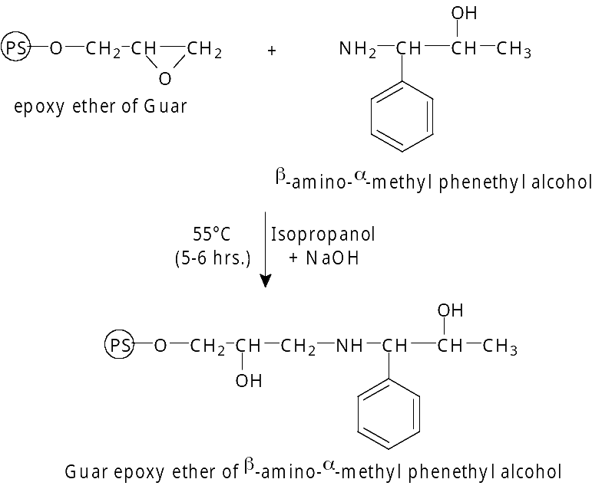
Analysis of metal uptake
Batch equilibrium technique was employed for measuring the metal uptake by the resin. In a set of six glass stoppered flasks, 0.084g of dried resin was taken and 40 mL of buffer (prepared by mixing different volumes of 0.2 M acetic acid and 0.2 M sodium acetate) was added to each flask for adjusting the pH value to 3.5, 4.0, 4.5, 5.0, 5.5 and 6.0, respectively. 1 mL of 1000-ppm metal ion solution was added to each flask and the contents were agitated for an hour. The two phases were separated after reaching equilibrium, using batch method and the metal content was determined in an aliquot of the filtrate by flame atomic absorption spectrometry (FAAS). Analyzing the eluates for the copper and nickel concentration in each set of experiments using FAAS we checked the achievement of equilibrium.
It was found that copper shows maximum chelation at pH 6.0, whereas nickel shows maximum chelation at pH 5.0 as inferred from their Distribution coefficient (D_{f}) values in Table 2. The resin was found to be highly selective for Cu at pH 6.0. The metal uptake is much higher in comparison to the theoretical uptake, calculated based on its nitrogen content data. This can be well explained by the fact that guar derivatives also act as very good adsorbents.
Table 2. Distribution coefficients.
pH | Distribution coefficient (D_{f}), mL/g
pH | Cu | Ni
3.5 | 342 | 126
4.0 | – | 202
4.5 | 717 | 468
5.0 | 880 | 859
5.5 | 1835 | 619
6.0 | 2098 | 543
6.5 | 1017 | –
Column separation
An ion exchange column of 20 cm height was packed with a slurry of GEE-AMPA prepared in dioxane. The buffer of 6.0 pH was allowed to flow through the column. An aliquot of sample solution containing standard amount of Cu(II) and Ni(II) ions was passed though the column at a flow rate of 1–2 mL/min. Loaded metal ions were eluted using 0.1 N HCl. In the first 10 mL fraction Ni(II) ions were eluted completely. The second fraction obtained had neither Ni(II) nor Cu(II) ions. Elution of Cu(II) was complete by addition of another 40 mL portion of eluate, which was collected as third fraction. Metal concentration in the eluate for each set of experiments was analyzed using FAAS.
ResultS and Discussion
The theoretical ion exchange capacity of GEE-AMPA resin was calculated and found out to be 0.991 meq/g. The metal capacity versus pH contours of GEE-AMPA resin with Cu(II) and Ni (II) ions are shown in Fig 2.
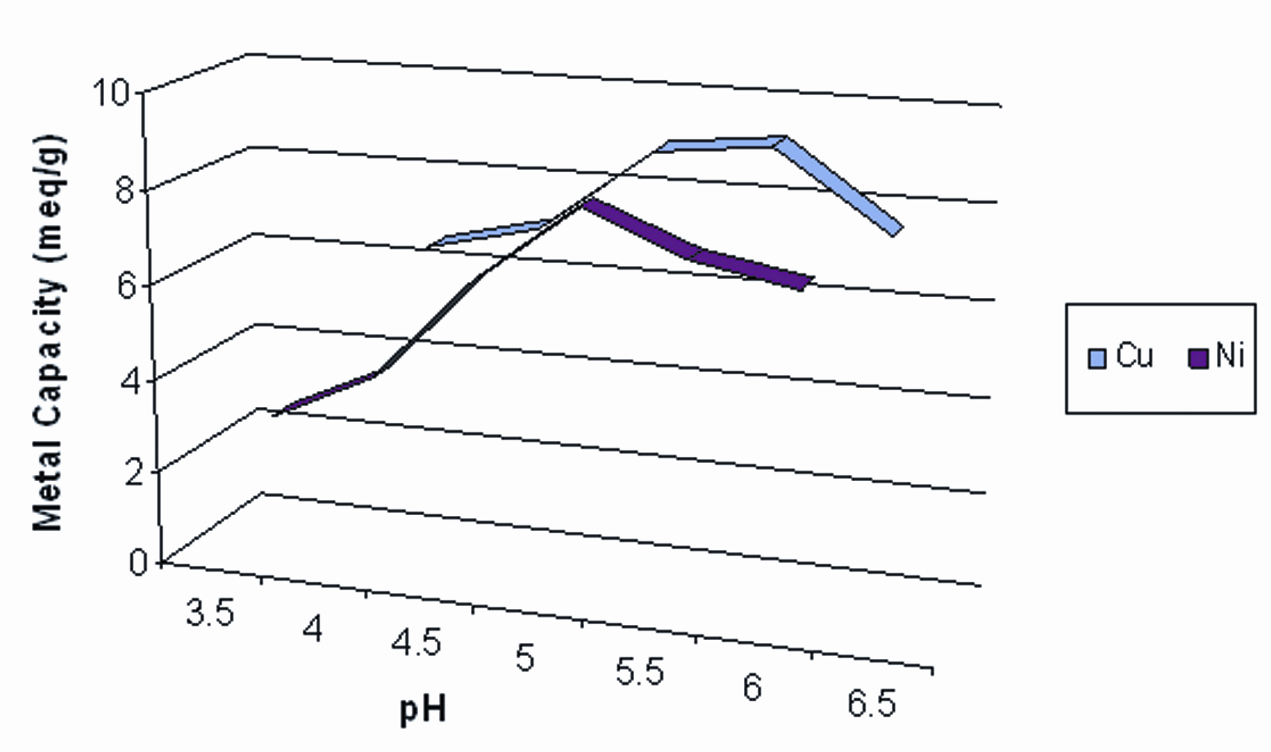
Fig. 2. Metal capacities versus pH for GEE-AMPA resin.
The perusal of the results reveals that the metal uptake by the resin increases at first and then decreases with increasing pH. The resin exhibited maximum metal uptake capacity for Cu (II) at pH 6.0, which is found to be four times higher than that shown for Ni (II). The distribution of metal ions in the resin also followed the above order. Maximum value for distribution coefficient for Cu was 2098 mL/g, while for Ni it was just 543 mL/g. Studies were also carried out for Fe(II), Zn(II) and Co(II). The comparison of their D_{f} values at pH 6.0 revealed that the resin is highly specific for Cu(II) at this pH and can be successfully used for separation of Cu from a sample containing Cu and Ni. Their D_{f} values decrease in the order
S. Loonker and J. K. Sethia: Use of newly synthesized guar based chelating ion exchange resin …
Cu II (2098) > Zn II (908) > Fe II (874) > Co II (858) > Ni II (543).
D_{f} values for Cu and Ni at various pH are summarized in Table 2. Analysis of Table 2 data reveals that effective separation of Cu and Ni can be carried successfully using column chromatography at pH 6 due to their appreciably high difference in D_{f} values. The results are reported in Table 3 and they are the average of four determinations.
Table 3. Separation of Cu(II)ions from Ni(II)ions.
Sam-ple  No. | Amount of Cu(II) and Ni(II) in mixture on column |  | Amount of Cu(II) and Ni(II) ions  in eluate
Sam-ple  No. | Cu(II)  mg | Ni(II)  mg | Cu(II)  mg | SD | RSD,  % | Ni(II)  mg | SD | RSD%
1 | 3.0 | 7.0 | 2.91 | 0.09 | 3.00 | 6.92 | 0.08 | 1.14
2 | 4.0 | 5.0 | 3.89 | 0.11 | 2.75 | 4.92 | 0.08 | 1.60
Note: Average of four determinations for each set is reported.
References
- Y. F. Lasheen, A. F. Seliman, A. A. Abdel-Rassoul, J. Chromatogr. A, 1136, 202 (2006).
- V. K. Singh, K. P. Singh, D. Mohan, Environ. Monit. Assess., 105, 43 (2005).
- H. Karami, M. F. Mousavi, Y. Yamini, M. Shamsipur, Anal. Chim. Acta, 509, 89 (2004).
- G. Doner, A. Ege, Anal. Chim. Acta, 547, 14 (2005).
- M. A. A. Akl, I. M. M. Kenawy, R. R. Lasheen, Microchem. J., 78, 143 (2004).
- M. Soylak, S. Saracoglu, U. Divrikli, L. Elci, Talanta, 66, 1098 (2005).
- T. Jaskari, M. Vuorio, K. Kontturi, A. Urtti, J. A. Manzanares, J. Hirvonen, J. Control. Release, 67, 179 (2000).
- A. W. Trochimczuk, S. Czerwińska, React. Func. Polym., 63, 215 (2005).
- N. Cardellicchio, S. Cavalli, P. Ragone, J. M. Riviello, J. Chromatogr. A, 847, 251 (1999).
- E. Santoyo, S. Santoyo-Gutierrez, P. V. Surendra, J. Chromatogr. A, 884, 229 (2000).

Използване на новосинтезирана ХЕЛАТНА йонообменна смола на основата на гума гуар за хроматографско разделяне на медни от никелови йони
С. Луункер, Дж. К. Сетия*
S. Loonker and J. K. Sethia: Use of newly synthesized guar based chelating ion exchange resin …
Департамент по химия, Университет Джай Нараин Виас, Джодпур 342 001 (Раджастан), Индия
Постъпила на 10 ноември 2007 г.; Преработена на 10 май 2008 г.
(Резюме)
Установено е, че омрежена гума гуар, функционализирана с β-амино-α-метилфенилетилов алкохол (AMФA) е много ефективна за разделяне на медни от никелови йони в смеси при използване на колонна хроматография. ИЧ спектри на смолата и данните за съдържанието на азот са в подкрепа на успешното въвеждане на хелатния агент в матрицата на гумата гуар. Съдържанието на влага, насипната плътност, насипният обем и йоно-обменният капацитет са определени със стандартни методи. Данните за коефициентите на разпределение, определени при различни рН за двата метални йони показват ефективно разделяне на йоните Cu(II) от Ni(II) с помощта на новосинтезирания епокси етер на β-амино-α-метилфенилетил алкохол и гума гуар.

