On-line error determination and processing for electrochemical impedance spectroscopy measurement data based on weighted harmonics autocorrelation
Bulgarian Chemical Communications, Volume 41, Number 2 (pp. 192–198) 2009
© 2009 Bulgarian Academy of Sciences, Union of Chemists in Bulgaria
C. A. Schiller¹*, R. Kaus²
* To whom all correspondence should be sent:
E-mail: cas@zahner.de
¹ Zahner Messsysteme, Kronach, Germany
² Fachhochschule Niederrhein, Krefeld, Germany
Received July 12, 2008; Revised August 8, 2008
A procedure taking into account the inter-correlation of the harmonics, observed in experimental EIS, is shown to provide realistic error estimation useful for reliability considerations. The deduction of the algorithm of this “weighted harmonics autocorrelation” procedure as well as the results of EIS control experiments, performed on well known objects, are thoroughly discussed.
The influence of three different kinds of specific interference on the measurement results is shown: distortions by a nonlinear system characteristic, contamination of the response signal by pink noise and contamination of the response signal by single frequency disturbance. The uncertainty predicted by the weighted harmonics autocorrelation procedure is compared with the deviations observed in the practical measurements.
Key words: Electrochemical Impedance Spectroscopy, error determination, uncertainty, monochromatic oversampling, limited frequency selectivity, weighted harmonics autocorrelation.

Introduction
In Electrochemical Impedance Spectroscopy (EIS), measurement results are commonly used in conjunction with mathematical models to extract physical parameters or to identify physical phenomena. In the early years, the comparison between experiments and deterministic process models was mainly qualitative. With growing number of fields for EIS application and ongoing improvement of the measuring technique, the aim of EIS changed to more quantitative terms, i.e. finding out of precise numerical values of particular quantities of interest. Such values, representing physical and chemical system parameters, appear encoded in the spectral transfer function, which usually can be modeled by equivalent circuits (EC) or reaction mechanism analysis (RMA).
The parameters searched for are determining the model transfer function and express desired research information about (for instance losses/efficiencies of batteries) rate constants and diffusion parameters of electrochemical reactions and over potential shares in fuel cells. As for all experimentally determined quantities, the knowledge of their uncertainty is essential to judge their reliability. Many aspects of the principle error structure of EIS data have already been treated thoroughly in literature [1]. Also the error propagation through the typical simulation and fitting procedure can usually be determined reliably.
However, a complete error treatment can be per-formed only if a reasonable uncertainty estimation of the initial EIS measurement data is available, too.
It is necessary to enlighten the role of different possible error contributions to the deviations, observed experimentally in EIS. The popular assumption that deficient instrumentation is usually responsible for discrepancies between observed and expected impedance data does not usually hold true. In practice, a much more important class of error sources lies in the misinterpretation of the system under test: the less experienced scientist expects a certain frequency response by his object, which he assumes as ideal, but may overlook that the observed frequency response belongs to an imper-fect real world object, often affected significantly by accompanying parasitic properties of the set-up around the sample. Parasitic reactance generated by stray capacitance, connection line inductance, bridge coupling [2] and mutual induction effect [3] represent an important class of error sources in the experimental practice. However, apart from mutual induction, errors caused by these effects can be taken into account without problems by extending the model accordingly and they are not subject of this work.
Instead, the topic here is the uncertainty due to the effect of Limited Frequency Selectivity (LFS): an experimental impedance spectrum assigns the course of certain measured impedance values to certain frequencies, but basically, this assignment can never be mathematically true. This can be understood considering the response to a mono-chromatic excitation: due to the very basic effect of limited measurement time, monochromatic excita-tion never exists in perfection [4]♦ and the response must be always the response to a mixture of dif-ferent frequencies with – hopefully – the frequency of interest dominating. For the same reason, the best conceivable signal frequency filter in the data acquisition path of any impedance instrumentation has a LFS defined by the measurement time allocated, too.
Generally, the effect of the LFS appears as follows: apart from the wanted response signal, belonging to a certain frequency of interest, unwanted noise is recorded additionally. So the Signal to Noise ratio (S/N) can be considered as a measure of the uncertainty in principle.
As a strategy for error determination it has been suggested in the literature to measure the data at a certain frequency for more than few times or even for several complete spectra [5]. As a result, uncertainty can be calculated directly from the scattering. A severe disadvantage of this procedure is that the later error reduction by calculating the mean values scales only with the square root of the time interval, while continuous coherent data acquisition would have reduced the error proportionally with the time. Besides, coherent data acquisition often can suppress deviations perfectly, even if the individual time slot samples would exhibit large scattering – a too pessimistic error estimation is the consequence.
In the present work, an alternative approach, based on harmonic analysis, is described which avoids the drawbacks mentioned above. The reported procedure uses the fact that under mono-chromatic (sinusoidal) excitation of a system the harmonic distortion content of the response signal can be used as a measure of the uncertainty. This method requires two prerequisites: the EIS measure-ment procedure must provide the necessary infor-mation about the harmonics and the harmonic con-tent must be unequivocally assigned to distortions.
Experimental
In order to determine the S/N ration of a single measurement, monochromatic over sampling (MOS) is applied. This means that in contrast to multi-
—————————————————————
♦ The correlation Δν ∝ 1/t between lifetime t and spectral purity respectively line width Δν due to the quantum mechanical uncertainty principle is not only valid for photoemission but also determines measuring accuracy of EIS.
spectral methods the harmonics are intentionally not excited, but they are detected in the response signal by Discrete Fourier Transformation (DFT) analysis, nevertheless. In an ideal case, single-sine excitation results in a response signal consisting of a single line in the frequency spectrum. Limited measure-ment time interval, non-linearity and noise in a real system however add additional lines to the response spectrum. The MOS method makes it possible to calculate the impedance solely from the funda-mental, while the harmonic content can unambi-guously be attributed to unwanted distortions. In contrast, when using multi-spectral excitation, the noise origin of harmonics in the response spectrum cannot be identified in general, because it is noise mixed with the intentionally excited frequency line response. As a work-around procedure it has been proposed [6, 7] to correlate sequential multi-spectral measurements with changing excitation content. It is obvious that this strategy should fail if the system under test is not strictly stable. Besides, a much higher time effort is necessary until the noise influence for a certain frequency sample becomes accessible.
However, also for MOS, the overall S/N ratio calculated from the harmonic content cannot simply be used as a reliable uncertainty measure. Instead the harmonic content has to be weighted in a certain manner because of reasons discussed in the following text.
C. A. Schiller and R. Kaus: Online error determination and processing for EIS measurement data
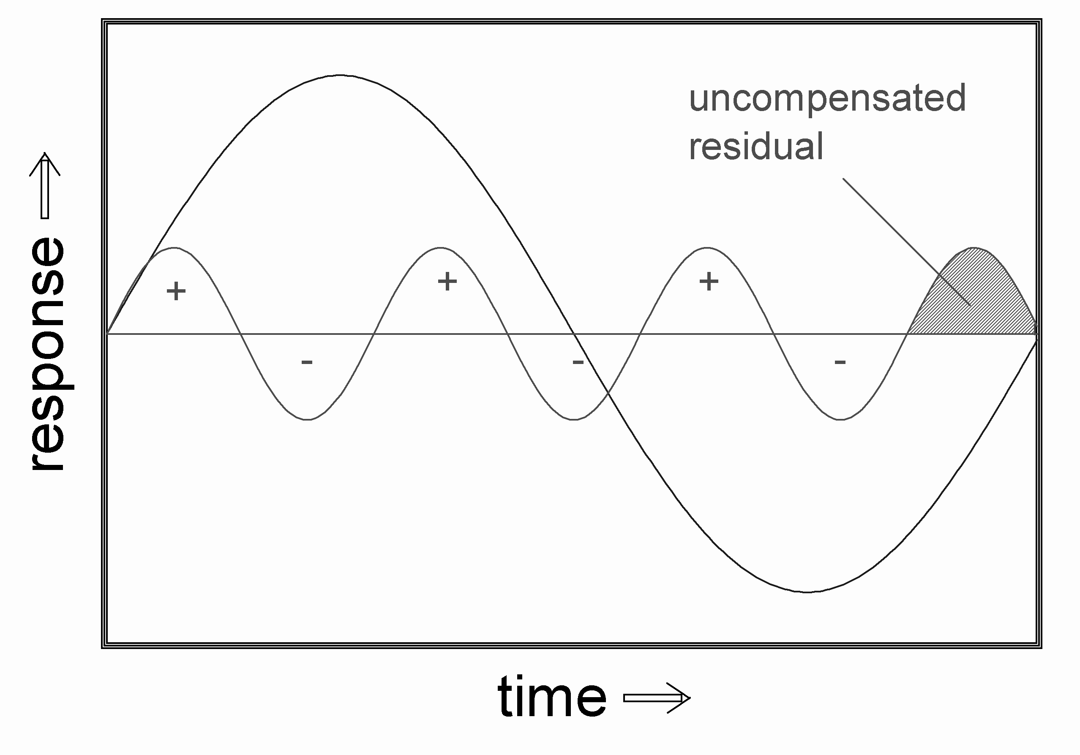
Fig. 1. Illustration of a signal and an interference at
3.5-fold frequency. The leakage due to the misfit in periodicity is larger than that in Fig. 2.
Fig. 1 shows schematically a measurement window time interval used for EIS with one period of sinusoidal excitation, together with an inter-ference signal of 3.5 times the signal frequency. Fig. 2 sketches a similar situation, where the interference is 7.5 times the signal frequency. Comparing both figures one can suppose that the remaining inter-ference due to the misfit between time window and periodicity decreases with increasing frequency. To be more precise, due to the limited measurement time interval (in the example it is the minimum time interval conforming to the systems theory), fre-quency components which are not exactly periodic with the time window are “rubbed off” on the results for the periodic signals, like for instance the fundamental wave. This “leakage” caused by the “aliasing” mechanism [8] declines with increasing frequency distance between interference and disturbed signal. It is maximal if the interference arises at (n + 0.5) times of the exci-tation frequency (n is an integer) and it vanishes, if the interference matches a harmonic (see Fig. 3).
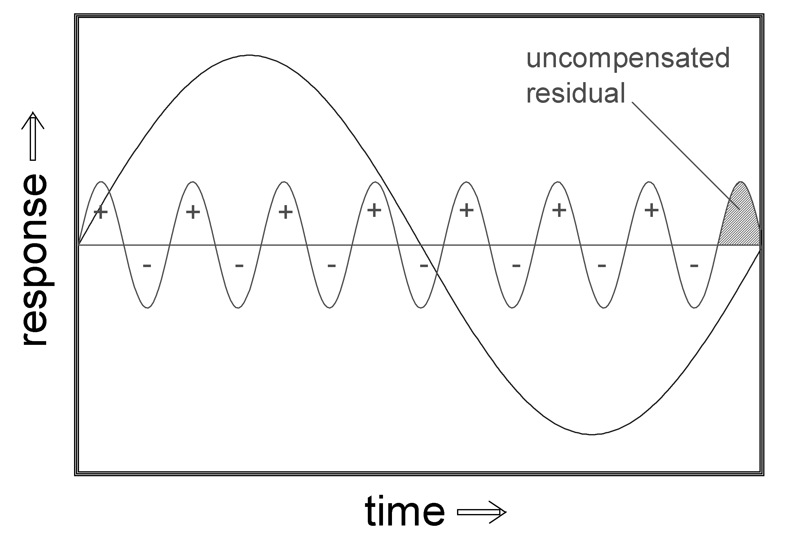
Fig. 2. Illustration of a signal and an interference at
7.5-fold frequency. The leakage due to the misfit in periodicity is smaller than that in Fig. 1 because of the shorter cycle time at higher frequency.
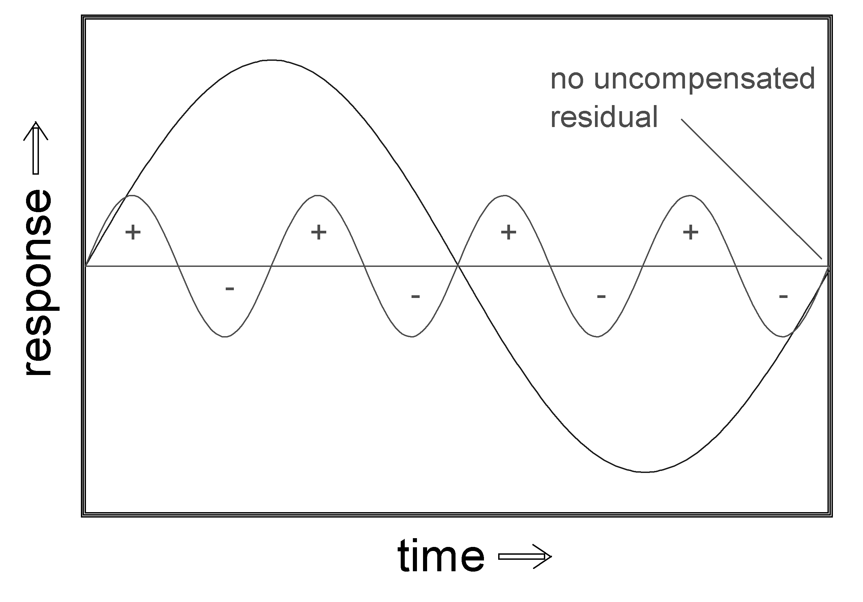
Fig. 3. Illustration of a signal and an interference at
four-fold frequency. The leakage due to the misfit in periodicity vanishes at integer multiples of the signal frequency (harmonics).
If the interference frequency is an integer multiple of the signal frequency, i.e. a harmonic, a single line in the response spectrum results. As one can see in Fig. 3, in this case the distortion can be removed by the DFT filter perfectly. So, an additional single line in the Fourier spectrum does not indicate impaired accuracy automatically. In contrast, interfering signals with frequencies dif-fering from the harmonics will generate several adjacent lines due to the leakage effect. They impair the accuracy and have to be taken into account in an uncertainty calculation. This can be accomplished using the autocorrelation algorithm described below.
The intensity of disturbing lines in relation to the fundamental ones must be considered, too. Appar-ently, a large signal is less affected by the same absolute amount of noise than a small signal.
If the excitation signal already contains distor-tions, e.g. due to imperfect functioning of the poten-tiostat, harmonics can be observed, which may not be mistaken for noise. The content of harmonics in the response, which are already present in the excitation signal, must be scaled down accordingly.
C. A. Schiller and R. Kaus: Online error determination and processing for EIS measurement data
All these issues are considered in the “weighted harmonics autocorrelation” procedure, which is summarized in the following:
- Acquire the excitation and response signals with the MOS method application;
- Extract the fundamentals from the response spectrum. The quotient with the fundamental of the excitation spectrum is used to determine the impedance;
- Weight the harmonics of the response spectrum due to existing degrees of distortion in the excitation spectrum;
- Normalize each residual harmonic according to the intensity of the fundamental (division by the fundamental amplitude) and weight it according to its harmonic order (division by the frequency);
- Auto-correlate the weighted harmonic spectrum. The resulting amplitude of the first-order line distance yields the error indicator searched for.
The error indicator can be tested and calibrated in a way that the uncertainty prediction for white noise will match the error determined by a simu-lation. For the simulation purposes, a sine wave with an amplitude ‘A’ in a time window of 2^{n} is generated and superimposed by a defined distortion amplitude. This distortion can be generated either by white noise with a variable amplitude from 2 times ‘A’ to 0.1 times ‘A’, resulting in a S/N ratio of 0.5 to 10 respectively, or by a sinusoidal signal of comparable amplitude with an arbitrarily varying frequency. The resulting superimposed signal is treated by DFT (in particular the Fast Fourier Transform FFT) as a model for the MOS measurement procedure. Then, the amplitude of the fundamental is evaluated and the deviation between the known original and the evaluated amplitude affected by leakage in the disturbed case is recorded.
A linear correlation is found between the observed deviation and the output of the weighted harmonics autocorrelation procedure. Therefore, a single constant weighting factor can be determined to calibrate the weighted harmonics autocorrelation uncertainty forecast.
The result of a simulation done for an interfering sine-signal of varying frequency is depicted in Fig. 4. As it is expected, the deviation is minimal at integer multiples of signal frequency and it is locally maximal at (n + 0.5) times the signal frequency. Deviation also decreases with increasing frequency of the interfering signal, as it stated above.
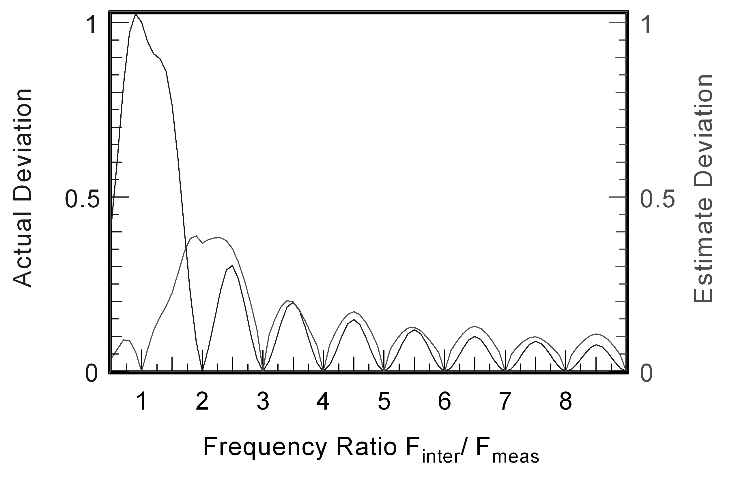
Fig. 4. Simulation of a sinusoidal interference of varying frequency.
The deviation observed from the simulation and the predicted uncertainty calculated by the weighted harmonics autocorrelation method are in good agreement except for interference frequencies close to the signal frequency
Obviously, the largest deviation appears for interference frequencies close to the signal frequency. This problem can be assigned to the fundamental relation between measurement time window and frequency uncertainty: if the frequency difference between a signal and a distortion tends to zero, the necessary measurement time for a successful separation tends to infinity.
The online error determination procedure was also tested in practical measurements. Three different kinds of specific interferences were used: superimposed pink noise, sine interference and inherent distortions due to a non-linearity of the object. The set-up used in case of external interference is sketched in Fig. 5: a signal generator FG for interference overlay produces either sine signal or noise with limited bandwidth, alternatively.
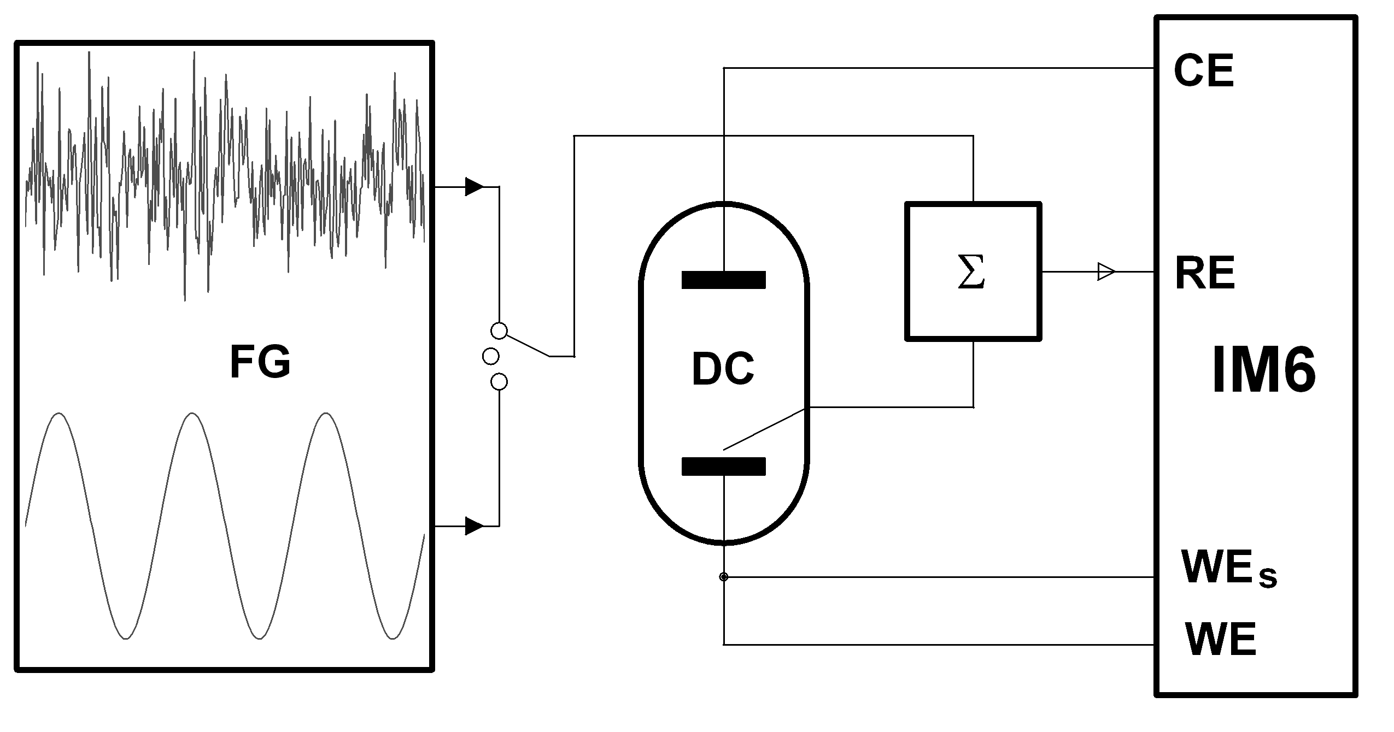
Fig. 5. Set-up for EIS control experiments consisting of a frequency generator FG, a dummy cell DC, a summing up circuit Σ, and an electrochemical workstation IM6.
The potentiostat terminals are WE for the working electrode current output, WE_{s} for the working electrode potential sense input, RE for the reference electrode potential sense input, and CE for the counter-electrode current output
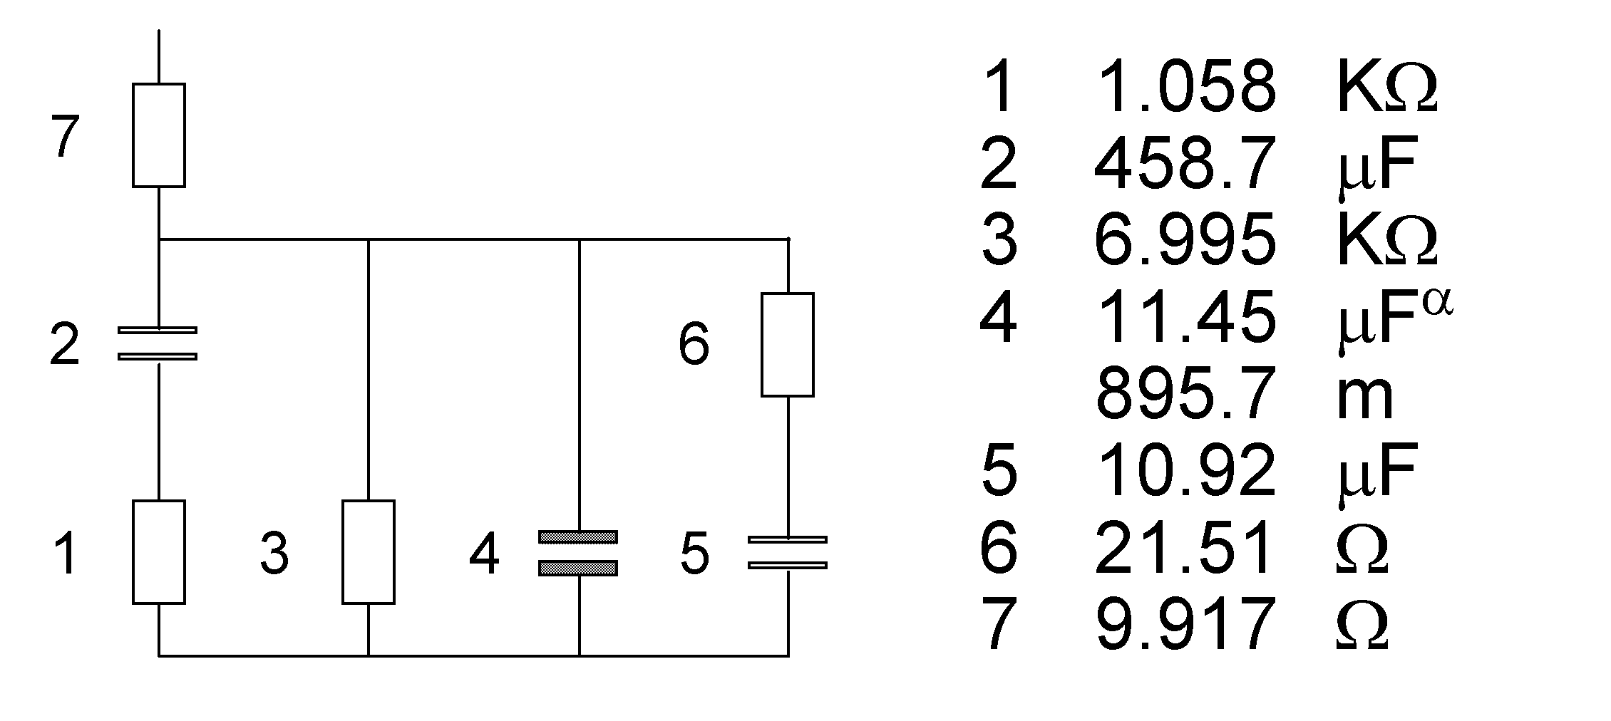
Fig. 6. Equivalent circuit of the dummy cell
(DC in Fig. 5).
A dummy cell DC with well known properties is used as a reference object. EIS measurements were performed with the electrochemical workstation IM6, which uses the MOS principle. During measurements under interference overlay the generator signal is fed into the reference input RE of the IM6 via the summing up circuit Σ. The equivalent circuit of the dummy cell is depicted in Fig. 6.
C. A. Schiller and R. Kaus: Online error determination and processing for EIS measurement data
Results and discussion
Injecting pink noise into the summing up circuit Σ (c.f. Fig. 5), results in an impedance spectrum of the dummy cell (Fig. 6) depicted in Fig. 7 as Bode plot.
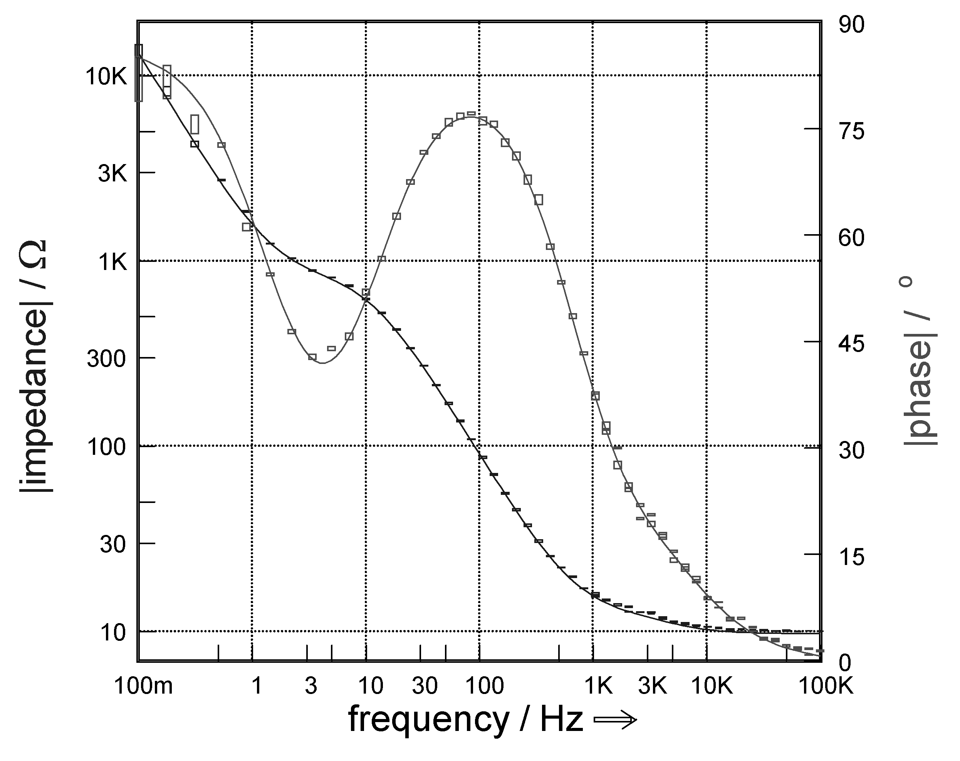
Fig. 7. Bode plot of a dummy cell (Fig. 6) measurement with the test set-up sketched in Fig. 5 with superimposed pink noise (error rectangles) and flawless measurement without noise (lines).
The rectangles characterize the measurement result under pink noise interference, whereas the lines represent the result of an undisturbed measurement. The size of the rectangles, indicating the standard deviation σ derived by the algorithm discussed above, are in good agreement with the measurement error known from a comparison with the flawless measurement. This is more clearly visible in the complex plane representation (Fig. 8). Apparently the weighted harmonics autocorrelation algorithm leads to a useful prediction of the uncertainty caused by the presence of noise.
Measuring the dummy cell from 1 Hz to 1 kHz in the presence of a sinusoidal interference signal of 100 Hz leads to the result shown in Fig. 9 as complex plane plot.
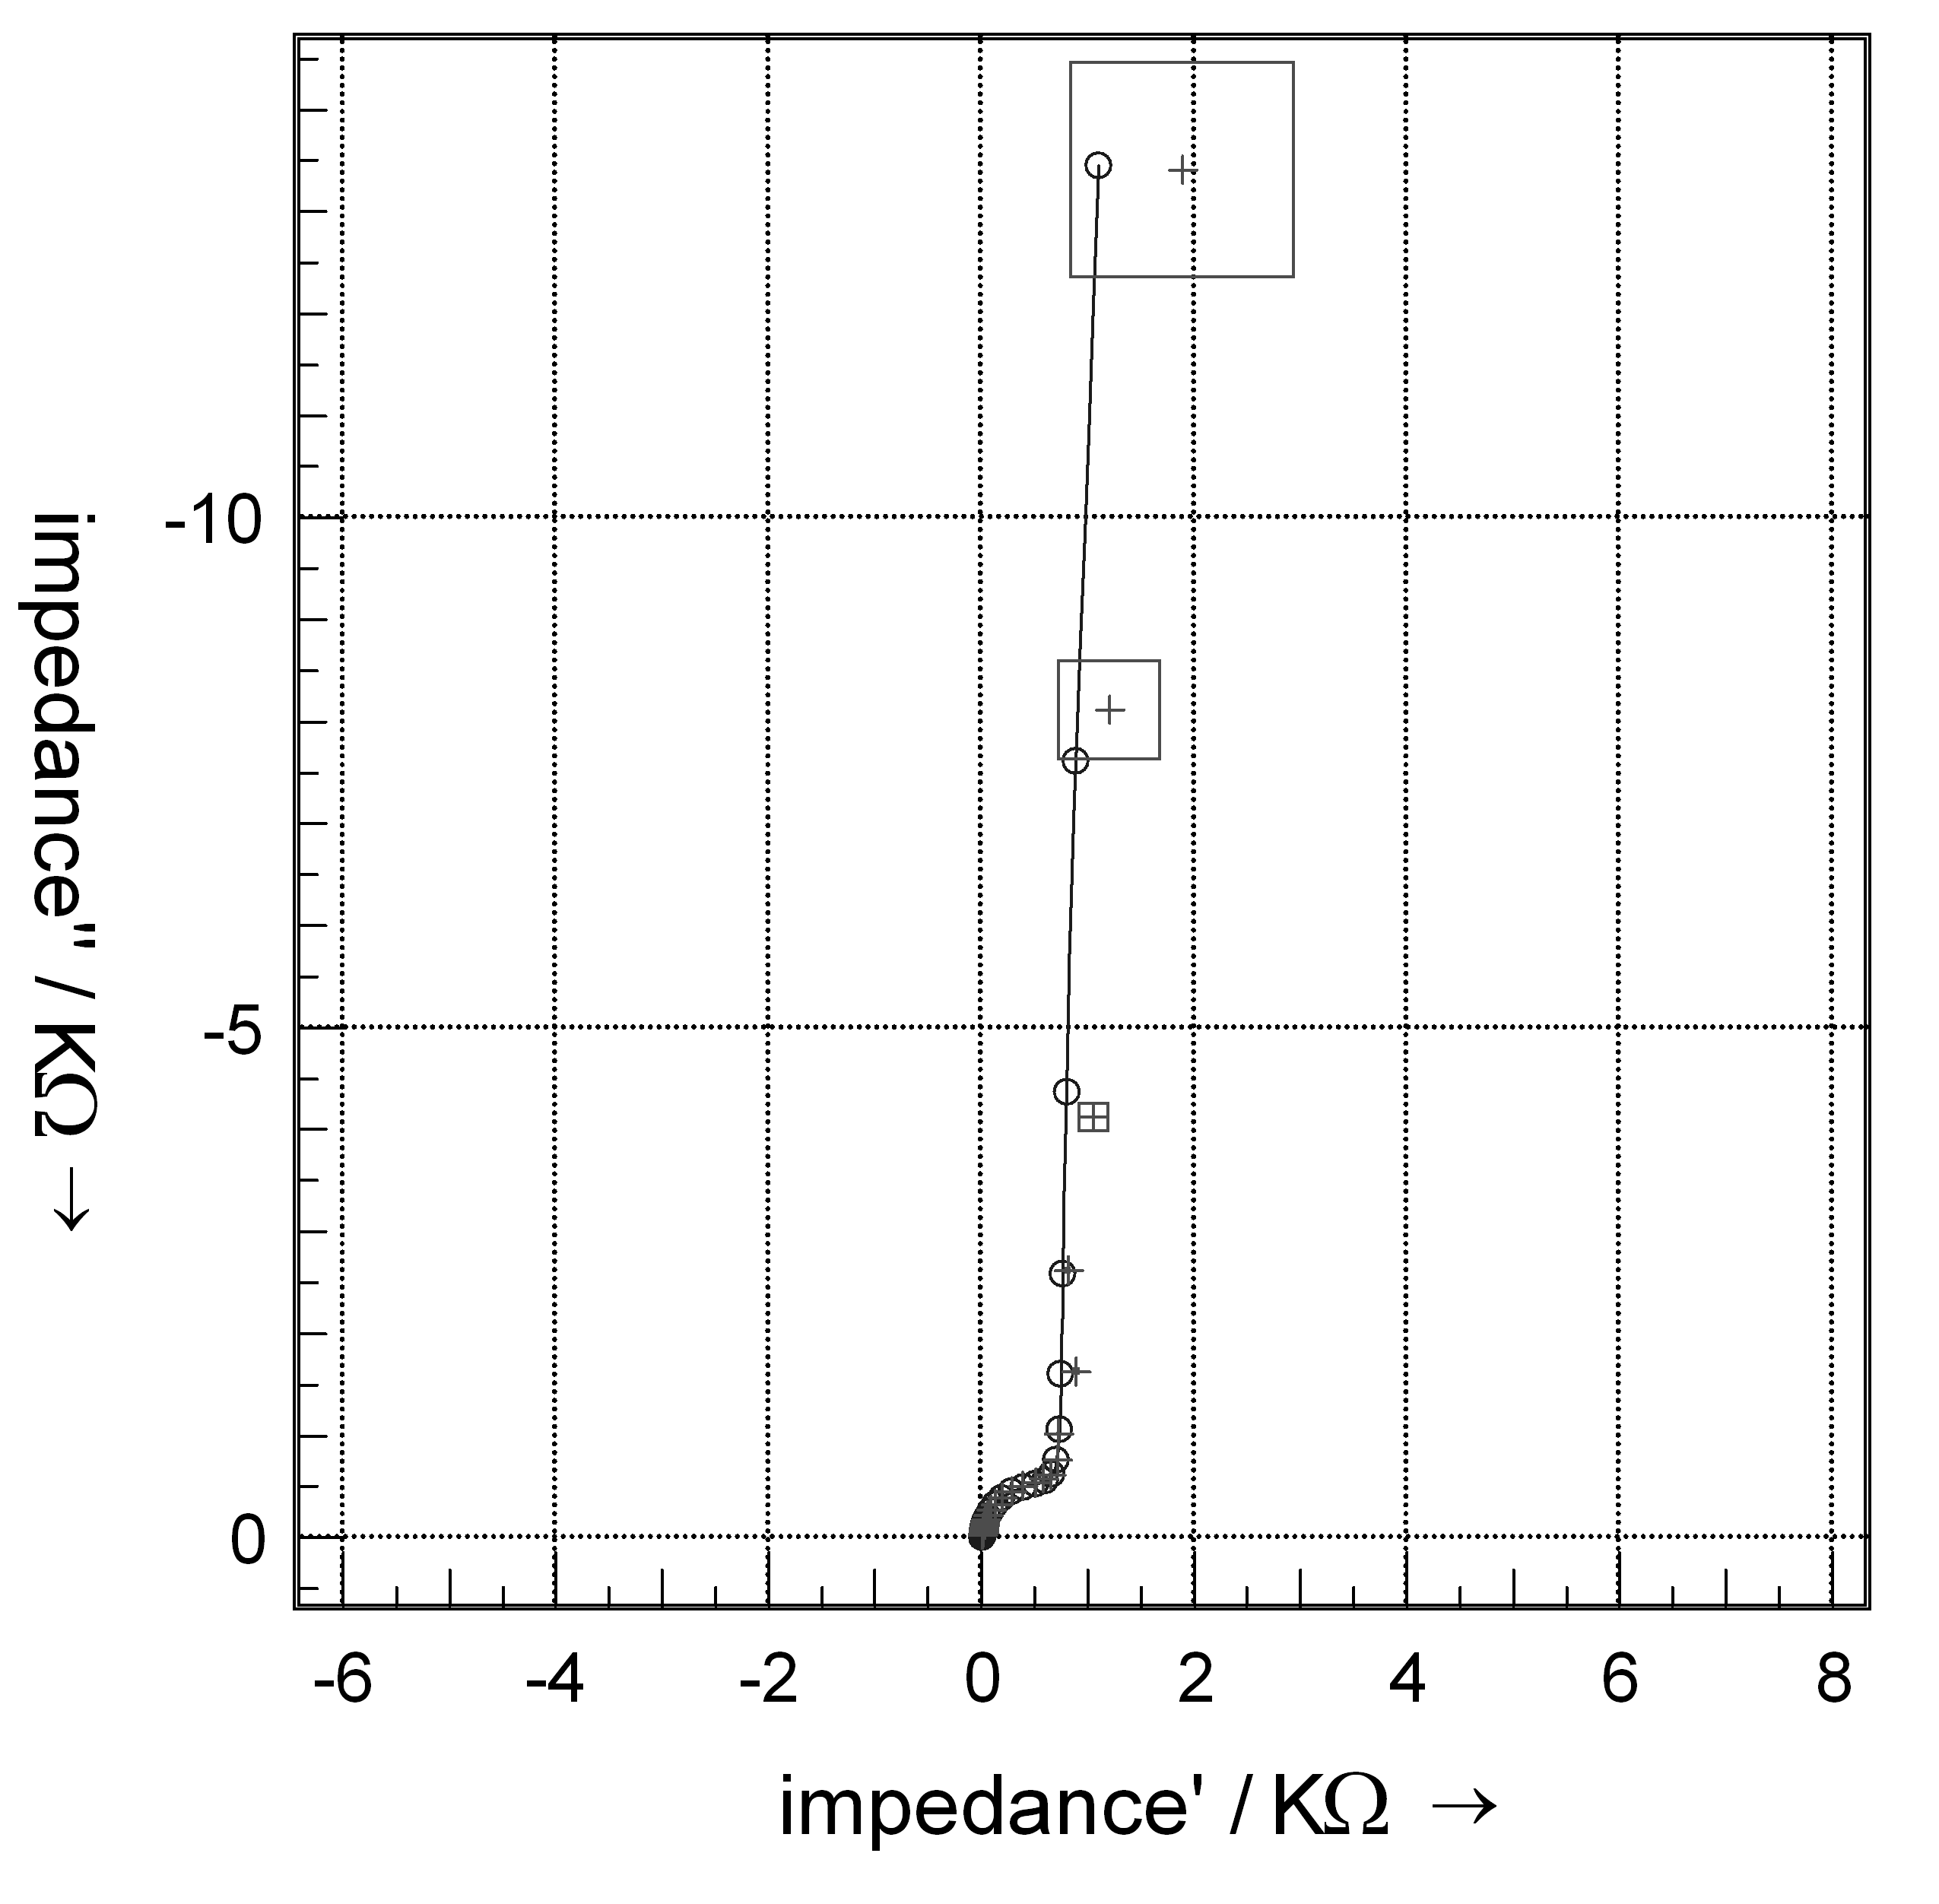
Fig. 8. Complex plane plot of a dummy cell (Fig. 6) measurement with the test set-up sketched in Fig. 5 with superimposed pink noise together with the result of a flawless measurement.
The straight line as well as the circles show the measurement without noise, the squares with centred crosses represent the predicted error with the measurement data under interfering noise.
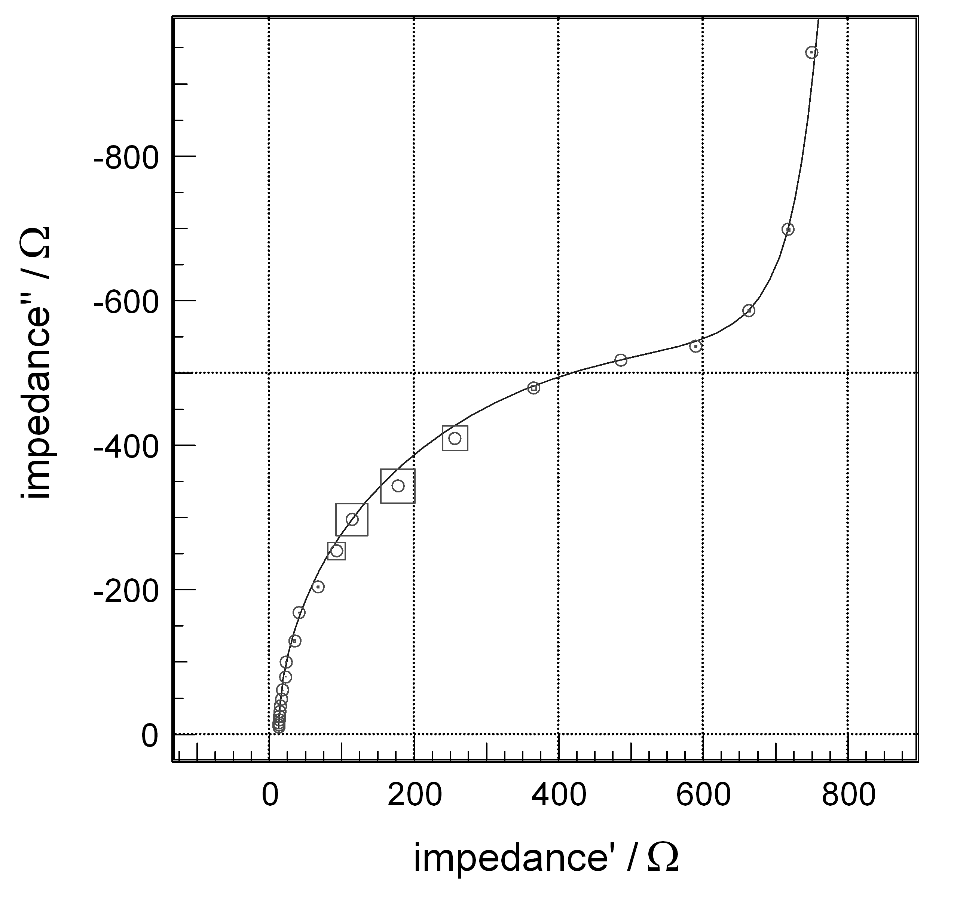
Fig.9. Complex plane plot of an EIS measurement
of a dummy cell between 1 Hz and 1 kHz with a superimposed interfering sine wave of 100 Hz.
The squares with the centered circles indicate the uncertainty predicted by the weighted harmonics autocorrelation (one σ) and the measurement data with additional interference. The solid line char-acterizes the correct (undisturbed) result.
As it is stated above, the largest deviation between undisturbed (solid line in Fig. 9) and noisy measurement (circles in Fig. 9) is observed at signal frequencies around the interference frequency. The error predicted by the weighted harmonics auto-correlation algorithm is maximal in this frequency region, too. As it can be seen, the weighted harmonics autocorrelation algorithm leads to an acceptable uncertainty estimation for the case of a sine interference, too.
C. A. Schiller and R. Kaus: Online error determination and processing for EIS measurement data
Further to external interference pick up, the non-linear behaviour of an investigated object can lead to errors in impedance measurements. As a repre-sentative example for this kind of error contribution, two power Schottky diodes connected in anti-parallel way were investigated by EIS under a bias current of 10 µA. In Figs. 10 and 11 a Bode and a complex plane plot respectively show the results. The straight lines represent a flawless measurement, using only amplitude of 1 mV.
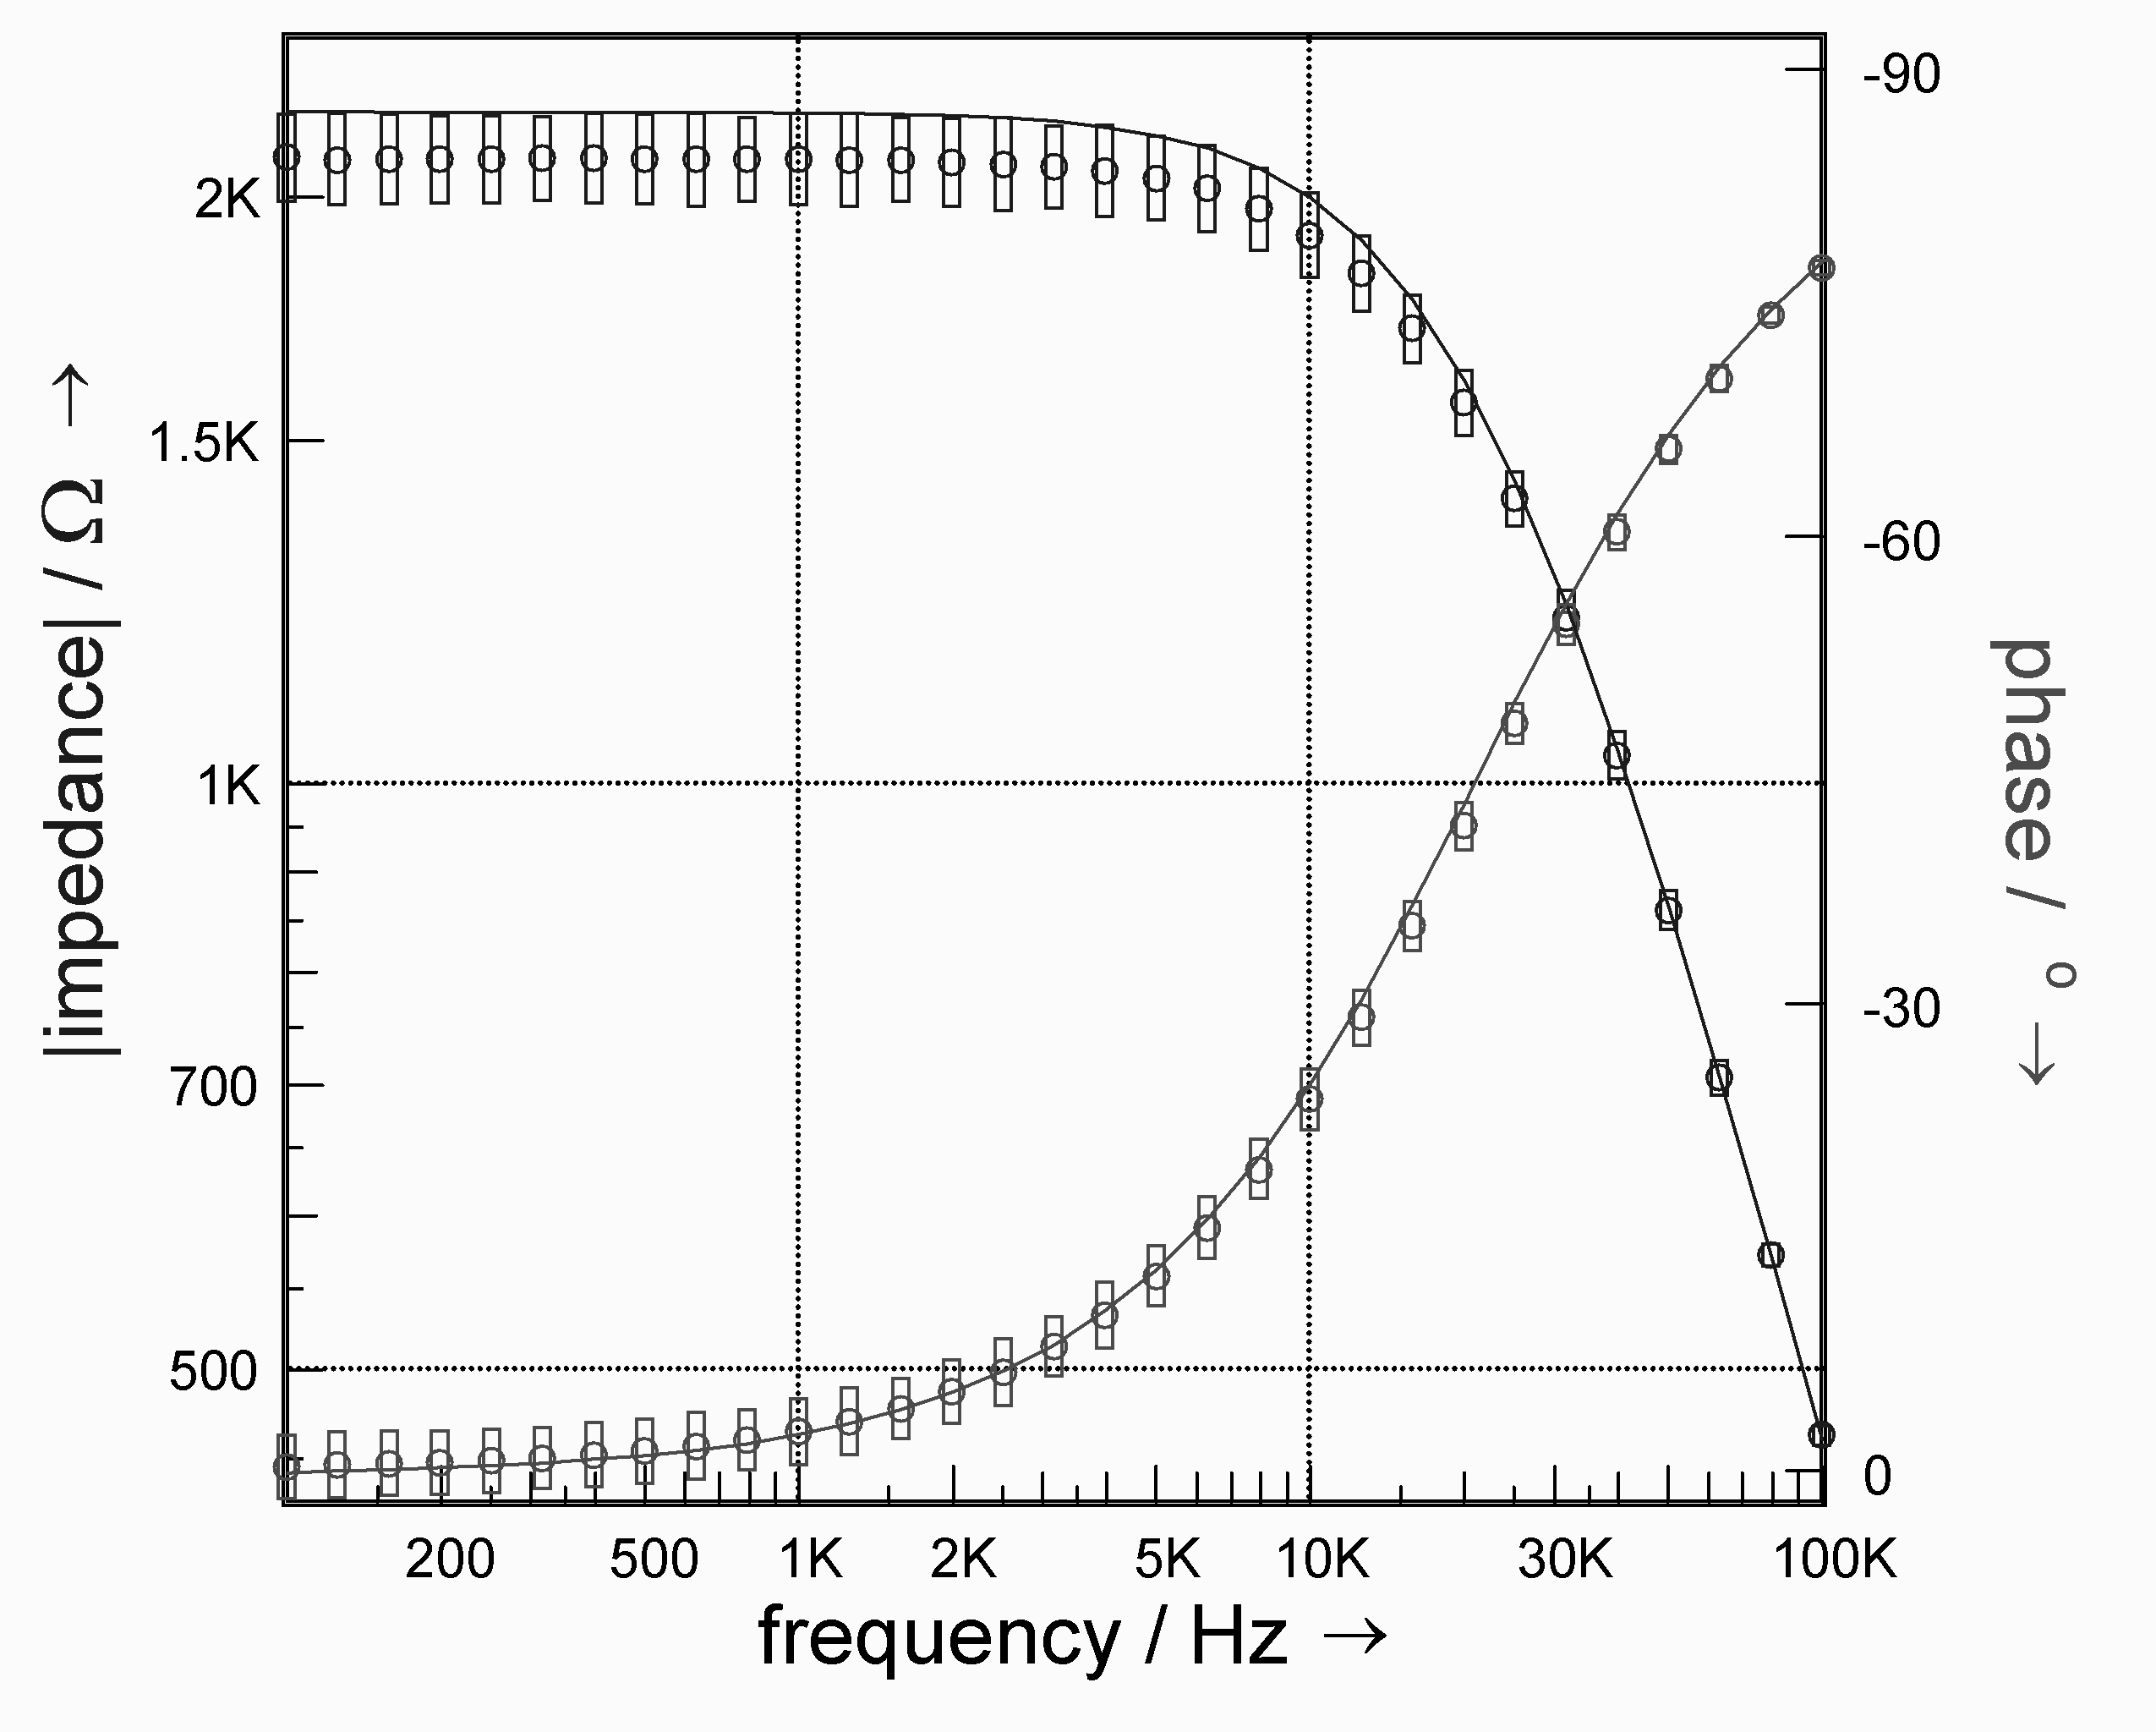
Fig. 10. Bode plot of impedance spectra of two anti-parallelly connected Schottky diodes.
The straight line was obtained with a 1 mV excitation amplitude, circles and rectangles represent the data points and the predicted uncertainty evaluated at 20 mV amplitude.
Under such small-signal conditions the Schottky diodes exhibit linear behaviour. An excitation amplitude of 20 mV, however, forces a non-linear response. Therefore, the spectrum must deviate from the former, i.e. the straight line. This can be clearly observed from a comparison of the measured data points (circles) and the straight line obtained with an amplitude of 1 mV.
Again, the uncertainty predicted by weighted harmonic autocorrelation is conform with the deviation between the high amplitude spectrum and the small signal control experiment: the larger the actual deviation, the larger the predicted error.
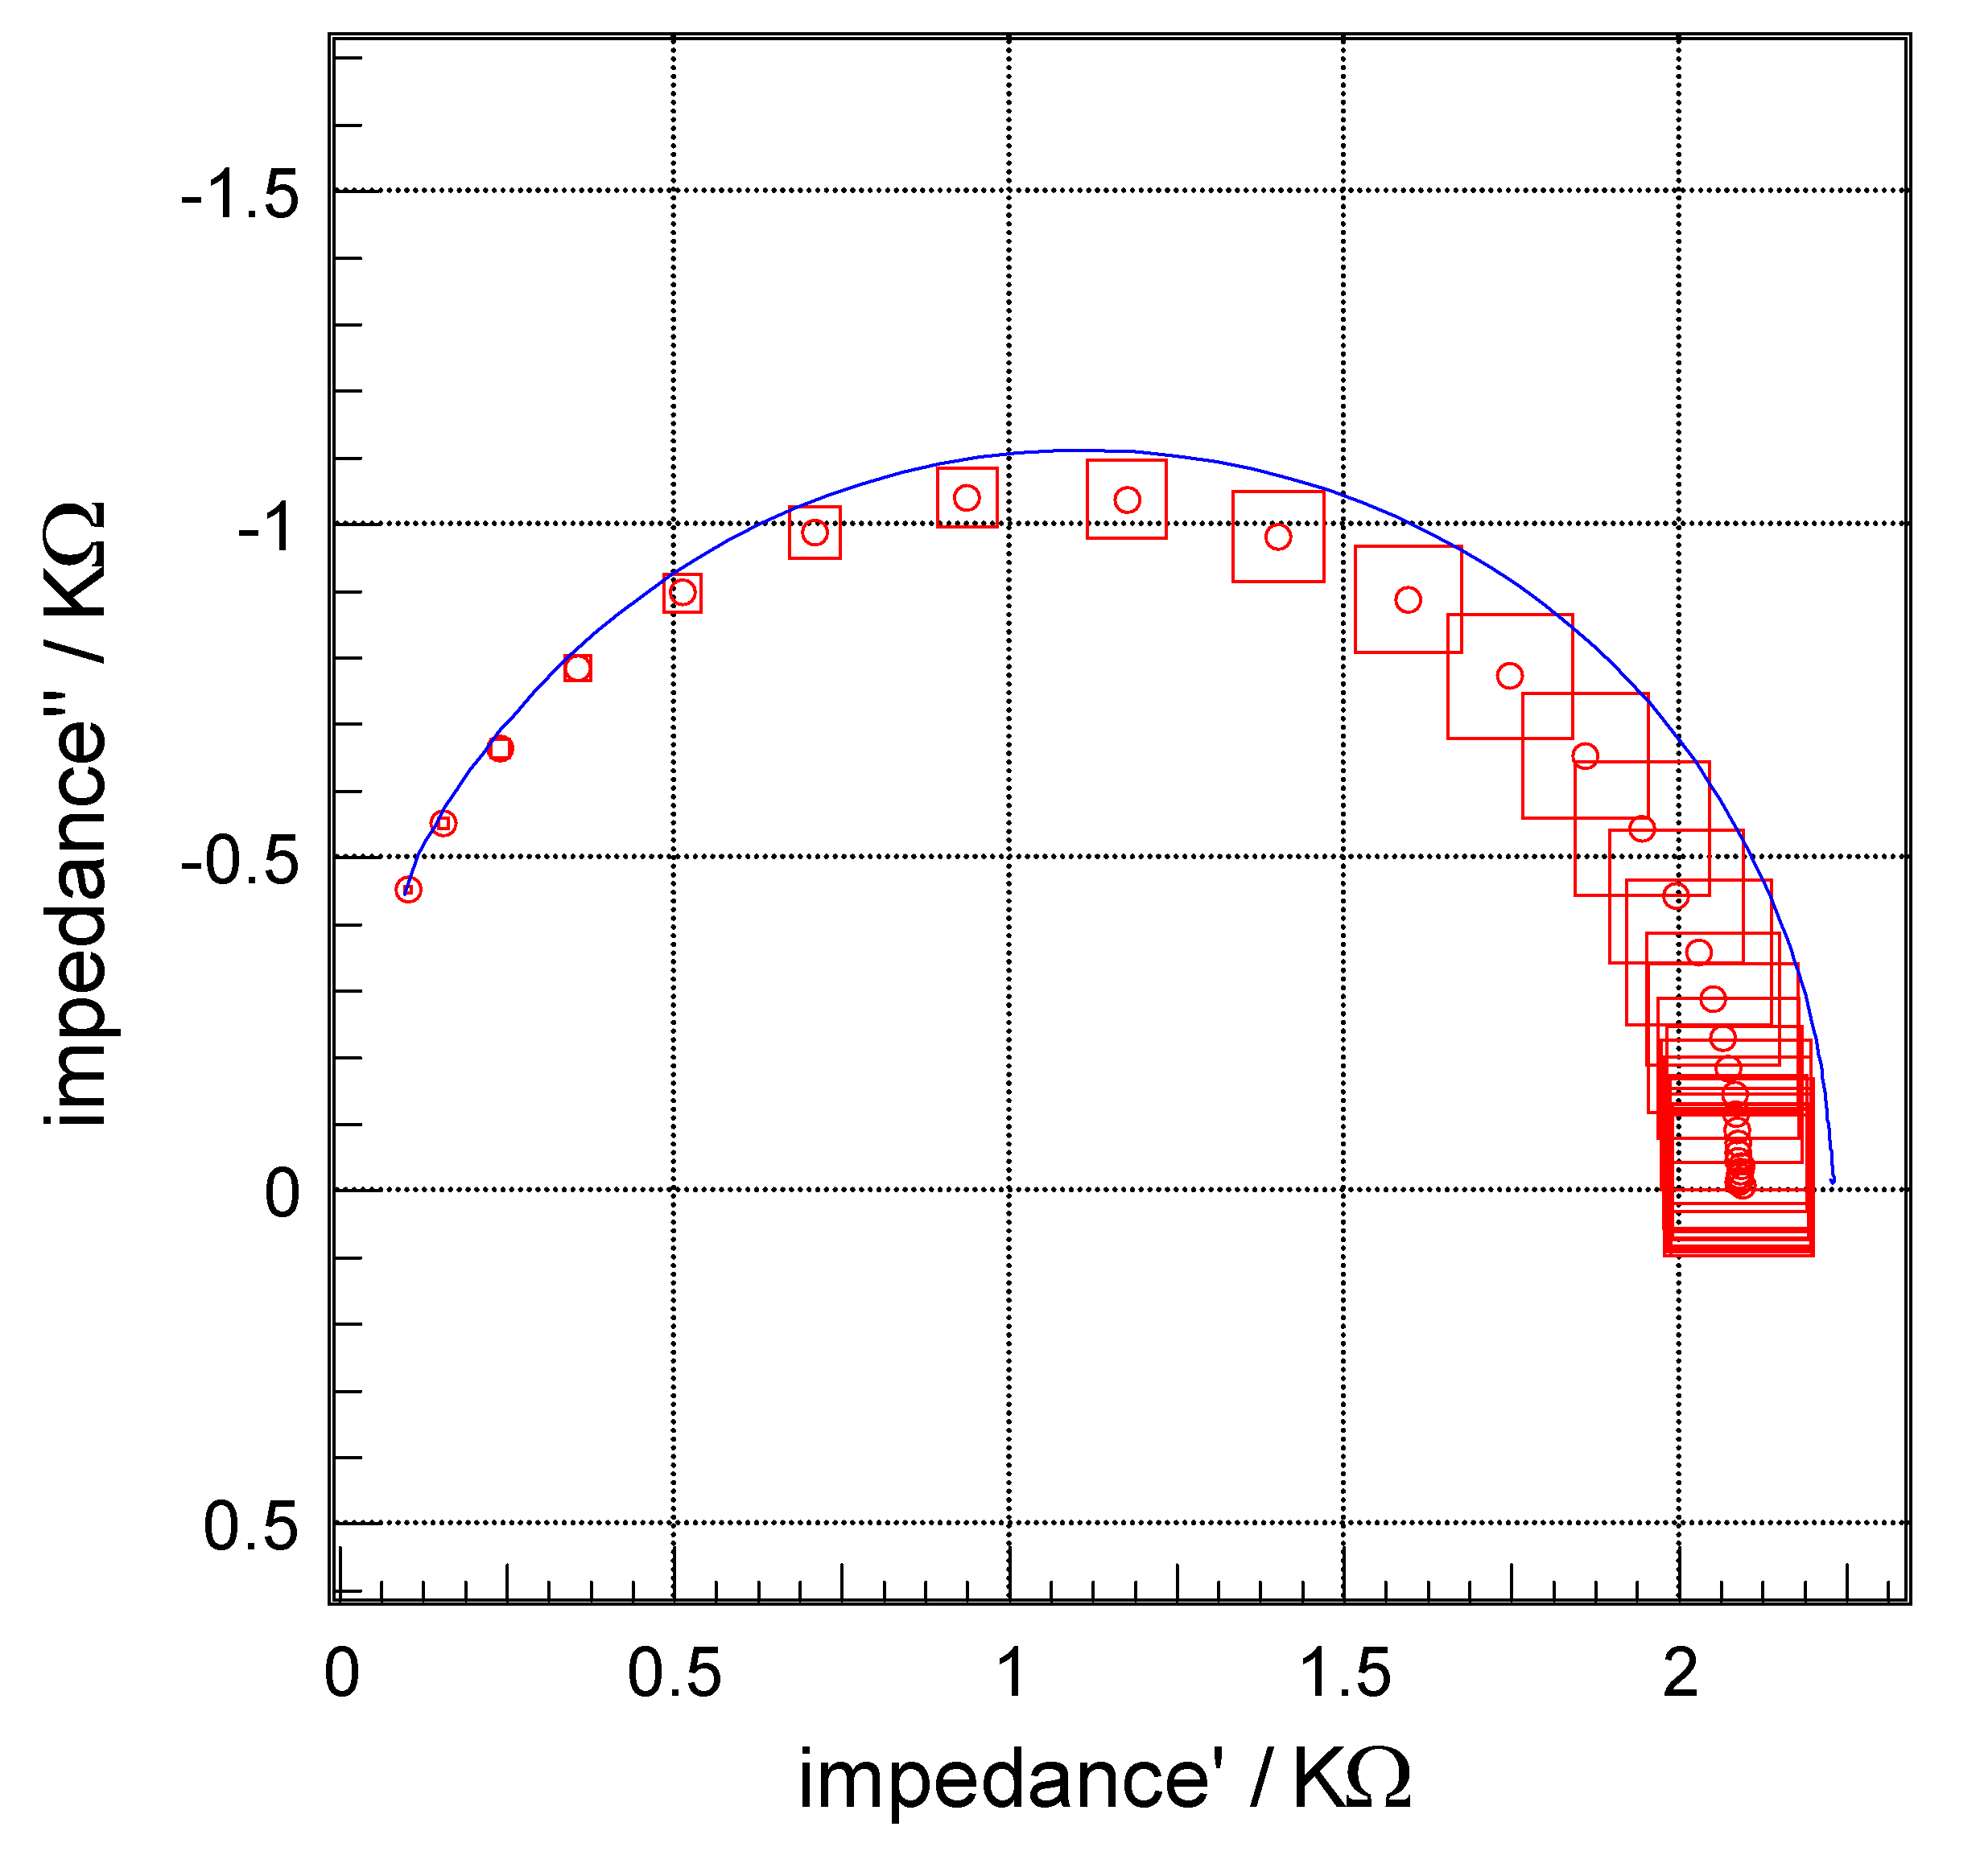
Fig. 11. Complex plane plot of the impedance spectra of the two anti-parallelly connected Schottky diodes.
Further details as indicated in Fig. 10.
CONCLUSION
The weighted harmonics autocorrelation algorithm represented here is a valuable method to predict the uncertainty for most common kinds of distortions appearing in EIS. This has been demonstrated applying different kinds of artificial interference, which usually appear also in practical experiments. The uncertainty caused by super-imposed noise was detected reliably, as well as the uncertainty appearing in the presence of a discrete frequency interference. Concerning the origin and the resulting effect, a totally different type of dis-
turbance, assigned to inherent object non-linearity, can be detected by the algorithm as well. It is characteristic of this situation that well-shaped impedance spectra with no extensive visible scat-tering are observed. Nevertheless, the weighted harmonics autocorrelation algorithm can detect such a problematic situation and provide for a realistic error forecast in this case as well.
In contrast to the error analysis of multi-spectral excitation measurements, the represented algorithm provides a straight forward, instant way of error estimation even for a single sample. It is therefore applicable not only to impedance spectra, but also to single-frequency measurements versus time, poten-tial, temperature etc. No time consuming, barely transparent procedure relying on the reproducibility of repetitive excitations is necessary, so even the time drift of objects that are not perfectly in steady state, does not affect the reliability of the uncertainty determination.
C. A. Schiller and R. Kaus: Online error determination and processing for EIS measurement data
References
- M. E. Orazem, J. Electroanal. Chem., 572, 317 (2004).
- H. Göhr, M. Mirnik, C.-A. Schiller, J. Electroanal. Chem., 180, 273 (1984).
- F. Richter, C.-A. Schiller, W. Strunz, N. Wagner, http://accessimpedance.iusi.bas.bg, Imp. Contribut. Online, 4 (2006) P5-1; Bulg. Chem. Commun., 39, 211 (2007).
- G. Nicolay, F. Reinert, S. Schmidt, D. Ehm, P. Steiner, S. Hüfner, Phys. Rev., B 62, 1631 (2000).
- J. R. Dygas, M. W. Breiter, Electrochim. Acta, 44, 4163 (1999).
- G. S. Popkirov, R. N. Schindler, Electrochim. Acta, 40, 2517 (1995).
- E. Van Gheem, R. Pintelon, J. Vereecken, J. Schoukens, A. Hubin, P. Verboven, O. Blajiev, Electrochim. Acta, 49, 4753 (2004).
- E. O. Brigham, The Fast Fourier Transform, Prentice Hall, Inc., Englewood Cliffs, N.J., 1974.

Он-Лайн определяне И обработка на грешки при данни получени с електрохимична импедансна спектроскопия на основата на автокорелациЯ на претеглени хармоници
К. А. Шилер¹*, Р. Каус²
¹ Цанер Мессистем, Кронах, Германия
² Университет Долен Рейн, Крефелд, Германия
Постъпила на 12 юли 2008 г., Преработена на 8 август 2008 г.
(Резюме)
Представена е процедура, отчитаща вътрешната корелация на хармониците наблюдавана при експерименти с електрохимична импедансна спектроскопия (ЕИС), която дава реалистична оценка на грешката и осигурява необходимата надежност на данните. Подробно е дискутирано извеждането на алгоритъма на процедурата за „автокорелация на претеглените хармоници“, както и резултатите от контролни експерименти с ЕИС, проведени върху добре познати обекти.
Показано е влиянието на три различни вида специфични взаимодействия върху експерименталните резултати: деформации от нелинейни системни характеристики, замърсяване на изходящия сигнал с розов шум, замърсяване на изходящия сигнал с единична честотна пертурбация. Неточността предсказана от автокорела-ционната процедура на претеглените хармоници е сравнена с отклоненията наблюдавани при обикновените измервания.

