Control of production campaigns with optimal loading of the power systems during multipurpose and multiproduct batch chemical plants operation
Bulgarian Chemical Communications, Volume 41, Number 4 (pp. 414–421) 2009
© 2009 Bulgarian Academy of Sciences, Union of Chemists in Bulgaria
B. B. Ivanov*, K. I. Mintchev
* To whom all correspondence should be sent:
E-mail: bivanov@bas.bg
Process Systems Engineering Laboratory, Institute of Chemical Engineering, Bulgarian Academy of Sciences,
Acad. G. Bonchev St., Block 103, 1113 Sofia, Bulgaria
Received September 19, 2008; Revised June 3, 2009
The paper is devoted to the problem of optimal loading of the joint systems of power supply of multipurpose and multiproduct batch chemical plants (MMBCP) operating in regime of production campaign. Mathematical method is proposed for determining the control independent variables that ensures minimum deviation of the loading characteristics of power demand of the related power systems from the ideal ones. The models developed for power consumption of the individual productions that belong to a production campaign were based on Fourier series. The task of optimum control was formulated as a non-linear mathematical programming one. The method proposed is verified by a test example.
Key words: multipurpose and multiproduct batch chemical plants, optimal loading of the power systems.

Introduction
Up to 50% of the world industrial units, related to chemical industry, are batch operating ones Stoltze et al. [1]. The chemical industry is a large power consumer and its effective use of power is very important. Referring to the continuous systems, the problem of effective use of their power utilization nets is most often seen as reduction of the power demand by effective utilization of the net internal power or introduction of energy-saving technologies. This is realized mainly by process heat integration according to Linnhoff [2]. However, the power bills of the batch processing systems represent only 5−10% of the total production costs per unit of product [3]. The power effectiveness of these systems depends strongly on the optimal load of the external power supply systems that is tem-porally non-uniform. Characteristic property of their performance is the fact that during simultaneous operation of a set of batch productions it is possible to reach the loading threshold values leading to emergency situations or to experience falls of the effectiveness parameters of the external power supply systems. The occurrence of such problems is characteristic of the operation of this class of systems. They are often met in various industries, such as the food processing, pharmaceutical, oils and paints and fine chemicals processing and they are considered widely in the literature [4, 5].
Referring to available sources, the problem of optimal loading of the various power systems connected with multipurpose and multiproduct batch chemical plants (MMBCP) has two aspects. The first aspect includes problems of shrinking demands of any kind of power by process heat integration [3, 6–8,]. This approach is known to lead to high utilization effectiveness of the systems’ internal power, and, while using appropriate sche-dules and heat integration flow charts, also to loading reduction and therefore to more uniform load of the particular external power system. How-ever, the ideas of heat integration may not be always applicable, as they are intercorrelated with system reconstruction activities that require proofs of eco-nomical feasibility. Besides, one may not reach the desirable loading non-uniformity.
Another approach to deal with effective power utilization is referring to development of appropriate production schedules [3, 4, 6, 9–12] that lead to decrease in loading non-uniformity. The latter unila-terally leads to higher performance effectiveness of the relevant power system.
Among the first papers to consider the issue of optimal loading of the power systems during operation of a group of batch productions is the one of Bieler et al. [13]. This work proposed a method for assessing the performance conditions of systems including batch production units that leads to a decrease in the peak load of the power systems. The task has been solved by analytical models of power consumption, based on Fourier series, while the optimal operation conditions were found by formu-lating this task in terms of mathematical pro-gramming. The formulation thus proposed by
Ivanov et al. [9] considered the deviation of the instant power of start-up of batch production as a single control variable. In this way, the possibility to achieve optimal load of the power demand systems can be largely limited.
Referring to another work by Badel. et al. [14], the issue of optimal loading of multipurpose plant systems has been discussed from the point of view of financial resources. This work assumes operation of the system in a production schedule “follow-up” regime of the type Job Shop Scheduling.
An interesting approach is reported in refs. [13, 15, 16], where mathematical models of power con-sumption of some charts of batch reactors have been proposed. Nevertheless, the approach of MMBCP operation control considered in this group of works is not enough general to be used.
From the above review of the literature, it becomes clear that the issues related to optimal loading of the power systems during operation of multipurpose and multi-product chemical plants can be resolved following two main directions, namely: 1. Using means and charts allowing maximum utilization of the systems’ internal energy by process heat integration, and 2. Creating perfor-mance conditions that lead to optimal load of the external power systems by formulation of appro-priate schedules of operation and selection of appropriate production technologies for the majority of the products.
In any case, the issue of formulation of appro-priate mathematical criteria for evaluation of the power effectiveness as well as effective methods for determination of the control variables leading to optimal loading of the various power systems still remains to be targeted.
Problem description
Let us consider a multipurpose chemical plant producing simultaneously a given amount of products within a production campaign (Fig. 1). The productions included in the campaign are batch ones with fixed production cycle. Assume that some stages of these productions, related to fixed power types, are power consuming and that they load the relevant external power supply system batchwise during the process stage time. Referring to fixed schedules and vessel parameters, one can determine the amount of power corresponding to any heat carrier required to produce a unit of end product (electrical power, cold, steam, cooling water, etc.). The consumption of any power type in the various stages of the process is carried out at constant intensity. During the operation of the set of produc-tions simultaneously within a campaign using the various external power systems, depending on the process arrangement in time one may obtain dif-ferent loading and often in some time periods it may exceed significantly the allowable threshold level of the external power system.
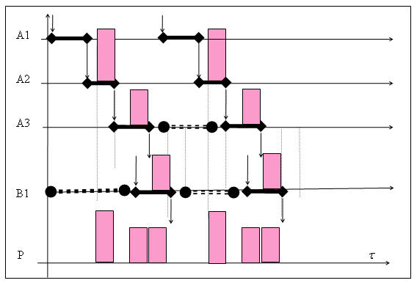
Fig. 1. Gant’s chart of a production campaign of two processes.
Considering the operation of such a production system, one may find ways to dislocate the produc-tions themselves in the course of overall production or to delay the start-up of any one of the batches in a series or to change its size. Obviously, using these control variables one can reach optimal load of the relevant power systems.
B. B. Ivanov and K. I. Mintchev: Control of production campaigns
The aim of the study was to determine, within a campaign and for batch production, the values of the batch size, the delay of production start-up in a campaign, compared to a pre-selected basic pro-duction, as well as the waiting time interval among the individual batches - in such a way as to ensure the external power system by type the best loading in terms of a pre-selected criterion. Additionally, the number of batches in each production, pre-deter-mined in order to fulfil the planned overall pro-duction program, has to be determined. In order to solve such a task, it is evident that one has to propose appropriate criterion relationships to be able to evaluate the power demand, as well as to for-mulate appropriate mathematical models, describing the power consumption in time.
The aim of the study was to formulate a mathe-matical model for evaluation of the control inde-pendent variables that ensure pre-determined loading requirements of the power systems during MMBCP operation in a fixed production campaign.
Theory
Basic data. Let us consider the sets of variables, as follows:
Set $I\left\{ i_{1},i_{2},\text{.}\text{.}\text{.},i_{N} \right\}$ – set of products subject to simultaneous production.
Set $J_{i}\left\{ j_{1},j_{2},\text{.}\text{.}\text{.},j_{N} \right\}$ – set of stages of any separate production process.
Set $P_{\text{ij}}\left\{p_{1},p_{2},\text{.}\text{.}\text{.}\text{.}\text{.}p_{N}\right\}$ – set of processes within any production stage.
Additionally, also consider the data, as follows:
$е_{\text{ijpw}}$– the amount of power of type w, required to produce a unit mass of end product during the p-th process of the j-th stage and in the i-th production line.
The power demand in the case of permanent loading during the process will be:
$p_{\text{ijpw}}=\frac{e_{\text{ijpw}}B_{i}}{τ_{\text{ijp}}}$, respectively,
where τ_{ijp} is the time interval of the relevant process, and B_{i} is the batch size.
The duration of each stage of a given production will be:
$τ_{\text{ij}}=\sum_{p_{\text{ij}}}{τ_{\text{ijp}}}\text{ , }∀i∈I,∀j∈J$.
The amount of mass of product of any kind for the planning horizon H should not be less than the previously fixed value, namely, $G_{i}^{\text{min}}$.
The cycle time intervals of the productions operating in regime of overlapping cycles is calcu-lated by means of the equation $τ_{i}={\text{max}}_{j}\left(τ_{\text{ij}}\right)$, and in the cases where the production arrangement is without overlapping of cycles, the cycle time will be $τ_{i}=\sum_{j}{τ_{\text{ij}}}$.
It is assumed also that the relationships for determination of the process time intervals as a function of the batch size are known:
$τ_{\text{ijp}}=F_{\text{ijp}}^{f}(B_{i}),$ $∀_{i}∈I,∀_{j}∈J_{i},∀_{p}∈P_{\text{ij}}$
The Max and Min batch size are also previously calculated for any product:
where $V_{\text{ij}}^{\text{MIN}},V_{\text{ij}}^{\text{MAX}}$ indicate the maximum and the minimum permissible volumes of the vessels used in the relevant production stages, and s_{ij} is the dimension coefficient that determines the vessel’s volume required to produce a unit mass of end product corresponding to the i-th production j-th-stage. Besides, one assumes the maximum per-missible average intensity of loading of the relevant power system, $P_{w}^{\text{max}}$, to be predetermined.
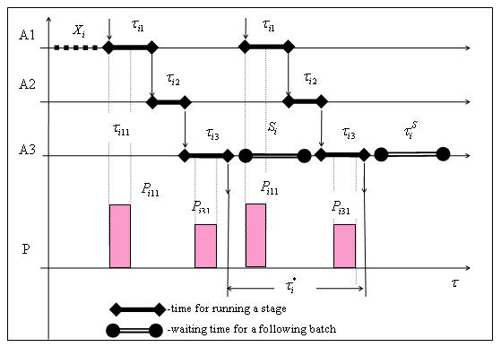
Fig. 2. Gant’s chart of a production including three stages.
Control variables. The following sets of continuous control variables are entered:
B. B. Ivanov and K. I. Mintchev: Control of production campaigns
- Time intreval of dislocation of the start-up of operation of the separate productions $X_{i}\text{ , }∀i∈I$.
- Waiting time interval among the separate production batches $S_{i}\text{ , }∀i∈I$.
- Size of the batch mass produced - $B_{i}\text{ , }∀i∈I$.
The size of the batch mass produced, corresponding to each product, may assume values within the fixed range $B_{i}^{\text{MIN}},B_{i}^{\text{MAX}}$, previously cal-culated and depending on the degree of com-pleteness of the individual batch vessels, engaged in the production of a given product. The intensity of the power demand of given type and/or the time interval of the individual processes are directly related to the size of the production lot.
Constraints. The following sets of inequality constraints are entered:
- Constraints of permissible size of the batch of product:
$B_{i}^{\text{MIN}}≤B_{i}≤B_{i}^{\text{MAX}}\text{ , }∀i∈I$ (1)
- Constraints for permissible waiting time inter-val between the batches:
$0≤S_{i}≤\frac{H−N_{i} τ_{i}}{N_{i}}\text{ , }∀i∈I$ (2)
where
$N_{i}=\left\lfloor \frac{G_{i}^{\text{min}}}{B_{i}}\right\rfloor \text{ , }∀i∈I$
means permissible minimum number of batches that has to be produced in each production process for the planning horizon H.
- Constraints for the allowable dislocation time intervals for the start-up of each batch relevant to one basic production process:
$0≤X_{i}≤\left( τ_{i}+S_{i}\right)\text{ , }∀i∈I$ (3)
- Constraints providing for execution of the programme by quantities:
$G_{i}^{\text{min}}≤\left\lfloor \frac{H}{τ_{i}+S_{i}}\right\rfloor B_{i}\text{ , }∀i∈I$ (4)
- Constraints providing for execution of the time programme:
$\left(τ_{i}+S_{i}\right) N_{i}≤H\text{ , }∀i∈I$ (5)
- Constraint providing for permissible average power demand during production of the products in the campaign in the course of the planning:
$\sum_{i}{P_{\text{iw}}^{\text{const}}\left(S_{i},B_{i}\right)}≤{\text{ P}}_{w}^{\text{max}}\text{, }∀w∈W$ (6)
Mathematical model of power consumption during production campaign
The function of variation of the intensity of power of any type for each process and stage of production can be written analytically by repre-senting the periodical function of loading through Fourier series (Fig. 2):
$\begin{aligned}P_{\text{ijpw}}\left( S_{i},X_{i},B_{i},t\right)=\frac{A_{\text{ijpw}}^{0}}{2}+ \\ +\sum_{k}{\left(A_{\text{ijpw}}^{K} \text{sin}\left(\frac{2πk}{τ_{i}^{}}\left(t−τ_{\text{ijp}}^{\text{shift}}\right)\right)\right)}+ \\ +\sum_{k}{\left(B_{\text{ijpw}}^{K}\text{.}\text{cos} \left(\frac{2πk}{τ_{i}^{}}\left(t−τ_{\text{ijp}}^{\text{shift}}\right)\right)\right)}\end{aligned}$ (7)
where τ_{i}* = τ_{i} + S_{i},
$$\begin{aligned} τ_{\text{ijp}}^{\text{shift}}=X_{i}+\sum_{j=1}^{j}{\sum_{p∈P_{j}}{τ_{\text{ijp}}}+\sum_{p=1}^{P}{τ_{\text{ijp}}}\frac{−}{}τ_{\text{ij}1}}\frac{}{}\sum_{p∈P_{1}}{τ_{i1p}}\text{, } \\ ∀i,j,p \end{aligned}$$
k is the harmonic number of the development in series of Fourier, $A_{\text{ijpw}}^{0},A_{\text{ijpw}}^{k},B_{\text{ijpw}}^{k}$ are the Fourier coefficients that can be determined, depending on the loading curve by using analytical relationships reported for the most frequent cases or for arbitrary curves by using numerical methods. The coeffi-cients referring to the cases of permanent loading during some process (which is the most frequent case) depend only on the process time interval and on the constant power -component and they can be written, as shown below:
$\begin{aligned}A_{\text{ijpw}}^{0}=\frac{2 e_{\text{ijpw}}}{τ_{i}^{}} B_{i}, \\ A_{\text{ijpw}}^{k}=\frac{e_{\text{ijpw}}}{{πkτ}_{\text{ijp}}} B_{i} \text{sin} \left(\frac{2πk τ_{\text{ijp}}}{τ_{i}^{}}\right), \\ B_{\text{ijpw}}^{k}=\frac{e_{\text{ijpw}}}{{πkτ}_{\text{ijp}}} B_{i} \text{cos} \left(\frac{2πk τ_{\text{ijp}}}{τ_{i}^{}}\right)\end{aligned}$ (8)
Based on the Fourier transformation of the sepa-rate processes, one can write the analytical equa-tions of the stages, of the productions and of the campaign, as follows:
B. B. Ivanov and K. I. Mintchev: Control of production campaigns
- The capacity of power demand of any kind in stage j of a given production i is described as:
$\begin{aligned}P_{\text{ijw}}\left( S_{i},X_{i},B_{i},t \right)=P_{\text{ijw}}^{\text{const}}\left( S_{i},B_{i} \right)+ \\ +P_{\text{ijw}}^{\text{var}}\left( S_{i},X_{i},B_{i},t \right) , ∀i∈\text{I,}∀j∈J, \\ ∀w∈W\end{aligned}$ (9)
where
$\begin{aligned}P_{\text{ijw}}^{\text{const}}\left( S_{i},B_{i} \right)=\sum_{p}{\frac{A_{\text{ijpw}}^{0}}{2}}\text{ , } \\ ∀i∈I,∀j∈J,∀w∈W\end{aligned}$ (10)
$\begin{aligned}P_{\text{ijw}}^{\text{var}}\left( S_{i},X_{i},B_{i},t \right)= \\ \sum_{p}{\begin{aligned}\left\{\sum_{k}{\left(A_{\text{ijpw}}^{K} \text{sin} \left(\frac{2πk}{τ_{i}^{}}\left(t−τ_{\text{ijp}}^{\text{shift}}\right)\right)\right)}+ | \right\}\end{aligned}\left\{\right\}}\end{aligned}$ (11)
- Capacity of power demand of any type for production i is described as:
$\begin{aligned}P_{\text{iw}}(S_{i},X_{i},B_{i},t)=P_{\text{iw}}^{\text{const}}(S_{i},B_{i})+ \\ +P_{\text{iw}}^{\text{var}}(S_{i},X_{i},B_{i},t)\text{, }∀i∈I,∀w∈W\end{aligned}$ (12)
where
$\begin{aligned}P_{\text{iw}}^{\text{const}}\left( S_{i},B_{i} \right)=\sum_{j}{P_{\text{ijw}}^{\text{const}}\left( S_{i},B_{i} \right)}\text{ , } \\ ∀i∈I,∀w∈W\end{aligned}$ (13)
$\begin{aligned}P_{\text{iw}}^{\text{var}}\left( S_{i},X_{i},B_{i},t \right)=\sum_{j}{P_{\text{ijw}}^{\text{var}}\left( S_{i},X_{i},B_{i},t \right)}\text{ , } \\ ∀i∈I,∀w∈W\end{aligned}$(14)
- Capacity of power demand of any type for the whole campaign is described as:
$P_{w}\left( S,X,B,t \right)=P_{w}^{\text{const}}\left( S,B \right)+P_{w}^{\text{var}}\left( S,X,B,t \right)$
(15)
where:
$P_{w}^{\text{const}}\left( \text{S,B} \right)=\sum_{i}{P_{\text{iw}}^{\text{const}}\left( S_{i},B_{i} \right)}$,
$P_{w}^{\text{var}}\left( S,X,B,t \right)=\sum_{i}{P_{\text{iw}}^{\text{var}}\left( S_{i},X_{i},B_{i},t \right)}$.
The constant component of the capacity of the power demand $P_{w}^{\text{const}}$ does not depend on time and it is considered to be the ideal value that should be targeted as a result of the control of the production campaign based on criterion of minimum oscilla-tion. The variable component $P_{w}^{\text{var}}$ shows the power variance around the permanent component. This function can be used for assessing the degree of de-viation of the real curve compared to the ideal one.
The variable component is determined by the relationship:
$\int_{0}^{H}{P_{w}^{\text{var}}\left( S,X,B,t \right)} \text{dt}=0$. (16)
Objective function. The deviation of the real curve with respect to the ideal one is evaluated by the relationship:
$J_{w}=\frac{\int_{0}^{H}{\left| P_{w}^{\text{var}}( S,X,B,t) \right| \text{dt}}}{HP_{w}^{\text{const}}} \text{100}\text{\%}$. (17)
Formulation of the problem of optimal control ensuring minimum variance of the power demand
The problem of optimal control of a given pro-duction campaign providing for minimum deviation of the curve of the power loading with regard to the ideal curve can be formulated as a non-linear pro-gamming task with continuous independent vari-ables, as follows: the values of the sets of control variables (S, X, B) are found in such a way as to ensure minimum of the objective function (Eqn. (17)) conforming to the set of inequality constraints (Eqns. (1) through (6)). Thus formulated, the task can be solved by using some of the known NLP techniques [17].
Example problem. An example represents the production process of three different products, carried out simultaneously in one production campaign. The workshop, involved in producing the three products, contains three reaction units with similar vessels of different operating volumes.
B. B. Ivanov and K. I. Mintchev: Control of production campaigns
Table 1 contains the data related to the vessels.
Table 1. Data related to the vessels.
Ves-  sels type P | Work  volume (min/max) | Ves-  sels  type V | Work  volume (min/max) | Ves-sels type D | Work  volume (min/max)
P1 | 300/300 | V1 | 300/300 | D1 | 140/140
P2 | 250/250 | V2 | 400/400 | D2 | 160/160
P3 | 250/250 | V3 | 250/250
Table 2 contains the time intervals of the production stages in terms of products.
Table 2. Time intervals of the production stages in terms of products.
Stage | Production А | Production В | Production C
Stage 1 | 30 min. | 30 min. | 30 min.
Stage 2 | 240 min. | 240 min. | 240 min.
Stage 3 | 30 min. | 30 min.
The size coefficients (indicating the required operating volumes for production of unit of end product) by individual stages and productions are presented in Table 3.
Table 3. Size coefficients by individual stages and productions.
Stage/Product | Stage 1 | Stage 2 | Stage 3
Product A | 1.2 | 1.96 | 6.3
Product B | 1.2 | 1.23 | 7.3
Product C | 1.2 | 1
The power required to produce a unit of end product by individual stages and productions is given in Table 4.
Table 4. Power required to produce an end product unit by individual stages and productions.
No | Power required for production of a unit product  in stage
No | Stage 1, kW | Stage 2, kW | Stage 3, kW
Product A | 0.24 | 0 | 0.092
Product B | 0.295 | 0 | 0.11
Product C | 0.029 | 0
The planning horizon of this production campaign is H = 100 hours.
Table 5 describes the vessels for production of products “А”, “В” and “С”.
The task was solved by using software package ECAM performing a NLP task.
Table 6 contains the optimal values of the control variables.
Figures 3, 4 and 5 illustrate the curves of variation of the power demand, corresponding to the individual productions and the total loading of the power system.
B. B. Ivanov and K. I. Mintchev: Control of production campaigns
Table 5. List of the vessels relevant to separate pro-
ductions.
Production process | Stage 1 | Stage 2 | Stage 3 | Planned amount
Product A | P1 | V1 | D1 | 400
Product B | P2 | V2 | D2 | 250
Product C | P3 | V3 |  | 3000

Table 6. Optimal values of the control variables.
Production | Time of starting-up,  h | Time of cycle and waiting time between batches, h | Optimum size of a batch and total amount produced in the horizon, kg | Maximum peak power, kW | Mean power in the planning horizon, kW | Process variability, %
А | 0 | 5.47/1.47 | 22.22/406.2 | 10.56 | 1.34 | 11.17
B | 1.06 | 7.33/3.33 | 21.91/298.9 | 13.2 | 1.21 | 67.5
C | 2.52 | 6.909/2.909 | 208.33/3015 | 12.1 | 0.87 | 52.5
A+B+C |  |  |  | 25.01 | 3.433 | 16.325

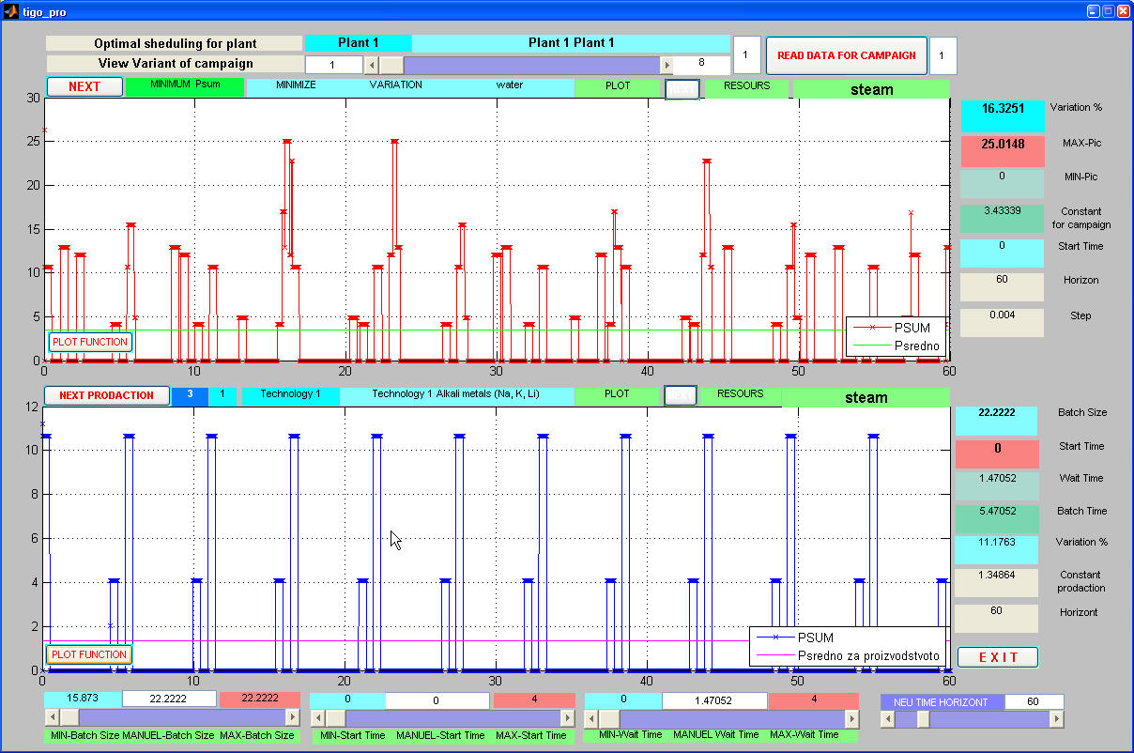
Fig. 3. Loading of the power system at optimal dislocation (arrangement) of the start-up of productions “B” and “C” with regard to production “A”. Upper curve – overall loading of the power system during operation of the three production processes; Lower curve – loading due to production process “A”.

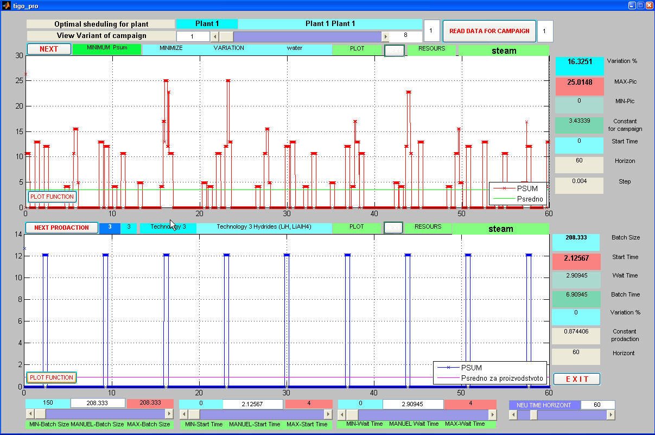
Fig. 4. Loading of the power system at optimal dislocation (arrangement) of the start-up of productions “B” and “C” with regard to production “A”. Upper curve – overall loading of the power system during operation of the three production processes; Lower curve – loading due to production process “B”.
B. B. Ivanov and K. I. Mintchev: Control of production campaigns
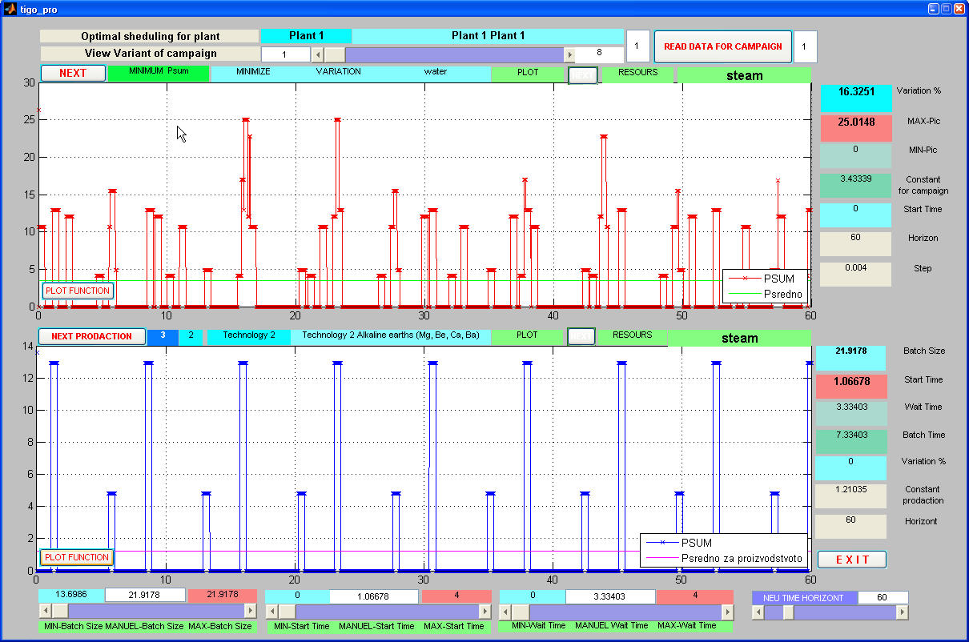
Fig. 5. Loading of the power system at optimal dislocation (arrangement) of the start-up of productions “B” and “C” with regard to production “A”. Upper curve – overall loading of the power system during operation of the three production processes; Lower curve – loading due to production process “C”.

Conslusions
Based on the analysis of production campaigns involving power supply systems in MBCP operation, the following conclusions could be drawn:- A mathematical model of the general problem of controlling the production campaigns of MBCP operation, while accounting for the power loading of the external power supply systems, is proposed.
- The control problem is formulated as a task of the non-linear mathematical programming metho-dology.
- The theory proposed is verified by an example problem solved by using software package ECAM.
References
B. B. Ivanov and K. I. Mintchev: Control of production campaigns
- S. Stoltze, J. Mikkelsen, B. Lorentzen, P. M. Petersen, B. Qvale, J. Energy Resources Technol.; Trans. ASME, 117, 142 (1995).
- B. Linnhoff, Trans. IChemE, Part A, 71, 503 (1993).
- N. Vaklieva-Bancheva, B. B. Ivanov, N. Shah, C. C. Pantelides, Comput. Chem. Eng., 20, 989 (1996).
- D. C. A. Muller, F. M. A. Marechal, T. Wolewinski, P. J. Roux, Appl. Therm. Eng., 27, 2677 (2007).
- D. W. T. Rippin, Comput. Chem. Eng., 17, Suppl., S1 (1993).
- Z. Calderón, R. Grau, A. Espuña, L. Puigjaner, Hung. J. Ind. Chem., 28, 31 (2000).
- K. C. Furman, N. V. Sahinidis., Ind. Eng. Chem. Res., 41, 2335 (2002).
- C. Jiménez-González, M. R. Overcash,. J. Chem. Technol. Biotechnol., 75, 983 (2000).
- B. Ivanov, N. Vaklieva-Bancheva, Chr. Boyadjiev, Hung. J. Ind. Chem., 18, 55 (1990).
- I. Cho, B. Lee, I. B. Lee, E. S. Lee, Hwahak Konghak, 36, 601 (1998).
- N. G. Vaklieva-Bancheva, E. G. Shopova, B. B. Ivanov, Hung. J. Ind. Chem., 30, 199 (2002).
- J. M. Pinto, I. E. Grossmann, Comput. Chem. Eng., 21, 801 (1997).
- P. S. Bieler, U. Fischer, K. Hungerbühler, Ind. Eng. Chem. Res., 42, 6135 (2003).
- M. Badell, J. Romero, L. Puigjaner, Int. J. Production Economics, 95, 359 (2005).
- P. S. Bieler, ETH Zürich, Swiss Federal Office of Energy, Final Report, March 2004.
- P. S. Bieler, U. Fischer, K. Hungerbühler, Ind. Eng. Chem. Res., 43, 7785 (2004).
- A. Brooke, D. Kendrick, A. Meeraus, R. Raman, GAMS: A User's Guide, GAMS Development Corporation, Washington, 1998.

Управление на производствени кампании, осигуряващо оптимално натоварване на енергосистемите при работата на многоцелеви заводи
Б. Иванов*, К. Минчев
Лаборатория Инженерно-химична системотехника, Институт по инженерна химия,
Българска академия на науките, ул. „Акад. Г. Бончев”, бл. 103, 1113 София
Постъпила на 19 септември 2008 г.; Преработена на 3 юни 2009 г.
(Резюме)
Работата е посветена на проблема за оптималното натоварване на общите системи за енергозахранване на многоцелеви заводи, работещи в режим на производствени кампании. Предложен е математичен метод за определяне на управляващите независими променливи, осигуряващи минимално отклонение на кривите на натоварването на съответните енергосистеми от идеалните такива. За описание на моделите на потребление на енергия на отделните производства и производственната кампания са използувани редове на Фурие. Задачата за оптимално управление е формулирана като задача на нелинейното математичното програмиране. За потвърждение на предлагания метод е предложен тестов пример.

