Fluorescein as corrosion inhibitor for carbon steel in well water
© 2009 Bulgarian Academy of Sciences, Union of Chemists in Bulgaria
Bulgarian Chemical Communications, Volume 41, Number 4 (pp. 374–379) 2009
J. Sathiyabama¹, S. Rajendran^{1,2}*, J. A. Selvi³, J. Jeyasundari⁴
* To whom all correspondence should be sent:
E-mail: susairajendran@gmail.com
¹ Department of Chemistry, GTN Arts College, Dindigul - 624005, Tamilnadu, India
² Corrosion Research Centre, Department of Physical Sciences, Servite College of Education for Women,
Thogaimalai - 621 313, Tamilnadu, India
³ Department of Chemistry, Vinayaga Mission University, Aarupadai Veedu Institute of Technology,
OMR, Paiyanur - 603104, India
⁴ Department of Chemistry, SVN College, Madurai, India
Received January 10, 2009; Revised April 23, 2009
The inhibition efficiency of fluorescein in controlling corrosion of carbon steel, immersed in well water, has been evaluated by mass loss method both in the absence and presence of zinc ion. The formulation consisting of 60 ppm of Fluorescein (FN) and 50 ppm of Zn²⁺ offers 98% inhibition efficiency to carbon steel immersed in well water. A synergistic effect exists between FN and Zn²⁺. The inhibition efficiency (IE) of the FN-Zn²⁺ system decreases with increases in immersion period. Addition of N-cetyl-N,N,N-trimethyl ammonium bromide (CTAB) sodium dodecyl sulphate (SDS), sodium sulphite (Na₂SO₃) does not change the excellent inhibition efficiency of the FN-Zn²⁺ system. Polarization study suggests that the FN-Zn²⁺ functions as an anodic inhibitor system. AC impedance spectra reveal the presence of a protective film on the metal surface. FTIR spectra indicate that the protective film consists of Fe²⁺-FN complex and Zn(OH)₂.
Key words: carbon steel, corrosion inhibition, fluorescein, dyes and synergistic effect.

Introduction
Several compounds such as nitrate [1, 2] phos-phates [3, 4] silicates [5] sodium salicylate [6] sodium cinnamate [7] molybdate [8, 9] phosphoric acids [10, 12] polyacrylamide [13] and caffeine [14, 15] have been used as corrosion inhibitors. Talati and Gandhi [16, 18] have studied the effect of some dyes as corrosion inhibitors for B26S aluminium in hydrochloric acid. The inhibition efficiency (IE) of triphenylmethane dyes such as Victoria Blue, Fast Green, Light Green, Malachite Green, Fuchsine base, Fuchsine acid, Crystal Violet and Methyl Violet 6B in controlling corrosion of aluminium in phosphonic acid has been studied by Talati and Daraji using mass loss and polarization studies [19]. Though several dyes have been used as corrosion inhibitors, the mechanistic aspects of corrosion inhi-bition have not been studied in detail. This prompted us to investigate (i) the inhibition efficiency of fluorescein in controlling the corrosion of carbon steel immersed in well water in the absence and presence of zinc ion (ii) the influence of pH and immersion period (iii) to analyze the protective film formed on the metal surface by FTIR spectroscopy (iv) to propose a suitable mechanism of corrosion inhibition based on the results of electrochemical studies such as polarization and AC impedance and FTIR spectra.
Experimental
Preparation of the specimens
Carbon steel specimens (0.0267% S, 0.06% P, 0.4% Mn, 0.1% C and the rest iron) of the dimen-sions 10×4.0×0.2 cm were polished to mirror finish and degreased with trichloroethylene and used for mass loss method and surface examination studies.
Mass loss method. Relevant data on the well water, used in this study, are given in Table 1.
Table 1. Parameters of well water.
Parameter | Value
pH | 8.38
Conductivity | 3110×10^{–4} S·m^{–1}
TDS | 2013 ppm
Chloride | 665 ppm
Sulphate | 14 ppm
Total hardness | 1100 ppm

Carbon steel specimens, in triplicate were im-mersed in 100 ml of well water and various concen-trations of fluorescein in the presence and absence of Zn²⁺ (as ZnSO₄.7H₂O) for a period of one day. The corrosion products were cleaned with Clarke's solution [20]. The weight of the specimens before and after immersion was determined using Shimadzu balance AY62. The corrosion inhibition efficiency was calculated based on Eqn (1):
IE = 100 [1−W₂/W₁], % (1)
Where W₁ is the corrosion rate in the absence of the inhibitor and W₂ is the corrosion rate in the presence of inhibitor.
Surface examination study
FTIR spectra. The carbon steel specimens were immersed in various test solutions for one day. The specimens were taken out of the test solutions and dried. The film formed on the metal surface was carefully removed and thoroughly mixed with KBr so as to make it uniform throughout. The FTIR spectra were recorded on a Perkin-Elmer 1600 spec-trophotometer.
Potentiodynamic polarization study. Polarization study was carried out by H and CH Electrochemical Impedance Analyzer Model CHI 660A using a three electrode cell assembly. Carbon steel was used as working electrode with platinum as counter elec-trode and saturated calomel electrode (SCE) as reference electrode. The corrosion parameters such as corrosion potential (E_{corr}) corrosion current (I_{corr}) and Tafel’s slopes (anodic slope b_{a} and cathodic slope b_{c}) were calculated.
AC Impedance spectra. AC impedance spectra were recorded by the same instrument used for polarization study using the same type of three electrode cell assembly. The real part (Z') and imaginary part (Z") of the cell impedance were measured in ohms at various frequencies. The charge transfer resistance (R_{t}) and double layer capacitance (C_{dl}) values were calculated.
Decolourization process. The optical density of FN solution before and after decolourization was measured by the instrument Photoelectric Calori-meter-112. The carbon steel was immersed in 100 ml of the formulation consisting of 60 ppm of FN and 50 ppm of Zn²⁺ for one day. After one day im-mersion, the carbon steels were removed and the solution was subjected to electrochemical deco-lourization process. The platinized titanium elec-trode was used as the anode and the graphite was used as the cathode. The electrolysis was carried out in an undivided cell with a stirring bar.
Results and Discussion
Analysis of results from mass loss study
The calculated inhibition efficiencies (IE) of fluorescein in controlling the corrosion of carbon steel immersed in well water both in the absence and presence of zinc ion have been tabulated in Table 2. The calculated values indicate the ability of fluo-rescein to be a good corrosion inhibitor. The inhibi-tion efficiency is found to be enhanced in the presence of zinc ion.
J. Sathiyabama et al.: Fluorescein as corrosion inhibitor for carbon steel
Table 2. Corrosion rates (CR) of carbon steel in well water in the absence and presence of inhibitors and the inhibition efficiencies obtained by mass loss method. Inhibitor system: Fluorescein (FN)+Zn²⁺. Immersion period: one day.
Zn²⁺ /FN, ppm | 0 | 10 | 25 | 50
0 | - | 3 | 7 | 15
20 | 13 | 35 | 70 | 96
60 | 16 | 38 | 75 | 98
100 | 22 | 45 | 82 | 98
140 | 25 | 50 | 83 | 98
180 | 30 | 65 | 90 | 98
CR(mdd)
0 | 59.09 | 59.09 | 59.09 | 59.09
20 | 51.40 | 38.41 | 17.23 | 2.36
60 | 50.32 | 36.64 | 14.77 | 1.18
100 | 46.09 | 36.64 | 14.77 | 1.179
140 | 44.32 | 29.54 | 10.04 | 1.178
180 | 41.36 | 20.68 | 5.91 | 1.175

Influence of immersion period on inhibition efficiency. The IE of FN (60 ppm)-Zn²⁺ (50 ppm) (Table 3) system is found to decrease as the immer-sion period increases. This indicates that the pro-tective film, formed on the metal surface, is unable to withstand the continuous attack of corrosive ions such as Cl– ion (665 ppm) present in well water for long time. There is a competition between the formations of FeCl₂ (and also FeCl₃) and Fe-FN complex on the anodic sites of the metal surface. The formation of FeCl₂ is favoured, compared to the formation of Fe-FN complex [21, 22].
Table 3. Influence of immersion period on the inhibition efficiency of FN (60 ppm)+Zn²⁺ (50 ppm) system.
Immersion period, day | 1 | 3 | 5 | 7
System: well water CR, mdd | 59.09 | 21.52 | 14.9 | 17
System: well water + FN (60 ppm) + Zn²⁺ (50 ppm) CR, mdd | 1.18 | 1.29 | 1.49 | 3.06
IE% | 98 | 94 | 90 | 82

Influence of N-cetyl N,N,N-trimethyl ammonium bromide (CTAB) on the inhibition efficiency of FN (60 ppm) + Zn²⁺ (50 ppm) system. The influence of CTAB on the inhibition efficiency of FN (60 ppm) + Zn²⁺ (50 ppm) system is given in Table 4. It is interesting to find that the IE of the FN-Zn²⁺ system is not changed upon the addition of CTAB. CTAB is a biocide. It can control the corrosion caused by bacteria. The present study reveals that the for-mulation consisting of FN, Zn²⁺ and CTAB has excellent corrosion inhibition efficiency. It is expected that this formulation will have also excellent biocidal efficiency. Hence, this formu-lation may be used in cooling water system.
Influence of sodium dodecyl sulphate (SDS) on the inhibition efficiency of FN (60 ppm) - Zn²⁺ (50 ppm) system. The influence of SDS on the inhibition efficiency of FN (60 ppm) - Zn²⁺ (50 ppm) system is given in Table 4. The IE of FN-Zn²⁺ system is not changed by the addition of SDS. It can control the corrosion caused by bacteria. The present study reveals that the formulation consisting of FN, Zn²⁺ and SDS has excellent corrosion inhibition effi-ciency. It is expected that this formulation will also have excellent biocidal efficiency.
Influence of sodium sulphite (Na₂SO₃) on the inhibition efficiency of FN (60 ppm)-Zn²⁺ (50 ppm) system. The influence of Na₂SO₃ on the inhibition efficiency of FN-Zn²⁺ system is given in Table 4. Addition of Na₂SO₃ has no influence on the inhi-bition efficiency of FN (60 ppm) + Zn²⁺ (50 ppm) system.
Table 4. Influence of N-Cetyl-N,N,N-trimethyl ammo-nium bromide (CTAB) on the inhibition efficiency of FN (60 ppm) + Zn²⁺ (50 ppm) system. Inhibitor system: FN (60 ppm) + Zn²⁺ (50 ppm) + CTAB; FN (60 ppm) + Zn²⁺ (50 ppm) + SDS; FN (60 ppm) + Zn²⁺ (50 ppm) + Na₂SO₃. Immersion period: one day.
FN,  ppm | Zn²,  ppm | CTAB/SDS/Na₂SO₃,  ppm | CR,  mdd | IE,  %
0 | 0 | 0 | 59.09 | --
60 | 50 | 50 | 1.18 | 98
60 | 50 | 100 | 1.179 | 98
60 | 50 | 150 | 1.178 | 98
60 | 50 | 200 | 1.176 | 98
60 | 50 | 250 | 1.175 | 98
Table 5. Influence of various pH on the inhibition effi-ciency of FN + Zn²⁺ system. Inhibitor system: FN (60 ppm) + Zn²⁺ (50 ppm) + Na₂SO₃. Immersion period: one day.
pH | 6 | 8 | 11
System: well water; CR, mdd | 17.27 | 59.09 | 3.64
System: well water + FN (60 ppm) + Zn²⁺ (50 ppm); CR, mdd  IE% | 16.55  72 | 1.18  98 | 0.546  85

Influence of pH on inhibition efficiency. The IE of the FN-Zn²⁺ system has been studied at different pH of the solutions and it is calculated. IE values have been tabulated in Table 5. At pH 6 the IE is found to be 72%. This decrease in IE is due to the fact that the protective film formed on the metal surface is broken by the attack of H⁺ ions. At pH 8 the IE is 98%. Further increase in pH of the solution lowers IE substantially. The experimental results suggest that the amount of Zn²⁺ available to trans-port FN towards the metal surface decreases at high pH. This may be due to the fact that zinc ions in the bulk of the solution might have been precipitated as zinc hydroxide.
Analysis of polarization curves
The potentiodynamic polarization curves of carbon steel immersed in well water in the absence and presence of inhibitors are shown in Fig. 1a, b and c. The corrosion parameters are given in Table 6.
J. Sathiyabama et al.: Fluorescein as corrosion inhibitor for carbon steel

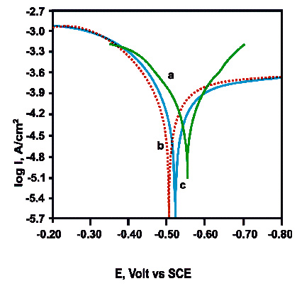
Fig. 1. Polarization curves of carbon steel immersed in test solution. a. well water; b. well water + FN (60 ppm); c. well water + FN (60 ppm) + Zn²⁺ (50 ppm).
When carbon steel is immersed in well water the corrosion potential is −550 mV vs SCE (Saturated Calomel Electrode). The corrosion current is 5.2480×10⁻⁴ A/cm². When FN (60 ppm) and Zn²⁺ (50 ppm) are added to the above system the corrosion potential shifts to the anodic side (−522 mV vs SCE). This suggests that this formulation controls the anodic reaction predominantly. In the presence of this inhibitor system, the corrosion current decreases from 5.2480×10⁻⁴ A/cm² down to 4.365×10⁻⁵ A/cm². This suggests the inhibitive nature of this inhibitor system.
Table 6. Corrosion parameters of carbon steel immersed in well water in the absence and presence of inhibitors. Inhibitor: FN (60 ppm) + Zn²⁺ (50 ppm).
FN, ppm | Zn²⁺,  ppm | E_{cor},  mV vs SCE | b_{a},  mV | b_{c},  mV | I_{corr},  A/cm²
0 | 0 | −550 | 115 | 125 | 5.2480×10⁻⁴
60 | 0 | −509 | 100 | 186 | 5.1095×10⁻⁵
60 | 50 | −522 | 71 | 114 | 4.365×10⁻⁵
Analysis of AC impedance spectra
The AC impedance spectra of carbon steel of our study are shown in Fig. 2a, b and c.
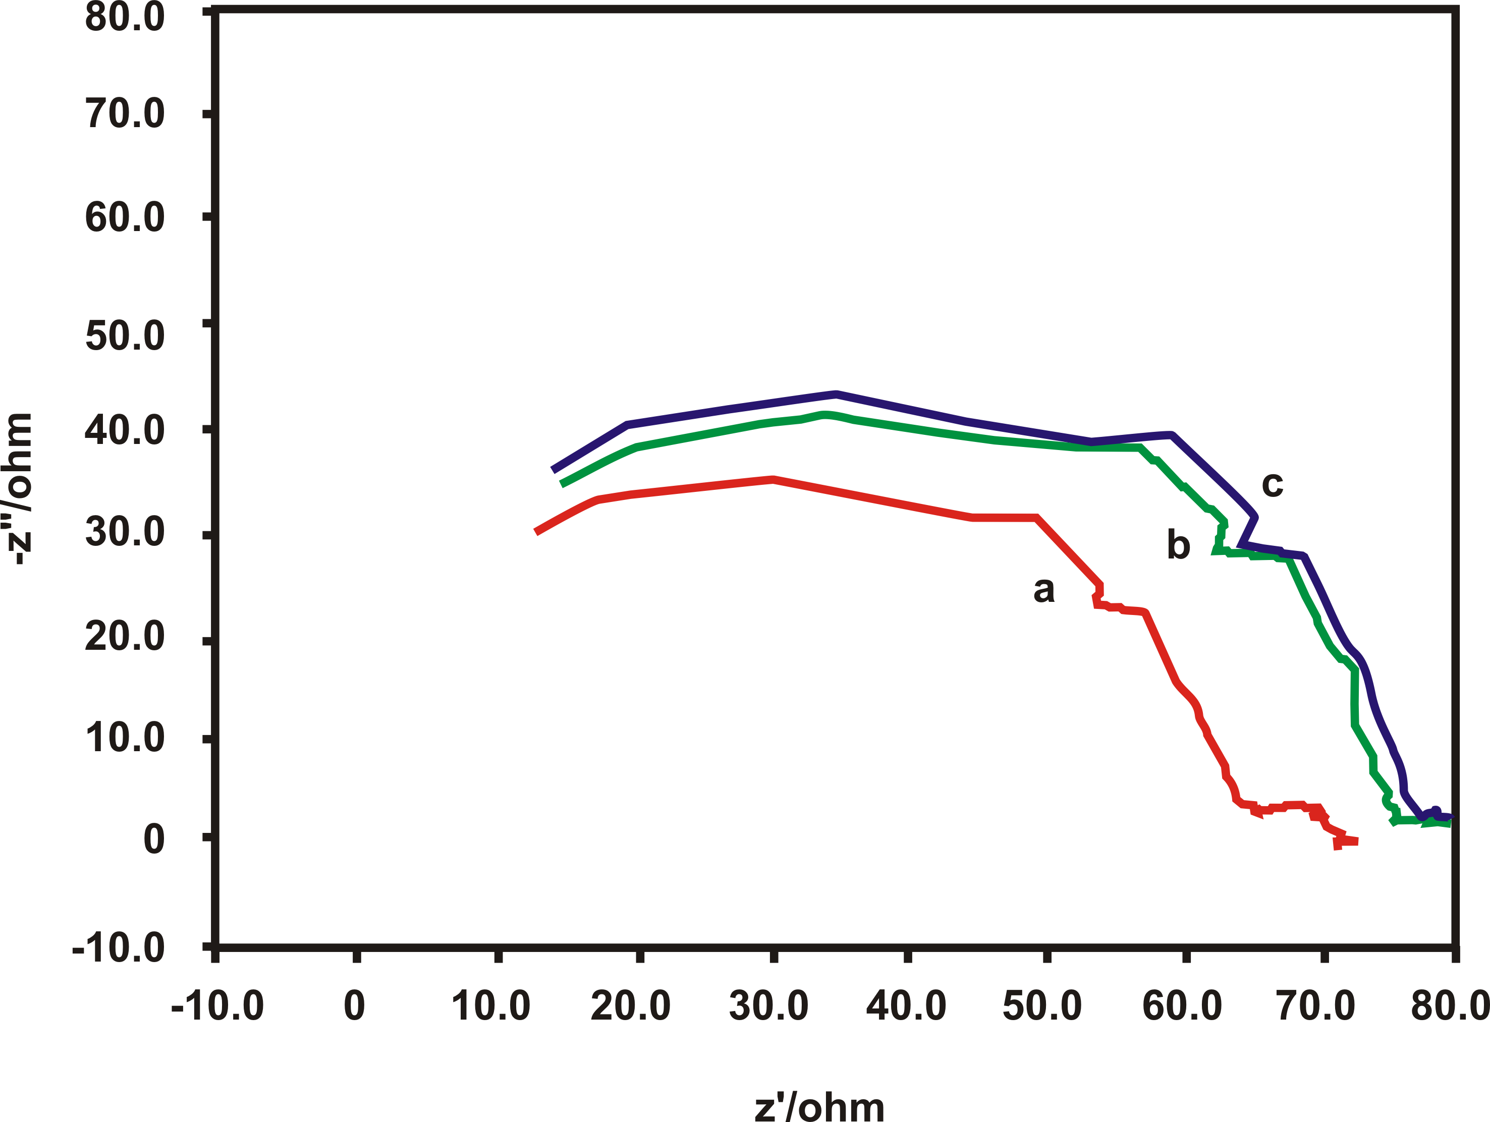
Fig. 2. AC Impedance spectra of carbon steel immersed in test solution: a - well water; b - well water + FN (60 ppm); c - well water + FN (60 ppm) + Zn²⁺ (50 ppm).
The impedance parameters have been tabulated in Table 7. When carbon steel is immersed in well water the charge transfer resistance R_{t} is 59.6 ohm∙cm². The double layer capacitance C_{dl} is 4.8854×10⁻⁸ µF/cm². When the formulation con-sisting of FN and Zn²⁺ is added the R_{t} value increases to 66.66 ohm∙cm² and the C_{dl} value decreases to 4.367×10⁻⁹ µF/cm². This increase in charge transfer resistance value (R_{t}) and the decrease in the double layer capacitance value (C_{dl}) confirm the formation of a protective film on the surface of the metal. This accounts for the better inhibition efficiency of the FN-Zn²⁺ system.
Table 7. AC Impedance parameters of carbon steel immersed in well water in the absence and presence of inhibitors. Inhibitors: FN (60 ppm) + Zn²⁺ (50 ppm).
FN  ppm | Zn²⁺,  ppm | R_{t},  ohm∙cm² | C_{dl} ,  µF/cm²
0 | 0 | 59.6 | 4.8854×10⁻⁸
60 | 0 | 60.63 | 4.8236×10⁻⁸
60 | 50 | 66.66 | 4.367×10⁻⁹
Analysis of FTIR spectra
The FTIR spectrum (KBr) of pure fluorescein is shown in Fig. 3a. The FTIR spectrum (KBr) of the film formed on the surface of the carbon steel after immersion in solution containing 60 ppm of FN and 50 ppm of Zn²⁺ is shown in Fig. 3b. The OH stretching frequency shifts from 3428 cm⁻¹ to 3463. The C=O stretching frequency shifts from 1592 cm⁻¹ to 1625. The C–O–C asymmetric bending vibration frequency shifts from 1091 to 1078 cm⁻¹. It was inferred that fluorescein has co-ordinated with Fe²⁺ through oxygen atom of OH group carboxyl oxygen and aromatic II electron resulting in the formation of Fe²⁺-FN complex on the anodic sites of the metal surface. The band at 1338 cm⁻¹ is due to Zn(OH)₂ formed on the cathodic sites of the metal surface [22−24]. Thus FTIR spectral study leads to the conclusion that the protective film consists of Fe²⁺-FN complex and Zn(OH)₂.
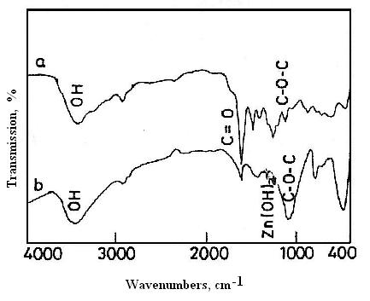
Fig. 3. FTIR spectra (KBr) of pure FN (a) and of film formed on the surface of the metal immersed in test solution FN (60 ppm) + Zn2+ (50 ppm) (b).
Decolourization process
Platinized titanium anode and graphite cathode were immersed in the solution to be decolourized. Current was passed for 10 min without addition of NaCl. The potential was 6 volts and current density was 0.25 A/cm². There was no decolourization, when 2 g of NaCl was added (2% solution) partial decolurization took place after passing a current for 10 min. However, very interestingly when 5 g of NaCl was added (5% solution) the solution was decolourized completely, within a few seconds. Hence this formulation, namely 5% solution of NaCl, platinized titanium anode, graphite cathode, passing a current density of 0.25 A/cm² and a potential of 6 volts, for a few seconds may be used to decolourize the test solution of FN.
J. Sathiyabama et al.: Fluorescein as corrosion inhibitor for carbon steel
The supporting electrolyte plays an important role in the oxidation process [23]. When NaCl solution is electrolysed, the active species produced is Cl⁺ [24, 25]. The latter oxidized the coloured material into colourless product.
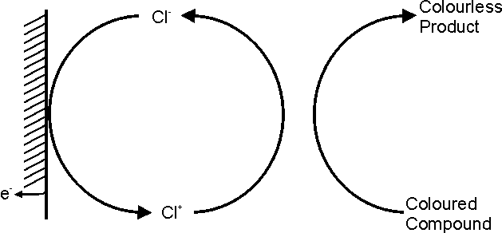
Scheme 1. Electrochemically regenerated Cl⁺.
The optical density value for the coloured solu-tion before decolourization was 0.50 and after decolourization was 0.03. Hence, the efficiency of decolourization is 94%.
The main objection in case of using dyes as corrosion inhibitors in cooling water system is the colour of the dye. The present study has revealed a method of decolourizing the coloured inhibitor solutions.
Mechanism of corrosion inhibition
Following these discussions, a mechanism can be proposed for the corrosion inhibition of carbon steel immersed in well water by FN (60 ppm)-Zn²⁺ (50 ppm) system.
J. Sathiyabama et al.: Fluorescein as corrosion inhibitor for carbon steel
- When the formulation consists of 60 ppm of FN and 50 ppm of Zn²⁺ in well water there is formation of FN-Zn²⁺ complex in solution.
- When carbon steel is immersed in this solution FN-Zn²⁺ complex diffuses from the bulk of the solution towards the metal surface.
- FN-Zn²⁺ complex is converted into FN-Fe²⁺ complex on the anodic sites of the metal surface with the release of zinc ion:
Zn²⁺−FN + Fe²⁺ → Fe²⁺−FN + Zn²⁺
- The released Zn²⁺ combines with OH⁻ to form Zn(OH)₂ on the cathodic sites of the metal surface:
Zn²⁺ + 2OH– → Zn(OH)₂ ↓
- Thus the protective film consists of FN-Fe²⁺ complex and Zn(OH)₂.
- In nearly neutral aqueous solution the anodic reaction is the formation of Fe²⁺. This anodic reaction is controlled by the formation of FN-Fe²⁺ complex on the anodic site of the metal surface. The cathodic reaction is the generation of OH–, which is controlled by the formation of Zn(OH)₂ on the cathodic sites of the metal surface.
Fe →Fe²⁺ + 2e– (Anodic reaction)
2H₂O + O₂ + 4e⁻ → 4OH– (Cathodic reaction)
- This accounts for the synergistic effect of the FN-Zn²⁺ system.
Conclusions
To summarize, fluorescein acts as a corrosion inhibitor for carbon steel in well water. Its efficiency is increased due to the transporting ability of zinc ion through the formation of the FN-Zn²⁺ complex. A suitable mechanism has been proposed for the corrosion inhibition based on the results of electro-chemical studies such as polarization and AC impedance and FTIR spectra. Perusal of the spectral analysis suggests that the protective film consists of Fe²⁺-FN complex on the anodic sites and Zn(OH)₂ on the cathodic sites on the metal surface, which confirms that FN-Zn²⁺ system functions as a anodic inhibitor system.
Acknowledgement: The authors are thankful to their management and University Grants Commis-sion, India for help and encouragement.
References
- M. Cohen, Corrosion, 32, 461 (1976).
- S. Sanyal, Bull. Electrochem., 6, 392 (1990).
- J. L. Mansa, Szybalski, Corrosion, 8, 381 (1952).
- K. S. Rajagopalan, K. Venu, Indian J. Techn., 6, 239 (1968).
- J. W. Wood, J. S. Beecher, P. S. Lawrence, Corrosion, 13, 41 (1957).
- E. V. Bogatyreva, S. A. Balezin, Zh. Prikl. Khim., 35, 1071 (1962).
- E. V. Bogatyreva, V. V. Nagaev, Zh. Prikl. Khim., 35, 550 (1962).
- S. Rajendran, B. V. Apparao, N. Palaniswamy, J. Electrochem. Soc., India, 47, 43 (1998).
- S. Rajendran, B. V. Apparao, A. Mani, N. Palaniswamy, Anti-Corros. Methods Mater., 45, 25 (1998).
- Y. I. Kuzentzov, T. I. Bardasheva, Zashch. Met., 24, 234 (1988).
- K. Airey, R. D. Armstrong, T. Handside, Corros. Sci., 28, 449 (1998).
- S. Rajendran, B. V. Apparao, N. Palaniswamy, Anti-Corros. Methods Mater., 47, 294 (2000).
- S. Rajendran, B. V. Apparao, N. Palaniswamy, Anti-Corros. Methods Mater., 44, 308 (1997).
- S. Rajendran, S. Vaibhavi, N. Anthony, D. C. Trivedi, Corrosion, 59, 529 (2003).
- S. Rajendran, A. J. Amalraj, M. J. Joice, N. Anthony, D. C. Trivedi, M. Sunderavadivelu, Corros. Rev., 22, 233 (2004).
- J. D. Talati, D. K. Gandhi, Werkst. Korros., 33, 155 (1982).
- J. D. Talati, D. K. Gandhi, Indian J. Technol., 20, 312 (1982).
- J. D. Talati, D. K. Gandhi, Corrosion, 40, 88 (1984).
- J. D. Talati, J. M. Daraji, J. Electrochem. Soc., India, 35, 175 (1986).
- G. Wranglan, Introduction to Corrosion and Protec-tion of Metals, Chapman and Hall, London, UK, 1985, p. 236.
- S. K. Selvaraj, A. J. Kennedy, A. J. Amalraj, S. Rajendran, N. Palaniswamy, Corros. Rev., 22, 219 (2004).
- S. Rajendran, S. M. Reenkala, N. Anthony, R. Ramaraj, Corros. Sci., 44, 449 (2002).
- S. Durai, S. Chellammal, N. Balasubramanian, C. A. Basha, J. Trans. SAEST, 39, 113 (2004).
- S. Rajendran, D. C. Trivedi, Synthesis, Feb. 1995,
p. 153
- R. L. Dotson, R. W. Lynch, J. Electrochem. Soc., 128, 798 (1981).

Флуоресцеин като инхибитор на корозия на въглеродна стомана
във водни кладенци
Дж. Сатиябама¹, С. Раджендран^{1,2}*, Дж. А. Селви³, Дж. Джеясундари⁴
¹ Департамент по химия, ГТН колеж по изкуства, Диндигул 624005, Тамилнаду, Индия
² Център за изследване на корозията, Департамент по физически науки,
Сервит Колеж за образование на жените, Тогаймалай 621313, Тамилнаду, Индия
³ Департамент по химия, Университет Винаяга, Аарупадай Вееду Технологичен институт,
ОМР, Пайянур 603104, Индия
⁴ Департамент по химия, С. В. Н. Колеж, Мадурай, Индия
Постъпила на 10 януари 2009 г.; Преработена на 23 април 2009 г.
(Резюме)
Определено е инхибиторното действие на флуоресцеин за контролиране на корозията на въглеродна стомана потопена в воден кладенец чрез загубата на маса в отсъствие и присъствие на цинкови йони. Рецептурата включваща 60 ppm флуоресцеин (FN) и 50 ppm Zn²⁺ дава 98% ефикасност за въглеродна стомана потопена във воден кладенец. Намерен е синергичен ефект между FN и Zn²⁺. Инхибиторното действие на системата FN-Zn²⁺ намалява с увеличаване на периода на потапяне. Добавянето на N-цетил-N,N,N-триметиламониев бромид (CTAB), натриев додецилсулфат (SDS), натриев сулфит (Na₂SO₃) не променят отличното инхибиторно действие на системата FN-Zn²⁺. Резултатът от поляризационно изследване предполага, че системата FN-Zn²⁺ действа като анодна инхибираща система. Импедансни спектри показват присъствие на защитен филм върху повърхността на метала. ИЧ спектри показват, че защитния филм сессъстои от комплекс Fe²⁺-FN и Zn(OH)₂.

