Application of Bessel’s functions in the modelling of chemical engineering processes
Bulgarian Chemical Communications, Volume 41, Number 4 (pp. 343–354) 2009
© 2009 Bulgarian Academy of Sciences, Union of Chemists in Bulgaria
T. St. Petrova
* To whom all correspondence should be sent:
E-mail: tpetrova@ice.bas.bg
Institute of Chemical Engineering, Bulgarian Academy of Sciences,
Acad. G. Bonchev St., Block 103, 1113 Sofia, Bulgaria
Received March 18, 2009
It is shown, that under given conditions the differential equations, describing some kind of transfer processes, allow an exact solution, expressed by Bessel’s functions. For that purpose a wide range literature survey, covering the modelling of transfer processes in chemical engineering as well as in the related fields, is done. The typical examples from hydrodynamics, heat transfer, diffusion, bioprocesses and so on, are considered and discussed.
Keywords: chemical engineering, transfer processes, modelling, Bessel’s functions.

Introduction
Modelling of transfer processes is based on the construction of some hypothesis for the process state and its growth in the space and time. The next step is to express that hypothesis by specific mathematical structure, e.g., to work out equations – ordinary (ODE) or partial differential (PDE), in which the unknown process function and variables are taking part. The sound reasoning to compose these equations follows from balance of transfer towards certain volume or boundaries. Finally, to "shut up" the resulting system of equations it is necessary to lay down the initial or/and boundary conditions for unknown functions and variables over the boundary domain and time interval, where the process occurred. When the initial time conditions are given and the domain for other independent variables (coordinates) is not fixed preliminary, the so called Cauchy’s problem is obtained. If the unknown function(s) are determined on the domain boundaries, the boundary value problem exists. The most often used type of boundary conditions are those of Dirichlet (value of unknown function at the boundary) and Neumann’s (the value of normal derivative of this function at the boundary) condi-tions.
The number of cases, where the so composed system of equations and initial and boundary conditions (model of process) admits solution (exact or numerical), is limited. The more complete account of all alterations of the unknown functions and values leads to a more complex and unsolvable
model, especially when introducing physical or geometrical non-linearity. There are several approaches to obtain the exact solution, the common between them is to decrease the number of independent variables and reduce the above system to a simpler and solvable system, for example:
- introducing of additional assumptions to simplify the system (symmetry, isotropy, indepen-dence from temperature, time, etc.)
- applying of different integral transformations (Laplace, Fourier), method of separation of vari-ables, method of eigenfunctions and eigenvalues;
- expansion of the unknown function in series (Taylor, Fourier), using special functions (Green, harmonic, etc.).
The above mentioned approaches to obtaining the solution are related mainly to systems containing linear PDE of second order and corresponding initial and boundary conditions. The various kinds of linear PDE, domain boundaries and boundary conditions, as well as methods for solving some linear PDE are well-known and these can be seen in a lot of mathematical textbooks like [1, Ch. 8].
In this work, the focus is centred only on those cases, where the linear PDE’s describing various chemical transfer processes, allow the exact solution expressed in terms of one special kind of functions – Bessel’s functions (BF). Modelling of different process cases from hydrodynamics, diffusion, heat transfer and other interdisciplinary topics, which illustrated the wide application of the BF, are considered. The theoretical conditions needed to obtain a solution in BF are briefly represented in next section.
Types of linear PDEs in transfer process modelling and conditions for their reducing to Bessel’s ODE. Bessel’s ODE solutions and their properties
Some of the most used in transfer processes modelling linear PDE of second order are repre-sented in Figure 1. For simplicity, the considered equations are written towards a function f = f(x, t) of only two linearly independent variables, with con-stant coefficients. Generally speaking, the elliptical PDE describe stationary processes (distribution of temperature and electrostatic fields, elastic defor-mation). Parabolic and hyperbolic PDE describe time-dependent, transient processes (free fluctua-tions after a given initial disturbance), or processes of distribution of the disturbances (forced fluctua-tions, emitting waves) [2].
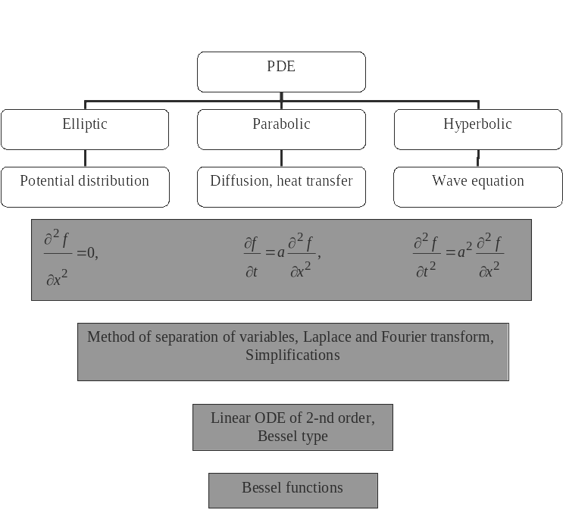
Fig. 1. Connection between linear PDE and Bessel’s ODE.
The representatives of linear elliptical PDE are Laplace, Poisson and Helmholtz equations. The Laplace equation describes a potential field distribution. If the right hand side of this equation is not equal to zero, we have inhomogeneity and the so called Poisson equation. Here the inhomogeneity is a result of internal impact (force, heat, current and other sources) on the considered domain.
The parabolic PDE widespread representatives are heat transfer and diffusion equations. They can be reduced and solved by the method of separation of variables (MSV) and their solutions contain exponential functions of negative arguments, partial solutions of Helmholtz equation and arbitrary constants; the latter ones are determined from the problem boundary conditions.
The typical example of hyperbolic PDE is the wave equation. It can be solved with the D`Alambert formulae when two initial conditions for the unknown function and its derivative are given. The Laplace и Fourier transforms are used to convert a hyperbolic into the elliptic type PDE towards one of the spatial coordinates. Another way to reduce it is to apply the MSV both to hyperbolic and parabolic PDE in the cases of mixed problems. The Helmholtz equation represents time-independent form of wave equation, obtained by him after applying the MSV. This equation is used in problems of transmission and distribution of electro-magnetic, seismologic and other waves in space.
Commonly speaking when we try to solve some of the most familiar linear PDE we become aware of the fact that to apply one of several methods decreasing the number of independent variables, the Bessel ODE may appear as a result in certain cases. It is occurring most frequently when we search solutions of linear boundary problems consisting in Laplace or Helmholtz equation in cylindrical or spherical coordinates. One of the most popular ways to find it is to apply MSV, which turns the basic equation into a set of ODEs, each one of them is towards one independent variable only. Then non-trivial solutions of ODE must be detected such ones that satisfy the given boundary conditions only for the eigenvalues and respectively the searched solution is expressed by the corresponding set-up of orthogonal eigenfunctions and unknown coeffi-cients. In problems with cylindrical or spherical symmetry, these orthogonal eigenfunctions are solu-tions of Laplace operator; in case of Cartesian coor-dinates the trigonometric functions appear [3]. The unknown coefficients are determined from the boundary conditions with the requirement that the solution must be physically reliable.
T. St. Petrova: Application of Bessel’s functions in the modelling of chemical engineering processes
The MSV is a very simple and powerful instru-ment but its application is possible only if the following conditions are fulfilled [4]: “(i) the vari-ables are separable out in the given coordinate system, (ii) the existence of an infinite set of eigen-functions for the reduced, self-adjoint ordinary differential equation, (iii) the orthogonality of the eigenfunctions permitting the direct evaluation of the coefficients in the series expansion that repre-sents the solution, and (iv) the boundary data are given on constant coordinate lines”. The last restriction can be overcome successfully with newly discovered way [4], proposed recently for a heat conduction linear problems in domains with complex geometry. When the MSV is applicable and we have Bessel’s type of ODE, the following solutions are well-known – these are the so called Bessel’s functions (BF). They can be classified (Figs. 2−5) according to the coordinate system considered and type of space – real or complex. Since Bessel’s ODE is of second order, it has two linearly independent solutions. Each linear combina-tion of these solutions is also a solution.
As it is seen from Fig. 3, 4 and 5 different types of BF have different behaviour. The cylindrical BF of 1-st kind is limited at point x = 0, but those of
2-nd kind here turned to infinity. The BF of 3-th kind are also limited at the same point, but for the case of too large complex argument. It can be seen from Figure 4 that the values of modified BF are real numbers at complex value of its argument. Unlike BF of 1-st and 2-nd kind, which are oscil-lating functions of real argument, the modified BF I_{α} and K_{α} are exponentially increasing/decreasing func-tions of complex arguments. In Figure 5 the sphe-rical BF are represented.
The BF properties are described at some length [3, 5−10], but even nowadays they still continue to be a subject of learning and intrigue many researchers from various scientific fields [11−15]. The general properties of BF are: 1) they can be developed in asymptotic series, 2) they are ortho-gonal functions, 3) they satisfy various recurrent relations and 4) they permit various integral repre-sentations.
T. St. Petrova: Application of Bessel’s functions in the modelling of chemical engineering processes

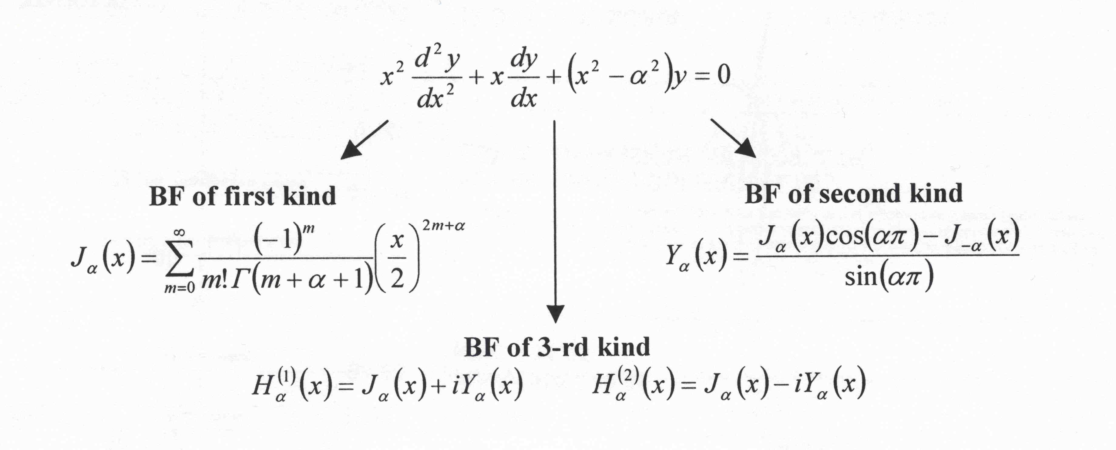
Fig. 2. Cylindrical Bessel’s functions of 1-st, 2-nd and 3-th kind (solutions of Bessel’s ODE in cylindrical coordinates) J_{α}(x), Y_{α}(x), H_{α}⁽¹⁾(x) and H_{α}⁽²⁾(x).
Fig. 3. Graphical representation of J_{α}(x), Y_{α}(x), and H_{α}(x+iy).
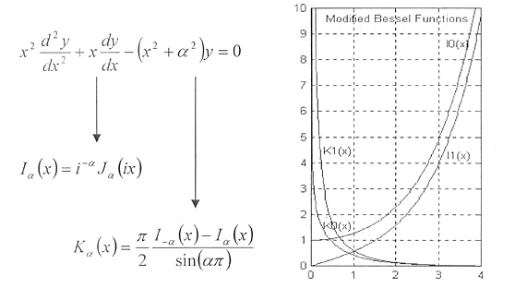
Fig. 4. Modified Bessel’s functions I_{α} and K_{α}.
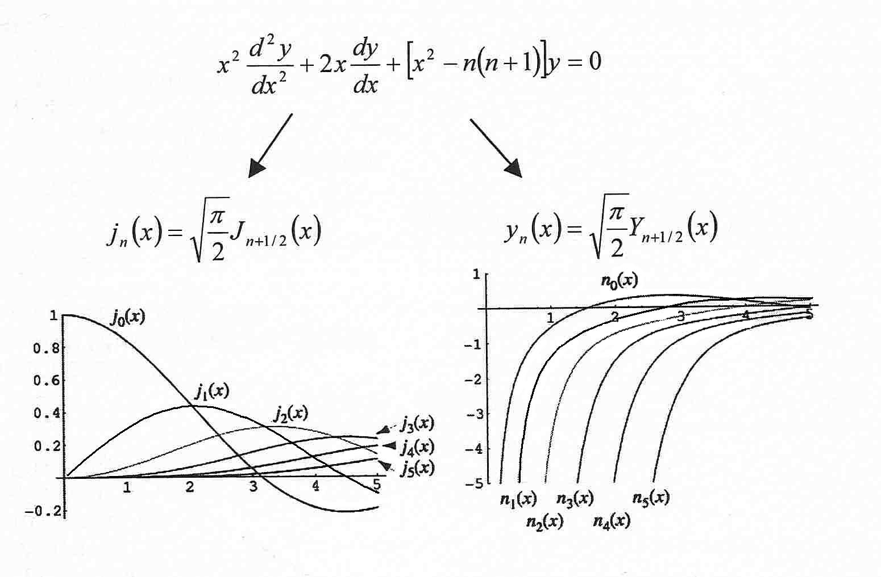
Fig. 5. Spherical Bessel’s functions j_{n} and y_{n}.

Zeros of BF played crucial role in their imple-mentation in practice. Relton [16] shows that the number of that zeros turns to infinity. In principle, their calculation is often very complex but if it was done once, they can be used repeatedly. At present the Bessel’s ODE solutions and zero’s calculation and their graphical representation are laid at the core of many modern software packages [17−19].
T. St. Petrova: Application of Bessel’s functions in the modelling of chemical engineering processes
After this brief introduction to the mathematical apparatus connected to BF, some examples of chemical engineering processes in hydrodynamics, heat and mass transfer, bioprocesses and etc. will be described, in which modelling the BF appeared.
Examples of BF application to modelling of transfer processes in chemical engineering
Heat transfer
The classical example for illustration of MSV application in this area is the heat transfer in homo-geneous infinite cylinder with surface area S and radius R₀. The mathematical process description is given by:
$\frac{∂U}{∂t}=a^{2}\left(\frac{∂^{2}U}{∂r^{2}}+\frac{1}{r}\frac{∂U}{∂r}+\frac{1}{r^{2}}\frac{∂^{2}U}{∂ϕ^{2}}\right)$ (1)
$U\left(r,0\right)=f\left(r\right), U\left(R_{0},t\right)|_{S}=0$. (2)
Assuming that at each point in the cylinder the temperature U = U(r, φ, t) depends only on the radii r, the above equation will be simplified into next one:
$\frac{∂U}{∂t}=a^{2}\left(\frac{∂^{2}U}{∂r^{2}}+\frac{1}{r}\frac{∂U}{∂r}\right)$. (3)
Let the MSV be applied, i.e., we look for a non-trivial solution of the type U(r, t) = R(r).T(t), which satisfies the boundary and initial conditions. After the substitution and rearrangement the next system of two ODEs follows:
or
$\begin{aligned}|T^{'}\left(t\right)+a^{2}λ^{2}T\left(t\right)=0 \\ |r^{2}R^{''}\left(r\right)+rR^{'}\left(r\right)+\left(λ^{2}r^{2}−0\right)R\left(r\right)=0\end{aligned}$ (4)
The constant λ is called “separation constant” and it is determined from the boundary (or similar to them) conditions. The second equation in (4) is Bessel’s ODE towards coordinate r, λ_{k} are the eigen-values with corresponding eigenfunctions J₀(λ_{k}r). Finally, the exact solution of Eqn. (3) is given as:
$U\left(r,t\right)=\sum_{k=1}^{∞}{A_{k}J_{0}\left(λ_{k}r\right)} \text{exp}\left(−a^{2}λ_{k}^{2}t\right)$ (5)
The obtained in this (or similar) way exact solu-tion in terms of BF can be used to calculate several important parameters needed in design and con-struction of chemical engineering apparatuses and equipment like heat exchangers and their compo-nents. Typical example for the efficiency calculation of finned elliptical-tube heat exchangers, part of the drying system in Brazilian powdered milk plant, is considered in [20]. The efficiency η(θ) of a rec-tangular fin in an elliptical tube as a function of the polar coordinate θ is expressed by:
$$η\left(θ\right)=\frac{2r_{0}\left(θ\right)}{m\left[r_{c}^{2}−r_{0}^{2}\left(θ\right)\right]}\text{.}$$
(6)
$$m=\sqrt{\frac{2h_{\text{sl}}}{k_{\text{fin}}s}}$$
where I₀, I₁ and K₀, K₁ are modified BF of 1-st and 2-nd kind respectively, k_{fin} is the fin thermal conductivity, h_{sl} is the shell exchanger heat-transfer coefficient, s – the fin thickness, r₀, r_{c}– geometrical parameters of finned elliptical-tube.
An analogous situation exists in the calculation of cooling towers efficiency. The towers consist of the plate-finned tubes with external radius R [21]. These plate-finned tubes are approximately simu-lated through round tubes with an equivalent radius r_{f}, when a criterion for equal performance is adopted. The simplification based on the asymptotic properties of BF was considered likewise and finally the efficiency takes the form:
$$η=\text{tanh}{\left(\text{mR}φ\right)}/{\text{mR}}φ$$
where
$φ=\left(\frac{r_{f}}{R}−1\right)\text{.}\left[1+0,\text{35}\text{ln}\frac{r_{f}}{R}\right]$ (7)
In the case of more complex fin geometry – cylindrical fins with hyperbolic profile [22], two simple numerical procedures for solving general Bessel’s ODE are proposed to estimate the tempe-rature changes in such fins. The aim of these procedures is to evade the assessment of elegant, but sophisticated exact solution for temperature distri-bution and to correspond with fin’s efficiencies expressed by modified BF of fractional order. In the later work [23] a new way to facilitate the calcu-lations, manifesting modified BF with exponential functions, is suggested. The comparison made between the exact and approximated formulas in regard to efficiency shows that efficiency value can be calculated sufficiently precise with approximated formulae, which require using of electronic calculator only.
T. St. Petrova: Application of Bessel’s functions in the modelling of chemical engineering processes
Another case when the BF arises is heat transfer modelling as considered in [24]. Here the problem of cross-flow streaming of heated object with large value of length to diameter ratio (like thermo-anemometer) is solved for small Pe numbers using the theory of analytic functions. After applying the right and reverse Fourier transform action and taking into account the integral form of modified BF [9] in the obtained solution, the following exact expression for the Nusselt number is worked out:
Nu = 2/K₀(Pe/4), (8)
where Nu is the ratio of convective to conductive heat transfer across (normally to) the boundary, K₀ is a modified BF of 2-nd kind. The comparison done between Eqn. (8) and other theoretical relations is very good, as well as a qualitative similarity to the experimental data was observed.
Mass transfer
Owing to the analogy between mathematical descriptions of heat and mass transfer processes, the BF arises again as solutions of various diffusion type of processes. In [25] a model is proposed describing changes in tracer (solid phosphorus) concentration profiles in the apparatus with circula-tion fluidized bed. Mixing of flow of dispersed particles in ascending line is characterized by the coefficients of axial and radial dispersion D_{a} and D_{r}. If the tracer injection like delta-function at the beginning is provided and the tracer concentration
c = c(t,x,r) profiles are evaluated by a dispersion model with ideal displacement, the diffusion and convection under conditions of steady flow is described by:
$D_{a}\frac{∂^{2}c}{∂x^{2}}+\frac{D_{r}}{r}\frac{∂}{∂r}\left(r\frac{∂c}{∂r}\right)−U_{s}\frac{∂c}{∂x}=\frac{∂c}{∂t}$ (9)
at the following boundary and initial conditions:
$r=R, \frac{∂c}{∂r}=0; r=0, \frac{∂c}{∂r}=0, x=−∞, c=0;$$c\left(t,x,r\right)=c_{0}\text{.}δ\left(t,x,r\right)$ (10)
The analytical solution of the upper system has a dimensionless form:
$\frac{c}{c_{0}}=\frac{\text{exp}\left(\text{ϕξ}\right)}{2π\sqrt{\text{πθ}}} \text{.}\sum_{n=0}^{∞}{\frac{J_{0}\left(β_{n}ρ\right)}{J_{0}^{2}\left(β_{n}\right)}}\left[−\frac{ξ^{2}}{4θ}−\left(ϕ^{2}+β_{n}^{2}\right)θ\right]$(11)
$$\begin{aligned}ρ=\frac{r}{R}, ξ=\frac{z\sqrt{D_{r}}}{R\sqrt{D_{a}}}, \text{ϕϕ}φ=\frac{U_{s}\text{.}R}{2\sqrt{D_{a}D_{r}}}, \\ θ=\frac{D_{r}\text{.}t}{R^{2}}, {\text{Pe}}_{a}=\frac{U_{s}\text{.}L}{D_{a}}, {\text{Pe}}_{r}=\frac{2U_{s}\text{.}R}{D_{r}}\end{aligned}$$
Perhaps except only sections near the wall of air duct, the match between model and experiment is very good [25, Fig. 4−6]. The dimensionless equa-tions, in which Peclet numbers are determined as a functions of Reynolds number and bed porosity, are derived too (mean error 10%).
In two consecutive works [26, 27] the problem of transfer modelling of one or more pollutants in an-isotropic underground media into the horizontal and vertical direction has been studied. The respective system of advection-dispersion equation and initial and boundary conditions is solved analytically where values of axial and radial Pe numbers are unknown. They are determined later on by solving the inverse problem with Monte-Carlo method and experimental data for pollutants distribution.
$\frac{∂C}{∂t}+u\frac{∂C}{∂x}=\frac{η}{{\text{Pe}}_{R}}\left(\frac{∂^{2}C}{∂r^{2}}+\frac{1}{r}\frac{∂C}{∂r}\right)+\frac{1}{{\text{Pe}}_{L}}\frac{∂^{2}C}{∂x^{2}}$ (12)
$$\begin{aligned}\frac{∂C\left(r,x,t\right)}{∂r}|_{r=1}=0,\underset{x→+∞}{ℓ\text{im}} C\left(r,x,t\right)=0, \\ \underset{x→+∞}{ℓ\text{im}} \frac{∂C}{∂x}=0, \\ C\left(r,0,t\right)=C_{0}H\left(t\right), C\left(r,x,0\right)=0;\end{aligned}$$
Here L is the column length, R is the column radius, C₀ is the pollutant inlet concentration, H(t) – Hevyside function, η = L/R. Because of its compli-cated mathematical expression the analytic solution is not presented in details here; it is a linear combi-nation from BF of 1-st kind and two exponential functions whose arguments are Pe numbers. A very good coincidence is observed between the model and experimental values of pollutant concentrations [26 Fig. 2].
T. St. Petrova: Application of Bessel’s functions in the modelling of chemical engineering processes
Another approach to modelling transfer process like osmotic transfer of water molecules in nano-pores of the hexagonally packed carbon nanotube membranes is presented in ref. [28]. It was found through random walk model that the flow through any of the cylindrical membrane pores is stochastic. Then the final number of water molecules passing through each of the cylindrical pores for time t, is a function with the following distribution:
$P\left[ΔN\left(t\right)=ν\right]=\text{exp}\left(−k^{'}t\right){\left(\frac{p}{q}\right)}^{ν}I_{ν}\left(2k^{'}{\text{tp}}^{1/2}q^{1/2}\right)$, (13)
where p,q = 1 – p are probabilities for water mole-cule to “hop” by one molecular diameter toward the salt-solution and pure-water compartments respect-ively, $k^{'}$ – “hopping” rate.
In the modelling of water diffusion in polymer particles (amorphous macromolecular systems and foods) with spherical or cylindrical shape, one is seeking a solution of the diffusion equation of the second law of Fick [29]. The solution obtained in [29, Eqn. (18)] for the normalized water uptake M_{t} is:
$\frac{M_{t}}{M_{∞}}=1−\sum_{n=1}^{∞}{\frac{4}{a^{2}α_{n}^{2}}}\text{exp}\left[−{Dα}_{n}^{2} t\right]$ , (14)
where aα_{n} are the roots of J₀(aα_{n}) = 0, D is a diffusion coefficient. That solution is compared with the solutions of other simpler models. It is well seen [29, Fig. 2] that there is a qualitative difference in the behaviour of these solutions for M_{t} with respect to the time t, because without accounting for zeros of the BF, the linearity of the other solutions is valid only for the first 15−20% of the entire process.
The consistent application of the fractal diffusion model, the MSV, and the construction of analytical continuation in eigenfunctions BF allow obtaining exact solution for the distribution of concentration in a limited volume of the vessel (reactor) in the case of CO₂ and N₂ diffusion in mesoporous mate-rials (γ-alumina) [30]. This allows simulating and analyzing in detail the diffusion kinetics only through the use of BF of fractional order and their positive zeros.
In [31] it has been shown that the effectiveness factor for a catalyst pellet can be expressed for an irreversible first-order reaction by a single function, namely the modified Bessel function, independent of the shape of the pellet. Such a relation has been derived by transforming the Laplacian into a three-dimensional coordinate system, appearing in the differential mass balance equation of diffusion and reaction in a catalyst pellet, to the one-dimen-sional system. The order of the Bessel’s function is strictly connected with the shape of the pellet, which is characterized by the geometrical shape parameter. The derived relationship thus enables the effect-iveness factor to be calculated quickly for any simple shape of the catalyst pellet. It can therefore replace tedious and not always feasible rigorous calculations in the modelling and sizing of heterogeneous cata-lytic reactors.
Later, Argentinean scientists’ team [32] deve-loped models of Burghardt and found out that their one-dimensional model for the effectiveness factor of granules, already defined by the form factor, is applied with great precision in 3-D cases. Simplified procedures for calculating the efficiency of cylin-drical pellets with arbitrary cross-section have been developed in [32], as an alternative for the same problem, if the form factor cannot be thus calcu-lated, by a method of boundary elements. The study of the convergence of different equations for the degree of effectiveness of one cylindrical bead and disk expressed by modified BF has been worked out also by Asif [33]. It was found that the degree of effectiveness is increased if the factor of the form of granules differs from the spherical one.
Bioprocesses
Two-step reduction of benzene concentration in the bioreactor was studied: absorption in cylindrical polymer particles, and subsequent biodegradation of the rest in the liquid phase of benzene through the bioreactor after inoculation with Alcaligenes xylo-soxidans [34]. The idea is to remediate partially the initial solution to a concentration of benzene, non-toxic to the environment. Benzene is first absorbed by the polymer to a concentration suitable for the microorganisms already present in the bioreactor, which are extracting it finally. Crank equations involving the BF are used [35] for calculation of the average effective diffusivity of benzene D_{e} within the solid cylindrical polymer particles, in [34, Eqn. (4)]:
$\frac{{\hat{M}}_{t}}{{\hat{M}}_{∞}}=1−\sum_{n=1}^{∞}{\frac{4α\left(α+1\right)\text{exp}\left(\frac{−q_{n}^{2}D_{e}t}{{\overline{r}}^{2}}\right)}{4+4α+q_{n}^{2}α^{2}}}$. (15)
Here ${\hat{M}}_{t}$ is the mass of phenol absorbed from the medium by a single bead at time t, ${\hat{M}}_{∞}$ is the total mass of phenol absorbed by a bead, $\overline{r}$ is the average radius of the beads, and q_{n}’s are the roots of the following characteristic equation, including BF of 1-st kind:
T. St. Petrova: Application of Bessel’s functions in the modelling of chemical engineering processes
${αq}_{n}J_{0}\left(q_{n}\right)+2J_{1}\left(q_{n}\right)=0$. (16)
The coincidence between measured and calcu-lated values in the above equation for the ratio ${\hat{M}}_{t}/{\hat{M}}_{∞}$ is very good [34, Fig. 3].
Also in 2003, Japanese scientists’ team studied the process of simultaneous nitrification and denitri-fication of wastewater in membrane bioreactor with aeration and biofilm fixed on the hollow fiber mem-brane surface [36]. The bacteria, oxidizing ammo-nium compounds, are concentrated mainly inside the biofilm and the bacteria, carrying out denitrifi-cation, are distributed outside. The constant speed of reaction of the 1-st order k₁ for nitrification is deter-mined by combining of experimentally measured concentration profiles of ammonia nitrogen/total nitrogen in biofilm, and the exact solution of the equation of mass balance within a biofilm:
$D_{A}\frac{1}{r}\frac{d}{\text{dr}}\left(r\frac{{\text{dC}}_{A}}{\text{dr}}\right)=k_{l}C_{A}; r=r_{b}, C_{A}=C_{b}; r=r_{m}, C_{A}=C_{m}$ (17)
r = r_{b}, C_{A} = C_{b}; r = r_{m}, C_{A} = C_{m}
where C_{A} is the concentration of ammonia nitrogen, C_{B} – the concentration at the outside biofilm surface, C_{m} – the concentration at the outside mem-brane surface, D_{A} – the diffusion coefficient inside the biofilm. The exact solution of the above system includes modified BF I₀ and K₀ of 1-st and 2-nd kind:
$C_{A}=A\text{.}I_{0}\left(\sqrt{\frac{k_{l}}{D_{A}}}r\right)+B\text{.}K_{0}\left(\sqrt{\frac{k_{l}}{D_{A}}}r\right)$, (18)
where A and B are algebraic expressions, consisting of the same functions and boundary value concen-trations. Kinetic parameters are identified with its help – the rate of nitrification in three different axial positions in the reactor, diffusion coefficient, and experimental results show that nitrogen impurities are completely reduced at the exit of the apparatus.
Hydrodynamic
The influence of the superficially active substances (SAS) on the hydrodynamics was studied in [37]. The distribution of velocities in a thin laminar film, which was solved SAS, is determined. After a number of simplifying assumptions the non-homogeneous Bessel’s differential equation about one velocity component is obtained, in which the influence of SAS appeared in its right side. Longitudinal velocity component is expressed by the BF of the first kind and argument, depending on the longitudinal coordinate, the initial thickness of the film, and the change of surface tension. It was found out that the surface concentration of SAS and the distribution on the surface of the film can be determined by the rate of adsorption.
Another problem connected with SAS is solved in [38]. In the presence of SAS considering the impact of the phases, limiting the film, the rate of thinning of emulsion films in the cylindrical coor-dinates and for semi-infinite area has been studied. The mechanism of SAS emerging is divided into 2 stages - the diffusion from volume of the film to the layer in immediate vicinity of the film surface, and adsorption of SAS from that layer to the film sur-face. Depending on the rate of these stages, slowed diffusion or delayed adsorption, respectively, were observed. Equations of the Navier-Stokes and boundary conditions are simplified and this leads to an analytical solution for determining the compo-nents of velocity in r and z in the surrounding film phase. This solution contains BF of 1-st kind.
The idea of modelling the process of spreading of a liquid flow in packed columns by the Gaussian normal distribution is started in [39], and subse-quently is further developed in [40] and [41]. Based on this idea various mathematical models are developed subsequently, most of whose analytical solutions for the liquid density of irrigation in different cases of initial irrigation and other types of boundary conditions are derived [42−59]. The most common type of solution has been presented by converged infinite series and is a combination of exponents, BF and unknown coefficients, the latter being determined based on the boundary conditions. Table 1 shows some of the results obtained by different researchers on modelling the liquid density of irrigation in packed columns.
BF can be used in modelling of gas flow maldis-tribution in the packed columns too [60−62]. For the gas phase the analytical formula (from the disper-sion model of [60]) for a gas flow maldistribution factor has been worked out. Later an additional term taking into account the effects of the discrete struc-ture of the packing layer itself is added to this for-mula [61−62], since in the solution for the velocity given by dispersion model, the structure of layers is assumed to be homogeneous and isotropic medium:
T. St. Petrova: Application of Bessel’s functions in the modelling of chemical engineering processes
${\left(M_{f}^{\text{real}}\right)}^{2}={\left(M_{f}^{\text{model}}\right)}^{2}+{\left(M_{f}^{\text{noise}}\right)}^{2}$ (19)
In the modelling of the blood flow movement in arterial vessels different boundary conditions have been tested in cases of deformable or non-deform-able arterial walls [63]. For determining appropriate choice of boundary condition of pulsative blood flow in the model, the solution of Womersley [64] has been chosen:
$\begin{aligned}w\left(r,t\right)=\frac{2}{{πR}^{2}}B_{0}\left[1−{\left(\frac{r}{R}\right)}^{2}\right]+ \\ \\ +\sum_{n=1}^{N}{\frac{B_{n}}{{πR}^{2}}\left[\frac{1−\frac{J_{0}\left(α_{n}\frac{r}{R}i^{3/2}\right)}{J_{0}\left(α_{n}i^{3/2}\right)}}{1−\frac{2J_{1}\left(α_{n}i^{3/2}\right)}{α_{n}i^{3/2}J_{0}\left(α_{n}i^{3/2}\right)}}\right]} \text{exp}\left(\text{in}ωt\right)\end{aligned}$ (20)
where R is the inlet radius of the considered arterial vessel, α_{n} are eigenvalues, i − imaginary unit. Pulsa-tion of the flow is modelled by a Fourier series with coefficients B₀, B_{n}. Since they were unknown [63] they were determined by experimental data for blood velocity profile taken by ultrasonic Doppler method. The argument of the BF of the first kind contains the frequency ω of the cardiac cycle ~ 1s. The appropriate choice of Eqn. (20) upon comparing calculated and experimental data on the rate of blood flow can be seen in [63, Fig. 3].
The review of all selected examples of BF appli-cations in all considered areas would be incomplete if the similarities between the diffusion boundary problem, dispersion model for spreading fluids and heat transfer problem are not mentioned [11]. The different cases of problems boundary conditions and the effects, which they are corresponding to, are dis-cussed. In particular, the boundary condition, used in [47, 48] are considered. It is an assessment of the zeros of the BF of the first kind and 1-st order involved in that condition, using Newton-Rapson’s method.

Table 1. Analytical solutions for liquid density of irrigation, expressed in BF for different boundary conditions.
Equation: $\frac{∂^{2}f\left(\text{r,z}\right)}{∂r^{2}}+\frac{1}{r}\frac{∂f\left(\text{r,z}\right)}{∂r}=\frac{∂f\left(\text{r,z}\right)}{∂z}$
Boundary condition | Solution | Source
$$f_{r=∞}=Q$$ | $$f=\frac{Q}{4π\text{DH}}\text{exp}\left(−\frac{r^{2}}{4\text{DH}}\right)$$ | [41, 65–68]
$$f\left(a,z\right)=\text{Kw}\left(z\right)$$ | $$\frac{f\left(r,z\right)}{f_{0}}=\frac{K}{K+1}−4K\sum_{n=1}^{∞}{\frac{J_{0}\left(q_{n}r/a\right)\text{exp}\left(−q_{n}^{2}\text{To}\right)}{\left(4K+4K^{2}+q_{n}^{2}\right)J_{0}\left(q_{n}\right)}}$$ | [69]
$$\begin{aligned}−\frac{∂f\left(r,z\right)}{∂r}=B \left\{ f\left(r,z\right)−\text{CW} \right\} , \\ \text{for} r=1\end{aligned}$$ | $$f^{u}\left(r,z\right)=A_{0}+\sum_{n=1}^{∞}{A_{n}^{u}J_{0}\left(q_{n}r\right)\text{exp}\left(−q_{n^{2}}z\right)}$$  $A_{0}=\frac{C}{1+C}$;$A_{n}^{u}=\frac{2\left(q_{n}^{2}/B−2C\right)}{\left[{\left(q_{n}^{2}/B−2C\right)}^{2}+q_{n}^{2}+4C\right]J_{0}\left(q_{n}\right)}$ | [44−46, 49, 50, 53−58]
$$−2π\text{aD}{\left(\frac{∂f}{∂r}\right)}_{r=a}=\text{kf}\left(a,z\right)−k^{'}w\left(z\right)$$ | $$\begin{aligned}\frac{f}{f_{0}}=\frac{1}{1+α}\text{.}\left(1+2\left(1+α\right)\right) x \\ x \sum_{n=1}^{∞}{\frac{q_{n}J_{0}\left(q_{n}r/a\right)\text{exp}\left(−q_{n}^{2}\text{To}\right)}{\left[{\left(2{βq}_{n}^{2}−\frac{2}{α}\right)}^{2}+q_{n}^{2}+4α\right]J_{1}\left(q_{n}\right)}} \\ α=\frac{k}{{πa}^{2}k^{'}}, β=\frac{πD}{k}, \text{To}=\frac{\text{DH}}{a^{2}}\end{aligned}$$ | [47, 48]

Reasons for using BF in the modeling of chemical engineering transfer processes
- Heat transfer, diffusion and hydrodynamic processes of flow moving and flow state, can be modelled successfully by PDEs. There are methods for solving them by which they are restricted to the Bessel’s type of ODE for some of the variables. The exact solution of the ordinary or modified Bessel’s equation contains BF.
- The solution in BF is obtained when the system of linear PDE, with boundary and initial conditions is located in the area with simple boundaries – rectangle, circle, etc., and the presence of symmetry (cylindrical or spherical).
T. St. Petrova: Application of Bessel’s functions in the modelling of chemical engineering processes
- In many cases it is possible to simplify the right exact solution, using the properties of BF (asymp-totic at large or small value of the argument, ortho-gonality, recurrent relations between BF, integral representations). This saves time and resources in its calculation.
- Opportunity to compare the exact and other existing approximate solutions allows evaluating the details based on which it is determined as well as when to use which one, especially in the calculation of kinetic and other important indicators of the effectiveness of a transfer process.
NOMENCLATURE
A, B constants, in the algebraic expressions,
Eqn. (18);
a thermal diffusivity, (m²/s);
B₀, B_{n} Fourier series coefficients;
C_{A} concentration of ammonia nitrogen, (g/m³);
C_{b} concentration on the outside biofilm surface, (g/m³);
C_{m} concentration on the outside membrane surface, (g/m³);
C₀ scale of pollutant concentration, (g/m³);
c, c₀, recent and initial relative concentrations of the phosphorus tracer, (−);
D diffusion coefficient, (cm²/s);
D_{A} diffusion coefficient inside the biofilm, (m²/day);
D_{a}, D_{r} coefficients of axial and lateral solids dispersion, respectively, (m²/s);
D_{e} average effective diffusivity of benzene inside the solid cylindrical polymer particles, (cm²/s);
f function; liquid density of irrigation in Table 1, (m²/m³∙s);
H_{a}(x+iy) BF of 3-th kind, complex argument;
H(t) Hevyside function;
h_{sl} shell exchanger heat-transfer coefficient, (W/m²∙K);
i imaginary unit;
$I_{α}$ modified BF of 1-st kind, order α = 0,1,2 .. ;
$J_{α}$ cylindrical BF of 1-st kind, order
α = 0,1,2 ...;
$j_{n}\left(x\right)$ spherical BF of 1-st kind;
$K_{α}$ modified BF of 2-nd kind, order α = 0,1,2 ..;
$k_{\text{fin}}$ fin thermal conductivity, (W/m∙K);
$k,n$ summation indexes;
$k^{'}$ hopping rate, nm/s;
$k_{l}$ constant rate of reaction of the 1st order for nitrification, (l/day);
L column length, (m);
$M_{f}$ - gas maldistribution factor,(−);
$M_{t}$ water uptake, in Eqn. (14), (mg);
${\hat{M}}_{t}$ mass of phenol absorbed from the medium by a single bead at time t, in Eqn. (15), (mg);
$M_{∞}$ mass of water uptake as time approaches infinity, in Eqn. (14), (mg);
${\hat{M}}_{∞}$ the total mass of phenol absorbed by a bead, in Eqn. (15), (mg);
T. St. Petrova: Application of Bessel’s functions in the modelling of chemical engineering processes
p probability of water molecule to “hop” by one molecular diameter toward the salt-solution;
q = 1–p probability of water molecule to “hop” by one molecular diameter toward the pure-water compartments;
$q_{n}$ roots of Eqn. (16);
$R$ radius, (m);
$R_{0}$ cylinder radius, (m);
$r$ radial coordinate, (m);
$r_{0},r_{c}$ geometrical parameters of finned elliptical-tube, (m);
$r_{f}$ equivalent radius, (m);
$\overline{r}$ the average radius of a bead, (m);
$S$ cylinder surface area, (m²);
s fin thickness, (m);
t time, (s);
U_{s} superficial solids velocity, (m/s);
$U$ temperature, (°C);
$u$ dimensionless velocity in Eqn. (12);
$x,y$ spatial coordinates, (m);
$Y_{α}\left(x\right)$ BF of 2-nd kind;
$y_{n}\left(x\right)$ spherical BF of 2-nd kind;
${aα}_{n}$ roots of $J_{0}\left({aα}_{n}\right)=0$;
$α_{n}$ modified Womersley number, after [64];
$β_{n}$ the n-th positive zero of J₁;
$δ$ Dirac’s function;
$η=\frac{L}{R}$ dimensionless parameter, (−);
$η\left(θ\right)$ efficiency, (−);
$θ$ polar coordinate, (m);
$ϕ$ angular coordinate, (grad);
$λ$ separation constant;
$λ_{k}$ eigenvalues in Eqn. (5);
φ dimensionless parameter in Eqn. (7);
ω frequency of the cardiac cycle, (s).
Abbreviations
BF Bessel’s functions;
MSV Method of separation of variables;
ODE ordinary differential equation;
PDE partial differential equation;
SAS surface active substances (surfactants).
REFERENCES
- J. Mathews, R. L. Walker, Mathematical Methods of Physics, Atomizdat, Moskow, 1972 (in Russian).
- G. Korn, T. Korn, Mathematical Handbook for Scientists and Engineers, 4-th edn., Nauka, Moskow, 1977. (in Russian).
- V. I. Levin, Mathematical Methods of Physics, 2-nd edn., Uchpedgiz, Moskow, 1960 (in Russian).
- P. N. Shankar, Current Science, 88, 266 (2005).
- http://en.wikipedia.org/wiki/Bessel_function.
- http://ccrma.stanford.edu/~jos/mdft/Bessel_Functions.html.
- http://www.inrne.bas.bg/wop/ARCHIVE/wop_1_2006/nauka_mater.pdf.
- A. V. Efimov, Matematical Analysis (Special Sections) Part 1, Visshaya Shkola, Moscow, 1980 (in Russian).
- M. Abramowitz, I. A. Stegun, (eds.), Modified Bessel Functions I and K, 9-th printing, Dover, New York, 1972.
- B. G. Korenev, Bessel Functions and Their Applications, CRC Press, London, New York, 2002.
- I. A. Furzer, AIChE J., 32, 325 (1986).
- X. A. Lin, O. P. Agrawal, J. Franklin Inst., 332, 333 (1995).
- E. A. Skelton, J. Math. Anal. Appl., 267, 338 (2002).
- A. Grey, G. B. Mathews, A Treatise of Bessel Func-tions and Their Applications to Physics, Merchant Books, 2007.
- D. Borwein, J. M. Borwein, O-Yeat Chan, J. Math. Anal. Appl., 341, 478 (2008).
- http://www.du.edu/~jcalvert/math/bessels.htm - Comments on the book of F. E. Relton, Applied Bessel Functions, Blackie and Son, London, 1946.
- K. Syverud, S. T. Moe, R. J. A. Minja, in: Proc. 10th Int. Symp. Wood and Pulping Chemistry, June 7–10, 1999, Yokohama, Japan, Part 2, p. 232.
- L. F. de Moura, in: 1st Int. Conf. Foundations of Systems Biology in Engineering, August 7−10, 2005, Santa Barbara, California, USA.
- http://www.higgins.ucdavis.edu/chemmath.php.
- C. P. Ribeiro Jr., M. H. C. Andrade, Braz. J. Chem. Eng., 21, 345 (2004).
- A. Hasan, K. Siren, Appl. Therm. Eng., 23, 325 (2003).
- A. Campo, B. Morrone, S. Chikh, Int. J. Numer. Meth. Heat Fluid Flow, 14, 1002 (2004).
- A. Campo, J. Cui, J. Heat Transfer, 130, 054501-1 (2008).
- V. Bertola, E. Cafaro, Int. J. Heat Mass Transfer, 49, 2859 (2006).
- F. Wei, Y. Jin, Zh. Yu, W. Chen, S. Mori, J. Chem. Eng. Jpn., 28, 506 (1995).
- F. Catania, M. Massabò, O. Paladino, Transactions of the 2nd Biennial Meeting of the iEMSs, University of Osnabruck, Germany, 14−17 June, 2004 (on CD).
- F. Catania, M. Massabò, O. Paladino, Environ. Metrics, 17, 199 (2006).
- A. Kalra, Sh. Garde, G. Hummer, Proc. Nat. Acad. Sci. U.S.A., 100, 10175 (2003).
- N. A. Peppas, L. Brannon-Peppas, J. Food Eng., 22, 189 (1994).
- Sh. Wang, Zh. Ma, H. Yao, Chem. Eng. Sci., 64, 1318 (2009).
T. St. Petrova: Application of Bessel’s functions in the modelling of chemical engineering processes
- A. Burghardt; A. Kubaczka, Chem. Eng. Process., 35, 65 (1996).
- N. J. Mariani, S. D. Keegan, O. M. Marti’nez, G. F. Baretto, Chem. Eng. Res. Des., 81, 1033 (2003).
- M. Asif, Chem. Eng. Res. Des., 82, 605 (2004).
- J. Daugulis, B. G. Amsden, J. Bochanysz, A. Kayssi, Biotechnol. Lett., 25, 1203 (2003).
- J. Crank, The Mathematics of Diffusion, Clarendon Press, Oxford, viii, 1975.
- K. Hibiya, A. Terada, S. Tsuneda, A. Hirata, J. Biotechnol., 100, 23 (2003).
- Hr. Boyadjiev, Proc. Inst. Gen. Inorg. Chem. Bulg. Acad. Sci., III, 137 (1965). (in Bulgarian).
- V. Beshkov, B. Radoev, I. Ivanov, God. Sofii. Univ. Khim. Fac., 63, 197 (1968/1969) (in Bulgarian).
- K. Thormann, Distillation und Rektifizieren, Spamer, Leipzig, 1928.
- A. H. Scott, Trans. Inst. Chem. Eng. 13, 211 (1935).
- R. S. Tour, F. Lerman, Trans. Am. Inst. Chem. Eng., 40, 79 (1944).
- Z. Cihla, O. Schmidt, Collect. Czech. Chem. Commun., 22, 896 (1957).
- Z. Cihla, O. Schmidt, Collect. Czech. Chem. Commun., 23, 569 (1958).
- V. Kolář, V. Stanĕk, Collect. Czech. Chem. Commun., 30, 1054 (1965).
- V. Kolář, V. Stanĕk, Collect. Czech. Chem. Commun., 32, 4207 (1967).
- V. Stanĕk, V. Kolàř, Collect. Czech. Chem. Commun., 33, 1062 (1968).
- E. Dutkai, E. Ruckenstein, Chem. Engn. Sci., 23, 1365 (1968).
- E. Dutkai, E. Ruckenstein, Chem. Engn. Sci., 25, 483 (1970).
- V. Stanĕk, V. Kolàř, Collect. Czech. Chem. Commun., 38, 1012 (1973).
- V. Stanĕk, V. Kolàř, Collect. Czech. Chem. Commun., 38, 2865 (1973).
- E. Brignole, G. Zacharonek, J. Mangosio, Chem. Engng. Sci., 28, 1225 (1973).
- V. Stanĕk, V. Kolàř, Collect. Czech. Chem. Commun., 39, 2007 (1974).
- V. Stanĕk, Kr. Semkov, N. Kolev, G. Paskalev, Collect. Czech. Chem. Commun., 50, 2685 (1985).
- Kr. Semkov, N. Kolev, V. Stanek, P. Moravec, Collect. Czech. Chem. Commun., 52, 1430 (1987).
- Kr. Semkov, N. Kolev, V. Stanek, P. Moravec, Collect. Czech. Chem. Commun., 52, 1440 (1987).
- Kr. Semkov, N. Kolev, V. Stanek, Collect. Czech. Chem. Commun., 52, 2438 (1987).
- Kr. Semkov, T. Petrova, P. Moravec, Bulg. Chem. Commun., 32, 497 (2000).
- T. Petrova, Kr. Semkov, P. Moravec, Bulg. Chem. Commun., 34, 82 (2002).
- K. Onda, H. Takeuchi, Y. Maeda, N. Takeuchi, Chem. Eng. Sci., 28, 1677 (1973).
- T. Petrova, Kr. Semkov, Ch. Dodev, Chem. Eng. Process., 42, 931 (2003).
- T. Petrova, Kr. Semkov, in: Proc. 11-th Workshop Transport Phenomena in Two-Phase Flow, Septem-ber 1–5, 2006, Sunny Beach Resort, Bulgaria, J. Hristov (ed.), p. 93.
- T. Petrova, PhD Thesis, Inst. Chem. Eng., Bulg. Acad. Sci., Sofia, 2008.
- R. Torii, M. Oshima, T. Kobayashi, K. Takagi, T. E. Tezduyar, Comput. Meth. Appl. Mech. Eng., 195, 1885 (2006).
- J. R. Womersley, J. Physiol., 127, 553 (1955).
- M. I. Kabakov, V. V. Dil’man, Тheor. Found. Chem. Eng., 7, 815 (1973).
- N. N. Kolev, A. L. Boev, R. D. Darakchiev, Тheor. Found. Chem. Eng., 15, 299 (1981).
T. St. Petrova: Application of Bessel’s functions in the modelling of chemical engineering processes
- D. Dzhonova-Atanasova, N. Kolev, S. Nakov, M. Gyupchanov, M. Hristov, Compt. Rend. Acad. Bulg. Sci., 58, 1281 (2005).
- D. Dzhonova-Atanasova, N. Kolev, Sv. Nakov, Chem. Eng. Technol., 30, 202 (2007).
- K. E. Porter, M. C. Jones, Trans. Inst. Chem. Eng., 41, 240 (1963).

ПРИЛОЖЕНИЕ НА БЕСЕЛЕВИТЕ ФУНКЦИИ В МОДЕЛИРАНЕТО
НА ИНЖЕНЕРНО-ХИМИЧНИ ПРОЦЕСИ
Т. Ст. Петрова
Институт по инженерна химия, Българска академия на науките, ул. „Акад. Г. Бончев“, бл. 103, 1113 София
Постъпила на 18 март 2009 г.
(Резюме)
Показано е, че при определени условия диференциалните уравнения, описващи съответния преносен процес, допускат решение, изразяващо се чрез Беселевите функции (БФ). За целта е направено проучване върху широк кръг работи, обхващащ моделирането на преносни процеси както в химичното инженерство, така и в сродни и близки до него области. Разгледани са различни типове случаи от хидродинамиката, топлопроводността и дифузията, биопроцесите и др. В заключение са обособени основанията за използването на БФ при моделирането на преносни процеси в инженерната химия.

