Bulgarian Chemical Communications, Volume 44, Number 1(pp. 11 –19) 2012
Catalytic synthesis of diphenylmethyl ethers (DPME) using Preyssler acid H₁₄[NaP₅W₃₀O₁₁₀] and silica-supported Preyssler catalysts
Ali Gharib ^{1,2}*, Nader Noroozi Pesyan³, Manouchehr Jahangir ¹, Mina Roshani ¹, J. (Hans) W. Scheeren⁴
¹Department of Chemistry, Islamic Azad University, Mashhad, Iran
²Agricultural Researches and Services Center, Mashhad, Iran
³Department of Chemistry, Faculty of Science, Urmia University, 57159, Urmia, Iran
⁴Cluster for Molecular Chemistry, Department of Organic Chemistry, Radboud University Nijmegen, The Netherlands
Received September 4, 2010; Revised March 18, 2011
A simple procedure for the preparation of diphenylmethylethers from benzhydrol and alcohols or phenols using Preyssler acid and silica-supported heteropolyacids (HPAs) catalysts is reported. The inexpensive and ecofriendly (green) synthesis offers satisfactory yields. The catalyst is easily recoverable and may be recycled and reused without loss of catalytic activity.
Keywords: Diphenylmethyl ethers, Preyssler catalyst, Heteropolyacid, Phenol

Introduction
Among solid catalysts, heteropolyacids constitute a large class of compounds that are remarkable owing to their physicochemical properties like strong Brǿnsted acidity, reversible transformations, activation of molecular oxygen and hydrogen peroxide, high proton mobility and solubility in polar solvents. These properties have made them popular in many fields, such as catalysis, biology, medicine, magnetism, photochemistry and material science [1]. Heteropolyacids (HPAs) are transition metal oxygen anion clusters that exhibit a wide range of well-defined molecular structures, surface charge densities, chemical and electronic properties [2]. They also display acid and redox catalytic properties [3]. Among various HPA structural classes, Keggin-type [4] HPAs have been mostly investigated as catalytic materials. The acid and redox catalytic properties of HPAs have been conventionally modified by replacing the protons with metal cations and/or by changing the heteroatom of the framework polyatoms [5,7]. HPAs are inorganic acids and strong oxidizing agents [6]. Although Keggin-type polyoxoanions and their derivatives have been widely studied and much attention has been devoted to their catalytic behavior [8], the catalytic reactions and the application of Preyssler anions have been largely overlooked [9]. The Preyssler type heteropolyacid, H₁₄[NaP₅W₃₀O₁₁₀], is remarkable owing to its
*) To whom all correspondence should be sent:
E-mail: : aligharib5@yahoo.com
© 2012 Bulgarian Academy of Sciences, Union of Chemists in Bulgaria
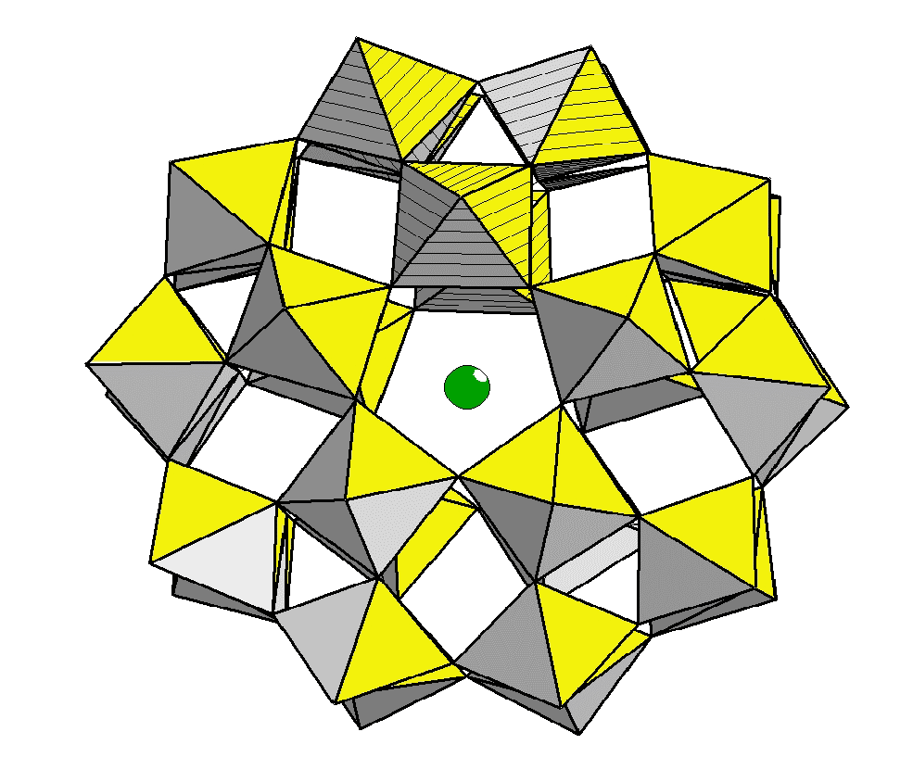
Fig. 1.
exclusive physicochemical properties such as strong Brønsted acidity, reversible transformations, solubility in polar and non-polar solvents, high hydrolytic stability and high thermal stability, all very important in catalytic processes. The structure of the Preyssler anion, [NaP₅W₃₀O₁₁₀]¹⁴⁻, is shown in Fig. 1. The anion has an approximate D₅h symmetry and consists of a cyclic assembly of five PW₆O₂₂ units; each derived from the Keggin anion, [PW₁₂O₄₀]³⁻, by removal of two sets of three corner-shared WO₆ octahedra. A sodium ion is located within the polyanion on the fivefold axis and 1.25Å above the pseudo mirror plane that contains the five phosphorus atoms [10]. Preyssler polyanion as a large anion can provide many ‘‘sites’’ on the oval-shaped molecule that are likely to render the catalyst effective. Recently, we studied the catalytic activity in preparation of DPME by using various heteropolyacids as catalysts under green and mild conditions. We have already used this catalyst in the esterification of butanol, esterification of salicylic acid with aliphatic and benzylic alcohols, synthesis of β-butyrolactone, ε-caprolactone and 2-cumaranone, synthesis of aspirin [11-14]. DPME and DPM groups are found as part of the structure of pharmacologically active compounds [15]. There are some studies on the preparation of DPME from diphenylmethyl phosphate-trifluoroacetic acid [16], xenon difluoride [17], diphenylmethyl chloride or bromide in the presence of a base [18] or p-toluenesulfonic acids [19], diphenylmethyl-diazomethane [20], diphenylmethanol in the presence of concentrated sulphuric acid [21], ytterbium triflate-ferric chloride [22]. In this research, we used a Preyssler heteropolyacid and a silica-supported Preyssler catalyst in preparation of DPME from various alcohols and phenols.
Experimental
Materials
Ali Gharib et al.: Catalytic synthesis of diphenylmethyl ethers (DPME) using Preyssler acid H₁₄[NaP₅W₃₀O₁₁₀] and…
All chemicals were obtained from Merck and were used as received.
Instruments
IR spectra were obtained on a Buck Scientific 500 spectrometer. ¹H NMR spectra were recorded on a FT NMR Bruker 100 MHz Aspect 3000 spectrometer. GLC analysis was performed on a PU 4500 gas chromatograph with FID detector. The purity of the products was determined by GC analysis. The products were characterized by comparison of their spectroscopic (IR, ¹H NMR, GC) data with those of authentic samples. The yields were determined by GC. The mass spectra were scanned on a Varian MAT CH-7 instrument at 70 eV. Melting points were recorded on an Electrothermal type 9100 melting point apparatus without correction.
Catalyst Preparation
H₁₄[NaP₅W₃₀O₁₁₀],(H₁₄-P₅), H₁₄[NaP₅W₂₉MoO₁₁₀], (H₁₄-P₅Mo) and H₁₄P₅/SiO₂ were prepared as described earlier [11-14].
Procedure for the preparation of DPME of alcohols
In a round-bottom flask, alcohol (1 mmol), diphenylmethanol (1 mmol), heteropolyacid catalyst (0.05 mmol) and solvent (5 mL) were added and the mixture was stirred as indicated in Tables 1a, 1b, 1c. After completion of the reaction, the catalyst was filtered off and washed with ethyl ether (3 ×10 mL ). Then, the solution was washed with water (3 × 10 mL) and 3M NaOH (15 mL), dried over anhydrous MgSO₄, after which the solvent was evaporated. The pure product (DPME) was obtained by column chromatography.

Recycling of the catalyst
The filtered catalyst was washed with toluene (2 × 5 mL), dried under vacuum and then reused.
Benzhydryl phenethyl ether (1a). ¹H-NMR (400 MHz, δ_{H} , CDCl₃): 2.72 (t, 2H, 6Hz), 3.50 (t, 2H, 6Hz), 5.43 (s, 1H), 7.13-7.35 (m, 15H); IR (KBr) ν_{max}/cm⁻¹: 1635, 1240, 1040, 1048, 710, 842.
Dibenzhydryl ether (1b). ¹H-NMR (400 MHz, δ_{H} , CDCl₃): 5.40 (s, 2H), 7.21-7.39 (m, 20H); IR (KBr) ν_{max}/cm⁻¹: 1645, 1243, 1040, 1051, 720, 842.
Benzhydryl 4-methylphenyl ether (1c). ¹H-NMR (400 MHz, δ_{H} , CDCl₃): 2.20 (s, 3H), 5.50 (s, 1H), 6.70 (d, 2H, J=8Hz), 6.96 (d, 2H, J=8Hz), 7.17-7.36 (m, 10H); IR (KBr) ν_{max}/cm⁻¹: 1639, 1240, 1038, 1049, 719, 840.
Benzhydryl 3-methylphenyl ether (2c). ¹H-NMR (400 MHz, δ_{H} , CDCl₃): 2.22 (s, 3H), 5.50 (s, 1H), 6.90 (m, 3H), 7.16- 7.36 (m, 11H); IR (KBr) ν_{max}/cm⁻¹: 1638, 1240, 1041, 1048, 717, 841.
Benzhydryl 4-nitrophenyl ether (6c). ¹H-NMR (400 MHz, δ_{H} , CDCl₃): 5.51 (s, 1H), 6.90 (d, 2H, J=8Hz), 7.16-7.35 (m, 10H), 8.3 (d, 2H, J=8Hz); IR (KBr) ν_{max}/cm⁻¹: 1605, 1550, 1319, 1240, 1040, 1045, 710, 840.
Benzhydryl phenyl ether (7c). ¹H-NMR (400 MHz, δ_{H} , CDCl₃): 5.50 (s, 1H), 6.92 (m, 3H), 7.14-7.38 (m, 12H); IR (KBr) ν_{max}/cm⁻¹: 1643, 1245, 1041, 1050, 718, 840.
Benzhydryl t-butyl ether (12c). ¹H-NMR (400 MHz, δ_{H} , CDCl₃): 1,20 (s, 9H), 5.35 (s, 1H), 7.11-7.30 (m, 10H); IR (KBr) ν_{max}/cm⁻¹: 1246, 1038, 1525,1600, 715.
Benzhydryl allyl ether (13c). ¹H-NMR (400 MHz, δ_{H} , CDCl₃): 3.81 (d, 2H, J=3Hz), 5.20 (m, 2H), 5.43 (s, 1H), 6.01 (m, 1H), 7.15-722 (m, 10H); IR (KBr) ν_{max}/cm⁻¹: 1585, 1220, 1030, 1520,1580, 710.
Benzhydryl isopropyl ether (15c). ¹H-NMR (400 MHz, δ_{H} , CDCl₃): 1.21 (6H, d, J=6Hz), 3.68 (1H, sp, J=6Hz), 5.32 (s, 1H), 7.16-7.25 (10H, m); IR (KBr) ν_{max}/cm⁻¹: 1250, 1040, 1520,1600, 710.
Benzhydryl methyl ether (16c). ¹H-NMR (400 MHz, δ_{H} , CDCl₃): 3.48 (3H, s), 5.37 (1H, s) 7.31-7.40 (10H, m); IR (KBr) ν_{max}/cm⁻¹: 1240, 1030, 1510,1595, 720.
Benzhydryl benzyl ether (17c). ¹H-NMR (400 MHz, δ_{H} , CDCl₃): 4.50 (s, 2H), 5.39 (s, 1H) 7.11-7.35 (m, 15H); IR (KBr) ν_{max}/cm⁻¹: 1640, 1250, 1040, 1050, 705, 840.

Results and Discussion
The heterogeneous catalytic synthesis of DPME from benzyl alcohol derivatives, allylic and aliphatic alcohols using Preyssler heteropolyacids supported onto silica gel at the indicated times and temperatures is reported and the products are identified by TLC (Scheme 1).
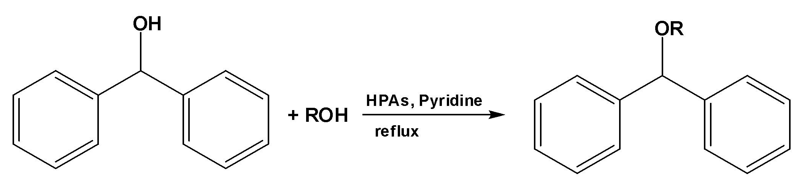
Scheme 1. Synthesis of DPME from alcohols and phenols using heteropolyacid catalysts
The reaction conditions were optimized by studying the effects of alcohol type, reaction time, catalyst type and other important factors, such as the solvent that controls the yield of diphenylmethyl ethers. The reaction was performed using various heteropolyacid catalysts. For preparing DPM-ethers, methanol, benzhydrol and various heteropolyacid (HPAs) catalysts were used under different conditions (Tables 1a, 1b, 1c).
The preparation of DPME starting from methanol and benzhydrol was tested under various conditions (temperature and solvent), using the bulk catalyst. The reaction gives higher yields in pyridine than in chloroform solution. The reaction was completed in 1 h at 115 °C, with pyridine as a solvent and 95% DPME was obtained (Table 1c, entry 16).
We performed the reaction under the same conditions for the protection of substituted phenols. The reactions proceeded efficiently with good yields. The nature of the substituents had no effect on the conversion rates (Table 1c, entries 1, 2, 6).
Silica supported Preyssler catalysts gave similar yields, also providing easy separation, simple recycling and recovery. The recycled heteropolyacid catalysts were used in reaction without loss of activity.
Effect of the alcohol type
The reaction with primary alcohols gave DPME in higher yields compared with secondary alcohols (Table 1c, entries 14 and 15). In benzylic alcohols with electron-donating substituents DPME was obtained with a higher yield than in alcohols with electron-withdrawing groups (Table 1a, entries 9-16). This can be attributed to the activating effect of the substituents.
Effect of the reaction temperature
Ali Gharib et al.: Catalytic synthesis of diphenylmethyl ethers (DPME) using Preyssler acid H₁₄[NaP₅W₃₀O₁₁₀] and…
The reaction was carried out at two temperatures: room temperature (lowest temperature) and reflux temperature (highest temperature, 115ºC). The maximum yield was reached at the reflux temperature (115ºC). This effect was expected since increasing the temperature apparently favours the acceleration of the forward reaction. In general, at room temperature (25ºC) no product was obtained.
Reusability of the catalyst
In order to know whether the catalysts would succumb to poisoning and loss of catalytic activity, the catalyst was recovered after the reaction and reused in the esterification reactions. These studies were performed with all forms of Preyssler catalysts. We have found that Preyssler catalysts can be reused several times without any appreciable loss of activity. IR spectra of the resulting solids indicated that the catalyst can be recovered without structural degradation. After several consecutive recoveries the catalytic activity only slightly
decreased, pointing to the stability and retention capability of the polyanion. Similar results were obtained for DPME of phenol (88% yield, Table 1c, entry 7).
Effect of the solvent
Preparation of DPME from benzhydrol and alcohols or phenols using heteropolyacid catalysts were carried out in various solvents, such as pyridine and chloroform. We have found that pyridine is the most effective solvent because of its solubility in polar and non-polar conditions, which corresponds to the activity of heteropolyacids in polar and non-polar solvents and systems. The results are shown in Table 2. The product yields were in the order: pyridine > chloroform. It is noteworthy to mention that even prolonged heating of the reactants in neat pyridine and chloroform in absence of catalyst did not give products.
Effect of the reaction time
Typical time courses of the reactions with various types of alcohols and phenols are shown in Tables 1a-c at reflux temperatures. The results show that in the initial stage, the reaction proceeds rapidly. The effect of reaction time on DPME percent yield indicates that the latter strongly depends on reaction time. The best reaction time

Table 1a. Preparation of DPME from alcohols, phenols and benzhydrol using bulk Preyssler catalysts and silica supported Preyssler catalysts under reflux at different times with pyridine as a solvent
Entry | Alcohol | ªTime (h) | ^{c}Yield(%)  H₁₄-P₅ | ^{c}Yield(%)  H₁₄P₅Mo | ^{c}Yield(%)  H₁₄P₅/SiO₂ (50%) | ^{c}Yield(%)  H₁₄-P₅/SiO₂ (40%)
1 |  | 1 | 92 | 90 | 90(90,89)^{b} | 88(88,87) ^{b}
2 |  | 1.5 | 93 | 91.5 | 91(90,89)^{b} | 88.5
3 |  | 1 | 96.5 | 94 | 95(94,94)^{b} | 93(93,92)^{b}
4 |  | 1 | 90(90,89) ^{b} | 87.5 | 88.5 | 87(87,86)^{b}
5 |  | 1.5 | 86 | 83 | 85 | 83(83,82)^{b}
6 |  | 2 | 70(70,69) ^{b} | 66 | 68.5 | 67
7 |  | 2 | 75 | 73.5 | 73(72,72)^{b} | 72
8 |  | 2 | 78(77,77) ^{b} | 76 | 77(76, 75)^{b} | 75.5
9 |  | 2.5 | 46.5 | 43.5 | 45 | 42.5
10 |  | 1.5 | 63 | 61.5 | 61 | 59.5
11 |  | 1.5 | 59.5 | 57 | 57.5 | 56
12 |  | 2.5 | 49.5 | 46 | 48(47,46)^{b} | 47
13 |  | 2 | 51 | 47 | 50(50,49)^{b} | 47
14 |  | 0.5 | 94(94,93)^{b} | 91 | 93(93,92)^{b} | 91(90,90)^{b}
15 |  | 1 | 90.5(90,89)^{b} | 87(87,85.5) ^{b} | 88 | 87(87,86)^{b}
16 |  | 1.5 | 86 | 83 | 85 | 82.5(82,1)^{b}
17 |  | 2.25 | 92(91,90.5) ^{b} | 87 | 90(90,89)^{b} | 87
18 |  | 2.25 | 90(90,89)^{b} | 86.5 | 88(88,87)^{b} | 84.5
19 |  | 1.5 | 88 | 84 | 86.5 | 85(85,84)^{b}
^{b} In parentheses, yields obtained in the first and second reuse of the catalyst. ^{a,b,c}Yields analyzed by GC.

Table 1b. Preparation of DPME from from alcohols, phenols and benzydrol using Preyssler catalysts and its silica supported under reflux, different times and pyridine as solvent
Entry | Alcohol | ªTime  (h) | ^{c}Yield(%)  H₁₄-P₅ | ^{c}Yield(%)  H₁₄P₅Mo | ^{c}Yield(%)  H₁₄-P₅/SiO₂ (50%) | ^{c}Yield(%)  H₁₄-P₅/SiO₂ (40%)
1 |  | 1 | 96(96,95)^{b} | 93(92.5,91.5) ^{b} | 94(94,93.5) ^{b} | 93(93,92) ^{b}
2 |  | 1 | 98 | 95.5 | 96.5 | 94
3 |  | 1.5 | 95 | 92 | 92.5 | 91
4 |  | 1.25 | 92 | 91 | 90 | 89
5 |  | 2.5 | 83 | 81.5 | 80.5 | 78
6 |  | 2.5 | 78 | 75.5 | 76.5 | 75
7 |  | 1.5 | 71 | 68 | 70 | 69
8 |  | 2 | 91.5 | 90 | 89 | 86.5
9 |  | 1.5 | 96(96,95) ^{b} | 95(94,92.5) ^{b} | 95(95,94) ^{b} | 93.5(93,92.5) ^{b}
10 |  | 2 | 93.5 | 92 | 90.5 | 88
11 |  | 1.5 | 94.5 | 92.5 | 91.5 | 90
12 |  | 2 | 69.5 | 67.5 | 67 | 65
13 |  | 1.5 | 82 | 80 | 79.5 | 78.5
^{b} In parentheses, yields obtained in the first and second reuse of the catalyst. ^{a,b,c}Yields analyzed by GC.

Table 1c. Preparation of DPME from from alcohols, phenols and benzydrol using Preyssler catalysts and its silica supported under reflux, different times and pyridine as solvent
Entry | Alcohol | ^{b}Time  (h) | ^{c}Yield(%)  H₁₄-P₅ | ^{c}Yield(%)  H₁₄P₅Mo | ^{c}Yield(%)  H₁₄-P₅/SiO₂ (50%) | ^{c}Yield(%)  H₁₄-P₅/SiO₂ (40%)
1 |  | 1 | 89.5(89.5,89) ^{b} | 88(88,87) ^{b} | 87.5(87,86) ^{b} | 86.5(86,85.5) ^{b}
2 |  | 1 | 85 | 83.5 | 84 | 82
3 |  | 1.5 | 86 | 84 | 83.5 | 82
4 |  | 1.25 | 88 | 87 | 87 | 86
6 |  | 1 | 83 | 81.5 | 81 | 79
7 |  | 1 | 88(88,87) ^{b} | 86 | 81 | 77
8 |  | 2.5 | 76 | 73.5 | 74.5 | 73.5
9 |  | 1 | 91 | 89 | 89 | 88
10 |  | 1 | 96 | 94.5 | 94 | 92.5
11 |  | 1 | 93 | 87 | 87.5 | 86
12 |  | 1.5 | 87(87,86) ^{b} | 85(85,84) ^{b} | 84.5(84.5,84) ^{b} | 82(82,81) ^{b}
13 |  | 1 | 89 | 90 | 91 | 90
14 |  | 1 | 94 | 86 | 86 | 85
15 |  | 1 | 91 | 90 | 90 | 88
16 |  | 1 | 95 | 91 | 91.5 | 91
17 |  | 1 | 85 | 84 | 82.5 | 80
^{b} In parentheses, yields obtained in the first and second reuse of the catalyst. ^{a,b,c}Yields analyzed by GC.

Table 2. Preparation of DPME from from alcohols, phenols and benzydrol using Preyssler, heteropolyacids catalysts under reflux, different times and chloroform as solvent
Entry | Alcohol | ªTime  (h) | ^{b}Yield(%)  H₁₄[NaP₅W₃₀O₁₁₀] | ^{c}Yield(%)  H₁₄[NaP₅W₂₉MoO₁₁₀]
1 |  | 1 | 84.5 | 83
2 |  | 1 | 81 | 80
3 |  | 1.5 | 82 | 80.5
4 |  | 1.25 | 83.5 | 81.5
6 |  | 1 | 79 | 77
7 |  | 1 | 85.5 | 83.5
8 |  | 2.5 | 73.5 | 72
9 |  | 1 | 88 | 86.5
10 |  | 1 | 92.5 | 91
11 |  | 1 | 90 | 88.5
12 |  | 1.5 | 84.5 | 82
13 |  | 1 | 86 | 84.5
14 |  | 1 | 91.5 | 89.5
15 |  | 1 | 87 | 85
16 |  | 1 | 91 | 89.5
17 |  | 1 | 80.5 | 78.5
17 |  | 2.25 | 92(91,90.5) ^{b} | 87
18 |  | 2.25 | 90(90,89)^{b} | 86.5
19 |  | 1.5 | 88 | 84

^{a,b,c}Yields analyzed by GC.

was found to be 1 h at reflux temperature. At any reaction time, H₁₄[NaP₅W₃₀O₁₁₀] was found to be the most active heteropolyacid catalyst.
Ali Gharib et al.: Catalytic synthesis of diphenylmethyl ethers (DPME) using Preyssler acid H₁₄[NaP₅W₃₀O₁₁₀] and…

Effect of the catalyst type
The reaction of DPME preparation was followed by GC. The yields are shown in Tables 1a-c. According to the results, the highest yield was achieved in the presence of H₁₄[NaP₅W₃₀O₁₁₀], (H₁₄–P₅) and H₁₄[NaP₅W₂₉MoO₁₁₀], (H₁₄–P₅Mo) as catalysts. The Preyssler catalysts used in this system gave similar results. Along with the bulk catalyst we used H₁₄[NaP₅W₂₉MoO₁₁₀]/SiO₂ and H₁₄[NaP₅W₃₀O₁₁₀]/SiO₂ for comparative purposes; very similar yields were obtained in comparable reaction times (Table 1a-c). Furthermore, the use of the supported catalyst allows its easy separation and recovery for immediate reutilization. The highest yield of the products was achieved using H₁₄[NaP₅W₃₀O₁₁₀] as a catalyst.
Comparison of the catalysts (Tables 1a-c) showed that H₁₄[NaP₅W₃₀O₁₁₀] is the catalyst of choice. In all cases the supported polyacid was less active than the non-supported one.
Conclusions
The preparation of DPME of alcohols and phenols in the presence of an inexpensive, reusable, easy to handle, non-corrosive, highly hydrolytic, thermally stable and environmentally benign Preyssler heteropolyacid catalyst was studied. This catalyst offers advantages as regards simplicity of operation due to the heterogeneous nature of reaction, easy work-up, high yields of products, high selectivity and recyclability of the catalyst. The catalyst can be easily recovered, regenerated and reused without loss of structure and appreciable activity, thus providing an economic and environmentally friendly method for DPME preparation.
Ali Gharib et al.: Catalytic synthesis of diphenylmethyl ethers (DPME) using Preyssler acid H₁₄[NaP₅W₃₀O₁₁₀] and…
Acknowledgements: The authors are thankful to the Agricultural Researches & Services Center, Mashhad, Feyzabad, Iran, the Mashhad Islamic Azad University, the Chemistry Department, University of Oslo, Norway and the National Research Council of Canada for the support of this work. Special thanks are due to Professor Dr. J. (Hans) W. Scheeren from the Organic Chemistry Department, Radboud University Nijmegen, The Netherlands.
REFERENCES
1. C.L. Hill, Chem. Rev., 98, 1 (1998).
2. M. T. Pope, Heteropoly and Isopoly Oxometalates, Springer-Verlag, New York, 1983.
3. I.V. Kozhevnikov, Catal. Rev. Sci. Eng., 37, 311 (1995). Kozhevnikov, I.V. Catalysis by Polyoxometalates. In Catalysts for fine chemical synthesis; Wiley & Sons: Chichester, UK, 2002; Volume 2, p. 216.
4. J.F. Keggin, Nature, 131, 908 (1933).
5. G. B. McGarvey, J. B. Moffat, J. Catal., 128, 69 (1991).
6. T. Okuhara, N. Mizuno, M. Misono, Adv. Catal., 41, 113 (1996).
7. G.B. McGarvey, J. B. Moffat, J. Catal., 128, 69 (1991).
8. T. Okuhara, T. Nishimura, K. Ohashi, M. Misono, Chem. Lett., 1201 (1990).
9. M.K. Harrup, C. Hill, L. J. Cardona, Inorg. Chem., 33 (1993).
10. M.H. Alizadeh, S.P. Harmalker, Y. Jeanenin, J. Martin-Frere, M.T. Pope, J. Am. Chem. Soc., 107, 2662 (1985).
11. F.F. Bamoharram, M. M. Heravi, M. Roshani, M. Jahangir, A. Gharib, A. J. Appl. Catal. A: Gen., 302, 42 (2006).
12. F.F. Bamoharram, M. M. Heravi, M. Roshani, A. Gharib, M. Jahangir, J. Mol. Catal. A: Chem., 252, 90 (2006).
13. F.F. Bamoharram, M. M. Heravi, M. Roshani, M. Jahangir, A. Gharib, Journal of Molecular Catalysis A: Chemical., 271, 126 (2007).
14. F.F. Bamoharram, M. M. Heravi, M. Roshani, A. Gharib, M. Jahangir, J. Chinese Chem. Soc.., 17, 505 (2006).
15. V. Namboodiri, R. Varma, Tetrahedron Lett., 43, 4593 (2002).
16. L. Lapatsanis, Tetrahedron Lett., 19, 3943 (1978).
17. S. Stavber, M. Zupan, M. Tetrahedron Lett., 34, 4355 (1993).
18. D. Dobson, A. Todd, J. Gilmore, J. Synth. Commun., 21, 601 (1991).
19. R. Parades, R. Perez, Tetrahedron Lett., 39, 2037 (1998).
20. M. Kolovos, C. Froussios, Tetrahedron Lett., 25, 3909 (1984).
21. S. Sugsawa, K. Fujiwara, Org. Synth. Coll., 4, 72 (1963).
22. G. Sharma, T. Prasad, A. Mahalingam, Tetrahedron Lett., 42, 759 (2001).

КАТАЛИТИЧНА СИНТЕЗА НА ДИФЕНИЛ-МЕТИЛОВИ ЕТЕРИ (DPME) ИЗПОЛЗВАЙКИ PREYSSLER‘ОВА КИСЕЛИНА H₁₄[NaP₅W₃₀O₁₁₀] И PREYSSLER‘ОВ КАТАЛИЗАТОР ВЪРХУ ПОДЛОЖКА ОТ СИЛИЦИЕВ ДИОКСИД
А. Гариб ^{1,2}, M. Джахангир¹, M. Рошани ¹, Я. (Ханс) В. Схеерен³
¹Деапартамент по химия, Ислямски университет „Азад“, Машхад, Иран
²Център за селско-стопански изследвания и услуги, Машхад, Иран
³Клъстер за молекулна химия, Департамент по органична химия,Университет Радбоуд в Наймехен, Нидерландия
Постъпила на 4 септември, 2010 г.; коригирана и приета на 18 март, 2011 г.
(Резюме)

Съобщава се за получаването на дифенил-метилови етери от бензихидрол и алкохоли или феноли с помощта на Preyssler‘ова киселина и катализатори от херетерополикиселини (HPA), нанесени върху подложка от силициев диоксид. Тази евтина и екологично-съобразна (зелена) синтеза предлага задоволителни добиви. Катализаторът лесно се възстановява и може да се използва многократно без загуба на каталитична активност.

Ali Gharib et al.: Catalytic synthesis of diphenylmethyl ethers (DPME) using Preyssler acid H₁₄[NaP₅W₃₀O₁₁₀] and…

