Bulgarian Chemical Communications, Volume 44, Number 4 (pp. 289 - 298) 2012
* To whom all correspondence should be sent:
E-mail: mustafadurgun@harran.edu.tr
Dissymmetric tetradentate salicylaldimine Cu(II) and Co(II) complexes derived from 1,8-naphthalene and different salicylaldehydes
A. Kilic¹, E. Tas², B. Deveci¹, M. Durgun¹
¹Department of Chemistry, University of Harran, 63190, Sanliurfa, Turkey
²Department of Chemistry, University of Siirt, 56100, Siirt, Turkey
Received: June 17, 2011; Accepted: January 9, 2012
The synthesis, structure and spectroscopic properties of salicylaldimine Schiff base ligands (L_{n}H₂) (n = 1, 2, 3 and 4) (L₁H₂=N, N’-[1,8-naphthalene]-3-methylsalicylaldimine, L₂H₂ = N,N’-[1,8-naphthalene]-5-methylsalicylaldimine, L₃H₂ = N,N’-[1,8-naphthalene]-3-methoxy-salicylaldimine and L₄H₂= N,N’-[1,8-naphthalene]- 5-methoxysalicyl- aldimine), respectively and their mononuclear Cu(II) and Co(II) complexes [ML_{n}] are described. Four new dissymmetric tetradentate salicylaldimine ligands containing a donor set of N₂O₂ were prepared by reaction of 1,8-naphthalene with different salicylaldehydes. Tetradentate Cu(II) and Co(II) complexes were obtained by reacting the ligands with Cu(Ac)₂.H₂O and Co(Ac)₂.4H₂O in a 1:1 mole ratio. The ligands and their Cu(II) and Co(II) complexes were characterized by ¹H-NMR, FT-IR, UV-Vis, elemental analysis, molar conductivity, magnetic susceptibility, X-ray powder analysis, and their morphology was studied by SEM measurements.
Keywords: salicylaldimine, Cu(II) and Co(II) complexes, spectroscopy, X-ray powder, SEM analyses

1. Introduction
Since the first report of the Schiff reaction [1], the synthesis of symmetric tetradentate Schiff bases as ligands, and of their metal complexes, has been widely described. Some of them may be used as catalysts in various chemical processes [2, 3], or as models for a better understanding of some biological systems [4-6]. However, the unsymmetric tetradentate Schiff base metal complexes were less studied than the symmetric ones [7]. The investigation of Schiff base metal complexes has been of interest for many years to help understanding the interactions between metal ions and proteins or as other biological references. Recent years have witnessed a great deal of interest in the synthesis and characterization of transition metal complexes containing Schiff bases as ligands due to their applications as catalysts for many reactions [8-10], relation to synthetic and natural oxygen carriers [11] and use as new structural probes in nucleic acids chemistry and therapeutic agents [12-15]. Schiff base metal complexes containing different metal ions such as Ni, Co and Cu have been studied in great details for their various crystallographic features, structure-redox relationships, enzymatic reactions, mesogenic characteristics and catalytic properties [16-18]. Although the magnetic, spectroscopic and catalytic properties of these Schiff base complexes are well documented [19, 20], new and specific applications for such a unique class of compounds could be found. A considerable number of Schiff base complexes are of potential biological interest, being used as more or less successful models of biological compounds [21]. In addition, they are convenient model compounds for studying theoretical aspects of photochemistry and designing molecular architecture by means of molecular motifs capable of H-bond formation [22]. Their photochromic behavior suggests the possibility of using these compounds as elements for constructing optical switches or optical memory devices [23].
© 2012 Bulgarian Academy of Sciences, Union of Chemists in Bulgaria
In the present study, we report the synthesis and characterization of four new Schiff base ligands (L₁H₂, L₂H₂, L₃H₂ and L₄H₂, where L₁H₂ = N,N’-[1,8-naphthalene]-3-methylsalicylaldimine, L₂H₂ = N,N’-[1,8-naphthalene]- 5-methylsalicyl- aldimine, L₃H₂ = N, N’-[1,8-naphthalene]- 3-methoxysalicylaldimine and L₄H₂ = N,N’-[1,8-naphthalene]- 5-methoxysalicylaldimine) involving N₂O₂ donor sites and their mononuclear Cu(II) and Co(II) complexes.
2. Experimental
All reagents and solvents were of reagent-grade quality and were purchased from commercial suppliers. The elemental analyses were carried out in the Laboratory of the Scientific and Technical Research Council of Turkey (TUBITAK). NMR spectra were recorded at 297 K on a Varian Mercury AS 400 NMR instrument at 400 MHz, FT-IR spectra were recorded on a Perkin Elmer Spectrum RXI FT-IR Spectrometer in KBr pellets. Infrared spectra of the ligands and their metal complexes were recorded in KBr pellets in the range from 4000 to 400 cm⁻¹. Magnetic susceptibilities were determined on a Model MK1 Sherwood Scientific Magnetic Susceptibility Balance at room temperature (20ºC) using Hg[Co(SCN)₄] as a calibrant; diamagnetic corrections were calculated from Pascal’s constants [24]. Electronic spectral studies were conducted on a Perkin Elmer model Lambda 25 UV-Vis spectrophotometer in the wavelength range of 200-1100 nm. Molar conductivities (Λ_{M}) were recorded on an Inolab Terminal 740 WTW Series instrument. X-ray powder spectra were recorded on a Rigaku Ultima III Series spectrograph. The scanning electron microscopy (SEM) measurements were carried out on a Zeiss Evo 50 Series instrument. The samples were sputter coated with carbon using a Balzers Med 010 device to prevent charging when analyzed by the electron beam.
Synthesis of Ligands (L₁H₂, L₂H₂, L₃H₂ and L₄H₂):
N,N’-[1,8-naphthalene]-3-methylsalicylaldimine (L₁H₂), N,N’-[1,8-naphthalene]-5-methyl- salicylaldimine (L₂H₂), N,N’-[1,8-naphthalene]- 3-methoxysalicylaldimine (L₃H₂) and N, N’-[1,8-naphthalene]-5-methoxysalicylaldimine (L₄H₂) ligands were synthesized by the reaction of 5.0 mmol 1,8-diamino naphthalene in 40 ml absolute ethanol with 10.0 mmol 3-methylsalicylaldehyde for L₁H₂, 10.0 mmol 5-methylsalicylaldehyde for L₂H₂, 10.0 mmol 3-methoxysalicylaldehyde for L₃H₂ and 10 mmol 5-methoxysalicylaldehyde for L₄H₂, in 50 ml ethanol. 3-4 drops of formic acid were added as a catalyst. The mixtures were refluxed for 3-4 h and were cooled to room temperature. The crystals were filtered in vacuum. Then the products were recrystallized from MeOH-CHCl₃.
Synthesis of the Cu(II) and Co(II) complexes
1.0 mmol of the ligands ( L₁H₂, L₂H₂, L₃H₂ or L₄H₂ ) were dissolved in absolute ethanol (60 ml). A solution of 1.0 mmol of the metal salt [Cu(Ac)₂.H₂O or Co(Ac)₂.4H₂O] in absolute ethanol (35 ml), was dropwise added under continuous stirring in a N₂ atmosphere. The stirred mixture was heated to the reflux temperature and was maintained at this temperature for 5 hours. Then, the mixture was evaporated to a volume of 10-15 ml in vacuum and left to cool to room temperature. The compounds were precipitated after adding 5 ml of ethanol. The products were filtered in vacuum and washed with a small amount of ethanol and water. The products were recrystallized from ethanol and dried at 100 ºC.
A. Kilic et al: Dissymmetrical tetradentate salicylaldimine Cu(II) and Co(II) metal complexes...
3. Results and discussion
The reaction steps for the synthesis of the ligands and their mononuclear Cu(II) and Co(II) complexes are shown in Schemes 1 and 2. In the first step, the ligands (L₁H₂, L₂H₂, L₃H₂ and L₄H₂) were

R= 3-CH₃ (L₁H₂), 5-CH₃ (L₂H₂), 3-OCH₃ (L₃H₂), 5-OCH₃ (L₄H₂)
Scheme 1 Synthetic route for preparation of the ligands (L_{n}H₂).
R= 3-CH₃ (L₁H₂), 5-CH₃ (L₂H₂), 3-OCH₃ (L₃H₂), 5-OCH₃ (L₄H₂)
Scheme 2 Synthetic route for preparation of mononuclear Cu(II) and Co(II) complexes

Table 1. Formula, color, melting point, yield, magnetic susceptibility and elemental analysis data for the ligands and their Cu(II) and Co(II) complexes.
Compound | Color | M.p. ºC(dec.) | Yield  (%) | μ_{eff}  [B.M] | Λ_{M}  Ω⁻¹cm² mol⁻¹ | Elemental analyses  Calcd (Found) %  C H N
L₁H₂  C₂₆H₂₂N₂O₂ | Dirty  White | 219 | 57 | - | - | 79.18  (79.40) | 5.58  (5.56) | 7.16  (7.13)
CuL₁  C₂₆H₂₀N₂O₂Cu | Dark Green | >300 | 48 | 1.50 | 8.6 | 68.49  (68.90) | 4.39  (4.41) | 6.14  (6.16)
L₂H₂  C₂₆H₂₂N₂O₂ | Orange | 233 | 62 | - | - | 79.18  (78.60) | 5.58  (5.55) | 7.16  (7.06)
CuL₂  C₂₆H₂₀N₂O₂Cu | Dark  Brown | >300 | 56 | 1.41 | 10.2 | 68.49  (68.10) | 4.39  (4.36) | 6.14  (6.10)
CoL₂  C₂₆H₂₀N₂O₂Co | Dark  Brown | >300 | 73 | 2.15 | 12.8 | 69.19  (68.80) | 4.45  (4.42) | 6.26  (6.18)
L₃H₂  C₂₂H₂₂N₂O₄ | Pink | 186 | 68 | - | - | 73.24  (73.70) | 5.16  (5.20) | 6.57  (6.62)
CuL₃  C₂₆H₂₀N₂O₄Cu | Dark  Green | >300 | 44 | 1.67 | 10.8 | 64.92  (65.30) | 4.10  (4.13) | 5.74  (5.79)
CoL₃  C₂₆H₂₀N₂O₄Co | Brown | 226 | 76 | 2.18 | 9.6 | 63.60  (63.3) | 4.14  (4.12) | 5.79  (5.77)
L₄H₂  C₂₆H₂₂N₂O₄ | Orange | 181 | 80 | - | - | 73.24  (72.80) | 5.16  (5.14) | 6.57  (6.54)
CuL₄  C₂₆H₂₀N₂O₄Cu | Green | >300 | 88 | 1.47 | 13.7 | 64.00  (63.78) | 4.10  (4.08) | 5.74  (5.71)
CoL₄  C₂₆H₂₀N₂O₄Co | Dark  Brown | 238 | 67 | 2.27 | 9.2 | 81.35  (79.70) | 8.47  (8.43) | 4.75  (4.73)
Table 2. Characteristic ¹H-NMR spectra of the ligands
Compound | Solvent | ¹H NMR (TMS, δ ppm)
L₁H₂ | CHCl₃ | 13.02 (2H, s, -OH), 8.38 (2H, s, CH=N), 7.72 (2H, s, Ar-CH), 7.31-7.26 (6H, m, Ar-CH), 6.91 (2H, s, Ar-CH), 6.75 (2H, s, Ar-CH) and 2.24 (6H, s, C-CH₃)
L₂H₂ | CHCl₃ | 13.18 (2H, s, -OH), 8.42 (2H, s, CH=N), 7.80 (2H, s, Ar-CH), 7.30-7.26 (6H, m, Ar-CH), 6.92 (2H, s, Ar-CH), 6.64 (2H, d, Ar-CH) and 2.35 (6H, s, C-CH₃)
L₃H₂ | CHCl₃ | 12.98 (2H, s, -OH), 8.39 (2H, s, CH=N), 7.72 (2H, s, Ar-CH), 7.28 (4H, s, Ar-CH), 6.75 (2H, s, Ar-CH), 6.74-6.65 (4H, m, Ar-CH), and 3.68 (6H, s, O-CH₃)
L₄H₂ | CHCl₃ | 13.04 (2H, s, -OH), 8.40 (2H, s, CH=N), 7.76 (2H, s, Ar-CH), 7.32 (4H, s, Ar-CH), 6.96 (2H, s, Ar-CH), 6.65-6.63 (4H, m, Ar-CH) and 3.73 (6H, s, O-CH₃)

synthesized by condensation of 1,8-diamino naphthalene with different salicylaldehydes. In the second step, the mononuclear Cu(II) and Co(II) complexes were synthesized by condensation of the ligands with the metal acetate salt. The Co(II) complex of the L₁H₂ ligand was not formed under these conditions. For the structural characterization of the ligands and their mononuclear Cu(II) and Co(II) complexes, elemental analysis, ¹H-NMR, FT-IR spectra, UV-Vis spectra, magnetic susceptibility measurements, molar conductivity, X-ray powder analyses and SEM measurements were used and the corresponding data are given in Tables 1-3. The metal-to-ligand ratio in the mononuclear Cu(II) and Co(II) complexes was found to be 1:1. The interaction of the ligands (L₁H₂, L₂H₂, L₃H₂ and L₄H₂) with Cu(II) and Co(II) salt yielded complexes corresponding to the general formula [Cu(L_{n})] and [Co(L_{n})].
A. Kilic et al: Dissymmetrical tetradentate salicylaldimine Cu(II) and Co(II) metal complexes...

Table 3. Characteristic FT-IR bands (cm⁻¹) of the ligands and their Cu(II) and Co(II) complexes in KBr pellets.
Compound | O-H | Ar-CH | Aliph-CH | C-O | C=N | M-O | M-N
L₁H₂ | 3275 | 3050 | 2967-2843 | 1229 | 1627 | - | -
CuL₁ | - | 3054 | 2956-2852 | 1232 | 1602 | 490 | 512
L₂H₂ | 3296 | 3022 | 2917-2861 | 1257 | 1602 | - | -
CuL₂ | - | 3016 | 2920-2861 | 1240 | 1586 | 492 | 516
CoL₂ | - | 3018 | 2924-2857 | 1258 | 1577 | 501 | 546
L₃H₂ | 3312 | 3044 | 2964-2835 | 1242 | 1612 | - | -
CuL₃ | - | 3048 | 2934-2834 | 1241 | 1603 | 498 | 525
CoL₃ | - | 3057 | 2927-2831 | 1246 | 1604 | 502 | 548
L₄H₂ | 3341 | 3045 | 2953-2830 | 1239 | 1604 | - | -
CuL₄ | - | 3046 | 2934-2831 | 1232 | 1587 | 496 | 528
CoL₄ | - | 3055 | 2955-2831 | 1236 | 1598 | 503 | 537

3. 1. NMR Spectra
The ¹H-NMR spectral data obtained for the ligands in CDCl₃, together with the assignments are given in Table 2. The ¹H-NMR spectra of L₁H₂, L₂H₂, L₃H₂ and L₄H₂ in CDCl₃ do not give any signal corresponding to 1,8-diamino naphthalene protons and different salicylaldehyde protons. The ¹H-NMR spectra of the free ligands show a peak at 13.02 ppm for L₁H₂, at 13.18 ppm for L₂H₂, at 12.98 ppm for L₃H₂ and at 13.04 ppm for L₄H₂, characteristic of intramolecular hydrogen bonded OH proton. The peaks in the range 7.72-6.75 ppm for L₁H₂, 7.80-6.64 ppm for L₂H₂, 7.72-6.65 ppm for L₃H₂ and 7.76-6.63 ppm for L₄H₂ are assignable to the protons of Ar-CH. In the ¹H-NMR spectra of the ligands, the chemical shift observed at δ=8.38 for L₁H₂, δ=8.42 for L₂H₂, δ=8.39 for L₃H₂ and δ=8.40 for L₄H₂ is assigned to the proton of azomethine (CH=N) as a singlet [25]. The protons of the methyl groups of the ligands exhibit a singlet peak at δ=2.24 for L₁H₂ and 2.35 ppm for L₂H₂. Also, the peaks in the range 3.68-3.73 ppm for the L₃H₂ and L₄H₂ ligands are assignable to the protons of O-CH₃ groups as singlet peaks.
3. 2. IR Spectra
The main stretching frequencies of the FT-IR spectra of the ligands L₁H₂, L₂H₂ L₃H₂ and L₄H₂ and of their mononuclear Cu(II) and Co(II) complexes are given in Table 3. The FT-IR spectra of the ligands and of their corresponding Cu(II) and Co(II) complexes are found to be very similar to each other. Hence, significant frequencies are selected by comparing the FT-IR spectra of the ligands with those of the mononuclear Cu(II) and Co(II) complexes. Coordination of the Schiff base ligands to Cu(II) and Co(II) through the nitrogen atom is expected to reduce the electron density in the
A. Kilic et al: Dissymmetrical tetradentate salicylaldimine Cu(II) and Co(II) metal complexes...

Table 4. Characteristic UV-Vis bands of the ligands and their Cu(II) and Co(II) complexes.
Compound | Solvents | Wavelength [λmax. (nm)(logε)]
L₁H₂ | EtOH  MeOH | 236*(5.33), 281*(4.67), 330*(5.093), 343*(5.09)  281(4.86), 291(4.79), 331(5.26)
CuL₁ | CHCl₃  DMF  DMSO | 273(1.79), 299(1.78), 405*, 692(1.98), 774*, 890*  289(3.64), 343*, 415*, 715(2.6), 798(2.67),  305, 308, 387*, 399*, 403*, 563, 799
L₂H₂ | EtOH  MeOH | 350(5.09), 413*(2.7), 438*(2.64), 467*(2.5), 495*(2.19)  279(6.34), 347(6.55), 348(4.33), 410*(2.82), 433*(2.76), 463*(2.6)
CuL₂ | DMF  DMSO | 333*(0.59), 410(0.89), 450*(0.99), 775*(1.87)  305(4.89), 345(5.25), 355(4.8), 400*(5.1), 455*(4.14), 685*(3.1)
CoL₂ | DMF  DMSO | 346(2.89), 470*  307, 308, 346, 350, 418*, 563*, 745*
L₃H₂ | EtOH  MeOH | 233*(5.71), 237(5.18), 285*(4.48), 332(4.9), 344*(4.91)  285(3.95), 344(4.38)
CuL₃ | CHCl₃  DMF  DMSO | 423, 457*, 570, 710*, 795*  275(4.6), 344(4.44), 450*, 604(3.3), 655*, 800*  346(4.87), 387*(4.37), 410*(4.07), 572*(3.2), 667*(3.14)
CoL₃ | CHCl₃  DMF  DMSO | 267*(4.15), 268*(4.39), 340(4.47)  321(4.13), 600*, 858(2.41)  352(4.8), 398*(4.48), 460*(3.9), 600*(3.36), 886*(2.52)
L₄H₂ | EtOH  MeOH | 235*(5.07), 238(5.24), 302*(4.48), 350(4.69),  304(4.13), 348(4.37), 429*(2.76), 466*(2.58), 490(2.23)
CuL₄ | CHCl₃  DMF  DMSO | 354(2.03), 363(1.94), 450*  287(2.56), 335*, 420*, 480*  305, 388*, 675*
CoL₄ | CHCl₃  DMF  DMSO | 350(4.97), 351(5.38), 411*(3.69)  325(3.23), 590*, 640*, 800*  305(5.02), 354(5.04), 473*(4.18), 480*(4.46), 863*(2.83)
* = shoulder peak

azomethine link and lower the υ(C=N) absorption frequency. The very strong and sharp υ(C=N) bands in the FT-IR spectrum of the free ligands are observed in the region 1627-1602 cm⁻¹. These bands are, however, shifted to 1603-1586 cm⁻¹ in the spectra of the Cu(II) complexes and to 1604-1577 cm⁻¹ in the spectra of the Co(II) complexes, which points to the coordination of the υ(C=N) nitrogen to the Cu(II) and the Co(II) ion [26-28]. The FT-IR spectra of the free ligands are characterized by the appearance of a band at 3275 cm⁻¹ for L₁H₂, 3296 cm⁻¹ for L₂H₂, 3312 cm⁻¹ for L₃H₂, and 3341 cm⁻¹ for L₄H₂, due to the υ(O-H) groups. In the FT-IR spectra of Cu(II) and Co(II) complexes, these bands disappear. The coordination is further confirmed by the shift in the υ(C-O) stretching vibration of the phenoxy group from the region 1257-1229 cm⁻¹ to a different frequency range which indicates υ(M-O) coordination [29, 30]. The coordination of the azomethine nitrogen and the phenolic oxygen is further supported by the appearance of two peaks at 548-512 cm⁻¹ for phenolic υ(M-N) and at 503-490 cm⁻¹ due to υ(M-O) stretching vibrations that are not observed in the FT-IR spectra of the ligands [25]. Thus, it is clear that the free ligands are bonded to the Cu(II) and Co(II) ion in a N₂O₂ fashion through the deprotonated phenolate oxygen and the azomethine nitrogen.
3. 3. UV-Vis Spectra
Electronic spectra of the ligands and their mononuclear Cu(II) and Co(II) complexes were recorded in the 200-1100 nm range in different solutions at room temperature and the obtained data are given in Table 4. The electronic spectra of the ligands and their mononuclear Cu(II) and Co(II) complexes in the different solvents consist of very intense bands due to intraligand π→π*and n→π* transitions, metal-to-ligand or ligand-to-metal charge-transfer and d-d transitions, respectively. The absorption bands below 299 nm in different solvents are practically identical and can be attributed to π→π* transitions in the benzene ring or azomethine (C=N) groups. The absorption bands observed below 399 nm in different solvents are most probably due to the n→π* transition in the imine group corresponding to the ligands or the Cu(II) and Co(II) complexes [31, 32]. In the spectra of the corresponding mononuclear Cu(II) and Co(II) complexes, position and intensity of the bands, characteristic of the ligands appeared to be modified with respect to those of the free ligands. In addition, these spectra also presented new absorption bands in the range 400-886 nm that were characteristic of the formed mononuclear Cu(II) and Co(II) complexes. These bands were attributed to the d→π* charge-transfer transitions, which overlap with the π→π*or n→π* transitions of the free ligands. These modifications in shifts and intensity for the absorption bands supported the coordination of the ligand to the central Cu(II) and Co(II) ion [33]. Also, the absorption bands in the range 400-495 nm in the different solvents are assigned to M→L charge transfer (MLCT) or L→M charge transfer (LMCT) and ¹A_{1g}→¹B_{1g} transitions [34], respectively. The electronic spectra of Cu(II) and Co(II) in various solvents show broad bands in the range 563-886 nm, assigned to d-d transitions (d_{xy}→d_{x}²_{-y}² and d_{z}2→d_{x}²_{-y}²) characteristic for tetragonal, elongated octahedral or square planar geometry [35, 36].
3. 4. Magnetic Moments
Magnetic susceptibility measurements provide sufficient data to characterize the structure of the Cu(II) and Co(II) complexes. Since the Cu(II) and Co(II) complexes are paramagnetic, their NMR spectra could be not obtained. The magnetic moments of the Cu(II) complexes at room temperature are found between 1.67-1.41 B.M., which are typical for mononuclear Cu(II) complexes with a S=1/2 spin-state and probably indicate antiferromagnetic coupling of spins at this

(a) | (b)
Fig. 1. X-ray powder diffractograms of (a) L₁H₂ and (b) [CuL₁]
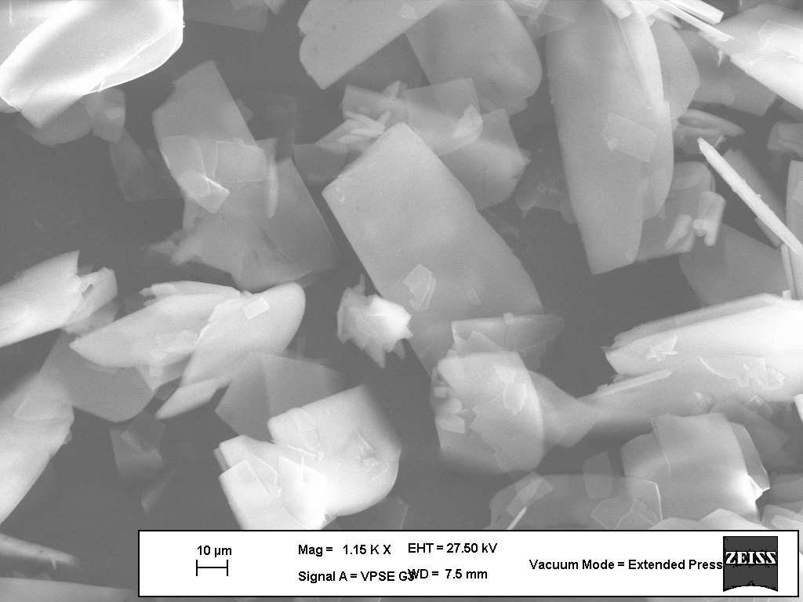  (a) | 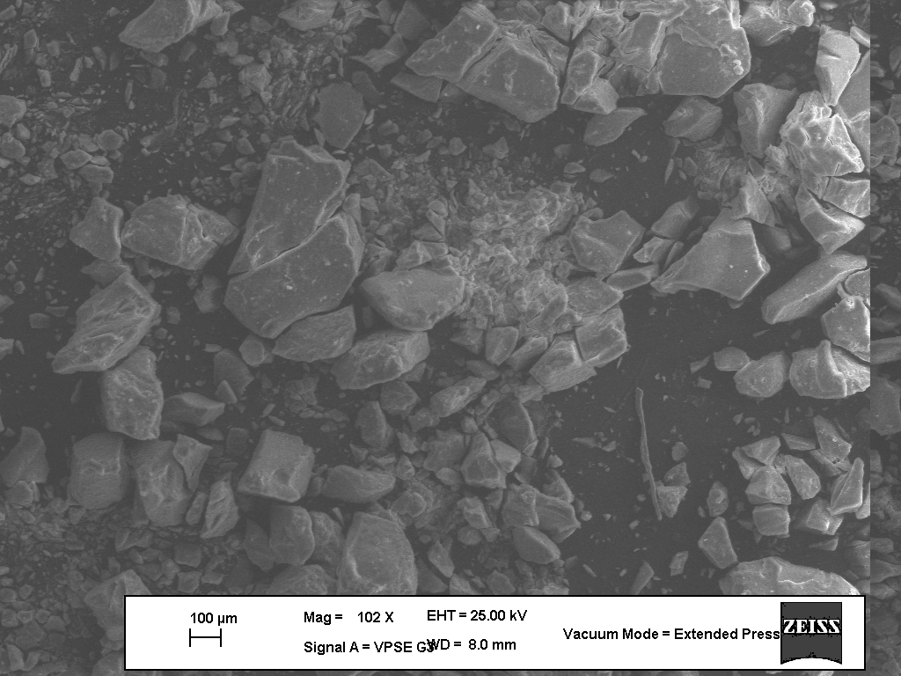  (b)
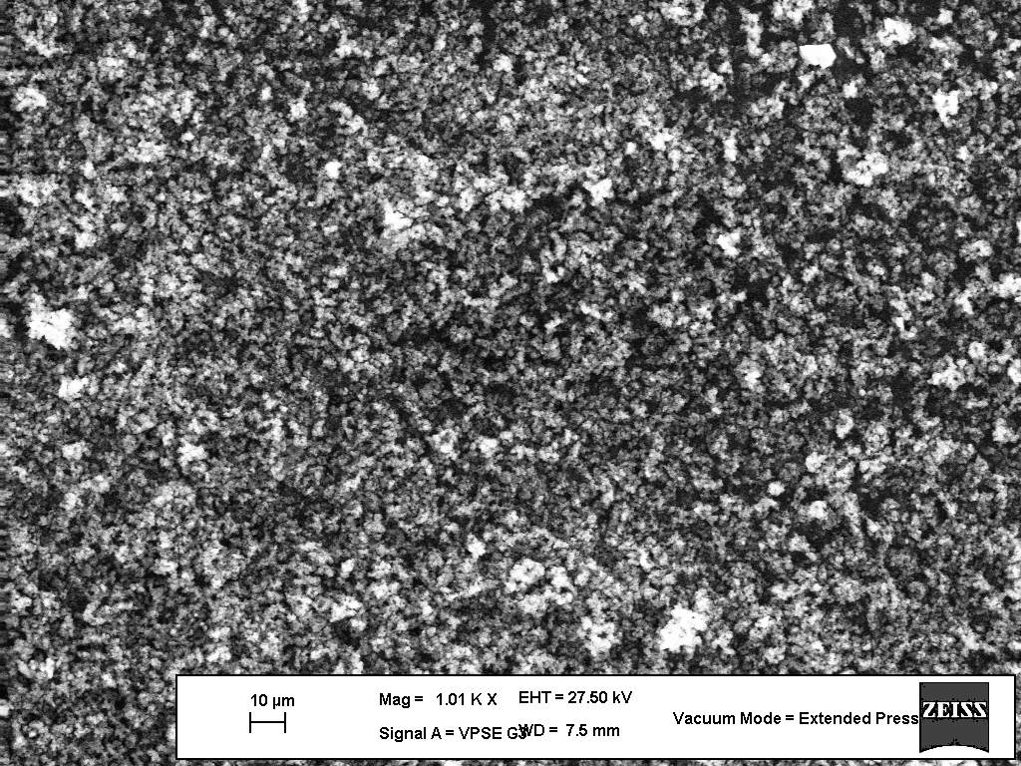  (c) | Fig. 2. SEM micrographs of (a) L₂H₂, (b) [CuL₂] and (c) [CoL₂]

temperature. The magnetic moments of the d⁷ Co(II) complexes at room temperature are also found between 2.27-2.15 B.M. (low-spin), which are close to the spin-only magnetic moments for one unpaired electron.
3. 5. Solubility and Molar Conductivity
The ligands L₁H₂, L₂H₂ L₃H₂ and L₄H₂ are soluble in EtOH, MeOH, DMSO and DMF solvents, while their mononuclear Cu(II) and Co(II) complexes are slightly soluble in common solvents. All complexes are stable at room temperature in the solvents reported in this study. With a view to studying the electrolytic nature of the mononuclear Cu(II) and Co(II) complexes, their molar conductivities were measured in DMF (dimethyl formamide) at 10⁻³ M. The molar conductivity (Λ_{M}) values of these Cu(II) complexes are in the range of 13.7-8.6 and those of the Co(II) complexes are in the range of 12.8-9.2 Ω⁻¹cm² mol⁻¹ at room temperature, indicating their almost non-electrolytic nature (Scheme 2 ) [20, 37]. Due to the lack of free ions in the Cu(II) and Co(II) complexes, the results indicate that these metal complexes are very poor in molar conductivity. Probably, due to a different electron behavior, the electrical conductivity of the Cu(II) complexes differs from that of the Co(II) complexes. Conductivity measurements have frequently been used in structural elucidation of metal chelates within the limits of their solubility. They provide a method of testing the degree of ionization of the complexes, the molecular ions that a complex liberates in solution (if anions are present outside the coordination sphere), the higher will be its molar conductivity and vice versa. The molar conductivity values indicate that the anions may be present outside the coordination sphere or inside or absent [38].
3. 6. Crystallography and SEM analyses
We did not succeed in preparing single crystals of the ligands and their Cu(II) and Co(II) complexes in different solvents. However, the crystalline nature of the ligands can be readily evidenced from their X-ray powder patterns. The ligands exhibit sharp reflections and all diffractograms are nearly identical, indicating the isostructural nature of the ligands. Also, the large number of reflections, as well as their positions indicate a low crystal symmetry [39, 40]. These results point to the crystalline and not amorphous nature of the ligands. The X-ray powder patterns of the Cu(II) and Co(II) complexes exhibited, however, only broad humps, not typical for a crystalline nature ( Figure 1).
The morphology of the compounds was illustrated by scanning electron micrography (SEM). Figures 2a, 2b, and 2c depict the SEM photographs of the ligand (L₂H₂), the [CuL₂] and [CoL₂] complexes. We noted that there is a uniform matrix of the synthesized complexes in the pictograph. This leads us to believe that we are dealing with a homogeneous phase material. The crystalline shape is observed in the ligand (L₂H₂). The amorphous shape is observed in the [CuL₂] and [CoL₂] complexes.
Conclusions
The synthesis, structure and spectroscopic properties of Schiff base ligands (L_{n}H₂) (n = 1, 2, 3 and 4) (L₁H₂ = N,N’-[1,8-naphthalene]- 3-methylsalicylaldimine, L₂H₂= N,N’- [1,8-naphthalene]-5-methylsalicylaldimine, L₃H₂ = N,N’-[1,8-naphthalene]-3-methoxysalicyl-aldimine and L₄H₂ = N,N’-[1,8-naphthalene] -5-methoxysalicylaldimine), respectively and their mononuclear Cu(II) and Co(II) complexes [ML_{n}] are described. Classical methods such as ¹H-NMR, FT-IR, UV-Vis, elemental analysis, X-ray powder analysis, magnetic susceptibility and molar conductivity used for structural characterization and the SEM measurements for their morphology determination provided a powerful tool to reveal the complementary nature of the molecular structure of the new Schiff bases and their mononuclear Cu(II) and Co(II) complexes. This result agrees with the expected structure given in Scheme 2. Due to the lack of free ions in the Cu(II) and Co(II) complexes, the results indicate that these metal complexes are very poor in molar conductivity. These results show that the ligands are of crystalline and not amorphous nature, whereas the X-ray powder patterns of the Cu(II) and Co(II) complexes exhibited only broad humps, not typical for a crystalline nature.

Acknowledgements. This work was supported, in part, by the HUBAK Fund of Harran University, Sanliurfa, Turkey.
References
- H.S. Schiff, Ann. Chim. (Paris) 131, 118 (1864).
- R.A. Sheldon, J.K. Kochi, Metal Catalyzed Oxidation of Organic Compounds, Academic Press, New York. (1981). p. 350.
- T.G. Traylor, Y.S. Byun, P.S. Traylor, P. Battioni, D. Mansuy, J. Am. Chem. Soc. 113, 7821 (1991).
- J.P. Costes, G. Gros, M.H. Darbieu, Y.P. Laurent, Trans. Met. Chem. 7, 219(1982).
- D. Mansuy, Pure Appl. Chem. 59, 759 (1987).
- J.E. Kovacic, Spectrochim. Acta 23A, 183 (1987).
- A. Ourari, K. Ourari, W. Moumeni, L. Sibous, G.M. Bouet, M.A. Khan, Trans. Met. Chem. 31, 169 (2006).
- N.S. Enikolopyan, K.A. Bogdanova, K.A. Askarov, Russ. Chem. Rev., 52, 25 (1983).
- W.H. Leung, C.M. Che, Inorg. Chem., 28, 4116 (1989).
- A.M. El-Hendawy, A.H. Alkubaisi, A. El-Ghany, K. El-Korashy, M.N. Sharab, Polyhedron, 12, 2343 (1993).
- P.J. McCarthy, R.J. Hovey, K. Veno, A.E. Martell, J. Am. Chem. Soc., 77, 5820 (1955).
- J.K. Barton, Science 233, 727 (1986).
- C.J. Burrows, J.G. Muller, Chem. Rev., 99, 2777 (1998).
- S. Delaney, M. Pascaly, P.K. Bhattacharya, K. Han, J.K. Barton, Inorg. Chem., 41, 1966 (2002).
- M. Odabasoglu, F. Arslan, H. Olmaz, O. Buyukgungor, Dyes and Pigments, 75, 507 (2007).
- E.J. Cambel, S.T. Nguyen, Tetrahedron, 42, 1221 (2001).
- A.J. Stemmler, C.T. Burrows, J. Am. Chem. Soc. 121, 6956 (1999).
- R. Klement, F. Stock, H. Elias, H. Paulus, M. Valko, M. Mazur, Polyhedron, 18, 3617 (1999).
- E. Gallo, C. Floriani, H. Miyasaka, N. Matsumoto, Inorg. Chem., 35, 5964 (1996).
- Kilic, E. Tas, B. Deveci, I. Yilmaz, Polyhedron, 26, 4009 (2007).
- K.S. Suslick, T.J. Reinert, J. Chem. Educ., 62, 974 (1988).
- E. Hadjoudis, M. Vittoakis, I. Moustaki- Mavridis, Tetrahedron, 43, 1345 (1987).
- G.M.J. Schmidt, in: Solid State Photochemistry, Verlag Chemie, Weinheim, NewYork, 1976.
- A. Earnshaw, Introduction to Magnetochemistry, Academic Press, London, 1968. pp. 4.
- E. Tas, M. Aslanoglu, A. Kilic, O. Kaplan and H. Temel, J. Chem. Res. (S), 4, 242 (2006).

- E. Tas, A. Kilic, N. Konak, I. Yilmaz, Polyhedron, 27, 1024 (2008).
- O. Pouralimardin, A.C. Chamayou, C. Janiak, H.H. Monfared, Inorg. Chim. Acta, 360, 1599 (2007).
- J. L. Wyk, S. F. Mapolie, A. Lennartson, M. Hakanson, S. Jagner, Inorg. Chim. Acta, 361, 2094 (2008).
- R.B. Coles, C.M. Harris, E. Sinn, Inorg. Chem., 8, 2607 (1969).
- E. Schon, D.A. Plattner, P. Chen, Inorg. Chem., 43, 3164 (2004).
- C. Fraser, B. Bosnich, Inorg. Chem., 33, 338 (1994).
- S. Ilhan, H. Temel, I. Yilmaz, A. Kilic, Trans. Met. Chem., 32, 344 (2007).
- A. Pui, J.P. Mahy, Polyhedron, 26, 3143 (2007).
- A.B.P. Lever, Inorganic Electronic Spectroscopy, Elsevier, Amsterdam. (1984). pp. 863.
- J. F. Larrow, E. N. Jacobsen, Y. Gao, Y. Hong, X. Nie, C. M. Zepp, J. Org. Chem., 59 (1994) 1939.
- H. Gary, C. J. Ballhausen, J. Am. Chem. Soc., 85, 260 (1963).
- R. L. Dutta, Inorganic Chemistry, Part II, 2nd Ed., The New Book Stall, Calcutta, (1981) p.386.
- M. S J. Refat, J. Mol. Struct., 742, 24 (2007).
- B. R. Srinivasan, N. S. Dhuri, C. Nathar, W. Bensch, Trans. Met. Chem., 32, 64 (2007).
- A. Kilic, E. Tas, I. Yilmaz, J. Chem. Sci., 121, 43 (2009).

Асиметрични тетрадентат салицилалдиминови Cu(II) и Co(II) комплекси, получени от 1,8-нафталин и различни салицилалдехиди
А. Килич¹, Е. Тас², Б. Девичи¹, М. Дургун¹*
¹Департамент по химия, Университет в Харан, 63190 Санлиурфа, Турция
²Департамент по химия, Университет в Сиирт, 56100, Сиирт, Турция
Постъпила на 17 юни 2011, Приета на 9 януари 2012
(Резюме)
Описани са синтезът, структурата и спектроскопските свойства на лиганди на салицилалдиминови Шифови бази (L_{n}H₂) (n = 1, 2, 3 и 4) (L₁H₂=N, N’-[1,8-нафталин]-3-метилсалицилалдимин, L₂H₂ = N,N’-[1,8- нафталин]-5- метилсалицилалдимин, L₃H₂ = N,N’-[1,8- нафталин]-3-метокси-салицилалдимин и L₄H₂= N,N’-[1,8- нафталин]- 5-метоксисалицил- алдимин), съответно и техните мононуклеарни Cu(II) и Co(II) комплекси [ML_{n}]. Четири нови асиметрични тетрадентат салицилалдиминови лиганди, съдържащи донорни групи N₂O_{2,} са получени чрез реакция на 1,8- нафталин с различни салицилалдехиди. Тетрадентатни Cu(II) и Co(II) комплекси са получени чрез реакция на лигандите с Cu(Ac)₂.H₂O и Co(Ac)₂.4H₂O в моларно съотношение 1:1. Лигандите и техните Cu(II) и Co(II) комплекси бяха характеризирани чрез ¹H-NMR, FT-IR, UV-Vis, елементен анализ, моларна проводност, магнитна чувствителност, Рентгенов прахов анализ и беше изследвана тяхната морфология чрез SEM измервания.

