Bulgarian Chemical Communications, Volume 44, Number 4 (pp. 318 – 323) 2012
Conducting polyanilline based paints on hot dip galvanized low carbon steel for corrosion protection
P. Deshpande*¹, S. Vagge¹, S. Jagtap², R. Khiarnar³, S. Kelkar⁴, M. More ⁵
1 Department of Metallurgy and Materials Science, College of Engineering, Shivajinagar, Pune- 411005 (M.S.), India
² Sinhgad Institute of Technology, Lonavala, Pune- 411 001 (M.S.), India
³ Department of Physics, Swami Ramanand Teerth, Marathwada University, Nanded - 431 606 (M.S), India
⁴ National Chemical Laboratory, Pune- 411008 ( M.S.), India
⁵ Department of Physics, University of Pune, Pune - 411 007 (M.S), India
Received February 20, 2012; Accepted February 20, 2012
Conducting polyaniline based paints have been applied on hot dip galvanized low carbon steel samples. The corrosion protection performance of these paint coatings was evaluated by using Tafel plots and impedance spectroscopy. It was found that the paint coatings offered significant corrosion protection to hot dip galvanized low carbon steel in aqueous 3.5 wt % NaCl solution.
Key words: Conducting polyaniline based paints; hot dip galvanized low carbon steel; corrosion prevention

Introduction
The use of conducting polymers for the corrosion protection of metals and alloys has received substantial attention recently [1–3]. Within the class of conducting polymers, polyaniline occupies a unique place due to its stability, low cost and ease of synthesis [4]. However, the extent of using this conducting polymer family is limited due to the exclusivity of the monomers that are required for synthesis [5, 6]. Presently three methodologies are being used to overcome this situation.
The first approach is concerned with the use of substituted conducting polyanilines on metals and alloys. Dimitra Sazou reported the electrochemical polymerization of several ring substituted anilines such as o-toluidine, m-toluidine, o- nisidine and o-chloroaniline on iron samples from aqueous oxalic acid. It was found that the anticorrosion ability of the conducting polymer increases in the order: polyaniline>poly (o-toluidine) ≈ poly(m- toluidine) >poly(o-anisidine)>poly(o-chloroaniline) [7]. P. Patil et al. carried out electrochemical synthesis of conducting poly(o-toluidine) and conducting poly(o-anisidine) flims on low carbon steel substrates from aqueous solutions of sodium tartrate and sodium salicylate respectively, and evaluated their corrosion protection performance in 3 % NaCl. A reduction in the corrosion rate by a factor of 50 and 15 was noted in case of conducting poly (o-toluidine) and conducting poly (o-anisidine) respectively in these works [8, 9]. Aziz Yagan et al. reported conducting poly (N-methylaniline) electrodeposited coating on iron from aqueous solution of oxalic acid and found that PNMA coating provides corrosion protection to iron in 0.5 M NaCl and 0.1 M HCl [10].
* To whom all correspondence should be sent:
E-mail: pravinpd@hotmail.com
© 2012 Bulgarian Academy of Sciences, Union of Chemists in Bulgaria
The second method is based on the copolymerization of two conducting polymers. Gozen Bereket et al. carried out the electrochemical deposition of poly(aniline-co-2-anisidine) films on stainless steel in tetrabutylammonium perchlorate/acetone solution containing perchloric acid. They found that the polyaniline, poly(2-anisidine) and poly(aniline-co-2- anisidine) films have corrosion protection effect for 304-stainless steel in 0.5 M HCl. However, the conducting poly(aniline-co-2-anisidine) coating was unstable and its durability was maintained up to 3 hrs [11]. A. Ozyilmaz et al. used aqueous sodium oxalate solutions both with and without p-toluenesulfonic acid to synthesize conducting poly(aniline-co-o-anisidine) film on mild steel. These conducting copolymer coatings provided significant corrosion protection in 3.5 % NaCl for longer periods [12].
The third technique involves the formation of bi layer coatings which consist either of a top coat of conducting polyaniline on the layer of the other conducting polymer such as polypyrrole, or a top coat of conducting polyaniline on the metallic coating such as nickel. R. Rajagopalan et al. electrodeposited conducting polyaniline-polypyrrole composite coatings on low carbon steel. It was shown that the composite coating shows better corrosion resistant properties than the homo polymeric coatings [13]. Recently S. Ananda Kumar et al. reported corrosion resistant behavior of polyaniline-nickel, nickel-polyaniline, polyaniline-zinc and zinc-polyaniline coating on mild steel substrates. PANI-Zn coating was found to offer the maximum protection compared to other coatings [14]. However, it will be difficult to electro-deposit a zinc layer on the conducting polyaniline film commercially. In addition, in most of the reported investigations electrochemical techniques such as cyclic voltammetry were used for synthesis of conducting polymer coating on the metals and alloys. Cyclic voltammetry is not suitable for practical applications. Hot-dip galvanized coatings are used to protect steel against corrosion due to their low cost and ease of application. It is beneficial to improve the corrosion resistance of such coatings to enhance their service life [15]. Since hot dip galvanizing is a commercially established technique, it was thought that conducting polyaniline based paint on hot dip galvanized steel might provide an alternative to conventional toxic paint formulations. This technology is being used for applying coatings on electrical poles, fencing, domestic roofs, refrigerator panels, etc. It will also be possible to prepare conducting polyaniline based paints on a commercial scale and to apply these paints on massive engineering structures such as poles and fencing. To the best of our knowledge, there are no reports in the literature regarding application of conducting polyniline based paint coating on hot dip galvanized steel for corrosion prevention. Therefore, in the present work we have prepared conducting polyaniline based paints and subsequently applied on hot dip galvanized low carbon steel samples. Hot dip galvanized coating was obtained on low carbon steel samples by immersing these samples in molten zinc. The corrosion resistance of the painted steel samples was subsequently evaluated using potentiodynamic techniques and impedance spectroscopy and reported in this work.
Experimental
Materials
Aniline (AR grade supplied by Loba Chemicals, Colaba, Mumbai – 400 005, India) was double distilled prior to use. Chemicals - hydrochloric acid, ammonium persulphate and ammonia solution (AR grade supplied by Loba Chemicals, Colaba, Mumbai – 400 005, India) were used without further purification. Ingredients - Xylene, titanium dioxide (TiO₂), and dioctyl phthalate (DOP) (R grade supplied by Loba Chemicals, Colaba, Mumbai - 400 005, India) were used as received. Standard epoxy resin (GY 250 supplied by Huntsman Advanced Materials, India) Pvt Ltd. Andheri (East), Mumbai – 400 093, India) was used as received. Low carbon steel samples (AISI 1015) and zinc ingots were purchased from a local supplier.
Conducting polyaniline based paints preparation and its application
Conducting polyaniline was synthesized from aniline in aqueous HCl solution using ammonium persulphate as catalyst by following the method of Chaing and MacDiarmid [16]. Conducting polyaniline based paints were prepared by adopting a technique developed by P. Deb et al. [17] and elaborated below. The ingredients listed in the Table 1 were added after filtering to the solution of epoxy resin and the mixture was ball milled for 16 hrs (Drive motor: Crompton Make - 2 HP, 1440 rpm 415 V, 50 Hz, FLP foot mounted motor along with gearbox U 287, 25:1 Shanthi Make: Ball Mill supplied by Indo German Industries, Daman, India). The purpose of adding TiO₂ and Di-octyl phthalate (DOP) in the epoxy resin is to improve viscosity and elastic properties of the paints. Xylene was used as a solvent for paint formulation. The paints were filtered through fine cotton and applied on the low carbon steel samples. Hot dip galvanizing coating was obtained on low carbon steel samples by following the procedure adopted by S. Vagge and V. Raja [18]. Conducting paint formulations were subsequently applied on hot dip galvanized low carbon steel samples.

Table1. Conducting polyaniline based paint ingredients.
Ingredients | wt %
Epoxy Resin (GY 250) | 100 gm
PANI-HCl | 0.1 gm to 1.5 gm
TiO₂ | 10 gm
DOP | 10 gm
Xylene | 10 gm
Characterization
Conducting polyaniline powder was characterized by using UV-Vis spectrometry. The UV-Vis absorption study was carried out ex situ in the wave length range 200-1200 nm using micro processor controlled double beam UV-vis spectrophotometer (Model U 2000, Hitachi, Japan).
Corrosion studies
A corrosion cell with three electrode geometry of a paint coated sample as working electrode (8 cm²), platinum as counter electrode, and a saturated calomel electrode (SCE) as a reference electrode was used. The cell was coupled with a Gamry Reference system 600 (Wilmington, USA) for corrosion studies.
Results and Discussion
UV – Vis Analysis
The optical absorption spectrum of the conducting polyaniline powder in DMSO is shown in Fig. 1.
This spectrum shows the characteristics peak at 327 nm and a weak broad peak at 580 nm. The first one corresponds to the π – π * transition and n – π * transition. The second one at 580 nm can be assigned to the excition transition, which is rather weak in these polymers [19].
Corrosion studies
The corrosion protection performance of unpainted hot dip galvanized low carbon steel and conducting polyaniline based paint coating was assessed by potentiodynamic polarization and EIS studies in aqueous 3.5 wt % NaCl solution.
The potentio dynamic polarization curves for unpainted hot dip galvanized low carbon steel and for conducting polyaniline based painted hot dip galvanized low carbon steel samples in 3.5 wt % NaCl solution are shown in Fig. 2. (curve a - unpainted hot dip galvanized low carbon steel, curve b – 1.5 wt % painted steel, curve c – 1 wt % painted steel and curve d – 0.1 wt % painted steel).
The values of the corrosion potential, corrosion current density and corrosion rate obtained from Fig. 2 are recorded in Table 2.
The positive shift in the E_{corr} and substantial reduction in the I_{corr} of the hot dip galvanized low carbon steel due to the conducting polyaniline based paint is observed, indicating that the conducting polyaniline based paint protects the underlying substrate from the corrosion in aqueous 3.5 wt % NaCl. The E_{corr} increases from – 1063 mV versus SCE for unpainted hot dip galvanized steel to – 1040 mV versus SCE for 1 wt % PANI - HCl painted steel. It is also observed that the I_{corr} decreases from 0.006 mA/cm² ⁽for unpainted hot dip galvanized steel) to 10.4 µA/cm² for 1 wt% PANI-HCl painted steel respectively. The corrosion
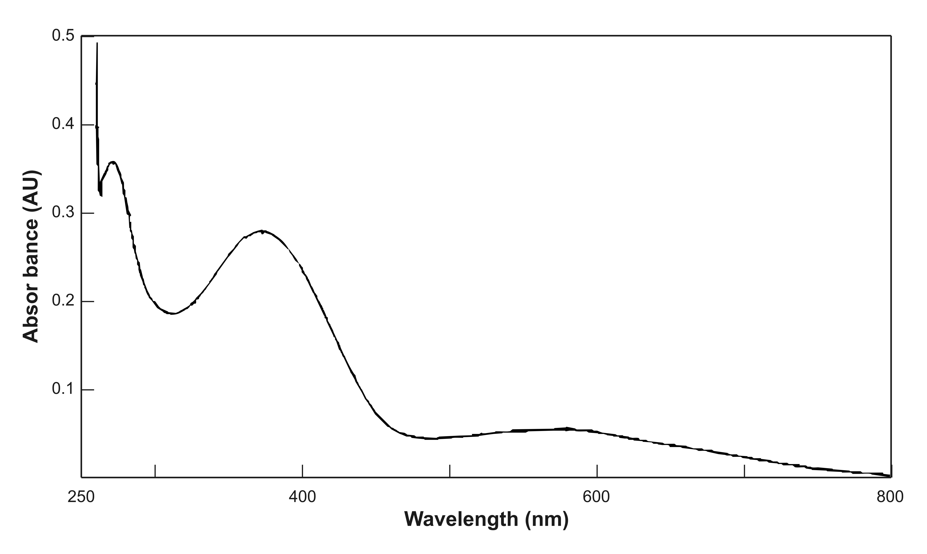
Fig. 1. UV Analysis of the conducting polyaniline powder in DMSO.

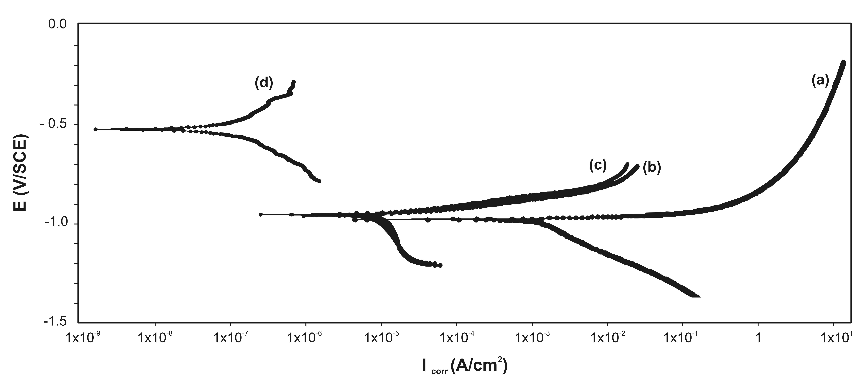
Fig. 2. Tafel plot for hot dip galvanized low carbon steel samples and paint coated carbon steel samples in 3.5 wt % NaCl (curve a - unpainted hot dip galvanized low carbon steel, curve b - 1.5 wt % painted steel, curve c - 1 wt % painted steel and curve d - 0.1 wt % painted steel).
Fig. 3. Nyquist plot for hot dip galvanized low carbon steel sample and for paint coated carbon steel samples. (curve a - unpainted hot dip galvanized low carbon steel, curve b - 1.5 wt % painted steel, curve c - 1 wt % painted steel and curve d - 0.1 wt % painted steel).

rate of 1 wt % PANI-HCl paint coated steel is found to be 1.769 mpy which is 3.5 times lower than that of unpainted hot dip galvanized steel.

Table 2. Comparison of corrosion rates for unpainted hot dip galvanized steel and paint coated hot dip galvanized steel.
Parameters | I_{corr,}  A/cm ² | E_{corr,}  mV | B_{A},  V/dec | B_{C},  V/dec | Corrosion Rate,  mpy
Unpainted hot dip galvanized steel | 0.006x10⁻³ | -1063 | 1.4786 | 2.0209 | 6.1
0.1 wt% PANI- HCl painted steel | 236x10⁻⁹ | -521 | 1.4824 | 2.0267 | 1.998
1 wt % PANI –HCl painted steel | 10.40x10⁻⁶ | -1040 | 1.4886 | 2.1209 | 1.769
1.5 wt % PANI-HCl painted steel | 17.30x10⁻⁶ | -1040 | 1.4856 | 2.0288 | 2.937

Table 3. Impedance parameters based on curve fitting and corrosion protection efficiency.
Parameters | R_{p,}  _{ohms /cm}² | C_{c,}  µF | R_{f,}  _{ohms/cm}² | C_{f,}  µF | R_{u,}  _{ohms /cm}² | P_{R},  _{ohms /cm}² | % P. E.
Unpainted hot dip galvanized steel | 323 | 45 | 2.0 | 231 | 56 | 381 | -
0.1 wt % PANI-HCl painted steel | 433 | 4.40 | 1.03 | 249.1 | 33.73 | 467.76 | 18.54
1 wt % PANI-HCl painted steel | 213.7 | 17.51 | 1.27 | 556.8 | 322.5 | 537.47 | 29.11
1.5 wt % PANI-HCl painted steel | 196 | 25.81 | 3.89 | 507.2 | 201.5 | 401.39 | 5.1

The Nyquist plots for hot dip galvanized low carbon steel sample and paint coated carbon steel samples in 3.5 wt % NaCl are shown in the Fig. 3.
The Nyquist impedance plots for hot dip galvanized low carbon steel and painted steel sample shown in the Fig. 3 are modeled by using the equivalent circuit depicted in the Fig. 4.
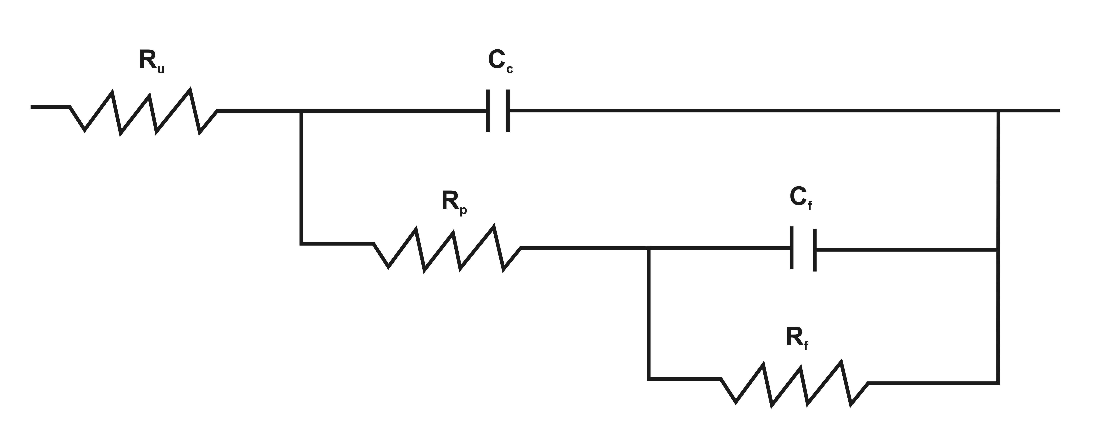
Fig. 4. Equivalent circuit used for modeling impedance curve.
It consists of the electrolyte resistance (R_{u}), the pore resistance (R_{p}), the coating capacitance (C_{c}), the charge transfer resistance (R_{f}) and double layer capacitance (C_{f}). The impedance plot of hot dip galvanized low carbon steel sample can be fitted with two semicircles, a smaller one at high frequency range followed by a larger one at lower frequencies. The first semicircle is attributed to the formation of the corrosion film and the second one to processes occcuring below the corrosion film. The Nyquist impedance plot of conducting polymer based paint coated sample is also modeled using the same circuit. However, the parameter values of the best fit to the impdence curve are different when compared to those for unpainted hot dip galvanized low carbon steel. It can be also fitted with two semicircles, a smaller one at high frequency range followed by a larger one at lower frequencies. The first capacitve loop can be attributed to the paint/steel interface. It is characterized by the pore resistance (Rp) and the coating capacitance (Cc). The second semicircle can be attribued to the processes occuring below the paint coating. It is characterized by charge transfer resistance (Rf) and double layer capacitance (Cf). The values of these impedance parameters obtained from the fitting of the experimental parameters are given in Table 3. The polarization resistance (P_{R}) was calculated by using following relation and recorded in Table 3.
P_{R} = R_{p} + R_{f} + R_{u},
where Rp is the pore resistance, R_{f} is the charge transfer resistance and R_{u} is the electrolyte resistance. The protection efficiency based on EIS data was calculated by using following expression [20] and recorded in Table 3.
$\%P\text{.}E\text{.}=\frac{P_{c}−P_{R}}{P_{c}}\text{.}\text{100}$,
where P_{R} and P_{c} denote the polarization resistance of unpainted hot dip galvanized low carbon steel sample and painted hot dip galvanized low carbon steel sample respectively.
The R_{f} value for 1 wt % PANI-HCl painted steel is found to be to order of 537.47 ohms/cm², which is 71 % higher than that of unpainted steel. The higher value of the R_{f} can be attributed to the effective barrier property of the paint coating. The lower values of Cc for paint coated samples provide further support for the protection of steel by paint coating. The polarization resistance in the case of unpainted hot dip galvanized steel is of the order of 381 ohms per cm², which is close to the value reported by Vagge et al. [21]. It increases with the weight percentage of conducting polyaniline in paint formulation and reaches maximum i.e. 537.47 ohms per cm² for 1 wt % PANI-HCl painted hot dip galvanized steel and subsequently decreases. Thus EIS results support the Tafel investigations and it can be said that hot dip galvanized steel can be protected by applying conducting polyaniline based paint. It can be observed that the paints with lower loading of PANI- HCl offer good corrosion protection and the paint containing 1 wt % PANI-HCl is more effective in corrosion protection of hot dip galvanized steel in aqueous a 3.5 wt % NaCl solution. These results are in agreement with previous studies of conducting polyaniline based paints on low carbon steel [17].
Conclusions
Hot-dip galvanized coatings are used to protect steel against corrosion due to their low cost and ease of application. It is beneficial to improve the corrosion resistance of these coatings in order to prolong their service life. Conducting polyaniline based paints can be applied on hot dip galvanized low carbon steel. The paints containing a lower loading of PANI- HCl further enhance corrosion protection offered by hot dip galvanized coating to low carbon steel, and the paint containing 1 wt % PANI-HCl is more effective for corrosion prevention of hot dip galvanized steel in aqueous 3.5 wt % NaCl solution.
Acknowledgements: The authors thank Prof. M. Rathod, Head, Department of Metallurgy and Materials Science, College of Engineering, Pune – 411005 (M.S.), India for providing facilities for the work and Prof. Anil Sahasrabudhe, Director, College of Engineering, Pune-411005 (M.S.), India for his encouragement.
References:
- D.Tallman, G. Spiniks, A. Dominis, G. Wallace, J. Sol. State Electrochem. 6, 73 (2002).
- G. Spinks, A. Dominis, G. Wallace, D. Tallman, J. Sol. State Electrochem. 6, 85 (2002).
- S. Biallozor, A. Kupniewska, Synth. Metals, 155, 443 (2005).
- P. Deshpande, D. Peshwe, S. Pathak, J. Institution of Engineers (India) 82, 33 (2001).
- H. Nalwa, Hand Book of Organic Conductive Molecules and Polymers, John Wiley and Sons, New York, USA (1997).
- T. Skotheim, R. Elsenbaumer and J. Reynolds, Handbook of Conducting Polymers, Marcel Dekkar, New York, USA (1997).
- D. Sazou, Synth. Metals 118, 133 (2001).
- V. Shinde, S. Sainkar, P. Patil, J. Appl. Polymer Sci. 96, 685 (2005).
- M. Wankhede, A. Gaikwad, P. Patil, Surf. Coat. Tech. 01, 2240 (2006).
- A. Yagan, N. Pekmez, A. Yildiz , Electrochim. Acta 53, 5242 (2008).
- G. Bereket, E. Hur,Y. Sahin , Prog. in Org. Coat. 54, 63 (2005).
- A. Ozyilmaz, G. Ozyilmaz, N. Colak, Sur. and Coat. Tech. 201, 2484 (2006).
- R. Rajagopalan, J. Iroh, Surf. Engin. 18, 59 (2002).
- S. Ananda Kumar, K. Shree Meenakshi, T. Sankaranarayanan, S. Srikanth, Prog. in Org. Coat. 62, 285 (2008).
- S. Vagge, V. Raja, Surf. and Coat. Tech. 203, 3092 (2009).
- J. Chaing, A. MacDiarmid, Synth. Metals 13, 193 (1986).
- A. Samui, A. Patankar, J. Ragarajan, P. Deb, Prog. in Org. Coat. 47, 1 (2003).
- S. Vagge, V. Raja, Surf. and Coat. Tech. 201, 2296 (2006).
- C. Ozdemir, H. Can, N. Kolac, A. Guner, J. App. Polymer Sci. 99, 2182 (2006).
- S. Chaudhari, P. Patil, Electro Chim. Acta 53, 927 (2007).
- S. Vagge, V. Raja, Appl. Surf. Sci. 253, 8415 (2007).

Проводящи бои на полианилинова основа за корозионна защита на поцинкована на горещо нисковъглеродна стомана
П. Дешпанд*¹, С. Ваг¹, С. Джагтап², Р. Кхиарнар³, С. Келкар⁴, М. Мор⁵
¹ Департамент по металургия и материалознание, Колеж по инженерство, Шиважинагар, Пун- 411005(М.С.), Индия
²Технологичен Институт Синхгад, Лонавала, Пун - 411001(М.С. Щат Махаращра), Индия
³ Департамент по физика, Свами Рамананд Тиирт, Университет Маратвада, Нандед- 431 606 (М.С.), Индия
⁴Национална химична лаборатория, Пун - 411008(М.С.), Индия
⁵ Департамент по физика, Университет Пун, Пун - 411007(М.С.), Индия

Постъпила на 20 февруари, 2012 г; приета на 20 февруари, 2012 г

(Резюме)

Проводящи бои на полианилинова основа са приложени върху образци от поцинкована на горещо нисковъглеродна стомана. Корозионната защита на такива покрития е оценена с помощта на Тафелови зависимости и импедансна спектроскопия. Установено е, че покритията с боя осигуряват значителна защита от корозия на поцинкованата на горещо нисковъглеродна стомана в разтвори на 3.5 % (тегл.) NaCl.

