Bulgarian Chemical Communications, Volume 44, Number 4 (pp. 346 – 355) 2012
Electrochemical impedance spectroscopy using exponentially-rising voltage steps.
(II) Analysis of the hydrogen electro-insertion into palladium foils
P. Millet
Institut de Chimie Moléculaire et des Matériaux d’Orsay, UMR CNRS n° 8182, Université Paris Sud 11, 15 rue Georges Clémenceau, 91405 Orsay cedex France
Received February 20, 2012; accepted February 20, 2012
Electrochemical impedance spectroscopy (EIS) is commonly used by electrochemists to analyze multi-step reaction paths occurring at electrode/electrolyte interfaces. Since the kinetics of individual reaction steps is usually a function of electrode potential, the impedance of the interface is measured for different but constant potential values. In most cases, impedance diagrams are obtained from harmonic analysis: a surimposed low amplitude (typically 5-10 mV) ac potential modulations or alternatively, a low amplitude (typically a few mA) ac galvanostatic modulation, is used as perturbation. However, according to the theory of linear and time invariant systems, harmonic analysis should be restricted to the analysis of linear and reversible processes. To a certain extend, the problem of linearity can be circumvented by reducing the amplitude of the modulation. But that does not help to solve the problem of irreversibility. For example, a significantly large hysteresis is observed during the electro-insertion of hydrogen into palladium or palladium alloy electrodes. This is a clear indication that non-linear phenomena are taking place and therefore, the use of harmonic analysis should be prohibited because the system does not fulfill the requirements of linearity and time invariance imposed by the theory of systems. There is therefore a need to use non-alternating perturbations. The purpose of this paper is to report on the measurement of impedance spectra from exponentially-rising voltage steps. This is a methodology-oriented communication. In the first part of the paper, an electrical circuit containing only electrical resistances and capacitances is used as a model system to explain how impedance diagrams can be obtained from such non-harmonic perturbations. In the second part of the paper, the methodology is extended to the electro-insertion of hydrogen in palladium foils.

Key words: Impedance spectroscopy, Palladium, Hydriding kinetics, Voltage step
© 2012 Bulgarian Academy of Sciences, Union of Chemists in Bulgaria
* To whom all correspondence should be sent:
E-mail: pierre.millet@u-psud.fr

Introduction
The advantages of exponentially-rising voltage steps over voltage sine waves for the measurement of chemical or electrochemical impedances have been exposed in the first part of this part. The purpose of this second part is to report on the determination of the impedance of a palladium electrode during hydrogen insertion using an exponentially-rising voltage step as electrical perturbation. Analysis of phase transformation processes observed in most hydrogen-absorbing materials (pure metals, alloys or compounds) is still a matter of active research, in view of electrochemical or chemical hydrogen storage applications. Metal-hydride forming materials (some elemental metals, some alloys and some intermetallic compounds) are of great practical interest for miscellaneous industrial applications such as H₂(g) storage and purification, NiMH batteries, heat pumps or hydrogen isotopic separation. The current status of metal hydride technology is such that new materials with enhanced thermodynamic and kinetic properties are still required, in particular for the storage of gaseous hydrogen in the automotive industry, an application for which the energy density of current storage tanks is still a limiting factor [1]. The kinetics of hydrogen insertion can be analyzed through either electrochemical or chemical (gas-phase) experiments and both techniques provide complementary information [2]. One of the most striking characteristic of metal hydrogen systems is the presence of a large hysteresis which complicates the measurements of kinetic parameters. Hysteresis indicates that irreversible processes are taking place at the microscopic scale and therefore, sine waves perturbations commonly used in the popular electrochemical impedance spectroscopy (EIS) are inappropriate. There is a need to use non-alternating perturbations. The purpose of this paper is to investigate the possibility of measuring electrochemical impedances from exponentially-rising voltage step experiments. This is a methodology-oriented communication. In the first part of the paper, an electrical circuit containing only electrical resistances and capacitances was used as a model system. The situation was simple because experiments are very brief (a few milliseconds long). As a result, sampling conditions and data treatment procedures are easy to manage and impedance diagrams are easy to obtain. In the second part of the paper, the methodology is extended to the study of a more complicated case, the electro-insertion of hydrogen into palladium foils.
Experimental
Chemicals
A palladium foil (99.9 %, 100 μm thick, 680.23 mg = 6393 Pd μmole, S ≈ 8 cm², Aldrich) has been used as working electrode. The roughness factor of the foil determined from cyclic voltammetry experiments by integrating the reduction peak of chemisorbed oxygen [3] and using a reference charge of 0.42 mC cm⁻², was found to be close to unity. Although the sample microstructure can potentially have a strong impact on hydrogen solubility and mobility, the Pd electrode was used “as-received” (a cold-rolled sample) without any preliminary treatment to adjust the microstructure to any reference state. 0.1 M H₂SO₄ solutions prepared from suprapur (Merck Co.) H₂SO₄ using 18 MΩ cm deionised water have been used as liquid electrolyte.
Experimental setup
Electrochemical experiments have been performed using a conventional one-compartment electrochemical cell. The Pd working electrode was connected to the external electric circuitry using a gold connector. Two large counter electrodes (Pt foils) were placed on each side of the Pd WE to warrant symmetrical loadings/un-loadings as described elsewhere [4]. Short (10 cm long) electric cables were used to minimize parasite impedance losses. A computer-controlled Radiometer Analytical PGZ 402 potentiostat-galvanostat was used to apply exponentially-rising voltage steps and collect transient current responses with sampling rates of a few kHZ. In addition, an Agilent DSO 6032 A (2 channels, 300 MHz) oscilloscope was also used to sample the transients during the first tens of milliseconds of the experiments, when the double layer capacitance is charged.
PdH isotherms
A typical electrochemical PdH isotherm measured at room temperature using galvanostatic pulses [5] is plotted in figure 1. The hydrogen content of the Pd foil is expressed in terms of H/Pd, the dimensionless ratio of mole numbers. At low hydrogen contents (H/Pd < 0.04), a homogeneous solid solution (α-PdH) of hydrogen in palladium is formed. In this composition range, the Pd-H system is bi-variant and the electrode potential rises with composition. After saturation, a sub-stoechiometric (PdH_{0.6} at this temperature) hydride phase (β-PdH) starts to precipitate. The system becomes mono-variant and according to Gibbs’ rule of phase, a potential plateau appears. Once the sample is fully hydrided (H/Pd ≈ 0.6), it is still possible to insert limited amounts of hydrogen to form a new solid solution of hydrogen in β-PdH. Since α-PdH is now totally transformed into β-PdH, the PdH system is again bi-variant and the electrode potential rises again sharply with composition. A symmetrical situation prevails during desorption. However, phase limits are slightly different because of hysteresis. As can be seen from Fig. 1, the potential plateau during electrochemical insertion is close to + 50 mV vs. RHE at 298 K and the amplitude of hysteresis is ca. 12 mV. Because of hysteresis, it is not possible to follow a reversible path during a displacement from one plateau to the other. Starting from one equilibrium point {electrode potential;composition point) along the absorption plateau, it is only possible to move along a closed loop (labels A and B in Fig. 1). The use of sine wave perturbations in this two-phase domain would change the composition at the measurement point during the experiment and would complicate the interpretation.
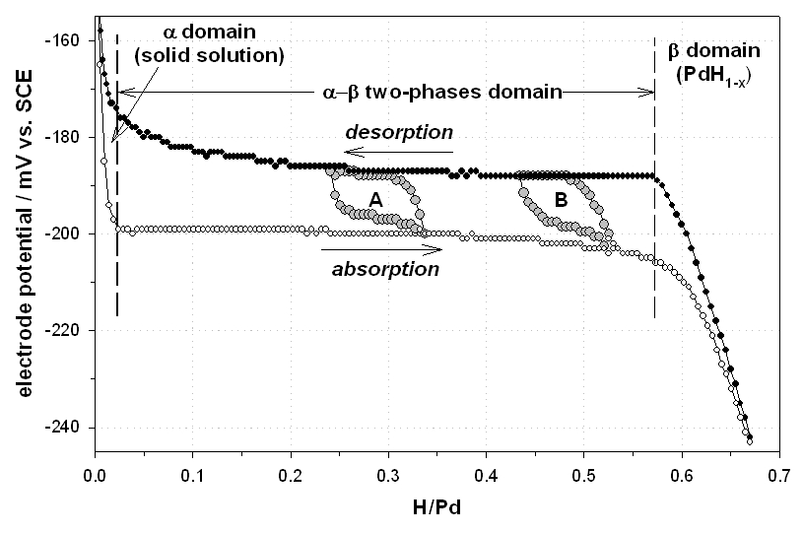
Fig. 1. Experimental PdH isotherm measured at 298K in H₂SO₄ 1 M.

Results reported in this paper focus on the methodology. Data were obtained in the solid solution domain (α –PdH) were reversible hydriding phenomena are taking place. In such domains, both sine waves and exponentially-rising voltage steps can be used as perturbations and it is therefore possible to compare impedance diagrams obtained by both methods.
THEORY
The basic principles of impedance spectroscopy from exponentially-rising voltage steps have been described in the first part of the paper.
Hydrogen insertion mechanism
As discussed elsewhere [2], the electrochemical insertion of hydrogen in Pd is a multi-step process. In the low hydrogen concentration domain (where single-phased solid solutions are formed), each individual step of the multi-step process is reversible. In acidic media, the detailed reaction path is:
H⁺ + 1 e⁻ + M <──> MH_{ad}^{surface} (step 1–a)
2 MH_{ad}^{surface} <──> H₂(g) + 2 M (step 1–b)
H⁺ + 1 e⁻ + MH_{ad}^{surface} <──> H₂(g) + M (step 1–b’)
MH_{ad}^{surface} <──> M + H_{ab}^{sub-surface} (step 1–c)
H_{ab}^{sub-surface} <──> H_{bulk} (step 1–d)
where H_{ad} denotes a surface ad-atom, H_{ab} denotes a hydrogen atom absorbed in the metal sub-surface and H_{bulk} denotes a hydrogen atom in bulk regions. H_{ad} species are formed by the reduction of protons (Volmer step 1–a). From the viewpoint of H insertion, surface recombination of hydrogen ad-atoms (Tafel step 1–b) and electrochemical recombination (Heyrovsky step 1–b’), both leading to hydrogen evolution, are side-steps, the kinetics of which is an increasing function of electrode overvoltage. Surface ad-atoms can also cross the metal surface, reach sub-surface regions (step 1–c) and then bulk regions (step 1–d) by diffusion. According to Frumkin et al. [6], steps (1–a) and (1–c) form one single step whereas according to Bockris et al. [7], they are separated steps.
Model impedances
Impedances associated with reaction steps (1–a, 1–b, 1–b’, 1–c) can be modeled by frequency-independent resistances. Analytical expressions of diffusion impedances (step 1–d) have been derived in the literature for various geometries including planar diffusion [8, 9] which is more specifically considered here. Electrochemical impedance diagrams can be modeled using the equivalent circuit shown in Fig. 2.
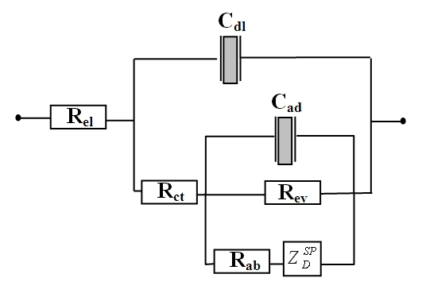
Fig. 2. Electrical equivalent circuit associated with the hydriding reaction
The corresponding impedance expression is given by Eq. (1):
$Z \left(ω\right)=R_{\text{el}}+\frac{1}{j ω C_{\text{dl}}+\frac{1}{R_{\text{ct}}+\frac{1}{j ω C_{\text{ad}} +\left(\frac{1}{R_{3} + Z_{D}^{ \text{SP}}}\right)+\frac{1}{R_{\text{ev}}}}}}$ (1)
where:
R_{el} in Ω cm² is the resistance of the electrolyte between working and reference electrodes
C_{dl} in F cm^{–2} is the double layer capacitance
R_{ct} in Ω cm² is the charge transfer resistance associated with step (1-a)
C_{ad} in F cm^{–2} is the adsorption capacitance associated with step (1-a)
R_{ab} in Ω cm² is the resistance associated with step (1–c)
R_{ev} in Ω cm² is the resistance associated with the hydrogen evolution step (1–b or 1–b’)
$Z_{D}^{\text{SP}}\left(ω\right)$ in Ω cm² is the diffusion impedance associated with hydrogen transport to bulk regions (step 1–d). An analytical expression is available from the literature [8,9] :
$Z_{D}^{\text{SP}}\left(ω\right)=R_{D}^{\text{SP}}\frac{\text{coth} \left(u^{ p}\right)}{u^{ p}}$ (2)
where D stands for diffusion and SP for single phase domain.
$$R_{D}^{\text{SP}}=\frac{δ}{F D_{H}} \left(−\frac{∂E}{∂C_{H}}\right)$$
is the diffusion resistance in Ω cm²;
$u=j \frac{ω δ^{2}}{D_{H}}$.
j is the imaginary unit; 2δ is the thickness of the palladium foil in cm; D_{H} is the hydrogen diffusion coefficient in cm² s^{–1}; 0 < p < 1 is a dimensionless factor used to model interfaces with distributed properties [10] (p = 0.5 for an ideal interface); $−\left(\frac{∂E}{∂C_{H}}\right)$ is the slope of the electrochemical isotherm at the measurement point in V mol^{–1} cm³.
The graph of $Z_{D}^{\text{SP}}\left(ω\right)$ is very typical. At high frequencies
$\underset{ω → ∞}{\text{lim} \text{coth} \left[u\left(ω\right)\right]}=\underset{ω → ∞}{\text{lim} \frac{e^{ u}+ e^{ −u}}{e^{ u}− e^{ −u}}}=\underset{ω → ∞}{\text{lim} \frac{e^{ u}}{e^{ u}}}=1$+ j 0
(the imaginary part is zero), since $\underset{ω → ∞}{\text{lim} Z_{D}^{\text{SP}} \left(ω\right)}≈\frac{R_{D}}{u}=0+j 0=\left\{0;0\right\}$.
In the intermediate frequency range (f in Hz), as long as ω is sufficiently high, coth(u) ≈ 1, and therefore,
$Z_{D}^{\text{SP}} \left(ω\right)≈ \frac{R_{D}}{u}$.
Taking $u = \sqrt{π f \frac{δ^{ 2}}{D}}+j \sqrt{π f \frac{δ^{ 2}}{D}}$ ( ω = 2.π.f).
$Z_{D}^{\text{SP}} \left(ω\right)=\frac{1}{2 F \left(−\frac{∂C}{∂E}\right) \sqrt{D} \sqrt{π f}}−j \frac{1}{2 F \left(−\frac{∂C}{∂E}\right) \sqrt{D} \sqrt{π f}}$ (3)
This is the equation of a semi-line in the Nyquist plan.
In the low frequency range, $\text{th} \left(u\right)=\frac{e^{u}−e^{− u}}{e^{u}+e^{− u}}$.
The exponential function can be approximated by Taylor series:
$$e^{u}=\sum_{n=0}^{n=∞}{\frac{u^{n}}{n !}}=1+u+\frac{u^{ 2}}{2 !}+\text{.}\text{.}\text{.}$$
By considering only fifth order terms, we obtain:
$$e^{u}=1+u+\frac{u^{ 2}}{2}+\frac{u^{ 3}}{6}+\frac{u^{ 4}}{\text{24}}+\frac{u^{ 5}}{\text{120}}$$
$$e^{− u}=1−u+\frac{u^{ 2}}{2}−\frac{u^{ 3}}{6}+\frac{u^{ 4}}{\text{24}}−\frac{u^{ 5}}{\text{120}}$$
Therefore:
$$\text{th} \left(u\right)≈\frac{2 u+\frac{u^{ 3}}{3}+\frac{u^{ 5}}{\text{60}}}{2 +u^{ 2}+\frac{u^{ 4}}{\text{12}}}≈\frac{u+\frac{u^{ 3}}{6}+\frac{u^{ 5}}{\text{120}}}{1 +\frac{u^{ 2}}{2}+\frac{u^{ 4}}{\text{24}}}≈u \left[\frac{1+\frac{u^{ 2}}{6}+\frac{u^{ 4}}{\text{120}}}{1 +\frac{u^{ 2}}{2}+\frac{u^{ 4}}{\text{24}}}\right]≈u \left(1−\frac{u^{ 2}}{3}\right)$$
since $u=\sqrt{\frac{ j ω δ^{2}}{D}}$ => $u^{ 2}=\frac{ j ω δ^{2}}{D}$ => $u^{ 4}=−\frac{ω^{ 2} δ^{4}}{D^{ 2}}$
therefore :
$$\frac{Z_{D}^{\text{SP}}\left(ω\right)}{R_{D}^{\text{SP}}}≈\frac{1}{u^{ 2} \left(1−\frac{u^{ 2}}{3}\right)}≈\frac{3}{3 u^{ 2} −u^{ 4}}≈\frac{3+j 0}{\frac{ω^{ 2} δ^{ 4}}{D^{ 2}}+j \frac{3 ω δ^{ 2}}{D}}$$
Neglecting fourth order terms, we obtain:
$Z_{D}^{\text{SP}}\left(ω\right)≈\frac{R_{D}^{\text{SP}}}{3}−j \frac{D_{H} R_{D}^{\text{SP}}}{ω δ^{ 2}}=R_{\text{in}}−j \frac{1}{ω C_{\text{in}}}$ (4)
Eq. (4) is the equation of a vertical semi-line along the imaginary axis in Nyquist coordinates. R_{in} is the insertion resistance in Ω cm² :
$R_{\text{in}}=\frac{R_{D}}{3}=\frac{δ}{3 F D_{H}} \left(−\frac{∂E}{∂C_{H}}\right)$ (5)
C_{in} is the insertion capacitance per unit area of interface in F cm^{–2}:
$C_{\text{in}}=\frac{δ^{ 2}}{D_{H} R_{D}}=\frac{δ F}{\left(−\frac{∂E}{∂C_{H}}\right)}$ (6)
τ_{in} = R_{in}.C_{in} in seconds is the insertion time constant.
Results and Discussion
From the experimental viewpoint, the problem is to determine the impedance of a given system of interest by using an exponentially-rising voltage step as perturbation. In the case considered here, the system is the electrode/electrolyte electrochemical interface represented by the circuit of Fig. 2. In a typical experiment, two transient signals are sampled synchronously: the exponentially-rising step E(t) and the current response I(t). To determine the unknown impedance of the interface there are two options: (i) frequency-domain analysis : the Fourier transform of both E(t) and I(t) are numerically calculated and the ratio of the two FTs is taken as shown by Eq. (10), yielding the impedance Z(ω) of the circuit; this is the most straightforward method; (ii) time-domain analysis: a model circuit impedance Z(ω) is postulated; then, I(ω), the FT of the current response to a voltage step is calculated from Eq. (10): I(ω) = E(ω) / Z(ω); then, model I(t) is calculated from I(ω) by inverse Fourier transformation and used to fit transient experimental current I(t); parameters of the model impedance Z(ω) are iteratively adjusted to minimize the difference between model and experimental I(t) in order to determine the exact characteristic of circuit components. This second approach is more difficult to implement than the first one but can sometimes be more efficient and even more accurate. It can also be automated. The two approaches are detailed in the followings.
Frequency-domain analysis
Impedance diagram of the hydrogen insertion reaction
Interface impedance parameters can be determined from a frequency-domain analysis of experimental data. The equivalent electrical circuit of Fig. 2 can be simplified by considering that (i) the parasitic reaction of the HER is negligible (this assumption is justified because experiments considered here were made at high potential values where Pd-H solid solutions are formed; accordingly, resistance R₄ is infinite); (ii) the adsorption capacitance C₂ is small and its impedance is infinite. The simplified electrical circuit is pictured in Fig. 3.
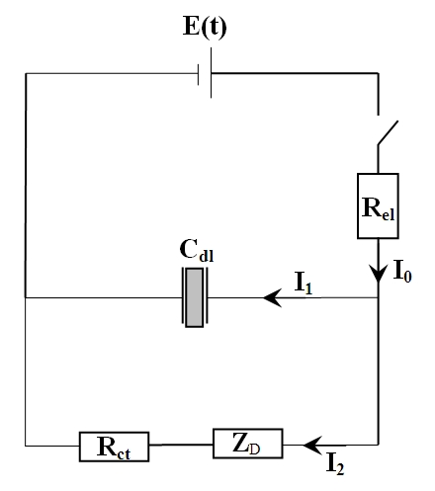
Fig. 3. Simplified equivalent circuit of the Pd-H interface
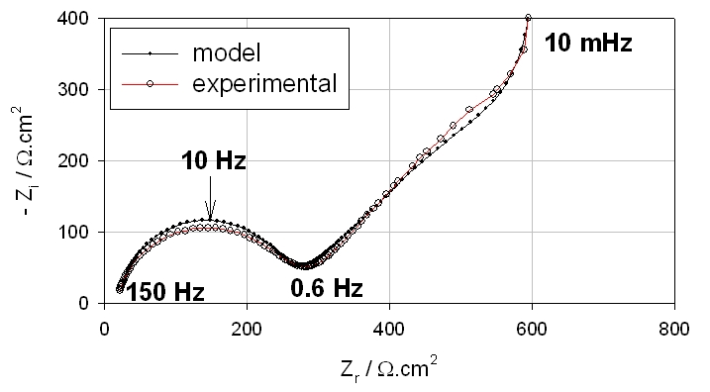
Fig. 4. (o) experimental impedance diagram measured at 298K on a PdH electrode in 0.1 M H₂SO₄ solution at + 60 mV RHE;(+) model impedance diagram from Eq. (7).
The analytical impedance of the electrical circuit of Fig. 3 is given by equation (7) where ω = 2 π f is the pulsation in rad.s⁻¹ and f is the normal frequency in Hz:
$Z \left(ω\right)=R_{\text{el}}+\frac{1}{j ω C_{\text{cl}} +\frac{1}{R_{\text{ct}}+Z_{D}}}$ (7)
The impedance diagram of the working electrode has been measured at a potential of + 60 mV (Fig. 4). The experimental impedance diagram has been fitted using Eq. (7) and the best fit is also plotted in Fig. 4.
At E = + 160 mV RHE, the slope of the isotherm is large (see Fig. 1) and the corresponding insertion capacitance C_{in} is rather low. The value of the hydrogen diffusion coefficient obtained from the fit is similar to values reported in the literature for palladium at 298 K [11]. The pulsation at the summit of the HF semi-circle is rather low, and this may be partly due to un-reduced surface oxides (the experiment was performed on the “as-received” sample) or to un-activated surface sites. On a fully activated sample, characteristic frequencies of several hundred Hz can sometimes be observed.
Solution to the convolution equation in the frequency domain
The impedance diagram of the circuit of Fig. 1 can be obtained directly from exponentially-rising voltage-step experiments. The impedance Z(ω) is obtained directly from Eq. (8):
$Z (ω)=\frac{E \left(ω\right)}{I \left(ω\right)}$ (8)
where E is the voltage excitation in Volt, I₀ is the current response of the cell in A, and ω is the pulsation in rad.s^{–1}. E(ω) denotes the Fourier transform of the rising step E(t), and I₀(ω) denotes the Fourier transform of the current response I(t).
Sampling conditions and data treatment
A correct sampling rate is a key factor for obtaining experimental impedance diagrams. The sampling rate must respect the Nyquist criterion which states that the signal must be sampled more than twice as fast as the highest waveform frequency (f_{c}). If not, all of the power spectral density (PSD) which lies outside of the frequency range -f_{c} < f < f_{c} is spuriously moved into that range and the spectrum is corrupted. In other words, high-frequency components of a time function can impersonate lower frequencies if the sampling rate is too low. This phenomenon is called aliasing [12]. As discussed above, experiments have been made using exponentially-rising voltage steps. The typical current measured on the Pd electrode at E = + 60 mV RHE and T = 298K in response to a 10 mV rising step is reproduced in Fig. 5.
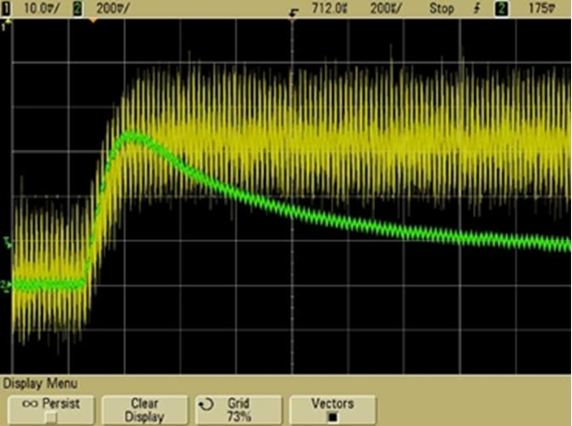
Fig. 5. Transient rising voltage step (top) and current response (bottom) measured on the Pd electrode at E = + 60 mV vs. RHE and T = 298K.
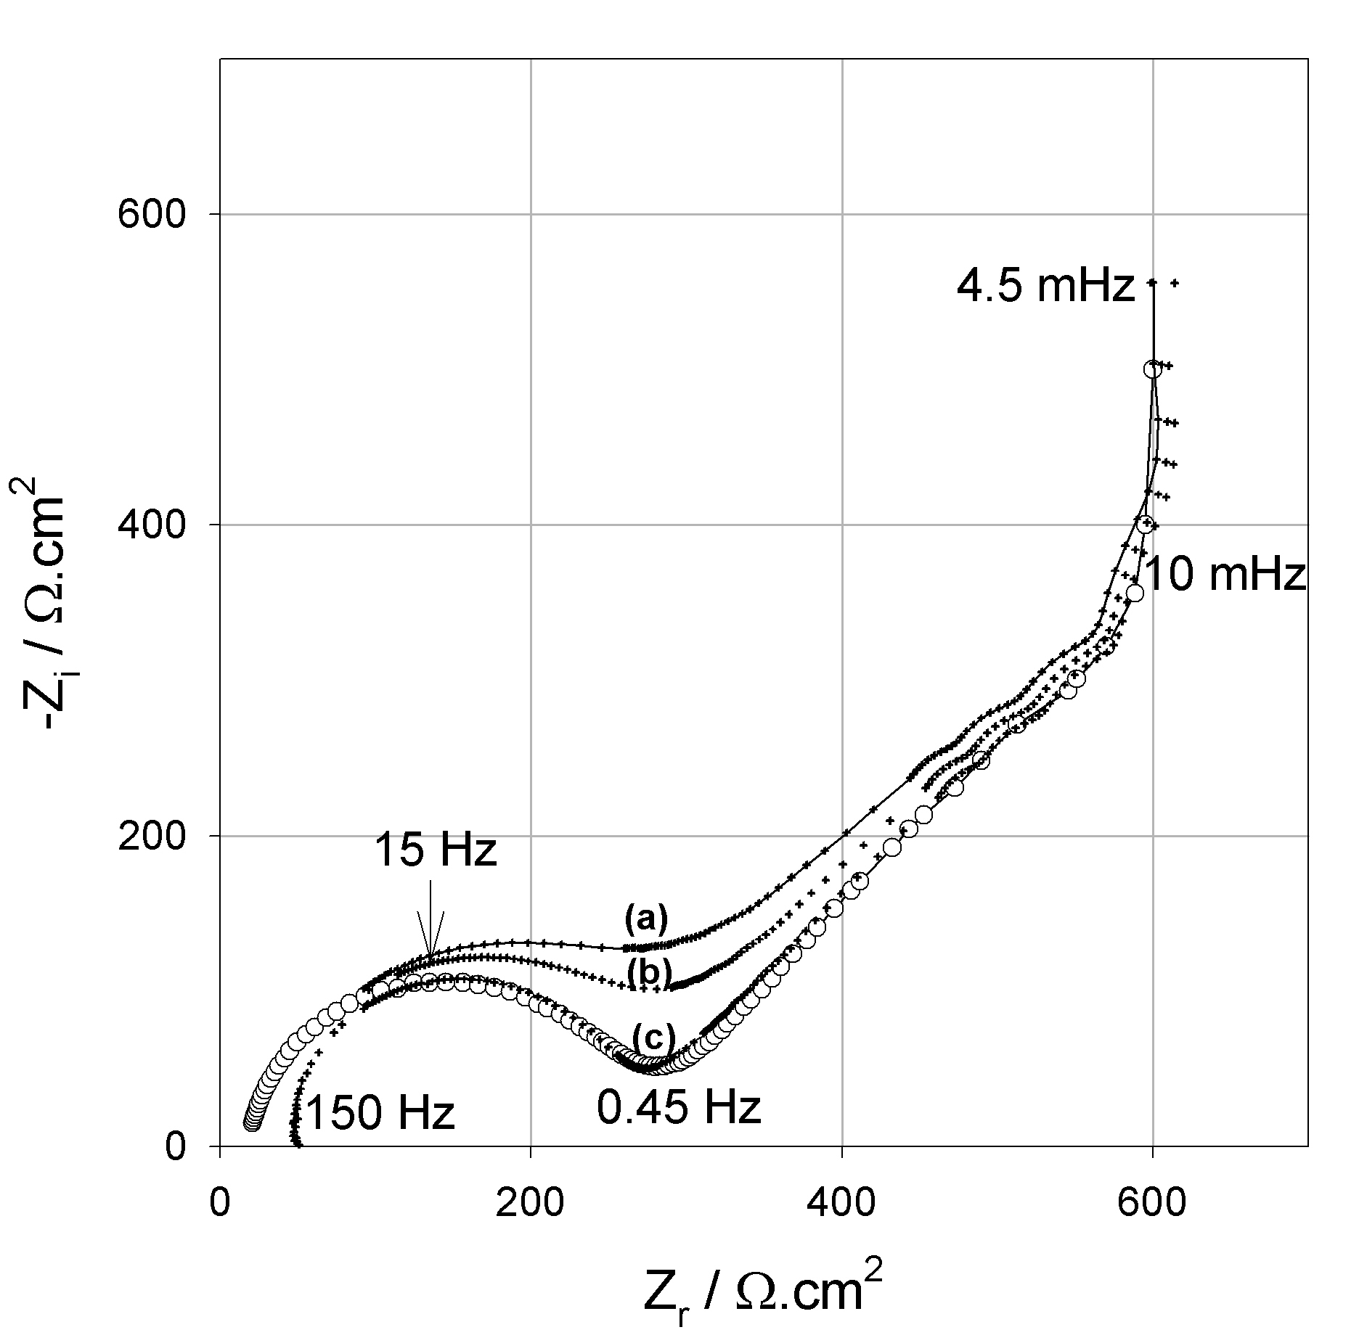
Fig. 6. Experimental electrochemical impedance diagrams measured on Pd-H at 298 K at E = +160 mV RHE. (o) theoretical from Eq. (7); (+) exponentially-rising voltage steps: (a) Δt = 50 ms (f_{max} = 10 Hz); (b) Δt = 25 ms (f_{max} = 20 Hz); (c) Δt = 2.5 ms (f_{max} = 200 Hz)
Considering the time constant of the exponentially-rising voltage step (τ = 1/b ≈ 65 μs), an appropriate sampling rate of one data-point every 10 μs (or less) corresponding to a maximum frequency of 50 kHz should be used to properly sample the peak current. Such a rate should be maintained until the end of the experiment (sometimes, depending on the electrode potential and hydrogen solubility, several tens of seconds are required) and this of course will yield large amounts of data points. However, the problem of data sampling can be simplified as discussed in the first part of this paper. First, there is no need to sample the exponentially-rising voltage step. Its shape was found sufficiently reproducible from one experiment to the other to allow the direct use of the analytical expression of E(ω) (Eqs. 13–14 in the first part of this paper) directly into Eq. (8). The amount of data is thus reduced by a factor of two. An additional advantage of this approach is that the voltage excitation does not introduce any noise in the impedance diagram. Second, the kinetics of surface (charge transfer step) and bulk (diffusion step) rate contributions usually differ significantly and appear at quite different frequencies (see Fig. 4 where the HF semi-circle is due to the parallel connection of the charge transfer resistance with the electrode/electrolyte capacitance and the MF 45º semi-line is due to bulk diffusion of atomic hydrogen). Therefore, the high frequency (HF) part of the impedance diagram associated with the surface step can be obtained with a good precision from the current response in the 0–0.5 ms time range. This is the period of time during which the double layer capacitance is charged and when a peak current is observed (Fig. 5). The medium (MF) and low (LF) frequency part of the impedance diagram can be obtained from the current response in the 0-10 s time range with a lower sampling rate of a few milliseconds. In the work reported here, the oscilloscope was used to record the transient at short times and the potentiostat was used to record the signal until equilibrium with a typical sampling rate of a few milliseconds. The oscilloscope was triggered by the rising potential on the first acquisition channel. The complete I(t) transient was finally obtained by adding the two signals, low-pass filtering and interpolating.
Comparison of model and experimental impedance values
The theoretical impedance diagram of the Pd foil polarized at E = + 160 mV RHE measured with sine wave perturbations is plotted in Fig. 6. Then, experimental electrochemical impedance diagrams have been obtained from rising voltage step experiments. Typically, the WE was first polarized at +160 mV RHE until equilibrium was reached and then a 10 mV amplitude step was applied and the resulting transient current was sampled. Impedance diagrams obtained with different sampling rates are also plotted in Fig. 6 for comparison. A sampling rate of one data-point every 2.5 ms is necessary to obtain a good agreement between theory and experiments in the medium and low frequency regions (hydrogen diffusion). However, the HF semi-circle still remains distorted due to aliasing effects and higher sampling rates are required to obtain a better resolution of the HF semi-circle and extract the corresponding kinetics information.
From these results, it can be concluded that impedance diagrams can be obtained with a good accruracy from exponentially-rising voltage-step experiments. Although impedance diagrams can be computed easily within a few seconds, a disdavantage of the technique is that it requires the acquisition of large amounts of data (several Mbyte files) and data sampling is the most critical issue. To a certain extend, logarithmic sampling of data can be used to circumvent the problem. Although Fourier-transforms cannot be obtained directly from such sketch of data, some solutions have been described in the literature [13]. Another option would be to use Laplace transformation in place of Fourier transformation as discussed in Ref. [14].
Time-domain analysis
Solution to the convolution equation in the time domain
Electrode impedance parameters can also be obtained from time-domain analysis of experimental data. In a typical experiment, the circuit of Figure 3 is excited by a voltage transient E(t) of any shape. E_{Rel}(t) (the voltage drop over the electrolyte resistance R_{el}), E_{Cdl}(t) (the voltage of the double layer capacitance C_{dl}), E_{Rct}(t) (the voltage of the charge transfer resistance R_{ct}) and E_{ZD}(t) (the voltage drop due to hydrogen diffusion) are the four unknown transient voltages of the problem. I₀(t) (the main transient current across the circuit), I₁(t) (the current across capacitance C_{cdl}) and I₂(t) (the current across resistance R₁) are the three unknown transient currents of the problem. By applying Kirchhoff’s laws (conservation of charge and energy) to the circuit of Figure 3, the following set of three equations is obtained:
$E \left(t\right)=R_{ \text{el}} I_{0} \left(t\right)+\frac{1}{C_{\text{dl}}} \int{ I_{1} \left(t\right) \text{dt}}$ (9)
$\frac{1}{C_{\text{dl}}} \int{ I_{1} \left(t\right) \text{dt}}=R_{ \text{ct}} \left[I_{0} \left(t\right)−I_{1} \left(t\right)\right]+Z_{D} \left[I_{0} \left(t\right)−I_{1} \left(t\right)\right]$ (10)
$I_{0}\left(t\right)=I_{1}\left(t\right)+I_{2}\left(t\right)$ (11)
The system can be solved by use of Laplace transformation. Solutions for the five voltage transients are:
$E_{\text{Re}l} \left(s\right)=R_{\text{el}} I_{0} \left(s\right)$ (12)
$E_{\text{Cdl}} \left(s\right)= \frac{I_{1} \left(s\right)}{s C_{\text{dl}}}$ (13)
$E_{\text{Rct}} \left(s\right)=R_{\text{ct}} \left[I_{0} \left(s\right)−I_{1} \left(s\right)\right]=R_{\text{ct}} I_{2} \left(s\right)$ (14)
$E_{\text{ZD}} \left(s\right)=Z_{D} \left(s\right) \left[I_{0} \left(s\right)−I_{1} \left(s\right)\right]=Z_{D} \left(s\right) I_{2} \left(s\right)$ (15)
Solutions for the three current transients are:
$I_{1} \left(s\right)=\frac{E \left(s\right)}{R_{ \text{el}}} \left[R_{ \text{ct}}+Z_{D} \left(s\right)\right] {\left[\frac{1}{s C_{\text{dl}}} \left(1+\frac{R_{ \text{ct}}}{R_{ \text{el}}}+\frac{Z_{D} \left(s\right)}{R_{ \text{el}}}\right)+R_{ \text{ct}}+Z_{D} \left(s\right)\right]}^{ −1}$ (16)
$I_{0} \left(s\right)=\frac{1}{R _{\text{el}}} \left[E \left(s\right)−\frac{I_{1} \left(s\right)}{s C_{ \text{dl}}}\right]$ (17)
$I_{2} \left(s\right)=I_{0} \left(s\right) −I_{1} \left(s\right)$ (18)
Time domain solutions to Eqs. (12–18) can be obtained numerically by computing the Fourier transforms (s = jω) and by taking the inverse discrete Fourier transform (IDFT), as discussed in the first part of this paper.
Transient voltage values
Numerical voltage responses of the circuit components (Fig. 3) to E(t) = exponentially-rising voltage step are plotted in Fig. 7. Data have been obtained by solving Eqs. (12–15) using parameters of Table 1. The time axis is in logarithmic scale to facilitate the differentiation of the different voltages. The rising voltage step E(t) has an amplitude of 10 mV and reaches its plateau value in less than 0.5 milliseconds. The main differences with the electrical circuit analyzed in the first part of the paper are (i) the total experiments extends over several tens of seconds; (ii) no stationary current is reached since Z_{D}(_{w}), the impedance of the electrode because infinite when the ω → 0.
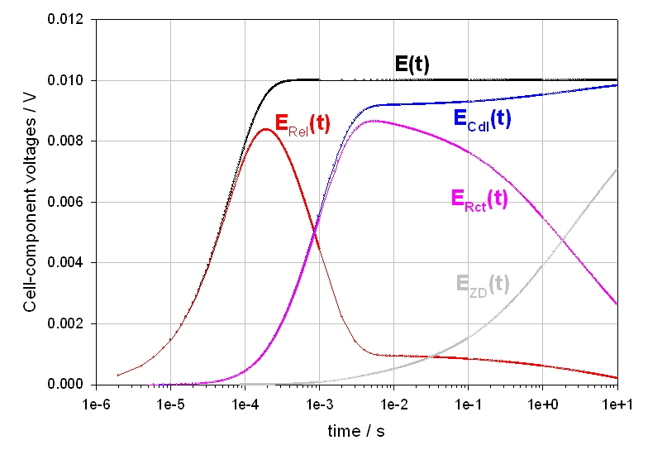
Fig. 7. Transient voltages responses of the electrical circuit of figure 1 when E(t) = a [1 –exp (-t/τ)]; a= 10 mV; τ = 1/b = 6.424×10⁻⁵ s

Table 1. Fit parameter values corresponding to the plot of Fig. 4.
R_{el}  Ω.cm² | τ_{c}  s | C_{dl}  μF.cm^{–2} | R_{ct}  Ω.cm² | R_{D}  Ω.cm² | D_{H}  cm².s^{–1} | $$−\left(∂ E/∂ C_{H}\right)$$  V.mol^{–1} .cm³ | R_{in}  Ω.cm² | C_{in}  F.cm^{–2} | τ_{in}  s | p
24 | 1×10⁻² | 45 | 224 | 1194 | 2.8×10⁻⁷ | 6484 | 398 | 0.074 | 29.5 | 0.52

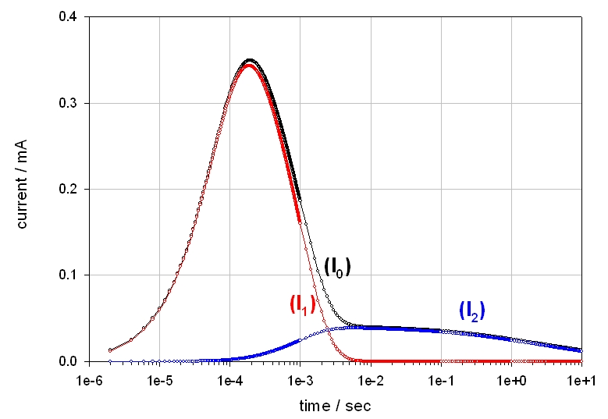
Fig. 8. Transient current responses of the interface (Fig. 3) when E(t) = a [1 – exp (-t/τ)] ; a = 10 mV ; τ = 1/b = 6.424×10^{–5} s.
At the onset of the voltage step (t < 0.2 ms) the main voltage drop is located across the electrolyte resistance. Then (0.1 –> 2 ms) the double layer capacitance charges and the charge transfer process begins, leading to the formation of hydrogen surface ad-atoms. Then hydrogen diffusion takes place for t > 10 ms until the end of the experiment.
Transient current values
Numerical current responses of the different components of the electrical circuit of figure 4 to an exponentially-rising voltage step E(t) are plotted in Fig. 8. Again, the time axis is in logarithmic scale to facilitate the differentiation of the different signals. The stationary currents are :
$I_{0} \left(t → ∞\right)=I_{1} \left(t → ∞\right)=I_{2} \left(t → ∞\right)=0$.
Comparison of experimental and model values
Results were obtained using a PGZ402 potentiostat from Radiometer. Exponentially-rising voltage steps with a mean time constant τ = 6.424×10^{–5} s have been used as voltage excitation:
E(t) = a. [1 – exp (-t/τ)] (19)
Experimental step-functions generated by the potentiostat are reproducible within ± 0.05 % from one experiment to the other. The experimental voltage step has been fitted using Eq. (19). Results are plotted in Fig. 9.
Then, the experimental current response I₀(t) has been fitted using a model equation. The model equation was obtained as follows. First, I(ω) 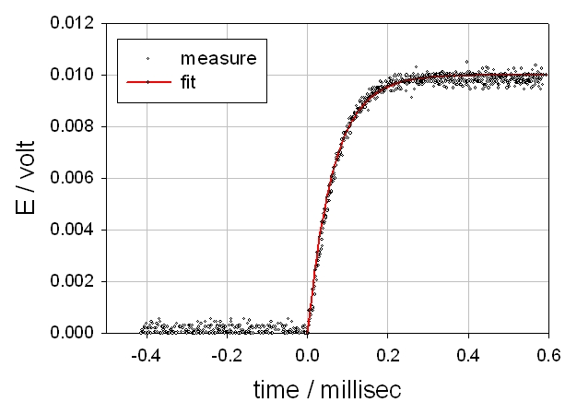 Fig. 9. Experimental (o) and model (―) potential steps..
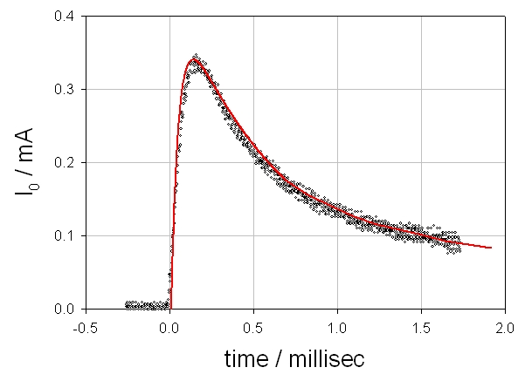
Fig. 10. Experimental (o) and model (–) current responses I₀(t).
was potential steps.calculated from I(ω) = Z(ω) / E(ω). Z(ω) was taken from Eq. (7) using the parameters of Table 1 and E(ω) was obtained by taking the FT of the exponentially-rising voltage step E(t). Second, I(t) was calculated from I(ω) by discrete inverse Fourier transformation. Results obtained for the first 2 milliseconds are plotted in Fig. 10. There is a good agreement between experimental and calculated transients, indicating that time-domain analysis of the current response of the electrochemical interface to an exponentially-rising voltage step can also be used to determine the impedance of an unknown circuit. Of course, the calculation is simple in the case presented here because Z(ω) was known accurately from sine wave experiments. Nevertheless, a similar methodology can be used when Z(ω) is unknown. In such cases, a model impedance is first postulated and then parameters are optimized iteratively by minimizing the difference between experimental and model I₀(t).
Conclusions
The work reported here describes a methodology used to determine the impedance of palladium electrodes from exponentially-rising voltage step experiments. When a voltage step experiment is carried out, two transient signals are measured: the voltage step E(t) and the current response I(t). To determine the unknown impedance of the electrochemical circuit there are two options: (i) frequency-domain analysis: the Fourier transform of both E(t) and I(t) is taken and the ratio of the two FT is calculated, yielding the impedance of the circuit; (ii) time-domain analysis: a model impedance is postulated, the associated current transient I(t) obtained in response to the exponentially-rising voltage step is calculated and used to fit transient experimental current I(t); parameters of the model impedance circuit are iteratively adjusted to minimize the difference between calculated and experimental I(t) in order to determine the exact characteristic of circuit components. From a practical viewpoint, there are two main critical problems. First, an appropriate sampling rate must be used. Second, data filtering is required. When these problems are appropriately handled, then correct impedance diagrams are obtained. Therefore, it can be concluded that exponentially-rising voltage steps can be used to measure electrochemical impedance diagrams.
Acknowledgements: Financial support from the French Agence Nationale de la Recherche, within the frame of the Plan d’Action National sur l’Hydrogène (EolHy project ANR-06-PANH—008-06 and AP’H project ANR-05-PANH—011-04), is acknowledged.
References:
- L. Schlapbach, A. Züttel, Nature 414, 353-358, (2001).
- P. Millet, R. Ngameni, Electrochimica Acta 2011, doi: 10.1016/j.electacta.2010.12.106.
- G. Tsirlina, S. Baronov, F. Spiridonov, M. Rusanova, T. Safonova, O. Petrii, Russ. J. Electrochem. 36, 1179, (2000).
- J. Chen, R. Durand, C. Montella, J. Chem. Phys. 91, 383, (1994).
- P. Millet, Electrochem. Commun. 7, 40, (2005).
- A. Frumkin, in: P. Delahay (Ed.), Advances in Electrochemistry and Electro-chemical Engineering, Vol. 3, Interscience, NewYork, 1963.
- J. Bockris, J. McBreen, L. Nanis, J. Electrochem. Soc. 112, 1025, (1965).
- L. Jacobsen, K. West, Electrochimica Acta 40, 255, (1995).
- C. Lim, S. Pyum, Electrochimica Acta 38, 2645, (1993).
- E. Barsoukov, J. R. Mac Donald, Impedance Spectroscopy, Theory, Experiment, and Applications, Wiley, 2005.
- R. Bucur, E. Indren, Acta Met. 35, 1325, (1987).
- W. Press, in Numerical Recipes, the Art of Scientific Computing, Cambridge University Press: Cambridge, 1986.
- H. Wiese, K. Weil, IEEE Transactions on Acoustics, Speech, and Signal Processing, 36(7) July 1988.
- E. Barsoukov, S. Ryu, H. Lee, J. Electroanal. Chem. 536, 109,(2002).

Електрохимична импедансна спектроскопия с експоненциално нарастващи стъпки на напрежението.
(II) Анализ на интеркалацията на водород в палaдиеви фолиа.
П. Мийе
Институт по молекулярна химия и материали в Орсе, UMR CNRS n° 8182, Университет Париж Юг, ул. Жорж Клемансо 11, 15, 91405 Орсе седекс, Франция
Постъпила на 20 февруари, 2012 г.; приета на 20 февруари, 2012 г.
(Резюме)
Електрохимичната импедансна спектроскопия (IES) обикновено се използва от електрохимиците за анализиране на многостепенни реакции, протичащи на фазовата граница електрод/електролит. Понеже кинетиката на отделните стъпки на реакцията обикновено е функция на електродния потенциал, импедансът на фазовата граница се измерва при различни, но постоянни стойности на потенциала. В повечето случаи импедансните диаграми се получават чрез хармоничен анализ: за възбуждане се използва наложена променливотокова модулация на потенциала с ниска амплитуда (типично 5-10 мВ) или галваностатична променливотокова модулация с ниска амплитуда (типично няколко мА). Според теорията на линейните и непроменливи във времето системи обаче, хармоничният анализ следва да бъде ограничен до анализа на линейни и обратими процеси. Проблемът с линейността може да бъде преодолян до известна степен чрез намаляване амплитудата на модулацията. Но това не помага да се разреши проблема с необратимостта. Например, при електро-интеркалацията на водород в електроди от паладий или паладиеви сплави, се наблюдава значителен хистерезис. Това е ясно указание, че протичат нелинейни процеси и следователно хармоничният анализ не може да се използва, защото системата не изпълнява изискванията за линейност и неизменност във времето, наложени от системната теория. Значи трябва да се използва непроменливо възбуждане. Целта на настоящата работа е да се докладва за измерването на импедансни спектри при възбуждане с експоненциално нарастващи стъпки по напрежение. Това съобщение е ориентирано към методологията. В първата част на работата, електрическа схема съдържаща само електрическо съпротивление и капацитет се използва като моделна система, за да се обясни как от такова нехармонично възбуждане може да се получи импедансна диаграма. Във втората част на работата, методологията се разширява до електро-интеркалацията на водород в паладиево фолио.

