Impedance investigation of BaCe_{0.85}Y_{0.15}O_{3-δ} properties for hydrogen conductor in fuel cells
G. Raikova¹*, M. Krapchanska1, I. Genov¹, G. Caboche², L. Combemale², A. Thorel³, A. Chesnaud³, D. Vladikova¹, Z. Stoynov¹
¹Institute of Electrochemistry and Energy Systems “Acad. E. Budevski” – Bulgarian Academy of Sciences, 10 Acad. G. Bonchev St., Sofia 1113, Bulgaria
²Institute Carnot de Bourgogne, Université de Bourgogne, BP47870, 21078 Dijon Cedex, France
³Centre des Matériaux, Mines-ParisTech, BP 87, 91003 Evry Cedex, France
Received August 10, 2012; accepted October 2, 2012

The influence of the sintering conditions on the electrochemical properties of the proton conducting electrolyte BaCe_{0.85}Y_{0.15}O_{3-δ} (BCY15) and Ni - based BCY15 cermet anode for application in high temperature proton conducting fuel cell are investigated by electrochemical impedance spectroscopy. The results show that at lower sintering temperatures due to the formation of parasitic Y₂O₃ phase an increase of both the electrolyte and electrode resistances is observed. This effect is strongly reduced by enhancement of the sintering temperature. The obtained BCY15 conductivity (σ = 2.5x10⁻² S/cm at 700ºC) is comparable with that of the best proton conducting materials, while the BCY15-Ni cermet (with ASR = 2.5 Ωcm² at 700ºC) needs further optimization. The results of impedance investigations of BCY15 as proton conducting electrolyte and cermet anode have been applied in development of innovative high temperature dual membrane fuel cell.
Keywords: BCY15, Proton-conducting electrolyte, Anode, Electrochemical impedance spectroscopy

INTRODUCTION
The registration of high temperature proton conductivity in doped Sr and Ba cerates in the late eighties of the last century [1, 2] opened a new niche for optimization of SOFC towards reduction of the operating temperature (500-800ºC) due to the higher mobility of protons. High temperature proton conducting fuel cell (PCFC) design eliminates the principal disadvantage of SOFC to form water at the anode side, where it mixes with the fuel, resulting in electromotive force losses. However, PCFC needs the development of an appropriate cathode material and interconnect resistive to the highly corrosive oxygenized water, as well as a counter-flow to sweep water out of the catalytic sites. Acceptor doped perovskites with general formula AB_{1-x}M_{x}O_{3-α} (A = Ba, Sr; B = Ce, Zr; M = rare earth metal; x - less than the upper limit of solid solution formation) are promising proton conducting systems. Proton conduction increases in the order BaCeO₃ > SrCeO₃ > SrZrO₃, while the chemical stability deteriorates in the opposite order [3, 4].
Under humidified hydrogen atmosphere protonic defects are formed by dissociative absorption of water in the presence of oxygen vacancies. Water vapor dissociates into a hydroxide ion which fills an oxide-ion vacancy, and a proton that forms a covalent bond with lattice oxygen, i.e. two proton defects are created stoiciometrically [5], marked according to Kröger-Vink notation as follows:
(1)
Since the incorporation of water is exothermic [3, 6], the protonic transport is dominating at lower temperatures (under 600ºC).
The doping with aliovalent rare earth cations brings to the formation of oxygen vacancies and significantly improves the proton conductivity [3-5, 7]. In the BaCeO₃ system, which is considered to be very promising because of the registered high protonic conductivity (0.01 – 0.05 S/cm between 600-800ºC [6, 8]), the reaction can be described as:
(2)
Proton conductivity in cerates depends on the crystallographic structure, which is a function of temperature and doping concentration. It decreases when transformations to higher symmetry (from orthorhombic to cubic) which bring to equivalent distribution of all oxygen positions and to evenly distributed oxygen ion vacancies take place [3, 7, 9]. In addition to the temperature, gas atmosphere and pressure, including water vapor, is detrimental for proton conductivity.
The disadvantages of SOFC and PCFC connected with the production of water at the electrodes can be avoided in the innovative design of high temperature dual membrane fuel cell, named “IDEAL Cell” after the acronym of a running FP7 project [10]. The “IDEAL Cell” concept [11] is based on a junction between a SOFC cathode/electrolyte part and a PCFC electrolyte/anode part through a mixed oxide ion and proton conducting porous ceramic membrane. Oxygen ions created at the cathode side progress toward the central membrane where they meet the protons created at the anode side, and produce water [12] which is evacuated through the interconnecting porous media. In this way oxygen, hydrogen and water are located in 3 independent chambers (Fig. 1).
Fig.1. Representation of the PCFC anode/electrolyte couple, the SOFC electrolyte/cathode couple and the IDEAL-Cell concept
This paper presents results for the BaCe_{0.85}Y_{0.15}O_{3-δ} (BCY15) and Ni-BCY15 cermet conductivities in wet hydrogen. The influence of the different sintering conditions on their electrochemical properties is analyzed by electrochemical impedance spectroscopy for performance optimization in the new dual membrane cell configuration.
Experimental
The BCY15 powders, supplied by Marion Technologies (MT), were fabricated by auto-combustion process starting from metal nitrates and applying urea as reducing agent. Calcinations of the precursor at 1100-1150ºC in a carrier gas (helium or argon) for complete CO₂ elimination ensured the production of single phase powder with chemical composition Ba_{1.04}Ce_{0.82}Y_{0.15}O_{3-α}, determined by ion coupled plasma analysis with dominating particle size round 200 nm and minor degree of agglomeration.
The BCY15 electrolyte support pellets (diameter/thickness = 20-25/1-1,3 mm) were prepared by cold pressing and sintered in the temperature range from 1100°C to 1450°C for 5 hours at heating rate 300°C h⁻¹.
BCY15/NiO (NOVAMET, HP green NiO-Type A) slurry with composition 28.6 vol.% BCY15 and 71.4 vol.% NiO was deposited by tape-casting and sintered in the temperature range 1100-1350 °C.
For impedance characterization of the BCY15 electrolyte supported Pt/BCY15/Pt symmetrical half cells were prepared. Platinum (Metalor) electrodes were painted and sintered in air following a procedure recommended by the producer.
In order to characterise the changes in the microstructure of the materials, a series of analytical techniques was used: X-Ray Diffraction (XRD) with Energy-dispersive X-ray spectroscopy (EDX), Scanning Electron Microscopy (JEOL JSM 6400F), and Transmission Electron Microscopy (JEOL JEM-2100 TEM) in combination with Ultrathin windowed energy-dispersive X-ray spectrometer (EDS) and Scanning Transmission Electron Microscopy - High Angle Annular Dark Field (STEM - HAADF) on a TECNAL 20F ST microscopy.
The impedance measurements were performed with Solartron 1260 Frequency Response Analyser in a temperature interval of 200 – 700ºC at frequency range from 10 MHz down to 0.1 Hz and density of 5 points/decade. They were done in two modes: potentiostatic and galvanostatic. The half cell measurements were carried out at OCV in working atmosphere wet (3% H₂O) hydrogen.
The impedance data were analyzed by the technique of the Differential Impedance Analysis (DIA) [13, 14]. DIA works with no preliminary working hypotheses, because the information about the model structure is extracted directly from the experimental data. It also identifies frequency dependent behavior, which can be additionally analyzed by the secondary analysis. More information about the secondary DIA can be found in [14, 15]. Before the analysis a calibration procedure for post-experimental elimination of the parasitic components in the impedance diagrams coming from the cell rig was performed [15, 16].

Results and discussion
The results from the impedance measurements of dense BCY15 electrolyte (Fig. 2) are generalized in the Arrhenius plots (Fig. 2c). They show that different sintering conditions influence the BCY15 conductivity. The electrolyte sintered at 1300oC has higher resistivity and thus lower conductivity than the electrolyte sintered at 1450oC (Fig. 2).
Fig. 2. Complex plane impedance diagrams (a),(b) at 600ºC and corresponding Arrhenius plots (c) of Pt/BCY15/Pt sintered at: (•) 1300ºC and (■) 1450ºC
The change in the conductivity for these samples was explained with observed change in their microstructure. The performed XRD analyses show a presence of parasitic phase (Fig. 3), registered as Y₂O₃ which quantity decreases with the increase of the sintering temperature and thus improves the electrolyte conductivity.
Fig. 3. X-ray diffraction patterns of BCY15 sintered at different temperatures.
Table 1. EDX analysis of dense BCY15 electrolyte
 | Ce/Ba | Y/Ba
Theoretical ratio | 0.85 | 0.15
BCY15 electrolyte | 0.81 | 0.15

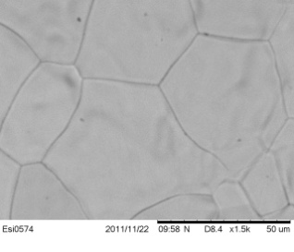
Fig. 4. SEM micrograph of dense BCY15 electrolyte
Fig. 5. Comparison of the BCY15 proton conductivity with data from the literature [5]: BaCe_{0.9}Nd_{0.1}O_{3-α} (BCNd); ScCe_{0.95}Yb_{0.05}O_{3-α} (SCYb); SrZr_{0.95}O_{3-α} (SZY); CaZr_{0.9}In_{0.1}O_{3-α} (CaZIn)

Fig. 6. Complex plane impedance diagrams (a), (b) at 500ºC and corresponding Arrhenius plots (c) of the anode polarization obtained from measurements of symmetrical half cell BCY15-Ni/BCY15/BCY15-Ni. The electrolyte support is sintered at 1450ºC/4 h; (●) – cermet sintered at 1100ºC/2h; (■) – cermet sintered at 1350ºC/2h; (▲) comparative measurement of Pt/BCY15/Pt

Fig. 7. X-ray diffraction patterns of BCY-NiO cermet layers sintered at 1100ºC/5h (before reduction) and 1450ºC/5h (after reduction)
The optimized in this way microstructure (grain size 35-50 μm, Fig. 4) and its chemical analysis (Table 1) makes BCY15 dense electrolyte conductivity comparable with that of the best proton conducting materials (Fig. 5).
Table 1. EDX analysis of dense BCY15 electrolyte
 | Ce/Ba | Y/Ba
Theoretical ratio | 0.85 | 0.15
BCY15 electrolyte | 0.81 | 0.15
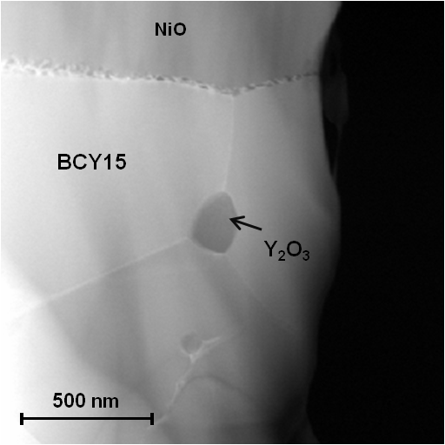
Fig. 8. SEM image of BCY15/NiO cermet before reduction
In order to fulfil its role, the anode composition (BCY15/NiO) should lead to the best compromise between a good mechanical compatibility with the BCY15 electrolyte(already optimized) and a good ionic and electronic conductivity, keeping a highly open porous microstructure (for gas convection) and avoiding eventual reactivity within the composite. The first impedance measurements on electrolyte supported BCY15-Ni/BCY15/BCY15-Ni half cell showed a big increase of the anode polarization and also of the electrolyte resistivity with respect to the results obtained from metal electrodes (Fig. 6). Absence of good lateral electrode conductivity was also registered.

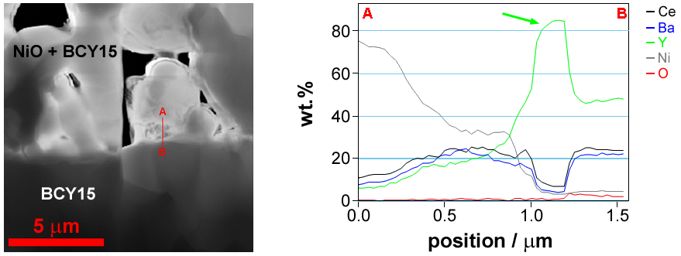
Fig. 9. STEM-HAADF image of the anode-electrolyte interface (left side image); linear composition profile (in wt%) across the interface in direction A→B (right side image)
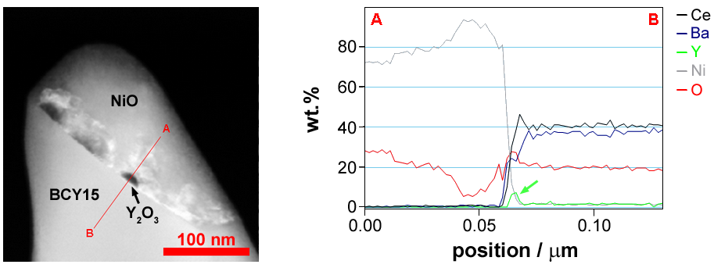

Fig. 10. STEM-HAADF image of the BCY15/NiO interface with Y₂O₃ inclusions (a); linear composition profile (in wt %) across the interface in direction A→B (b)

The microstructural analysis on those anodes (sintered at relatively low temperature - 1100°C for high porosity) indicates that cermet material is not a single-phased system. The appearance of additional peaks reveals the presence of Y₂O₃ and BaCeO₃ (Fig. 7).a single-phased system. The appearance of additional peaks reveals the presence of Y2O3 and BaCeO3 (Fig. 7).
Thorough SEM/STEM analytical experiments of the anode BCY15/NiO demonstrated an extensive precipitation of Y₂O₃ particles along the NiO/BCY15 and the anode/BCY15 electrolyte interface. It strongly decreases towards the depth of the electrolyte (Figs. 8, 9, 10).
Thus an efficient electrical barrier between the protonic (BCY) and the electronic (Ni) phases is produced. This phenomenon may be initiated by slight diffusion of Ba toward NiO. As it was expected, the increase of the sintering temperature decreases the quantity of parasitic phases and improves the cermet conductivity (Fig. 6).
After sintering at 1350°C for 2 hours and a reduction treatment at 700°C for 5 hours (in 5 vol.% H₂/95 vol. % Ar atmosphere) an improvement of both the ASR and the resistivity of the electrolyte was observed (Fig. 6). The obtained results for BCY15 electrolyte are already in the range of the values from the measurements of the standard Pt/BCY15/Pt cell (Fig.6d). The performed X-ray diffraction (XRD) shows that NiO is fully reduced to metallic Ni, and the system is stabilized towards segregation of Y2O3 and BaCeO3. In addition small quantity of a new cerium yttrium oxide phase is registered (Fig. 7). Its influence on the electrochemical behavior of the anode is not so strong; however the cermet needs additional optimization.
Conclusions
The results obtained from the impedance measurements of BCY15 for anode compartment (anode/electrolyte) in a PCFC and in a dual membrane fuel cell show that the sintering conditions are an important optimization parameter for both the electrolyte BCY15 and electrode BCY15-Ni cermet. Although the fabricated anode-electrolyte assembly has acceptable performance (σ_{(BCY15)} = 2.5 x 10⁻² S/cm and ASR_{(BCY15-Ni)} = 2.5 Ωcm² at 700ºC) further improvement of the cermet’s electrochemical behavior is required. It is expected that appropriate combination of the volume ratio BCY15/NiO and sintering temperature will ensure anodes with good mixed conductivity, sufficient porosity and lack of parasitic phases.
Acknowledgements: The research leading to these results has received funding from the European Community’s Seventh Framework Programme (FP7/2007-2013) under grant agreement No 213389. G. Raikova acknowledges also “Science and Business” BG051PO001/3.3-05-001 for the financial support that made possible the publication of this paper.

References
- H. Iwahara, H. Uchida and K. Ogaki, J. Electrochem. Soc. 135, 529, (1988).
- H. Iwahara, Solid State Ionics 168, 299, (2004).
- L. Malavasi, C.A.J. Fisher and M.S. Islam, Chem. Soc. Rev. 39, 4370, (2010).
- T. Ishihara, N.M. Sammes and O. Yamamoto in High Temperature Solid Oxide Fuel Cells: Fundamentals, Design and Applications, edited by S.C. Singhal and K. Kendall, (Elsevier, 2003) pp. 83-117.
- H. Iwahara, Solid State Ionics 86-88, 9, (1996).
- A. Bassano, V. Buscaglia, M. Viviani, M. Bassoli, M-T . Buscaglia, M. Sennour, A. Thorel and P. Nanni, Solid State Ionics 180, 168, (2009).
- N. Bonanos, K.S. Knight and B. Ellis, Solid State Ionics 79, 161, (1955).
- K.D. Kreuer, Annu. Rev. Mater. Res. 33, 333, (2003).
- K.S Knight, Solid State Ionics 127, 43, (2000).
- A.S. Thorel, A. Chesnaud, M. Viviani, A. Barbucci, S. Presto, P. Piccardo, Z. Ilhan, D. E. Vladikova and Z. Stoynov, in Solid Oxide Fuel Cells 11 (SOFCXI), edited by S.C. Singhal, and H. Yokokawa, (The Electrochemical Society Proceedings Series 25, ECS Transactions, 2009), pp.753–762.
- Patent N° 0550696000, March 17th, 2005, Cellule de pile a combustible haute temperature a conduction mixte anionique et protonique ; International extension in 2006 Issue 2, Pennington, NJ 753 (2009).
- D. Vladikova, Z. Stoynov, G. Raikova, A. Thorel, A. Chesnaud, J. Abreu, M. Viviani, A. Barbucci, S. Presto and P. Carpanese, Electrochim. Acta 56, 7955, (2011).
- Z. Stoynov, D. Vladikova, Differential Impedense Analysis, Marin Drinov Academic Publishing House, Sofia, 2005.
- Z. Stoynov and D. Vladikova, in Encyclopedia of Electrochemical Power Sources, edited by U. Garche (Elsevier, 2009) pp. 632-642.
- D. Vladikova, Z. Stoynov, J. Electroanal. Chem. 572, 377, (2004).
- D. Vladikova, Z. Stoynov, G. Raikova, in Z. Stoynov, D. Vladikova (Eds.), Portable and Emergency Energy Sources, Marin Drinov Academic Publishing House, Sofia, 2006, pp. 383-410.

ИМПЕДАНСНО ИЗСЛЕДВАНЕ НА СВОЙСТВАТА НА BaCe_{0.85}Y_{0.15}O_{3-δ} ЗА ВОДОРОДЕН ПРОВОДНИК В ГОРИВНИ КЛЕТКИ
Г. Райкова^{1*}, М. Кръпчанска¹, И. Генов¹, Ж. Кабоч², Л. Комбемел², А. Торел³, А. Чесно³, Д. Владикова¹, З. Стойнов¹
¹Институт по електрохимия и енергийни системи „Акад. Е. Будевски”, Българска академия на науките, ул. „Акад. Г. Бончев” бл. 10, 1113 София, България
² Институт Карно, Бургундски Университет, BP47870, 21078 Дижон, Франция
³ Център по материалознание, Мини-ПариТех, BP 87, 91 003 Еври, Франция
Постъпила на 10 август, 2012 г.; приета на 2 октомври, 2010 г.
(Резюме)
Чрез електрохимична импедансна спектроскопия е изследвано влиянието на условията на синтеруване върху електрохимичните свойствата на протон- проводящия електролит BaCe_{0.85}Y_{0.15}O_{2–δ} (BCY15), както и на Ni - базиран BCY15 кермет с приложение като анод във високо-температурна протон проводяща горивна клетка. Резултатите показват, че при по-ниски температури на синтеруване, образуването на паразитна Y₂O₃ фаза води до увеличеване както на съпротивлението на електролита, така и на това на електрода. Този ефект намалява с повишаване температурата на синтеруване. Получената стойност за проводимостта на BCY15 (σ = 2.5×10^{–2} S/см при 700ºC) е сравнима с тази на най-добрите протон-проведящи материали, докато кермета BCY15-Ni (с ASR = 2.5 Ωcm² 700ºC) се нуждае от допълнителна оптимизация. Проведеното импедансно изследване на протон-проводящия BCY15 като електролит и като кермет за анод е използвано в реализацията на иновативен дизайн на високо температурна двойно-мембранна горивна клетка.

