Bulgarian Chemical Communications, Volume 45, Number 3 (280 – 287) 2013
Hydrogen sorption properties of a MgH₂ - V₂O₅ composite prepared by ball milling
E. Grigorova ^{1 *}, M. Khristov ¹, P. Peshev ¹, D. Nihtianova ^{1, 2}, N. Velichkova ¹, G. Atanasova ¹
¹ Institute of General and Inorganic Chemistry, Bulgarian Academy of Sciences, bl.11, Acad. G. Bonchev str., 1113 Sofia, Bulgaria
² Institute of Mineralogy and Crystallography, Bulgarian Academy of Sciences, Acad. G. Bonchev Str., bl. 107, 1113 Sofia, Bulgaria
Received April 9, 2012; Revised November 7, 2012
A 90 wt.% MgH₂ – 10 wt.% V₂O₅ composite was obtained by ball milling of a mixture of magnesium hydride and vanadia for 60 min under argon. Hydrogen sorption properties of the composite were determined volumetrically with a Sieverts-type device. Absorption was studied at temperatures of 473 and 573 K and pressure of 1 MPa, while desorption was investigated at T = 573 and 623 K and P = 0.15 MPa. Structure, phase and surface composition of the starting compounds and the composite before and after hydriding were determined by XRD, thermal analysis, TEM and XPS. After hydriding the composite at 573 K, a high absorption capacity value of 6.3 wt.% H₂ was attained. However, fast hydrogen desorption was observed only at temperatures higher than those needed for practical use. Some ideas about further studies to be performed in view to improving the performance of vanadia-containing magnesium composites for hydrogen storage were discussed.
Keywords: hydrogen storage materials; composite materials; electron microscopy; photoelectron spectroscopy
* To whom all correspondence should be sent:
E-mail: egeorg@svr.igic.bas.bg
© 2013 Bulgarian Academy of Sciences, Union of Chemists in Bulgaria

INTRODUCTION
Owing to its high energy density, possibility of its production from various renewable sources, low weight and low environmental impact, hydrogen is considered as a promising energy carrier and a basis of the so-called hydrogen economy of the future. However, the key factor for the use of hydrogen as a clean fuel remains the development of safe and efficient materials for its storage. The requirements towards these materials are: suitable thermodynamic properties, favorable hydriding and dehydriding kinetics, high absorption capacity at relatively low temperature and pressure, good cycling properties and low price.
At present, there is no material capable to answer all these requirements. This also concerns the recently developed metal-organic frameworks [1], nanoporous polymers [2] and graphene nanostructures [3] which physisorbed not more than 1–2 wt.% of hydrogen, a capacity being far from the U.S. Department of Energy (DOE) target of 6-6.5 wt.% for hydrogen storage tanks. In a recent report on hydrogen clathrate hydrate [4] it is shown that hydrogen can be trapped under high pressure in the clathrate cavities reaching a mass ratio close to that defined by DOE, but such a material is only stable under high pressure or at very low temperature. It is also worth noting, that the DOE target is largely exceeded by some B-N compounds. Thus, the simplest one, ammonia borane (borazane), H₃NBH₃, which is a nontoxic nonflammable solid, has a record potential of 19.6 wt.% H₂ storage capacity, but unfortunately it irreversibly releases hydrogen [6].
Chronologically, bulk metal hydrides were, since the 1970-ies, the first substances subject to systematic studies as potential storage materials. At present it is worth pointing out that only low-weight metal hydrides and especially MgH₂ and materials on its basis present a real perspective of usage for automotive applications. This is due to the high absorption capacity (7.6 wt.% H₂ theoretical capacity) of magnesium, its availability and low cost. However, along with these advantages, Mg has a series of disadvantages, such as poor hydriding/ dehydriding kinetics and high temperature of reversible hydrogen absorption. Two principal approaches are applied to their overcoming. The first one consists in tailoring the properties through size restriction, most often by ball milling. In this way the crystallite size is reduced, fresh surface area is created and both thermodynamics and kinetics can be effectively controlled at a molecular level [7]. With the second approach, nanocrystalline composites of Mg (or MgH₂) with certain additives (catalysts) are prepared by high energy ball milling under inert (Ar) or reactive (H₂) atmosphere with a view to preserving the high absorption capacity of magnesium, simultaneously reaching suitable sorption characteristics under milder hydriding/dehydriding conditions [8–11]. A great variety of substances (mainly transition metals and their oxides, intermetallics, carbon materials, SiC etc.) exhaustively summarized in the above reviews [8, 10, 11] have been used as additives in the Mg-composites. As is pointed out in a recent paper of Borgschulte et al. [12], the exact phase of the additive, its promoting role and mechanism are still remaining unclear, which leads to a controversial debate on the origin of the effects observed. Probably, many interpretation inconsistencies are due to the complex character of the kinetic phenomena.
Recently, brittle MgH₂ was used quite often instead of the ductile magnesium powder as a starting substance for the preparation of Mg-based composite materials. This reduces the occurrence of cold welding during milling, thus increasing the efficiency and productivity of the process.
For many years in the past, the research activity of our laboratory in the field of hydrogen storage was devoted to studies on mechanically alloyed composites of magnesium with 3d-metal oxides. Thus, in papers published in 1987–1989 [13, 14] it was shown that mixtures of Mg with 10% TiO₂ or V₂O₅ obtained by ball milling had improved hydrogen absorption-desorption properties compared to those of pure magnesium. In a XPS study [15] the presence of elemental Ti and Ti³⁺ favoring dissociative chemisorption of hydrogen was established on the surface of the TiO₂-containing composite. The catalytic effect of TiO₂, V₂O_{5,} as well as of other transition metal oxides in which the metal can appear at different oxidation degrees, on improving the hydriding/dehydriding kinetics of Mg-based composites was confirmed by Oelerich et al. [16]. In a recent paper Croston et al. [17] demonstrated the decisive role played by the TiO₂ preparation procedure on the hydriding-dehydriding kinetics of the MgH₂-TiO₂ composite. It was shown that the anatase form was more effective at lowering the dehydrogenation onset temperature of MgH₂ than the rutile modification. According to these authors, such a behavior corresponds to two different mechanisms of dehydrogenation, changing from one of surface control followed by volume contraction to a two-dimensional Johnson-Mehl-Avrami nucleation and growth mechanism. Du et al. using the results of ab initio DFT calculations attempted to explain the catalytic role of V₂O₅ for MgH₂ destabilization with an elongation and weakening of the Mg-H bond length when MgH₂ clusters are positioned on single, two and three coordinated oxygen sites on the V₂O₅ (001) surface [18].
During the last years Nb₂O₅ proved to be a very effective catalyst for improving the hydrogen sorption kinetics of magnesium [19–21]. It was shown that during heating and cycling of MgH₂ ball milled with Nb₂O₅ additive, reduction of the oxide to metallic niobium occurred, accompanied by the appearance of a ternary MgNb₂O_{3.67} phase [22]. According to a model proposed in ref. [23], these products are working as catalysts, reducing the activation barrier of the reactions controlling the hydrogen sorption kinetics. Another model of the same authors is based on the fact that the products of Nb₂O₅ reduction embedded in an MgH₂ matrix emerge on the surface during hydrogenation, thus bringing up a possibility to generate gateways for further hydrogen diffusion. The effect of microstructure and the catalytic role of Nb₂O₅ on the hydriding /dehydriding kinetics of MgH₂ were studied in [24–26]. The decrease of the activation energy of dehydriding caused by the Nb₂O₅ was observed after 15 min of ball milling only [24]. It was demonstrated that the reduction of grain and particle size enhances substantially the hydriding/ dehydriding kinetics. In addition to the results mentioned above, it is worth noting a recent study of Dolci et al. [27] who reported the existence, besides MgNb₂O_{3.67}, of a number of other ternary Mg-Nb-O phases.
In the light of the brief review given above and taking into consideration that vanadium belongs to the same group of d-transition metals as niobium, it seemed interesting to the authors of the present paper to reexamine in some details the hydrogen sorption properties of a MgH₂-V₂O₅ composite with a view to enlarge the understanding of the role of oxide promoters in MgH₂-based hydrogen storage materials.
EXPERIMENTAL
Powdery MgH₂ (99.8% purity, Alfa Aesar) and specpure V₂O₅ (Alfa Aesar) were used for preparing the composite 90 wt.% MgH₂ – 10 wt.% V₂O₅. It was obtained by mechanical alloying in a Fritsch Pulverisette 6 planetary ball mill under argon. The ball-to-sample weight ratio was 10:1, the rotation speed 200 rpm and the time of milling, 60 min. This duration was chosen in order to avoid sticking of the particles and formation of agglomerates, which was often observed as a result of prolonged grinding. Messer GmbH argon and hydrogen gases with purity of 99.998% and 99.999%, respectively, were used in the experiments.
The sorption characteristics of the composite were determined volumetrically using a Sieverts-type device described elsewhere [28]. Hydrogen absorption was investigated at temperatures of 473 and 573 K and pressure of 1 MPa, while desorption was studied at T = 573 and 623 K and P = 0.15 MPa.
The phase composition of the starting compounds, the initial, hydrided and dehydrided composites was controlled with the use of a Bruker D8 Advance X-ray diffractometer (CuK_{α} radiation).
Additional characterization of the samples was performed by thermal analysis, transmission electron microscopy (TEM) and X-ray photoelectron spectroscopy (XPS). All procedures during these characterizations as well as the X-ray measurements were carried out in air. As demonstrated in a very recent paper of Vincent and Huot [29], air contamination is not as detrimental as often expected.
A combined DTA/TG apparatus (LABSYSTEM EVO, SETARAM, France) with a gas analyzer (Omnistar TM – type) was used in thermal analysis studies of the samples before and after ball milling and after 10 hydriding-dehydriding cycles. The investigations were carried out in a flow of 20 ml Ar/min with a heating rate of 10K/min.
The TEM studies were performed on a JEOL 2100 instrument at an accelerating voltage of 200 kV. The specimens were prepared by grinding and dispersing them in ethanol followed by an ultrasonic treatment for 6 min. The suspensions were dripped on standard holey carbon/Cu grids.
The XPS surface characterization of the composite before and after hydriding at T = 573 K and P = 1 MPa was carried out with the use of a VG ESCALAB II spectrometer. The spectra were recorded by means of unmonochromatized AlK_{α} radiation (hν = 1486.6 eV) with a total instrument resolution of 1 eV. Binding energy (BE) values were referenced to the C1s line of carbon at 285 eV. The C1s, Mg1s, Mg2s, Mg2p, O1s+V2p and V2p_{1/2} photoelectron spectra were obtained.
RESULTS AND DISCUSSION
The X-ray diffraction pattern of the as-received commercial MgH₂ powder revealed only the presence of its polymorphic modification stable at ambient conditions and having a rutile-type tetragonal structure (S.G. P4₂/mnm, No 136) [30, 31]. Similarly, only peaks corresponding to the widely known orthorhombic α-V₂O₅ (S.G. Pmnm, No 59) [32, 33] were observed on the XRD pattern of the starting oxide. Both patterns are trivial and are not presented here.
The results of the thermal analysis of magnesium hydride used are given in Fig. 1. It is evident that the decomposition reaction accompanied by hydrogen evolution starts at around 703 K. The weight loss of 6.35% is much lower than the theoretical (7.6%) which indicates incomplete decomposition of MgH₂ under the experimental conditions chosen, as well as the presence of some unhydrided magnesium.
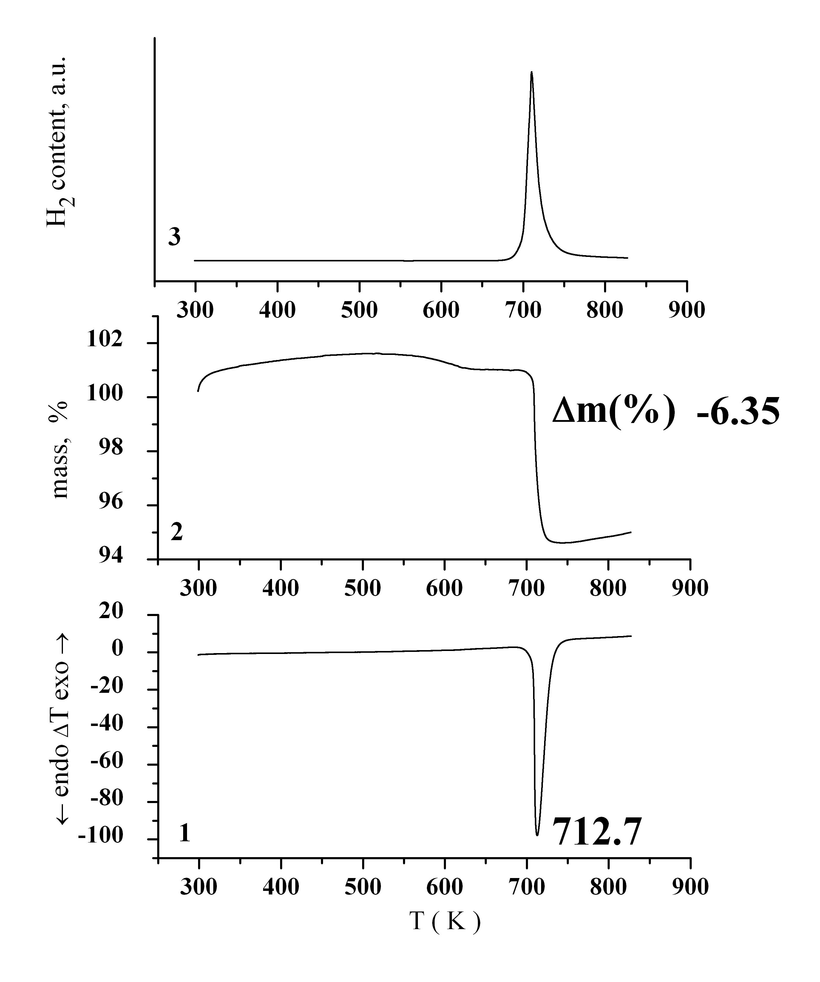
Fig. 1. DTA (1), TG (2) and evolved H₂ (3) curves of the as-received commercial MgH₂
The X-ray phase analysis of the composite obtained after ball milling of magnesium hydride with vanadia showed the presence of tetragonal MgH₂, orthorhombic α-V₂O₅ and some traces of Mg (Fig. 2). Appearance of polymorphic modifications of the components was not registered. The thermal analysis curves presented in Fig. 3 reveal that hydrogen evolution from the composite after ball milling took place at a lower temperature than from the hydrided sample with a simultaneous decrease of the H₂ percentage. Comparison showed that the decomposition of the composite after hydriding was probably more complex and proceeded in a broader temperature range.
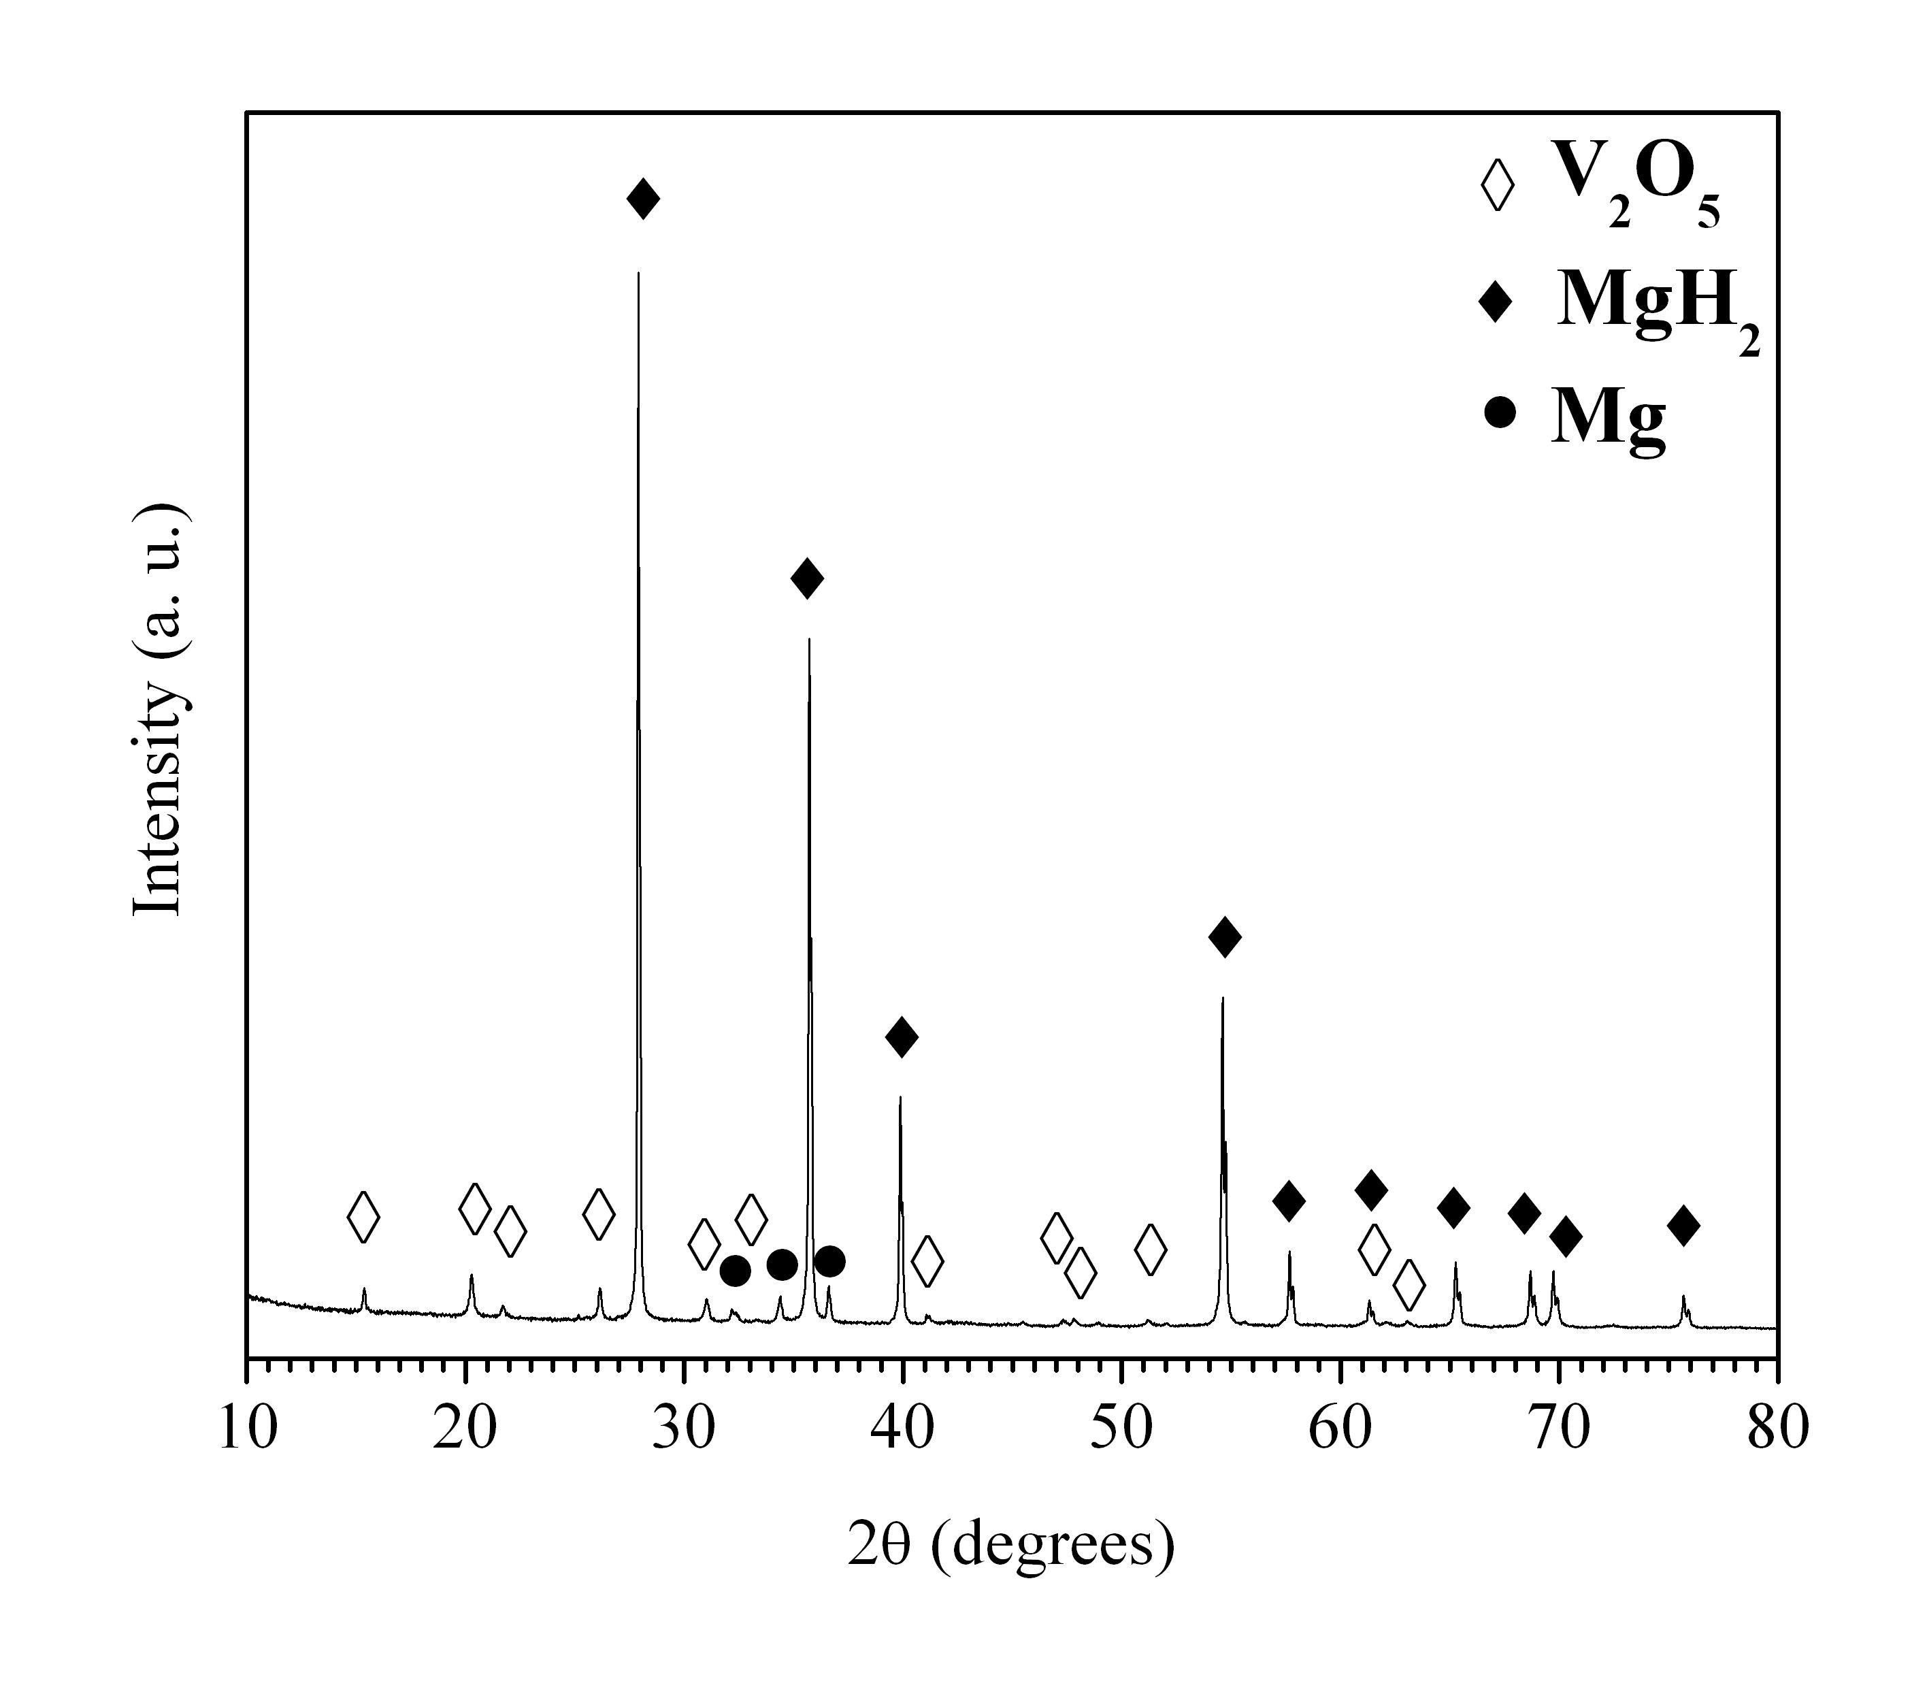
Fig. 2 X-ray diffraction pattern of the composite 90 wt. % MgH₂ - 10 wt. % V₂O₅ obtained by ball milling.
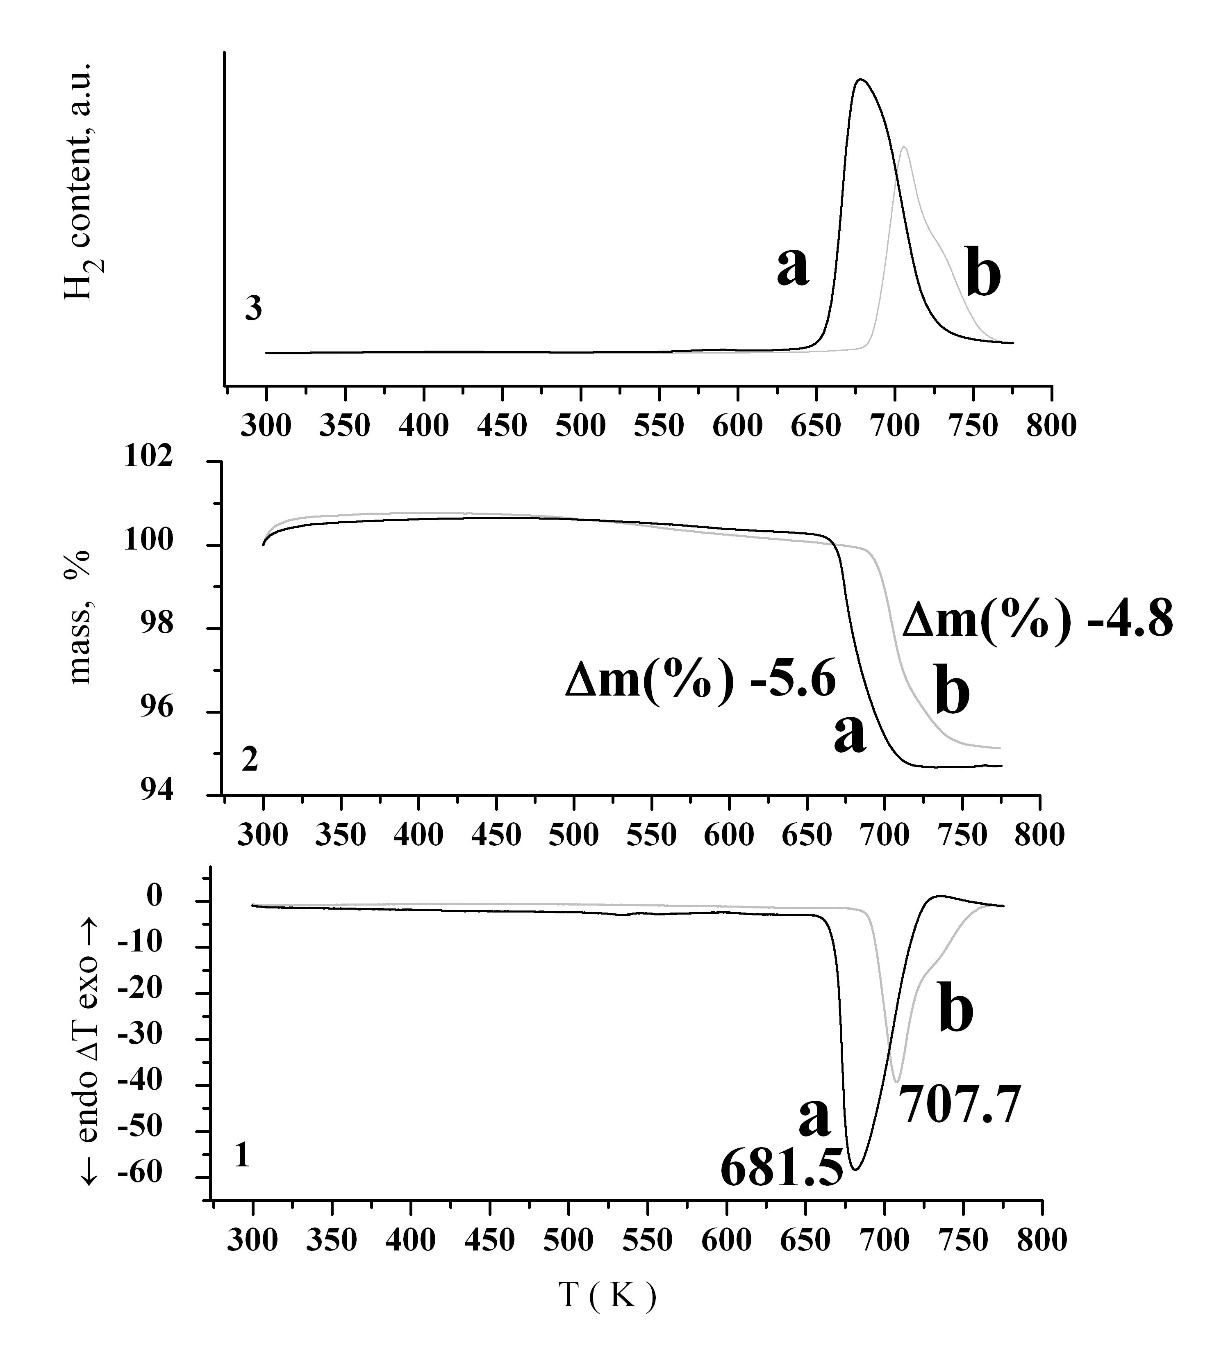
Fig. 3 DTA (1), TG (2) and evolved H₂ (3) curves of the composite 90 wt. % MgH₂ - 10 wt. % V₂O₅: (a) obtained by ball milling and (b) after hydriding at T = 573 K and P = 1 MPa.
A TEM image of the composite is presented in Fig. 4. It is evident that the sample consists of crystallites sized in a wide range, two principal groups of small and large particles, respectively, being observed. The polycrystalline electron diffraction pattern revealed, in contrast to the XRD data, a much richer phase composition of the ball milled composite. Thus, along with the tetragonal MgH₂, the presence of some orthorhombic γ-MgH₂ with α-PbO₂ type structure (S.G. Pbcn, No 60) [31, 34] was detected. This polymorph is, as a rule, a high pressure phase, but some authors observed its formation induced by lattice strains after prolonged milling of the tetragonal hydride [35, 36]. The present results show that even a relatively short milling time is sufficient for the tetragonal-orthorhombic MgH₂-transition to occur at a level which usually cannot be detected by X-ray measurements. Thus, a possible explanation of the observed lower temperature of hydrogen evolution from the ball milled sample (Fig. 3) compared to that from pure magnesium hydride consists in the presence of the less stable orthorhombic MgH₂ polymorph.
Electron diffraction permitted to establish that a small amount of the high-pressure β-V₂O₅ phase was also present in the MgH₂-V₂O₅ composite studied. Kusaba et al. [37] ascribed to β-V₂O₅ an orthorhombic structure, while according to Balog et al. [33] the phase with the same lattice parameters was monoclinic.
Finally, it is worth noting that, in accordance with the electron diffraction results, the ball milled composite contained a certain amount of metallic vanadium.

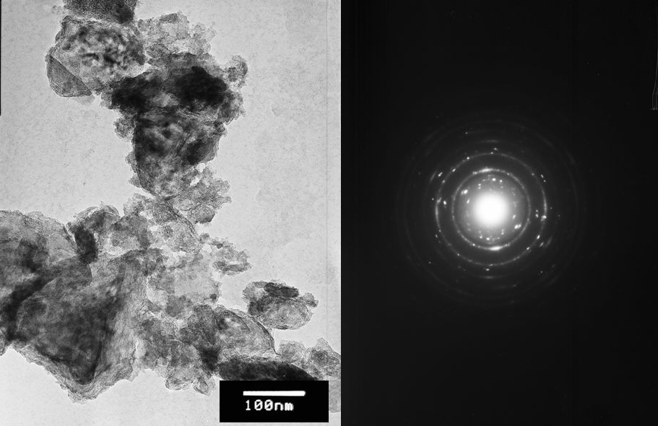

Fig. 4. TEM bright field micrograph and electron diffraction pattern of the composite 90 wt. % MgH₂ - 10 wt. % V₂O₅ obtained by ball milling

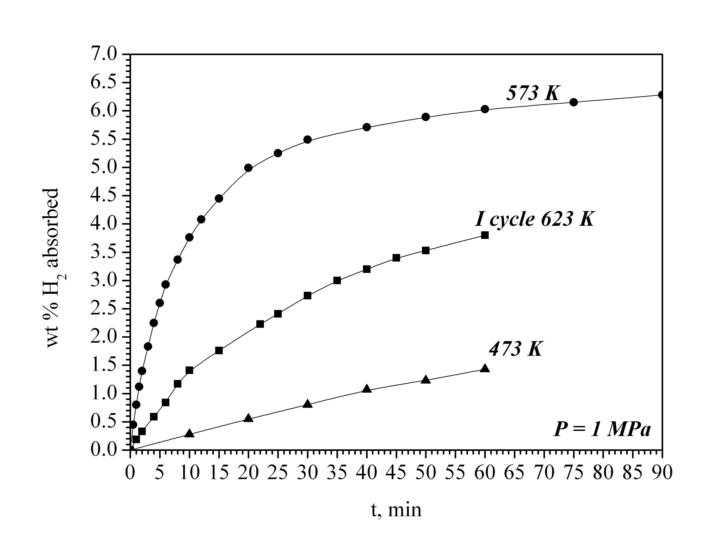
Fig. 5. Kinetic curves of hydrogen absorption by the composite 90 wt.% MgH₂ - 10 wt.% V₂O₅ at P = 1 MPa and different temperatures
The kinetic curves of hydrogen absorption by the ball milled composite at temperatures of 473 and 573 K and pressure of 1 MPa, along with the first cycle (cycle of activation) curve are given in Fig. 5. At 573 K, high absorption capacity of 6.3 wt.% H₂ was attained after 60 min hydriding. However, with a temperature decrease by 100 K the capacity drastically dropped down.
Desorption of hydrogen from the hydrided composite proceeded at T = 573 K and P = 0.15 MPa very slowly. After 1h of dehydriding only less than 0.5 wt.% H₂ was desorbed. When increasing the temperature to 623 K, desorption became much faster and was completed in 25 min attaining a capacity of about 5.4 wt.% H₂ (Fig. 6).
Hydriding of the 90 wt.% MgH₂–10 wt.% V₂O₅ composite was accompanied by a particle size decrease, as is evident from the comparison of the TEM pictures in Figs. 4 and 7. Simultaneously, an increased homogeneity of the crystallite size is observed in the hydrided sample due to recrystallization. The electron diffraction pattern showed that orthorhombic γ-MgH₂ was no more present, the sample being composed of tetragonal magnesium hydride, both polymorphs of vanadia and metallic vanadium. It is worth noting that, even after ten hydriding/dehydriding cycles, complete reduction of V₂O₅ to V was not attained.
The Mg2p and O1s X-ray photoelectron spectra of composite samples 90 wt.% MgH₂ – 10 wt.% V₂O₅ after ball milling and hydriding at T = 573 K and P = 1 MPa are shown in Fig. 8, the peaks positions being marked on the spectra. The slight shift of the Mg2p peak to a lower binding energy value suggests that magnesium is present on the sample surface mainly in oxidized form. Even after
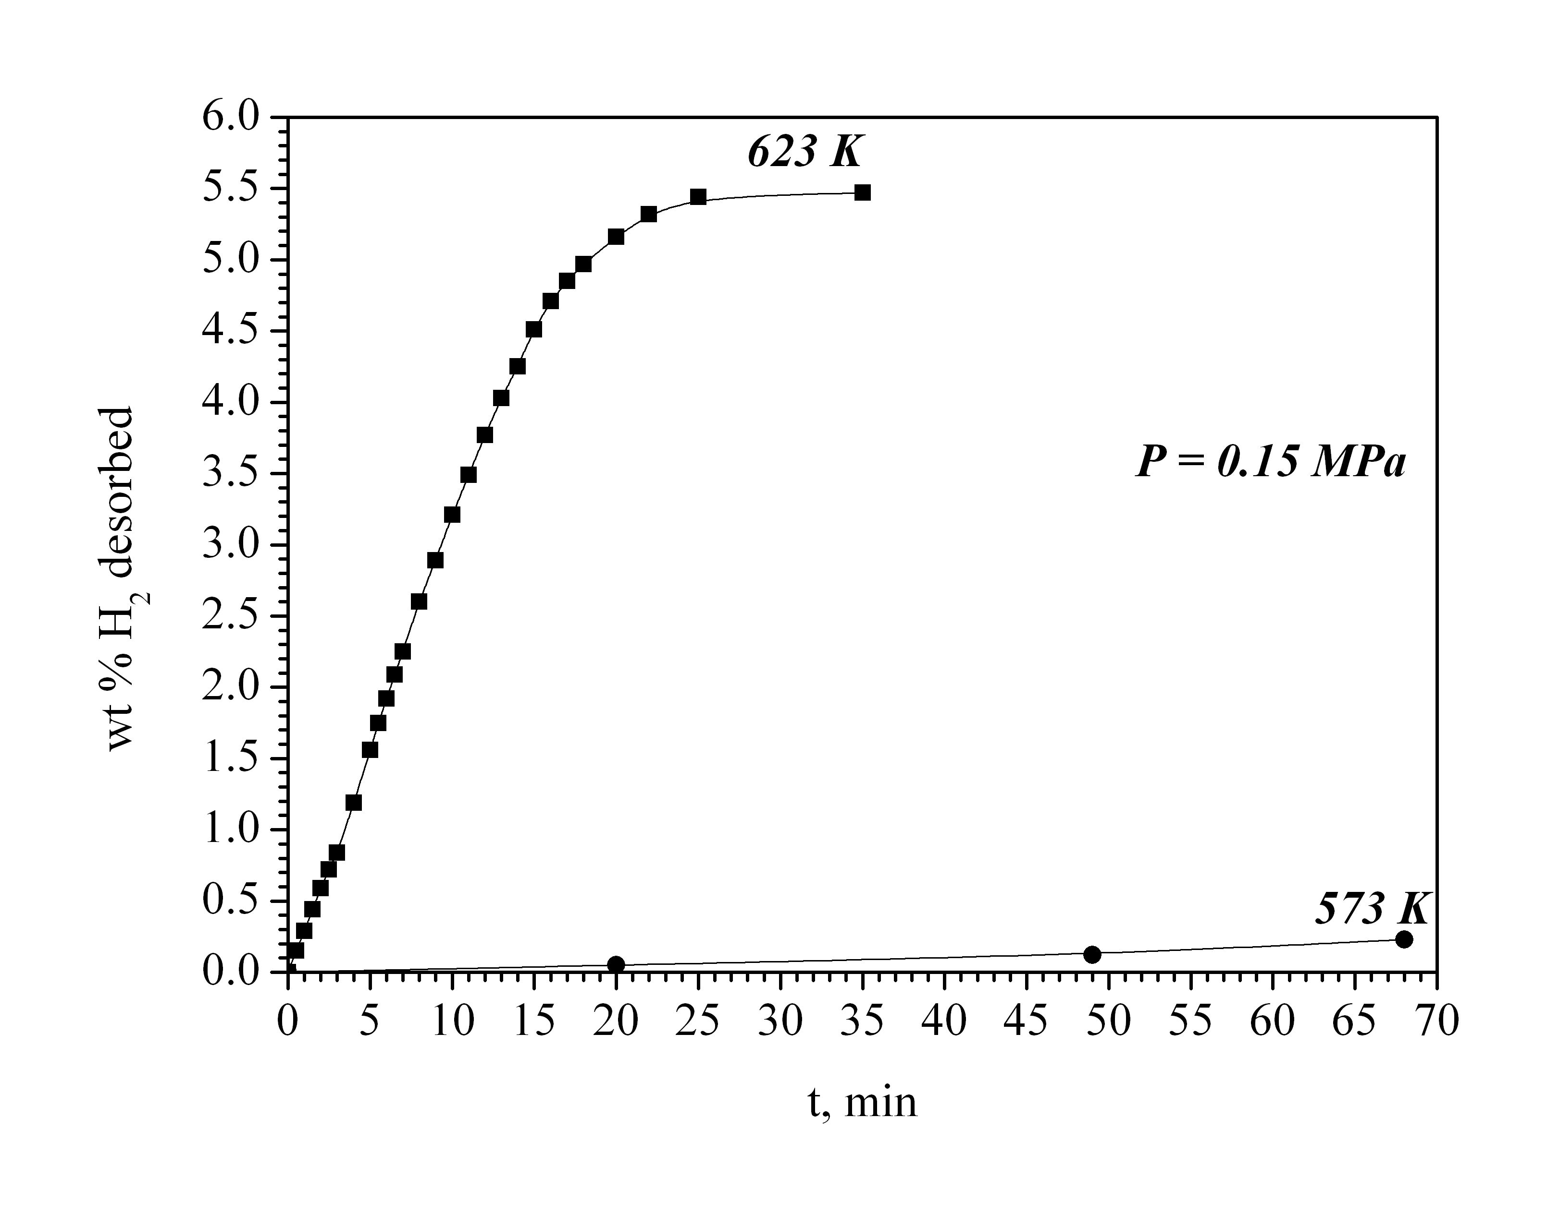
Fig. 6. Kinetic curves of hydrogen desorption from the composite 90 wt. % MgH₂ - 10 wt. % V₂O₅ at P = 0.15 MPa and different temperatures

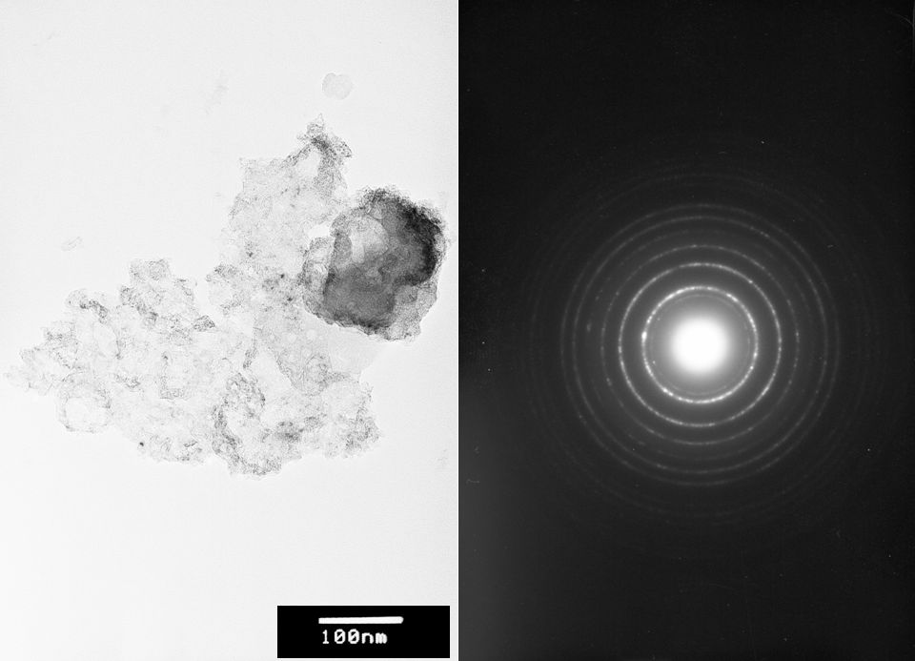

Fig. 7. TEM bright field micrograph and electron diffraction pattern of the composite 90 wt. % MgH₂ - 10 wt. % V₂O₅ after 60 min hydriding at T = 573 K and P = 1 MPa.

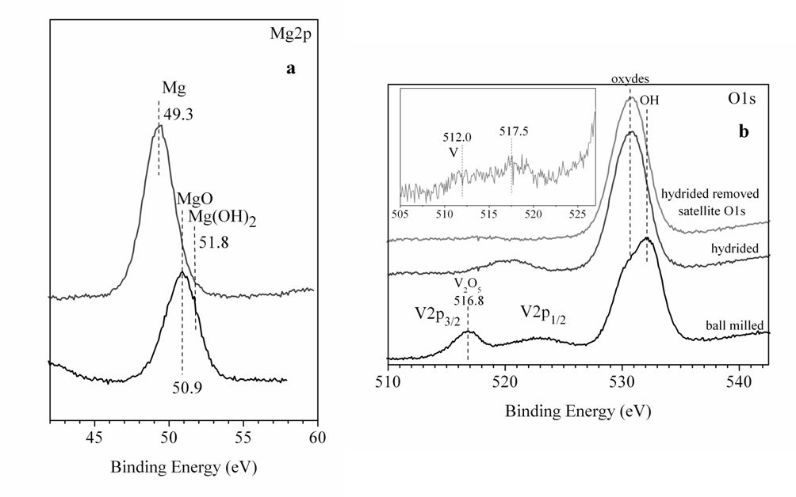
Fig. 8 XPS Mg2p (a) and O1s (b) spectra of the 90 wt. % MgH₂ - 10 wt. % V₂O₅ composite after ball milling and hydriding.

removal of the oxygen satellite, it is difficult to collect XPS data for vanadium, especially in the case of a hydrided specimen. This is probably due to the high reactivity of the samples and the low volume fraction of V₂O₅ in them. Broadened peaks were observed for V2p_{1/2}.
CONCLUSIONS
High absorption capacity of the composite 90 wt.% MgH₂ – 10 wt.% V₂O₅ (ca. 6.3 wt.% H₂) was attained after hydriding at 573 K, but at the same temperature hydrogen desorption proceeded very slowly. As a whole, however, the kinetic hydriding/dehydriding parameters of the vanadia-containing composite studied are, from a practical point of view, inferior as compared to the most performed magnesium-based hydrogen storage materials with oxide catalysts (e.g. Nb₂O₅ or TiO₂).
In the case of magnesium hydride composites with niobia, it has been found [12] that the enhanced hydrogen sorption kinetics are correlated to the presence of a substoichiometric MgH_{2-δ} phase recently established by neutron diffraction experiments [38]. This phase can appear in nanostructured samples usually obtained after prolonged ball milling. It is less stable than the stoichiometric one and acts as a gateway through which hydrogen released from magnesium hydride is flowing. It is also assumed [22] that some favorable influence on the hydrogen sorption kinetics can be exerted by oxygen deficient Mg–Nb-O phases (like MgNb₂O_{3.67}) formed during hydriding of MgH₂ – Nb₂O₅ composites.
In the context of the aforementioned, further studies of the authors will be focused on enhancing the hydrogen sorption kinetics of vanadia-containing MgH₂-composites by providing conditions for: (i) appearance of hydrogen depleted MgH₂ and (ii) formation of Mg_{x}V_{y}O_{z}, the more so as such phases are known as hydrogenation catalysts in petrochemistry [39].
It is generally accepted that the catalytic activity depends, to an important extent, on the catalyst biography. With the exception of a few papers (e.g. [17]) or the recently published study [40] there are no systematic studies on the hydriding/ dehydriding characteristics of magnesium-based composites as a function of the methods of preparation of their oxide or binary oxide-metal additives. In this aspect, a research work of authors is in progress, with special emphasis on vanadia.
Acknowledgement: Thanks are due to Dr. D. Rabadzhieva for her help in performing the thermal analysis measurements. Authors are grateful to the financial support of the National Centre for New Materials UNION (Contract No DO-02-82/2008).

REFERENCES
1. L.J. Murray, M. Dinča, J.R. Long, Chem. Soc. Rev., 38 1294 (2009).
2. J. Germain, J.M. Fréchet, F. Svec, Small, 5 1098 (2009).
3. S. Patchkowskii, J.S. Tse, S.N. Yurchenko, L. Zhechkov, T. Heine, G. Seifert, Proc. Natl. Acad. Sci. USA, 102 10439 (2005).
4. W.L. Mao, H.-K. Mao, A.F. Goncharov, V.V. Struzhkin, Q. Guo, J. Hu, J. Shu, R.J. Hemley, M. Somayazulu, Y. Zhao, Science, 297, 2247 (2002).
5. C.W. Hamilton, R.T. Baker, A. Staubitz, I. Manners Chem. Soc. Rev., 38, 279 (2009).
6. S. Harder, J. Spielmann, J. Intermann, H. Bandmann, Angew. Chem. Int. Ed. 50 4156 (2011).
7. K.-F. Aguey-Zinsou, J.-R. Ares-Fernández, Energy Environ. Sci., 3, 526 (2010).
8. J. Huot, G. Liang, R. Schulz, Appl. Phys., A 72, 187 (2001).
9. M. Dornheim, N. Eigen, G. Barkhordarian, T. Klassen, R. Bormann, Adv. Eng. Mater., 8, 377 (2006).
10. M. Dornheim, S. Doppiu, G. Barkhordarian, U. Boesenberg, T. Klassen, O. Gutfleisch, R. Bormann, Scripta Mater., 56, 841 (2007).
11.I.P. Jain, C. Lal, A. Jain, Int. J. Hydrogen Energy, 35, 5133 (2010).
12. A. Borgschulte, U. Bösenberg, G. Barkhordarian, M. Dornheim, R. Bormann, Catal. Today, 120, 262 (2007).
13. M. Khrussanova, M. Terzieva, P. Peshev, E.Yu. Ivanov, Mater. Res. Bull., 22, 405 (1987).
14. M. Khrussanova, M. Terzieva, P. Peshev, I. Konstanchuk, E. Ivanov, Z. Phys. Chem. (N.F.), 164, 1261 (1989).
15. P. Peshev, M. Khrussanova, D. Chakarov, M. Terzieva, Ts. Marinova, Mater. Res. Bull., 24, 207 (1989).
16. W. Oelerich, T. Klassen, R. Bormann, J. Alloys Compd., 315, 237 (2001).
17. D.L. Croston, D.M. Grant, G.S. Walker, J. Alloys Compd., 492, 251 (2010).
18. A. J. Du, C. S. Sean, X. D. Yao, C. H. Sun, L. Li, G. Q. Lu, Appl. Phys. Lett., 92, 163106 (2008).
19. G. Barkhordarian, T. Klassen, R. Bormann, Scripta Mater., 49, 213 (2003).
20 G. Barkhordarian, T. Klassen, R. Bormann, J. Alloys Compd., 364, 242 (2004).
21 N. Hanada, T. Ichikawa, S. Hino, H. Fujii, J. Alloys Compd., 420, 46 (2006).
22. O. Friedrichs, F. Aguey-Zinsou, J.R. Ares-Fernández, J.C. Sánchez-López, A. Justo, T. Klassen, R. Bormann, A. Fernández, Acta Mater., 54, 105 (2006).
23. O. Friedrichs, T. Klassen, J.C. Sánchez-López, R. Bormann, A. Fernández, Scripta Mater., 54, 1293 (2006).
24. D. Fátay, A. Révész, T. Spassov, J. Alloys Compd., 399, 237 (2005).
25. A. Révész, D. Fátay, T. Spassov, J. Mater. Res., 22, 3144 (2007).
26. A. Révész, D. Fátay, T.Spassov, J. Alloys Compd., 434-435, 725 (2007).
27. F. Dolci, M. Di Chio, M. Baricco, E. Giamello Mater. Res. Bull., 44, 194 (2009).
28. B. Tanguy, J.-L. Soubeyroux, M. Pezat, J. Portier, P. Hagenmuller, Mater. Res. Bull., 11, 1441 (1976).
29. S. D.Vincent, J. Huot, J. Alloys Compd., 509, L175 (2011).
30. W.H. Zachariasen, C.E. Holley Jr., J.F. Stamper Jr, Acta Crystallogr., 16, 352 (1963).
31. T. Moriwaki, Y. Akahama, H. Kawamura, S. Nakano, K. Takemura, J. Phys. Soc. Japan, 75, 074603 (2006).
32. R. Enjalbert, J. Galy Acta Crystallogr., C42, 1467 (1986).
33. P. Balog, D. Orosel, Z. Cancarevic, C. Schön, M. Jansen, J. Alloys Compd,. 429, 87 (2007).
34. M. Bortz, B. Bertheville, G. Böttger, K. Yvon, J. Alloys Compd.., 287, L4 (1999).
35. N. Hanada, T. Ichikawa, S. I. Orimo, H. Fujii J. Alloys Compd., 366, 269 (2004).
36. S. Gialanella, R. Ceccato, F. Casari, G. Ischita, A. Molinari, CALPHAD, 33, 82 (2009).
37. K. Kusaba, E. Ohshima, Y. Syono, T. Kikegawa, J. Cryst. Growth, 229, 467 (2001).
38. H. G. Schimmel, J. Huot, L. C. F. Chapon, D. Tichelaar, F. M. Mulder J. Am.Chem.Soc., 127, 14348 (2005).
39 S. R. G. Carrazán, C. Peres, J. P. Bernard, M. Ruwet, P. Ruiz, B. Delmon, J. Catal., 158, 452 (1996).
40 Y. Jia, L. Cheng, N. Pan, J. Zou, G. Lu, X. Yao, Adv. Energy Mater., 1, 387 (2011).

Сорбционни свойства по отношение на водород на композит MgH₂ - V₂O₅ получен чрез механоактивиране
Е. Григорова¹ , М. Христов¹, П. Пешев¹, Д. Нихтянова^{1, 2}, Н. Величкова¹, Г. Атанасова¹
¹⁾ Институт по обща и неорганична химия, Българска академия на науките, бул. Акад. Г. Бончев, блок 11, София 1113
²⁾Институт по минералогия и кристалография, Българска академия на науките, бул. Акад. Г. Бончев., блок 107, София 1113
Постъпила на 9 април, 2012 г.; коригирана на 7 ноември, 2012 г.
(Резюме)
Композит със състав 90 мас.% MgH₂ – 10 мас.% V₂O₅ беше получен чрез механоактивиране за 60 мин. под аргон на смес от MgH₂ и V₂O₅. Сорбционните свойства по отношение на водород бяха определени чрез апаратура базирана на обемен метод или метод на Сиверт. Абсорбцията беше проведена при температури 473 и 573 K и налягане 1 MPa, а десорбцията при T = 573 и 623 K и P = 0.15 MPa. Структурата, фазовият и повърхностният състав на изходните съединения и композита преди и след хидриране бяха изследвани чрез рентгеноструктурен фазов анализ, термичен анализ, трансмисионна електронна микрскопия и рентгенова фотоелектронна спектроскопия. След хидрирането на композита при 573 K беше достигнат висок абсорбционен капацитет от 6.3 мас.% H₂. Бърза десорбция беше наблюдавана при температури по-високи отколкото се изискват за практическо приложение. Някои идеи за бъдещи изследвания на композити на базата на магнезий съдържащи V₂O₅ са обсъдени с оглед подобряване на свойствата.

