Bulgarian Chemical Communications, Volume 45, Number 3 (301 – 309) 2013
Synthesis and crystal structure of an ammonium salt of 4-hydroxy-3-[(2-oxo-2H-chromen-3-yl)-(3,4,5-trimethoxyphenyl)-methyl]chromen-2-onе
S. Dochev¹, A. Penkova², P. Retailleau³, I. Manolov^{4*}
¹Research Group Mihovilovic, Research Division of Organic Chemistry, Institute of Applied Synthetic Chemistry, Faculty of Technical Chemistry, Vienna University of Technology, A-1060 Vienna, Austria
²University of Southern California, Los Angeles, California, USA, 90089-1453; Rostislaw Kaischew Institute of Physical Chemistry, Bulgarian Academy of Sciences, Acad. G. Bonchev str., 1113 Sofia, Bulgaria
³Service de Cristallochimie, Institut de Chimie des Substances Naturelles - CNRS, UPR2301 Bât 27 – 1, avenue de la Terrasse, 91198 Gif-sur-Yvette Cédex, France–
⁴Department of Pharmaceutical Chemistry, Faculty of Pharmacy, Medical University, 2, Dunav St., 1000 Sofia, Bulgaria
Received February 7, 2012; Revised March 23, 2013
The structure of ammonium salt of 4-hydroxy-3-[(2-oxo-2H-chromen-3-yl)-(3,4,5-trimethoxyphenyl)-methyl]-chromen-2-one was determined by X-ray crystallography. The compound crystallizes as a colourless prism in the monoclinic crystal system, space group P21/c (#14) with cell constants: a = 16.3834(3) Å, b=10.7529(2)Å, c=14.7635(3) Å, β=108.287(1)°,α=γ=90 V=2469.52(8) Å³, Z=4. The crystal structure was solved by direct methods and refined by full-matrix least-square on F² to a final R1 of 0.00467. The 4-hydroxycoumarins are intra molecularly hydrogen bonded between hydroxyls and carbonyls.The salt and the acid form of the title compound have slight differences between the bond lengths and the bond angles.
Key words: 4-Hydroxy-3-[(2-oxo-2H-chromen-3-yl)-(3,4,5-trimethoxyphenyl)-methyl] chromen-2-one, crystal structure, coumarin derivatives, Knoevenagel reaction, Hantzsch reaction and Pechmann condensation.

INTRODUCTION
The coumarins constitute an important class of compounds, with several types of pharmacological agents possessing anticancer [1], anti-HIV [2,3], anticoagulant [4-6], spasmolytic [7,8] and antibacterial activity among others. A large number of structurally novel coumarin derivatives have ultimately been reported to show substantial cytotoxic activity in vitro and in vivo [9,10].
* To whom all correspondence should be sent:
E-mail: imanolov@gmx.net
© 2013 Bulgarian Academy of Sciences, Union of Chemists in Bulgaria
Biscoumarin derivatives possess anticoagulant, spasmolytic, bacteriostatic rodenticidal, antioxidant, and antimetastatic activities. Some of them can be used as herbicides. By chemical modifications it is possible to obtain a compound with good biological activity, but with lower toxicity and fewer side effects. The products synthesized by the reaction of Knoevenagel are in an acid form of the molecules.
We studied the possibility for converting the hydroxy derivatives of the polysubstituted 1,4-dihydropyridine (structure analogues of well known Ca-channel blockers) to the corresponding coumarine products by Pechmann condensation. The synthesis were realized with agreement of the reaction conditions of the Hantzsch reaction and Pechmann condensation.
EXPERIMENTAL
All hydroxyl- and methoxy substituted aromatic aldehydes, ethyl acetoacetate, ammonium acetate, 4-hydroxycoumarin, 4-methyl acetophenone and sovents were reagent grade and were purchased from Sigma-Aldrich and Merck. Melting points were measured on Boetius hot plate microscope (Germany) and were uncorrected. IR spectra (nujol) were recorded on an IR-spectrometer FTIR-8101M Shimadzu. ¹H-NMR spectra were recorded at ambient temperature on a Bruker 250 WM (250 MHz) spectrometer in [d₆]-acetone, CDCl₃. Chemical shifts are given in ppm (δ) relative to TMS used as an internal standard. Mass spectra were recorded on a Jeol JMS D 300 double focusing mass spectrometer coupled to a JMA 2000 data system. The compounds were introduced by direct inlet probe, heated from 50 ºC to 400 ºC at a rate of 100 ºC/min. The ionization current was 300 mA, the accelerating voltage 3 kV and the chamber temperature 150ºC. TLC was performed on precoated plates Kieselgel 60 F₂₅₄ Merck (Germany) with layer thickness 0.25 mm and UV detection (254 nm). Yields of TLC-homogeneous isolated products are given. Results of elemental analyses indicated by the symbols of the elements were within ± 0.4 % of the theoretical values.
The crystal-structure determination was mounted on a glass fibre and used for a low-temperature X-ray structure determination. All measurements were made on a Nonius KappaCCD area-detector diffractometer [11] using graphite-monochromated Mo Kα radiation (λ = 0.71073 Å) and an Oxford Cryosystems Cryostream 700 cooler. The unit cell constants and an orientation matrix for data collection were obtained from a least-squares refinement of the setting angles of 5908 reflections in the range 4° < 2θ < 55°. The mosaicity was 0.390(1)°. A total of 299 frames were collected using φ and ω scans with κ offsets, 80 seconds exposure time and a rotation angle of 2.0° per frame, and a crystal-detector distance of 30.0 mm.
Data reduction was performed with HKL Denzo and Scalepack [12]. The intensities were corrected for Lorentz and polarization effects, but not for absorption. The space group was uniquely determined by the systematic absences. Equivalent reflections were merged. The data collection and refinement parameters are given in Table 1. A view of the molecule is shown in the Figs. 3 and 4.
The structure was solved by direct methods using SIR92 [13], which revealed the positions of all non-hydrogen atoms. The non-hydrogen atoms were refined anisotropically. The hydroxyl and ammonium H-atoms were placed in the positions indicated by a difference electron density map and their positions were allowed to refine together with individual isotropic displacement parameters (Tables 7-9). All remaining H-atoms were placed in geometrically calculated positions and refined by using a riding model where each H-atom was assigned a fixed isotropic displacement parameter with a value equal to 1.2Ueq of its parent C-atom (1.5Ueq for the methyl groups). The refinement of the structure was carried out on F2 by using full-matrix least-squares procedures, which minimised the function Σw(Fo2 – Fc2)2. The weighting scheme was based on counting statistics and included a factor to downweight the intense reflections. Plots of Σw(Fo2 – Fc2)2 versus Fc/Fc(max) and resolution showed no unusual trends. A correction for secondary extinction was applied.
Neutral atom scattering factors for non-hydrogen atoms were taken from Maslen, Fox and O'Keefe [14a], and the scattering factors for H-atoms were taken from Stewart, Davidson and Simpson [15]. Anomalous dispersion effects were included in Fc [16];the values for f' and f" were those of Creagh and McAuley [14b]. The values of the mass attenuation coefficients are those of Creagh and Hubbel [14c]. The SHELXL97 program [17] was used for all calculations.
Synthesis of 1,4-dihydropyridines
3,4,5-Trimethoxybenzaldehide (1.96 g, 10 mmol), 4-hydroxycoumarin (3.24 g, 10 mmol), 4-methoxyacetophenone (1.5 g, 10 mmol), ammonium acetate (30.8 g, 40 mmol), 40 mL of water were added and the reaction mixture refluxed and vigorously stirring for nearly 2 h. Usually the product must be well known 1,4-dihydropyridine (Hantzsch reaction). Yield 3.5 g (67 %), m. p. 174.8-177 ºC [18].
S. Dochev et al.:Synthesis and crystal structure of an ammonium salt of …
Synthesis of biscoumarins
4-Hydroxycoumarin (6.48 g, 40 mmol), 3,4,5-trimethoxybenzaldehyde (3.92 g, 20 mmol), 75 mL ethanol were mixed under stirring and heating at reflux for 10 min. After cooling the product was filtered and was recrystallized from acetonitrile (Knoevenagel reaction). Yield 5.4 g (54 %), m.p. 241-243ºC. TLC (hexane/chloroform/acetone 5:3:1) R_{f} 0.26. Anal. C₂₈H₂₂O₉ (502) (C, H) (Calcd/found): % C = 66.93 / 67.11 ; % H = 4.38 / 4.57. IR (nujol) cm⁻¹: 1661, 1620, 1266, 1211, 1129, 760. ¹H-NMR (DMSO-d₆) 3.2-3.6 d (9H), 4.4-4.6 s (1H), 5.0-5.5 s (1H), 6.0-6.4 d (1H), 6.8-7.8 m (10H). MS (FAB NEG): 502 (7.5), 501 (29), 306 (17.5), 305 (40), 199 (79), 161 (100). The other technique of mass spectral investigation led to another way of fragmentation. The condensation process lasted for 2 h in glacial acetic acid medium at reflux [19–25].
Results and Discussion
We would like to synthesized dihydropyridine derivatives and pyridine derivatives of 2H-chromen-2-one (coumarin). The synthesis were realized with agreement of the reaction conditions of the Hantzsch reaction and Pechmann condensation (Fig. 1). Usually the product must be well known 1,4-dihydropyridine. But in this case (Hantzsch reaction) instead of dihydropyridine derivative the product is ammonium salt of 4-hydroxy-3-[(2-oxo-2H-chromen-3-yl)-(3,4,5-trimethoxyphenyl)-methyl]chromen-2-one, i.e. biscoumarin derivative. We proved that this is a new way for producing biscoumarin derivatives. Anal. C₂₈H₂₅NO₉ (519) (C, H, N) (Calcd/found): % C = 64.74 / 64.81; % H = 4.82 / 4.76; % N = 2.70 / 2.58. Crystallographic data of the investigated crystal are listed in Table 1. The solid state structure of one molecule is shown in Figures 2, 3 and 4.
Diethyl 2,6-dimethyl-4-(4-methyl-2- oxo-2-chromen-5-yl)-1,4-dihydropyridine-3,5-dicarboxylate (1) | Diethyl 2,6-dimethyl-4-(4-methyl-2-oxo-2-chromen-7-yl)-1,4-dihydropyridine-3,5-dicarboxylate (2)
Fig. 1a.Expected 1,4-dihydropyridine derivatives and Pyridine derivative of coumarin
Fig. 1b.Pyridine derivative of coumarin (3)
Fig. 2. Unexpected ammonium salt of biscoumarin derivative

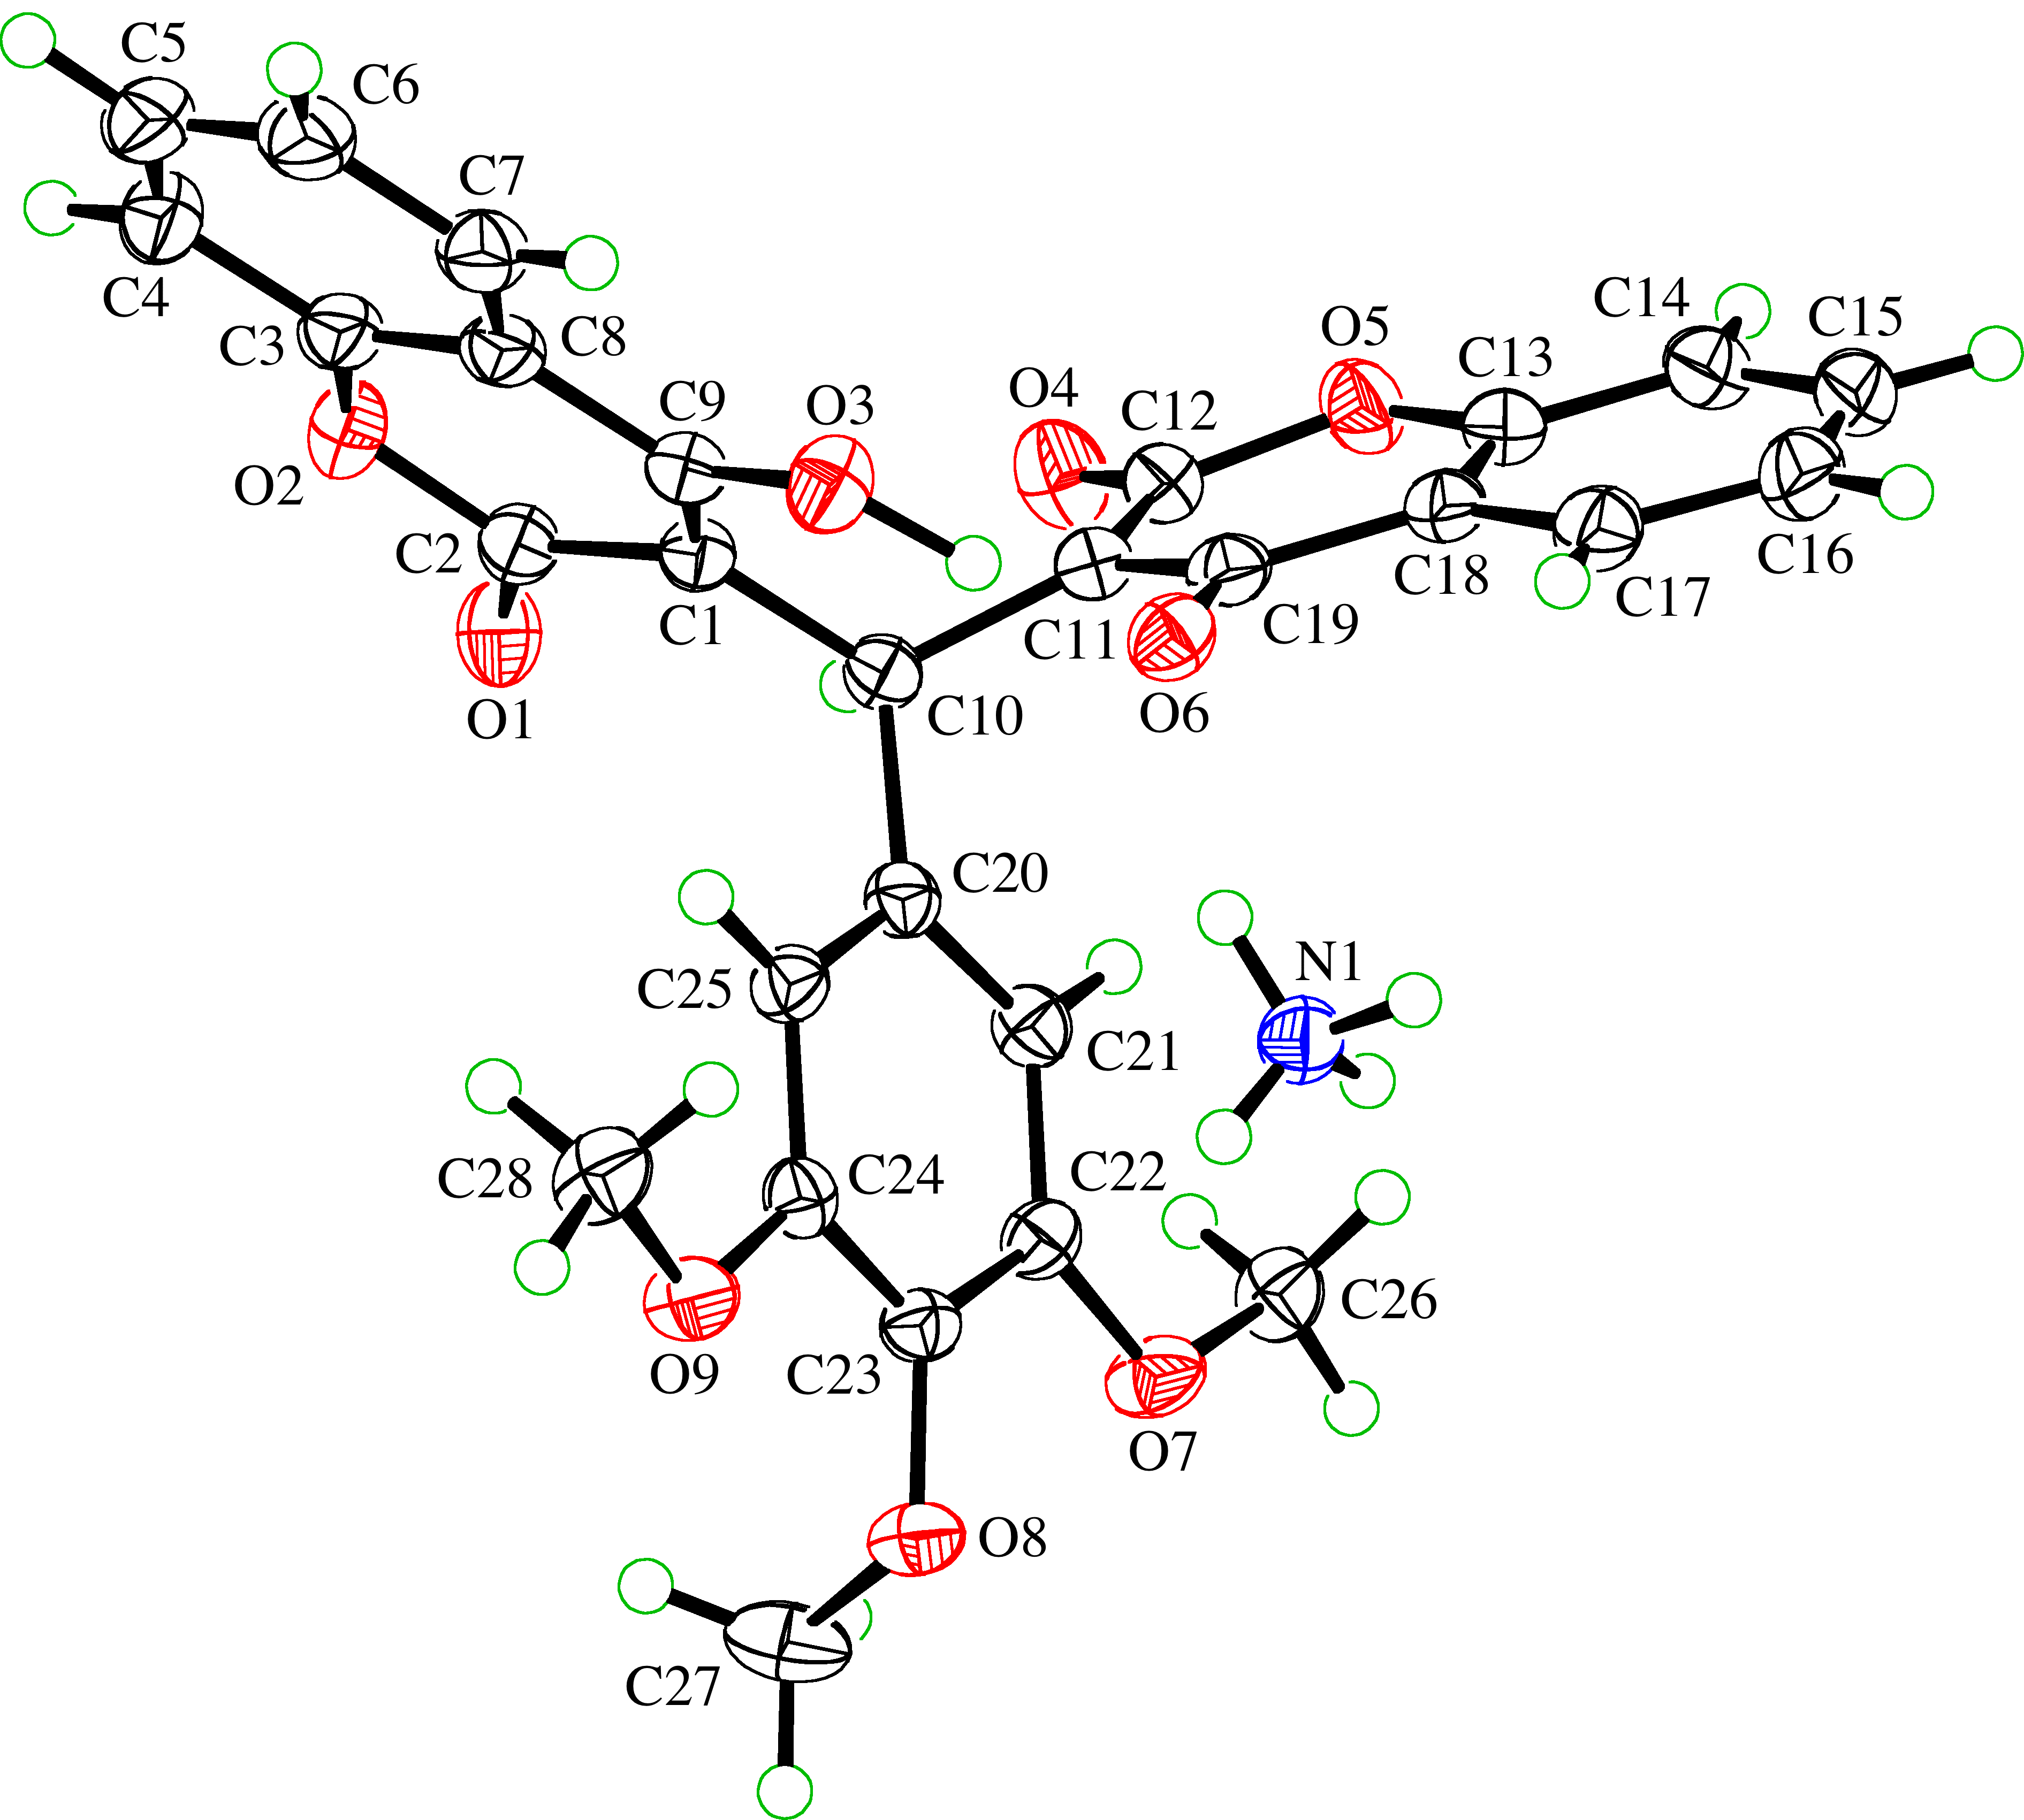

Fig. 3. ORTEP representation of the molecule (50 % probability ellipsoids; H-atoms given arbitrary displasement parameters for clarity) [30].

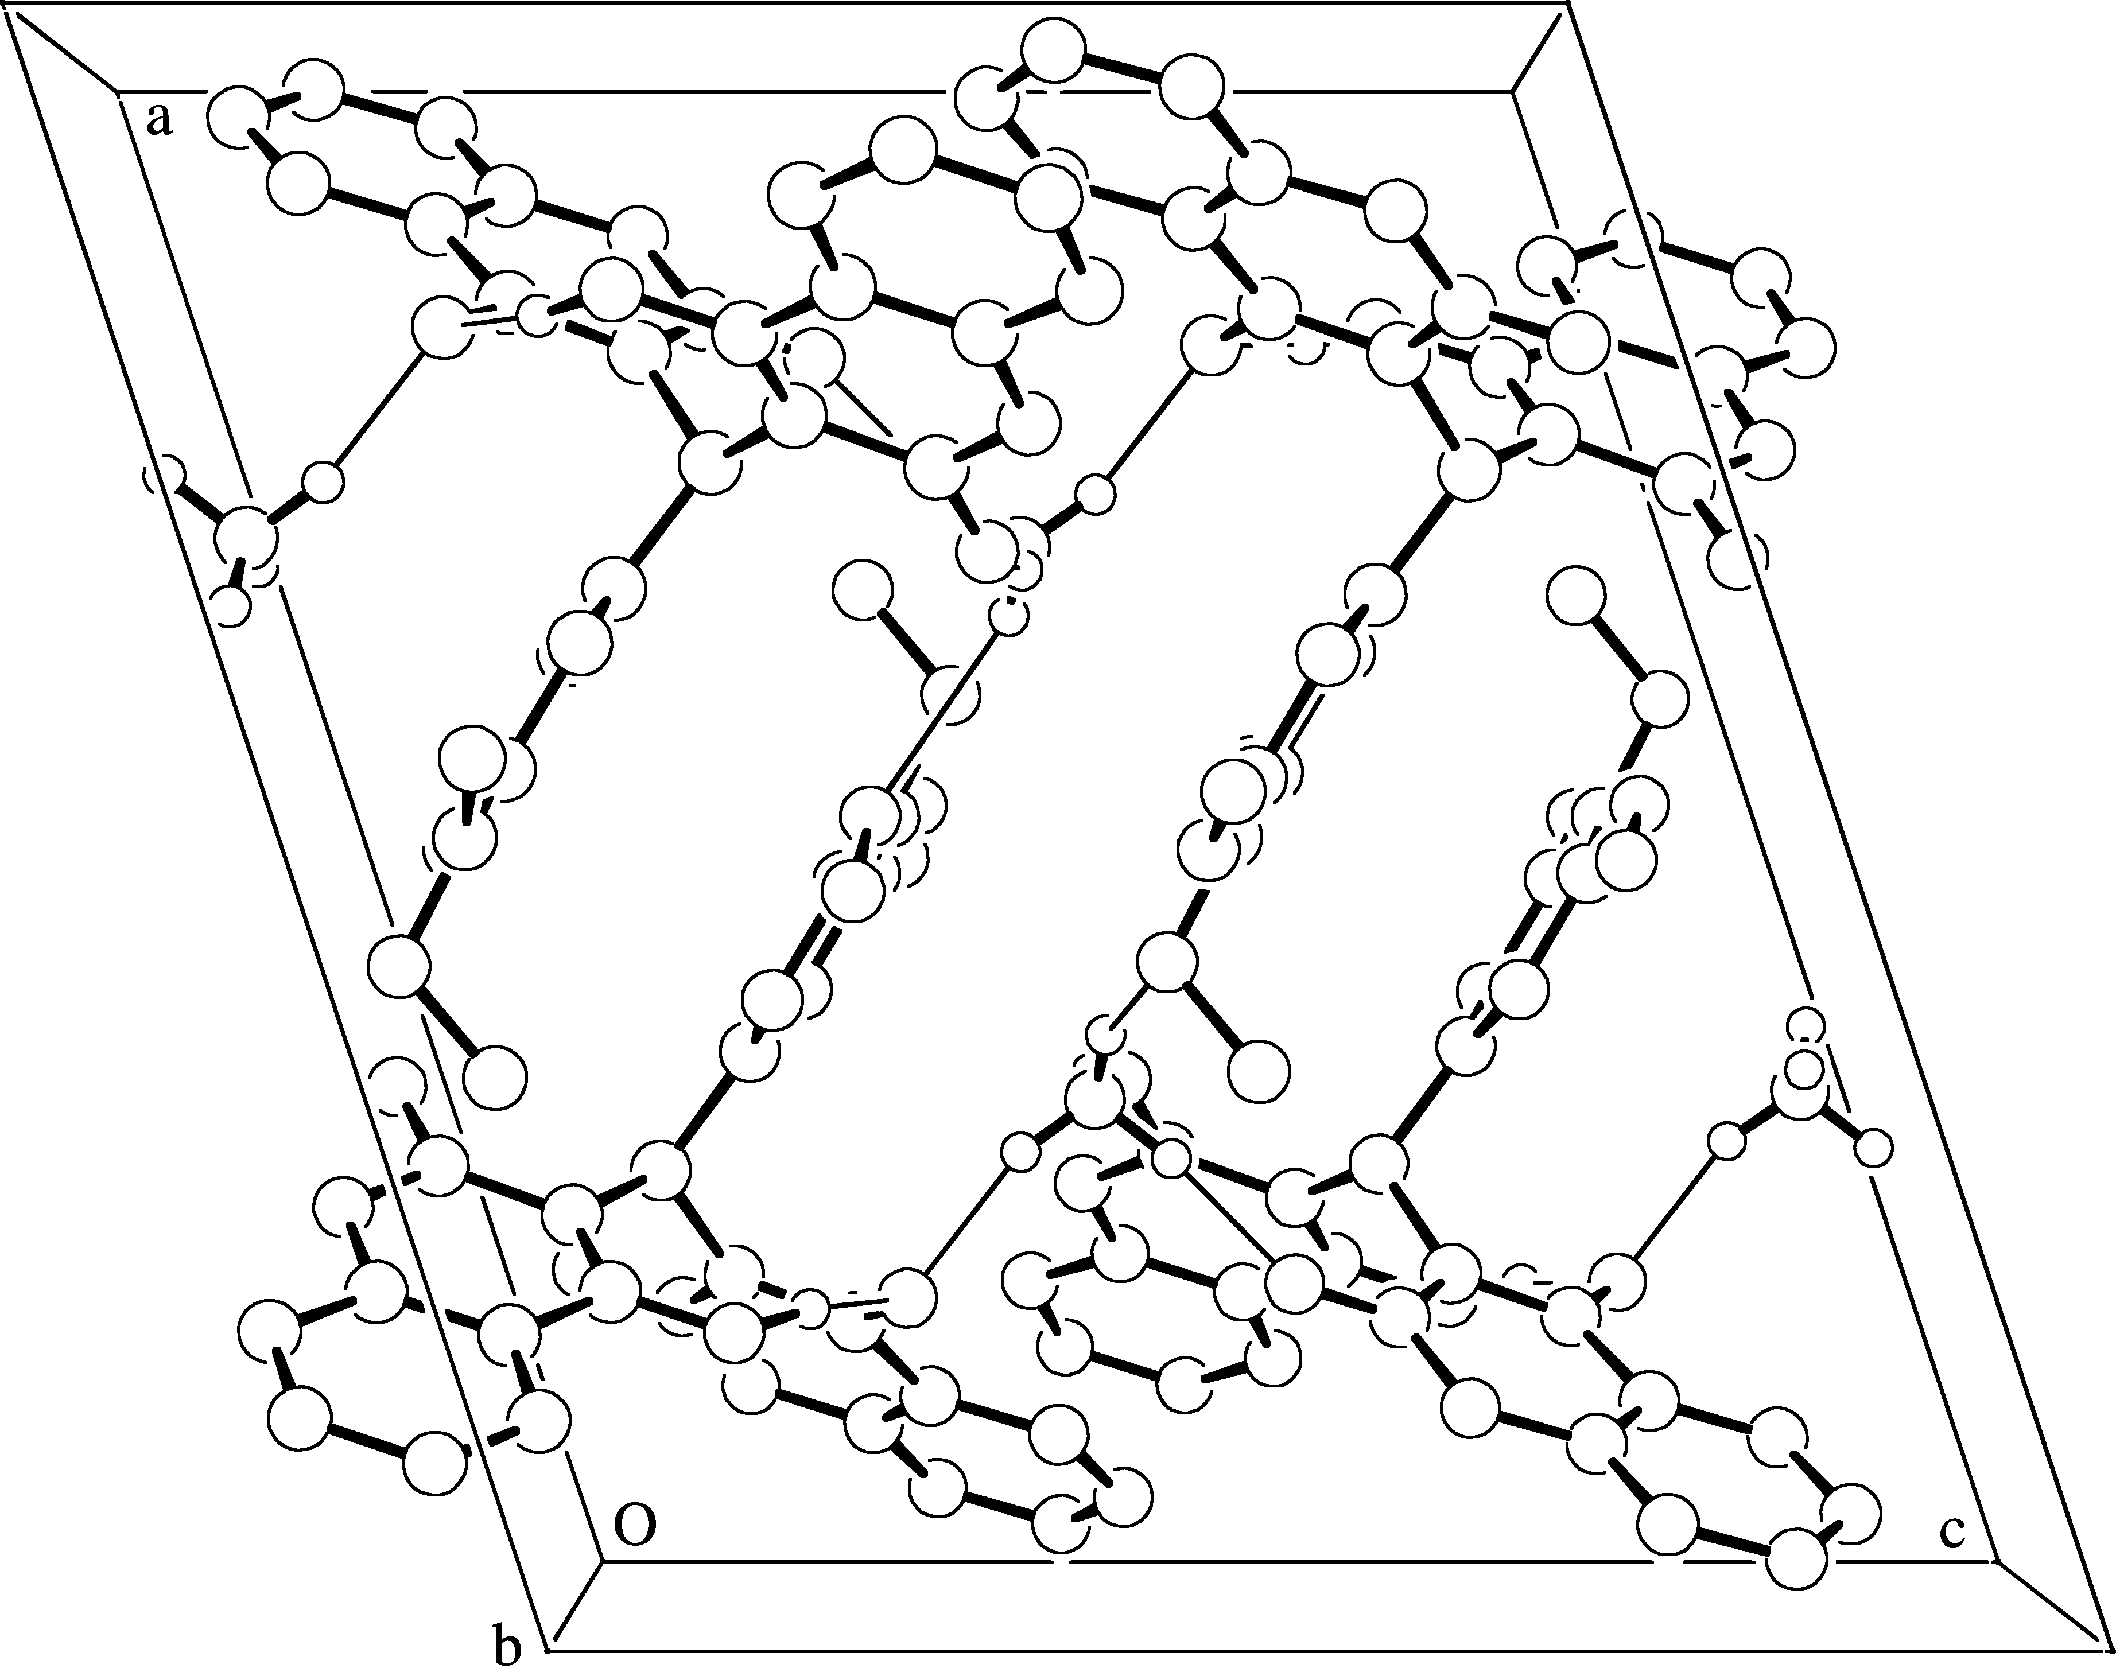
Fig. 4. Molecular packing projected down the α-axis showing the hydrogen bonding scheme (equivalent isotropic sphere for atoms; uninvolved H-atoms ommited for clarity).

Table 1. Crystal data and structure refinement
Empirical formula | C₂₈H₂₅NO₉
Formula weight [g mol⁻¹] | 519.51
Crystal colour, habit | colourless, prism
Crystal dimensions [mm] | 0.10 × 0.15 × 0.33
Temperature [K] | 160(1)
Crystal system | monoclinic
Space group | P21/c (#14)
Z | 4
Reflections for cell determination | 5908
2θ range for cell determination [°] | 4 – 55
Unit cell parameters a [Å] | 16.3834(3), α [°] = 90
b [Å] | 10.7529(2), β [°] = 108.287(1)
c [Å] | 14.7635(3), γ [°] = 90
V [Å³] | 2469.52(8)
F(000) | 1088
Dx [g cm⁻³] | 1.397
µ(Mo Kα) [mm⁻¹] | 0.105
Scan type | φ and ω
2θ_{(max)} [º] | 55
Total reflections measured | 54740
Symmetry independent reflections | 5651
R_{int} | 0.062
Reflections with I > 2 σ (I) | 4091
Reflections used in refinement | 5651
Parameters refined | 367
Final R(F)  [I > 2 σ (I) reflections] | 0.0467
wR(F²) (all data) | 0.1215
Weights: w = [σ²(F_{o}²) + (0.0570P)2 + 0.4821P]⁻¹
where P = (Fo2 + 2Fc2)/3
Goodness of fit | 1.050
Secondary extinction coefficient | 0.0056(7)
Final Δ_{max}/ σ | 0.001
Δρ(max; min) [e Å–3] | 0.23;-0.26
σ (d(C – C)) [Å] | 0.002 - 0.003
The structure of NH4+ C28H21O9– has been solved and refined successfully. Within the anion, the hydroxyl group forms a very strong intramolecular hydrogen bond with the adjacent oxide O-atom. The ammonium cation forms five hydrogen bonds with surrounding anions. These interactions link the ions into an extended two-dimensional network which lies parallel to the (100) plane. Data reduction was performed with HKL Denzo and Scalepack [12]. The intensities were corrected for Lorentz and polarization effects, but not for absorption. The space group was uniquely determined by the systematic absences. Equivalent reflections were merged. The data collection and refinement parameters and other data are given in Tables 1–9.
S. Dochev et al.:Synthesis and crystal structure of an ammonium salt of …
Two 4-hydroxycoumarin moieties are linked through a methylene bridge on which one hydrogen atom has been replaced with a 3,4,5-trimethoxyphenyl residue. The bond distances and angles are given in Tables 3 and 4.Most of the bond distances are of the expected length. The C10-C20 distance of 1.539(2) Å is longer than an unstrained C(_{sp}³)-C(_{Ar}) bond.We established that nearly all of the bonds are shorter than those in the unsubstituted aromatic nucleus in analogous biscoumarin derivative. In spite of the presence of ammonim cation two 4-hydroxycoumarin residues are arranged in a position which permits the formation of two intramolecular hydrogen bonds between a hydrohyl group of one coumarin fragment and a lacton carbonyl group of the other coumarin fragment. The space group P21/c (#14) and the cell Table 2. Fractional atomic coordinates and equivalent isotropic displacement parameters (Å²) with standard uncertainties in parentheses.
Atom | x | y | z | Ueq*
N 1 | 0.6775(1) | 0.6144(2) | 0.5363(1) | 0.0328(3)
O 1 | 0.66958(7) | 0.6285(1) | 1.01337(8) | 0.0366(3)
O 2 | 0.74348(7) | 0.4595(1) | 1.06661(8) | 0.0351(3)
O 3 | 0.82305(7) | 0.4302(1) | 0.82995(8) | 0.0355(3)
O 4 | 0.79762(8) | 0.8925(1) | 0.94087(9) | 00411(3)
O 5 | 0.87690(7) | 0.9271(1) | 0.84912(8) | 0.0363(3)
O 6 | 0.80640(7) | 0.5951(1) | 0.70960(8) | 0.0320(3)
O 7 | 0.48572(7) | 0.8400(1) | 0.59333(8) | 0.0359(3)
O 8 | 0.41413(6) | 0.6138(1) | 0.54350(8) | 0.0321(3)
O 9 | 0.49328(7) | 0.4084(1) | 0.62328(8) | 0.0341(3)
C 1 | 0.75099(9) | 0.5503(1) | 0.9183(1) | 0.0257(3)
C 2 | 0.7194(1) | 0.5515(2) | 0.9986(1) | 0.0292(4)
C 3 | 0.7945(1) | 0.3623(2) | 1.0569(1) | 0.0320(4)
C 4 | 0.8161(1) | 0.2748(2) | 1.1302(1) | 0.0405(4)
C 5 | 0.8664(1) | 0.1750(2) | 1.1220(1) | 0.0447(5)
C 6 | 0.8937(1) | 0.1612(2) | 1.0427(1) | 0.0428(5)
C 7 | 0.8714(1) | 0.2486(2) | 0.9706(1) | 0.0366(4)
C 8 | 0.82144(9) | 0.3520(2) | 0.9772(1) | 0.0308(4)
C 9 | 0.79740(9) | 0.4493(2) | 0.9049(1) | 0.0280(4)
C 10 | 0.72522(9) | 0.6624(1) | 0.8522(1) | 0.0256(3)
C 11 | 0.79614(9) | 0.7343(1) | 0.8281(1) | 0.0263(3)
C 12 | 0.8210(1) | 0.8504(2) | 0.8759(1) | 0.0304(4)
C 13 | 0.9015(1) | 0.9006(2) | 0.7702(1) | 0.0331(4)
C 14 | 0.9493(1) | 0.9911(2) | 0.7423(1) | 0.0404(4)
C 15 | 0.9727(1) | 0.9707(2) | 0.6621(1) | 0.0458(5)
C 16 | 0.9492(1) | 0.8606(2) | 0.6101(1) | 0.0460(5)
C 17 | 0.9032(1) | 0.7700(2) | 0.6396(1) | 0.0389(4)
C 18 | 0.87829(9) | 0.7895(2) | 0.7209(1) | 0.0313(4)
C 19 | 0.82578(9) | 0.7011(2) | 0.7536(1) | 0.0290(3)
C 20 | 0.64695(9) | 0.6419(1) | 0.7630(1) | 0.0252(3)
C 21 | 0.60766(9) | 0.7485(1) | 0.7157(1) | 0.0276(3)
C 22 | 0.53078(9) | 0.7406(1) | 0.6412(1) | 0.0275(3)
C 23 | 0.49343(9) | 0.6242(1) | 0.6135(1) | 0.0262(3)
C 24 | 0.53504(9) | 0.5173(1) | 0.6573(1) | 0.0260(3)
C 25 | 0.61187(9) | 0.5257(1) | 0.7328(1) | 0.0268(3)
C 26 | 0.5215(1) | 0.9609(1) | 0.6204(1) | 0.0332(4)
C 27 | 0.3451(1) | 0.6449(2) | 0.5803(1) | 0.0454(5)
C 28 | 0.5402(1) | 0.2948(2) | 0.6493(1) | 0.0381(4)
*Ueq is defined as one third of the trace of the orthogonalized Uij tensor
S. Dochev et al.:Synthesis and crystal structure of an ammonium salt of …
constants a = 16.3834(3) Å, b = 10.7529(2) Å, c = 14.7635(3) Å, β = 108.287(1)º, α = γ = 90 V = 2469.52(8) Å³ are different from the analogous data of the acid form of the molecule.
The compound was tested for in vivo activity on blood coagulation time using mice. It was assayed for acute toxicity after intra peritoneal and oral administration. Warfarin was used as a reference compound. the studies were approved by the authors' institutional committee on animal care [26].
Table 3. Bond lengths (Å) with standard uncertainties in parentheses
O 1 - C 2 | 1.228(2) | C 6 - C | 1.381(2)
O 2 - C 3 | 1.374(2) | C 7 - C 8 | 1.401(2)
O 2 - C 2 | 1.376(2) | C 8 - C 9 | 1.458(2)
O 3 - C 9 | 1.318(2) | C 10 - C 11 | 1.528(2)
O 4 - C 12 | 1.226(2) | C 10 - C 20 | 1.539(2)
O 5 - C 13 | 1.377(2) | C 11 - C 19 | 1.381(2)
O 5 - C 12 | 1.378(2) | C 11 - C 12 | 1.429(2)
O 6 - C 19 | 1.301(2) | C 13 - C 18 | 1.388(2)
O 7 - C 22 | 1.363(2) | C 13 - C 14 | 1.390(2)
O 7 - C 26 | 1.431(2) | C 14 - C 15 | 1.371(3)
O 8 - C 23 | 1.388(2) | C 15 - C 16 | 1.397(3)
O 8 - C 27 | 1.440(2) | C 16 - C 17 | 1.382(2)
O 9 - C 24 | 1.370(2) | C 17 - C 18 | 1.400(2)
O 9 - C 28 | 1.430(2) | C 18 - C 19 | 1.462(2)
C 1 - C 9 | 1.375(2) | C 20 - C 25 | 1.389(2)
C 1 - C 2 | 1.435(2) | C 20 - C 21 | 1.390(2)
C 1 - C 10 | 1.525(2) | C 21 - C 22 | 1.390(2)
C 3 - C 8 | 1.384(2) | C 22 - C 23 | 1.397(2)
C 3 - C 4 | 1.393(2) | C 23 - C 24 | 1.388(2)
C 4 - C 5 | 1.381(3) | C 24 - C 25 | 1.398(2)
C 5 - C 6 | 1.387(3)
Table 4. Bond angles (°) with standard uncertainties in parentheses.
C 3 –O 2–C 2 | 121.1(1) | O 4 –C 12–O 5 | 113.7(1)
C 13–O 5–C 12 | 121.1(1) | O 4–C 12 –C 11 | 126.7(2)
C 22–O 7–C 26 | 117.4(1) | O 5–C 12 –C 11 | 119.6(1)
C 23–O 8–C 27 | 111.3(1) | O 5–C 13 –C 18 | 121.1(1)
C 24–O 9–C 28 | 117.8(1) | O 5–C 13 – C 14 | 116.7(2)
C 9 –C 1–C 2 | 119.0(1) | C 18 –C 13 –C 14 | 122.2(2)
C 9–C 1–C 10 | 126.0(1) | C 15 –C 14 –C 13 | 118.7(2)
C 2–C 1–C 10 | 114.9(1) | C 14 –C15 –C 16 | 120.4(2)
O 1–C 2–O 2 | 114.2(1) | C 17 –C 16 –C 15 | 120.5(2)
O 1–C 2–C 1 | 125.8(1) | C 16 –C 17 –C 18 | 119.9(2)
O 2– C 2– C 1 | 120.0(1) | C 13 –C 18 –C 17 | 118.2(2)
O 2– C–C 8 | 121.1(1) | C 13 –C18 –C 19 | 118.6(1)
O 2– C 3,– C 4 | 116.6(2) | C 17 –C 18 –C 19 | 123.1(2)
C 8–C 3, – C 4 | 122.3(2) | O 6 –C 19 –C 11 | 122.2(1)
C 5 – C 4 – C 3 | 118.1(2) | O 6 –C 19 –C 18 | 118.8(1)
C 4– C 5–C 6 | 121.1(2) | C 11 –C 19 –C 18 | 119.0(2)
C 7– C 6– C 5 | 120.0(2) | C 25 –C 20 –C 21 | 120.0(1)
C 6– C 7– C 8 | 120.4(2) | C 25 –C 20 –C 10 | 123.6(1)
C 3–C 8– C 7 | 118.1(2) | C 21 –C 20 –C 10 | 116.3(1)
C 3–C 8–C 9 | 118.7(2) | C 20 –C 21 –C 22 | 120.6(1)
C 7–C 8–C 9 | 123.2(2) | O 7 –C 22 –C 21 | 124.8(1)
O 3–C 9–C 1 | 125.5(1) | O 7 –C 22 –C 23 | 115.8(1)
O 3–C 9 –C 8 | 114.8(1) | C 21–C 22–C 23 | 119.4(1)
C 1 – C 9 –C 8 | 119.8(1) | O 8–C 23 –C 24 | 119.2(1)
C 1 – C 10 –C 11 | 118.1(1) | O 8 –C 23–C 22 | 120.8(1)
C 1– C 10 – C 20 | 15.1(1) | C 24 –C 23 –C 22 | 120.0(1)
C 11– C 10–C 20 | 111.3(1) | O 9 –C 24 –C 23 | 114.9(1)
C 19 – C 11–C12 | 120.1(1) | O 9–C 24 –C 25 | 124.7(1)
C 19 –C 11–C 10 | 22.5(1) | C 23–C 24 –C 25 | 120.3(1)
C12 – C 11–C 10 | 116.6(1) | C 20 –C 25 –C 24 | 119.5(1)

Table 5. Torsion angles (°) with standard uncertainties in parentheses.
C 3 - O 2 - C 2 - O 1 | 175.8(1) | C 18 - C 13 - C 14 - C 15 | 1.5(2)
C 3 - O 2 - C 2 - C 1 | -3.1(2) | C 13 - C 14 - C 15 - C 16 | 0.5(2)
C 9 - C 1 - C 2 - O 1 | -171.6(1) | C 14 - C 15 - C 16 - C 17 | -0.9(3)
C 10 - C 1 - C 2 - O 1 | 5.8(2) | C 15 - C 16 - C 17 - C 18 | 1.3(2)
C 9 - C 1 - C 2 - O 2 | 7.2(2) | O 5 - C 13 - C 18 - C 17 | 178.1(1)
C 10 - C 1 - C 2 - O 2 | -175.5(1) | C 14 - C 13 - C 18 - C17 | -1.1(2)
C 2 - O 2 - C 3 - C 8 | -1.7(2) | O 5 - C 13 - C 18 - C 19 | 0.9(2)
C 2 - O 2 - C 3 - C 4 | 179.3(1) | C 14 - C 13 - C 18 - C 19 | -178.3(1)
O 2 - C 3 - C 4 - C 5 | 179.1(1) | C 16 - C 17 - C 18 - C 13 | -0.3(2)
C 8 - C 3 - C 4 - C 5 | 0.1(2) | C 16 - C 17 - C 18 - C 19 | 176.7(1)
C 3 - C 4 - C 5 - C 6 | -0.8(3) | C 12 - C 11 - C 19 - O 6 | 178.4(1)
C 4 - C 5 - C 6 - C 7 | 0.6(3) | C 10 - C 11 - C 19 - O 6 | -12.2(2)
C 5 - C 6 - C 7 - C 8 | 0.3(2) | 12 - C 11 - C 19 - C 18 | -3.8(2)
O 2 - C 3 - C 8 - C 7 | -178.2(1) | C 10 - C 11 - C 19 - C 18 | 165.7(1)
C 4 - C 3 - C 8 - C 7 | .7(2) | 13 - C 18 - C 19 - O 6 | 177.7(1)
O 2 - C 3 - C 8 - C 9 | 2.4(2) | C 17 - C 18 - C 19 - O 6 | 5.3(2)
C 4 - C 3 - C 8 - C 9 | 178.7(1) | 13 - C 18 - C 19 - C 11 | .4(2)
C 6 - C 7 - C 8 - C 3 | 0.9(2) | 17 - C 18 - C 19 - C 11 | 172.7(1)
C 6 - C 7 - C 8 - C 9 | 78.4(2) | 1 - C 10 - C 20 - C 25 | 12.6(2)
C 2 - C 1 - C 9 - O 3 | 73.1(1) | C 11 - C 10 - C 20 - C 25 | 125.2(2)
C 10 - C 1 - C 9 - O 3 | 4.0(2) | 1 - C 10 - C 20 - C 21 | 163.2(1)
C 2 - C 1 - C 9 - C 8 | 6.5(2) | 11 - C 10 - C 20 - C 21 | -59.1(2)
C 10 - C 1 - C 9 - C 8 | 76.5(1) | 25 - C 20 - C 21 - C 22 | 3.5(2)
C 3 - C 8 - C 9 - O 3 | 177.8(1) | 10 - C 20 - C 21 - C 22 | 172.4(1)
C 7 - C 8 - C 9 - O 3 | .9(2) | 26 - O 7 - C 22 - C 21 | .7(2)
C 3 - C 8 - C 9 - C 1 | .8(2) | 26 - O 7 - C 22 - C 23 | 79.4(1)
C 7 - C 8 - C 9 - C 1 | -177.5(1) | 20 - C 21 - C 22 - O 7 | 77.0(1)
C 9 - C 1 - C 10 - C 11 | -55.4(2) | 20 - C 21 - C 22 - C 23 | 0.6(2)
C 2 - C 1 - C 10 - C 11 | 127.5(1) | 27 - O 8 - C 23 - C 24 | 02.0(2)
C 9 - C 1 - C 10 - C 20 | 79.4(2) | 27 - O 8 - C 23 - C 22 | -77.0(2)
C 2 - C 1 - C 10 - C 20 | -97.7(2) | 7 - C 22 - C 23 - O 8 | 1.8(2)
C 1 - C 10 - C 11 - C 19 | .6(2) | 21 - C 22 - C 23 - O 8 | 76.0(1)
C 20 - C 10 - C 11 - C 19 | -49.8(2) | 7 - C 22 - C 23 - C 24 | 79.2(1)
C 1 - C 10 - C 11 - C 12 | -103.6(2) | C 21 - C 22 - C 23 - C 24 | -3.0(2)
C 20 - C 10 - C 11 - C 1 | 20.0(1) | 28 - O 9 - C 24 - C 23 | 66.4(1)
C 13 - O 5 - C 12 - O 4 | 172.4(1) | 28 - O 9 - C 24 - C 25 | 16.2(2)
C 13 - O 5 - C 12 - C 11 | 7.5(2) | O 8 - C 23 - C 24 - O 9 | 2.2(2)
C 19 - C 11 - C 12 - O 4 | 77.9(2) | 22 - C 23 - C 24 - O 9 | -178.8(1)
C 10 - C 11 - C 12 - O 4 | 7.8(2) | 8 - C 23 - C 24 - C 25 | -175.3(1)
C 19 - C 11 - C 12 - O 5 | 2.0(2) | 22 - C 23 - C 24 - C 25 | 3.7(2)
C 10 - C 11 - C 12 - O 5 | 172.1(1) | C 21 - C 20 - C 25 - C 24 | -2.8(2)
C 12 - O 5 - C 13 - C 18 | -6.9(2) | C 10 - C 20 - C 25 - C 24 | 172.8(1)
C 12 - O 5 - C 13 - C 14 | 72.3(1) | 9 - C 24 - C 25 - C 20 | 178.0(1)
O 5 - C 13 - C 14 - C 15 | 177.7(1) | 23 - C 24 - C 25 - C 20 | 0.8(2)
S. Dochev et al.:Synthesis and crystal structure of an ammonium salt of …
Table 6. Anisotropic atomic displacement parameters (Å2).
Atom | U11 | U22 | U33 | U23 | U13 | U12
N 1 | 0.0354(8) | 0.0330(9) | 0.0288(8) | –0.0013(6) | 0.0085(7) | –0.0043(7)
O 1 | 0.0449(7) | 0.0328(6) | 0.0381(7) | –0.0008(5) | .0219(5) | –0.0001(5)
O 2 | 0.0450(7) | 0.0327(6) | 0.0291(6) | 0.0042(5) | 0.0138(5) | –0.0014(5)
O 3 | 0.0405(6) | 0.0351(7) | 0.0350(7) | 0.0042(5) | 0.0176(5) | 0.0084(5)
O 4 | 0.0479(7) | 0.0368(7) | 0.0432(7) | –0.0105(6) | 0.0208(6) | –0.0103(5)
O 5 | 0.0361(6) | 0.0339(6) | 0.0401(7) | –0.0015(5) | .0136(5) | 0.0088(5)
O 6 | 0.0351(6) | 0.0342(6) | 0.0270(6) | –0.0006(5) | 0.0101(5) | 0.0024(5)
O 7 | 0.0374(6) | 0.0230(6) | 0.0387(7) | 0.0037(5) | -0.0006(5) | 0.0032(5)
O 8 | 0.0282(5) | 0.0319(6) | 0.0300(6) | –0.0014(5) | 0.0001(5) | 0.0014(5)
O 9 | 0.0359(6) | 0.0228(6) | 0.0369(7) | –0.0004(5) | 0.0019(5) | –0.0017(5)
C 1 | 0.0251(7) | 0.0267(8) | 0.0236(8) | 0.0003(6) | 0.0052(6) | -0.0029(6)
C 2 | 0.0305(8) | 0.0286(9) | 0.0269(8) | –0.0009(7) | 0.0067(6) | -0.0047(7)
C 3 | 0.0292(8) | 0.0303(9) | 0.0316(9) | 0.0023(7) | 0.0023(7) | -0.0045(7)
C 4 | 0.0421(9) | 0.040(1) | 0.036(1) | 0.0094(8) | .0065(8) | -0.0071(8)
C 5 | 0.0378(9) | 0.041(1) | 0.046(1) | 0.0158(9) | 0.0004(8) | -0.0032(8)
C 6 | 0.0315(9) | 0.036(1) | 0.055(1) | 0.0108(9) | 0.0052(8) | 0.0008(7)
C 7 | 0.0297(8) | 0.0340(9) | 0.043(1) | 0.0052(8) | 0.0066(7) | 0.0003(7)
C 8 | 0.0254(8) | 0.0289(9) | 0.0333(9) | 0.0013(7) | 0.0021(6) | -0.0043(6)
C 9 | .0239(7) | 0.0310(9) | 0.0271(8) | 0.0003(7) | 0.0051(6) | -0.0032(6)
C 10 | 0.0252(7) | 0.0254(8) | 0.0259(8) | -0.0014(6) | 0.0078(6) | -0.0006(6)
C 11 | 0.0239(7) | 0.0287(8) | 0.0246(8) | 0.0023(6) | 0.0052(6) | 0.0001(6)
C 12 | 0.0273(8) | 0.0314(9) | 0.0312(9) | 0.0034(7) | 0.0072(7) | -0.0024(6)
C 13 | 0.0246(8) | 0.039(1) | 0.0343(9) | 0.0079(7) | 0.0067(7) | 0.0015(7)
C 14 | 0.0271(8) | 0.042(1) | 0.049(1) | 0.0126(8) | 0.0076(8) | -0.0014(7)
C 15 | 0.0278(9) | 0.055(1) | 0.054(1) | 0.025(1) | 0.0114(8) | 0.0020(8)
C 16 | 0.0330(9) | 0.067(1) | 0.042(1) | 0.020(1) | 0.0172(8) | 0.0081(9)
C 17 | 0 0309(8) | 0.051(1) | 0.036(1) | 0.0090(8) | 0.0118(7) | 0.0065(8)
C 18 | 0.0230(7) | 0.041(1) | 0.0292(8) | 0.0085(7) | 0.0067(6) | 0.0046(7)
C 19 | 0.0244(7) | 0.0333(9) | 0.0268(8) | 0.0035(7) | 0.0045(6) | 0.0040(7)
C 20 | 0.0241(7) | 0.0279(8) | 0.0247(8) | –0.0004(6) | 0.0090(6) | -0.0003(6)
C 21 | 0.0288(8) | 0.0236(8) | 0.0305(8) | -0.0013(6) | 0.0097(6) | -0.0013(6)
C 22 | 0.0292(8) | 0.0248(8) | 0.0281(8) | 0.0026(6) | 0.0081(6) | 0.0037(6)
C 23 | 0.0251(7) | 0.0287(8) | 0.0235(8) | -0.0012(6) | 0.0057(6) | 0.0002(6)
C 24 | 0.0275(8) | 0.0245(8) | 0.0270(8) | -0.0011(6) | 0.0101(6) | -0.0026(6)
C 25 | 0.0269(8) | 0.0257(8) | 0.0275(8) | 0.0031(6) | 0.0080(6) | 0.0029(6)
C 26 | 0.0399(9) | 0.0224(8) | 0.0365(9) | 0.0000(7) | 0.0109(7) | 0.0009(7)
C 27 | 0.0269(9) | 0.046(1) | 0.056(1) | -0.0102(9) | 0.0033(8) | 0.0064(8)
C 28 | 0.048(1) | 0.0227(8) | 0.039(1) | -0.0001(7) | 0.0066(8) | 0.0012(7)
The anisotropic displacement parameter exponent takes the form:
-2π2(h2a*2U11+k2b*2U22+ ... +2hka*b*U12)
S. Dochev et al.:Synthesis and crystal structure of an ammonium salt of …
Table 7. Hydrogen atom coordinates and displacement parameters
Atom | x | y | z | Uiso
H 11 | 0.716(1) | 0.607(2) | 0.497(1) | 0.045(5)
H 12 | 0.662(1) | 0.699(2) | 0.533(2) | 0.065(7)
H 13 | 0.712(1) | 0.596(2) | 0.599(2) | 0.064(7)
H 14 | 0.635(2) | 0.559(2) | 0.514(2) | 0.063(7)
H 3 | 0.810(2) | 0.502(2) | 0.776(2) | 0.086(8)
H 4 | 0.797 | 0.284 | 1.184 | 0.049
H 5 | 0.882 | 0.115 | 1.172 | 0.054
H 6 | 0.928 | 0.091 | 1.038 | 0.051
H 7 | 0.890 | 0.239 | 0.916 | 0.044
H 10 | 0.704 | 0.723 | 0.891 | 0.031
H 141 | 0.965 | 1.065 | 0.778 | 0.049
H 15 | 1.005 | 1.032 | 0.642 | 0.055
H 16 | 0.965 | 0.848 | 0.554 | 0.055
H 17 | 0.888 | 0.695 | 0.605 | 0.047
H 21 | 0.634 | 0.827 | 0.734 | 0.033
H 25 | 0.640 | 0.452 | 0.763 | 0.032
H 261 | 0.529 | 0.975 | 0.688 | 0.050
H 262 | 0.483 | 1.024 | 0.582 | 0.050
H 263 | 0.577 | 0.967 | 0.609 | 0.050
H 271 | 0.347 | 0.590 | 0.634 | 0.068
H 272 | 0.290 | 0.635 | 0.530 | 0.068
H 273 | 0.351 | 0.731 | 0.602 | 0.068
H 28 | 0.593 | 0.299 | 0.632 | 0.057
H 282 | 0.505 | 0.225 | 0.615 | 0.057
H 283 | 0.554 | 0.282 | 0.718 | 0.057

Table 8. Selected bond lengths (Å) and angles (°) involving H-atoms.
N 1 - H 11 | 0.98(2) | N 1 - H 14 | 0.90(2)
N 1 - H 12 | 0.94(2) | O 3 - H 3 | 1.08(3)
N 1 - H 13 | 0.94(2) | O 6 - H 3 | .39(3)
H 11- N 1-H 12 | 105(2) | H 12 - N 1 - H 14 | 117(2)
H 11-N 1-H 13 | 106(2) | H 13 - N 1 - H 14 | 112(2)
H 12-N 1-H 13 | 109(2) | C 9 - O 3 - H 3 | 118(1)
H 11 - N 1 - H 14 | 108(2) | C 19 - O 6 - H 3 | 109(1)
Table 9. Hydrogen bonding geometry (Å, °).
D | H | A | D-H | H···A | D···A | D-H···A
O 3 | H 3 | O 6 | 1.08(3) | 1.39(3) | 2.464(2) | 172(2)
N 1 | H 11 · | O 4' | 0.98(2) | 1.78(2) | 2.758(2) | 171(2)
N 1 | H 12 | O 1' | 0.94(2) | 1.89(2) | 2.783(2) | 158(2)
N 1 | H 13 | O 6 | 0.94(2) | 1.87(2) | 2.768(2) | 159(2)
N 1 | H 14 · | O 8" | 0.90(2) | 2.10(2) | 2.924(2) | 153(2)
N 1 | H 14 · | O 9" | 0.90(2) | 2.44(2) | 3.049(2) | 125(2)
Primed atoms refer to the molecule in the following symmetry related positions:
' x, 11-y, -1+z " 1-x, 1-y, 1-z

This compound showed an effect on HIV replication in acutely infected cells by microtiter infection assay. The same substance demonstrated no impact on early stages of HIV-1 replication cycle [27, 28]. The structure of the title compound was solved and published previously [29].
S Dochev et al.:Synthesis and crystal structure of an ammonium salt of …
REFERENCES
- B. Hagmar, Pathol. Eur. 4, 283 (1969).
- Zhao H., N. Neamati, H. Hong, A. Mazumder, S. Wang, S. Sunder, G. W. A. Milne, Y. Pommier, T. R. Burke Jr., J. Med. Chem. 40, 242 (1997).
- Markal de Queroz P Italy PCT Int. Appl. WO 98 25,608 (1998).
- Nagashima R., R. O’Reilly, G. Levy. Clin. Pharm. Ther. 1, 22 (1969).
- R. O’Reilly, J. Ohms, C. Motley. J. Biol. Chem., 244, 1303 (1969).
- N. Numamoto, T. Yamamoto, A. Yamashita, T. Hatano, J. Kurahara. Jpn Kokai Tokkyo Koho JP 02 36,178 (1990).
- E. Boshetti, D. Molho, L. Fontaine. S. African 68 01, 383 (1968).
- C. Stacchino, R. Spano, A. Pettiti, Bull. Chim. Pharm., 122, 158 (1983).
- Lu H. D. et al. Ann. N. Y. Acad. Sci,. 833, 147 (1997).
- C.L. Laprinzi et al., N. Eng. J. Med., 340, 346 (1999).
- R. Hooft, KappaCCD Collect Software, Nonius BV, Delft, The Netherlands, 1999.
- Z. Otwinowski, W. Minor, in: Methods in Enzymology, Vol. 276, Macromolecular Crystallography, Part A (eds. C.W. Carter Jr., R.M. Sweet), Academic Press, New York, 1997, p. 307.
- A. Altomare, G. Cascarano, C. Giacovazzo, A. Guagliardi, M.C. Burla, G. Polidori, M. Camalli, SIR92, J. Appl. Crystallogr., 27, 435 (1994).
- a) E.N. Maslen, A.G. Fox, M.A. O'Keefe, in 'International Tables for Crystallography', Ed. A.J.C. Wilson, Kluwer Academic Publishers, Dordrecht, 1992, Vol. C, Table 6.1.1.1, p. 477; b) D.C. Creagh, W.J. McAuley, ibid. Table 4.2.6.8, p. 219; c) D.C. Creagh, J.H. Hubbell, ibid. Table 4.2.4.3, p. 200.
- R.F. Stewart, E.R. Davidson, W.T. Simpson, J. Chem. Phys., 42, 3175 (1965).
- J.A. Ibers, W.C. Hamilton, Acta Crystallogr. 17, 781 (1964).
- G.M. Sheldrick, SHELXL97, Acta Crystallogr., Sect A, 64, 112 (2008).
- S. Dochev, Diploma work, Medical University, Faculty of Pharmacy, Department of Organic Chemistry, Sofia, 2010.
- A.K. Mitra, A. De, N. Karchaudhuri, S. K. Misra, A. K. Mukhopadhyay, J. Indian Chem. Soc., 75, 526 (1998).
- A. Grussner, Jubilee Vol Emil Barell 238 (1946).
- P. Desnoyers, K. Binovic, Therapie, 22, 207 (1967).
- E. Perola, K. Xu, T. M. Kollmeyer, S. H. Kauffman, F. G. Prendergast, Y.-P. Pang, J. Med. Chem,. 43, 401 (2000).
- R. Griffith, R. Chanphen, S.P. Leach, P.A. Keller, Bioorg. Med. Chem. Lett., 12, 539 (2002).
- P.A. Keller, C. Birch, S.P. Leach, D. Tyssen, R. Griffith, J. Mol. Graphics & Modelling, 21, 365 (2003).
- K.M. Khan, S. Iqbal, M.A. Lodhi, G.M. Maharvi, S. Perveen, M.I. Choudhary, Atta-Ur-Rahman, Z.H. Zahid, C.T. Supuran, J. Enzyme Inhib. Med. Chem., 19, 367 (2004).
- I. Мanolov, C. Maichle-Moessmer, N. Danchev, Eur. J. Med. Chem., 41, 882 (2006).
- S. Raleva, A. Savov, L. Froloshka, D. Dundarova, I. Manolov, R. Argirova. Biotechnol.& Biotechnol. Eq., 19, 11 (2005).
- P. Genova, D. Dundarova, S. Raleva, R. Argirova, I. Manolov. Farmacya (Sofia). LII, 74 (2005).
- I. Manolov, M. Ströbele, H.-Jürgen Meyer. Anal. Sci.- X-Ray Struct. Anal. Online, 24, 135 (2008).
- C. K. Johnson, ORTEPII, Report ORNL-5138, Oak Ridge National Laboratory, Oak Ridge, Tennesse, 1976.

Синтез и кристална структура на амониева сол на 4-хидрокси-3-[(2-оксо-2Н-хромен-3-ил)-(3,4,5-триметоксифенил)метил]хромен-2-он

С. Дочев¹, А. Петкова², П. Ретайльо³, И. Манолов⁴

¹Изследователска група Миховилович, Научен отдел по oрганична химия, Институт по приложна синтетична химия, Факултет по техническа химия, Университет по технология Виена, А-1060 Виена, Австрия
² Южнокалифорнийски Университет, Лос Анджелис, Калифорния, САЩ, 90089-1453; Институт по физикохимия „Акад. Р. Каишев”, БАН, ул. „Акад. Г. Бончев”, 1113 София, България
³Лаборатория по кристалография, Институт по Химия на природните продукти – ЦНРС, УПР2301, 91198-седекс, Жиф-сюр-Ивет, Франция
⁴Катедра по Фармацевтична химия, Фармацевтичен факултет, Медицински университет, ул. „Дунав” 2, 1000 София, България
Постъпила на 7 февруари, 2012 г.; коригирана на 23 март, 2013 г.
(Резюме)
Структурата на амониевата сол на 4-хидрокси-3-[(2-оксо-2Н-хромен-3-ил)-(3,4,5-триметоксифенил) метил]хромен-2-он е определена с помощта на рентгеноструктурен анализ. Съединението кристализира в моноклинната система във вид на безцветни призматични кристали, пространствена група P21/c (#14) с константи a = 16.3834(3) Å, b=10.7529(2)Å, c=14.7635(3) Å, β=108.287(1)°,α=γ=90 V=2469.52(8) Å³, Z=4. Кристалната структура е доказана с директни методи и точно определена с помощта на метода на най-малките квадрати за F² до стойност R1 = 0.00467. Двата 4-хидроксикумаринови фрагмента в молекулата са свързани с вътрешномолекулни водородни връзкимежду хидроксилните и карбонилните групи. Солта и киселинната форма на съединението показват слаби различия в дължините на химичните връзки и валентните ъгли.

