Bulgarian Chemical Communications, Volume 45, Number 3 (347 – 352) 2013

Electrochemical characterization of Jordanian coins

M.K. Hourani*, A.I. Wehbeh
Department of Chemistry, The University of Jordan, Amman 11942 – Jordan
Received July 5, 2012; Accepted February 12, 2013
Cyclic voltammetry was applied for characterization of Jordanian coins. Four different Jordanian coins of different composition were investigated by cyclic voltammetry. These are the piaster, the shelling (5-piaster coin), the quarter , and the half-dinar. The coin samples were collected from the market in addition to new coins obtained from the Central Bank of Jordan (CBJ). Each of the investigated coins displayed a distinct voltammogram that can be easily related to the composition of the coin. The voltammograms were, indeed, “electrochemical spectra” or " voltammetric signatures" of the coins. The voltammogram of the piaster which is composed of a copper plated stainless steel shows very close resemblance to the voltammogram of copper. The shelling which is composed of nickel plated stainless steel displayed a voltammogram that shows close similarity to the voltammogram of nickel. The quarter displayed a voltammogram that is very close to the voltammogram of copper. The half-dinar coin is composed of a nickel plated stainless steel disk and a copper alloy ring. The voltammogram of the disk is close to the voltammogram of nickel while the ring showed a voltammogram that shows great resemblance to the voltammogram of copper.

Key words: Characterization of coins, Jordanian coins, Cyclic voltammograms of coins, Electrochemical characterization

Introduction
Characterization of coins and metal alloys is an important task that was approached by various techniques. These techniques include scanning electron microscopy (SEM) [1] , atomic absorption spectrometry (AAS) [2] , laser ablation inductively coupled plasma mass spectrometry (LA-ICP-MS) [3] , x-ray diffraction (XRD) [4] , energy dispersive x-ray spectroscopy (EDX) [5] , neutron activation analysis (NAA) [6] , proton-induced x-ray emission (PIXE) [7] , Mossbauer microscopy [8] and cyclic voltammetry [9]. Cyclic voltammetry proved itself as a simple, inexpensive technique for characterization of metallic surfaces at ambient conditions. In fact, cyclic voltammetry, is the electrochemical analog, of the UHV electron spectroscopies; Auger and X-ray photon spectroscopy and low energy electron diffraction (LEED) [10]. Cyclic voltammogram provides the whole electrochemical picture for the surface and the produced voltammogram, to an extent, resembles the survey scan in X-ray photon spectroscopy [11].
This paper presents an application of cyclic voltammetry to characterization of Jordanian coins. Jordanian coins are metallic alloys of a very specific well-known composition. Based on the premise that coins as metallic alloys display very distinct voltammetric features depending on their composition, cyclic voltammetry can be used for characterization of coins.
* To whom all correspondence should be sent:
E-mail: mhourani@ju.edu.jo
© 2013 Bulgarian Academy of Sciences, Union of Chemists in Bulgaria
The present work was undertaken with a major goal of application of cyclic voltammetry to analysis of Jordanian coins. Cyclic voltammetry may provide a sensitive, reliable and inexpensive method for characterization of coins as exemplified by Jordanian coins. Simple home-made potentiostats can be constructed and used to pursue this task. The degree of expertise to run the experiment cannot be compared with any of the above-mentioned techniques.
Materials and methods
Cell, Materials and Electrodes
A potentiostat (Model 273A Princeton Applied Research, EG&G) interfaced to a computer via GPIB card (IEEE). M 270 PAR V.4.41 software was used for experiment control and data acquisition (Princeton Applied Research, EG&G). A conventional H-shape, three-electrode cell equipped with a multiple inlet system for admission of supporting electrolyte and for purging and blanketing the solution with oxygen-free nitrogen was used. The reference electrode was Ag/AgCl/[Cl⁻] = 1.0 M and all the potentials were measured and referenced to this electrode. The working electrode was the coin or a pure metal wire of platinum (1.0 mm diameter, 99.99% pure, Johnson Matthy), copper (1.0 mm diameter, 99.99 pure , Goodfellow), and nickel (1.0 mm diameter, 99.99% pure, Goodfellow). The wires were rounded at the end which offered a mark for obtaining a reproducible surface area on immersion beneath the surface of the solution in the working electrode compartment. The coins were collected randomly from the market in addition to new coins obtained from the Central Bank of Jordan (CBJ). The auxiliary electrode was made of platinum (99.99% pure, Johnson Matthy).
All the reagents used were of analytical-reagent grade and were used as received without further purification. The nitrogen or argon gases were G5 grade (99.999% minimum purity) products supplied by International Industrial & Medical Liquid Gas, Jordan). Gas cylinders were coupled with Oxosorb cartridges (Supelco) for removal of residual traces, if any, of oxygen. All solutions were prepared from the reagents dissolved in triply distilled water; the second distillation of which was carried out from basic potassium permanganate solution.
Experimental procedures
System cleanliness
The electrochemical cell and all the related glassware and PTFE tubing were cleaned by submerging and soaking in chromic acid solution for a minimum of two hours followed by extensive rinsing with triply distilled water. Platinum electrode was cleaned with freshly prepared hot chromic acid followed by thorough rinsing with triply distilled water.
System cleanliness, including the cell, the PTFE tubes, the electrodes, supporting electrolyte solutions, and purging gas as an integrated system was ensured by reproducing the cyclic voltammogram of polycrystalline platinum electrode in 0.5 M H₂SO₄. The resolution of the hydrogen adsorption/desorption and oxygen adsorption/desorption peaks, the width of the double layer region, and the stability of the voltammogram upon potential cyclization provided enough evidence for system cleanliness. This procedure was followed at the beginning of every set of experiments.
Sample pretreatment
The coin samples were collected randomly from the market while new coins were obtained from Central Bank of Jordan (CBJ). Copper-coated and copper-based samples were cleaned by immersion in 1 M HNO₃ solution for 10 s. Nickel-coated coin samples were cleaned by dipping in chromic acid solution for few seconds. In both cases, the coins were rinsed extensively with triply distilled water.
The working electrode
The working electrode in our measurements was either a highly pure 1.0 mm-diameter copper wire (Goodfellow, 99.99% pure), a 1.0 mm-diameter nickel wire (Goodfellow, 99.99 pure) or the tested coins. The investigated coins were spot welded to the end of a platinum wire. A consistent surface area was produced by allowing the coin to form a hanging meniscus with the solution. Another alternative was based on using a cell with a side arm where the coin electrode was pressed snugly against the side arm of a specially designed electrochemical cell.
In all cases the electrodes were conditioned between the hydrogen and oxygen evolution limits until the stable voltammogram of a clean surface was produced.
Results and Discussion
The piaster
The piaster according to the data provided by the CBJ [12] is a copper plated steel coin with a mass of 5.5 g and a 22.00 mm diameter. The specific gravity as determined in our laboratory is 7.90.8 g/cm³. Figure 1 shows a representative cyclic voltammogram for the piaster electrode.
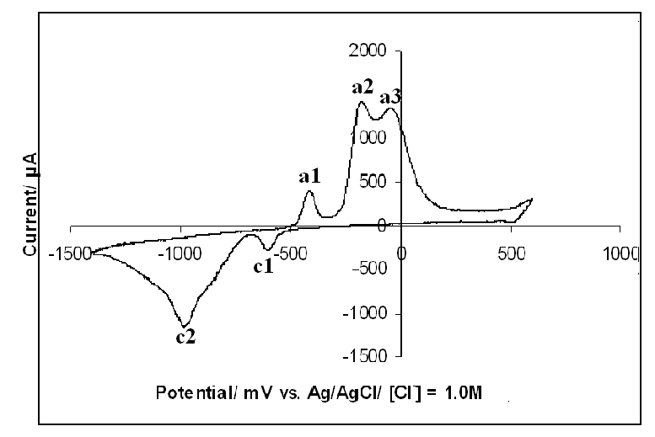
Fig. 1. Cyclic voltammogram of a 1-piaster Jordanian coin in 1.0 M KOH, recorded at scan rate of 50 mV/s.
The variation between the voltammograms of five sample coins was insignificant. The average peak potentials for the three main anodic peaks (peaks labeled a1, a2 and a3 in Figure 1) are -0.417 V, -0.112 V, and -0.050 V respectively. The average cathodic peaks (peaks c1 and c2 in

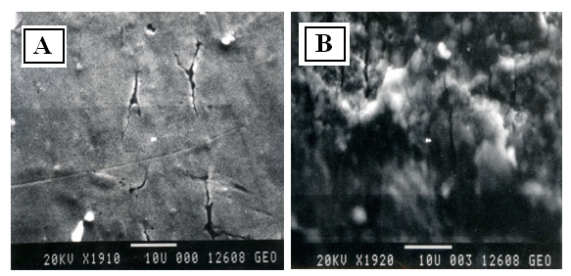
Fig. 2. SEM micrographs of the 1-piaster of A) a new coin surface. B) Old coin surface.

Figure 1) are centered at -0.600 V and -0.991V respectively. Comparing the voltammograms of the piaster coins with the voltammograms of polycrystalline copper metal revealed that the volatammograms of the piaster coins were very similar to the voltammogram of polycrystalline copper electrode [13].
Investigation of peak current (i_{p}) as a function of the scan rate revealed that all peak currents are proportional to the scan rate rather than (scan rate)^{1/2} which ensures that all peaks are associated with surface processes[11]. Variation of scan rate between 50 and 150 discloses that the best scan rate
in terms of the resolution of the peaks is around 50 mV/s.
Figure 2 shows the SEM micrographs for one of the sample coin collected from the market (referred to as the old coin) and the voltammogram for a coin obtained from CBJ (referred to as the new coin). The micrographs indicate that the surface of the old coin is rougher than the new coin. Chemical etching in nitric acid, however, seems to reduce the variation between the voltammograms of the coin samples.
The 10-piaster, the 5-piaster coins and the 2.5-piaster coins
The composition of the 2.5-, 5-, and 10-piaster coins as declared by CBJ is nickel-plated steel. Since these coins have the same chemical composition, only characterization of the 5-piaster coin was conducted.
The 5-piaster coin weighs 5.00 g, has a disk shape with 26.00 mm diameter.
Figure 3 shows an example voltammogram for the 5-piaster coin. The voltammogram shows two 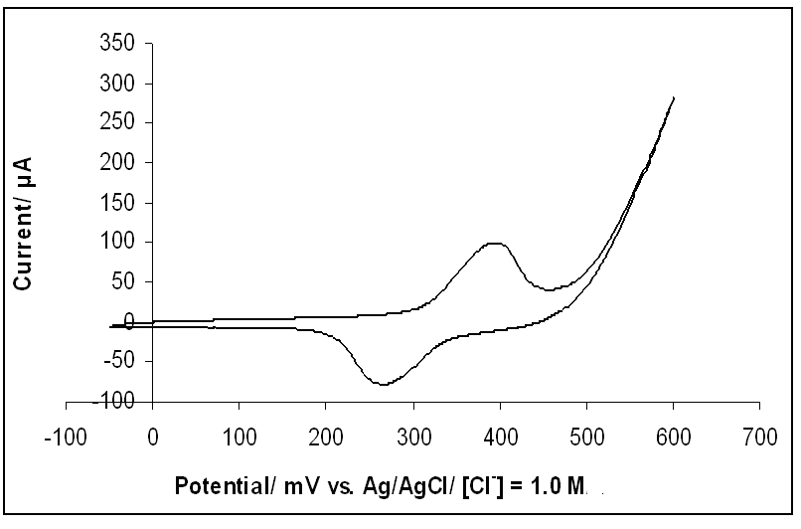Fig. 3. Cyclic voltammogram of the 5-piaster Jordanian coin in 1.0 M KOH, recorded at scan rate of 50 mV/s.
peaks; an anodic peak and a cathodic peak related to surface oxidation and reduction of the surface oxide. The variation between the peak potentials for the different samples is insignificant. The average peak potential for the anodic peak is 0.399 0.005V while the average peak potential for the cathodic peak is 0.280.01 V.
The voltammogram is similar to the voltammogram of nickel electrode produced under the same experimental conditions. The peak potentials of the sample coins and the nickel wire have the same anodic and cathodic peaks potentials but they differ in the peak sharpness and the peak width. The peak width of the nickel-plated sample coins is larger than that of the pure polycrystalline nickel electrode.
Investigation of the peak heights; the anodic peak current, i_{pa}, and the cathodic peak current, i_{pc}, revealed that i_{pa} and i_{pc} are proportional to the potential scan rate which indicates that the peaks on the voltammograms are associated with surface processes rather than bulk processes.

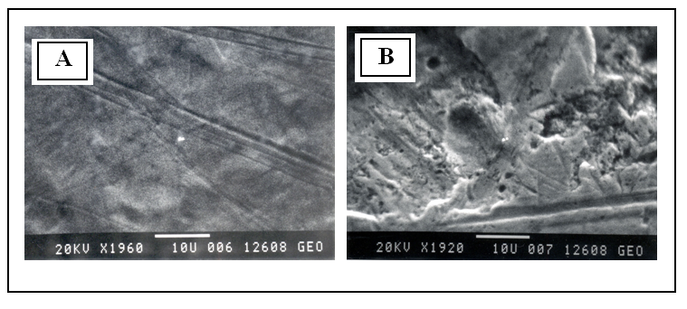
Fig. 4. SEM micrograph of the 5-piaster coin surfaces surface of A) a new 5-Piaster coin.B) an old 5-Piaster coin.

Figure 4 shows the SEM micrographs for an old coin collected from the market along with the SEM voltammogram of a new coin obtained directly from CBJ. The figure shows higher roughness degree for the old coin which is attributed to the effect of oxidation and handling between people hands. Despite the difference between the coins samples in roughness but there was no difference in the voltammograms because the voltammograms are insensitive to macroscopic long-range topographic differences. Moreover, it seems that the outer layers were removed by the applied chemical etching.
The quarter (25-piaster) coin
The quarter (25-piaster coin) is an alloy composed of 5.5% nickel, 24.5% zinc and 70.0% copper. The coin has a diameter of 26.50 mm, a mass of 7.40 and a density of 8.3  0.8 g. Figure 5 shows a representative voltammogram for the quarter coin
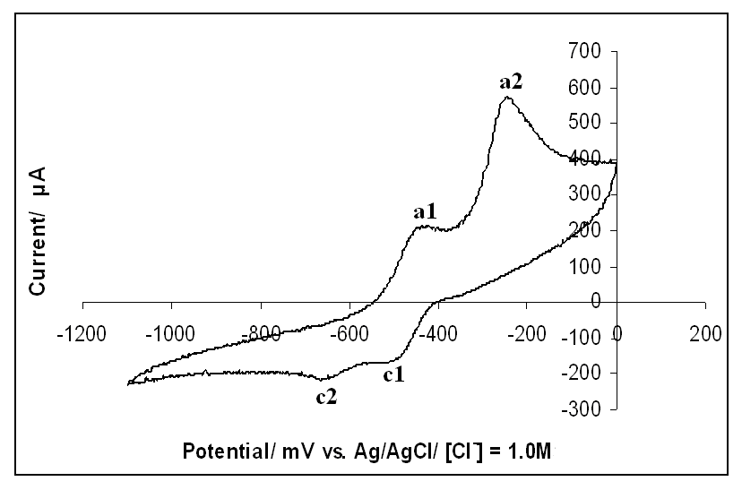
Fig. 5. Cyclic voltammogram of the quarter Jordanian coin in 1.0 M KOH, recorded at scan rate of 20 mV/s
The voltammogram shows two anodic peaks and their counter cathodic peaks. The peak potentials are E_{pa1} = -0.458 V, E_{pa2} = -0.263 V, E_{pc1} = -0.660 V and E_{pc2} = -0.483 V). There is an insignificant change between investigated samples in terms of the peak potentials. The standard deviation values for the four peaks E_{pa1}, E_{pa2}, E_{pc1}, and E_{pc2} are 0.003, 0.002, 0.002 and 0.004 respectively. The dependency of i_{p} for the four peaks was found to be, i_{p}  ν , where ν is the potential scan rate. The optimal scan rate in terms of peak resolution was 20 mV/s.
Figure 6 shows the SEM micrographs of two quarter coin samples, one of them is an old sample, collected from the market and another new sample supplied by CBJ. The surface of the old sample looks very rough compared with the SEM of the new coin. Though there is a difference between the SEM micrographs of the coins, the voltammograms were not affected by the roughness of the samples because cyclic voltammetry is not sensitive to macrotopography of the surface and the chemical etching was efficient in removing the impurities and the oxide from the outer surface layers.
The half-dinar coin
The half-dinar Jordanian coin is composed of an outer ring and an inner disk. The outer ring is composed of 29% copper, 2% nickel and 6% aluminum while the inner ring is composed of 75% copper and 25% nickel. The mass of the half-dinar coin is 9.60 g, its diameter is 29.00 mm and its density is 5.7 0.8 g/cm² for the outer ring and 8.3  0.8 g/cm³ for the inner disk.

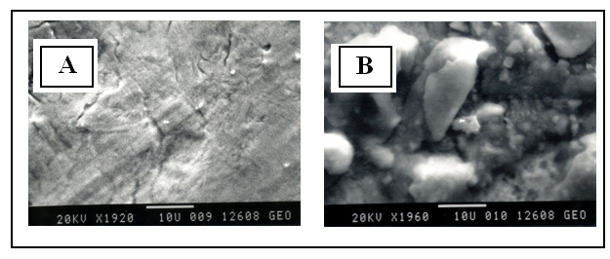
Fig. 6: SEM micrograph of the 25-piaster (quarter) coin surface of A) a new 25-Piaster coin B) an old 25-Piaster coin.
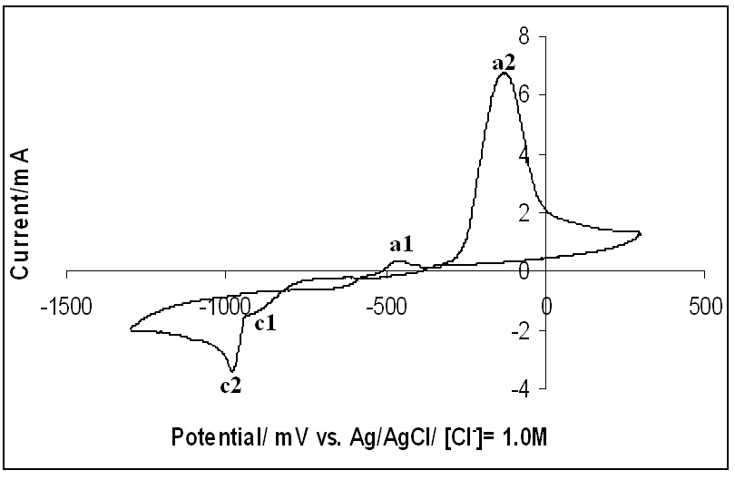 | 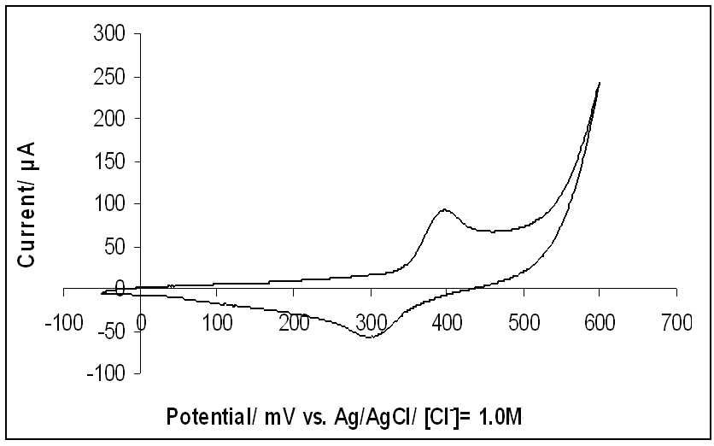
Fig. 7. Cyclic voltammogram of outer ring of the half-dinar Jordanian in 1.0 M KOH, recorded at scan rate of 10 mV/s. | Fig. 8. Cyclic voltammogram of the inner ring of the half-dinar Jordanian coin in 1.0 M KOH, recorded at scan rate of 10 mV/s.

Figure 7 shows a distinct voltammogram of the outer ring of the half-dinar coin. The voltammogram, though displays a similarity to the voltammogram of pure copper electrode, it shows unique distinct voltammetric features of the alloy it represents. There are two anodic peaks, one of them is a small peak appears at -0.450 V (a1) and another prominent anodic peak centered at -0.124 V (a2). On the negative-going scan, two cathodic peaks appear at -0.992 (c1) and -1.098 V (c2). Thevariation in peak potentials is insignificant as indicated by the standard deviation values, ±3, ±5, ±6, and ±2 mV for E_{pa1}, E_{pa2}, E_{pc1}, and E_{pc2} respectively. The peak potentials were independent of the scan rate as expected from surface processes while the peak currents were directly proportional to the scan rate, i_{p}  ν.
Figure 8 shows a representative voltammogram of the inner disk of half-dinar coin. The voltammogram shows only one anodic peak and its counter cathodic peak. The anodic peak is centered at 0.400 V while the cathodic peak is centered at 0.300 V. The variation between the six tested samples was insignificant as indicated by the values of the standard deviation for the anodic and cathodic peaks, ±0.005 and ±0.004 respectively. The peak potentials were also independent of the scan rate while peak currents showed direct proportionality with scan rate which indicates that these peaks are associated with surface rather than bulk processes. Though the coin is composed of 75% copper and 25% nicked, the voltammogram displays great similarity to nickel. This result is notunexpected because nickel is electrochemically more active than copper.
Conclusions
The cyclic voltammograms for the tested Jordanian coins were obtained under optimized conditions in terms of the composition of the supporting electrolyte and potential scan rates. A distinct voltammogram was obtained for each coin that is insensitive to the lifetime of introduction of the coin to the market. The voltammetric features were very indicative of the coin. When combined with the other physical properties of the coin like the mass, the diameter, and specific gravity, cyclic voltammetry can be used as a an inexpensive, reliable, simple and fast method for characterization of coins.
Acknowledgements: The authors would like to thank Miss Wafa Hourani for the invaluable comments and revising the manuscript.
References
1. I. Calliari, M. Magrini, A. Zambon, P. Guerriero, R. Martini, X-Ray Spectrum., 28, 68 – 90 (1999).
2. A. Denker, W. Bohne, J.Opitz-Coutureau, J. Rauschenberg,J. Röhrich, E. Strub, Nuclear Instr.Methods Physics Research B, 329, 65-70 (2005).
3. M. Ponting, J.A. Evans, V. Pashley, Archaeometry, 45,591(2003)
4. G. Giovannelli, S. Natali, B. Bozzini, A. Siciliano, G. Sarcinelli, R. Vitale, Archaeometry, 47, 817 (2005)
5. Lei Junfeng, Zeng Libo, Tong Hua, Yu Xiaoming, Liu Juntang, Hu Jiming, Microchim.Acta, 142, 123 (2003).
6. E.H. Bakraji, A. Sarhell, Nuclear Science Techniques, 10, 61 (1999)
7.V. Vijayan, R.K. Choudhury, C.B. Patel, Int.J.
PIXE, 15, 323 (2005).
8.A. Kyek, F.E. Wagner, G. Lehrberger, Q.A. Pankhurst, B. Ziegaus, Hyperfine Interactions, 126, 235 (2000).
9. N. Souissi, L. Bousselmi, S. Khosrof, E. Triki, Materials Corrosion, 55, 284 (2004)
10. J. E. Soto, D. Li, J. Sanabria, M.P. Soriaga, J. Mol. Struct., 890, 298 (2008)
11. A. Bard, L. Faulkner, Electrochemical Methods: fundamentals and Applications, Wiley: New York, 2004.
12. www.cbj.gov.jo
13. S.M. Abd el Haleem, Badr Ateya, J. Electroanal. Chem,117,309,(1981).

Електрохимично охарактеризиране на йордански монети

М.К. Хурани , А.И. Уехбе
Департамент по химия, Йордански университет, Аман 1942 – Йордания
Постъпила на 5 юли, 2012 г.; Приета на 12 февруари, 2013 г.
(Резюме)
Използвана е циклична волтамперометрия за охарактеризирането на йордански монети. Четири различни монети с различен състав са изследвани: пиастър, шелинг (от 5 пиастра), куартер и половин динар. Монетите са взети от обращение или са взети като нови от Централната банка на Йордания. Всяка от тях показва различна волтамперограма, което се обяснява с различния им състав. Волтамперограмите представляват “електрохимични спектри” или волтамперични “подписи” на монетите. Волтамперограмата на пиастъра, който представлява покрита с мед неръждаема стомана е твърде сходна с тази на медта. Шелингът, който представлява покрита с никел неръждаема стомана има волтамперограма сходна с тази на никела. Останалите монети също показват волтамперограми, сходни на тези на металите, от които са направени.

