Chemical characterization and statistical analysis of heavy metals produced discharges from South Pars Gas offshore for dispersion modeling
S.H. Fatemi^{1*}, A.H. Javid², P. Nasiri¹, M. Mirilavasani¹
¹Graduate School of Environmental Engineering, Science and Research Branch, Islamic Azad University, Tehran, Iran
²Graduate School of Marine Science and Technology, Science and Research Branch, Islamic Azad University, Tehran, Iran
Received June 26, 2015, Revised September 10, 2015
The most significant energy development project, the South Pars field, produces about 44 percent of total natural gas in Iran. Discovered in 1990 and located 62 miles offshore in the Persian Gulf, South Pars has a 24-phase development scheme. Phases 1-10, which are in production mode and are allocated for the domestic market for consumption and reinjection for EOR Produced water is the largest effluent discharge associated with South Pars offshore gas production. The total volume of produced water effluent is expected to increase with future anticipated development of offshore gas reserve. The environmental impact potentially caused by produced water is related to the fate and transport of its individual components including organic and inorganic compounds (e.g., petroleum hydrocarbons, heavy metals, nutrients, natural radionuclides) associated with the formation water and treating chemicals. Although produced water discharges are associated with rapid dilution and low-to-trace levels of pollutants, the potential for cumulative toxic effects under regional ocean currents warrants a need to assess the long-term risks to the marine ecosystems. In this paper at first the quantity and quality of produced water are measured and reported for one year and some statistical reviews has done. Determination of the heavy metals of effluent water - extraction and infra-red spectrometric and OSPAR reference method which is the standard method for dispersed heavy metals in produced water analysis in the UK for both oil and gas facilities used as standard method. Advection, diffusion and fate of heavy metal by wind and tidal currents and transport are indirectly taken into account in this study. Hydrodynamic, heavy metal and path of the heavy metal in Offshore Gas Platforms in South Pars Gas Field in 3 month has been simulated.
Keywords: Heavy Metals, Dispersion, Statistical, Analysis, Modelling, Persian Gulf

INTRODUCTION
Increasingly, offshore outfalls are being used for the disposal of wastewater in coastal areas. Because the discharged effluents generally exert different velocity, temperature, and density compared with the receiving water body, waste discharges form plumes and jets with high momentum and different densities [1,2,3]. The mixing and dispersion processes of a continuous discharge into a receiving water body can be divided into near-field, far-field, and intermediate regions according to length and time scale. In the vicinity of the discharge point, the jet trajectory and mixing are dominated by the momentum of the discharges and the density differences between discharges and the receiving water body. This region is referred to as the near field, where the typical time and length scales of the plume are in the order of minutes and water depths (tens to hundreds of meters), respectively.
To whom all correspondence should be sent:
E-mail: hamidrezafatemi@yahoo.com;
© 2015 Bulgarian Academy of Sciences, Union of Chemists in Bulgaria
After some time, or some distance, from the discharge point, the influence of the inflow characteristics dissipates and ambient flow conditions then control transport and mixing of the discharges. This region, where the diluted effluents are diffused with ocean currents, is referred to as the far field, where the typical time and length scales are in the order of hours and kilometers. Between these two regions, there is a zone called the intermediate field, which starts at the end of the jet regime [2,4,5]. The intermediate field may extend over distances greater than the water depth under conditions of weak ambient flow; however, under strong ambient conditions, intermediate-field processes can be far less significant than far-field dispersion processes. There is increasing environmental concern over the ocean discharge of contaminants, such as metals and hydrocarbons, in produced water because of their potential for bioaccumulation and toxicity, particularly by those dissolved in the water phase. It is noted that hydrocarbons and heavy metals show different fate and transport mechanisms due to their differences in physico-chemical properties. Low concentrations of hydrocarbons in a large discharge of produced water can be rapidly diluted by tidal currents and decay over time due to aerobic degradation. Thus, the effects of hydrocarbons associated with produced water discharges are primarily linked to localized areas and unlikely to cause large-scale environmental impacts. In contrast, a large number of heavy metals are stable, environmentally persistent, and highly toxic. Furthermore, they can be accumulated by marine life in concentrations several thousand times higher than those in the surrounding seawater [3]. For example, lead (Pb) is a highly toxic metal with persistent adverse effects in the marine ecosystem, and the toxic effects on shell_ sh can occur even in the presence of a very low concentration of Pb [5, 6, 7].
Produced water is the largest volume waste stream in the exploration and production process of oil and gas. Over the economic life of a producing field, the volume produced water can exceed by ten times the volume of hydrocarbon produced. During the later stages of production, produced water can account for as much as 98 % of the extracted fluids. Typical water production rates from oil platforms are from 2 400 to 40 000 m³/day and for gas platforms 1, 6-30 m³/day [6, 8]. These amounts to an expected discharge of produced water to the North Sea in 1998 of 3, 4 x 108 m³. When discharged the produced water still contains a wide range of components: dissolved organic components, various production chemical trace metals, naturally occurring radioactive material, inorganic salts. In addition the discharged water is almost depleted for oxygen and has an average COD or BOD value of 4 000 mg O₂/l [5, 8, 9, 10]. In addition to the organic components trace elements as Pb, Cd, Cu, Hg, Ni, Zn, As and Cr are dissolved in the produced water in considerably greater concentrations than in sea water [11, 12].
In this field, 11 platforms (we know as SPD) are in production mode and very platforms normally have 10-12 gas wells. The layout and configuration of these platforms has shown in Fig.1.
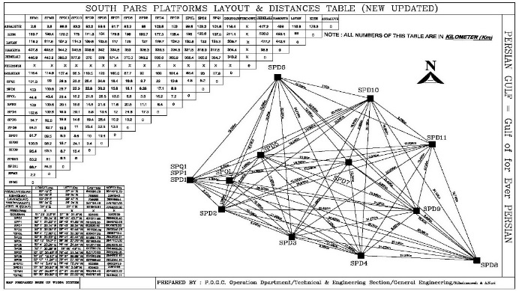
Fig. 1. The South Pars Gas Platforms layout
On the platforms, in process diagram separated water from the FWKO (Free Water Knock Out) drums and Coalesces is routed to the Oily Water Treatment Package that is common to both trains [13]. Typical produced water flow diagrams of platforms which are studied are shown in Fig.2.
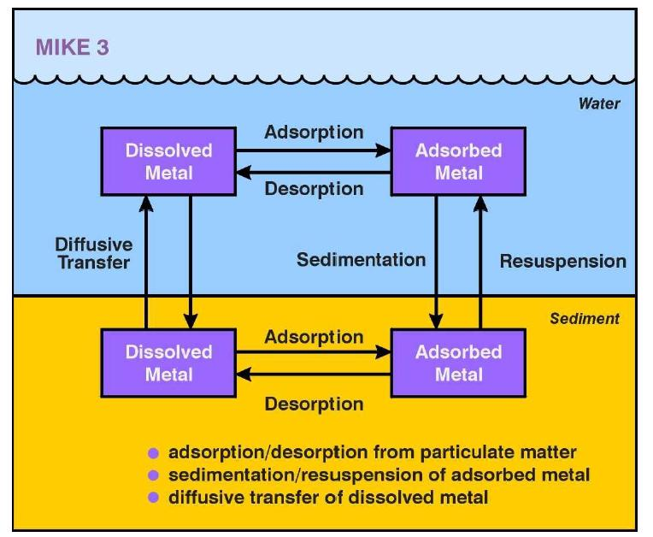
Fig. 2. Typical produced water flow diagram of platforms and Heavy Metal Changes in Sea
The package is designed to process a feed rate of 2000 bpd (barrels per day) liquids and to reduce suspended oil in water content of the separated water to 40 ppm wt. max [8]. Prior to disposal overboard via a disposal caisson. The Oily Water Treatment Package comprises:
- Hydro cyclones (two per FWKO Drum – one operating, one installed spare - and one for Test Separator).
- A water degassing drum – this handles the water from the hydro cyclones and the coalescing vessels. Reject oil from the hydro cyclones enters directly into the oil compartment of the drum.
- Filters and coalescer filters – these handle water from degassing drum before discharge to sea.
The treated water from the coalescer filters is discharged to the sea via the caisson. The reject stream from the OWTP (recovered condensate in water) is recycled back to the inlet of the FWKO Drum via the Flare KO Drum and Condensate Injection Pumps, due to its high water content.
METHOD
The data of produced water discharges and analytical results are gathered through one year and a statistical review has done. The IP 426:98 (04), Determination of the oil content of effluent water - Extraction and infra-red spectrometric and OSPAR Reference Method which is the standard method for dispersed oil in produced water analysis in the UK for both oil and gas facilities used as standard method (See Figure 3).
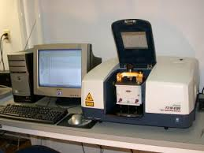
Fig.3. Infra-red spectroscope
In this method a sample of the discharge water to be analyzed is acidified to a low pH (<2), extracted with two volumes of Tetrachloroethylene (TTCE) or an alternative solvent approved by DECC, and the IR absorbance measured using an infrared analyzer with a fixed wavelength of 2930 cm⁻¹. The oil content of the sample is determined by comparison of the infrared absorbencies of the extract against a calibration graph prepared using a series of standards containing a known heavy metals [9]. The SPSS software for statistical assessment is used for analysis of produced water rate and oil content in all platforms.
MEASUREMENT DATA
The quantity and quality of produced water are measured and reported for one year and assumed for modeling and some statistical reviews. Table 1 includes oil content of produced water discharge and heavy metals within 3 months on the platform no5. An average of daily BBL of produced water discharges per each platforms and average of heavy metals components are shown in Table 1.
Statistical review by SPSS started with Manova method for 8 platforms heavy metals data in 26 times measurement. It assumed that sampling was random and error of first type was a=0.05.
This analysis shows that data of platforms are acceptable and useful for input of mathematical modeling which is an effective tool for the management of Persian Gulf operational platforms’ oily water discharges. Two soft wares; MIKE 21/3 (DHI 2007) and Delft3D (Delft3D 2009) are proposed software’s for predictions of ocean hydrodynamics; pollutant fate and transport in the far field; water quality and sediment processes (See Figure 4 and Figure 5).
MODEL SETUP
To order the model input data the bathymetry is used by structure distances of geographical width 2 minute in Southern- Northern direction, and the geographical 2 minute in Western-Eastern direction related to ETOPO1 altimetry data in NOAA site. So by the use of these data in 0.10 structure, the altimetry features of the place is counted and rendered in model (Fig. 4 and Fig. 5). Tidal surface elevation in Hormoz station utilized for Flow Model FM boundary condition that shown in Fig 5. By using Particle Tracking model of MIKE21, DHI, path of heavy metal has been simulated.
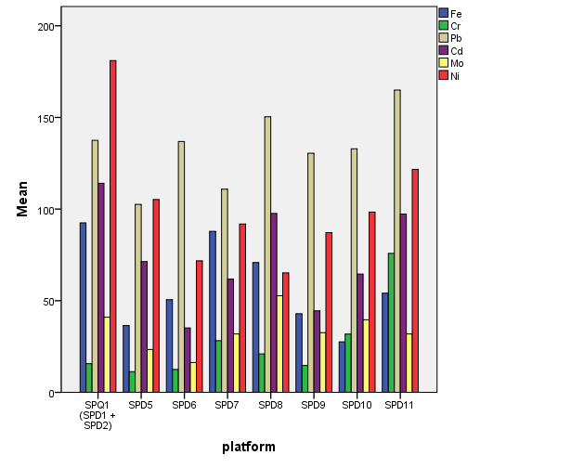
Fig.4. Measurement data gathering in gas platforms

Table 1. Data of heavy metals in platforms no. 5
Fe | Cr | Pb | Cd | Mo | Ni
101 | 11 | 146 | 129 | 55 | 200
99 | 12 | 150 | 111 | 50 | 201
97 | 15 | 134 | 100 | 48 | 199
90 | 9 | 135 | 120 | 48 | 188
90 | 10 | 142 | 118 | 44 | 189
92 | 11 | 141 | 117 | 34 | 199
98 | 17 | 120 | 110 | 30 | 167
100 | 14 | 122 | 120 | 46 | 168
86 | 19 | 160 | 121 | 43 | 155
93 | 23 | 165 | 119 | 42 | 185
90 | 15 | 133 | 101 | 46 | 183
81 | 15 | 133 | 102 | 48 | 190
81 | 15 | 140 | 109 | 40 | 199
78 | 17 | 138 | 115 | 38 | 193
78 | 18 | 132 | 114 | 37 | 188
102 | 17 | 119 | 115 | 34 | 193
102 | 11 | 123 | 119 | 43 | 170
93 | 10 | 125 | 118 | 39 | 173
95 | 16 | 140 | 117 | 51 | 190
99 | 16 | 139 | 110 | 33 | 177
92 | 16 | 147 | 103 | 39 | 160
91 | 15 | 148 | 111 | 41 | 161
100 | 23 | 134 | 124 | 40 | 171
103 | 22 | 130 | 127 | 31 | 155
88 | 21 | 136 | 109 | 34 | 163
85 | 20 | 143 | 107 | 32 | 190

Table 2. Multivariate Tests
Effect |  | Value | F | Hypothesis df | Error df | Sig.
Intercept | Pillai's Trace | .999 | 38754.175ª | 4.000 | 197.000 | .000
Intercept | Wilks' Lambda | .001 | 38754.175ª | 4.000 | 197.000 | .000
Intercept | Hotelling's Trace | 786.887 | 38754.175ª | 4.000 | 197.000 | .000
Intercept | Roy's Largest Root | 786.887 | 38754.175ª | 4.000 | 197.000 | .000
Platform | Pillai's Trace | 1.686 | 20.822 | 28.000 | 800.000 | .000
Platform | Wilks' Lambda | .002 | 109.934 | 28.000 | 711.716 | .000
Platform | Hotelling's Trace | 149.993 | 1047.271 | 28.000 | 782.000 | .000
Platform | Roy's Largest Root | 148.352 | 4238.641^{b} | 7.000 | 200.000 | .000
a.Exact statistic b. The statistic is an upper bound on F that yields a lower bound on the significance level.
c. Design: Intercept + platform

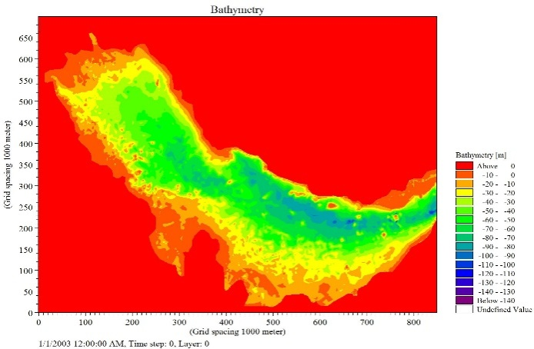
Fig. 5. Bathymetric data particle tracking models.
RESULTS
In this research hydrodynamic parameters such as tidal surface elevation that measured in in Daiier Port have been used for model validation. Compare between numerical results and field measurements shown a good agreement between numerical results and field measurements in Daiier Port. Hydrodynamic results of model have been shown in Fig 6. The model shows the tracking of heavy metals from in offshore gas platforms in South Pars Gas Field for 6 month (See the 4 Shapes in Fig 6). Dispersion modeling of heavy metals, which includes hydrodynamic model and qualitative water model from produced water which has been done for a year for each discharge location.
CONCLUSIONS AND DISCUSSION
Gathering of sound and acceptable data for modeling is very important step of work. In this paper we submit a few tables of data which has produced by standard sampling and lab tests. Then a statistical review report has submitted based on SPSS software and it proved that these data are useful for next step of modeling. In this paper at first the quantity and quality of produced water are measured and reported for one year and some statistical reviews has done.
In addition to the organic components trace elements as Pb, Cd, Cu, Hg, Ni, Zn, As and Cr are dissolved in the produced water in considerably greater concentrations than in sea water the risk assessment of that high environment risk near Booshehr seaside and transition of heavy metals was indirect of northwest of Persian gulf.

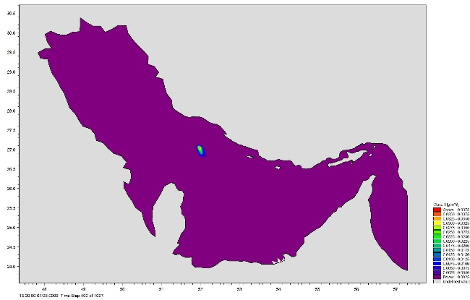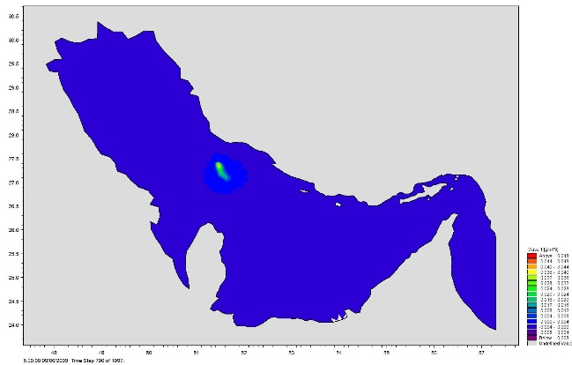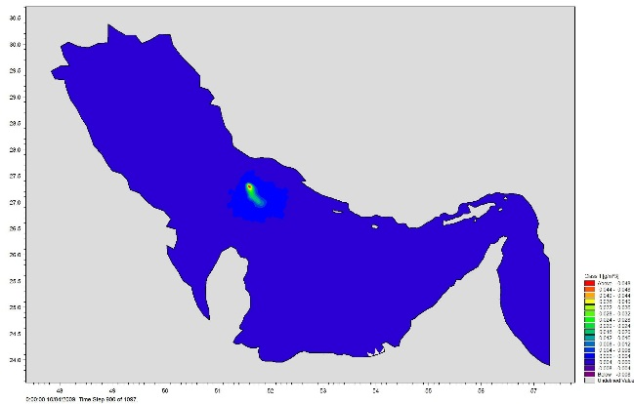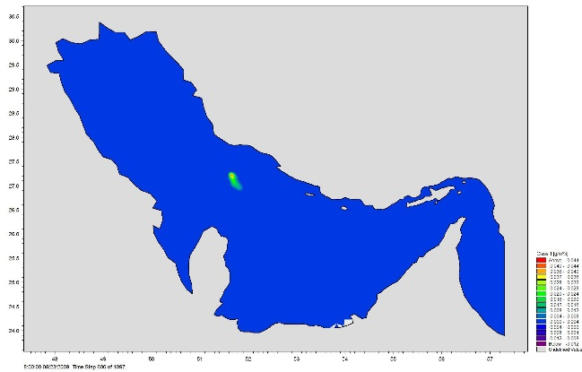
Fig. 6. Tracking of heavy metals from in offshore gas platforms in South Pars Gas Field for 6 month.

REFERENCES
1. P. Tkalich, X. B. Chao, Proceedings of the International Oil Spill Conference, 26-29 March 2001, Florida, Washington DC, 2001, p. 1133.
2. J.A. Fay, The Spread of Oil Slick on a Calm Sea, Hoult, D.P. (Ed), Oil on the Sea. Plenum Press, New York, NY, 1969, p. 53.
3. Perianez, R.2005, “Modeling the Dispersion of Radio Nuclides in the Marine Environment” Springer
4. D Mackay, S. Paterson, K. Trudel, A Mathematical Model of Oil Spill Behavior, Environmental Protection Service, Fisheries and Environmen Canada, 1980.
5. A. Johansen., Spill Technol. Newslett., III, 134 (1982).
6. M. Fingas, J. Advance Marine Technol., 11, 41 (1994).
7. A.J. Elliot, Deutsche Hydrographische Zeitschrift, 39, 113 (1986).
8. A. F.Blumberg, G. L .Mellor, A description of a three-dimensional coastal ocean circulation model. Geophysical Fluid Dynamics Program, Princeton University, Princeton, NJ, 1987.
9. G. W. Bryan, W. J. Langston, Environ. Pollut., 76, 89 (1982).
10. Z. Chen, G. H. Huang, J. of Environ. Eng. Div. ASCE, 129(1), 79 (2003).
11. J. R. Dojlido, G.A. Best, Chemistry of water and water pollution. Ellis Horwood Ltd, Chichester, UK. 1993.
12. P. Foster, Environ. Pollut., 10, 45 (1976).
13. P. A. Gillibrand, R .Stagg, W. R. Turrell, ICES CM/c , 11, 421 (1995).

