Modified graphite electrodes as catalysts for electroreduction of hydrogen peroxide
Bulgarian Chemical Communications, Volume 40, Number 3 (pp. 233–239) 2008
© 2008 Bulgarian Academy of Sciences, Union of Chemists in Bulgaria
E. Horozova¹*, T. Dodevska², N. Dimcheva¹
* To whom all correspondence should be sent:
E-mail: horozova@argon.acad.bg; dodevska@mail.bg
¹ Department of Physical Chemistry, Plovdiv University, 24, Tsar Assen St., 4000 Plovdiv, Bulgaria
² Department of Inorganic and Physical Chemistry, University of Food Technology,
26, Maritza Blvd., 4002 Plovdiv, Bulgaria
Received October 23, 2007, Revised February 15, 2008
The adsorption behaviour and electrocatalytic activity of compact graphite electrodes, modified only with micro-quantities of palladium or with a mixture of (Pd+Au), have been studied in the reaction of electroreduction of hydrogen peroxide. The influence of the following factors has been investigated: composition of the promoter, pH and tempera-ture of the working ambience on the electrocatalytic activity of the series of modified graphites at potentials of 0 and
–50 mV (vs. Ag/AgCl). The electrode modified with microquantities of (Pd+Au) mixed in a proportion of 70:30% exhibits optimal operational characteristics (electrode sensitivity, linear concentration area and low background currents).
Key words: modified graphite electrodes, hydrogen peroxide, electroreduction

Introduction
Research aimed at developing methods for detecting hydrogen peroxide is of great importance at present. On the one hand, this is connected with the wide application of hydrogen peroxide in various spheres of industry (food processing, textile, cosmetic, pharmaceutical industries and medicine), and on the other hand, it is an interim product both of environmental processes and biochemical reac-tions. Most of the known enzymes-oxydoreductases (e.g. glucose oxidase, xanthine oxidase, etc.) catalyze chemical transformations of their typical substrates, whereby hydrogen peroxide is produced beside the reaction product. The working principle of most amperometric biosensors is based on the detection of hydrogen peroxide generated in the enzyme oxidation of the substrate.
Monitoring hydrogen peroxide through reliable, expeditious and economical methods is of great significance for many processes. Spectrophoto-metric [1–3], enzyme [4], thermooptic [5], hemilu-miniscent [6, 7] and other techniques and devices are used to detect and monitor it. Analyses thus made are quite time-consuming, they are influenced by the analytes accompanying the hydrogen peroxide, and require very expensive reagents. Electroanalytical methods, with their long linear area of concentration dependence and fast response, are very appropriate. They are based on direct reduction or oxidation of hydrogen peroxide. Electrooxidation of hydrogen peroxide, however, is carried out at potentials, at which most of the components of the real samples (biological liquids, food, pharmaceutical, ecological samples) are co-oxidized as well, which substan-tially increases the quantitative determination of the substrate. That is why, a lot of research is aimed at searching of alternatives for improving the selec-tivity of the electrochemical detection of H₂O₂. A widely applicable strategy is the application (immo-bilization) of catalytically active substances on the surface of the electrode, such as metals, their oxides or complexes, enzymes, etc. [8–37]. The electrodes, thus modified, are included in electrochemical systems, based on registering the current generated in the electroreduction of hydrogen peroxide, and the process occurs at working potentials of about 0 mV (vs. Ag/AgCl). At such potentials the typical components of biological liquids, such as ascorbic acid, uric acid, glutathione, etc., are electroche-mically inactive.
The detection of hydrogen peroxide has been experimented with various modified electrodes: gold [8, 9], platinum [10], gold-palladium composite electrodes [11], electrodes of various kinds of carbon materials – graphite [12, 15], glass-graphite [13, 14, 17, 24], carbon-paste electrodes [14, 15, 18–20], etc. Improvement of the selectivity of the electrochemical signal of hydrogen peroxide with these electrodes is achieved by using various cataly-tically active modifying components: transitional metals and their oxides [12–14]; platinum metals dispersed separately [15, 21], mixed with other platinum metals [8, 16, 17], in polymer films [10], together with Prussian Blue [22]; thiol and Nile Blue [9], etc. Especially popular in recent years have been the investigations for electroanalytical detection of H₂O₂ by using micro- and nanostruc-tured carbon films containing metal particles, such as platinum, nickel, copper, iridium and silver [23-25]. Most of the research on developing modified graphite electrodes is focused on their inclusion in electro- and bioelectrochemical systems, based on the electroreduction of H₂O₂. Peroxidase of horse-radish [26–29] and other vegetable peroxidases [29–31], immobilized mainly on carbon transducers, as well as some hem-containing proteins [31–34] are of interest because they are efficient catalysts of electroreduction of H₂O₂ at working potentials of about 0 mV (vs. Ag/AgCl, in neutral solutions) where the obstructing influence of by-analytes is eliminated. Despite the high selectivity and sensi-tivity of these biosensors, the low operational stabi-lity of the biocomponent makes them more suitable for the construction of single-use elements.
Micro- and nanostructured graphites with metals from the platinum group are alternative electrocata-lysts for the electroreduction of H₂O₂ at low working potentials [35], at which the interfering substances do not undergo electrochemical transformations [36]. In addition, their good characteristics (they can be stored for about a year and yet continue to have suf-ficient electrocatalytic activity [35, 36], high opera-tional stability in a wide pH range and a simple preparation procedure) make them promising electro-catalysts in developing amperometric sensors on the basis of electroreduction of H₂O₂ [37]. The aim of this work is to investigate the electrocatalytic acti-vity of graphite electrodes modified only with microquantities of Pd or with a mixture of (Pd+Au) in the reaction of H₂O₂ electroreduction.
Experimental
Inert pads of graphite type GMZ with a geo-metric surface S = 1.6–1.8 cm² (0.7×0.7×0.3 cm) were used. The structural characteristics of graphite are as follows: specific surface 0.8 cm²·g^{–1}, density 1.56–1.70 g·cm³ and porosity 20–25%. The graphite pads were kindly provided by Prof. Bogdanovskiy, the State University of Moscow, Russia. The graphite pads were modified with microquantities of platinum metals – sole palladium or palladium and gold mixed in the ratios (Pd:Au) 90:10%, 70:30%, 50:50%. The catalytically active components were deposited in a potentiostatic regime (E_{r}^{deposit} = +0.05 V vs. reversible hydrogen electrode) by a brief elec-trolysis (t_{deposit} = 10 s) from the following elec-
trolyte: Pd from 2% PdCl₂ + 0.1 M HCl and (Pd+Au) from 2% PdCl₂ + 2% HАuCl₄ + 0.1 M HCl in the above ratios (Pd:Au). The electrodes will be further denoted in the text as electrodes type A, B, C and D as follows:
Graphite modified with individual Pd (electrode type A);
Graphite modified with (Pd+Au) mixed in the ratio 90:10% (electrode type B);
Graphite modified with (Pd+Au) mixed in the ratio 70:30% (electrode type C);
Graphite modified with (Pd+Au) mixed in the ratio 50:50% (electrode type D).
All electrochemical measurements were per-formed in a three-electrode cell with separated com-partments (working volume 12–15 mL). An Ag|AgCl electrode was used as a reference electrode, and platinum wire – as a counter electrode. The electro-chemical setup also involved a bipotentiostat, type BiPAD (TACUSSEL, Villeurbanne, France); a generator, type EG-20 (Elpan, Lubawa, Poland); a digital voltmeter, type 1AB105 (ZPU, Pravets, Bul-garia); XY-Recorder (VEB, Messapparatewerk, Schlotheim, GDR); a thermostat UH (VEB MLW Prüfgeräte-Werk, Medingen, Germany); a pH-meter OP-208 (Radelkis, Budapest, Hungary). The solu-tions were bubbled with argon during the measure-ments.
Results and Discussion
Adsorption capacity and characteristics of the energy state of hydrogen, hemosorbed on the surface of modified graphite electrodes
The pure graphite pads, which do not contain metal phase have no hydrogen maxima of the poten-tiodynamic I-E curves (Fig. 1a and 1b, curves 1). At the same time, on the anodic potentiodynamic I-E curves of the graphites containing microquantities of Pd and (Pd+Au) in various proportions (electrodes type A, B, C, D) peaks in the desorption of hydro-gen are fixed. By integrating the area under the respective peaks in the range from –490 to –240 mV (vs. Ag/AgCl), and turning off the electricity for the purely graphite pads (the background current), the amount of electricity Q⁰_{H}, necessary for taking away the adsorbed hydrogen, was determined. From the value of Q⁰_{H}, provided the monolayer of H_{ads} is formed at E = –640 mV (vs. Ag/AgCl) to which a charge of 210 μC·cm^{–2}, the real surface of the electrodes was determined (Table 1).
E. Horozova et al.: Modified graphite electrodes as catalysts …

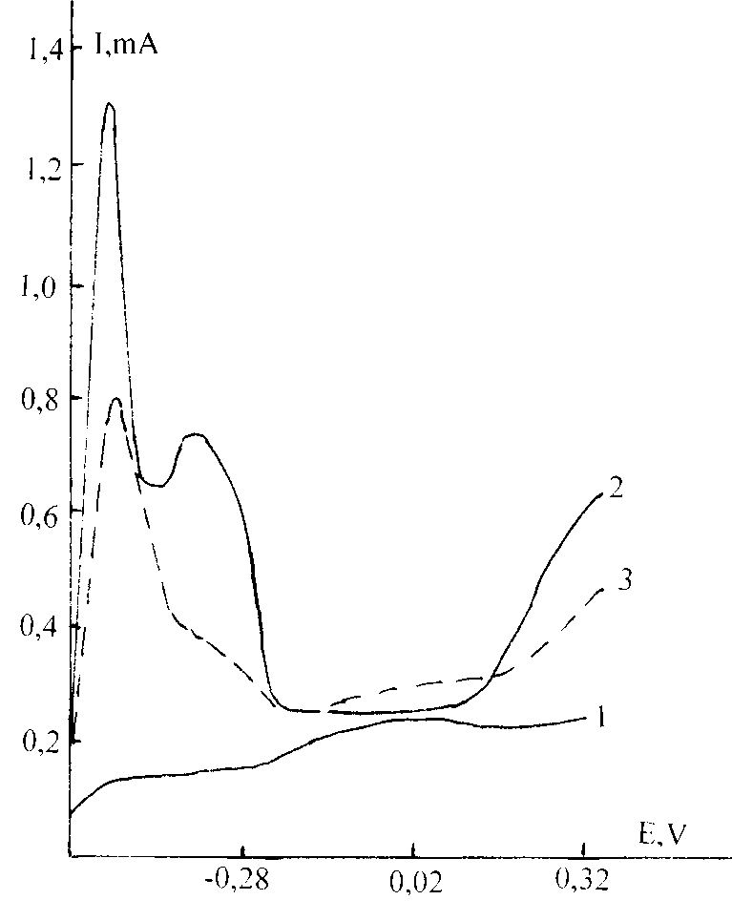 a 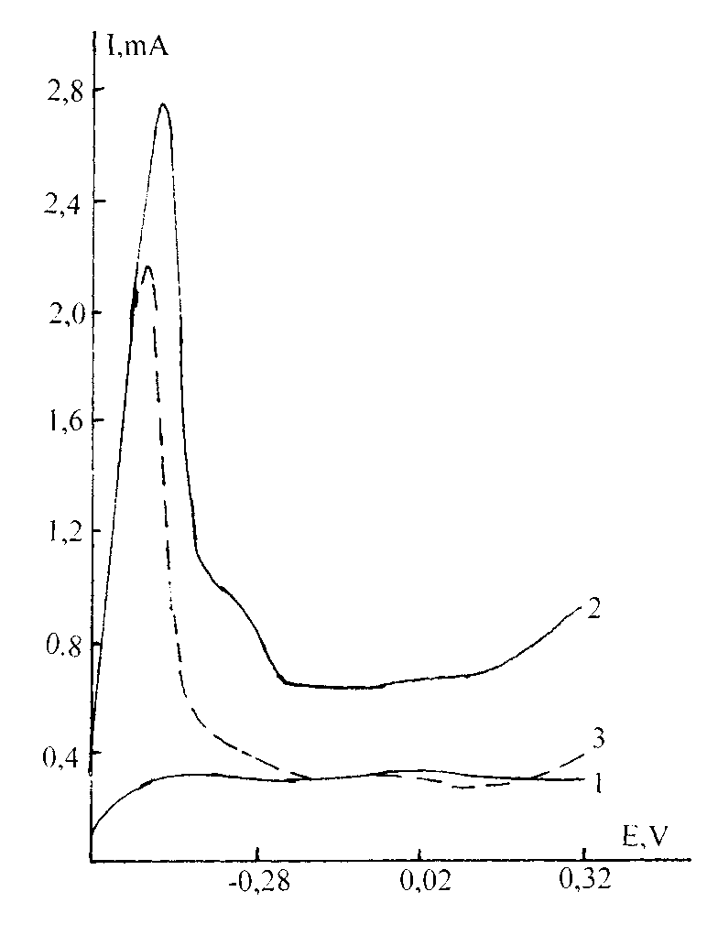 b
Fig. 1. a. Anodic potentiodynamic I-E curves of graphite electrode (curve 1); graphite electrode modified with Pd (curve 2) and graphite electrode modified with (Pd:Au 70:30%) (curve 3); background electrolyte 0.1 M phosphate-citrate buffer, pH 7.0; reference electrode Ag/AgCl; V = 10 mV·s^{–1}; b. Anodic potentiodynamic I-E curves of graphite electrode (curve 1); graphite electrode modified with (Pd:Au 90:10%) (curve 2) and graphite electrode modified with (Pd:Au 50:50%) (curve 3); background electrolyte 0.1 M phosphate-citrate buffer, pH 7.0; reference electrode Ag/AgCl; V = 10 mV·s^{–1}.
Table 1. Adsorption characteristics – real surface S_{real} and values of the desorption potentials of hydrogen E^{des}_{H} for modified graphite electrodes in phosphate-citrate buffer, pH 7.0; temperature 25ºC.
Electrode  type | $$Q_{H}^{0}×{\text{10}}^{3}, C$$ |  | S_{real.} , m² |  | $Е_{H}^{\text{des}\text{.}}, V$ (vs. Ag/AgCl)
Electrode  type | freshly prepared | After ageing | freshly prepared | After ageing | 1st peak | 2nd peak
type А | 10.71 | 9.66 | 51 | 46 | –0.52 | –0.37
type В | 3.94 | 3.26 | 18.76 | 15.52 | –0.45 | –0.30 check
type С | 8.51 | 4.95 | 40.88 | 23.57 | –0.43 | -
type D | 1.91 | 1.6 | 9.08 | 7.62 | –0.48 | -

The adsorption capacity of the modified graphites is considerably dependent on the microaddition of Au to the catalytically active component – the microquantities of palladium. It decreases with the increase of the Au additive to the microquantities of Pd (Table 1), both for the freshly produced electrodes and for the electrodes after ageing. In comparison to the electrode modified only with Pd microquantities (type A), in the case of the graphite, modified with a mixture of (Pd+Au) microquantities in the ratio 50:50% (type D) Q⁰_{H}, respectively the real surface (S_{real}), is reduced 6 times. S_{real} of the modified graphites (types A, B, C and D) after ageing of 3–4 weeks is reduced as a result of recrystallization. The data provided in Table 1 show that depending on the type of the modifying com-ponent the decrease of S_{real} after ageing varies. For the type A electrode (modified with microquantities of Pd only) it is only 10%, whereas for the elec-trodes of types B, C and D (modified with Pd+Au mixtures) the decrease is as follows: for electrodes types B and D the decrease of S_{real} is 16–17%, and for electrode type C – 42%.
The energy spectrum of hydrogen adsorption of the electrodes under survey also depends on whether they have been modified with microquantities of Pd only or with microquantities of (Pd+Au). On the anodic potentiodynamic curve (Fig. 1a, curve 2) of the graphite modified with palladium microquan-tities only (type A), two peaks are observed which correspond to two forms of adsorbed hydrogen – weakly linked at a potential of –0.52 V, and strongly linked at a potential of –0.37 V. With the change of the composition of the modifying catalytically active component of Pd microquantities only to (Pd+Au) mixture (in different proportions), the second form of adsorbed hydrogen disappears. On the potentiodynamic curve of the type B electrode (Fig. 1b, curve 2), only one hydrogen maximum can be seen at a potential of –0.45 V, and a check at a potential of –0.30 V. This check of the I-E curves for the electrodes type C (Fig. 1a, curve 3) and type D (Fig. 1b, curve 3) disappears, that is, they are characterized by only one form of adsorbed hydrogen – for type C at a potential of –0.43 V, and for type D at a potential of –0.48 V.
E. Horozova et al.: Modified graphite electrodes as catalysts …
A comparison of the values of the potentials of hydrogen desorption E^{des}_{H} for the electrode type A with those for the electrodes types B, C and D, shows that the modification of graphite with micro-quantities of (Pd+Au) mixed in different propor-tions, leads to a shift of E^{des}_{H} in anode direction, that is for electrodes types B, C and D, the energy of the bond Pd – H is increased.
Electrocatalytic activity of modified graphites
Figure 2 shows the polarization curves of the electroreduction of hydrogen peroxide on graphite electrodes modified with microquantities of Pd only, and with (Pd+Au) mixture (electrodes types A, B, C and D) in the potential range of –300 to +250 mV (vs. Ag/AgCl). In this potential region, cathode currents of electroreduction of hydrogen peroxide have been registered only for the four modified graphite electrodes, whereas for the purely graphite pad (empty squares) and for graphite modified only with microquantities of gold (crosses) such currents have not been observed.
The polarization curves presented for the elec-trodes type A, B, C and D show intervals of poten-tial where the current hardly varies (a “plateau region”). These plateau regions are strictly dependent on the type of catalytically active component (microquantities of Pd alone, or Pd combined with Au in the ratios – 90:10%, 70:30%, and 50:50%).
E. Horozova et al.: Modified graphite electrodes as catalysts …
For the graphite electrode modified only with microquantities of Pd (type A, empty triangles), the plateau region is from –50 to +50 mV; for the electrode type B (solid squares) this range is from -100 to +150 mV, and for the type D graphite (asterisks) – from –50 to +150 mV. Type C electrode (empty circles) is characterized by a wider plateau from around -150mV to around +150 mV.
For all types of modified graphites, the depend-ence of the electrode signal (cathode current) on the
concentration of the hydrogen peroxide was investi-gated at two potentials from the range of the plateau – 0 mV and –50 mV in buffer solutions at pH 7.0 and 8.4. The electrode signal, which increases linearly with the substrate concentration (calibration graph, n = 3), and the sensitivity (determined as the slope of the linear part, dI/dC), depend on the nature of the catalytically active component, deposited on the graphite (Table 2).
Fig. 2. Steady-state current as a function of potential applied at modified graphites when 0.1 mM H₂O₂ is present; electrodes: Δ - type A; ■ - type B; ○ - type C;
∗ - type D; background electrolyte 0.1 M phosphate-citrate buffer, pH 7.0; reference electrode Ag/AgCl; temperature 25ºC.
For all four types of modified graphite, the sensi-tivity increases as the potential becomes more negative. The signal obtained at –50 mV is higher than that registered at 0 mV, as follows: for electrode type A it is 1.5 times higher (in phosphate-citrate buffer, pH 7.0); for electrodes types B and C – 1.2 times (both in phosphate-citrate buffer, pH 7.0, and for phosphate buffer pH 8.4); for electrode type D – 1.4 times (in phosphate-citrate buffer, pH 7.0) and 1.7 times (in phosphate buffer, pH 8.4).

Table 2. Basic operational characteristics of graphite electrodes modified with microqantities of Pd or mixture of (Pd+Au) during hydrogen peroxide electrochemical reduction; temperature 25°C; phosphate-citrate buffer pH 7.0 and phosphate buffer pH 8.4.
Potential,  mV  (vs. Ag/AgCl) | Electrode sensitivity, μА·μМ^{–1**} |  |  |  | Linear range, μМ***
Potential,  mV  (vs. Ag/AgCl) | Electrode type |  |  |  | Electrode type
Potential,  mV  (vs. Ag/AgCl) | A | B | C | D | А | В | С | D
–50 | 0.56 | 0.30 | 0.86 | 0.34 | 10–500 | 10–750 | 10–1270 | 10–840
 |  | 0.27* | 0.81* | 0.30* |  | 10–1130* | 10–1270* | 10–680*
0 | 0.38 | 0.25 | 0.71 | 0.24 | 10–500 | 10–520 | 10–830 | 10–1130
 |  | 0.25* | 0.71* | 0.18* |  | 10–1270* | 10–1270* | 10–1060*
* Phosphate buffer pH 8.4;
** The electrode sensitivity was determined as the slope of the linear portion of the calibration graph;
*** The linear portion of the calibration graph.

The range of linearity of the electrode signal also depends on the applied potential for electroreduction of hydrogen peroxide (Table 2). For electrodes types B and C, the linearity of the signal, as well as the sensitivity, increases as the potential moves in cathode direction, that is, at –50 mV, whereas for the type D electrode this dependence is the opposite – the linear part of the calibration graph is shorter at –50 mV (up to 840 μM) compared with potential 0 mV (up to 1130 μM) (in phosphate-citrate buffer, pH 7.0). For this electrode in phosphate buffer, pH = 8.4 for potentials –50 mV and 0 mV, the range of linearity of the signal is up to 680 μM and up to 1060 μM, respectively. For the graphite modified only with microquantities of Pd (type A) the linearity of the signal does not depend on the applied potential.
From the data on the main operational charac-teristics of graphite electrodes (Table 2), it is evident that the highest sensitivity (dI/dC = 0.86 ± 0.02 μA·μM^{–1}) in the electroreduction of H₂O₂ is exhi-bited by the modified graphite of type C at applied potential of –50 mV. The same electrode is also characterized by the longest linear range on the calibration graph at –50 mV (up to 1270 μM). At potential of –50 mV for electrode type C the lowest background currents are also registered.
At potentials from the plateau region, the effect of the temperature on the electrode responce of modi-fied graphites has been investigated. Temperature-kinetic investigation at potentials 0, –50 and –100 mV in Arrhenius coordinates (lgI vs. 1/T) for elec-trode type C shows that the lines corresponding to different potentials of polarization have the same slope (not shown). The values of the activation energy E_{a} and its independence on the potential of polarization show that the rate of electroreduction of H₂O₂ on all four types of modified graphite is limited by the concentration polarization. This type of pola-rization can be caused either by a delay of the supply of H₂O₂ to the electrode or by the slow course of a purely chemical reaction (homogeneous or heteroge-neous), which precedes its own electrochemical act.
E. Horozova et al.: Modified graphite electrodes as catalysts …
The comparative study of the data from Table 2 and Table 3 shows that: 1) electrodes of types A and
C, which are characterized by equal values of the activation energy, in the reaction of electroreduction of H₂O₂ exhibit quite different activity (electrode sensitivity in μA·μM^{–1}), and 2) for electrodes of the types D and B, a great difference in the activation energy is observed, but there are no noticeable changes in the electrode sensitivity. These discre-pancies between E_{a} and activity can be explained by the values of the pre-exponential factor Z₀ (Table 3), which were determined from the equation $I=Z_{o}\text{.}e^{{E_{a}}/{\text{RT}}}$. The electrodes catalysts change the rate of the reaction by influencing either the value of E_{a} or the value of Z₀. The activation energy is proportional to the productivity of the active centres, and Z₀ is proportional to the number of active centres on a unit of surface. Modified graphites of the types A and C change the rate of the process by affecting mainly the value of Z₀ (Table 3) – the more active electrode (type C) is distinguished by a greater number of active centres. When the electrodes are arranged in the order – B, C, A and D, from the data shown in Table 3 it is evident that both the values of E_{a} and Z₀ decrease at the same time. This phenom-enon is known as “compensation effect”, in which the pre-exponential factor is a linear function of the activation energy, that is, $\text{ln}Z_{o}=α\text{.}E_{a}+β$ (Fig. 3). In the compensation effect, the decrease of the number of active centres is accompanied by an increase in the productivity and a decrease in the activation energy.
Fig. 3. LnZ₀ as a function of activation energy E_{a} at applied potential –100 mV (Ag/AgCl); phosphate-citrate buffer pH 7.0; temperature 25ºC.

Table 3. Values of the activation energy E_{a} and the pre-exponential factor Z₀ for modified graphite electrodes; applied potentials –50 and –100 mV (vs. Ag/AgCl); phosphate-citrate buffer pH 7.0; temperature 25ºC.
Еlectrode type | Potential, mV (vs. Ag/AgCl)
Еlectrode type | –50 |  |  |  | –100
Еlectrode type | E_{a}, kJ·mol^{–1} | LnZ₀ | Z₀×10^{–6}, μA | r² | E_{a}, kJ·mol^{–1} | LnZ₀ | Z₀×10^{–6}, μA | r²
type А | 24.23 ± 1.3 | 13.58 | 0.79 | 0.92₂ | 22.51 ± 1.3 | 12.92 | 0.41 | 0.98₁
type В | 30.59 ± 1.3 | 16.19 | 10.75 | 0.92₁ | 31.68 ± 1.3 | 16.61 | 16.33 | 0.89₃
type С | 23.78 ± 1.3 | 13.74 | 0.92 | 0.98₂ | 23.61 ± 1.3 | 13.71 | 0.90 | 0.98₄
type D | 7.23 ± 1.3 | 7.06 | 1.16.10^{–3} | 0.98₄ | 7.65 ± 1.3 | 7.11 | 1.23.10^{–3} | 0.99₅

Acknowledgments: Financial support from the University of Food Technology Research Fund (grant 18/08-H) and Plovdiv University Research Fund (grant PU-016-X-07) is gratefully acknowledged.
References
- F. Wang, Y. Z. Wu, S. S. Shang, Y. X. Ci, J. Fresenius, Anal. Chem., 344, 556 (1992)
- H. Afsar, B. Demirata, J. Fresenius, Anal. Chem., 374, 460 (1993)
- J. M. Fernandez-Romero, M. D. Luque de Castro, Anal. Chem., 65, 3046 (1993)
- G. Demmano, E.Selegny, J. C. Vincent, Eur. J. Biochem., 238, 735 (1996)
- X. Z. Wu, H. Shindoh, T. Hobo, Anal. Chim. Acta, 299, 33 (1995)
- D. Price, P. J. Worsfold, R. F. C. Mantourna, Anal. Chim. Acta, 298, 121 (1994)
- U. Spohn, F. Preuschoff, G. Blankenstein, D. Janasek, M. R. Kula, A. Hacker, Anal. Chim. Acta, 303, 109 (1995)
- D. Janasek, W. Vastarella, U. Spohn, N. Teusher, A. Heilm, Anal. Bioanal. Chem., 374, 1267 (2002)
- H. H. Liu, J. L. Lu, M. Znang, D. W. Pang, Anal. Sci., 18, 1339 (2002)
- M. T. Sulak, Ö. Gokdogan, A. Gülce, H. Gülce, Biosens. Bioelectron., 21, 1719 (2006)
- D. A. Johnston, M. F. Cardosi, D. H. Vanghan, Electroanalysis, 7, 520 (1995)
- R. L. R. P. Fagury, K. O. L. K. Omuro, Anal. Lett., 38, 1857 (2005)
- Z. Taha, J. Wang, J. Electroanal., 3, 215 (1991)
- K. Schachl, H. Alemu, K. Kalcher, J. Ježkova, I. Svancara, K. Vytřas, Analyst, 122,985 (1997)
- J. Wang, N. Naser, L. Angnes, H. Wu, L. Chen, Anal. Chem., 64,1285 (1992)
- L. Gorton, T. Svensson, J. Mol. Catal., 38, 49 (1986)
- J. A. Cox, R. K. Jaworski, Anal. Chem. 61, 2176 (1989)
- X. Cai, K. Kalcher, G. Kölbl, C. Neuhold, W. Diewald, B. Ogorevc, Electroanalysis, 7, 340 (1995)
- F. Mizutani, S. Yabuki, T. Katsura, Denki Kadaku, 60, 1141 (1992)
- S. Manino, M. S. Cosino, S. Ratti, Electroanalysis, 5, 145 (1993)
- M. S. Celej, G. Rivas, Electroanalysis, 10, 771 (1998)
E. Horozova et al.: Modified graphite electrodes as catalysts …
- V. M. Ivama, S. H. P. Serrano, J. Bras. Chem. Soc., 14, 551 (2003)
- O. Niwa, Bull. Chem. Soc. Jap., 78, 555 (2005)
- C. M. Welch, C. E. Banks, A. O. Simm, R. G. Compton, Anal. Bioanal. Chem., 385, 12 (2005)
- T. You, O. Niwa, M. Tomita, S. Hirono, Anal. Chem., 75, 2080 (2003)
- T. Ruzgas, L. Gorton, J. Emneus, G. Marco-Varga, J. Electroanal. Chem., 391, 41 (1995)
- V. Rajendran, E. Csoregi, Y. Okamoto, L. Gorton, Anal. Chim. Acta, 373, 241(1998)
- E. Ferapontova, V. Grigorenko, A. Egorov, T. Börchers, T. Ruzgas, L. Gorton, Biosens. Bioelectron., 16, 147 (2001)
- A. Lindgren, T. Ruzgas, L. Gorton, Curr. Top. Anal. Chem. 2, 71 (2001).
- M. Nissum, C. Schodt, K. Welmoder, Biochim. Biophys. Acta 1545, 339 (2001)
- T. Lötzbeyer, W. Schuhmann, H. L. Schmidt, Bioelectrochem. Bioenerg., 42, 1 (1997)
- W. Yang, Y. Li, Y. Bai, Ch. Sun, Sensor Actuator B, 115, 42 (2006)
- Z. Zhang, S. Chouchane, R. Magliozzo, J. Rusling, Anal. Chem., 74, 163 (2002)
- A. Yu, F. Caruso, Anal. Chem., 75, 3031 (2003)
- E. Horozova, Z. Jordanova, A. Angelacheva, Bull. Electrochem., 13, 321 (1997)
- N. Dimcheva, E. Horozova, Z. Jordanova, Z. Naturforsch., C, 57, 705 (2002)
- T. Dodevska, E. Horozova, N. Dimcheva, Anal. Bioanal. Chem., 386, 1413 (2006)

Модифицирани графитови електроди като катализатори
за електроредукция на водороден пероксид
Е. Хорозова¹*, Т. Додевска², Н. Димчева¹
¹ Катедра „Физикохимия“, Пловдивски университет „Паисий Хилендарски“,
ул. „Цар Асен“ 24, Пловдив 4000
² Катедра „Неорганична химия и физикохимия“, Университет по хранителни технологии,
бул. „Марица“ 26, Пловдив 4002
Постъпила на 23 октомври 2007 г., Преработена на 15 февруари 2008 г.
(Резюме)
Изучени са адсорбционното поведение и електрокаталитичната активност на компактни графитови електроди модифицирани само с микроколичества от паладий или със смес от (Pd + Au) в реакцията електро-редукция на водороден пероксид. Изследвано е влиянието на състава на промотора, рН и температурата на работната среда върху електрокаталитичната активност на серията модифицирани графити при потенциали 0 mV и –50 mV (Ag/AgCl). Модифицираният с микроколичества на смес от (Pd + Au) в съотношение 70:30% електрод показва оптимални операционни характиристики (електродна чувствителност, линейна концентра-ционна област и ниски фонови токове).

