Inhibitor composition for corrosion protection of steels in water systems
based on polymers and inorganic salts
Bulgarian Chemical Communications, Volume 40, Number 3 (pp. 244–247) 2008
© 2008 Bulgarian Academy of Sciences, Union of Chemists in Bulgaria
R. Raicheff¹, G. Raichevski², V. Bachvarov²*
* To whom all correspondence should be sent:
E-mail: raicheff@uctm.edu; bachvaro@ipchp.ipc.bas.bg
¹ Institute of Electrochemistry and Energy Systems, Bulgarian Academy of Science, Sofia 1113, Bulgaria
² Institute of Physical Chemistry, Bulgarian Academy of Science, Sofia 1113, Bulgaria
Received February 11, 2008, Revised March 19, 2008
The inhibiting properties of various compositions of polyethylene glycol and some inorganic salts (Na₂MO₄ and Na₂WO₄.2H₂O) in respect to the corrosion of carbon steel in water environment have been studied using electro-chemical polarization techniques, gravimetric measurements, electron microscopy (SEM) and metallography obser-vations. As a model medium of non-treated water 0.1 N Na₂SO₄ solution (pH = 6.7) is used. It is established that the composition of polyethylene glycol (molecular mass 1000) and Na₂WO₄.2H₂O is the most efficient – the inhibition effect is up to 90%. It is shown that the inhibitor composition affects most significantly the anodic behaviour and susceptibility of the steel to passivation. The addition of the composition results in considerable decrease in the rate of anodic dissolution of the steel and increase of the width of the passive region as well as in lowering of the passivation current density. Formation of protective film of mixed oxide-adsorption nature on the steel surface in the presence of the inhibitor composition is suggested.
Key words: corrosion, carbon steel, inhibitors, water system, electrochemical measurements.

INTRODUCTION
The water circulation systems, widely used in metallurgy, power and chemical plants, heat-supply installations, etc., are among the equipments most affected by corrosion. The corrosive agent in this case is the water, which contains mineral salts (most often chlorides and sulphates) as well as various microorganisms causing additional damages of installations because of the biocorrosion processes. The construction materials for water systems are usually ordinary carbon steels and cast iron.
The most effective and broadly applied method for corrosion protection of those systems is the addition of inhibitors in conjunction with biocides [1–3]. The literature survey shows that at first as inhibitors have been used various inorganic oxi-dizing salts. The increased environment restrictions, however, have limited the application of most of those inhibitors because of the toxicity of the heavy metals (e.g. chromium). The attempts for replace-ment with simple N-, S- or P-containing organic compounds have not been very successful. Thus, in recent years the interest in inhibitor compositions based on high-weight molecular compounds is increasing because of their non-toxicity and stability in water environment in a wide range of pH and temperature [4–7].
The aim of the present work is to study the inhibiting action of composition of polymers (polyethylene glycol) and some inorganic salts (Na₂MO₄ and Na₂WO₄.2H₂O) in respect to corro-sion of carbon steel in a model water medium.
EXPERIMENTAL
The corrosion rate of low-carbon steel (0.10% C) and the effect of the inhibitor compositions on the corrosion behaviour of the steel have been studied using gravimetric and polarization resistance measurements and potentiodynamic polarization method. As a model medium of non-treated water 0.1 N Na₂SO₄ solution (pH = 6.7) was used. The polarization resistance was measured after a contact of the steel sample with the medium for 1 and 24 h. An apparatus for direct resistance measurement with alternating polarization voltage of a rectangular pulse and amplitude of 10 mV in respect to the cor-rosion potential was used. The polarization curves of the steel were recorded using a potential sweep technique (PAR Corrosion measurement system with potentiostat 263A and Soft Corr III package) at a scanning rate of 1 mV/s. The electrode potentials were measured against saturated calomel electrode (SCE). All measurements were performed at room temperature.
The surface morphology of the samples after exposure in the corrosion medium was studied by scanning electron microscopy (SEM). The average thickness of the protective films formed on the steel surface after exposure in the solution with inhibitor composition was determined by metallographic observations of the sample cross-sections.
RESULTS AND DISCUSSION
The gravimetric measurements of the corrosion rate of the steel in 0.1 N Na₂SO₄ solution, without and in the presence of composition of polyethylene glycol (PEG) with various molecular mass (up to 100000) and the oxidizing salts Na₂MO₄ or Na₂WO₄.2H₂O, showed that the most effective is polyethylene glycol with an average molecular mass 1000 (PEG-1000) at a concentration in the medium of about 1 g/l. The inhibition effect for such compo-sitions reaches 85–90%.
The main results from polarization resistance measurements are illustrated in Table 1. It is seen that the composition of PEG-1000 and Na₂WO₄ is more effective as inhibitor of the steel corrosion in comparison with this of PEG-1000 and Na₂MO₄. The increase of R_{p} with time is obviously related with the formation of protective films. The film formed in the presence of the inhibitor composition is uniform, without any cracks and with an average thickness of about 5 μm (Fig. 1).
R. Raicheff et al.: Inhibitor composition for corrosion protection of steels in water systems
Table 1. Polarization resistance (R_{p}) of steel in solution of 0.1 N Na₂SO₄ without and with inhibitors.
Inhibitor addition | R_{p}, ohm·cm²
Inhibitor addition | after 1 h | after 24 h
None | 2140 | 2200
1 g/l PEG-1000 + 1 g/l Na₂MO₄ | 2360 | 3300
1 g/l PEG-1000 + 1 g/l Na₂WO₄.2H₂O | 4750 | 6570
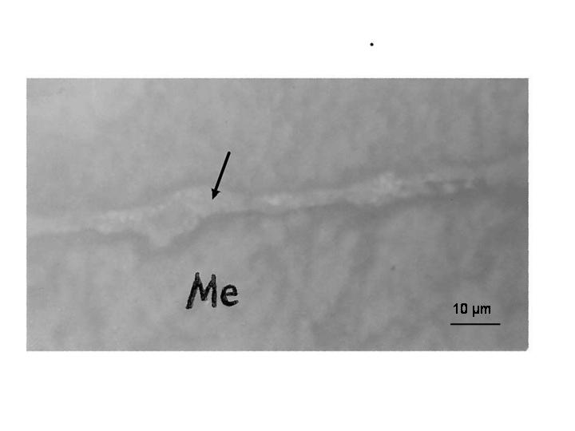
Fig. 1. Cross-section micrograph of a steel sample with protective film formed in 0.1 N Na₂SO₄ in the presence of the inhibitor composition (1 g/l Na₂WO₄.2H₂O + 1 g/l PЕG-1000).
The potentiodynamic polarization curves of the steel in the model medium without and with addition of inhibitors are shown in Figs. 2 and 3.
In the presence of PEG-1000 and Na₂MO₄, and especially Na₂WO₄, the rate of anodic dissolution of the metal decreases. The inhibitor compositions lead also to a considerable increase in the susceptibility of the steel to passivation in water solutions, the effect is more strongly expressed for the composi-tion of PEG-1000 and Na₂WO₄.
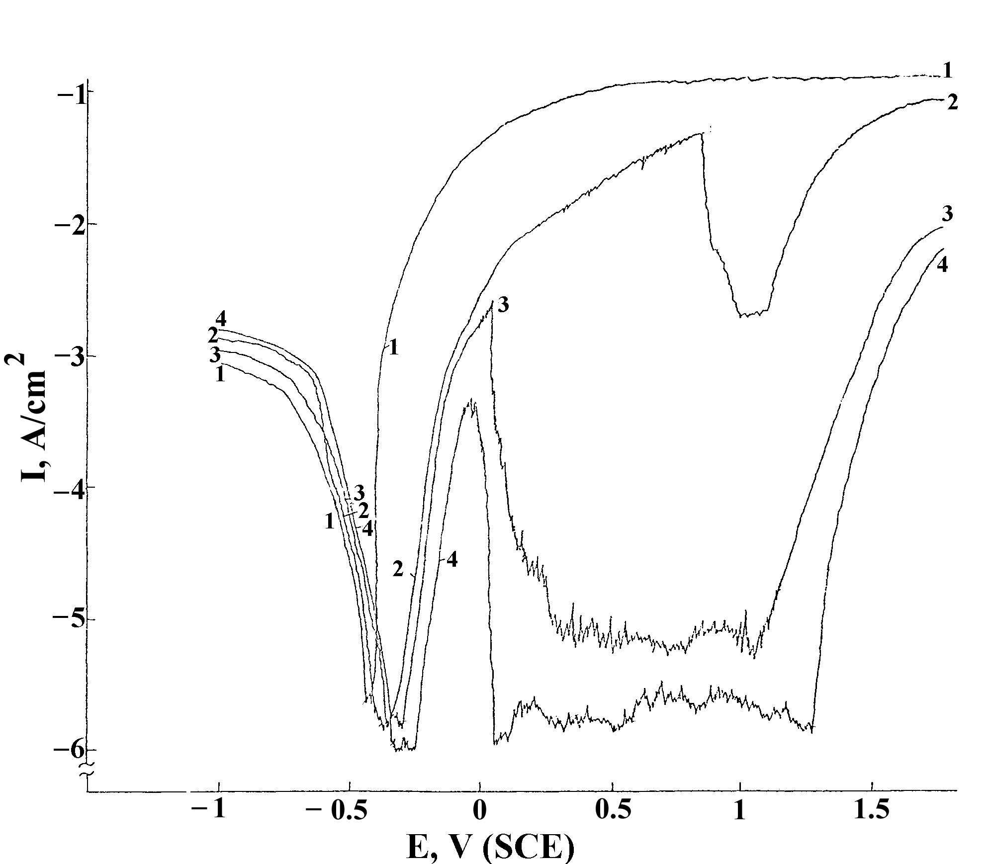
Fig. 2. Potentiodynamic polarization curves of steel in solutions: 1 - 0.1 N Na₂SO₄; 2 - 0.1 N Na₂SO₄ + 1 g/l PEG – 1000; 3 - 0.1 N Na₂SO₄ + 1 g/l Na₂MO₄;
4 - 0.1 N Na₂SO₄ + 1 g/l PEG-1000 + 1 g/l Nа₂МО₄.
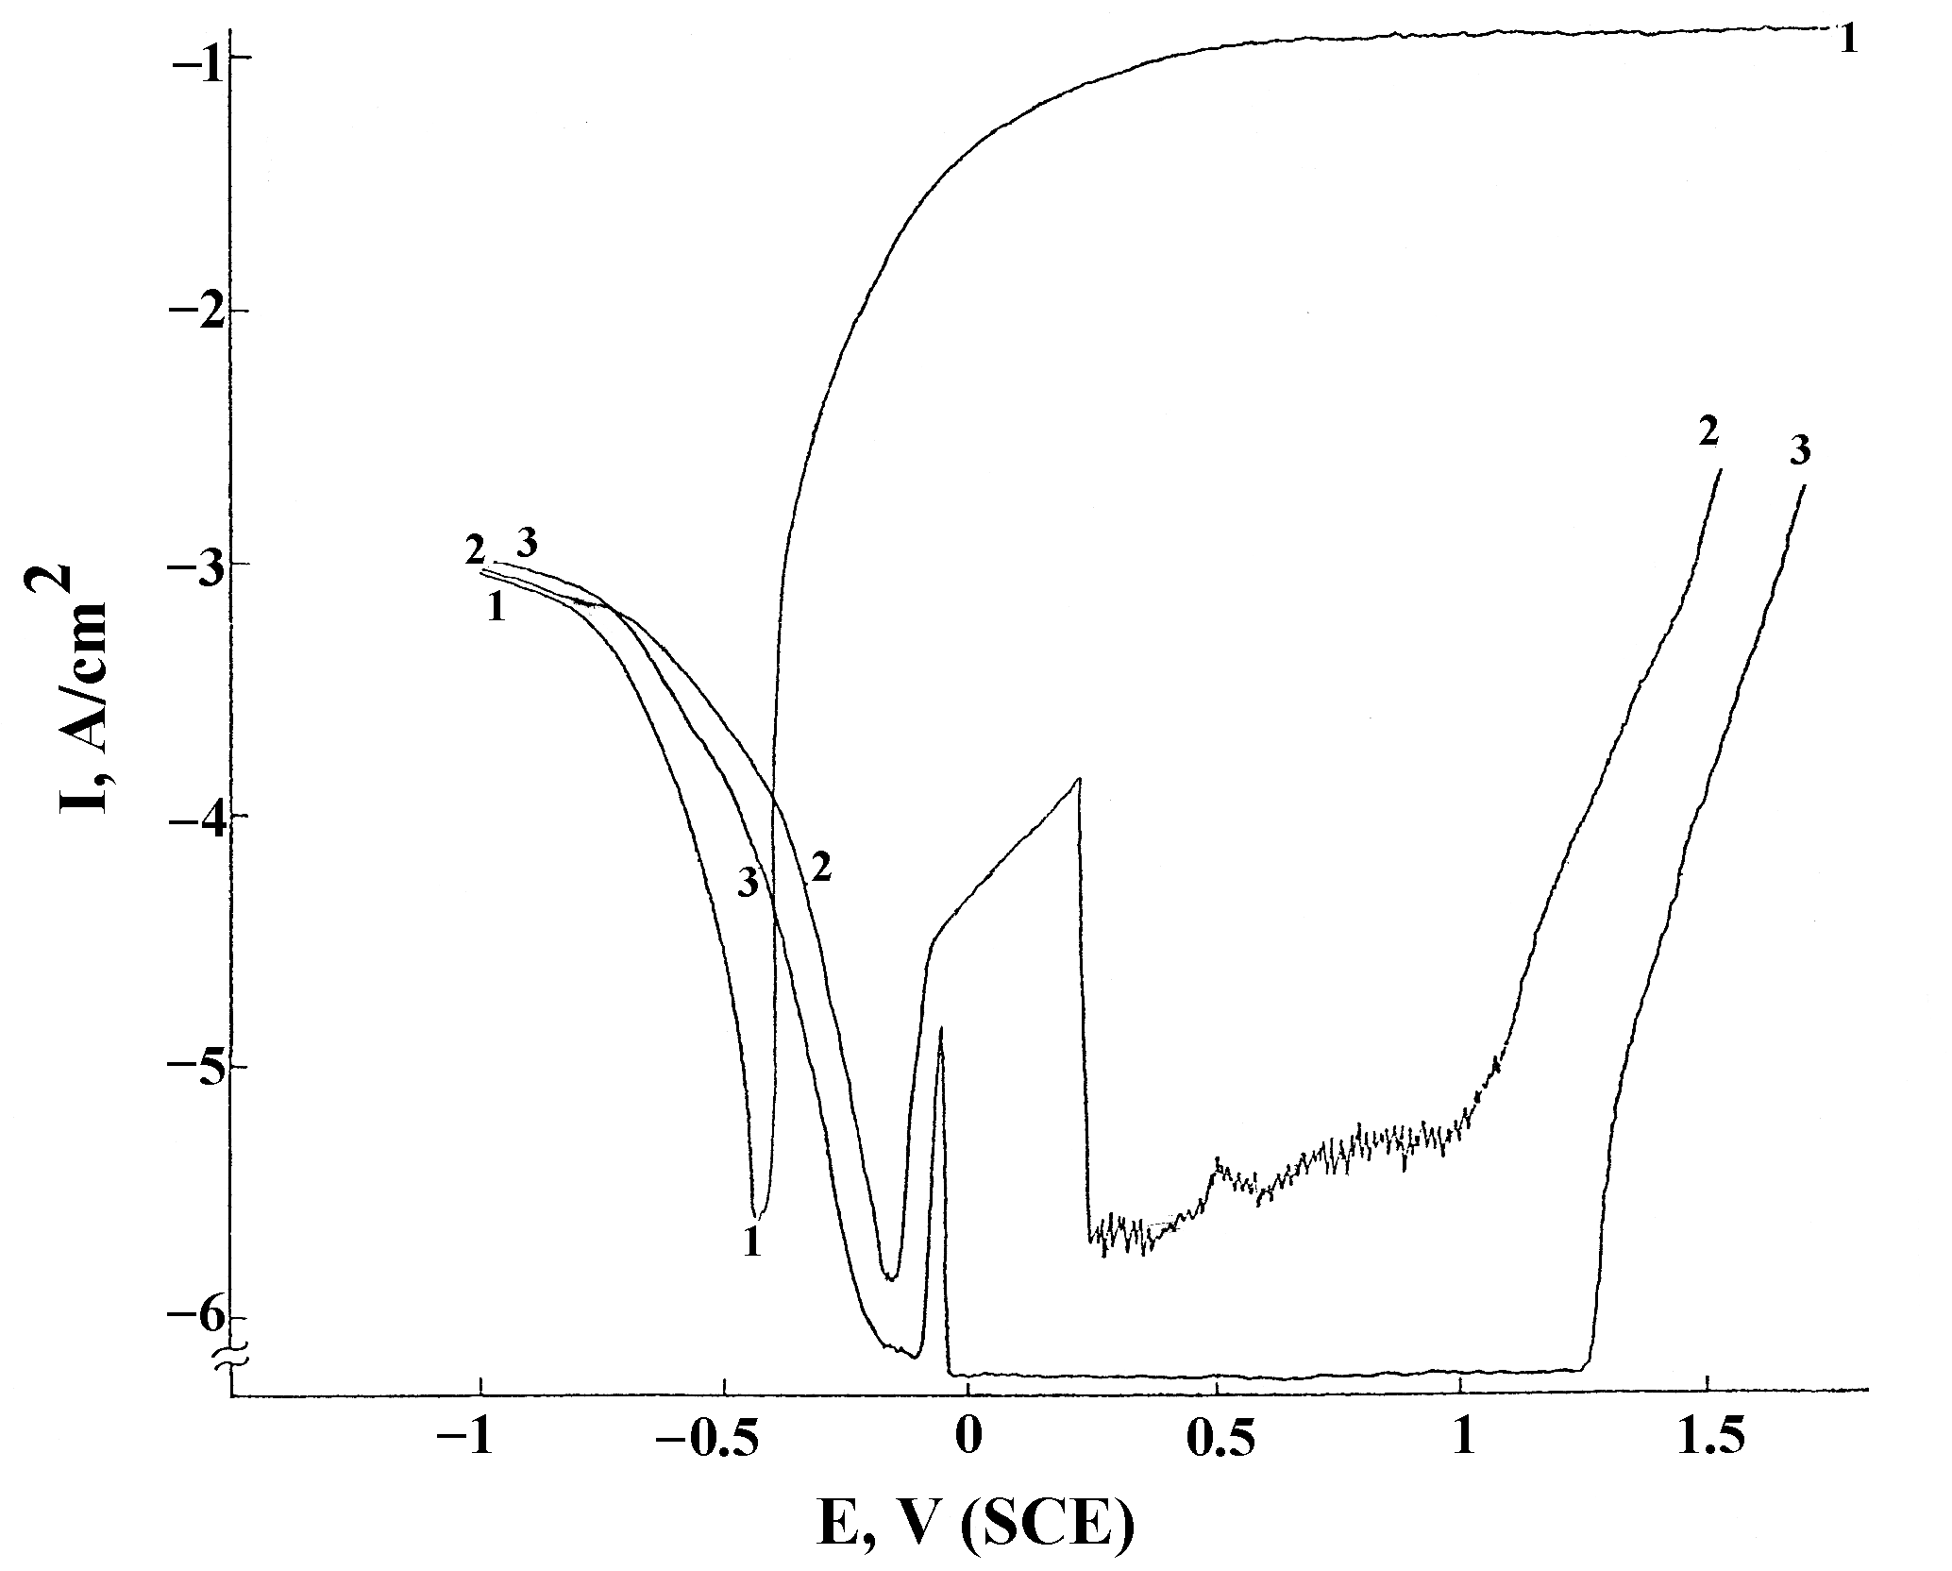
Fig. 3. Potentiodynamic polarization curves of steel in solutions: 1 - 0.1 N Na₂SO₄; 2 - 0.1 N Na₂SO₄ + 1 g/l Na₂WO₄.2H₂O; 3 - 0.1 N Na₂SO₄ + 1 g/l PEG - 1000 + 1 g/l Nа₂WО₄.2H₂O.
In this case, the process of active anodic disso-lution of the steel is almost completely suppressed while the passive region is very large (about 1.4 V) and the current density in this region is very small (less than 1 μA/cm²), which suggests a high stability of the passive state. The protective film is obviously of mixed oxide-adsorption nature – thin compact oxide film on the metal surface and thick layer of adsorbed polymer molecules outside.
Figure 4 illustrates the surface morphology of the samples after exposure in the corrosive solution. It is seen that in the absence of inhibitor, the surface is heavily damaged and the corrosion attack is localized predominantly at the grain boundaries. In the presence of inhibitor composition, however, the corrosion damages are uniform and much less expressed.
The positive effect of the inhibitor composition is well expressed during anodic dissolution of the steel samples at a potential E_{a} = 0.5 V (Fig. 5). In the solution without inhibitor, the steel at this potential is an active state and dissolves with a very high rate (100 mA/cm²). As a result, a large number of deep corrosion pits (1–3 μm) appears on the surface. The pits develop on the grain boundaries and other structural defects as non-metallic inclu-sions, etc. (Fig. 5A). In the presence of the inhibitor composition, however, the metal surface at this potential is in a stable passive state and localized corrosion damages cannot be detected even after 60 min anodic treatment of the sample (Fig. 5B). Thus, the inhibitor composition leads not only to decrease in the rate of general corrosion, but prevents also to a large extent the development of localized corro-sion damages.
R. Raicheff et al.: Inhibitor composition for corrosion protection of steels in water systems

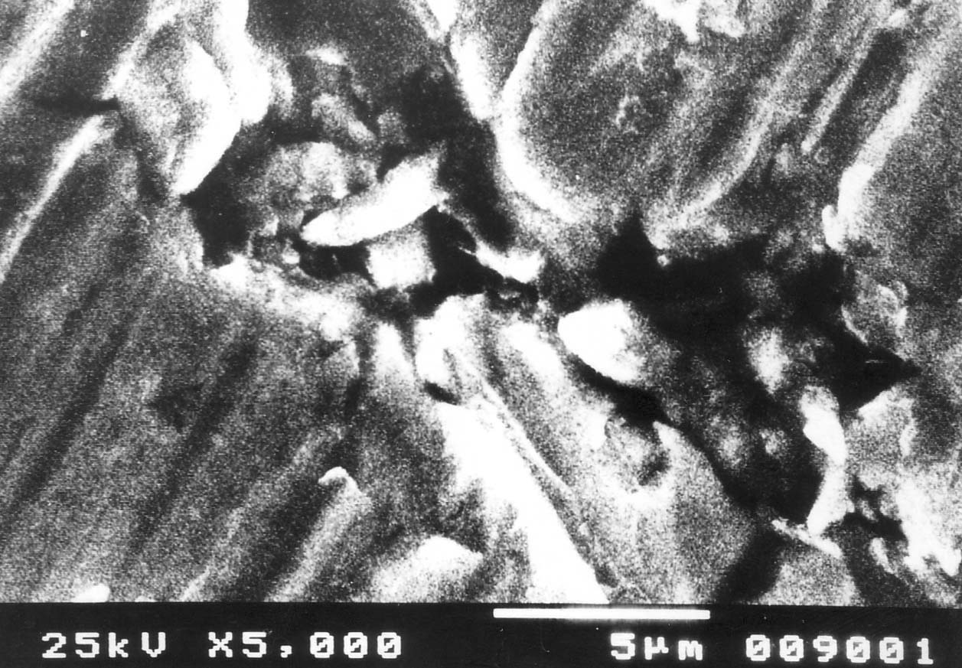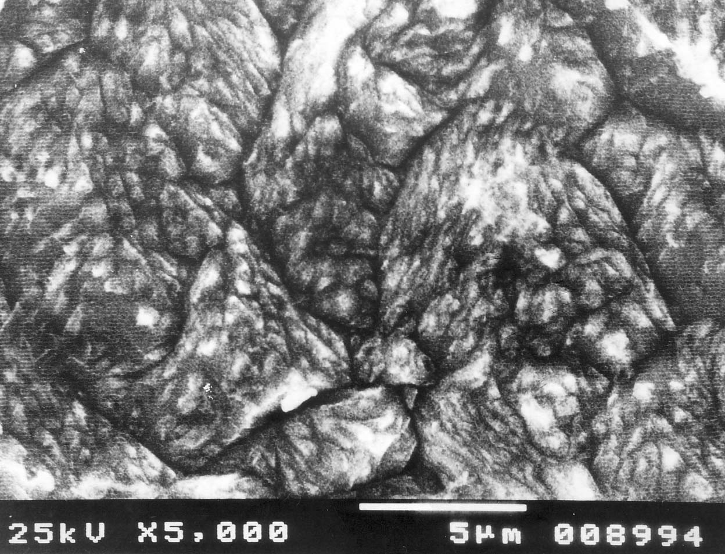
A
B
Fig. 4. SEM micrographs of steel samples after 24 h exposure in solutions:
A - 0.1 N Na₂SO₄; B - 0.1 N Na₂SO₄ + 1 g/l Nа₂WО₄.2H₂O + 1 g/l PEG-1000.
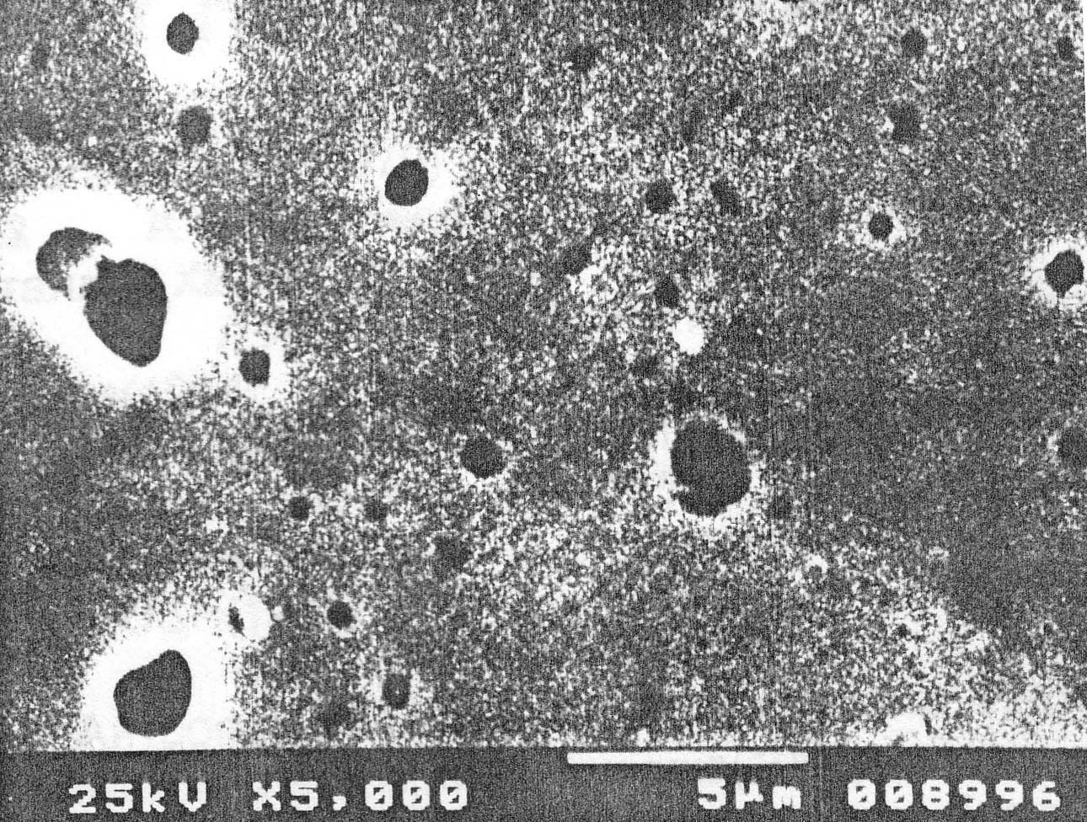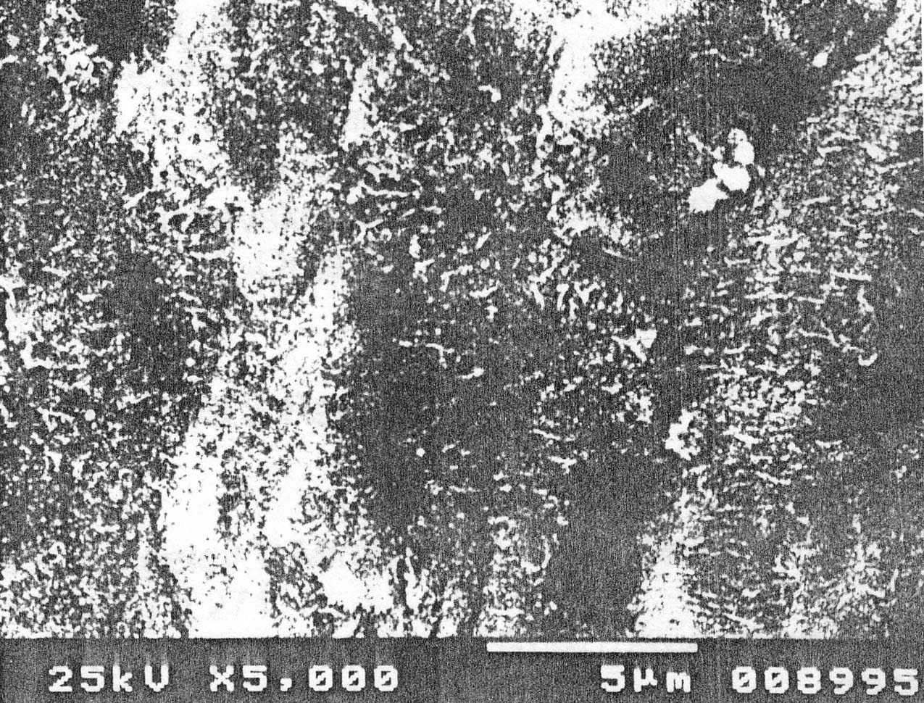
A
B
Fig. 5. SEM micrographs of steel samples after anodic dissolution at Ea = 0.5 V in solutions:
A - 0.1 N Na₂SO₄ for 10 min; B - 0.1 N Na₂SO₄ + 1 g/l Nа₂WО₄.2H₂O + 1 g/l PEG-1000 for 60 min.

CONCLUSION
On the basis of the results in the present study, the following conclusions could be made:
1. The composition of polyethylene glycol (PEG-1000) and Na₂MO₄ and especially Na₂WO₄.2H₂O is an effective inhibitor of corrosion of steel in neutral water environment.
2. The addition of the inhibitor composition results in a considerable decrease in the rate of anodic dissolution and increase in the susceptibility of steel to passivation and stability of the passivity.
3. The inhibitor composition leads to a decrease in the rate of general corrosion and may prevent the development of localized corrosion damages.
R. Raicheff et al.: Inhibitor composition for corrosion protection of steels in water systems
REFERENCES
- R. Raicheff, Corrosion and Protection of Materials, New Sciences, Sofia, 2001.
- J. S. Robinson, Corrosion Inhibitors, Noyes Data Corporation, New York, 1979.
- M. Jovchev, Corrosion of Power and Nuclear Plant Equipments, Energoatomizdat, Moskow, 1988 (in Russian).
- V. Mircheva, S. Rangelov, Comp. Rend. Acad. Bulg. Sci., 45, 55 (1992).
- G. Raichevski, V. Mircheva, S. Nikolova, 29 Int. Congr. Coatings, November 23-25, 1995, Bratislava, Slovakia, p. 153.
- S. Rangelov, V. Mircheva, D. Trifonova, J. Matter. Sci. Lett., 15, 271 (1996).
- S. Rangelov, V. Mircheva, Corros. Sci., 38, 1 (1996).

ИНХИБИТОРНА КОМПОЗИЦИЯ НА БАЗАТА НА ПОЛИМЕРИ И НЕОРГАНИЧНИ СОЛИ
ЗА ЗАЩИТА НА СТОМАНА ОТ КОРОЗИЯ ВЪВ ВОДНИ СИСТЕМИ
Р. Райчев¹, Г. Райчевски², В. Бъчваров²*
¹ Институт по електрохимия и енергийни системи, Българска академия на науките, София 1113
² Институт по физикохимия, Българска академия на науките, София 1113
Постъпила на 11 февруари 2008 г., Преработена на 19 март 2008 г.
(Резюме)
Изследвани са инхибиторните свойства на различни композиции на базата на полиетиленгликол и неорганични соли (Na₃PO₄.12H₂O, Na₂MO₄ и Na₂WO₄.2H₂O) по отношение на корозията на нисковъглеродна стомана (0.10% С) във водна среда, с помощта на електрохимична поляризационна техника, гравиметрични измервания, сканираща електронна микроскопия и металографски наблюдения. Като моделна среда на необработена вода е използван 0.1 M Na₂SO₄ (pH = 6.7).
Установено е, че композицията от полиетиленгликол (молекулна маса 1000) и Na₂WO₄.2H₂O е най-ефективна като инхибитор – защитният ефект е около 90%. Показано е тако също, че инхибиторната композиция оказва най-силно влияние върху анодните отнасяния и склонността на стоманата към пасивация. Добавката на инхибитор води до значително намаляване на скоростта на анодно разтваряне на метал и разширяване на пасивната зона на стоманата, както и до намаляване на анодния ток в тази зона. Инхибиторният ефект на изследваната композиция е обяснен с формиране на пасивен филм върху металната повърхност със смесена оксидно-адсорбционна природа.

