Relationship between chemical structure parameters
and inhibitor efficiency of some azoles
Bulgarian Chemical Communications, Volume 40, Number 3 (pp. 300–305) 2008
© 2008 Bulgarian Academy of Sciences, Union of Chemists in Bulgaria
A. K. Popova, М. S. Machkova, А. G. Djambova, A. Zwetanova*, S. N. Raicheva
* To whom all correspondence should be sent:
E-mail: alz@uctm.edu
University of Chemical Technology and Metallurgy, 8 Kliment Ohridski Blv., 1756 Sofia, Bulgaria
Received November 12, 2007, Revised February 5, 2008
The adsorption of aromatic molecules with planar structure diminishes the corrosion rate of mild steel in acidic medium. Benzimidazole (BI), 2-aminobenzimidazole and 2-merkaptobenzimidazole are studied as corrosion inhibitors (CI) in 1 M hydrochloric acid.
The effect of molecular structure upon the adsorption step in the total electrochemical process is tracked out. Conclusions about the mechanism of adsorption on account of potentiostatic current-time curves taken after CI injecting in the pre-electrode space are drawn.
Calculations by the semi-empirical quantum methods – AM1 and PM3 – for the determination of chemical structure parameters of a molecule in gaseous phase are done, such as total energy, energy of the HOMO, energy of the LUMO, partial charge of hetero-atoms, dipole moment, area of adsorbed molecule.
The values of these parameters are compared to the experimental values of degree of protection, obtained through gravimetric and polarization curves techniques in 1 M hydrochloric acid and fixed inhibitor concentration.
On the basis of these results, conclusions are drawn about the molecular structure – inhibition efficiency relationship of the compounds studied. The best inhibitor studied is 2-aminobenzimidazole.
Key words: acidic corrosion, quantum chemical parameters, mild steel.

Introduction
Corrosion is one of the major factors determining the durability of materials. Despite their limited corrosion resistance iron and mild steel remain still widely used as engineering materials. Inhibitors of corrosion (CI) are used for their protection. So for instance, the dissolution rate during cleaning, pickling and scaling etching is quite high in acid medium and its suppression may be achieved by organic compounds containing p electrons and/or hetero-atoms (i.e. S, N and O). Recently, the effect of functional groups and concentration of some N- and S-containing organic compounds such as substi-tuted benzimidazoles on the corrosion of iron and mild steel has been studied [1–3]. These molecules can be adsorbed onto the metal surface through negatively charged centres that are believed to be related to π-electrons and/or via the nitrogen or sulphur atom directly to the surface atoms, forming a coordinate-type bond. This phenomenon involves donation of electrons from the filled π-orbital of the ligand into the empty orbital of iron or vice versa electrons from Fe – into the empty inhibitor orbital. In this case the orientation of the inhibitor molecule towards the metal surface is important, namely the symmetry of the corresponding orbitals. Conse-quently, the protection efficiency of an organic inhibitor does not only depend on the structural characteristics of the inhibitor, but also on the structure of the alloy and electrolyte environment. The selection of a suitable inhibitor for a particular system is a difficult task because of the selectivity of the inhibitors and the wide variety of media. Moreover, it is known that aromatic amines in acid-ic medium could be protonated, which influences their structural parameters. In the last two decades the application of theoretical approach gives rise to a number of studies aiming at revealing the relation-ship between the structure of CI molecule and its inhibitor efficiency (IE). The latter is to a great extent facilitated from the development and availability of computational techniques and friendly software.
The present study is aiming using semi-empirical quantum methods and electrochemical measure-ments to throw light upon possible correlation between molecular properties and IE. To this end, the relation between IE and quantum chemical para-meters: total energy, energy of highest occupied orbital (HOMO), energy of lowest unoccupied orbital (LUMO), energy gap between the last two, dipole moment and area of the adsorbed molecule is sought.
The substances are chosen to study the effect of substituent – an electron acceptor – on the conju-gated electron system of BI and, hence, on the IE.
Experimental
Electrochemical data
The electrochemical data concerning inhibition efficiency from gravimetric and polarization curves techniques were summarized from publications [1, 2]. For the sake of clarity the experimental condi-tions are briefly reminded here. The corroding material was mild steel with the following chemical composition (wt.%): C 0.16; Mn 0.35; Si 0.016; P 0.01; S 0.029; Cr 0.06; Cu 0.10; Fe – balance. Gravimetric tests were carried out using a Sartorius analytical balance with precision of ±0.1 mg. The investigated solutions were not deaerated. The working specimens were of a round shape to avoid effects of edges, where high-speed corrosion occurs, with an area of 11.3 cm². Three specimens were immersed in a beaker of 250 ml volume. The hydro-chloric acid with purity pro analyze with concen-tration 1 mol/l aerated was the aggressive medium; the exposure time interval – 24 hours at room temperature (20±1ºC). Polarization curves were registered using a conventional three-electrode cell. The inhibiting efficiency, IE (%) is evaluated from the gravimetric and polarization curves data by the following formulae:
(1)
or
$\text{IE}\text{\%}=\frac{j_{0\text{corr}}−j_{\text{inhcorr}}}{j_{0\text{corr}}}⋅\text{100}$ (2)
where w₀ and w_{i} in g·m^{–2}·h^{–1} are the average corrosion rates in the absence and in the presence of an inhibitor, j_{0corr} and j_{inh corr} are the corresponding corrosion current densities.
Adsorption was studied registering the potentio-static current-time curves of the steel electrode kept at a constant potential when inhibitor was injecting in the pre-electrode space. The inhibitors used were commercially available substances i.e. benzimid-azole, BI, 2-aminobenzimidazole, NBI, and 2-mer-kaptobensimidazole, SHI. Their structural formulae and the abbreviations used in the paper are presented in Fig. 1.
Method of calculation
Molecular orbital theory (MO theory) is one of the approaches to study the metal-inhibitor inter-action. It has been shown that the most important interaction between two molecules is the one occurring between the HOMO (highest occupied MO) of the first molecule and the LUMO (lowest unoccupied MO) of the second, because it will results in the largest drop of energy [4].
Quantum calculations were carried out for the lowest state in vacuum of the neutral inhibitor molecules and cations using Restricted Hartree-Fock (RHF) level; and AM1 and PM3 semi-empi-rical SCF-MO methods incorporated in HyperChem v.7 package for Windows [5]. Calculations were performed on an Intel Pentium 1.5 GHz computer. First geometry optimization was done. HyperChem started with a set of Cartesian coordinates for the molecule/cation and tried to find a new set of coor-dinates with a local minimum potential energy. Then static values were calculated. The following quantum chemical properties were considered: potential energy (E_{total}), dipole moment (μ), HOMO energy, LUMO energy, net atomic charges of the hetero-atoms in the calculated structures – q N(1) for the “pyrole” nitrogen and q N(2) for the “pyridine” nitrogen, surface area of adsorbed molecule S_{ads} (assuming parallel orientation to the metal surface), surface area of the solvated molecule S_{solv} (solvent probe radius 1.4 Å). The values of the frontier orbitals of the inhibitor cations were calcu-lated because they are the species in solution coming in contact with iron metal. Solvating energies were neglected.
HOMO and LUMO values for iron were taken from the literature [6, 7], cited in [8], as ionization potential and electron affinity, respectively.
A. K. Popova et al.: Relationship between chemical structure parameters and inhibitor efficiency of some azoles
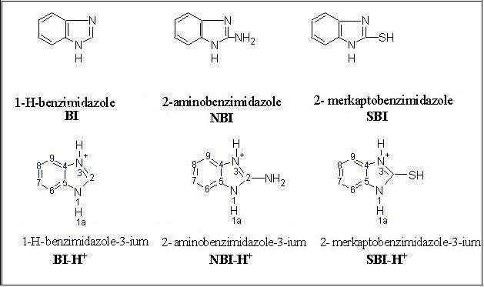
Fig. 1. Structural formulae and abbreviations used of the inhibitor studied.
Results and Discussion
According to polarization measurements [2], the inhibitors studied affect both the metal ionization and the hydrogen evolution reactions, i.e. they are of mixed type. The inhibition action is due to the adsorption of the planar inhibitor molecule on the metal surface forming a bond between the lone electron pair of a heteroatom and/or with π-elec-tronic cloud of 6-member ring, thereby reducing the corrosive attack. The 5-member ring contains two nitrogen atoms. N (1) or “pyrolic”, whose unshared electron pair participates in p-electron sextet and N (3) or “pyridin”, whose unshared electron pair is free and can coordinate a proton, transforming a molecule into a cation in acidic media.
To throw light on the type of interaction between iron and the inhibitors by a molecular orbital approach, the experimental results of IE% are summarized in Tables 1 and 2 together with some quantum chemical parameters obtained with AM1 and PM3 methods, respectively. As one can see comparing the data in the two tables there are differences in the corresponding structure properties due to the different parameterization, although both methods neglect the differential overlap. Typically, non-bonding interactions are less repulsive in PM3 than in AM1.
A comparison with literature data could be done only for neutral BI and it appears quite fair – E_{HOMO} = 8.988 eV and E_{LUMO} = 0.068 eV [3].
The data for cations, as is expected, differ from these for neutral molecules. The values of the total energy, the molecular weight or S_{ads} and the inhi-bitor efficiency do not change in parallel, which is an indication that the inhibition is not related to physisorption of the inhibitor on the metal surface. There is also no direct relationship between the IE% and the E_{HOMO} calculated by AM1. However, there is a similarity in the change of E_{HOMO} and E_{LUMO,} calculated by PM3, on the one side, and the IE%, on the other.
The rationalization of this behaviour is possible in the light of the theory of the frontier orbitals, in which E_{HOMO} and E_{LUMO} are related to chemical interaction of two species. The condition for the reaction and its mechanism hang from the difference ΔE = E_{LUMO}(I) – E_{HOMO}(II) and also from the symmetry of the frontier orbitals. In Table 3 the values of ΔE for the atomic iron–inhibitor molecule interaction are presented.
A. K. Popova et al.: Relationship between chemical structure parameters and inhibitor efficiency of some azoles
Taking into account the limitations of the Koop-mans’ theorem, the orbital energies of the frontier orbitals are given by the following equations [4]:
–E_{HOMO} = IP; where IP is the ionization potential and –E_{LUMO} = EA, where EA is the electron affinity. The following values are taken from literature for atomic Fe: E_{LUMO} = –0.25 eV [8] and E_{HOMO} = –7.81 eV [9].
From the results above, it appears that the possibility of reaction between the atomic iron and the inhibitor molecule is best for the NBI-H+ (PM3 method). This behaviour involves donation of electron density from the HOMO orbital of the inhibitor to the empty LUMO orbital of iron. The higher the inhibition the lower is the energy difference. Since the dipole moment of the inhibitor cations (Tables 1 and 2) is larger than that of water (1.8 D) they should displace the adsorbed water molecules from the iron surface.

Table 1. Experimental IE% and quantum chemical (AM1) properties values.
Inhibitor  Property | BI | NBI | SBI | BI-H+ | NBI-H+ | SBI-H+
–E_{t}, kcal·mol^{–1} | 32083 | 35669 | 40711 | 30388 | 37354 | 32221
–E_{HOMO}, eV | 9.00 | 9.04 | 5.55 | 16.0 | 13.10 | 13.39
–E_{LUMO}, eV | –0.06 | 1.87 | 2.15 | 8.14 | 4.52 | 6.13
E_{LUMO} – E_{HOMO}, eV | 8.94 | 7.17 | 3.4 | 7.84 | 8.58 | 7.26
–q (N1) | 0.249 | 0.208 | 0.203 | 0.353 | 0.303 | 0.343
–q (N3) | 0.138 | 0.143 | 0.089 | 0.321 | 0.303 | 0.354
Μ, D | 3.14 | 4.38 | 5.46 | 2.00 | 6.13 | 2.09
S_{ads}, Ǻ² | 35.2 | 36.0 | 47.4 | 41.6 | 42.8 | 47.4
S_{sol} , Ǻ² | 206 | 212 | 270 | 218 | 221 | 278
Molecular weight | 118.14 | 133.15 | 150.20 | 119.15 | 134.16 | 151.21
IE, % (Eqn. (1)) C_{min} |  |  |  | 0.30 | 0.82 | 0.25
IE, % (Eqn. (2)) C_{max} |  |  |  | 0.59 | 0.89 | 0.86
Table 2. Experimental IE% and quantum chemical (PM3) properties values.
Inhibitor  Property | BI | NBI | SBI | BI-H+ | NBI-H+ | SBI-H+
–E_{t}, kcal·mol^{–1} | 28721 | 31190 | 36927 | 28931 | 33037 | 36738
–E_{HOMO}, eV | 8.89 | 9.15 | 5.88 | 13.63 | 13.28 | 13.11
–E_{LUMO}, eV | 0.07 | 1.65 | 2.43 | 5.32 | 5.00 | 5.16
E_{LUMO} – E_{HOMO}, eV | 8.82 | 7.50 | 3.45 | 8.31 | 8.28 | 7.95
–q (N1) | 0.241 | 0.106 | 0.059 | 0.142 | 0.153 | 0.311
–q (N3) | 0.330 | 0.103 | 0.429 | 0.142 | 0.153 | 0.311
Μ, D | 3.38 | 3.78 | 5.07 | 4.93 | 5.28 | 2.80

Table 3. ∆E for the interaction atomic iron-inhibitor molecule.
Method | Inhibitor | E_{HOMO(inh)} –E_{LUMO(Fe)}, eV | E_{HOMO(Fe)} –E_{LUMO(inh)}, eV
AM1 | BI | –13.38 | –2.49
 | NBI | –13.03 | –2.84
 | SBI | –12.86 | –2.65
PM3 | BI-N+ | –15.75 | +0.33
 | NBI-H+ | –12.85 | –3.29
 | SBI-H+ | –13.14 | –0.68
The hardness, a property defined by Pearson, is the energy gap between the two frontier orbitals of the reacting species. The more electronegative species will accept electrons. A hard molecule has a large HOMO-LUMO gap, while a soft molecule has a small HOMO-LUMO gap.
Changes in the electron density of a chemical system result from the mixing of suitably situated excited-state wave functions with the ground state wave function. The mixing coefficient is inversely proportional to the excitation energy between the ground state and the excited state. Therefore, soft molecules with small gap will have their electron density changed more easily than a hard molecule. The inhibitors studied could be described as hard reactants. Their electron density is hard to change and, therefore, remain the classical electrostatic effects, or ionic bonding.
It is useful to remind that donated electron density must come from a definite filled orbital and go to a definite empty orbital. Also different atoms have different local softness and different tendencies to react. The net charges on the atoms will determine the reactive sites for ionic bonding.
Examining again the data shown in Tables 1 and 2 it is evident that the net charges on N(1) and N(3) atoms are negative. PM3 method predicts equal charges for the two atoms, while AM1 method for BI-H+ and SBI-H+ calculates different values. Still there remains a tendency for the net charges to equalize by protonation. The inhibitor with the smallest negative charges (NBI-H+) has the largest IE, which is expected for negatively charged iron surface in 1 M HCl.
Further, the symmetry of the orbitals was examined. 3D HOMO orbitals of the three inhibitors studied are represented in Fig. 2. It mainly consists of 2p_{z} orbital of N(1) and/or N(3) atom. A favour-able space orientation is expected by this orbital and both 3d_{x2} and 3d_{x2=y2} orbitals of the Fe atom.
It has been reported that the adsorption of Cl– on iron increases its softness [10]. This means that the HOMO-LUMO gap of iron should decrease upon adsorption of chlorides. The bond between the iron surface covered by chloride ions and the inhibitor molecules will have to the same extent a covalent character. The electronic charge density on the N-atoms, calculated by PM3, increases diminishing the IE% of SBI-H+. Dipole moments, as vector sum from x,y,z components (y – the largest one), give some idea for the orientation of cations towards the negative charged iron surface. Assuming a parallel orientation of the inhibitor molecule, the blocked surface area is estimated and cited in Table 1 as S_{ads}.
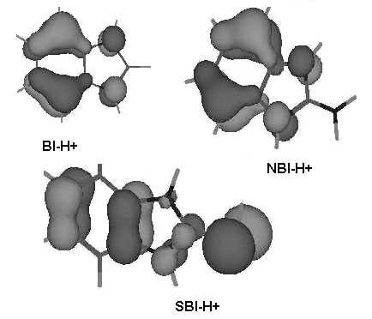
Fig. 2. 3D-representation of the HOMO-orbitals of the inhibitors studied.
The last property – the S_{solv} – is calculated by the program and gives a notion of the dimensions of the hydrated cations entering the double layer. The both parameters seem not to play a decisive role in inhibition, because they predict the largest effect for the SBI-H+, which is not the case.
A. K. Popova et al.: Relationship between chemical structure parameters and inhibitor efficiency of some azoles
The knowledge of the adsorption step could be helpful in elucidation of the inhibition process. The kinetics of adsorption of the inhibitors was studied registering potentiostatic–current-time curves at various potentials vs standard hydrogen electrode E_{SHE} after injecting (in t = 0) inhibitor in the pre-electrode space. In Fig. 3 are shown the corres-ponding curves for the inhibitors studied. The inhi-bitor effect can be clearly seen as current density drop.
In 1 M HCl solution the corrosion process proceeds in the absence and in the presence of inhibitor with the discharge of the hydrogen ions as a rate determining step. Reshetnikov et al. [11] developed a method to evaluate the factors affecting the adsorption step in the overall inhibition process.
Generally two main factors are considered – (i) the geometric factor [12] affects the adsorption, proceeding through a blocking mechanism and (ii) the electronic one accounts for the interactions of the adsorbed molecule with the metal surface leading to a coordination type bonding; the latter influences the double layer potential. It is assumed that no discharge of H⁺ takes place on the occupied by the inhibitor surface, while the rate of the discharge remains unchanged in the presence of inhibitor on the bare surface. Therefore, the authors described the diminishing of the current after inhibitor injecting in case of pure surface blocking with the following equation:
$j=j_{0}\left(1−θ,\right)$ (3)
where j_{o} is the current prior the inhibitor injecting and θ the degree of electrode surface coverage by the inhibitor species. In case of pure energetic effect the corresponding equation is
$j=j_{0}\text{exp}\left(−k^{'}ψ_{1}^{'}\right),$ (4)
where ψ’₁ is the changed potential by the adsorption and k’ is a constant. Assuming the ψ’₁ proportional to θ one obtains:
$j=j_{0}\text{exp}\left(−kθ\right),$ (5)
where k is a constant. The next step was the substi-tution of θ in Eqns. (3) and (5) with the expressions for adsorption isotherms on surfaces – homogeneous (H) and inhomogeneous – two cases: distribution of adsorption centres vs energy (i) uniform (UI) and (ii) - exponential (EI). Finally, to distinguish among the different cases the following equations were proposed:
- For the type of the surface by a purely blocking mechanism on homogeneous surface (H)
$$\text{ln}j/{j_{0}}=k_{2}t,$$
on uniformly inhomogeneous (UI)
$$\text{ln}Δj=k_{5}+k_{6}\text{ln}t$$
on exponentially inhomogeneous (EI)
$$j−j_{0}=Δj=k_{3}+k_{4}\text{ln}t,$$
- For inhibition mechanism through ψ’₁-effect
on homogeneous surface (H):
$$\text{ln}{j_{0}}/j=k_{9}+k_{\text{10}}\text{ln}t,$$
on uniformly inhomogeneous (UI)
$\text{ln}j/{j_{∞}}=k_{7}+k_{8}\text{ln}t,$
on exponentially inhomogeneous (EI)
$\text{lnln}j/{j_{0}}=k_{\text{11}}+k_{\text{12}}\text{ln}t,$
In the above treatment the interaction of the adsorbed species was neglected, that limits its vali-dity. The results of the graphical analyses, shown elsewhere [13], are summarized in Table 4.
At low concentration, BI preferably blocks the surface, its cations being adsorbed most probably upon sites with nearly uniform heat of adsorption. One might suppose also that no interactions exist between the adsorbed species. At high concentra-tions the inhibition mechanism changes. Nearly the same is the case with SBI. While the first inhibitor remains a poor inhibitor at all concentrations, SBI, probably due to strong lateral interactions, pro-nounced stronger at high concentrations, results in IE close to 88%. The parameters E_{homo}, ΔE and μ discussed previously support such an explanation for IE of the studied inhibitors.
A. K. Popova et al.: Relationship between chemical structure parameters and inhibitor efficiency of some azoles
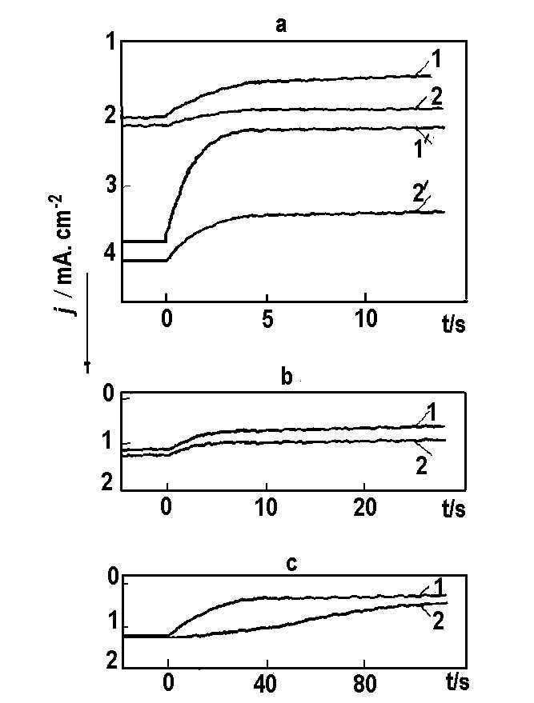
Fig. 3. Potentiostatic current density – time curves after injecting inhibitors with concentration in mol/l:
a. BI, curve 1 - 2×10^{–2}; curve 2 - 4×10^{–3} (potential E_{SHE} =
–0.38 V); 1’ - 2×10^{–2}; curve 2’ - 2×10^{–3} (E_{SHE} = –0.43 V); b. NBI, curve 1 - 8×10^{–4}; curve 2 - 9×10^{–5} (E_{SHE} =
–0.32 V); c) SBI, curve 1 - 8×10^{–5}; curve 2 - 1×10^{–5}
(E_{SHE} = –0.32 V);
Table 4. Prevailing mechanism of inhibition, type of metal surface and degree of protection IE, % (abbrevia-tions are explained in the text).
Inhibitor | C_{min} | IE, % | C_{max} | IE, %
BI | θ, H | 30 | ψ’₁, UI | 59
NBI | ψ’₁, UI | 82 | ψ’₁, EI | 89
SH | θ, EI | 25 | ψ’₁, UI | 86
Conclusions
The inhibition action of three benzimidazoles was studied with electrochemical techniques and by quantum mechanical calculations. The increasing inhibitor efficiency in series BI < SBI < NBI was explained by the structural characteristics of the inhibitor cations, showing undoubtedly that the best of them – NBI-H+ – is chemisorbed to a higher degree on the iron surface through the donation of electron density to the vacant Fe d-orbital(s).
References
- A. Popova, E. Sokolova, S. Raicheva, M. Christov, Corros. Sci., 45, 33 (2003).
- A. Popova, M. Christov, E. Sokolova, S. Raicheva , Corros. Sci., 46, 1333 (2004).
- G. Bereket, E. Hur, C. Ogretir, J. Mol. Struct. (Teochem), 578, 78 (2002).
- K. Fukui, Science, 218, 747 (1982).
- www.hyper.com.
- C. Moore, National Standard Reference Data Series NSRDS-NBS, 34 (1970).
- R. Pearson, J. Chem. Sci., 117, 369 (2005).
- H. Hotop, W. C. Lineberg, J. Phys. Chem. Ref. Data, 14, 731 (1985).
- P. Mutombo, N. Hackerman, Anti-Corr. Meth. Mater., 45, 413 (1998).
- K. Aramaki, T. Mochizuki, H. Nishihara, Electrochem. Soc., 135, 2427 (1988).
- S. M. Reshetnikov, Zashchita Metallov, 15, 469 (1979) (in Russian),.
- V. Grigoriev, V. Ekilik, Chemical Structure and Protective Action of Corrosion Inhibitors, Rostov University, 1987 (in Russian)
- A. Zwetanova, A. Djambova, A. Popova, S. Raicheva, ACH-Model in Chemistry, 132, 733 (1995).

ВРЪЗКА МЕЖДУ ПАРАМЕТРИ НА ХИМИЧНАТА СТРУКТУРА
И СТЕПЕНТА НА КОРОЗИОННА ЗАЩИТА НА НЯКОИ АЗОЛИ
Ан. К. Попова, М. С. Мачкова, Ан. Г. Джамбова, Ал. Цветанова*, Св. Н. Райчева
Химикотехнологичен и металургичен университет, бул. „Кл. Охридски“ № 8, 1756 София
Постъпила на 12 ноември 2007 г., Преработена на 5 февруари 2008 г.
(Резюме)
Адсорбцията на ароматни молекули с планарна структура намалява скоростта на корозия на мека стомана в кисела среда. Изследвани са като корозионни инхибитори бензимидазол (BI), 2-аминобензимидазол и 2-меркап-тобензимидазол в 1 М солна киселина.
A. K. Popova et al.: Relationship between chemical structure parameters and inhibitor efficiency of some azoles
Проследено е влиянието на молекулната структура върху адсорбционния стадий в общия корозионен процес. Направени са заключения за механизма на адсорбция въз основа на потенциостатични ток-потенциал криви, снети след въвеждане на инхибитор в приелектродното пространство.
Направени са изчисления чрез полуемпирични квантовохимични методи – АМ1 и ПМ3 – за определяне на следните параметри на химичната структура на молекула в газообразно състояние – обща енергия, енергиите на най-високата заета (НОМО) и на най-ниската незаета (LUMO) орбитали, парциален заряд на хетероатомите, диполен момент, площ на адсорбираната молекула. Стойностите на тези параметри са сравнени със стойнос-тите на опитно определената в 1 М солна киселина и зададена концентрация на инхибитора степен на защита, получени чрез гравиметрични изследвания и по метода на поляризационните криви.
На базата на тези резултати са направени заключения за връзката между молекулната структура и степента на защита на изследваните съединения. Най-добри инхибиторни свойства има 2-аминобензимидазола.

