Microcontroller converter of corrosion rate with current output
Bulgarian Chemical Communications, Volume 40, Number 3 (pp. 330–332) 2008
© 2008 Bulgarian Academy of Sciences, Union of Chemists in Bulgaria
Y. S. Yanev*, O. A. Farhi
* To whom all correspondence should be sent:
E-mail: yayanev@gmail.com
Technical University, Studentska St. 1, 9100 Varna, Bulgaria
Received September 27, 2007, Revised February 19, 2008
The converter discussed in this report is a part of the task of introducing automatic corrosion rate control in steam boilers, which could facilitate inhibitor dosing optimization for boiler water. The polarization resistance technique is used for corrosion rate determination. Microcontroller arrangement allows introduction of automatic correction of solution resistance effect. A simplified block-diagram is discussed. Experimental results obtained by corrosion probe simulation in the Randle model are presented.
Key words: corrosion monitoring, linear polarization resistance, conductivity.

Introduction
Corrosion is one of the major causes for problems in steam boiler operation. For ship boilers particularly, corrosion effects include reduction of the equipment lifecycle, need of emergency repairs, increased fuel consumption, and downtime-associated losses.
In order to limit acidic and caustic corrosion, a specific pH of boiler water must be maintained. Measures against oxygen corrosion include deaera-tion or heating of incoming water up to 90°С and adding of an inhibitor. Currently, there is no con-stant monitoring of corrosion rate in steam boilers. Introduction of such monitoring may improve the operational conditions and facilitate optimal inhi-bitor dosing. A yet limited number of companies now offer corrosion monitoring equipment at high price. Development of relatively cheap corrosion rate converters with current output and parameters suited to specific applications would lead to their wider use in automation systems.
The review [1] on corrosion monitoring tech-niques in industrial waters shows that electro-chemical techniques are appropriate from applica-tion point of view – the polarization resistance tech-nique based on Stern-Geary equation [1]:
$i_{\text{corr}}=\frac{1}{R_{p}}\text{.}\frac{b_{a}\text{.}b_{c}}{2,\text{303}(b_{a}+b_{c})}$ (1)
where i_{corr} – corrosion current density (mA/cm²), b_{a} – anodic Tafel slope (mV), b_{c} – cathodic Tafel slope (mV), and R_{p} – polarization resistance (ohm·cm²). The relationship between corrosion current density and corrosion rate, in mm per year, is expressed by Faraday law [1]:
${\text{mm}}/{\text{year}}=3,\text{15}\text{.}{\text{10}}^{5}\frac{M}{n\text{.}F\text{.}d}\text{.}i_{\text{corr}}=1,\text{37}\text{.}{\text{10}}^{5}\frac{M}{n\text{.}F\text{.}d}\text{.}\frac{B}{R_{p}}$ (2)
where M – molecular weight of metal (g/mole), n – number of electrons involved in the corrosion reaction (mole), F – Faraday’s constant, d – density of metal (g/sm³), and B = (b_{a}b_{c})/(b_{a}+b_{c}) mV. After substitution of specific values of constants for iron, the result is [1]:
${\text{mm}}/{\text{year}}=\frac{3,\text{03}\text{.}{\text{10}}^{2}}{R_{p}}$ (3)
For industrial applications, an electrochemical probe is commonly used with two equal electrodes fed with square pulses [2, 3]. The equivalent circuit of such probe is shown in Fig. 1.
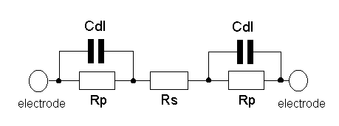
Fig. 1. Equivalent circuit: R_{p} - polarization resistance,
R_{s} - solution resistance of electrolyte between electrodes, C_{dl} - double layer capacitance of liquid/metal interface.
When a small potential is applied to the electrodes (10–20 mV), after the capacitors C_{dl} become charged, the current through the probe will depend on the applied voltage and the sum of resistances 2R_{p}+R_{s}. The effect of solution resistance in high conductivity conditions may be ignored; for low conductivity, however, it must be taken into consideration. In Ref. [3] the use of three-electrode probe in low conductivity conditions is recom-mended, but this makes the device more complex and expensive. In Ref. [4] measurement of R_{s} is suggested by conductometric method and cor-rection of the result for R_{p} thereafter. The use of micro-controller and a contact measurement tech-nique for the specific electrical conductivity [5] allows automatic correction of the result depending on solution resistance. Where required, an output conductivity block may be included, the signal whereof is used for management of boiler “blow down” operation.
Principle of operation
The converter discussed herein uses a two-electrode corrosion probe with two equal electrodes powered with rectangular voltage. The simplified block-diagram is shown in Fig. 2. It includes square-pulse generator G controlled by the micro-controller μC, the output of which is connected to the buffer input А1. The electrochemical probe is placed bet-ween the buffer output А1 and the current-voltage converter input А2; the latter’s output being con-nected to one of the micro-controller’s ADC module inputs. PWM module output, through the low pass filter F, is connected to the voltage-current converter input U/I. Its output is the converter output.
The principle of operation is illustrated with the time-impulse diagram on Fig. 3. The generator G produces bipolar square pulses of amplitude 15 mV and duration τ = 4R_{p}C_{dl} [4], with substantial pause in-between – V₁ on Fig. 3а. Through the buffer amplifier А1, the pulses are applied to the probe electrodes. The potential at the current-voltage converter output А2 (V₂ on Fig. 3b) is proportional to the current between the electrodes.
Two measurements are taken – in the beginning (t₁) and at the end (t₂) of the positive pulse, which is described by the equations:
and (4)
Hence:
(5)
After substitution in Eqn. (3) the resulting corrosion rate is:
(6)
This value is used for control of the PWM 1 microcontroller module. The value measured in the moment t₁ is proportional to solution conductivity and is used to control PWM 2. Thus, a second current output is included providing information about the specific electric conductivity of boiler water.
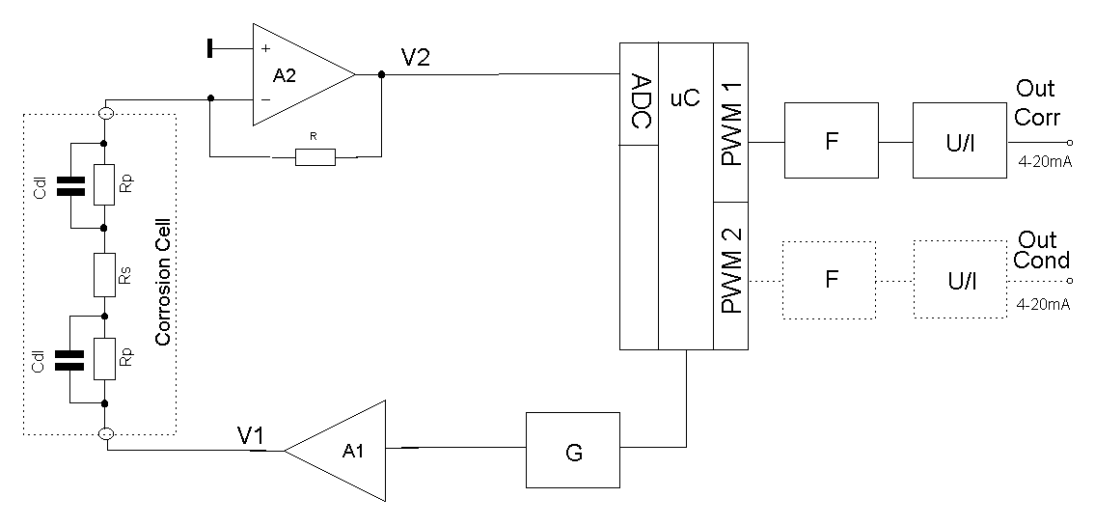
Fig. 2. Block-diagram.
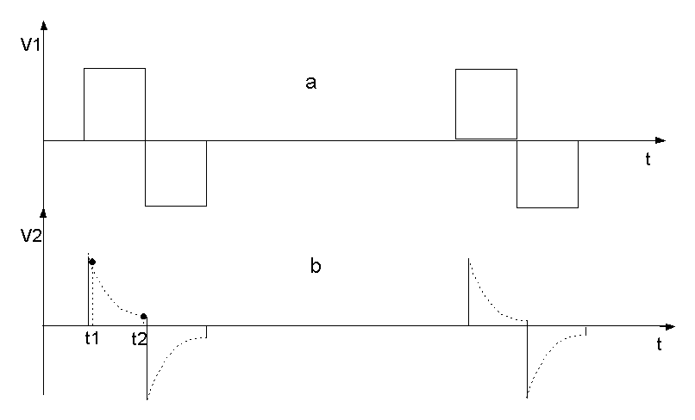
Fig. 3. Time-pulse diagram.
Experimental Results
Converter operability was subjected to laboratory tests, where the electrochemical probe was simu-lated using Randle model with the following para-meters: R_{s} = 100 Ω, 150 Ω; C_{dl} = 11 μF; R_{p} = 181–2424 Ω. The results are shown in Table 1. Converter settings were done at solution resistance of 150 Ω. It can be seen that in this case, the maximum error of the output current is 1.25%, and when solution resistance is changed by 50%, such change being possible during boiler operation, the error does not exceed 2.5%.
Y. S. Yanev and O. A. Farhi: Microcontroller converter of corrosion rate with current output
Conclusion
The converter under review represents a step towards solving the task of the development of rela-tively inexpensive devices for use in steam boiler operation monitoring systems. Experimental results show that, notwithstanding the simple arrangement solution, good metrological parameters may be achieved as well as module application for automa-tion purposes at substantially lower cost as com-pared to similar devices. The opportunity to obtain information also about specific electric conductivity of boiler water allows application of the converter for control of boiler “blow down”, the latter repre-senting substantial practical benefit.

Table 1. Experimental results.
 | R_{s} = 150 Ω
R_{p}, Ω | 181 | 205 | 235 | 282 | 346 | 449 | 638 | 1101 | 1738 | 2424
I_{Т}, mA | 20 | 18 | 16 | 14 | 12 | 10 | 8 | 6 | 5 | 4.5
I_{експ}, mA | 19.8 | 18 | 16.2 | 14.1 | 12.2 | 10.2 | 8.1 | 6 | 5 | 4.45
ΔI, mA | –0.2 | 0 | 0.2 | 0.1 | 0.2 | 0.2 | 0.1 | 0 | 0 | 0.05
δ, % | –1.25 | 0 | 1.25 | 0.625 | 1.25 | 1.25 | 0.625 | 0 | 0 | 0.3
 | R_{s} = 100 Ω
I, mA | 20.3 | 18.4 | 16.4 | 14.3 | 12.3 | 10.3 | 8.15 | 6.05 | 5.0 | 4.45
Δ, mA | 0.3 | 0.4 | 0.4 | 0.3 | 0.3 | 0.3 | 0.18 | 0.05 | 0 | 0.05
δ, % | 1.9 | 2.5 | 2.5 | 1.9 | 1.9 | 1.9 | 1.2 | 0.3 | 0 | 0.3

References
Y. S. Yanev and O. A. Farhi: Microcontroller converter of corrosion rate with current output
- T. Y. Chen, R. H. Banks, J. Brechears, S. N. Nicolich, D. M. Cicero, Corrosion Monitoring Techniques for Industrial Cooling Water and Process Systems, Ondeo Nalco Company, International Water Conference, 2002.
- www.rohrbackcosasco.com/corrater.aspx?cid=psg
- http://www.cp.umist.ac.uk/CPC/L_Notes.
- R. Raicheff, M. Aroyo, V. Ketrov, Werkstof. Korros., 31, 923 (1980).
- P. P. Shipkov, Y. S.Yanev, I. L. Ivanov, BG Patent 46425 (1993).

МИКРОКОНТРОЛЕРЕН ПРЕОБРАЗОВАТЕЛ НА НИВО НА КОРОЗИЯ С ТОКОВ ИЗХОД
Ян. С. Янев*, О. А. Фархи
Технически университет, ул. „Студентска“ № 1, 9100 Варна
Постъпила на 27 септември 2007 г., Преработена на 19 февруари 2008 г.
(Резюме)
Разглежданият в доклада преобразовател е част от задачата за въвеждане на автоматичен контрол на нивото на корозия в парни котли, което би помогнало за оптимизиране на дозирането на добавяния към котелната вода инхибитор. Използван е методът на поляризационното съпротивление за определяне на нивото на корозия.. Микроконтролерната реализация позволява въвеждане на автоматична корекция на влиянието на съпротивлението на разтвора. Разгледана е опростена блокова схема. Действието е пояснено с време-импулсана диаграма. Показани са експериментални резултати, получени чрез симулиране на корозионната клетка с модел на Randle.

