Phosphating of ferro-carbon alloys by modifying zinc-phosphate solutions
Bulgarian Chemical Communications, Volume 40, Number 3 (pp. 355–359) 2008
© 2008 Bulgarian Academy of Sciences, Union of Chemists in Bulgaria
L. Fachikov*, Y. Tumbaleva, D. Ivanova
* To whom all correspondence should be sent:
E-mail: fachikov@uctm.edu
University of Chemical Technology and Metallurgy, 8 “Kliment Ohridski” Blvd., Bulgaria, 1756 Sofia,
Received May 15, 2008, Revised May 25, 2008
The paper presented considers investigation of the effects of three types of phosphates (nickel, calcium and manganese), added to zinc-phosphate compound for ferro-carbon alloys phosphating, KAF-101ZT. By gravimetric, chemical, electrochemical and physical methods there are determined the characteristics of preparations (density, pH, conductivity, total and free acidity) and those of the produced coatings (thickness, phase and chemical compositions, structure, protection ability).
It is proved that Ni- phosphate presence increases the coating thickness and formation rate for all working solution concentrations (5–20%) and temperatures (20–80ºС). Under the same conditions, Ca-phosphate has a minor effect while the manganese one decreases the deposition rate and coating thickness.
The phosphate coatings consist mainly of the phases hopeite and phosphophyllite, in the manganese phosphate containing solutions partial replacement of Fe by Mn being observed in the later. EDX-analyses show Ca and Ni presence in the coatings when Ca- and Ni-phosphates are added to the solutions. The coatings habitus is retained, the grain sizes increasing in presence of nickel, not changing in calcium and decreasing when manganese phosphates are added to the solutions.
The coating corrosion potential in 3.5% NaCl solution shifts in positive direction in the following sequence:
Zn-Mn → Zn-Ca → Zn → Zn-Ni.
Key words: ferro-carbon alloys, zinc phosphating.

introduction
The production of zinc phosphate coatings is the most wide spread and investigated metal phos-phating method [1, 2]. Various means - addition of activators, accelerators, stabilizers, etc., are used to increase the phosphating process rate and to improve the coating quality. One of the ways, where a significant part of the current investigations are focused, is addition of different metal ions – Ca²⁺, Ni²⁺, Mn²⁺, etc. to the phosphating solutions [3–5]. After [6, 7] the Ca²⁺-ions causes considerable changes of the coating crystal structure, grain size and corrosion resistance. The process itself is classi-fied in practice as calcium-modified zinc phos-phating. The manganese and nickel modified zinc-phosphate preparations lead to structure refinement and corrosion resistance improvement of the phosphate coatings [8].
The paper presented considers investigation of the effects of three phosphate types (calcium, nickel and manganese) added to zinc-phosphate prepara-tion for ferro-carbon alloys phosphating, KAF-101ZT. There are determined the characteristics of the phosphating preparations, experimental condi-tions and the properties of the phosphate coatings.
experimental
The studies are performed with low carbon steel samples (0.17% С). For the gravimetric tests, the samples have square shape (5×10^{–3} m²) and for SEM, EDX, Rë and electrochemical examinations disk shape of area 1×10^{–3} m².
The samples preparation before the tests covers successively the operations: alkaline degreasing, washing, pickling, washing, drying.
The phosphating operation environments are water solutions of zinc preparation KAF-101ZT, as well as its modified variants KAF-90ZN, KAF-90ZK and KAF-90ZM in which 10% of the zinc phosphate are replaced by phosphates of nickel, calcium and manganese, respectively. For all the preparations the proportion Р₂О₅/NO₃– = 1/3 is valid.
The conditions of the experiments carrying out are as follows:
- concentrations: 5.0, 10.0, 15.0 and 20.0 vol.%
- temperatures: 20.0, 40.0, 60.0 and 80.0 ± 1.0ºС
- experiment duration: 5.0, 10.0, 15.0 and 20.0 min.
Several methods are employed in performing the examinations:
- gravimetric method. The essence of the method is previously described in details [9], and generally it consists in determination of the sample mass variation – before phosphating, after the coating formation and after its removal.
- SEM. The analyses are performed by means of microscope JEOL JSM 6390.
- EDX. Apparatus INCA Energy 350-Oxford Instruments is used.
- Rë-phase analysis. It is made by apparatus Philips APD 15.
- electrochemical method. By means of PAR-263A the variation of the potential with time is measured during the formation of the phosphate coatings and during their exposition in 3.5% NaCl.
results and discussion
Table 1 presents the values of the most important features which characterize the examined phos-phating preparations: total, K_{t} and free, K_{f} acidity; рН; density ρ and conductivity σ.
From the data given in the Table 1, it follows that рН, density and conductivity of the concentrates of all studied phosphating preparations are close in value. In the case of calcium phosphate modification the total, K_{t} and free, K_{f} acidities decrease compara-tively slightly and in case of adding nickel and manganese phosphate they grow considerably com-pared to the values of these characteristics for the zinc preparation.
Table 1. Characteristics of the phosphating preparations.
characteristics  preparation | К_{t} | К_{f} | рН | ρ,  g/cm³ | σ,  mS/cm
KAF-101ZT | 292 | 38 | 0.90 | 1.335 | 172.8
KAF-90ZK | 276 | 32 | 0.98 | 1.332 | 166.7
KAF - 90ZN | 328 | 50 | 0.87 | 1.335 | 175.0
KAF-90ZM | 330 | 66 | 0.91 | 1.330 | 173.6
Figure1 presents the typical kinetic dependences “thickness/ phosphate coating mass - time” obtained for the studied preparations at concentration 10% (Fig. 1a) and 20% (Fig. 1b) and operation solution temperature 80^{о}С. The curves courses show that the addition of nickel phosphate to the solutions increases approximately two times the coating mass/ thickness. The calcium phosphate results in insigni-ficant thickness growth and the manganese one in its decrease. It follows from Figure 1 that the coating nucleation and growth is performed at the highest speed in the Ni-containing solutions, followed by the Ca-containing ones while in the presence of manganese phosphate in the solution it is lower than that of the basic zinc preparation.
Analogical dependences “thickness/mass - time” are obtained for all other concentrations and tempe-ratures of the studied phosphating preparations.
Figure 2 presents the effect of the temperature on the thickness, М₁, of the coatings formed in 15% solutions of the phosphating preparations. Coatings of the smallest thickness for all preparations are formed at 20ºС, and of the largest one – at 40ºС, followed by 60ºС and 80ºС. An exclusion of the observed dependence are the results obtained for KAF-90ZN, where coatings of the largest thick-ness/mass are produced at 60ºС and decreasing ones in the sequence 80, 40 and 20ºС. Completely analo-gical dependences are obtained also for the other examined concentrations of the phosphating prepa-rations.
The X-ray phase analysis shows the presence mainly of hopeit and phosphophyllite phases in the phosphate coatings. With the exception of the coatings formed in solutions of KAF-90ZM, where partial replacement of the iron by manganese occurred, in the other modified preparations there are no differences in the phase composition.
L. Fachikov et al.: Phosphating of ferro-carbon alloys
The basic elements contained in the coatings, determined by means of EDX-analysis, are Zn, Fe, P, O, Mn and in smaller quantities Ni and Ca in the corresponding modified zinc phosphate prepara-tions.
Figure 3 shows micrographs (SEM) of the phos-phate coatings formed on steel samples in solutions of the examined preparations of concentration 20%, temperature 80ºС, for time 10 min. It follows from the figure that the coating habitus in spite of the addition of nickel, calcium or manganese phosphate to the basic zinc phosphating preparation is retained. The grain sizes in the presence of Ni²⁺ ions in the solution grow (b), almost do not change in presence of Ca²⁺ ions (c) and decrease in presence of Mn²⁺ ions (d) in the phosphating preparations. The elec-trode potential variation during the phosphate coatings formation is presented in Figure 4. After the initial, for a comparatively short time, shift of the potential in negative direction there follows its stable movement towards more positive values. The order of that movement is in the following sequence KAF-90ZM → KAF-90ZK → KAF-90ZN →
KAF-101ZT.
The phosphate coatings corrosion stability is determined by measuring their corrosion potential in a model 3.5% water solution of sodium chloride (Figure 5). It is seen that after the initial fast shift in negative direction, after about 15 min the potentials are steady-state. The corrosion potential of the studied phosphate coatings becomes more negative in the following order: KAF-90ZN → KAF-101ZT → KAF-90ZK → KAF-90ZM.

a | b
Fig. 1. Effect of the phosphating time, τ on the formed phosphate coating mass/ thickness, М₁:
а – 10%, 80ºС; b – 20%, 80ºС.

a | b
c | d
Fig. 2. Dependences “coating thickness - time” for different environment temperatures:
a – KAF-101ZT; b – KAF-90ZK; c – KAF-90ZN; d – KAF-90ZM; concentration – 15%.
L. Fachikov et al.: Phosphating of ferro-carbon alloys
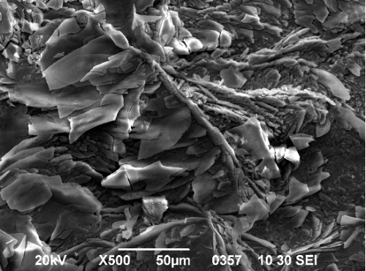 a | 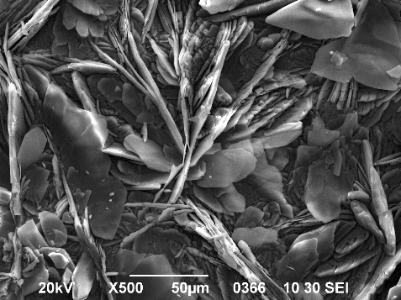 b
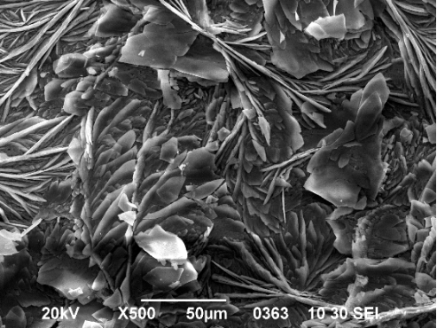 c | 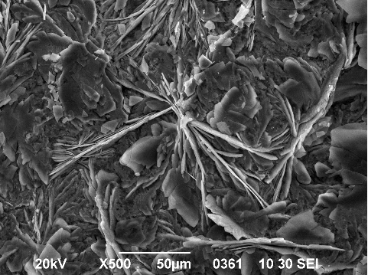 d
Fig. 3. Microphotographs of phosphate coatings: а- KAF-101ZT; b- KAF-90ZN; c- KAF-90ZK; d- KAF-90ZM.

Fig. 4. Dependences “potential-time” during phosphate coating formation, concentration – 20%,  temperature – 80ºC, duration – 20 min. | Fig. 5. Dependence “potential-time”, during exposure  of phosphate samples in 3.5% NaCl, 20 ± 2ºС.

conclusion
At investigation of zinc phosphating preparation modified (10%), respectively by nickel, calcium and manganese phosphate it was established that:
The presence of nickel phosphate leads to increase of the formed coating mass as well as to increase of the grain size; the calcium phosphate increases insignificantly the thickness and slightly refines the phosphate grains.
When manganese phosphate is added, coatings of smaller mass/ thickness and more refined crystals are produced, compared to those formed in the zinc-phosphate preparation.
L. Fachikov et al.: Phosphating of ferro-carbon alloys
In 3.5% NaCl the highest stability have the coatings formed in zinc preparation modified by nickel phosphate while for the calcium and manganese phosphates the corrosion resistance of the phosphate coatings is lower.
REFERENCES
- D. Rausch, The Phosphating of Metals, Finishing Publications Ltd, Teddington, Middlesex, England, 1990.
- D. B. Freeman, Phosphating and Metal Pretreatment, Woodhead-Foulkner, Cambridge, 1986.
- U. B. Nair, Met. Finish., 93, 40 (1995).
- J. Donofrio, Met. Finish., 98, 57 (2000).
- A. S. Akhtar, D. Susac, P. Glaze, K. C. Wong, P. C. Wong, K. A. Mitchell, Surf. Coat. Tech., 187, 208 (2004).
- G. N. Bhar, N. C. Debnath, S. Roy, Surf. Coat. Tech., 35, 171 (1988)
- W. P. Kripps, in: Metals Handbook, 9th Ed., ASM, Ohio, 1987, p. 380.
- N. A. Perekhrest, K. N. Pimenova, V. D. Litovchenko, L. I. Biryuk, Zashtita Metallov, 28, 134 (1992), (in Russian).
- L. Fachikov, D. Ivanova, D. Dimov, J. UCTM, Sofia, 41, 15 (2006).

ФОСФАТИРАНЕ НА ЖЕЛЯЗОВЪГЛЕРОДНИ СПЛАВИ
В МОДИФИЦИРАНИ ЦИНКОВИ ПРЕПАРАТИ
Л. Фачиков*, Я. Тумбалева, Д. Иванова
Химикотехнологичен и металургичен университет, бул. „Кл. Охридски“ № 8, 1756 София
Постъпила на 15 май 2008 г., Преработена на 25 май 2008 г.
(Резюме)
В представената работа е изследвано влиянието на три вида фосфати (никелов, калциев и манганов), прибавени към цинковофосфатен препарат за фосфатиране на желязовъглеродни сплави, КАФ - 101ЦТ. Посредством гравиметричен, химични, електрохимични и физични методи са определени характеристиките на препаратите (плътност, рН, проводимост, обща и свободна киселинност) и на получаваните покрития (дебелина, фазов и химичен състав, структура, защитна способност).
L. Fachikov et al.: Phosphating of ferro-carbon alloys
Установено е, че наличието на Ni-фосфат увеличава дебелината и скоростта на получаване на покритията, при всички концентрации (5–20%) и температури (20–80ºС) на работните разтвори. При същите условия, Ca-фосфат влияе незначително, докато мангановия намалява скоростта на отлагане и дебелината на покритията.
Фосфатните покрития се състоят основно от фазите хопеит и фосфофилит, като при съдържащите манганов фосфат разтвори, във фосфофилита е наблюдавано частично заместване на Fe с Mn. EDX-анализи показаха наличие на Ca и Ni в покритията, при добавянe на Ca- и Ni-фосфат към разтворите. Хабитусът на покритията се запазва, като размерите на зърната се увеличават при наличие на никелов, не се променят в присъствие на калциев и намаляват при добавяне на манганов фосфат към работните разтвори.
Корозионният потенциал на покритията в 3.5% разтвор на NaCl, се измества в положителна посока в следната последователност: Zn-Mn → Zn-Ca → Zn → Zn-Ni.

