One-pot preparation of magnetic chitosan beads
© 2008 Bulgarian Academy of Sciences, Union of Chemists in Bulgaria
Bulgarian Chemical Communications, Volume 40, Number 4 (pp. 491–497) 2008
O. Stoilova¹, H. Penchev¹, T. Ruskov², I. Spirov², N. Manolova¹, I. Rashkov¹*
* To whom all correspondence should be sent:
E-mail: rashkov@polymer.bas.bg
¹ Laboratory of Bioactive Polymers, Institute of Polymers, Bulgarian Academy of Sciences,
Acad. G. Bonchev St., 103A, 1113 Sofia, Bulgaria
² Laboratory of Mössbauer Spectroscopy and Low Activity, INRNE, Bulgarian Academy of Sciences,
Tsarigradsko Chaussee 72, 1784 Sofia, Bulgaria
Dedicated to Academician Ivan Juchnovski on the occasion of his 70th birthday
Received January 7, 2008; Revised January 30, 2008
A new one-pot method for preparation of magnetic chitosan beads comprising in situ prepared magnetite nanoparticles was proposed. The main advantage of the proposed method is the simultaneous obtaining of the ferromagnetic material and formation of chitosan beads by combination of two methods – the sol-gel method and capillary extrusion. In addition, appropriate conditions for effective involving of pre-formed suspension of magnetic nanoparticles into chitosan beads without losses of magnetic material during the extrusion were found. Moreover, the sol-gel method allowed considerable amounts of magnetite to be incorporated in the beads. The equilibrium swelling degree of the prepared beads depended on pH of the medium. Optical and scanning electron microscopy revealed that the core of the beads had highly porous structure. The measurements of the magnetization of the beads showed that saturation could not be reached even at a maximum external magnetic field of 6 kOe. The Mössbauer analyses revealed that the in situ formed magnetic nanoparticles were in superparamagnetic state and a part of them was in intermediate state between superparamagnetic and ferrimagnetic one.
Key words: chitosan, magnetic nanoparticles, superparamagnetic state, sol-gel method.

INTRODUCTION
Chitosan as a natural polysaccharide derived from renewable sources is one of the most studied biopolymers with significant potential for different applications including medical, pharmaceutical and biotechnological applications because of its good biocompatibility, biodegradability and low toxicity [1]. The appropriate involving of magnetic material in chitosan-based materials would enlarge the areas of its possible application, e.g. for fast and easy separation of microorganisms, as magnetic drug-targeting carriers, contrast enhancement agents in magnetic resonance imaging, etc. That is why chitosan has recently attracted increasing interest as carrier in magneto-sensitive materials.
The emulsion-phase-separation technique con-sisting in formation of a water-in-oil emulsion with the use of a surfactant has been reported for prepa-ration of magnetic chitosan beads [2–5]. However, the size and morphology of the prepared beads depend on numerous factors such as temperature, stirring rate, concentration of the surfactant, visco-sity of the phases, etc. which might limit their application. Recently, we have proposed a novel effective route for preparation of magnetic chitosan beads by mechanical incorporation of micro- (2 μm) and nanosized (10 nm) powder of magnetic mate-rial, varying the weight ratios of chitosan:Fe₃O₄ from 4:1 to 1:1 [6]. The main disadvantage of that method is the loss of ferromagnetic material because of its sedimentation during the beads formation which leads to obtaining of beads with non-uniform amounts of Fe₃O₄.
The present work reports on a new one-pot method for fabrication of magnetic chitosan beads. The combination of the sol-gel method and capillary extrusion allows nanosized magnetite to be obtained simultaneously with the formation of the beads thus circumventing the loss of magnetite.
EXPERIMENTAL
Materials
Chitosan from crab shells (MW = 6×10⁵ with 80% deacetylation degree) and glutaraldehyde (50% aqueous solution) were purchased from Fluka. Iron(III) chloride hexahydrate (97%), iron(II) chlo-ride tetrahydrate (99%) and ammonium hydroxide (25% in water) were supplied by Aldrich. All salts used for the preparation of buffer solutions were of analytical grade. The following buffer solutions were used: pH 4.0 (CH₃COOH/NaOH), pH 7.0 (KH₂PO₄/Na₂HPO₄) and pH 9.0 (NaHCO₃/Na₂CO₃). All other chemicals were of analytical grade and used without further purification.
Preparation of magnetic chitosan beads
Two types of magnetic chitosan beads – with in situ prepared or pre-formed nanosized magnetite – were prepared. For preparation of chitosan beads with in situ prepared nanosized magnetite, further denoted as Ch/Fe₃O₄ (in situ), solution containing 40 ml of 0.4% chitosan solution in 0.4 М HCl, 0.05 M FeCl₂ and 0.1 M FeCl₃ was prepared. The obtained homogeneous solution was filtered and dropped through capillary (diameter 0.5 mm) into ammonium hydroxide precipitation bath (2.9 M NH₃), containing 0.026 М Na₂SO₃. The prepared Ch/Fe₃O₄ (in situ) beads were kept in the precipi-tation bath for 24 h and then were repeatedly washed with deionized water to neutral reaction of the aqueous phase. A part of the beads were cross-linked with glutaraldehyde (GA) in aqueous solution of GA (0.03 М) at mole ratio [GA]:[aminoglucoside units] = 5:1 at 28°С for 1 h. The crosslinked beads were washed repeatedly for removing any unreacted crosslinking agent. The beads, before and after crosslinking, were dried to constant weight at room temperature.
For comparison, beads with pre-formed magne-tite were prepared. For convenience, these beads are further denoted as Ch/Fe₃O₄. In a typical run, pre-formed dispersion of magnetic nanoparticles was prepared as previously described [7]. Briefly, 1 ml of degassed solution of FeCl₂ (2 M FeCl₂ in 2 M HCl, 0.002 mol) and 4 ml of degassed solution of FeCl₃ (1 M FeCl₃ in 2 M HCl, 0.004 mol) were mixed under nitrogen and vigorously stirred. Then 50 ml degassed solution of 0.7 M NH₃ was added dropwise under nitrogen. Magnetite, as a black pre-cipitate was immediately formed and after repeat-edly washing by degassed water, magnetite suspen-sion (14 mg/ml) was prepared by ultrasonic disper-sion in degassed water. Then, under vigorous stirring, 10 ml of preformed suspension were added to 10 ml of 3% chitosan solution in 1% CH₃COOH. The obtained homogeneous viscous chitosan suspension was dropped through a capillary (diameter 0.5 mm) into 5% NaOH, thus causing formation of coacervate chitosan beads. After 24 h staying in the precipita-tion bath, they were repeatedly washed with deion-ized water to neutral reaction of the aqueous phase. The prepared Ch/Fe₃O₄ beads were cross-linked in aqueous solution of GA (0.03 М) at 28°С for 1 h at a mole ratio [GA]:[aminoglucoside units] = 5:1.
O. Stoilova et al.: One-pot preparation of magnetic chitosan beads
Characterization
Beads surface and core morphology was observed by scanning electron microscope (SEM) Jeol JSM-5510. Specimens, preliminary freeze-dried, were placed on the sample holders and vacuum-coated with gold in Jeol JFC-1200 fine coater. The IR-spectra were taken with a FTIR Bruker Vector 22 spectrophotometer on a KBr plate. Thermogravi-metric analyses (TGA) were carried out under nitrogen with a TA Instruments Q500 thermogra-vimetric analyzer in the 25–1000°C range, at a 10 °C/min rate (HiRes method). The equilibrium swelling degree (α_{eq}) of the magnetic beads was determined gravimetrically by immersion of dry and previously weighed beads in buffer solutions (pH 4, 7 and 9 and constant ionic strength I = 0.1) at 25°С. Then, the beads were weighed at regular intervals of time after gentle removing of the excess of buffer solution. The procedure was repeated until reaching a constant weight of the swollen beads. The α_{eq} was estimated by the equation: α_{eq} = [(w_{eq} – w_{d})/w_{d}]×100 (in %), where w_{eq} and w_{d} were the weights of the sample in equilibrium swollen and in dry state, respectively. The results are averages from three measurements. Phase composition and particle size of the Ch/Fe₃O₄ (in situ) beads were studied by X-ray powder diffraction (XRD) analysis. XRD spectra were recorded at room temperature with computer controlled D8 Bruker Advance powder diffracto-meter with a filtered Cu-K_{α} radiation and a scintilla-tion registration. Data were collected in the 2θ range from 5 to 85° with a step 0.02° and counting time of 1 s/step. The magnetization of the Ch/Fe₃O₄ (in situ) beads was measured with a vibrating-sample mag-netometer by applying an increasing magnetic field. Dry beads were fixed in quartz holders, which were placed in the magnetometer. The Mössbauer spec-troscopy analysis was performed in a transmission mode with conventional constant acceleration spec-trometer at 300 and 77K. A ⁵⁷Co source in an Rh matrix with a diameter of the activity spot of 5 mm was used. The spectra were fitted using conti-nuously magnetic field distribution and quadrupole splitting distribution. The isomer shifts of the spectra are referred to the centroid of α-Fe foil reference spectrum at room temperature. The dried beads were pulverized in a mortar, mixed with PVA powder (glue substance) and pressed into a disk.
RESULTS AND DISSCUSION
Preparation and characterization of magnetic chitosan beads
One-pot preparation of magnetic chitosan beads comprised in situ prepared nanosized magnetite by combining the sol-gel and simple coacervation methods. Simultaneous formation of the nanosized magnetite and beads, which occurs during the extrusion of the mixed chitosan, FeCl₂ and FeCl₃ solution into the alkaline precipitation bath, is due to the following reaction:

During the capillary extrusion of the chitosan/FeCl₂/FeCl₃ solution into ammonium hydroxide bath, the conversion of the water-soluble protonated form (–NH₃⁺) of chitosan to the water-insoluble neutral (–NH₂) form takes place. This leads to the simultaneous formation of beads and co-precipitation of FeCl₂ and FeCl₃, thus forming nanosized magnetite (Fe₃O₄). For comparison of the obtained Ch/Fe₃O₄ (in situ) beads, coacervate chitosan beads with pre-formed magnetite were prepared. This is a two-step process including preliminary preparation of nanosized magnetic suspension, followed by adding of this suspension to chitosan solution and subsequent extrusion of the obtained chitosan suspension into alkaline precipi-tation bath. This way of preparation (using Fe₃O₄ suspension) is more advantageous than involving magnetite powder since it allows better homoge-nization of the solution and thus minimizes the losses of magnetic material during the extrusion process.
The morphology of the beads surface and core was observed by SEM after freeze-drying. As seen from the SEM micrographs (Fig. 1), the surface of the prepared beads is smooth, while their cross-section reveals highly porous structure, char-acteristic of chitosan. The measurements showed that the pore size of the Ch/Fe₃O₄ beads (45 µm) was considerably larger than that of Ch/Fe₃O₄ (in situ) beads (1.8 µm).
O. Stoilova et al.: One-pot preparation of magnetic chitosan beads

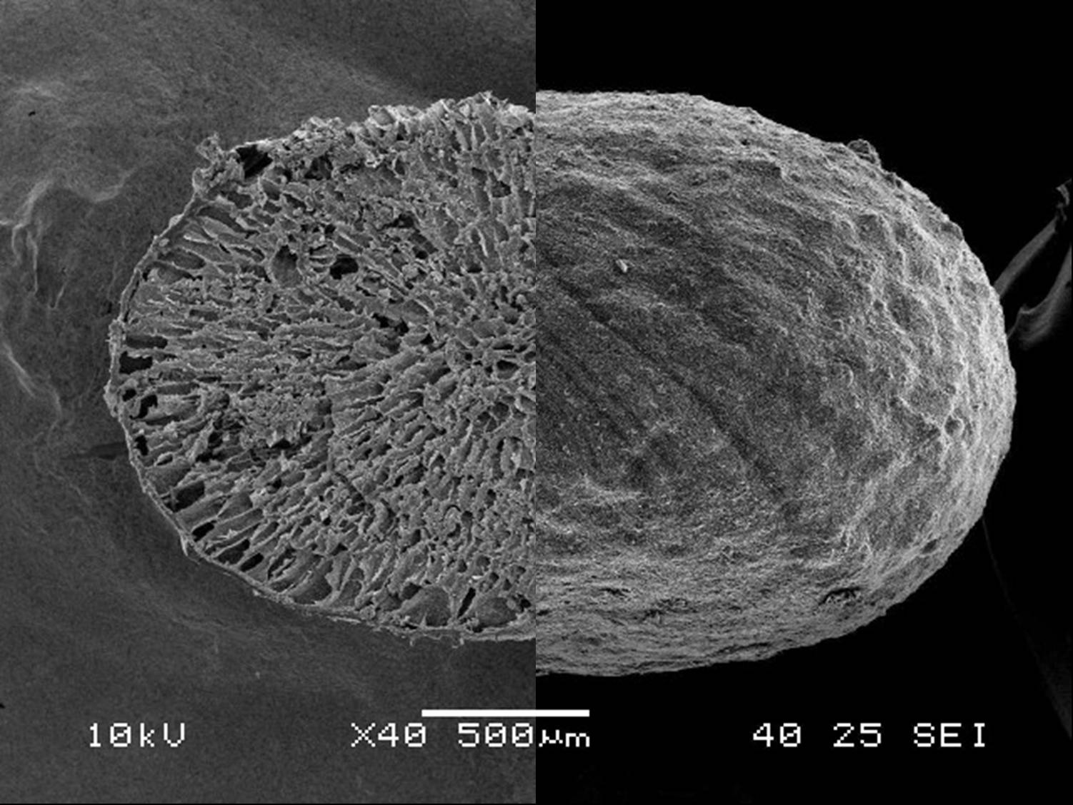 | 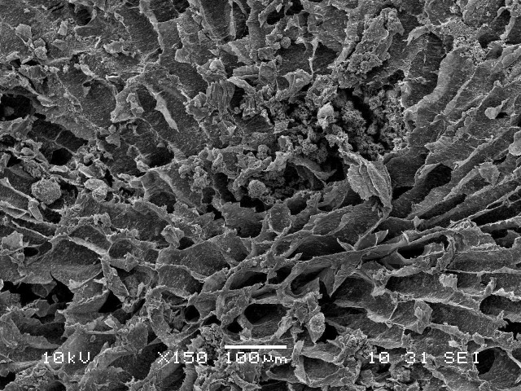
A | B
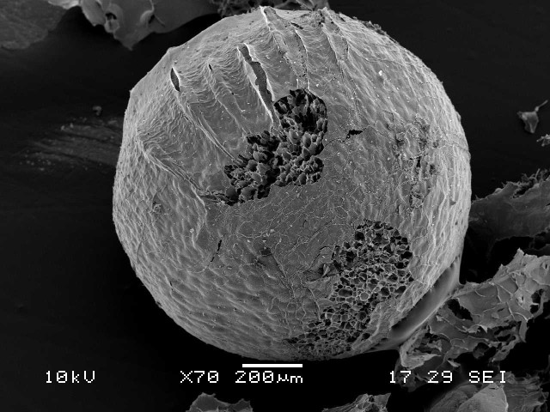 | 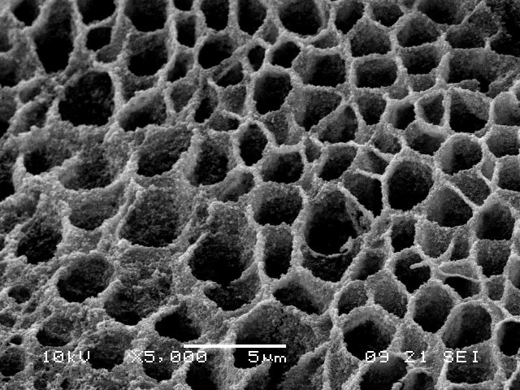
C | D
Fig. 1. SEM micrographs of freeze-dried magnetic chitosan beads: Ch/Fe₃O₄ ×40 (A)
and ×150 (B); Ch/Fe₃O₄ (in situ) ×70 (C) and ×5 000 (D).

The IR spectra of the beads showed the following characteristic for chitosan bands: in the range of 3500–3300 cm^{–1} (NH- and OH-stretching vibrations), the bands due to its saccharide structure – at 1153 cm^{–1} (OH-bending), 1068 cm^{–1} (–C–O–C– stretching vibrations) and 1030 cm^{–1} (OH-bending) and for Amide I at 1634 cm^{–1}. A new band in the low-frequency region (570–588 cm^{–1}), due to the iron oxide skeleton (–Fe–O– stretching vibrations), is an evidence for presence of magnetite in the beads [8].
The changes which occur after thermal treatment of Ch/Fe₃O₄ (in situ) beads were estimated by TGA (Fig. 2). The most considerable destruction (appro-ximately 32% weight losses) was observed in the range of 150–780°С. As seen, the first decompo-sition stage started at 150°С and ended at 420°С with weight loss of 15.8% from the sample initial weight. The second stage continued up to 780°С with weight losses of 15.9%. Clearly, these two stages correspond to the thermal decomposition of chitosan, which usually starts at 250°С and ends at 650°С [9].
Fig. 2. TGA thermogram of dried Ch/Fe₃O₄
(in situ) beads
The successful preparation of Ch/Fe₃O₄ (in situ) beads enriched in Fe₃O₄ has been evidenced by all these previous experiments. Moreover, the one-pot preparation of Ch/Fe₃O₄ (in situ) beads provides an additional possibility for their stabilization which is favored by the complex formation between amino groups of chitosan and iron ions [10, 11]. Therefore, the formation of physical network during the extrusion process leads to collapse of chitosan gel, thus decreasing the pore size of Ch/Fe₃O₄ (in situ) beads compared to Ch/Fe₃O₄ one. These peculiari-ties of the one-pot preparation of Ch/Fe₃O₄ (in situ) beads determine different behaviour of the beads at different pH values. The dependence of the equi-librium swelling degree (α_{eq}) of the Ch/Fe₃O₄ (in situ) and Ch/Fe₃O₄ beads on the pH (4, 7 and 9) of the medium is presented in Table 1. As seen, the highest α_{eq} value (exceeding 1000%) was attained in acidic medium for the Ch/Fe₃O₄ (in situ) beads. After 6 h at pH 4 the Ch/Fe₃O₄ (in situ) beads fragmented, thus hampering the determination of α_{eq} at this pH value. At pH 4 Ch/Fe₃O₄ beads dissolved in comparison with Ch/Fe₃O₄ (in situ). As seen (Table 1), the Ch/Fe₃O₄ (in situ) and Ch/Fe₃O₄ beads swelled slightly at pH 7 and pH 9, besides Ch/Fe₃O₄ (in situ) swelled less than Ch/Fe₃O₄ beads.
Table 1. Dependence of the equilibrium swelling degree (α_{eq}) of different magnetic chitosan beads on pH; 25°С;
I = 0.1.
Beads | α_{eq} , %
Beads | pH = 4 | pH = 7 | pH = 9
Ch/Fe₃O₄ (in situ) | 1300 ª | 24 | 16
Ch/Fe₃O₄ (in situ)/GA | 212 | 16 | 15
Ch/Fe₃O₄ | ^{b} | 125 | 162
Ch/Fe₃O₄/GA | 255 | 64 | 41
ª the beads are fragmented after 6 h; ^{b} the beads are dissolved.
As mentioned above, due to the formation of physical network by interaction between the amino groups of chitosan and iron ions in Ch/Fe₃O₄ (in situ) the pore size decreased thus decreasing the water uptake in the beads. After chemical cross-linking with glutaraldehyde (GA), both beads types were stable in acidic medium and reached equi-librium swelling degree for 24 h. Obviously, non-crosslinked beads swelled to a greater extent com-pared to the crosslinked ones and the α_{eq} values were higher in acidic than in neutral or alkaline solutions (Table 1). For example, at pH 7 the α_{eq} decreased in the order: Ch/Fe₃O₄ > Ch/Fe₃O₄/GA > Ch/Fe₃O₄ (in situ) > Ch/Fe₃O₄ (in situ)/GA. For the beads, crosslinked with GA, α_{eq} decreased in the order: рН 4 > рН 7 > рН 9.
O. Stoilova et al.: One-pot preparation of magnetic chitosan beads
The obtained results show the advantages of the one-pot preparation of magnetic chitosan beads. Further, the magnetic properties of the beads were studied.
Magnetic properties of the prepared magnetic chitosan beads
The presence only of magnetite (Fe₃O₄) phase was confirmed by XRD analysis of dried Ch/Fe₃O₄ (in situ) beads (Fig. 3). The iron oxide phase was identified from the XRD patterns by the peak positions at 18.2 (111), 30.0 (220), 35.5 (311), 43.1 (400), 53.4 (422), 57.0 (511), 63 (440) and 73.9 (533), which were in agreement with magnetite standard data.
The mean particle size of the formed in the beads ferromagnetic particles was 12 nm, as calculated by the Scherer’s equation. It has been reported that Fe₃O₄ particles with size lower than 20 nm are superparamagnetic [12]. Therefore, it might be assumed that a part of the magnetite, formed in situ in the beads, is in superparamagnetic state.
Magnetization of the Ch/Fe₃O₄ (in situ) beads as a function of internal magnetic field was measured by vibrating-sample magnetometer (Fig. 4). As seen, the saturation of magnetization could not be reached even at maximum internal magnetic field of 6 kOe. At Н = 0, the magnetization curve showed almost immeasurable coercivity (H_{c} = 100 Oe) and remanence (M_{r} = 1.2 ± 0.2 emu/g). These low values of H_{c} and M_{r} showed that magnetic particles formed in Ch/Fe₃O₄ (in situ) beads were in superpara-magnetic state [13].
Fig. 3. XRD patterns of the dried Ch/Fe₃O₄ (in situ) beads.
Fig. 4. Magnetization curve at 300K of the dried Ch/Fe₃O₄ (in situ) beads
However, the presence of immeasurable hyste-resis indicated that a part of the magnetic nanopar-ticles existed in different magnetic states – superpa-ramagnetic and intermediate state between superpa-ramagnetic and ferrimagnetic one. The low value of the saturation magnetization (σ_{s} = 11 emu/g) proved that the magnetic particles formed in Ch/Fe₃O₄ (in situ) beads were as small as single magnetic domain (D_{p} = 20 nm).
The results obtained from the Mössbauer spectra confirmed the assumption of superparamagnetic pro-perties of the obtained magnetic beads. The pro-perties of incorporated magnetic iron oxide nanopar-ticles in the porous polymer matrix depend consi-derably on the particle size. As already mentioned, particles with dimensions lower than 20 nm are often superparamagnetic, which means that the magneti-zation vector fluctuates among the easy directions of magnetization (superparamagnetic relaxation) [14]. When the relaxation time τ is longer than 10^{–8} s, the Mössbauer spectra are magnetically split. For τ < 10^{–9} s, the magnetic splitting collapses and spectra with singlets or doublets are obtained. In the case, when τ is between 10^{–9} and 10^{–8} s, spectra with broadened lines are observed because the fluctua-tions of the magnetization direction lead to a reduce-tion in the magnetic hyperfine splitting of the spectra.
O. Stoilova et al.: One-pot preparation of magnetic chitosan beads
The Mössbauer spectrum at 300K of Ch/Fe₃O₄ (in situ) dried beads (Fig. 5A) was fitted as super-position of two magnetic sextet’s distributions and a superimposed quadrupole doublets distribution. The spectrum was typical for magnetic particles in superparamagnetic state or close to it. Actually, the magnetic splitting collapsed only for 18.7% of mag-netic particles corresponding to quadrupole doublets distribution (Table 2). This component was due to the smallest nanoparticles which exhibited fast superparamagnetic relaxation (< 10^{–9} s). However, the majority of nanoparticles were in intermediate region (10^{–9} s < τ < 10^{–8} s). The Mössbauer spectrum of the same sample but at liquid nitrogen tempe-rature (Fig. 5B) was fitted as a superposition only of two magnetic sextet’s distribution; its Mössbauer parameters are presented in Table 2. At this tempe-rature (77K) the superparamagnetic relaxation was blocked for all magnetic nanoparticles, including these with the smallest diameter. Moreover, at this temperature both distributions of the magnetic field are related to Fe(II) and Fe(III), and not to octa-hedral and tetrahedral positions.
The reason was that the Mössbauer measure-ments were made under Verwey point (120К), when the electron exchange between Fe³⁺ and Fe²⁺ in octahedral positions in magnetite was absent. It was determined from the relation between the areas of both magnetic distributions that the spectrum of as-prepared magnetite might be interpreted as a spec-trum of magnetite with ratio Fe³⁺/Fe²⁺ = 4. This ratio is Fe³⁺/Fe²⁺ = 2 for standard magnetite. Therefore, probably in Ch/Fe₃O₄ (in situ) beads a part of the Fe(II) in position B was oxidized or a part of magnetite was converted in maghemite. These results are in agreement with the values of isomer shifts listed in Table 2.

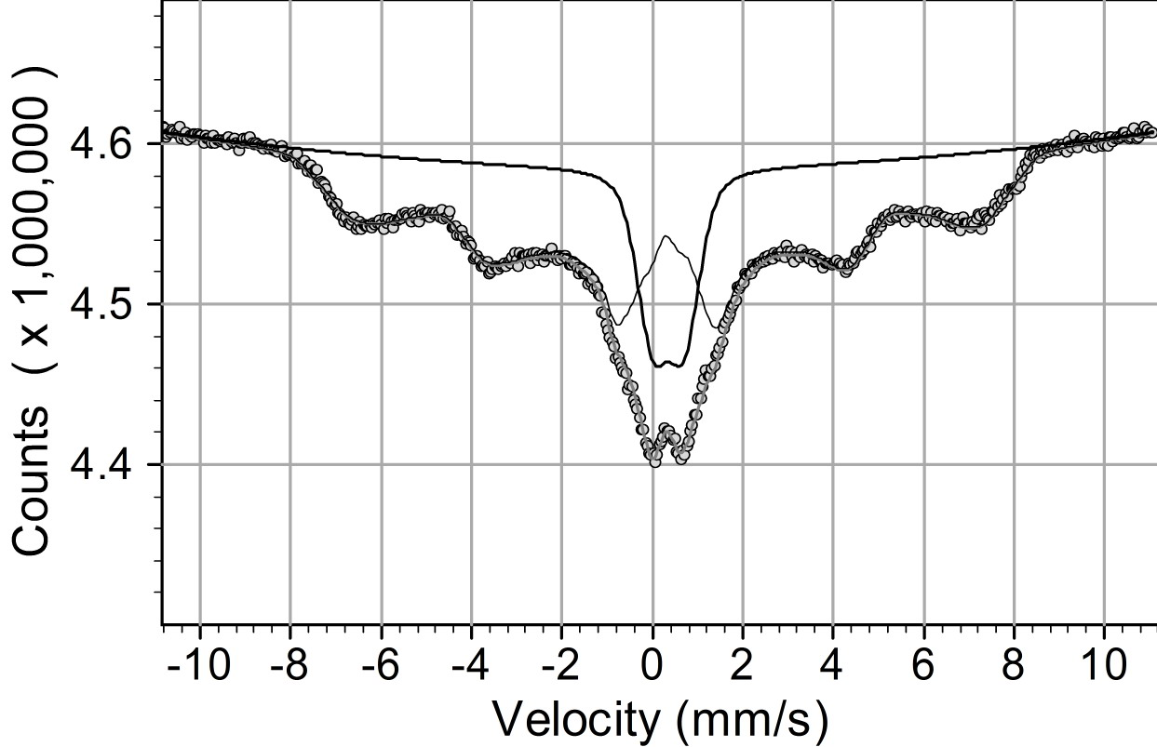 A | 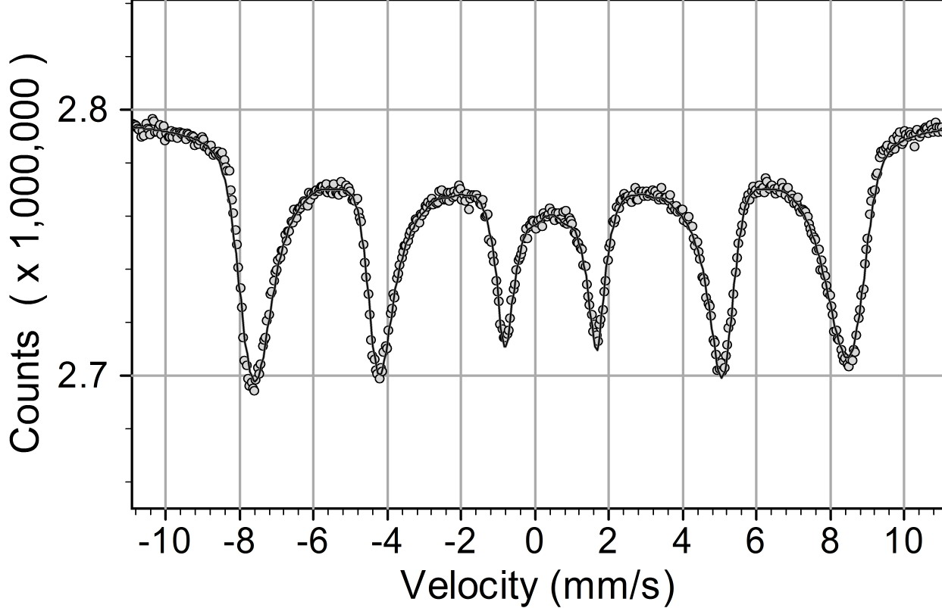 B
Fig. 5. Mössbauer spectra of dried Ch/Fe₃O₄ (in situ) beads recorded at 300K (A) and 77K (B).
Table 2. Mössbauer parameters ª of dried Ch/Fe₃O₄ (in situ) beads.
Sample | T ^{b}, K | SXT | IS, mm/s | H_{avr}, kOe | σH, kOe | H_{max}, kOe | QS_{avr}, mm/s | QS_{area}, %
Ch/Fe₃O₄ (in situ) | 300 | I | 0.30 | 296 | - | 436 | 0.78 | 18.7
Ch/Fe₃O₄ (in situ) | 300 | II | 0.68 | 276 | - | 430 | 0.78 | 18.7
Ch/Fe₃O₄ (in situ) | 77 | I | 0.44 | 422 | 53 | 504 | - | 0
Ch/Fe₃O₄ (in situ) | 77 | II | 0.37 | 403 | 52 | 498 | - | 0
ª isomer shift (IS); average magnetic field at the site of the Fe nucleus (H_{avr}); dispersion of magnetic hyperfine-field distribution (σH); maximum value of magnetic hyperfine-field distribution (H_{max}); average quadrupole splitting (QS_{avr}); relative spectral area of quadrupole doublets distribution (QS_{area}); ^{b} T (K) - temperature in K degrees.

As seen, the results are close to literature data for maghemite [15] implying that topotactic oxidation of magnetite has taken place during storage. At room temperature the Mössbauer spectra of bulk magnetite and maghemite are quite different. When the material is in the form of nanoparticles the crucial parameter of the Mössbauer spectra to distinguish between two possible iron oxides is the isomer shift. Moreover, the isomer shift is typically ≥ 1.0 mm/s for Fe²⁺, while 0.3–0.4 mm/s for Fe³⁺. Therefore, the values of isomer shift of Ch/Fe₃O₄ (in situ) presented in Table 2 suggest an average valence of iron close to Fe³⁺.
CONCLUSIONS
The combination of the sol-gel method with those of simple coacervation is successfully used for one-pot preparation of chitosan beads with in situ involved nanosized magnetite. Compared to the beads with pre-formed nanosized magnetite, these with in situ prepared magnetite are more stable in acidic medium. The size of the in situ prepared magnetite is 12 nm, as proved by the XRD calcula-tions and by the low values of saturated magneti-zation. The measurements of the magnetization and the Mössbauer analyses showed that the magnetic particles formed in the beads existed in superpara-magnetic state and a part of them was in interme-diate state between superparamagnetic and ferrimag-netic one. Therefore, the herein one-pot prepared Ch/Fe₃O₄ (in situ) beads are promising magnetic materials.
O. Stoilova et al.: One-pot preparation of magnetic chitosan beads
Acknowledgement: This work was supported by the Grant CH-1414 from the Bulgarian National Science Fund of Ministry of Education and Science.
REFERENCES
- K. Arai, T. Kinumaki, T. Fujita, Bull. Tokai Reg. Fish Res. Lab., 56, 89 (1968).
- C. Peniche, W. Argüelles-Monal, H. Peniche, N. Acosta, Macromol. Biosci., 3, 511 (2003).
- F.-L. Mi, T.-B. Wong, S.-S. Shyu, S.-F. Chang, J. Appl. Polym. Sci., 71, 747 (1999).
- J. Zhang, S. Zhang, G. Wu, W. Wang, S. Gao, J. Zhang, Y. Wang, J. Bioactive Compatible Polym., 22, 429 (2007).
- E. Denkbaş, E. Kiliçay, C. Birlekseven, E. Öztürk, React. Funct. Polym., 50, 225 (2001).
- D. Paneva, O. Stoilova, N. Manolova, I. Rashkov, e-Polymers, no. 060 (2004).
- R. Mincheva, O. Stoilova, H. Penchev, T. Ruskov, I. Spirov, N. Manolova, I. Rashkov, Eur. Polym. J., 44, 615 (2008).
- H. Ma, X. Qi, Y. Maitani, T. Nagai, Int. J. Pharm., 333, 177 (2007).
- J. Zhi, Y. Wang, Y. Lu, J. Ma, G. Luo, React. Funct. Polym., 66, 1552 (2006).
- M. Rinaudo, A. Domard, in: Chitin and chitosan, G. Skajak-Braek, T. Anthonsen, P. Sanford (eds.), Elsevier, London, 1989, p. 71.
- S. C. Bhatia, N. Ravi, Biomacromolecules, 1, 413 (2000).
- M. A. M. Gijs, Microfluid Nanofluid, 1, 22 (2004).
- B. Li, D. Jia, Y. Zhou, Q Hu, W. Cai, J. Magnetism Magnet. Mater., 306, 223 (2006).
- L. Neel, Ann. Geophys., 5, 99 (1949).
- G. M. Da Costa, E. De Grave, L. H. Bowen, P. M. A. De Bakker, R. E. Vandenberhe, Clays and Clay Minerals, 43, 562 (1995).

ЕДНОЕТАПНО ПОЛУЧАВАНЕ НА МАГНИТНИ ХИТОЗАНОВИ СФЕРИ
О. Стоилова¹, Хр. Пенчев¹, Т. Русков², Ив. Спиров², Н. Манолова¹, Ил. Рашков¹*
¹ Лаборатория „Биологично активни полимери“, Институт по полимери, Българска академия на науките,
ул. Акад. „Г. Бончев“, бл. 103А, 1113 София,
² Лаборатория по Мьосбауерова спектроскопия и ниска активност,
Институт за ядрени изследвания и ядрена енергетика, Българска академия на науките,
бул. „Цариградско шосе“ 72, 1784 София,
Посветена на акад. Иван Юхновски по повод на 70-та му годишнина
Постъпила на 7 януари 2008 г.; Преработена на 30 януари 2008 г.
(Резюме)
Предложен е нов едноетапен метод за получаване на магнитни хитозанови сфери, включващ in situ получени магнитни наночастици. Основното предимство на предложения метод е получаването на феромагнитен материал едновременно с формирането на хитозановите сфери като това става чрез комбинирането на два метода – зол-гел метода и капилярната екструзия. В допълнение, намерени са подходящите условия за ефективно включване на предварително получена суспензия от магнитни наночастици в хитозанови сфери без загуба на магнитен материал по време на екструзията на разтвора. Нещо повече, зол-гел методът позволява включването на значителни количества магнетит в сферите. Равновесната степен на набъбване на получените сфери зависи от рН на средата. Оптичната и сканираща електронна микроскопия разкриват силно порестата структура на сферите. Измерването на намагнитеността на сферите показва, че насищане не се достига дори при максимално външно магнитно поле от 6 kOe. Мьосбауеровите анализи показват, че in situ получените магнитни наночастици са в суперпарамагнитно състояние и част от тях са в междинно състояние – между суперпарамагнитно и феримагнитно.

