Application of diffusion-ordered spectroscopy for the analysis of cancer related biological samples
Bulgarian Chemical Communications, Volume 40, Number 4 (pp. 464–468) 2008
© 2008 Bulgarian Academy of Sciences, Union of Chemists in Bulgaria
G. I. Ivanova^{1,2}*, E. J. Cabrita¹, R. O´Connor³, A. J. Eustace³, D. F. Brougham^{3,4}
* To whom all correspondence should be sent:
E-mail: g.ivanova@dq.fct.unl.pt
¹ REQUIMTE/CQFB - Departamento de Química, Faculdade de Ciências e Tecnologia,
Universidade Nova de Lisboa, 2829-516 Caparica, Portugal
² Institute of Organic Chemistry with Centre of Phytochemistry, Bulgarian Academy of Sciences, 1113 Sofia, Bulgaria
³ National Institute of Cellular Biotechnology, Dublin City University, Dublin 9, Ireland
⁴ School of Chemical Sciences, Dublin City University, Dublin 9, Ireland
Dedicated to Academician Ivan Juchnovski on the occasion of his 70th birthday
Received January 2, 2008; Revised January 19, 2008
A preliminary application of diffusion-ordered spectroscopy (DOSY) for separation, identification and characterisation of metabolites of human lung carcinoma cell extracts, exhibiting different levels of multi-drug resistance (MDR) is reported. The results show the presence of at least three lipid components of different sizes in the lipophilic extracts which can not be identified by one- and two-dimensional NMR techniques. A number of metabolites in the hydrophilic extracts of human lung carcinoma cell lines are successfully separated by different diffusivities. The appearance in the DOSY spectra of different metabolites with the same diffusion coefficient is consistent with them being chemically bound together.
Key words: cells; composition; NMR, diffusion; DOSY.

NMR spectroscopy is a powerful technique for the investigation of the metabolite composition of biological samples: biofluids, tissues and tissue extracts. Proton NMR spectra of tissues are usually extremely complex due to the large number of components in the samples, resulting in spectra with complex line shapes and significant overlap of the resonance signals. The tissue extracts, both hydro-philic and lipophilic, yield NMR spectra with enhanced resolution, improving the possibility for detailed metabolite identification and structural characterization [1–3].
Pulsed field gradient spin echo NMR spectro-scopy can be used for investigating diffusion phenomena in solution [4, 5]. Mixture analysis continues to be one of the most challenging pursuits in analytical science. Diffusion-ordered spectro-scopy (DOSY) allows the separation of components of different molecular size through differences in their diffusion coefficients and can be a powerful tool for mixture analysis. The diffusion coefficients of the components are dependent on their individual physical properties, such as the size and shape of the molecules as well as the temperature and viscosity of the solutions. In high resolution diffusion-ordered spectroscopy (DOSY), differences in the diffusion coefficient between species are sufficient to allow the spectrum of an intact mixture to be decomposed into the subspectra of individual components. Therefore, the DOSY technique offers a route whereby the components in complex biological systems such as tissue and tissue extracts might be separated and hence identified [5–7].
The aim of the present study has been to apply diffusion-ordered spectroscopy (DOSY) for separa-tion and identification of the metabolites of human lung carcinoma cell extracts, exhibiting different levels of multi-drug resistance (MDR). The human lung carcinoma cell extracts, both hydrophilic and lipophilic, have been studied.
Experimental
Cancer cell lines
The cell lines studied include the parent cell line DLKP (a human squamous non-small cell lung carcinoma) and the resistant daughter cell line DLKP-A5F. DLKP cells express a small amount of the multidrug resistance. The lipophilic (L) and hydrophilic (H) extracts of the parent cell line DLKP (a human squamous cell lung carcinoma) and resistant daughter cell line DLKP-A5F were prepared according to a slightly modified metho-dology published in the literature [8]. The extraction procedure was performed on a number of 1×10⁷ cells per NMR sample on a crushed ice bath at 4ºC. Cells were trypsinised, counted and pelleted into a 1.5 ml eppendorf tube. 500 μl of a 2:1 (v/v) ratio of ice cold methanol-chloroform were added and the pellet resuspended using a vortex. The tube was mixed for 10 min on a blood tube mixer. 500 µl of ice cold 1:1 (v/v) chloroform water mixture were added and again mixed using a vortex. The eppendorf tube was floated in a sonicating bath and sonicated for 10 min. The tube was centrifuged in a microfuge at 13000 rpm for 5 min. The top and bottom layers were removed to separate eppendorf tubes taking care not to disturb the pelleted debris. The solvent was evaporated using a centrifugal con-centrator (MaxiPrep, Holten) and the tubes placed in a darkened box in a freezer for later analysis.
NMR spectroscopy
The NMR spectra were recorded on a Bruker AvanceII 600 spectrometer, equipped with a cryo probe and pulse gradient units, capable of producing magnetic field pulsed gradients in the z-direction of 56.0 G/cm.
¹H NMR spectroscopy of lipophilic cell extracts
Standard 1D ¹H NMR spectra of the lipophilic cell extracts (10 mg), in deuterated chloroform were recorded at 300K, using 30º pulses. The solvent resonance peak at 7.26 ppm has been used as a chemical shift reference. Magnitude mode gradient-COSY spectra with double quantum filter, gradient pulses for selection, gradient ratio 16:12:40 and relaxation delay 1.5 s were performed. A total 2K data points in F₂ and 256 data points in F₁ over a spectral width of 4000 Hz were collected using 32 transients and 16 dummy scans. ¹H/¹H total correlation (TOCSY) spectra were recorded with 2K data points, spectral width 4000 Hz, relaxation delay 2 s, MLEV-17 sequence with a mixing time of 80 ms. A total 256 data points in F₁ were collected using 32 transients and 16 dummy scans.
G. I. Ivanova et al.: Application of diffusion-ordered spectroscopy
¹H NMR spectroscopy of hydrophilic cell extracts
1D ¹H NMR spectra of hydrophilic cell extracts (7 mg) in D₂O were recorded at 300K and 0.1% solution of TSP in D₂O as an external chemical shift reference, using a presaturation during the relaxation delay. Two-dimensional ¹H/¹H COSY (correlated spectroscopy) and ¹H/¹H TOCSY (total correlated spectroscopy) have been acquired in a phase sensi-tive mode. In both cases, 64 transients per increment and 256 increments were collected into 2K data points and relaxation delay 2 s. The spectral width in both dimensions was 5000 Hz. The TOCSY NMR spectra were recorded by use of MLEV-17 spin lock scheme for proton-proton transfer with a mixing time of 60 ms.
Diffusion-ordered NMR spectroscopy
The DOSY experiments were acquired using the bipolar pulse longitudinal eddy current delay (BPPLED) pulse sequence [9] and presaturation during the relaxation delay for the samples of hydrophilic extracts (in D₂O). Typically, in each experiment a number of 32 BPPLED spectra of 32K data points were collected, with a duration of the magnetic field pulse gradients (δ) of 2.2–3.0 ms, diffusion times (Δ) of 100–200 ms and an eddy current delay set to 5 ms. The pulse gradient (g) has been incremented from 2 to 95% of the maximum gradient strength in a linear ramp. The experiments were acquired at a temperature of 298K and air flow of 535 l/h, in 3 mm NMR tubes. NMR tubes of 3 mm size were used to increase samples concentra-tion and suppress the temperature induced convec-tion currents due the smaller diameter as compared to 5 mm tubes in the diffusion experiments.
Results
Typical ¹H NMR spectra of intact cancer cells (for comparison), their lipophilic and hydrophilic extracts are presented in Figure 1. The signal assign-ment of the spectra (Figure 1B and C) is based on the analysis of 1D and 2D (¹H/¹H COSY and ¹H/¹H TOCSY) spectra and is in agreement with the lite-rature data [10–12]. The main resonances observed in the spectra of lipophilic extracts (B) are those from fatty acids (saturated and unsaturated), choline, cholesterol and glycerol backbone moieties. In the ¹H NMR spectra of the hydrophilic extracts, the anticipated resonances of water-soluble cell meta-bolites (amino acids and other organic acids and bases) have been observed. The characteristic reso-nance signals of some of the major metabolites found in the samples are shown in Figure 1.
In the 2D DOSY (600 MHz) spectra of the lipo-philic extracts of the lung carcinoma cell lines studied, four groups of proton resonance signals characterized by a distinct self-diffusion coefficient have been observed (Fig. 2A, B).
The analysis of the spectra shows that the lipids extracted from both lung carcinoma cell lines contain at least three lipid components classified according to their self-diffusion coefficients and respectively different molecular size and molecular weight aromatic fractions. The diffusion coefficients of the separated components are presented in Table 1. As depicted from the 2D DOSY plots, the results in table 1 show that on the base of the measured diffu-sion coefficients, differences in the composition of the cellular extracts could be estimated. The presence of cholesteryl esters of fatty acids has been detected in both mixture components of DLKP_L (logD =
–9.02 and logD = –9.23 m²/s), but only in one of the components of DLKP5fA_L (logD = –9.17 m²/s). The results suggest the presence of high molecular weight free fatty acids and/or hydrocarbons (logD = –9.32 m²/s).
2D DOSY (600 MHz) spectra of the hydrophilic extracts in D₂O are presented in Fig. 3. The spectra are dominated by the resonance signals of myo-Inositol (myo-I), choline (Cho), creatine (Cr), gluta-mine (Glu)/glutatione (Glt). The signal overlap in the spectral area between 3.30 and 4.30 ppm as well as the low intensity of some components in the high field spectral area have hampered a more detailed analysis of the DOSY spectra.

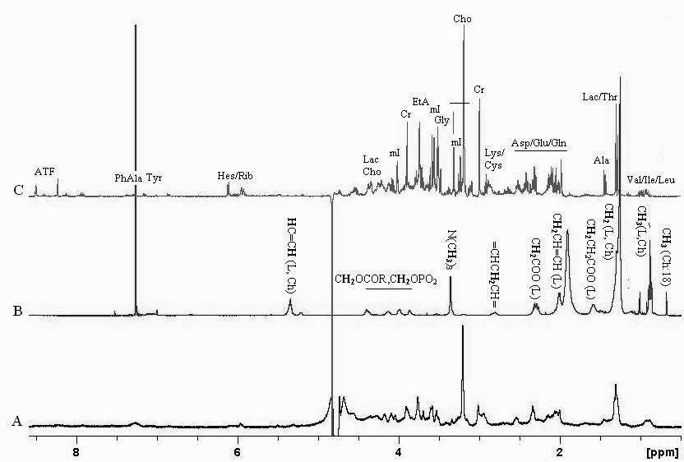
Fig. 1. Typical ¹H NMR spectra of intact DLKP lung carcinoma cells (A) and their lipophilic (B) and hydrophilic (C) extracts.
G. I. Ivanova et al.: Application of diffusion-ordered spectroscopy
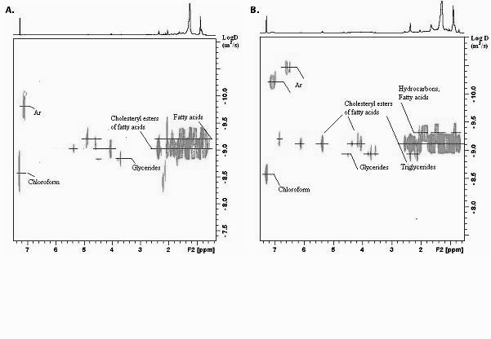
Fig. 2. 600 MHz 2D DOSY spectra of lipophilic extracts of DLKP (A) and DLKP5fA (B) cancer cells in CDCl₃,
and Δ = 200 ms; δ = 3.0 ms; TD = 32k .

The decay of the methyl resonances of the amino acids has been usually utilized to determine their D values. The analysis of the spectra of the hydro-philic extracts DLKP_W and DLKP5fA_W has shown that some of the characteristic signals of metabolites present in the samples can be separated in the DOSY experiment, according to their distinct diffusion coefficients. However, an estimation of the differences in the cellular composition requires further studies in order to improve the resolution in the diffusion dimension. Experimental conditions such as those concerning the influence of pH, temperature and/or application of complexation agents can be explored. Another option to increase the resolution in the diffusion dimension is the spread of chemical shifts in a 2nd frequency dimen-sion (¹H or ¹³C), creating a pseudo 3D experiment like COSY-DOSY or HSQC-DOSY.
Further studies exploring these possibilities are ongoing in order to improve the resolution in the diffusion dimension of DOSY spectra of complex biological samples.
G. I. Ivanova et al.: Application of diffusion-ordered spectroscopy
Table 1. Measured self-diffusion coefficients of the separated components of lipophilic extracts of DLKP_L and DLKP5fA_L.
Composition | DLKP_L | DLKP5fA_L
Composition | D* 10⁹ [m²/s] | D* 10⁹ [m²/s]
Chloroform | 2.45 | 3.31
Un | 3.98 | 1.99
Glycerides | 1.48 | 1.15
CholE/FA | 9.55 | 6.76
CholE/FA | 5.89 | 4.79
Ar | 1.48 | 4.79
Ar | 9.12 | 1.58

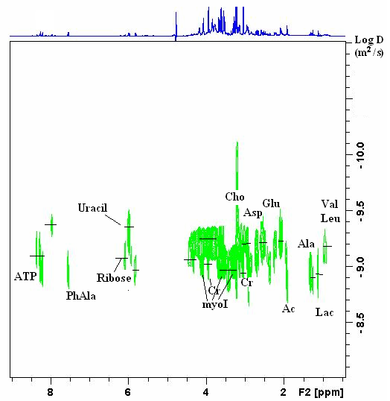
Fig. 3. 600 MHz 2D DOSY NMR spectra of hydrophilic extracts of DLKP5fA cancer cells in D₂O
and Δ =100 ms; δ = 2.2 ms; TD = 32k.

Conclusion
The preliminary results presented here show that Diffusion-Ordered NMR Spectroscopy (DOSY) can be a powerful tool for separation and spectral char-acterisation of the components of complex mixtures, such as tissue extracts. The DOSY techniques can be used as a tool to distinguish between components in a mixture due to the differences in their relative diffusion coefficient values. The diffusion coeffi-cient measurements of cell extracts allow an addi-tional chemical and physical characterization of individual components, in term of their diffusivities, size and shape of the molecules.
Acknowledgements: G. I. Ivanova acknowledges FCT-Portugal for the grant SFRH/BPD/24930/2005.
G. I. Ivanova et al.: Application of diffusion-ordered spectroscopy
References
- M. Bloom, K. T. Holmes, C. E. Mountford, P. G. Williams, J. Magn. Reson., 69, 73 (1986).
- C. E. Mountford, S. Doran, C. L. Lean, P. Russell, Chem.Rev., 104, 3677 (2004).
- T. L. Whitehead, T. Kieber-Emmons, Prog. NMR Spectr., 47, 165 (2005).
- C. S. Johnson, Progr. NMR Spectr., 34, 203 (1999).
- J. S. Gounarides, A. Chen, M. J. Shapiro, J. Chromatogr. B, 725, 79 (1999).
- Y. Cohen, L. Avram, L. Frish, Angew. Chem., Int. Ed., 44, 520 (2005).
- B. Antalek. Conc. Magn. Reson., 14, 225 (2002).
- J. E. Le Belle, N. G. Harris, S. R. Williams, K. K. Bhakoo, NMR Biomed.,15, 37 (2002).
- D. Wu, A. Chen, C. S. Johnson. J. Magn. Reson. Ser. A, 115, 260 (1995).
- U. Sharma, A. Mehta, V. Seenu, N. R. Jagannathan, Magn. Reson. Imag., 22, 697 (2004).
- V. Govindaraju, K. Young, A. A. Maudsley, NMR Biomed., 13, 129 (2000).
- N. J. Waters, E. Holmes, C. J. Waterfield, R. D. Farrant, J. K. Nicholson, Biochem. Pharmacol., 64, 67 (2002).

Приложение на дифузионно подредена спектроскопия
за анализ на ракови биологични проби
Г. Ив. Иванова^{1,2}*, Eур. Ж. Кабрита¹, Р. O´Конор³, Aл. Дж. Юстасе³, Д. Ф. Броухам^{3,4}
¹ Катедра по химия, Научен и технологичен факултет, Нов университет на Лисабон,
2829-516 Капарика, Португалия
² Институт по органична химия с център по фитохимия, Българска академия на науките, 1113 София
³ Национален институт по клетъчна биотехнология, Университет на град Дъблин, Дъблин 9, Ирландия
⁴ Химически факултет, Университет на град Дъблин, Дъблин 9, Ирландия
Посветена на акад. Иван Юхновски по повод на 70-та му годишнина
Постъпила на 2 януари 2008 г.; Преработена на 19 януари 2008 г.
(Резюме)
Използвана е дифузионно подредена ЯМР спектроскопия за разделяне, откриване и характеризиране на метаболити в екстракти на човешки белодробни ракови клетки, проявяващи различна степен на резистентност към лекарства (мулти-лекарствена резистентност). Резултатите показват, че в липидните екстракти присъстват най-малко три липидни компонента с различен размер, които не могат да бъдат идентифицирани посредством традиционните едномерни и двумерни ЯМР техники. Метаболитите присъстващи в хидрофилните екстракти на човешки белодробни ракови клетки са успешно разделени на базата на разлика в техните дифузионни свойста. Появата на различни метаболити с еднакви коефициенти на дифузия в дифузионно подредените ЯМР спектри, са доказателство за наличието на химична връзка между тях.

