Computational study of the electronic spectra of some B–N dyes
Bulgarian Chemical Communications, Volume 40, Number 4 (pp. 450–455) 2008
© 2008 Bulgarian Academy of Sciences, Union of Chemists in Bulgaria
S. M. Bakalova¹, J. Kaneti^{1,2}*, O. Castaño²
* To whom all correspondence should be sent:
E-mail: kaneti@orgchm.bas.bg
¹ Institute of Organic Chemistry with Centre of Phytochemistry, Bulgarian Academy of Sciences, 1113 Sofia, Bulgaria
² Department of Physical Chemistry, Universidad de Alcalá, 28871 Alcalá de Henares (Madrid), Spain
Dedicated to Academician Ivan Juchnovski on the occasion of his 70th birthday
Received December 21, 2007; Revised January 17, 2008
Boron “complexes” of dipyrromethenes (BDP) have found wide application as excellent optoelectronic materials and luminescent chemo- and bio-sensors since the very end of the past century. Their high absorption coefficients and fluorescence quantum yields in the VIS spectral region are augmented by outstanding resistance to photodegradation. Presently, a large amount of empirical, unstructured knowledge on the relationships between molecular structure and spectroscopic parameters of BDP dyes has been accumulated. High level correlated calculations, CISD with size consistency corrections, reproduce fairly well the energies of lowest pyrromethene singlet excited states, but have a prohibitively high computational cost and do not satisfactorily predict substituent effects, Stokes’ shifts, and solvent effects on either absorption or emission.
We apply a recently proven semiempirical CISD AM1 methodology to study excited state energies and substituent effects on pyrromethene chromophores, parallel to TD DFT computations of the Frank-Condon absorption and emission transition energies. This combination of methodologies is a robust approach to the rational search for new compounds within the relatively novel class of boron-containing optical materials.
Key words: borindacene dyes, fluorescence, AM1, B3LYP and B2PLYP calculations.

Introduction
The search for new classes of heterocyclic compounds as fluorescent indicators and laser dyes is a challenging and rapidly advancing area. Pyrrolo-boraheterocycles such as [2,3-a,5,6-a]bis-pyrrolo-1,1-difluoro-[1,2,6]-boradiazine, or 4,4-difluoro-borindacene 1, BDP, Scheme 1, [5–7] have a number of convenient properties, in parti-cular an outstanding resistance to photodegrada-tion, high molar absorptivities and high fluor-escence quantum yields. BDP dyes have found interesting applications as optoelectronic mate-rials, laser active media and molecular chemo- and bio-sensors. [8–12].
There is indeed some remote topological similarity between borindacenes and triphenyl-methane dyes, e.g. rhodamines as well as fluor-escein, which has probably contributed to the rapid commercialization of the new heterocycles under the trademark BODIPY® [11, 12], but hardly to the understanding of structural and electronic factors behind the observed photophy-sical properties. The latter factors have been thoroughly studied with rhodamines, [4] while the introduction of the scarcely known boron atom into the seemingly aromatic [5–12] borahetero-cycles renders a wide unexplored area open to imagination and research.
X-ray structural as well as computational studies in general confirm the supposedly aromatic structure of pyrrolo-boraheterocycles [1, 2, 10]. The rather numerous computational papers how-ever provide no detailed description of the nature of the excited states and, in particular, of the fluorescent states. Knowledge of structural changes and electronic distributions of the latter geometry relaxed excited states is necessary for the descrip-tion of such quantities as emission wavenumbers and Stokes’ shifts. This information could signify-cantly amplify the capacity for rational search for and design of new compounds with promising photophysical and photochemical properties as fluorescent probes for biological assays. Notably, solvent effects on both absorption and emission maxima of BDP are minimal [5–7] and they will not be considered in the present study.
Scheme 1. Structural sketch of the parent
4,4-difluoro-s-borindacene.
Computational details
To model the well known electron excitation – emission cycle of Jablonski [3], Scheme 2, we use a computational cycle consisting of the following steps:
1. Semiempirical CISD calculation of the equi-librium geometry of the S₀ electronic state of the molecules with full geometry relaxation.
2. Single point semiempirical CISD, as well as TD DFT calculations of the S₁ energy at the S₀ geometry, relating the results to vertical Frank-Condon S₀ → S₁ absorption transition energies.
3. Semiempirical CISD calculation of the equi-librium geometry of the S₁ (or, possibly, T₁) elec-tronic state with full geometry relaxation.
4. Single point semiempirical CISD and TD DFT calculations of the S₀ energy at the S₁ (or, possibly, the T₁) geometry and relating the tran-sition energies to the corresponding vertical S₁ → S₀ and T₁ → S₀ emission energies.
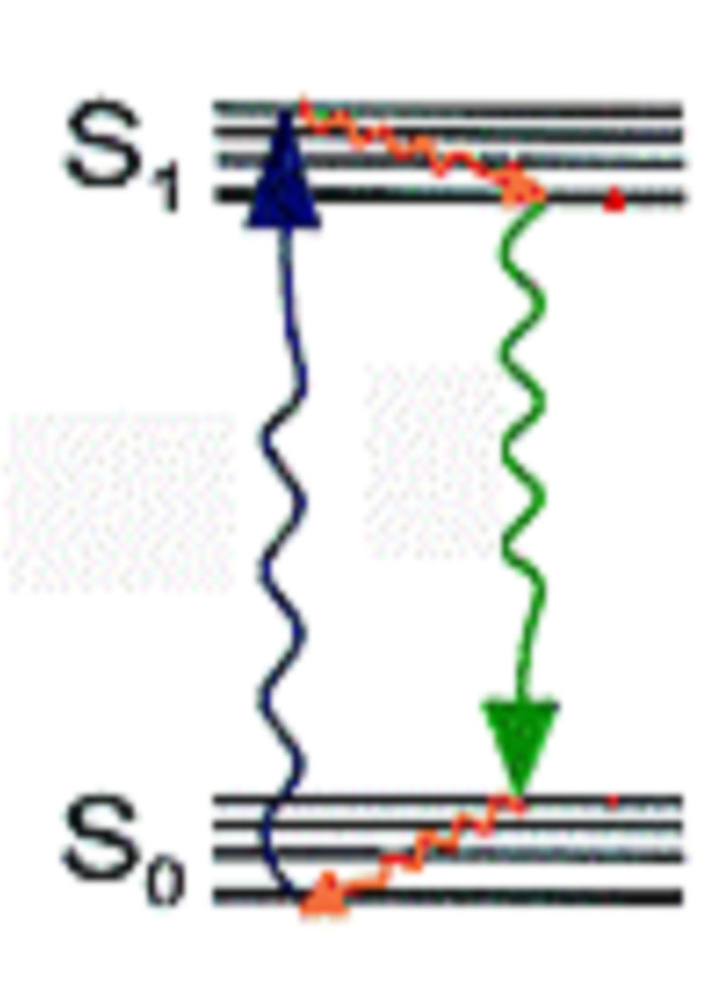
Scheme 2. The simplified Jablonski cycle,
used in the computational modelling.
While having so far used semiempirical AM1 method in all steps of the model computational cycle, we are aware of its deficiencies, in parti-cular its inability to reproduce simultaneously the qualitative trends in substituent and solvent effects on both electronic absorption and emission spectra for any given chemical compound or series of compounds. Apparently the same situation exists also with TD DFT or TD HF or nonempirical MO CIS calculations of electronic spectra [4]. The reasons for the present computational situation are clear: absorption spectra can be routinely repro-duced as vertical electron excitation energies from the ground molecular electronic states. However, CIS and TD DFT geometry optimizations of excited electronic states are troublesome and unre-liable due to their multireference nature [4]. There-fore, we take the liberty to carry out semiem-pirical CISD geometry optimizations of electronic states of interest, and use TD DFT at the latter semiempirical geometries to obtain the vertical transition energies for electron excitation as well as emission processes. The calculated TD DFT energies for the ground and lowest excited mole-cular electronic states are corrected for dynamic electron correlation using the recently introduced double-hybrid functional B2PLYP [13], which uses the “resolution of identity” methodology to introduce perturbational MP2 corrections to the standard generalized gradient (GGA) DFT energy [13, 14]. All CISD AM1 computations are per-formed with MOPAC 93 with c.i. = 5 open (2,2) EF for the semiempirical geometry optimizations [15]. Despite the semiempirical nature of AM1, CISD geometry optimizations are still very labo-rious. We persisted with the optimization process until reducing the calculated gradient norm below 1 kcal/Å or radian. For the TD B2PLYP 6-311++G(2d,2p) single point energy calculations we use ORCA [16] at the optimized AM1 geometries.
Results and Discussion
Electronic transition energies of medium size molecules are so far among the most problematic properties to reproduce by quantum mechanical calculations, giving at best a precision of e.g. 0.2 eV for electronic absorption energies, and in quite a few cases much worse [17]. Recent high basis set level TD DFT computations have shown con-vergence to significantly better precision, e.g. below 0.05 eV relative to the experiment, using augmented triple zeta basis sets and explicit treatments of solvent effects on electron transition energies. [17]. The computational cost of these calculations is however still too high for routine screening of large batches of essentially unknown heterocyclic structures for the desired photo-physical and photochemical properties. Our goal is rather a pragmatic search for a satisfactory, robust approach for the prediction of electronic absorption and emission energies, as well as their solvent dependence. Such an approach, a metho-dology or combination of methodologies, would ultimately lead to the ability to rationalize the search for new molecules with suitable photo-physical and optoelectronic properties.
S. M. Bakalova et al.: Computational study of the electronic spectra of some B–N dyes
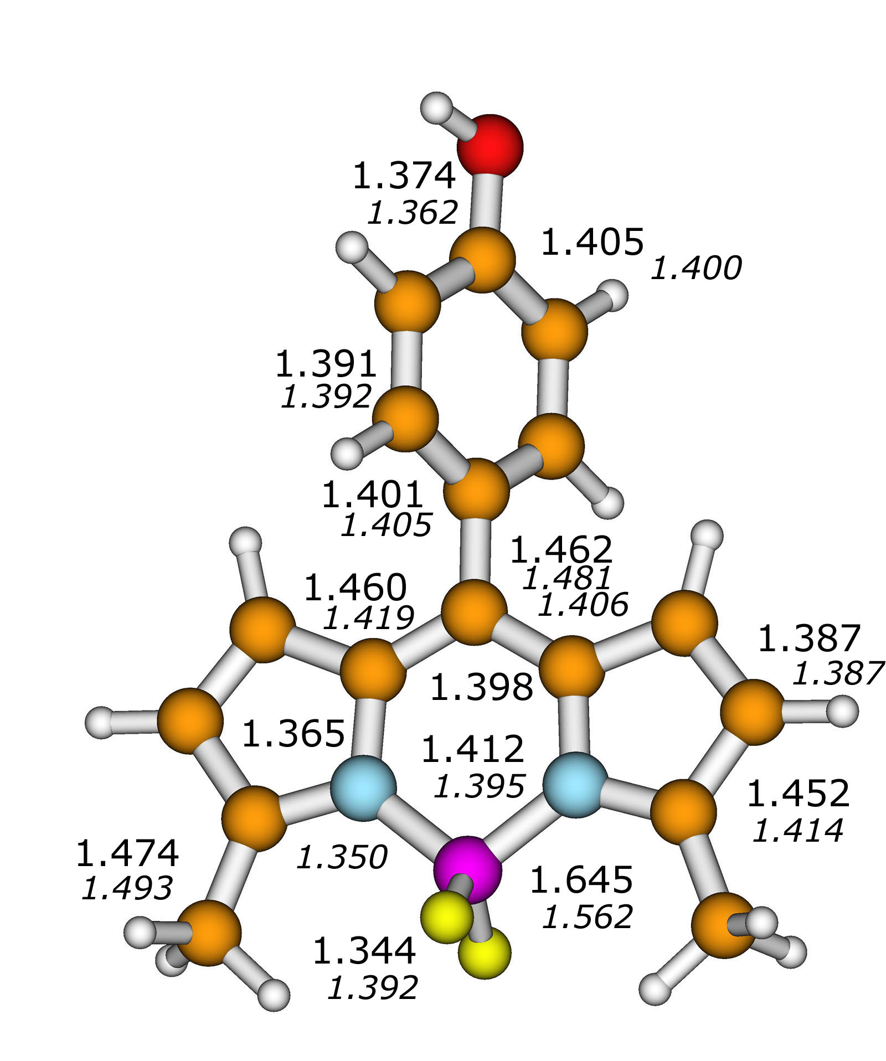
Fig. 1: CISD AM1 and B3LYP/6-31G* (italics) ground state geometries of 8-[4’-hydroxyphenyl]-4,4-difluoro-s-borindacene. Bond lengths are given in Å.
A prerequisite condition for the use of com-bined computational methodologies as rational search tools is the consistency of computed molecular parameters. In the present case, we note that CISD AM1 and B3LYP/6-31G* geometries of borindacene derivatives are reasonably close, with bond length differences usually below 0.02 Å, Fig. 1. For the shown borindacene derivative, the only more significant differences in calculated bond lengths between AM1 and B3LYP/6-31G* are for B–N, 1.645 vs. 1.562 Å, and B–F, 1.344 vs. 1.392 Å. The calculated rotation angle of the 8-aryl fragment relative to the borindacene is 56º (AM1), resp. 53º, (DFT).

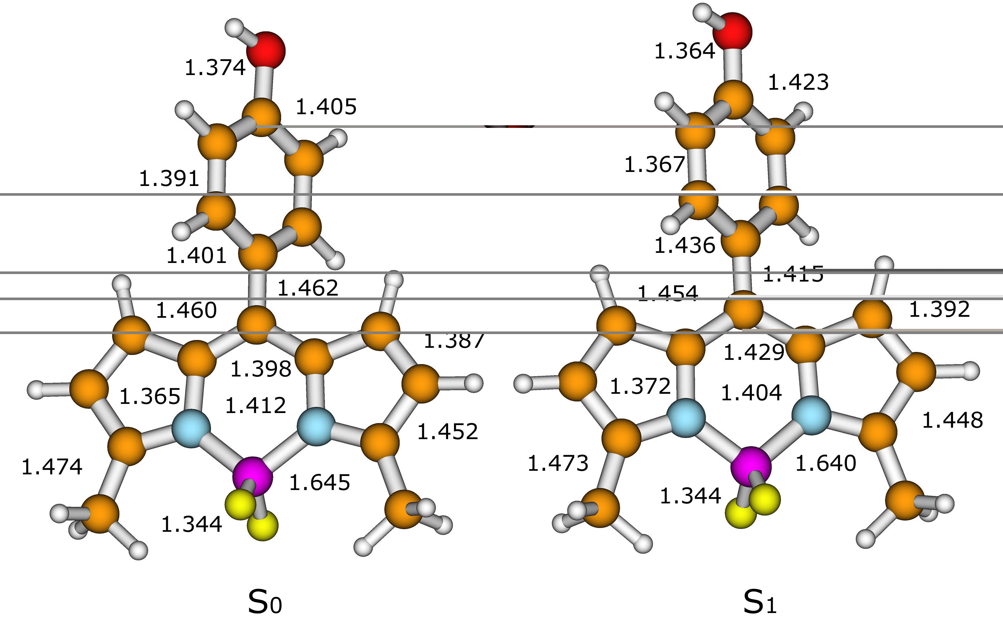
Fig. 2. CISD AM1 ground S₀ and first excited S₁ singlet state geometries of
8-[4’-hydroxyphenyl]-4,4-difluoro-s-borindacene. Bond lengths are given in Å.
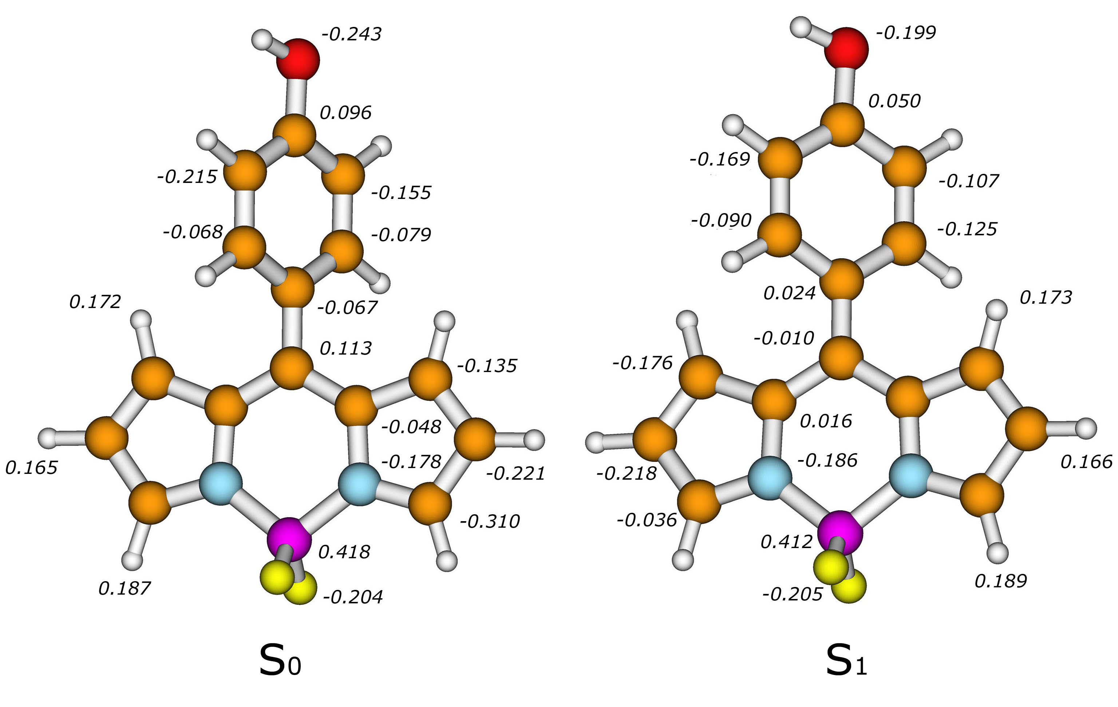
Fig. 3. CISD AM1 atomic point charges of 8-[4’-hydroxyphenyl]-4,4-difluoro-s-borindacene
in the ground S₀ and first excited S₁ singlet states.

Some understanding of the nature of electronic transitions in 8-aryl-BDP dyes can be gained by comparison of their geometries in the ground S₀ and excited S₁ electronic states. Bond length values calculated at the CISD AM1 semiempirical MO level are compared in Fig. 2 for the 4’-hydroxy-phenyl derivative. In the S₁ geometry of the aryl fragment one observes some indication of bond length redistribution typical of intramolecular charge transfer (ICT) dye molecules. However, these changes do not clearly characterize the underlying electron density redistribution taking place upon excitation from the S₀ to the S₁ state. Computed CISD AM1 atomic point charges of the ground S₀ and excited S₁ state are shown in Fig. 3.
S. M. Bakalova et al.: Computational study of the electronic spectra of some B–N dyes
Similar to geometry changes, the point charge redistribution in case of S₀–S₁ excitation does not clearly reflect the ICT pattern, widely discussed in relation to traditional dyes [6, 10]. Therefore, to clarify the nature of the lowest energy electron excitations in 8-aryl borindacenes, we consider explicitly the molecular orbitals taking part in the process (Fig. 4).

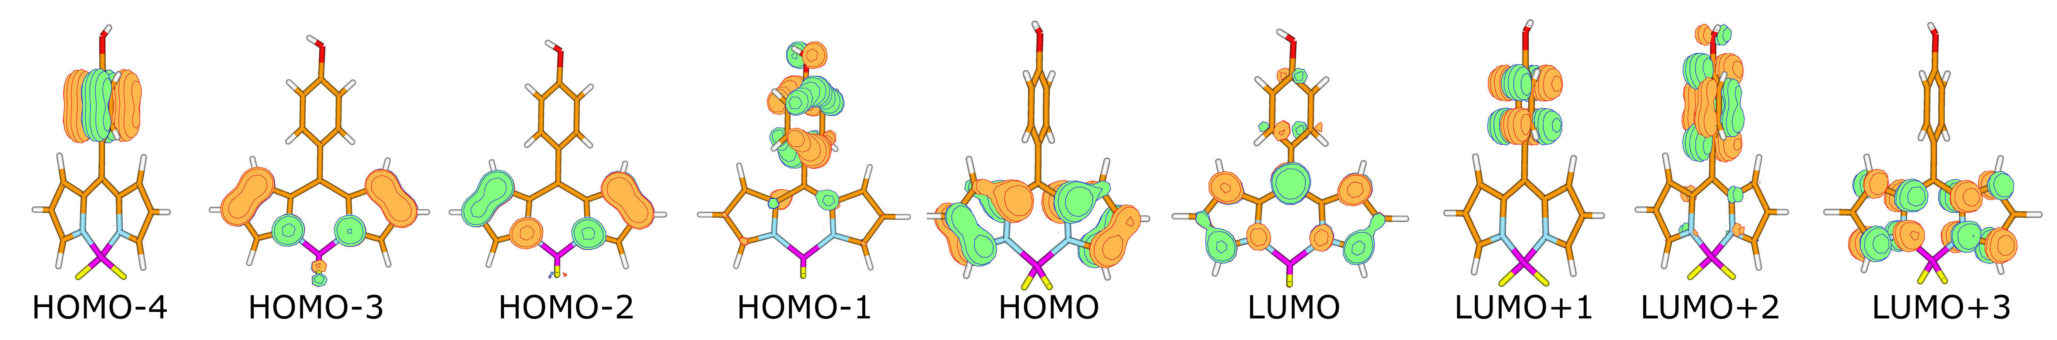
Fig. 4. Molecular orbitals of 8-[4’-hydroxyphenyl]-4,4-difluoro-borindacene, taking part in lowest electronic excitations. The approximate C_{2v} symmetry is apparent.
Table 1: Longest wavelength absorption and fluorescence emission maxima (ν) of 8-aryl substituted 3,5-dimethyl-4,4-difluoro-s-borindacenes, together with the respective Stokes’ shifts (Δν) in cyclohexane [5–7] and calculated vertical electron transition energies (E), 10³ cm^{–1}. Also given are the fluorescence quantum yields φ and theoretical oscillator strength F, derived from the B2PLYP/6-311++G(2d,2p) calculations.
Aryl | ν _{abs} | ν _{em} | Δν | φ | E_{abs} |  | F | E_{em} |  | F
 |  |  |  |  | AM1 | B2PLYP |  | AM1 | B2PLYP
 | 19.53 | 19.08 | 0.447 | 0.29 | 23.85 | 24.15 | 0.80 | 19.69 | 22.35 | 0.68
 | 19.53 | 19.05 | 0.484 | 0.25 | 23.60 | 24.12 | 0.81 | 19.30 | 22.18 | 0.67
 | 19.53 | 19.08 | 0.556 | 0.17 | 25.43 | 24.05 | 0.78 | 21.00 | 22.03 | 0.61
 | 19.69 | 19.31 | 0.454 | 0.15 | 24.89 | 24.02 | 0.76 | 18.59 | 22.65 | 0.66
 |  |  |  |  |  |  |  | 21.16 | 23.28 | 0.60
 | 19.61 | 19.19 | 0.414 | 0.42 | 24.60 | 23.95 | 0.74 | 20.09 | 22.75 | 0.80
 | 19.61 | 19.19 | 0.414 | 0.45 | 24.60 | 24.29 | 0.81 | 20.19 | 22.85 | 0.69
 | 19.42 | 18.76 | 0.656 | 0.073 | 23.70 | 23.81 | 0.78 | 19.45 | 21.12 | 0.60
 | 19.34 | 18.55 | 0.789 | 0.038 | 23.78 | 23.66 | 0.77 | 19.14 | 21.00 | 0.59

TD DFT calculations reveal a common char-acteristic of all three computed lowest singlet excited states. In all the 8-aryl-4,4-difluoro-borin-dacene molecules investigated computationally these states are dominated by electron excitations from consecutive highest occupied orbitals to the lowest unoccupied orbital. The corresponding CI expan-sions are regularly dominated up to 90% and more by excitations from HOMO to LUMO, S₁; from HOMO-1 to LUMO, S₂; and from HOMO-2 to LUMO, S₃, Fig. 4. Orbital distributions of the three highest occupied MO’s together with the LUMO, also reveal a relatively little absolute dipole moment change upon corresponding electron excitations, but significant change of dipole moment directions.
S. M. Bakalova et al.: Computational study of the electronic spectra of some B–N dyes
Substituents at position 8 of 4,4-difluoroborin-dacenes preserve the C_{2v} local symmetry of the parent molecule and thus provide a clear insight into the nature of electronic transitions. S₀ → S₁ exci-tation in BODIPY® molecules is accompanied by intense electron density reorganization from peri-pheral pyrrolic fragments towards the local C₂ symmetry axis and, in the case of π-electron with-drawing substituents as CN and COOCH₃ in the 8-aryl fragment, also to the electron acceptor substi-tuent along the same twofold symmetry axis. This explains the calculated high oscillator strengths for the lowest energy excitations of these compounds and the observed high molar absorptivities [6, 10].
Particularly revealing are the predicted in agree-ment with experiment substituent effects on absorp-tion and emission Frank-Condon transition energies, Table 1. Electron withdrawing substituents in the aryl fragment at position 8 stabilize the S₁ excited state by drawing the electron density to the central bora-heterocycle, thereby shifting both the S₀ → S₁ and the S₁ → S₀ electronic transitions in the direc-tion to the red. Vice versa, π -electron donating substituents in the aryl fragment at position 8 destabilize the S₁ state by drawing electronic density away from the symmetry axis, which results in a blue shift of the electronic transitions. Due to the nonplanar arrangement of 8-aryl substituents relative to the borindacene, the mentioned electronic effects are relatively small. Nevertheless, the above obser-vations are completely opposite to the traditional electronic substituent effects on the absorption or emission Frank-Condon energies of classical ICT organic chromophores like 4-dimethylaminobenzo-nitrile, or 2-propionyl-6-dimethylamino-naphthalene, PRODAN [1].
The results in Table 1 clearly reflect the trends outlined above based on considerations of BODIPY® orbitals. However, calculated absorption Frank-Condon energies are higher than experimental values by roughly 0.5 eV, or ca. 4000 cm^{–1}, i.e. a much worse result than recent B3LYP and PBE0 predictions [17]. This failure of single point TD B2PLYP/AM1 calculations to predict electronic absorption spectra is possibly due to obsolete boron atom parameterization in the original version of AM1 [18], now abandoned in the recent versions of MOPAC and superseded by PM3 and PM6 [15, 19]. Another possible reason for the faulty representation of BODIPY® ground electronic states may be the inability of semiempirical calculations to represent B–N bonding and its participation in the π-elec-tronic system of borindacenes correctly. The latter conjecture is based on the fact that the largest discrepancy between AM1 and B3LYP/6-31G* geo-metries of borindacenes, almost 0.1 Å, refers exactly to the B–N bond length. Further complete B2PLYP studies of borindacenes will certainly bring clarity to this point.
S. M. Bakalova et al.: Computational study of the electronic spectra of some B–N dyes
A considerably better relationship is obtained between theoretical B2PLYP/6-311++G(2d,2p)/ /CISD AM1 and experimentally observed emission Frank-Condon energies, Fig. 5. While the absolute differences between the latter values and calculated S₁ → S₀ vertical transition energies are still high, in the range of 0.3 eV (2500 cm^{–1}) and the slope of the linear relationship is relatively high, the vanishing intercept certainly indicates that CISD AM1 geometries of the emitting state, S₁ in the case of BODIPY®, represent qualitatively correctly the structural changes upon excitation. This result is another argument in favour of our computational approach in modeling the “simplified Jablonsky cycle”, Scheme 2, in the spectroscopic and theoretical study of molecular excited electronic states.
Fig. 5. The linear relationship between experimental and calculated single point B2PLYP 6-311++G(2d,2p)//CISD AM1 fluorescence emission energies.
Apparently, one more argument in the favour of our “reduced model of Jablonsky cycle” is the predicted dual emission of 8-[4’-dimethylamino-phenyl]-4,4-difluoro-borindacene, coming from closely lying adjacent S₁ and S₂ excited electronic states (Table 1). As it was stated in the above orbital analysis, the S₂ state is dominated by the HOMO-1 to LUMO excitation, Fig. 4, and should thus be a true charge transfer electronic state. Dual fluor-escence of 4’-aminophenyl borindacenes has indeed been observed experimentally [6], the relative intensity of the two bands depending on the solvent and certainly deserving further more detailed theoretical analysis.
Conclusion
A satisfactory linear relationship between calcu-lated single point B2PLYP/6-311++G(2d,2p)//CISD AM1 S₁ → S₀ emission energies and experimental fluorescence Frank-Condon energies of B–N containing 8-aryl-4,4-difluorobora-s-indacene dyes, BODIPY®, is in favour of the qualitative cor-rectness of our recently introduced computational approach modeling a “simplified Jablonsky cycle” to study structures and energies of excited molecular electronic states. However, in the studies of atypical B–N molecules at the boundary between organic and inorganic species, failure of semiempirical descriptions of corresponding ground electronic states cannot be excluded.
References
S. M. Bakalova et al.: Computational study of the electronic spectra of some B–N dyes
- J. R. Lakowicz, Principles of Fluorescence Spectro-scopy, 2nd edn., Kluwer, NY, 1999, pp. 63–93.
- P. Acebal, S. Blaya, L. Carretero, Chem. Phys. Lett., 374, 206-214 (2003).
- S. Bakalova, J. Kaneti, Spectrochim. Acta A, 56, 1443 (2000).
- A. Dreuw, M. Head-Gordon, Chem. Rev., 105, 4009 (2005).
- W. Qin, M. Baruah, A. Stefan, M. van der Auweraer, N. Boens, Chem. Phys. Chem., 6, 2343 (2005).
- W. W. Qin, M. Baruah, M. van der Auweraer, F. C. De Schryver, N. Boens, J. Phys. Chem. A, 109, 7371 (2005).
- M. Baruah, W. W. Qin, N. Basaric, W. M. De Borggraeve, N. Boens, J. Org. Chem., 70, 4152 (2005).
- J. B. Prieto, F. L. Arbeloa, V. M. Martinez, T. A. Lopez, F. Amat-Guerri, M. Liras, I. L. Arbeloa, Chem. Phys. Lett., 385, 29 (2004).
- J. B. Prieto, F. L. Arbeloa, V. M. Martinez, I. L. Arbeloa, Chem. Phys., 296, 13 (2004).
- F. L. Arbeloa, J. Banuelos, V. Martinez, T. Arbeloa, I. L. Arbeloa, Internat. Rev. Phys. Chem., 24, 339 (2005).
- Bioprobes 25: New Probes and Applications, Molecular Probes Inc., Eugene, Oregon, 1997.
- R. P. Haugland, Handbook of Fluorescent Probes and Research Chemicals, 9th edn.; Molecular Probes Inc., Eugene, OR, 2002.
- S. Grimme, J. Chem. Phys., 124, 034108 (2006).
- S. Grimme, F. Neese, J. Chem. Phys., 127, 154116 (2007).
- J. J. P. Stewart, J. Mol. Model., 13, 1173 (2007). MOPAC2007, J. J. P. Stewart, Stewart Computa-tional Chemistry, Colorado Springs, CO, USA, 2007, HTTP://OpenMOPAC.net.
- F. Neese, ORCA, University Bonn, 2007.
- D. Jacquemin, E. A. Perpete, G. E. Scuseria, I. Giofini, C. Adamo, J. Chem. Theory Comput., 4, 123 (2008).
- M. J. S. Dewar, C. Jie, E. G. Zoebish, Organometallics, 7, 513 (1988).
- J. J. P. Stewart, J. Mol. Model., 10, 155 (2004).

ИЗЧИСЛИТЕЛНО МОДЕЛИРАНЕ НА ЕЛЕКТРОННИТЕ СПЕКТРИ НА НЯКОИ БАГРИЛА, СЪДЪРЖАЩИ ВРЪЗКАТА B–N
Сн. М. Бакалова¹, Х. Ян. Канети^{1,2}*, Об. Д. Кастаньо²
¹ Институт по органична химия с център по фитохимия, Българска академия на науките,
ул. „Акад. Г. Бончев“, Блок 9, 1113 София
² Департамент по физикохимия, Университет Алкала, 28871 Алкала де Енарес, Мадрид, Испания
Посветена на акад. Иван Юхновски по повод на 70-та му годишнина
Постъпила на 21 декември 2007 г.; Преработена на 17 януари 2008 г.
(Резюме)
Борните „комплекси“ на дипирометени, БДП, намират широко приложение като превъзходни опто-електронни материали и луминесцентни хемо- и биосензори от самия край на миналия век. Те имат високи моларни абсорбционни коефициенти и флуоресцентни квантови добиви вьв видимата област, както и изключителна фотостабилност. Досега е натрупан голям обем емпирични неструктурирани факти за връзката между молекулна структура и спектроскопски параметри на БДП багрила. Пресмятанията на високо ниво, CISD с корекции за съразмерност на вълновите функции, отчитат задоволително енергиите на най-ниските синглетни възбудени състояния на пирометени, но имат твърде висока цена в изчислителни ресурси и не възпроизвеждат ефектите на заместителя, Стоксовите отмествания и ефектите на разтворителя както върху абсорбцията, така и върху емисията.
Ние прилагаме един наскоро въведен полуемпиричен CISD AM1 подход за изчисляване на енергиите на възбудените състояния и ефектите на заместителя при пирометенови хромофори, съвместно с TD DFT пресмятания на енергиите на Франк-Кондоновите абсорбционни и емисионни преходи. Това съчетание на методики е удобен подход за рационално търсене на нови съединения в сравнително новия клас бор-съдържащи оптични материали.

