Molecular mechanics (MM3(π)) conformational analysis of molecules containing conjugated π-electron fragments: a molecular tweezer
Bulgarian Chemical Communications, Volume 40, Number 4 (pp. 505–511) 2008
© 2008 Bulgarian Academy of Sciences, Union of Chemists in Bulgaria
M. I. Kotev, P. M. Ivanov*
* To whom all correspondence should be sent:
E-mail: ivanov@bas.bg
Laboratory of Physical Organic and Computational Chemistry, Institute of Organic Chemistry with Centre of Phytochemistry, Bulgarian Academy of Sciences, Acad. G. Bonchev St., Block 9, 1113 Sofia, Bulgaria
Dedicated to Academician Ivan Juchnovski on the occasion of his 70th birthday
Received January 17, 2008; Revised February 15, 2008
The conformations of a molecular tweezer formed by two aromatic chiral molecules, bonded and separated, by a conjugated spacer, were studied with molecular mechanics. This molecule contains conjugated π-electron fragment and necessitates special treatment with the MM3(π) modeling protocol. Comparison was made with results from the standard MM3 scheme and semiempirical and ab initio MO, and DFT quantum-mechanical methods. The CONFLEX conformational search procedure was used for finding low-energy conformations. Although one and the same cluster of conformations for the molecular tweezer is strongly preferred when using the two molecular mechanics modeling protocols (MM3 and MM3(π)), differences were obtained in the geometries of the lowest-energy conformations.
Key words: molecular tweezer, conformational analysis, molecular mechanics, MM3(π), CONFLEX search.

INTRODUCTION
We reported recently results from molecular mechanics study of the preferred conformations of tylosin [1, 2] and leucomycin-V [3]. We emphasized in these studies the dependency of the results on the molecular mechanics protocol used and the com-pleteness of the conformational search. A thorough search for the lowest energy conformations based on the CONFLEX [4–6] procedure as a searcher and the MM3(92) force field [7–10] as a molecular mechanics model was performed. Two problems are of particular importance when molecular mechanics is used for modeling the conformations of large molecules: (i) the proper choice of a force field for modeling the system under study; (ii) reliable and efficient conformational search of low-energy conformations when many degrees of freedom for intramolecular rotations determine the conforma-tional flexibility of the molecule. A specific char-acteristic and an advantage of the Allinger’s MM3 force field is that an extension of the force field, MM3(π) [11, 12], has been devised to model mole-cules with conjugated π-electron fragments.
As an overall result of methodological signify-cance from an earlier study [3] is the differences that manifest two very similar molecules, leucomycin-V and its 9-epi isomer (they differ only by the chirality of the C(9) macroring carbon atom), when compa-rative studies are carried out using the MM3 and MM3(π) molecular mechanics modeling protocols. This prompted us to extend further our study by examining also the conformations of a molecular tweezer containing conjugated π-electron spacer – di-(R,R)-1-[10-(1-hydroxy-2,2,2-trifluoroethyl)-9-anthryl]-2,2,2-trifluoroethyl muconate (1). A cau-tionary note is made in the present report regarding the execution of conformational search/minimiza-tion studies in the case of cooperative movements of the atoms on potential energy surface of small slope – molecules like 1, where aromatic rings are present [13].
The chiral molecular tweezer (1) (Fig. 1) was synthesized recently. It contains conjugated π-elec-tron spacer and behaves as an excellent chiral solvating agent (CSA) [14]. CSA are optically pure compounds that after binding pairs of enantiomers produce diastereomeric associates with different NMR spectra. Common CSAs can usually parti-cipate in hydrogen bonds or π interactions. Some non-cyclic compounds with flexibly-sized cavities, which are frequently termed molecular tweezers or clips, proved to be effective as synthetic receptors. This kind of compounds is characterized by having two planar aromatic groups, separated by a semi-rigid spacer, which enhances the selective binding with aromatic guests by π interactions [15]. Molecular tweezers are studied also in relation to elucidating the mechanisms of the recognition of sequence information in high-molar mass copoly-mers by small molecules of complementary struc-ture [16]. Intensive research is carried out on such systems during the last two decades [17–50].
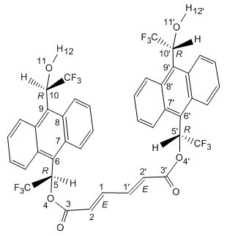
Dihedral angle
D₁ | 1-2-3-4
D₂ | 1’-2’-3’-4’
D₃ | 2-3-4-5
D₄ | 2’-3’-4’-5’
D₅ | 3-4-5-6
D₆ | 3’-4’-5’-6’
D₇ | 4-5-6-7
D₈ | 4’-5’-6’-7’
D₉ | 8-9-10-11
D₁₀ | 8’-9’-10’-11’
D₁₁ | 9-10-11-12
D₁₂ | 9’-10’-11’-12’
D₁₃ | 2-1-1’-2’
Fig.1. Numbering of the atoms in di-(R,R)-1-[10-(1-hydroxy-2,2,2-trifluoroethyl)-9-anthryl]-2,2,2-trifluoroethyl muconate (1) and the definition
of dihedral angles.
Method and Computational details
The version 3.6 of CONFLEX [4–6] was used. A gradual increase to a search limit of 4.0 kcal·mol^{–1} for 1 determined the energy range from which the initial structures for the search were selected [4-6]. The variable torsional angles (Fig. 1), which were used for conformation comparison when eliminating identical conformers are: D1 = 1 – 2 – 3 – 4, D2 = 1’ – 2’ – 3’ – 4’, D3 = 2 – 3 – 4 – 5, D4 = 2’ – 3’ – 4’ – 5’, D5 = 3 – 4 – 5 – 6, D6 = 3’ – 4’ – 5’ – 6’,
D7 = 4 – 5 – 6 – 7, D8 = 4’ – 5’ – 6’ – 7’, D9 = 8 – 9 – 10 – 11, D10 = 8’ – 9’ – 10’ – 11’, D11 = 9 – 10 – 11 – 12’, D12 = 9’ – 10’ – 11’ – 12’, D13 = 2 – 1 – 1’ – 2’. Nine dihedrals describe the geometry of the π-conjugated bridge and these are the angles which were used for cluster analysis in Table 1 [because of the preferred s-trans conformation for this fragment of the π-spacer, D13 is always about 180º degrees, a letter-code A (vide infra)]. The default values of the options were used when the steric energies and the dihedral angles were compared in the redundancy test, e.g. 3N/100 kcal·mol^{–1} (N – the number of atoms) allowance for the comparison of steric energies in the first stage, and 10.0º allowance for the comparison of dihedral angles in the final stage. The whole set of confor-mations were subjected to a cluster analysis [51, 52] and the structures resulted sorted into 2 clusters (Table 1). Unique conformations were processed with the π-version of the MM3(92) program [10–12]. This approach is more economical than the direct search with the computational scheme for modeling conjugated π-electron segments in the molecule. In addition, an independent CONFLEX/MM3(π) search/ minimization study was also executed. The block-diagonal Newton-Raphson minimization procedure was used [10]. Electrostatic interactions were esti-mated with the value 2.0 of the dielectric parameter.
Results and discussion
Computed conformational data for 1 are summa-rized in Table 1. They include average steric ener-gies and populations of clusters and a letter-code representation of the important dihedral angles (Table 1). For the sake of compactness of the pre-sentation we used a letter-code designations of dihedral angles as given in Fig. 2 [1]. Letter G designates a dihedral angle in the range from 20 to 100º, G - from 100 to 150º, A - from 150º to –150º, etc.
M. I. Kotev and P. M. Ivanov: Molecular mechanics (MM3(π)) conformational analysis
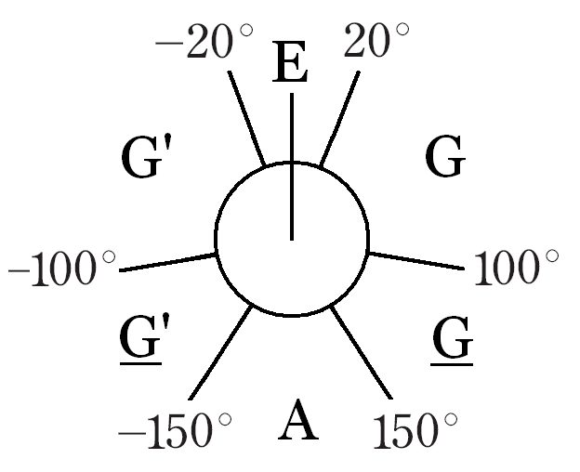
Fig. 2. Designation of dihedral angles.

Table 1. Cluster analysis of low-energy conformations of di-(R,R)-1-[10-(1-hydroxy-2,2,2-trifluoroethyl)-9-anthryl]-2,2,2-trifluoroethyl muconate (1) ª.
Clusters | Dihedral angles |  |  |  |  |  |  |  | Number of  conformations | ΔE₀ ^{b} |  | ΔEav ^{c} | Population ^{d}
Clusters | D1 | D2 | D3 | D4 | D5 | D6 | D7 | D8 | Number of  conformations | MM3 | MM3(π) | ΔEav ^{c} | Population ^{d}
I | A | A | G | G | G’ | G’ | G | G | 460 | 0.0 | 0.0 | 0.9 | 0.990
II | A | E | A | A | G’ | G’ | G | G | 85 | 3.6 | 4.0 | 4.4 | 0.010
a - Units are kcal·mol^{–1}; b - Relative steric energy of the lowest-energy conformation of the cluster. CONFLEX search has been carried out with the MM3 protocol. Search limit 4.0 kcal·mol^{–1} was used. The final set of coordinates for the lowest-energy conformations of each cluster was subjected to MM3(π) minimization. The independent CONFLEX/MM3(π) was executed with search limit 1.5 kcal·mol^{–1}; c - Average steric energy of the cluster; d - At 300K.

We have emphasized in our previous work [2, 3] the importance of using at the final stage of the minimization the version of MM3 devised to model molecules with conjugated π-electron fragments. Such a kind of treatment required the dienone portion of tylosin [2] and the diene fragment of leucomycin-V [3]. The overall result from the present study on 1 is that the conjugated π-electron spacer of the molecular tweezer 1 necessitates MM3(π) treatment. The concavely arranged host geometry of the two anthracene rings bound with the chiral CHOHCF₃ groups is important for the selective binding with aromatic or other guests. The confor-mational equilibrium and the C2 symmetry of 1 make it impossible to study its global geometry using NMR experiments [14]. Molecular mechanics modeling is of particular usefulness in such situa-tions. Although one and the same cluster of con-formations is strongly preferred when using the two molecular mechanics modeling protocols (CON-FLEX/MM3 and CONFLEX/MM3(π)), significant differences of the geometries for the π-bridge portion were obtained in the lowest-energy conformations (Fig. 3, A, B and Table 2, data in ‘bold’). These dif-ferences in the geometries did not appear however when using CONFLEX/MM3 search with subse-quent MM3(π) minimization (Tables 1 and 2). We had to carry out an independent CONFLEX/MM3(π) search/minimization study (Fig. 3, B). This is purely “technical” artifact that originates from the block-diagonal Newton-Raphson minimization procedure in MM3 that may not always produce completely converged results for molecules containing aromatic rings, as they present cases with cooperative move-ments of the atoms on a surface of small slope [13].
Attempting further to interpret the results, we compared the geometries derived with molecular mechanics with semiempirical molecular orbital (SE-MO) [53–55] and ab initio MO (RHF/6-31G*), ant DFT (hybrid functionals B3LYP and MPW1K with basis set 6-31G*) [56] methods (Table 2). The
CONFLEX/MM3 and CONFLEX/MM3(π) opti-mized geometries of the lowest-energy conforma-tions (Fig. 3, A and B) served as starting structures for the AM1, PM3, and Hartree-Fock computations. The ab initio MO optimized structure was used as starting geometry for the DFT calculations. Gaussian 98 was used for all quantum-mechanical computa-tions [56]. Significantly different final geometries were obtained (Fig. 3). The spacer of the muconate (1) connecting the two chiral arms is now flatter compared with the geometries from the molecular mechanics modeling, i.e. the tweezer does not possess enough flexibility and the two arms of the clip are positioned more distant from each other (Fig. 3, C–H). This result is not unexpected because the SE-MO, HF ab initio MO and standard DFT methods cannot model enough satisfactorily dispersion inter-actions and the system lacks forces that could deform the linear spacer. Structures C and D (AM1) have the same geometry of the conjugated spacer, but differ by the rotation of the CHOHCF₃ groups. Similar is the geometry of E, whereas the geometry of F (PM3) is completely different in comparison with all low-energy forms obtained after the CONFLEX search. Quite probably, the syn disposi-tion of the anthracene rings in this case does not correspond to a local minimum on the PM3 poten-tial energy surface. The present case, muconate 1, illustrates the different behaviour of the two SE-MO methods (cases D and F), as well as the importance of proper choice of the starting geometry (cases A and B). Except for PM3, all other quantum-mecha-nical methods produce symmetrical geometries (Table 2). The DFT optimized clips are more opened compared with the structures obtained with the other modeling protocols (compare G and H on Fig. 3 and the torsion angles D5, D6 in Table 2). It is gratifying, however, that in the prevailing number of cases cavities are produced after the optimizations with the SE-MO, ab initio MO and DFT methods (cases C, D, E, G, and H).
M. I. Kotev and P. M. Ivanov: Molecular mechanics (MM3(π)) conformational analysis

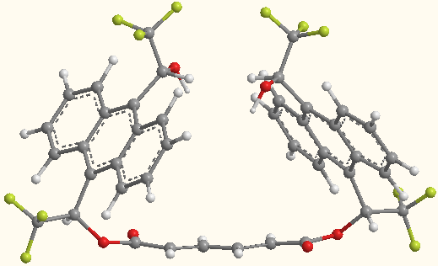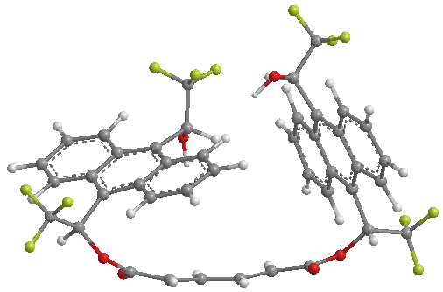
А CONFLEX/MM3 B CONFLEX/MM3(π)

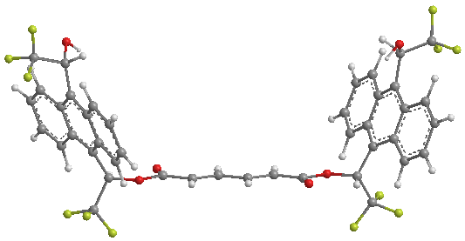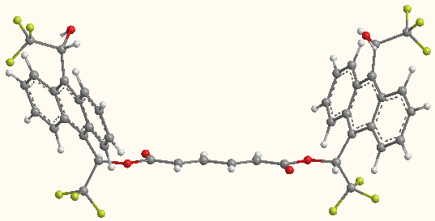
C АМ1 (1.4) D АМ1 (0.0)
(after CONFLEX/MM3) (after CONFLEX/MM3(π))

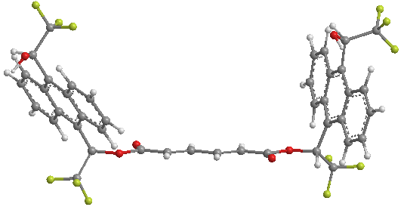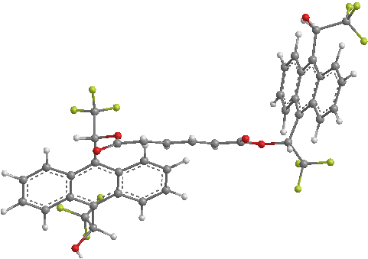
E РМ3 (0.0) F РМ3 (0.4)
(after CONFLEX/MM3) (after CONFLEX/MM3(π))

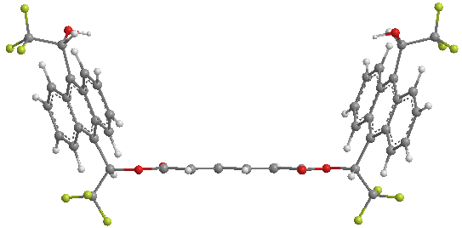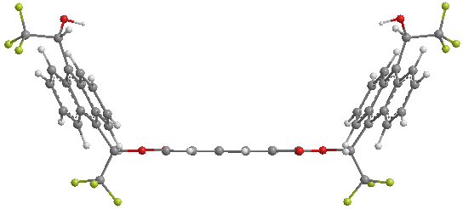
G RHF/6-31G* H B3LYP/6-31G*
(after CONFLEX/MM3) (after RHF/6-31G*)
Fig. 3. Optimized geometries of the lowest-energy conformations of 1. Relative AM1 and PM3 energies (in kcal·mol^{–1}) are given in parentheses.
M. I. Kotev and P. M. Ivanov: Molecular mechanics (MM3(π)) conformational analysis
Table 2. Comparison of the geometries (dihedral angles in degrees) of the lowest-energy conformations of 1 obtained with different methods.
Method | D1 | D2 | D3 | D4 | D5 | D6 | D7 | D8 | D9 | D10 | D11 | D12 | D13
А ª - CONFLEX/MM3 ^{b} | –174.6 | –174.9 | 142.1 | 143.1 | –62.1 | –62.9 | 136.4 | 136.6 | 138.1 | 137.9 | –61.9 | –61.0 | –175.0
B - CONFLEX/MM3(π) ^{c} | –153.9 | –174.6 | 138.1 | 144.3 | –54.2 | –76.3 | 138.9 | 136.3 | 141.1 | 137.9 | –62.8 | –69.1 | –167.7
MM3(π) ^{d} | –170.4 | –172.0 | 141.0 | 142.2 | –63.8 | –65.1 | 136.6 | 136.8 | 138.1 | 137.9 | –62.6 | –61.3 | –174.0
C - АМ1 ^{e} | 179.1 | 179.1 | 179.9 | 179.9 | –114.1 | –114.1 | 143.9 | 143.9 | 143.0 | 143.0 | –25.0 | –25.0 | 179.7
D - AM1 ^{f} | 179.9 | 179.9 | 179.2 | 179.2 | –115.3 | –115.3 | 144.4 | 144.3 | 127.5 | 127.5 | 49.4 | 49.4 | –179.8
E - PM3 ^{g} | 177.7 | –179.7 | 178.2 | 178.2 | –110.7 | –94.6 | 145.0 | 133.1 | 144.8 | 127.8 | –62.8 | 55.9 | –179.3
F - PM3 ^{h} | –27.6 | –179.2 | 175.9 | 178.2 | –100.2 | –94.2 | 145.9 | 133.1 | 143.9 | 127.8 | –64.5 | 56.0 | 179.3
G - RHF/6-31G* ^{i} | 179.5 | 179.5 | 180.0 | 180.0 | –103.5 | –103.6 | 139.4 | 139.4 | 140.1 | 140.1 | –52.3 | –52.3 | 179.8
RHF/6-31G* ^{j} | 179.4 | 179.4 | 180.0 | 108.0 | –103.7 | –104.3 | 139.4 | 139.3 | 140.1 | 140.1 | –52.2 | –52.3 | 179.8
H - B3LYP/ 6-31G* ^{k} | –179.5 | –179.5 | –179.2 | –179.2 | –119.0 | –119.0 | 138.7 | 138.7 | 140.0 | 140.0 | –40.0 | –40.0 | –179.5
MPW1K/6-31G* ^{l} | –179.7 | –179.7 | –179.5 | –179.5 | –118.8 | –118.8 | 138.3 | 138.3 | 139.7 | 139.7 | –35.2 | –35.2 | –179.5
a - The structures A-H are given in Fig. 3; b - CONFLEX/MM3 search; c - CONFLEX/MM3(π) search; d - ММ3(π) optimization after CONFLEX/MM3 search. The lowest-energy structure obtained in this way practically preserves its starting geometry (А) and it is not given on Fig. 3; e - АМ1 optimized geometry after CONFLEX/MM3 search; f - АМ1 optimized geometry after CONFLEX/MM3(π) search; g - РМ3 optimized geometry after CONFLEX/MM3 search; h - РМ3 optimized geometry after CONFLEX/MM3(π) search; i - RHF/6-31G* optimized geometry after CONFLEX/MM3 search; j - RHF/6-31G* optimized geometry after CONFLEX/MM3(π) search. HF optimized examples show identical geometries (energies) and only one structure is given in Fig. 3; k - B3LYP/ 6-31G* optimized geometry after RHF/6-31G*; l - MPW1K/6-31G* optimized geometry after RHF/6-31G*. Both DFT optimized structures are with the same geometries.

The lowest-energy MM3(π) structure of cluster II (Table 1) was also optimized with the SE-MO, and ab initio MO and DFT methods. The geometries obtained resemble structure F in Fig. 3. The anti disposition of the chiral clips (cluster II) is dis-favoured energetically by about 1–2 kcal·mol^{–1} in all cases.
Conclusions
Although one and the same cluster of confor-mations of 1 is strongly preferred when using the two molecular mechanics modeling protocols, signi-ficant differences were obtained in the geometries of the lowest energy conformations (Fig. 3, A and B). Both the molecular mechanics and quantum-mecha-nical methods confirm the prevalence of confor-mation that can easily adapt to a small molecule substrate by formation of a chiral cavity [14].
M. I. Kotev and P. M. Ivanov: Molecular mechanics (MM3(π)) conformational analysis
Acknowledgement: The National Science Fund of Bulgaria is acknowledged for the financial support (project X-1406).
REFERENCES
- P. M. Ivanov, J. Mol. Struct., 440, 121 (1998).
- P. M. Ivanov, J. Mol. Struct., 606, 217 (2002).
- M. I. Kotev, P. M. Ivanov, Chirality, 20, 400 (2008).
- H. Goto, E. Osawa, J. Mol. Struct. (Theochem), 285, 157 (1993).
- H. Goto, E. Osawa, J. Chem. Soc. Perkin Trans 2, 187 (1993).
- E. Osawa, H. Goto, M. Yamato, in: Computer Aided Innovation of New Materials, M. Doyama, J. Kihara, M. Tanaka, R. Yamamoto (Eds.), Elsevier Sci. Publ. BV (North-Holland), Amsterdam, 1993, p. 845.
- N. L. Allinger, Y. H. Yuh, J. H. Lii, J. Am. Chem. Soc., 111, 8551 (1989).
- J. H. Lii, N. L. Allinger, J. Am. Chem. Soc., 111, 8566 (1989).
- J. H. Lii, N. L. Allinger, J. Am. Chem. Soc., 111, 8576 (1989).
- MM3(92), Technical Utility Corporation, 235 Glen Village Court, Powell, OH 43065.
- N. L. Allinger, F. Li, L. Yan, J. C. Tai, J. Comput. Chem., 11, 868 (1990).
- N. L. Allinger, S. Rodriguez, K. Chen, J. Mol. Struct. (Theochem), 260, 161 (1992).
- P. M. Ivanov, QCPE Bull., 6, 6 (1986).
- M. Palomino-Schätzlein, A. Virgili, S. Gil, C. Jaime, J. Org. Chem., 71, 8114 (2006).
- M. Harmata, Acc. Chem. Res., 37, 862 (2004).
- H. M. Colquhoun, Z. Zhu, Ch. J. Cardin, Y. Gab, M. G. B. Drew, J. Am. Chem. Soc., 129, 16163 (2007).
- S. C. Zimmerman, M. Mrksich, M. Baloga, J. Am. Chem. Soc., 111, 8528 (1989).
- J. F. Blake, W. L. Jorgensen, J. Am. Chem. Soc., 112, 7269 (1990).
- L. Sharma, J. Inclusion Phenom. Mol. Recognit. Chem., 31, 161 (1998).
- F.-G. Klärner, U. Burkert, M. Kamieth, R. Boese, J. Benet-Buchholz, Chem. Eur. J., 5, 1700 (1999).
- F.-G. Klärner, J. Panitzky, D. Preda, L. T. Scott, J. Mol. Model., 6, 318 (2000).
- H. Kurebayashi, T. Haino, S. Usui, Y. Fukazawa, Tetrahedron, 57, 8667 (2001).
- S. P. Brown, T. Schaller, U. P. Seelbach, F. Koziol, C. Ochsenfeld, F.-G. Klärner, H. W. Spiess, Angew. Chem. Int. Ed., 40, 717 (2001).
- R. Ruloff, U. P. Seelbach, A. E. Merbach, F.-G. Klärner, J. Phys. Org. Chem., 15, 189 (2002).
- O. P. Kryatova, A. G. Kolchinski, E. V. Rybak-Akimova, J. Incl. Phenom. Macrocycl. Chem., 42, 251 (2002).
- J. S. Disch, R. J. Staples, T. E. Concolino, T. E. Haas, E. V. Rybak-Akimova, Inorg. Chem., 42, 6749 (2003).
- F.-G. Klärner, B. Kahlert, Acc. Chem. Res., 36, 919 (2003).
- C.-P. Du, J.-S. You, X.-Q Yu, C.-L. Liu, J.-B. Lan, R.-G. Xie, Tetrahedron: Asymmetry, 14, 3651 (2003).
- H. M. Colquhoun, Z. Zhu, Angew. Chem. Int. Edit., 43, 5040 (2004).
- N. C. Gianneschi, S.-H. Cho, S. B. T. Nguyen, C. A. Mirkin, Angew. Chem. Int. Ed., 43, 5503 (2004).
- A. Petitjean, R. G. Khoury, N. Kyritsakas, J.-M. Lehn, J. Am. Chem. Soc., 126, 6637 (2004).
- A. F. Jalbout, C. A. Morgado, L. Adamowicz, Chem. Phys. Lett., 383, 317 (2004).
- F.-G. Klärner, J. Polkowska, J. Panitzky, U. P. Seelbach, U. Burkert, M. Kamieth, M. Baumann, A. E. Wigger, R. Boese, D. Blaeser, Eur. J. Org. Chem., 7, 1405 (2004).
- H. Iwamoto, N. Takahashi, T. Maeda, Y. Hidaka, Y. Fukazawa, Tetrahedron Lett., 46, 6839 (2005).
- H. Nemoto, T. Kawano, N. Ueji, N. Sakamoto, T. Araki, N. Miyoshi, I. Suzuki, M. Shibuya, Tetrahedron Lett., 46, 551 (2005).
- M. Parac, M. Etinski, M. Peric, S. Grimme, J. Chem. Theory Comput., 1, 1110 (2005).
- 37. M. Fokkens, T. Schrader, F.-G. Klärner, J. Am. Chem. Soc., 127, 14415 (2005).
- T. Korenaga, Y. Kawauchi, T. Kosaki, T. Ema, T. Sakai, Bull. Chem. Soc. Jpn., 78, 2175 (2005).
- M. Lobert, H. Bandmann, U. Burkert, U. P. Büchele, V. Podsadlowski, F.-G. Klärner, Chem. Eur. J., 12, 1629 (2006).
- V. Balzani, H. Bandmann, P. Ceroni, C. Giansante, U. Hahn, F.-G. Klärner, U. Müller, W. M. Müller, C. Verhaelen, V. Vicinelli, F. Vögtle, J. Am. Chem. Soc., 128, 637 (2006).
- F.-G. Klärner, B. Kahlert, A. Nellesen, J. Zienau, C. Ochsenfeld, T. Schrader, J. Am. Chem. Soc., 128, 4831 (2006).
- R. Chhabra, J. Sharma, Y. Liu, H. Yan, Nano Lett., 6, 978 (2006).
- X.-X. Peng, H.-Y. Lu, T. Han, C.-F. Chen, Org. Lett., 9, 895 (2007).
- T. Schaller, U. P. Büchele, F.-G. Klärner, D. Bläser, R. Boese, S. P. Brown, H. W. Spiess, F. Koziol, J. Kussmann, C. Ochsenfeld, J. Am. Chem. Soc., 129, 1293 (2007).
- P. Degen, T. Optenhostert, H. Rehage, C. Verhaelen, M. Lange, J. Polkowska, F.-G. Klärner, Langmuir, 23, 11611 (2007).
- E. Scamporrino, P. Mineo, S. Dattilo, D. Vitalini, E. Spina, Macromol. Rapid Comm., 28, 1546 (2007).
- J. Zienau, J. Kussmann, F. Koziol, C. Ochsenfeld, Phys. Chem. Chem. Phys., 9, 4552 (2007).
- J. M. Hermida-Ramon, C. M. Estevez, M. Carlos, Chem. Eur. J., 13, 4743 (2007).
- J. L. Katz, B. J. Geller, P. D. Foster, Chem. Commun., 10, 1026 (2007).
- D. Margetic, R. N. Warrener, D. N. Butler, D. Officer, Theor. Chem. Acc., 117, 239 (2007).
- H. Goto, Y. Kawashima, M. Kashimura, S. Morimoto, E. Osawa, J. Chem. Soc. Perkin Trans 2, 1647 (1993).
- E. Osawa, H. Goto, T. Hata, E. Deretey, J. Mol. Struct. (Theochem), 398-399, 229, (1997).
- M. J. S. Dewar, E. G. Zoebisch, E. F. Healy, J. J. P. Stewart, J. Am. Chem. Soc., 107, 3902, (1985).
- M. J. S. Dewar, E. G. Zoebisch, J. Mol. Struct. (Theochem), 180, 1, (1988).
- J. J. P. Stewart, J. Comp. Chem., 10, 209, (1989).
- M. J. Frisch, G. W. Trucks, H. B. Schlegel, G. E. Scuseria, M. A. Robb, J. R. Cheeseman, V. G. Zakrzewski, J. A. Montgomery, Jr., R. E. Stratmann, J. C. Burant, S. Dapprich, J. M. Millam, A. D. Daniels, K. N. Kudin, M. C. Strain, O. Farkas, J. Tomasi, V. Barone, M. Cossi, R. Cammi, B. Mennucci, C. Pomelli, C. Adamo, S. Clifford, J. O chterski, G. A. Petersson, P. Y. Ayala, Q. Cui, K. Morokuma, D. K. Malick, A. D. Rabuck, K. Raghavachari, J. B. Foresman, J. Cioslowski, J. V. Ortiz, A. G. Baboul, B. B. Stefanov, G. Liu, A. Liashenko, P. Piskorz, I. Komaromi, R. Gomperts, R. L. Martin, D. J. Fox, T. Keith, M. A. Al-Laham, C. Y. Peng, A. Nanayakkara, C. Gonzalez, M. Challacombe, P. M. W. Gill, B. Johnson, W. Chen, M. W. Wong, J. L. Andres, C. Gonzalez, M. Head-Gordon, E. S. Replogle, J. A. Pople, Gaussian 98, Revision A.7, Gaussian, Inc., Pittsburgh PA, 1998.
M. I. Kotev and P. M. Ivanov: Molecular mechanics (MM3(π)) conformational analysis

Молекулно-механичен (MM3(π)) конформационен анализ на молекули съдържащи спрегнати π-електронни фрагменти: молекулна пинсета
М. И. Котев, П. М. Иванов*
Лаборатория „Физична органична и изчислителна химия“, Институт по органична химия
с център по фитохимия, Българска академия на науките, ул. „Акад. Г. Бончев“, блок 9, 1113 София
Посветена на акад. Иван Юхновски по повод на 70-та му годишнина
Постъпила на 17 януари 2008 г.; Преработена на 15 февруари 2008 г.
(Резюме)
С молекулна механика бяха проучени конформациите на молекулна пинсета (1), съдържаща две ароматни хирални щипки, свързани помежду си със спрегнат мостови фрагмент. Използван е ММ3(π) протокол за молекулно-механично моделиране и е направено сравнение с резултати от стандартния ММ3 метод, както и с полуемпирични, ab initio MO и DFT квантовомеханични методи. За конформационно търсене на нискоенер-гетични конформери е използван CONFLEX алгоритъма. Резултатите от ММ3 и ММ3(π) разглежданията показват, че 1 има силно предпочитание към един и същ клъстер от конформери, но геометриите на най-нискоенергетичните конформации, получени с двата протокола, се различават.

