IR spectra and structure of 3,5,5-trimethyl(cyclohex-2-enylidene) malononitrile and its potassium cyanide and sodium methoxide carbanionic adducts:
experimental and B3LYP studies
Bulgarian Chemical Communications, Volume 40, Number 4 (pp. 538–545) 2008
© 2008 Bulgarian Academy of Sciences, Union of Chemists in Bulgaria
S. S. Stoyanov*, A. D. Popova, J. A. Tsenov
* To whom all correspondence should be sent:
E-mail: cacafuego@abv.bg
Department of Structural Organic Analysis, Institute of Organic Chemistry with Centre of Phytochemistry,
Bulgarian Academy of Sciences, Acad. G Bonchev St., Block 9, 1113 Sofia, Bulgaria
Dedicated to Academician Ivan Juchnovski on the occasion of his 70th birthday
Received January 31, 2008; Revised February 4, 2008
A combined IR experimental/B3LYP computational approach has been applied to follow the formation and isomeri-zation of potassium cyanide and sodium methoxide carbanionic adducts of 3,5,5-trimethyl(cyclohex-2-enylidene) malononitrile 1. A good agreement has been found between theoretical and experimental IR data. In agreement between theory and experiment, 1 forms β- and δ-adducts with the above-mentioned nucleophiles. Structural changes, caused by conversion of 1 into β- and δ-adducts, have also been studied. According to the computations, the chemical motive force in the β→ δ isomerization is the much higher stability (by ca. 50 kJ·mol^{–1}) of the δ-adducts compared to β-ones.
Key words: IR, DFT B3LYP, 3,5,5-trimethyl(cyclohex-2-enylidene) malononitrile, adducts, carbanion, isomerization.

INTRODUCTION
3,5,5-trimethyl(cyclohex-2-enylidene) malononi-trile (TMCHM, 1) was prepared by Lemke in 1970 as a precursor in the Knoevenagel-type synthesis of a large series of its 12-ylidene derivatives [1–3].
These derivates are high-quality dyes for syn-thetic polymers [4] (and references there in); some of these dyes have solvatochromic properties [1–3]. Nowadays, 12-ylidene derivates of 1 are of special interest as non-linear optical [4–15] and fluorescent [7] materials. We did not find in the literature detailed vibrational studies of 1 itself; some 12-yli-dene derivates of 1 have been studied thoroughly by IR [5–7], polarized IR [6] and Raman [5] spectra, B3LYP quantum-chemical calculations [5, 7] and single-crystal X-ray diffraction [8–15].
On the other hand, it is well-known [16] that nucleophilic attacks to C=C bonds are favoured by electron-accepting substitutients, where A, Nu– and E⁺ are the acceptor, nucleophile and electrophile, respectively.
When the nucleophilic attacks take place in aprotic solvents (E⁺ is usually H⁺), the intermediate adducts 2 have been isolated in many cases [17–23]. Both sodium methoxide (Nu–≡CH₃O–) [22-23] and potassium cyanide (Nu–≡CN–) [24–27] carbanionic adducts of benzylidenemalononitrile [22] and other strongly polarized alkenes [21–28], butadienes and hexatrienes [22] have been studied. Nucleophilic attacks by uncharged Lewis bases Nu: result in the formation of zwitterions 3.
This result has been established in cases of tertialy phosphine adducts (3, Nu–≡R₃P:) of benzyli-denemalononitrile by IR [29–31], NMR [32] and confirmed by X-ray diffraction [33]. The heptyl-amine zwitterionic adduct (Nu–≡C₇H₁₅NH₂) of the same compound has also been studied by IR spectra [24]. Juchnovski at al. [22] found 30 years ago that 1,1-dicyano-4-phenylbutadiene 4 and other strongly polarized conjugated butadienes react with CH₃O–Na⁺ to form the β-adduct 5. Within 24 hours, however, 5 isomerizes spontaneously and practically completely into the corresponding δ-adduct 6.
The authors [22] supposed that the 5→6 iso-merization was provoked by the higher stability of 6, due to larger delocalization of the carbanionic charge in 6 compared to 5. This supposition was confirmed by ab initio HF calculations: The δ-adduct 6 is by 28.2 kJ·mol^{–1} more stable than the β-adduct 5. The title compound 1 is an analogue of 4, so it was of interest to check whether and what kind of adducts would be formed by the reaction of 4 with potassium cyanide and sodium methoxide.
EXPERIMENTAL
Compound 1 was prepared by the classical Gelmo’s method [1] and a sample of it was given to us by Kolev et al. [5]. The cyanide and methoxide were prepared by adding DMSO/DMSO-d₆ solu-tions of 1 to excess of dry KCN and NaOCH₃, res-pectivelly, under argon. After 1 min intense stirring, the reaction mixtures were separated by syringe-filter and the clear adduct solutions were put imme-diately into a CaF₂ cell of 0.129 mm path length. The IR spectra were recorded on Bruker IFS 113v and Tensor 27 FT spectrometers at a resolution of 1 cm^{–1} and 64 scans.
COMPUTATIONS
The Gaussian 98 program package [34] was used for Density Functional Theory (DFT, full optimi-zation) computations of energies, structures and IR spectra of the species studied. This theory is the groundwork of a series of cost-effective methods to approximate electron correlation effects [35]. We have employed the B3LYP functional, which com-bines Becke’s three-parameter non-local exchange with the correlation functional of Lee, Yang and
Parr [36, 37], adopting a 6-31++G** basis set with any symmetry restrictions. For each structure, the stationary points found on the molecular potential energy hypersurfaces were characterized using the standard analytical harmonic procedure. The absence of irrational frequencies or negative eigenvalues of the second-derivative matrix confirmed that the stationary points corresponded to global minima on the potential energy surfaces [35]. A standard least-square program was used for calculating the single-parameter linear regression indices.
RESULTS AND DISCUSSION
Correlation analysis
Comparison of the native B3LYP/6-31++G** vibrational frequencies of TMCHM 1 with those measured in DMSO solvent (see Spectral analysis below) resulted in the formation of an excellent (0.99 <R < 1) correlation (Eqn. 1):
S. S. Stoyanov et al.: IR spectra and structure of 3,5,5-trimethyl(cyclohex-2-enylidene) malononitrile
ν(exp.) = 0.93373 ν(theor.) + 55.75 (cm^{–1}) (1)
Correlation coefficient R = 0.99994; Standard deviation S.D. = 8.94 cm^{–1}; Number of data points
n = 34.
Eqn. (1) was used for correlational scalling [38] of the theoretical frequencies. As stated in Alcolea’s review article [39] (and references therein), the use of scaling equations instead of scaling factors gave better results, especially in the low-frequency region. For more recent works see [40–49] (and references therein).
Spectral analysis
Our theoretical and experimental IR data for 1 are compared in Table 1 together with the approxi-mate description of the corresponding vibrations.
There is nothing special in the data for the CH stretching vibrations, (Nos. 1–14 in Table 1). As it could be expected [50], the ν(=C–H) vibration was the most high-frequency one among them. We found in the experimental spectra a single moderate band in the ν(C≡N) region, without shoulders or satellites, at 2223 cm^{–1}. The calculations predict a small splitting Δν(C≡N)₂ = ν^{s}(C≡N)₂ – ν^{as}(C≡N)₂ of 13 cm^{–1} (Table 1, vibrations 15 and 16). The real splitting is probably even smaller, so we assign the band at 2223 cm^{–1} as a superposition of the ν^{s}(C≡N) and ν^{as}(C≡N) bands like in the cases of dozens of ylidenemalonitriles [22–24, 51] (and references therein). The strongest bands in the spectrum of TMCHM at 1614 and 1545 cm^{–1} correspond to the endo- and exocyclic ν(C=C) vibrations (Table 1, vibrations 17 and 18).
Table 1. Theoretical (B3LYP 6-31++G**) and experi-mental (solvent DMSO / DMSO-d₆ ) frequencies (ν in cm^{–1}) and integrated intensities (A in km·mol^{–1}) of TMCHM molecule 1.
No. | B3LYP6-31++G** |  |  |  | Experimental data ª
 | ν | ν ^{b} | A | Approximate description ^{c} | ν | A ^{d}
1 | 3189 | 3034 | 3.7 | ν(=C–H) | 3030 | vw
2 | 3131 | 2979 | 14.8 | νª(CH₃) | - ^{e} | -
3 | 3116 | 2966 | 25.8 | ν^{as}(CH₃) | 2962 | m
4 | 3108 | 2958 | 40.4 | ν^{as}(CH₃) | 2962 | m
5 | 3103 | 2953 | 11.8 | ν^{as}(CH₃) | 2962 | m
6 | 3101 | 2951 | 21.1 | ν^{as}(CH₃) | 2962 | m
7 | 3099 | 2949 | 3.4 | ν^{as}(CH₂) | 2962 | m
8 | 3073 | 2925 | 11.1 | ν^{as}(CH₃) | 2936 | vw
9 | 3047 | 2900 | 30.7 | ν^{as}(CH₂) | 2902 | w
10 | 3039 | 2894 | 13.8 | ν^{s}(CH₃) | 2902 | w
11 | 3031 | 2886 | 33.0 | ν^{s}(CH₃) | 2871 | w
12 | 3025 | 2880 | 23.0 | ν^{s}(CH₃) | 2871 | w
13 | 3011 | 2867 | 9.9 | ν^{s}(CH₂) | - ^{e} | -
14 | 2995 | 2852 | 18.1 | ν^{s}(CH₂) | 2828 | vw
15 | 2330 | 2232 | 73.3 | ν^{s}(C≡N)₂ | 2223 | 47.5
16 | 2317 | 2219 | 30.1 | ν^{as}(C≡N)₂ | 2223 | 47.5
17 | 1668 | 1613 | 187.5 | ν(C=C)^{endo} | 1614 | 78.9
18 | 1579 | 1530 | 148.3 | ν(C=C)^{exo} | 1545 | 70.1
19 | 1517 | 1473 | 8.5 | δ^{as}(CH₃) | 1470 | 2.1
20 | 1512 | 1467 | 5.4 | δ^{as}(CH₃) | - ^{e} | -
21 | 1500 | 1456 | 5.5 | δ^{as}(CH₃) | 1450 | sh
22 | 1492 | 1449 | 1.8 | δ^{as}(CH₃) | - ^{e} | -
23 | 1486 | 1444 | 15.6 | δ^{as}(CH₃) | 1439 | w
24 | 1481 | 1439 | 11.1 | δ^{as}(CH₃) | 1439 | w
25 | 1475 | 1433 | 2.6 | δ^{sciss}(CH₂) | - ^{e} | -
26 | 1464 | 1422 | 11.2 | δ^{sciss}(CH₂) | 1416 | w
27 | 1432 | 1393 | 5.8 | δ^{s}(CH₃) | -^{e} | -
28 | 1419 | 1381 | 12.2 | δ^{s}(CH₃) | 1386 | m
29 | 1411 | 1373 | 10.8 | δ^{s}(CH₃) | 1370 | w
30 | 1404 | 1367 | 9.2 | δ(CH) | 1350 | vw
31 | 1373 | 1337 | 7.6 | (delocalized) | - ^{e} | -
32 | 1352 | 1318 | 25.1 | ν(C–C)(ring) | 1326 | m
33 | 1320 | 1288 | 3.5 | γ^{wag}(CH₂) | 1286 | w
34 | 1317 | 1285 | 3.2 | γ^{wag}(CH₂) | 1286 | w
35 | 1285 | 1256 | 0.2 | ν(C–C)(ring) | - ^{e} | -
36 | 1223 | 1197 | 2.9 | ν(C–CH₃),  δ(C–C)(ring) | 1201 | vw
37 | 1199 | 1175 | 6.8 | ν(C–C≡N) | 1183 | vw
38 | 1188 | 1165 | 4.0 | ν(C–C)(ring),  γ(CH₂) | 1163 | vw
39 | 1166 | 1144 | 5.1 | ν(C–CH₃),  δ(CC)(ring) | 1149 | vw
40 ^{f} | 1156 | 1135 | 8.1 | ν(C–CH₃) | 1135 | vw
a - Measured after having decomposed the complex bands into com-ponents; b - Scaled, according to correlation Eqn. (1); c - Vibrational modes: ν, stretching; δ, in-plane bending; γ, out-of-plane bending; superscripts: s, symmetrical; as, asymmetrical; sciss, scissoring; wag, wagging; endo, endocyclic; exo, exocyclic; d - Relative intensities: m, moderate; w, weak; v, very; sh, shoulder; e - These bands were not detected in the experimental spectrum; f - Followed by 38 lower-frequency vibrations.
TMCHM 1 reacts rapidly with KCN and NaOCH₃. The bands of the starting compound 1 disappear and a few new bands appear in the IR spectra. So, let us consider the data in Table 2. The new bands are like the bands in the spectra of adducts of cinnamylidenemalononitrile [22–24]. Immediately after reacting 1 with KCN, we can see in the spectrum four very strong and two weak bands in the ν(C≡N) region (See also Fig. 1). Having in mind that the adduct A shows lower-frequency bands than B (as predicted by computations) as well as that the bands of A fade away on account of these of B, we assume that A and B (Table 2) are β- and δ-cyanide adducts of 1 respectively. The spectra show practically a full conversion of the β-cyanide adduct into the δ-one within 60 min. (Fig. 1). The weak bands above 2200 cm^{–1} of A and B (Table 2) correspond to the new (added) non-conjugated cyano group.
Table 2. Theoretical (B3LYP 6-31++G**) and experi-mental (solvent DMSO) cyano stretching IR frequencies (ν in cm^{–1}) and integrated intensities (A in km·mol^{–1}) of cyanide and methoxide carbanionic adducts of TMCHM.
S. S. Stoyanov et al.: IR spectra and structure of 3,5,5-trimethyl(cyclohex-2-enylidene) malononitrile
No. | B3LYP 6-31++G ** |  |  |  | Experimental data ª
No. | ν | ν ^{b} | A | Approximate  description ^{c} | ν | A ^{d}
β-cyanide adduct
15 ^{e} | 2298 | 2202 | 43.3 | ν(C≡N) ^{f} | 2210 | w^{g}
16 | 2242 | 2149 | 157.0 | ν^{s}(C≡N)₂ | 2163 | vs^{g}
17 ^{h} | 2192 | 2103 | 613.6 | ν^{as}(C≡N)₂ | 2101 | vs^{g}
δ-cyanide adduct
15 ^{e} | 2307 | 2210 | 44.2 | ν(C≡N)₂ | 2219 | 9.7
16 | 2259 | 2165 | 334.4 | ν^{s}(C≡N)₂ | 2163 | 115.7
17 ^{h} | 2217 | 2126 | 493.4 | ν^{as}(C≡N)₂ | 2119 | 193.6
β-methoxide adduct
18 ^{i} | 2241 | 2148 | 229.8 | ν^{s}(C≡N)₂ | – ^{j} | –
19 ^{k} | 2194 | 2104 | 603.8 | ν^{as}(C≡N)₂ | – ^{j} | –
δ-methoxide adduct
18 ^{i} | 2256 | 2162 | 321.1 | ν^{s}(C≡N)₂ | 2163 | 151.0
19 ^{k} | 2214 | 2123 | 503.3 | ν^{as}(C≡N)₂ | 2120 | 212.9
6. δ-methoxide adduct of cinnamethylidene-malononitrile [24]
12 ^{l} | 2445^{m} | 2183^{m} |  | ν^{s}(C≡N)₂ | 2164 | 110.1
13 ^{n} | 2398^{m} | 2141^{m} |  | ν^{as}(C≡N)₂ | 2123 | 220.4
a - Measured after having decomposed the complex bands into com-ponents; b - Scaled, according to correlation Eqn. (1); c - Vibrational modes: ν, stretching; superscripts: s, symmetrical; as, asymmetrical;
d - Relative intensities: w, weak; vs, very strong; e - Preceded by 14 ν(C–H) vibrations; f - Bands of the new (additionally introduced) cyano group; g - We have not measured spectra of this adduct with the absence of bands of corresponding δ – cyanide adduct; h - Followed by 67 lower-frequency vibrations; i - Preceded by 17 ν(C–H) vibrations; j - We did not find measurable amounts of this adduct; k - Followed by 74 lower-frequency vibrations; l - Preceded by 11 ν(C–H) vibrations; m - HF/6-31G [24]; n Followed by 63 lower-frequency vibrations.
The formation of D or the C→D isomerization was so rapid, that we were not able to detect other bands in the spectrum measured immediately after the reaction. In agreement between theory and experiment, the only adduct, registered in this case, was D (Table 2). This statement could be confirmed by experimental data for the δ-methoxide adduct of cinnamylidenemalononitrile [24] (6 in Table 2): D and 6 show very close cyano stretching frequencies and close intensities.

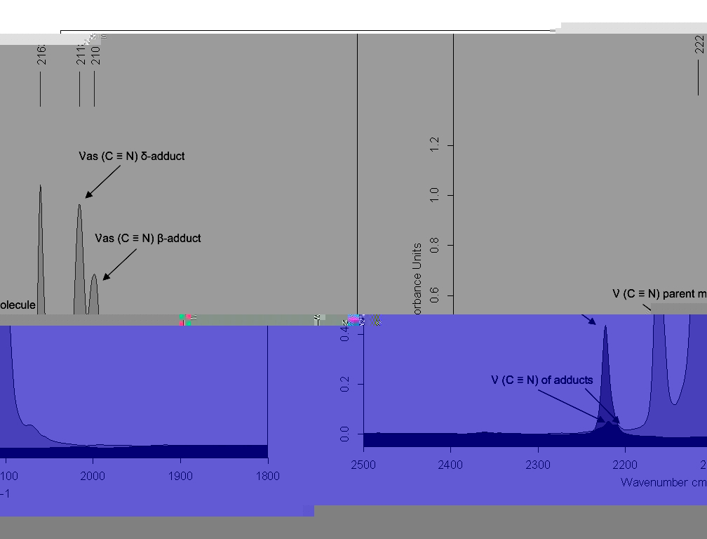
Fig. 1. IR spectra of TMCHM 1 (doubly shaded) and of its β- and δ-cyanide adducts.
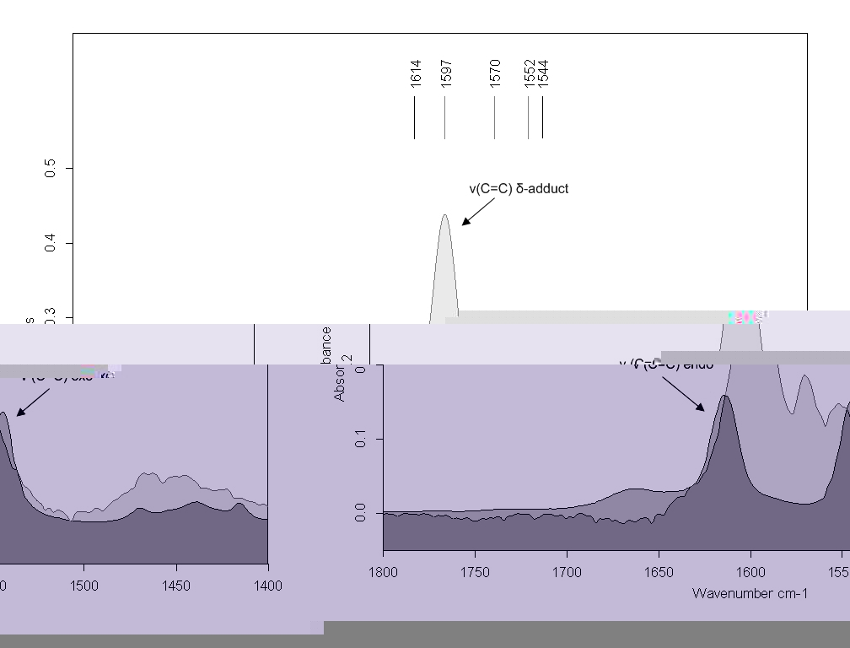
Fig. 2. IR spectra of TMCHM 1 (doubly shaded) and of its δ- methoxide adduct.
S. S. Stoyanov et al.: IR spectra and structure of 3,5,5-trimethyl(cyclohex-2-enylidene) malononitrile

Table 3. Theoretical (B3LYP 6-31++G**) and experi-menttal (solvent DMSO/DMSO-d₆) frequencies (ν in cm^{–1}) and integrated intensities (A in km·mol^{–1}) of δ-methoxide adduct of TMCHM.
No | B3LYP/6-31++G** |  |  |  | Experimental  data ª
No | ν | Ν ^{b} | A | Approximate description | ν | A ^{d}
1 | 3153 | 3000 | 15.5 | ν(CH) | 3009 | w
2 | 3133 | 2981 | 15.8 | ν^{as}(CH₃) | - ^{e} | -
3 | 3125 | 2974 | 33.5 | ν^{as}(CH₃) | - ^{e} | -
4 | 3103 | 2953 | 46.6 | ν^{as}(CH₃) | 2952 | m, br
5 | 3097 | 2948 | 46.4 | ν^{as}(OCH₃) | 2952 | m, br
6 | 3087 | 2938 | 62.7 | ν^{as}(CH₃) | - ^{e} | -
7 | 3081 | 2933 | 76.4 | ν^{as}(CH₃) | - ^{e} | -
8 | 3076 | 2928 | 9.9 | ν^{as}(CH₃) | - ^{e} | -
9 | 3071 | 2923 | 5.3 | ν^{as}(CH₃) | - ^{e} | -
10 | 3062 | 2915 | 19.9 | ν^{as}(CH₃) | 2910 | w, br
11 | 3053 | 2906 | 60.0 | ν^{as}(CH₃) | 2910 | w, br
12 | 3033 | 2888 | 91.9 | ν^{s}(CH₃) | - ^{e} | -
13 | 3025 | 2880 | 66.5 | ν^{s}(CH₃) | 2865 | w
14 | 3017 | 2872 | 46.7 | ν^{s}(CH₃) | 2865 | w
147112.0δ^{as}(OCH₃)1467vw15 | 3012 | 2868 | 29.3 | ν^{s}(CH₃) | 2865 | w
23 1515  16  3000  2857  30.9  ν^{s}(CH₃)  - ^{e}  -  17  2972  2831  70.4  ν^{s}(OCH₃)  2823  w  18  2256  2162  321.1  ν^{s}(C≡N)  2163  151.0  19  2214  2123  503.3  ν^{as}(C≡N)  2118  212.9  20  1634  1582  394.7  ν(C=C)  1598  386.5  1571 ^{f}  w  1552 ^{f}  w  21  1523  1478  7.2  δ^{as}(CH₃)  - ^{e}  vw  22 | 1506 | 1462 | 4.5 | δ^{as}(CH₃) | 1463 | w
24 | 1503 | 1459 | 6.9 | δ^{as}(CH₃) | 1463 | w
25 | 1496 | 1452 | 1.6 | δ^{as}(CH₃) | 1451 | w
26 | 1493 | 1449 | 2.9 | δ^{as}(CH₃) | 1451 | w
27 | 1488 | 1445 | 5.1 | δ^{as}(CH₃) | 1451 | vw
28 | 1486 | 1443 | 3.2 | δ^{as}(OCH₃) | 1451 | vw
29 | 1478 | 1436 | 1.5 | δ^{sciss}(CH₂) | 1425 | vw
30 | 1474 | 1432 | 2.8 | δ^{sciss}(CH₂) | 1425 | -
31 | 1459 | 1418 | 3.1 | δ^{s}(OCH₃) | 1425 | m
32 | 1420 | 1382 | 2.8 | δ^{s}(CH₃) | - ^{e} | m
33 | 1401 | 1364 | 17.4 | δ^{s}(CH₃) | 1365 | m
34 | 1397 | 1361 | 44.1 |  | 1365 | w
35 | 1396 | 1359 | 5.3 | δ^{s}(CH₃) | 1365 | vw
36 | 1375 | 1340 | 5.3 | δ(CH) | 1345 | vw
37 | 1347 | 1313 | 5.3 | ν(C–C) | 1320 | vw
38 | 1315 | 1283 | 5.3 | ν(C–C(CN)₂) | 1302 | vw
39 | 1312 | 1280 | 5.3 | ν(C–C) | 1302 | m
40 | 1294 | 1264 | 2.3 | ν(C–C) | 1270 | w
41 | 1282 | 1253 | 115.8 | ν(C–C) | 1266 | vw
42 | 1255 | 1228 | 17.7 | ν(C–C(CN)₂) | 1226 | vw
43 | 1218 | 1193 | 4.7 | ν(C–C) | 1206 | vw
44 | 1198 | 1174 | 30.2 | ν(C–C) | 1185 | vw
45 | 1193 | 1170 | 13.0 | ν(C–C) | 1148 | vw
46 | 1172 | 1150 | 1.4 | τ(OCH₃) | 1138 | vw
47 ^{g} | 1165 | 1144 | 10.0 | ν(C–C) | 1138 | vw
a - Measured after having decomposed the complex bands into components; b - Scaled, according to correlation Eqn. (1); c - Vibrational modes: ν, stretching; δ, in-plane bending; γ, out-of-plane bending; τ, torsion; superscripts: s, symmetrical; as, asymmetrical; sciss, scissoring; wag, wagging; d - Relative intensities: m, moderate; w, weak; v, very; sh, shoulder; br, broad; e - These bands were not detected in the experimental spectrum; f - The origin of these bands is not known; g - Followed by 46 lower-frequency vibrations.
Table 3 contains detailed IR data for the δ-meth-oxide adduct of 1. We shall put special emphasis on the band at 1598 cm^{–1}. It is the strongest one in the spectrum with A of 386.5 km·mol^{–1} (see also Fig. 2), and corresponds to the vibration of the newly formed quasi-double bond, which is strongly polarized by the C(CN)₂– group.
Structural analysis
The shapes of TMCHM 1 and of its β- and δ-cyanide adducts are shown on Figure 3.
S. S. Stoyanov et al.: IR spectra and structure of 3,5,5-trimethyl(cyclohex-2-enylidene) malononitrile
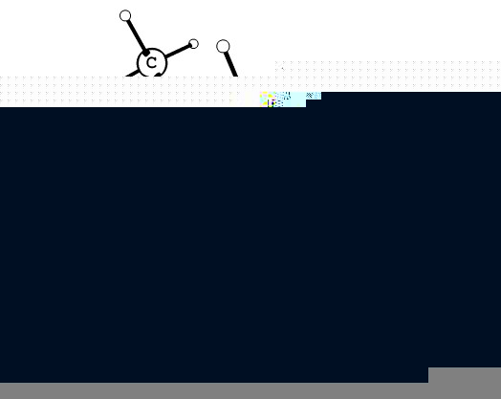 1
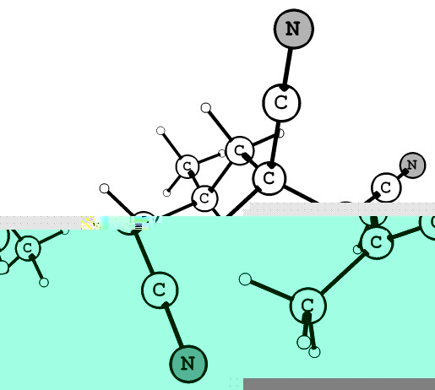 A
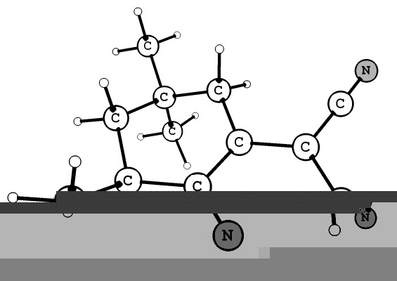 B
Fig. 3. B3LYP/6-31++G** optimized structures of TMCHM 1 and of its β- and δ-cyanide adducts
(A and B in Table 2).
It is seen there that the conversion of 1 into adducts is not accompanied by essential changes in the general form of the parent molecule. However, the structural elements in the fragment, where the reactions take place, undergo essential variations (Table 4). Big changes in the bond length take place in cases when double or quasi-double bonds become single ones and vise versa, e.g. R(5,6) and R(1,7). The biggest bond angle variations take place at atoms, which change their configurations from trigonal (sp²) into tetrahedral (sp³), e.g. A(6,1,7) and A(6,5,12).
The net atomic charges (Table 5) are in agreement with the bond length and bond angle variations (cf. Table 4). The largest charge changes take place at those atoms, which alter their configu-ration in the reaction course (atoms C¹, C⁵ and C⁶).
Energy analysis
Energy characteristics of the species studied are listed in Table 6. We can see there that δ-adducts of 1 are much more stable than the corresponding β-adducts. The large difference of 49.69 and 53.61 kJ·mol^{–1} between their energies can be assumed as the main groundwork of chemical motive force causing the β→δ isomerizations, like in the case of adducts 6 (Table 2).
S. S. Stoyanov et al.: IR spectra and structure of 3,5,5-trimethyl(cyclohex-2-enylidene) malononitrile

Table 4. Selected bond lengths R (Å) and bond angles A (degrees) of TMCHM and its cyanide and methoxide adducts.
Bonds and angles ª | Mole-cule | β-cyanide adduct | β-methoxide adduct | Δ ^{b} | δ-cyanide adduct | δ-methoxide adduct | ∇ ^{c}
R(5,6) | 1.356 | 1.339 | 1.341 | –0.017 | 1.516 | 1.500 | 0.160
 |  |  |  | –0.015 |  |  | 0.144
R(5,12) | 1.501 | 1.508 | 1.509 | 0.007 | 1.555 | 1.538 | 0.054
 |  |  |  | 0.008 |  |  | 0.037
R(6,1) | 1.445 | 1.525 | 1.513 | 0.080 | 1.363 | 1.363 | –0.082
 |  |  |  | 0.068 |  |  | –0.082
R(1,7) | 1.378 | 1.542 | 1.510 | 0.164 | 1.453 | 1.454 | 0.075
 |  |  |  | 0.132 |  |  | 0.076
R(7,8) | 1.431 | 1.399 | 1.406 | –0.032 | 1.410 | 1.411 | –0.021
 |  |  |  | –0.025 |  |  | –0.020
R(8,10) | 1.165 | 1.179 | 1.178 | 0.014 | 1.176 | 1.175 | 0.011
 |  |  |  | 0.013 |  |  | 0.010
A(1,6,5) | 122.4 | 124.9 | 125.5 | 2.5 | 125.0 | 125.7 | 2.6
 |  |  |  | 3.1 |  |  | 3.3
A(1,7,8) | 121.9 | 119.6 | 120.2 | –2.3 | 121.7 | 122.0 | –0.2
 |  |  |  | –1.7 |  |  | 0.1
A(6,1,7) | 121.3 | 110.9 | 110.4 | –10.4 | 123.3 | 123.8 | 2.0
 |  |  |  | –10.9 |  |  | 2.5
A(6,5,12) | 121.6 | 121.5 | 121.9 | –0.1 | 110.3 | 111.3 | –11.3
 |  |  |  | 0.3 |  |  | –10.3
a - Atom numbering according to Formula 1 in Introduction; b - Δ = value (β-adduct) – value (molecule) in the order: cyanide adduct, methoxide adduct; c - ∇ = value (δ-adduct) – value (molecule) in the above order. The largest $\left|Δ\right|$ and values are given in bold.

Table 5. Net Mulliken charges on selected atoms in TMCHM and its adducts.
S. S. Stoyanov et al.: IR spectra and structure of 3,5,5-trimethyl(cyclohex-2-enylidene) malononitrile
Atoms | Molecule | β-cyanide adduct | β-methoxide adduct | Δ ^{b} | δ-cyanide adduct | δ-methoxide adduct | ∇ ^{c}
1 | 1.30 | 0.33 | 0.39 | –0.98 | 1.29 | 1.44 | –0.01
 |  |  |  | –0.92 |  |  | 0.14
5 | 0.66 | 0.43 | 0.30 | –0.23 | 0.64 | 0.32 | –0.34
 |  |  |  | –0.36 |  |  | –0.98
6 | –1.01 | –0.05 | –0.31 | 0.96 | –0.36 | –0.37 | 0.65
 |  |  |  | 0.70 |  |  | 0.64
7 | 0.75 | 0.98 | 0.20 | 0.23 | 0.50 | 0.48 | –0.25
 |  |  |  | –0.55 |  |  | –0.27
8 | –0.23 | –0.52 | –0.39 | –0.28 | –0.20 | –0.34 | 0.03
 |  |  |  | –0.15 |  |  | –0.11
9 | –0.34 | –0.23 | –0.35 | 0.12 | –0.38 | –0.28 | –0.04
 |  |  |  | –0.01 |  |  | 0.07
10 | –0.48 | –0.55 | –0.60 | –0.07 | –0.63 | –0.64 | –0.15
 |  |  |  | –0.14 |  |  | –0.16
11 | –0.50 | –0.58 | –0.61 | –0.08 | –0.62 | –0.62 | –0.13
 |  |  |  | –0.10 |  |  | –0.12
a - Atom numbering according to Formula 1 in Introduction; b - Δ = value (β-adduct) – value (molecule) in the order: cyanide adduct, methoxide adduct; c - ∇ = value (δ-adduct) – value (molecule) in the above order. The largest $\left|Δ\right|$ and values are given in bold.

Table 6. Total energies (E in hartree) of TMCHM mole-cule, its cyanide and methoxide adducts and energy differences (∆E in kJ·mol^{–1}) between the corresponding β- and δ-adducts.
SpeciesE∆E ª = E_{δ} – E_{β}
TMCHM (1)
–575.213306
-

TMCHM – β-CN– adduct
–668.119159
49.69

TMCHM – δ-CN– adduct
–668.137592
-

TMCHM – β-CH₃O– adduct
–690.395773
53.61

TMCHM – δ-CH₃O– adduct
–690.415380
-

a - Corrected with zero-point vibrational energies (ZPVE).
CONCLUSIONS
S. S. Stoyanov et al.: IR spectra and structure of 3,5,5-trimethyl(cyclohex-2-enylidene) malononitrile
The combined IR experimental/B3LYP compu-tational approach, applied in the present work, made it possible both to prove the conversion of 3,3,5-trimethyl(cyclohex-2-enylidene)malononitrile into potassium cyanide and sodium methoxide adducts, as well as the chemical motive force which is the main groundwork of the β-adduct→δ-adduct isome-rizations: the much higer stability (i.e. lower total energy) of the δ-adducts, compared to the β -ones.
Acknowledgements: The authors thank the Prof. I. G. Binev for the useful discussion. The authors also thank Prof. Ts. M. Kolev, Dr. D. Y. Yancheva and Dr. B. A. Stamboliyska for providing us with a sample of 1. The financial support by the Bulgarian Council of Scientific Research for Project Chem. – 1510 is gratefully acknowledged.
REFERENCES
R. Lemke, Chem. Ber., 103, 1168 (1970).
R. Lemke, Chem. Ber., 103, 1894 (1970).
R. Lemke, Synthesis, 359 (1974).
D. Y. Yancheva, Ph.D.Thesis, Inst. Org. Chem., Bulg. Acad. Sci., Sofia, 2003.
T. M. Kolev, D. Y. Yancheva, B. A. Stamboliyska, Spectrochim. Acta. A, 59, 3325 (2003).
B. B. Ivanova, Spectrochim. Acta Part A, 65, 1035 (2006).
X, Liu, H. Ju, X. Zhao, X. Tao, W. Bian, M. Jiang, J. Mol. Struct. (TEOCHEM), 770, 73 (2006).
T. M. Kolev, D. Y. Yancheva, D. C. Kleb, Z. Krist.-New Cryst. ST, 216, 67 (2001).
T. Kolev, Z. Glavcheva, D. Yancheva, M. Schuerman, D. C. Cleb, H. Prent, P. Bleckmann, Acta Crystallogr., E57, 561 (2001).
T. Kolev, Z. Glavcheva, D. Yancheva, Acta Crystallogr., E57, 760 (2001).
T. Kolev, Z. Glavcheva, M. Schuerman, Acta Crystallogr., E57, 964 (2001).
T. Kolev, Z. Glavcheva, D. Yancheva, Acta Crystallogr., E57, 966 (2001).
T. Kolev, Z. Glavcheva, M. Schuerman, Acta Crystallogr., E57, 1166 (2001).
T. Kolev, D. Yancheva, M. Schuerman, Acta Crystallogr., E58, 1093 (2002).
T. Kolev, D. Yancheva, B. Shivachev, R. Petrova, M. Spiteler, Acta Crystallogr., E58, 1093 (2002).
S. Patai, Z. Rappoport, in: The Chemistry of the Alkenes, S. Patai (Ed.), Interscience, London, 1964, Ch. 8.
D. J. Kroeger, R. Stewart, Can. J. Chem., 45, 2163 (1967).
R. Stewart, D. J. Kroeger, Can. J. Chem., 45, 2173 (1967).
C. A. Fyfe, Can. J. Chem., 47, 2331 (1969).
I. N. Juchnovski, I. G. Binev, Tetrahedron Lett., 3645 (1974).
I. G. Binev, I. N. Juchnovski, Commun. Dept. Chem. Bulg. Acad. Sci., 9, 33 (1976).
I. N. Juchnovski, I. G. Binev, Bull. Soc. Chim. Belg. 86, 793 (1977).
I. N. Juchnovski, V. B. Radomirska I. G. Binev, Commun. Dept. Chem. Bulg. Acad. Sci., 14, 147 (1981).
I. G. Binev, Y. I. Binev, B. A. Stamboliyska, I. N. Juchnovski, J. Mol. Struct., 435, 235 (1997).
E. A. Velcheva, I. E. Bineva, I. N. Juchnovski, C. R. Acad. Bulg. Sci., 51, 41 (1998).
E. A. Velcheva, Y. I. Binev, M. J. Petrova, J. Mol. Struct., 475, 65 (1999).
E. A. Velcheva, Bulg. Chem. Commun. 32, 162 (2000).
Z. I. Demireva, I. G. Binev, I. N. Juchnovski, Tetrahedron Lett., 1713 (1972).
Z. Rappoport, S. Gerter, J. Chem. Soc., 1360 (1964).
D. A. Scola, J. S. Adams, Jr., J. Chem. Eng. Data, 15, 349 (1970).
B. A. Arbuzov, N. A Poleznaev, V. S. Vinogradova, I. I. Saydashev, Izv. Akad. Nauk SSSR, Ser. Khim., 2762 (1971).
C. A. Fyfe, M. Zbozny, Can. J. Chem., 50, 1713 (1972).
G. Ferguson, C. A. Fyfe, W. C. March, Can. J. Chem., 51, 2794 (1973).
M. J. Frisch, G. W. Trucks, H. B. Schlegel, G. E. Scuseria, M. A. Robb, J. R. Cheeseman, V. G. Zakrzewski, J. A. Montgomery, Jr., R. E. Stratmann, J. C. Burant, S. Dapprich, J. M. Millam, A. D. Daniels, K. N. Kudin, M. C. Strain, O. Farkas, J. Tomasi, V. Barone, M. Cossi, R. Cammi, B. Mennucci, C. Pomelli, C. Adamo, S. Clifford, J. Ochterski, G. A. Petersson, P. Y. Ayala, Q. Cui, K. Morokuma, D. K. Malick, A. D. Rabuck, K. Raghavachari, J. B. Foresman, J. Cioslowski, J. V. Ortiz, A. G. Baboul, B. B. Stefanov, G. Liu, A. Liashenko, P. Piskorz, I. Komaromi, R. Gomperts, R. L. Martin, D. J. Fox, T. Keith, M. A. Al-Laham, C. Y. Peng, A. Nanayakkara, C. Gonzalez, M. Challacombe, P. M. W. Gill, B. Johnson, W. Chen, M. W. Wong, J. L. Andres, C. Gonzalez, M. Head-Gordon, E. S. Replogle, J. A. Pople, Gaussian 98, revision A.7; Gaussian, Inc.; Pittsburgh, PA, 1998.
T. M. Kolev, E. A. Velcheva, B. A. Stamboliyska, Int. J. Quant. Chem., 102, 1069 (2005).
A. D. Becke, J. Chem. Phys. 98, 5648 (1993).
C. Lee, W. Yang, G. R. Parr, Phys. Rev. Part B, 37, 785 (1988).
I. G. Binev, J. A. Tsenov, E. A. Velcheva, I. N. Juchnovski, J. Mol. Struct., 344, 205 (1995).
A. Alcolea Palafox, Recent Res. Dev. Phys. Chem., 2, 213 (1998).
I. D. Reva, S. V. Ilieva, R. Fausto, Phys. Chem. Chem. Phys., 3, 4235 (2001).
O. Sala, N. S. Gonsalves, L. K. Nada, J. Mol. Struct., 565-566, 411 (2001).
M. K. Georgieva, Bulg. Chem. Commun., 32, 195 (2003).
M. Alcolea Palafox, V. K. Rastogi, L. Mittal, Int. J. Quant. Chem., 94, 198 (2003).
M. K. Georgieva, P. A. Angelova, I. G. Binev, J. Mol. Struct., 692, 23 (2003).
M. K. Georgieva, N. B. Nedelchev, I. N. Juchnovski, Bulg. Chem. Commun., 37, 235 (2005)
L. I. Daskalova, I. G. Binev, Int. J. Quant. Chem., 106, 1338 (2006).
A. D. Popova, M. K. Georgieva, O. I. Petrov, K. V. Petrova, E. A. Velcheva, Int. J. Quant. Chem., 107, 1752 (2007).
L. I. Daskalova, E. A. Velcheva, I. G. Binev, J. Mol. Struct., 826, 198 (2007).
L. I. Daskalova, J. Mol. Struct. (THEOCHEM), 848, 9 (2008)
G. N. Andreev, Molecular spectroscopy, Plovdiv University Press, 1999 (in Bulgarian).
I. G. Binev, E. A. Velcheva, Spectrosc. Lett., 32, 793 (1999).

S. S. Stoyanov et al.: IR spectra and structure of 3,5,5-trimethyl(cyclohex-2-enylidene) malononitrile
ИЧ спектри и структура на 3,5,5-триметил(циклохекс-2-енилиден) малононитрил и неговите калиево-цианидни и натриево-метоксидни карбанионни адукти. експериментално и B3LYP изследване
С. С. Стоянов*, Анг. Д. Попова, Й. Ан. Ценов
Лаборатория „Структурен органичен анализ“, Институт по органична химия с център по фитохимия,
Българска академия на науките, ул. „Акад. Г. Бончев“ бл. 9, 1113 София
Посветена на акад. Иван Юхновски по повод на 70-та му годишнина
Постъпила на 31 януари 2008 г.; Преработена на 4 февруари 2008 г.
(Резюме)
Приложен е, комбиниран ИЧ експериментален/B3LYP теоретичен подход, за изучаване на получаването и изомеризацията на калиево-цианидни и натриево-метоксидни карбанионни адукти на 3,5,5-триметил(цикло-хекс-2-енилиден) малононитрил 1. Установено е добро съответствие между теоретичните и експерименталните ИЧ данни. В съответствие между теория и експеримент, 1 образува β- и δ-адукти с посочените по-горе нуклеофили. Структурните промени, породени от превръщането на 1 в β- и δ-адукти, също са изучени. Според изчисленията, химически движеща сила на β→δ изомеризацията е по-високата стабилност (с около 50 kJ·mol^{–1}) на δ-адуктите, в сравнение с β-адуктите.

