Study of the copolymerization of n-(dichlorophenyl) maleimides
with methyl methacrylate
Bulgarian Chemical Communications, Volume 41, Number 1 (pp. 31–38) 2009
© 2009 Bulgarian Academy of Sciences, Union of Chemists in Bulgaria
V. B. Konsulov*, Z. S. Grozeva, J. I. Tacheva, K. D. Tachev
* To whom all correspondence should be sent:
E-mail: konsulov@shu-bg.net
Faculty of Natural Sciences, Konstantin Preslavsky University of Shumen, 115 Universitetska st.,
9712 Shumen, Bulgaria
Received November 27, 2007; Revised May 22, 2008
N-(2,3-dichlorophenyl)maleimide (2,3-DCMI), N-(2,4-dichlorophenyl)maleimide (2,4-DCMI) and N-(2,6-dichlorophenyl)maleimide (2,6-DCMI) were synthesized by the reaction of maleic anhydride with 2,3-, 2,4- or 2,6-dichloroaniline in two steps. The copolymerization of 2,3-, 2,4- and 2,6-DCMI (M₁) with methylmethacrylate (MMA – M₂) was performed in 1,4-dioxane (DO) in the presence of α,α′-azobisisobutironitrile (AIBN) as an initiator at 60°C. The monomer reactivity ratios in the copolymerization of DCMI with MMA (M₂) and Alfrey-Price Q-e values were determined as follows: r₁ = 0.16, r₂ = 1.97, Q = 0.58, e = 1.47 for 2,3-DCMI-MMA; r₁ = 0.09, r₂ = 2.23, Q = 0.55, e = 1.65 for 2,4-DCMI-MMA; r₁ = 0.04, r₂ = 4.19, Q = 0.30, e = 1.75 for 2,6-DCMI-MMA. The thermostability of the resulting maleimide copolymers was investigated by thermogravimetric analysis. Effects of molecular structure of the 2,3-, 2,4- and 2,6-DCMI compounds on their copolymerization with MMA and the properties of the copolymers have been discussed.
Key words: copolymerization, N-(dichlorophenyl)maleimides, methyl methacrylate, reactivity ratios, molecular structure, thermostability.

Introduction
New functional polymers and thermostable poly-meric materials, such as resistors, nonlinear optics polymer materials, membranes, sorbents, biocata-lysts and other materials with medical application [1–3], have been obtained by copolymerization of N-substituted maleimides (RMI) with vinyl or methacrylic monomers. For example, poly(male-imide-co-2-ethylacrylic acid) shows curative effect on Lewis lung carcinoma [3].
There is a great interest in the investigation of copolymerization and obtaining maleimide copoly-mers of MMA with halogen-containing RMI [1, 2, 5–14]. It is known that on the basis of polymethyl-methacrylate, the first industrial positive electron beam resistor was obtained. The sensitivity of the resistor depends on the type of the halogen atom and on the glass transition temperature (T_{g}) [1, 4].
Radical copolymerization of N-(4-bromophenyl) maleimide (BPMI) with MMA or 2-hydroxyethyl-methacrylate (HEMA) in dioxane was investigated in [5, 6]. The structure of the methacrylate mono-mers affects the reactivity ratios of BPMI-MMA
(r₁ = 0.098 and r₂ = 1.610) and BPMI-HEMA (r₁ = 0.124 and r₂ = 1.823). As it is shown in [5], there is a linear dependence of T_{g} with the increase of the number of maleimide links in the poly(N-4-bromo-phenylmaleimide-co-methylmethacrylate). A linear correlation was found between the T_{g} values and BPMI content of the copolymers.
Janovič reported results [7] of a study of the copolymerization of N-(2,4,6-tribromophenyl)male-imide (TBMI) with methylacrylate (MA) and MMA in toluene solution. The reactivity ratios were found to be r₁ = 0.095 and r₂ = 2.17 for the system TBMI-MA and r₁ = 0.037 and r₂ = 4.32 for the system TBMI-MMA. The copolymers show a considerable enhancement of the thermal stability and a raise in the glass transition temperature upon increasing TBMI content.
The copolymerization of MMA with N-chloro-phenyl maleimide (CPMI) was investigated in a number of articles [8–10]. The results show higher reactivity ratio of MMA compared to maleimide comonomers and indicate a random copolymeri-zation. Mishra et al. [10] evaluated the effect of incorporation of varying molar fraction of N-(2-, 3- or 4-chlorophenyl)maleimides in the poly(methyl methacrylate) backbone on the optical, physicome-chanical and thermal properties of cast acrylic sheets.
Copolymers of N-(3- or 4-halogenophenyl)ma-leimides with ethyl and butyl methacrylates were synthesized by free-radical bulk polymerization [11–13]. The influence of UV radiation on the structure and on the thermal stability, chemical resistance and on some physico-mechanical pro-perties of the copolymers was studied [11].
In a number of articles [5–14] the effect of the type of halogen atom (Cl or Br) and its position (o-, m- or p-) in the phenyl ring of RMI on the values of reactivity ratios (r₁ and r₂) and on the properties of maleimide copolymers was discussed. This paper reports the influence of the structure of N-dichlo-rophenyl maleimides (2,3-, 2,4- and 2,6-Cl substi-tuents in the phenyl ring) on the copolymerization with methyl methacrylate, the reactivity ratios and the properties of the random copolymers.
Experimental
Materials
The monomer methyl methacrylate (Fluka AG) was distilled at a temperature of 99–100ºC (MM = 100.12, ρ = 0.943 g/cm³). The maleic anhydride (Merck) was purified from maleic acid by subli-mation. The 2,3-, 2,4- and 2,6-dichloroanilines (Fluka AG) were purified by vacuum distillation. The 2,2′-azobisisobutyronitrile (AIBN) was recrys-tallized from ethanol (m.p. 103–104ºC). 1,4-dioxane (Fluka AG) was distilled over potassium hydroxide. All other reagents and solvents were of analytical purity grade (p.a.).
V. B. Konsulov et al.: Study of the copolymerization of n-(dichlorophenyl) maleimides with methyl methacrylate
Synthesis and characterization of
N-(dichlorophenyl)maleimides
N-Dichlorophenylmaleimides were prepared by reaction of maleic anhydride (MA) with 2,3-, 2,4-, and 2,6- chloroaniline, followed by cyclodehydra-tion of the resulting maleamic acid.
Procedure for synthesis of N-(2,6-dichloro-phenyl)maleimide. The maleimide monomer N-(2,6-dichlorophenyl)maleimide (2,6DCMI) was obtained from maleic anhydride (MA) and 2,6-dichloro-aniline (DCA) according to the following two-step reaction procedure: 32.404 g (0.2 mol) DCA were dissolved in 40 ml of dry chloroform. The prepared solution was added to 19.612 g (0.2 mol) MA dissolved in 31 ml chloroform upon stirring conti-nuously for 2 h in a glass reactor.
The obtained precipitate of N-(2,6-dichloro-phenyl)maleamic acid was filtered, washed with chloroform, and dried. 26.4 g (0.1 mol) of the resulting product and 2.9 g of sodium acetate were dissolved in 40 ml of acetic anhydride and the mixture was heated at 90ºC for 1 hour. The cooled down reaction mixture was poured onto 800 ml of ice water. The precipitate was filtered and the product was purified by recrystallization in ethanol-water mixture. The obtained yield was 23.5 g (89.0%). The N-(2,6-dichlorophenyl)maleimide is a crystalline substance with melting point of 130–131ºC.
Analysis: Calculated for C₁₀H₅O₂NCl₂ (242.06): C, 49.61; H, 2.08; N, 5.79; Cl, 29.29 %. Found: C, 49.55; H, 2.06; N, 5.72; Cl, 29.15%.
The molecular structure and the molecular diagram of N-(2,6-dichlorophenyl)maleimide are presented in the scheme:
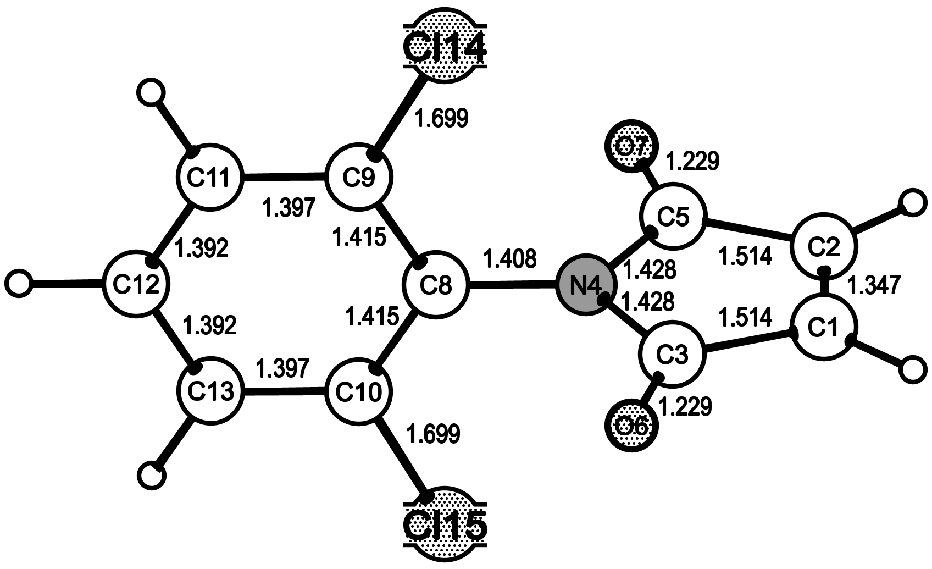
FT-IR: (cm^{–1}), 3097 and 3067 (ν_{=C–H}), 1776, 1715 ($ν_{C=O}^{s}{\text{, ν}}_{C=O}^{\text{as}}$), 1642 (ν_{CH=CH}), 1584, 1488, 1433 (ν_{C=C} Ar), 1392 (ν_{C–N} Ar), 1217 (ν_{C–O}),1155 (ν_{C–N–C} MI), 1055 (ν_{C–Cl}), 832(γ_{=C–H}, cis-MI), 804 and 715 (1,2,3-substituted phenyl), 686 (carbonyl ring deforma-tion).
¹H NMR (CDCl₃, TMS) δ, ppm: 7.43–7.28 (3H, Ar =C–H), 6.89 (2H, CH=CH).
¹³C NMR(CDCl₃) δ, ppm: 168.30 (C3, C4), 134.4 (C1, C2), Aromatic carbons:135.39 (C5), 131.16 (C6, C10), 128.51 (C7, C9) and 127.29 (C8).
The N-(2,3-dichlorophenyl)maleimide and N-(2,4-dichlorophenyl)maleimide were synthesized by a similar method.
Copolymerization
The copolymerization was performed as follows: a solution of DCMI, comonomer MMA and initiator AIBN in 1,4-dioxane as solvent were poured into a glass ampoule. The solution was degassed using dry nitrogen and the ampoule was immediately sealed and thermostated in an ultra-thermostat at 60 ± 0.1ºC. After the polymerization for a given time interval the glass ampoule was reopened and the viscous mixture was poured into ethanol. The obtained copolymers were purified twice by repre-cipitation from acetone solution into ethanol. The polymers were filtered and dried in vacuum at 50ºC. The composition of the obtained copolymers was calculated by elemental analysis data of nitrogen or chlorine and by ¹H NMR spectra [9, 15].
Instrumental analysis
The IR spectra were recorded on a BOMEM Michelson 100 FTIR spectrometer using KBr pellets or on Specord 75 IR instrument using suspension in nujol or polymer films. The ¹H and ¹³C NMR spectra were recorded on a Bruker DRX-250 spectrometer in solution of CDCl₃ or DMSO-d₆. The thermogravimetric analysis (TGA) was carried out in air atmosphere at a heating rate of 10ºC/min by means of a Derivatograph OD-102/MOM. The viscosity was measured in DO (or DMF) at 25ºC by means of an Ubbellode viscosimeter VPG (d = 0.54 mm). The elemental analysis was carried out on a Carlo Erba analyzer. The melting points of the crystalline products (maleimides) were determined by the Kofler microscope.
Results and Disscussion
Synthesis and characterization of
N-dichlorophenyl maleimides
N-(Dichlorophenyl)maleimides were obtained from maleic anhydride and 2,3-, 2,4- or 2,6-dichloroaniline (DCA) via two-step reaction:
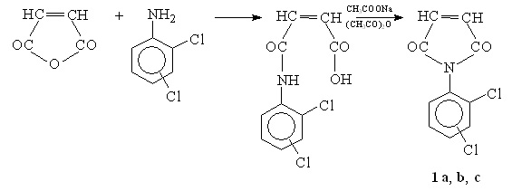
During the first stage in chloroform solution at 25ºC a reaction of N-acylation is taking place and the corresponding maleamic acid (MAA) is obtained. The MAA is light yellow sediment.
The reaction mixture of the obtained MAA with acetic anhydride was then treated with anhydrous sodium acetate and was heated up to 85–95ºC. The amount of sodium acetate (catalyst) affected the reaction rate. The optimal result was obtained in the presence of about 10% sodium acetate [16]. Under the above mentioned conditions, the MAA under-went cyclodehydration and the maleimide mono-mers 1a, b, c were obtained as a result.
The obtained DCMI are white crystalline substances, soluble in chloroform, acetone, dioxane, dimethylformamide. The experimental results are summarized in Table 1.
Table 1. Yield and characteristics of N-dichlorophenyl maleimides (2,3-, 2,4- and 2,6-DCMI).
Sample | DCMI | Yield,  % | Elemental analysis*, % |  |  |  | m.p.,  ºC
Sample | DCMI | Yield,  % | C | H | N | Cl | m.p.,  ºC
1a | 2,3-DCMI | 87.6 | 49.52 | 2.03 | 5.69 | 29.10 | 94–95
1b | 2,4-DCMI | 90.4 | 49.53 | 2.04 | 5.70 | 29.12 | 106–107
1c | 2,6-DCMI | 89.0 | 49.55 | 2.06 | 5.72 | 29.15 | 130–131
*Theoretical for C₁₀H₅O₂NCl₂ |  |  | 49.61 | 2.08 | 5.79 | 29.29
Synthesis and characterization of copolymers of
N-dichlorophenyl maleimides with methyl methacrylate
The copolymerization of N-dichlorophenyl male-imides (1a, b, c) with methyl methacrylate was carried out at 60ºC in dioxane in the presence of 0.75% AIBN as initiator according to the following scheme:
V. B. Konsulov et al.: Study of the copolymerization of n-(dichlorophenyl) maleimides with methyl methacrylate
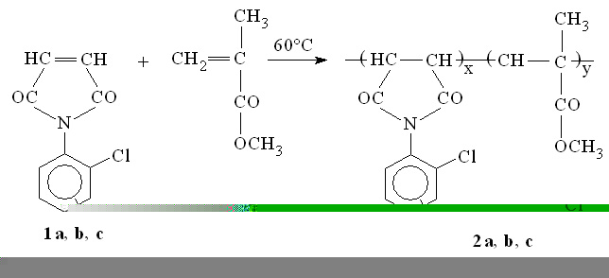
Under these conditions the polymerization pro-ceeded via chain-radical mechanism in homo-geneous medium. The copolymers were isolated through precipitation of the polymer solution in ethanol and were purified by double precipitation from acetone in ethanol/water or diethyl ether. The obtained maleimide copolymers of MMA are white powder-like substances, soluble in organic solvents such as dioxane, acetone, chloroform, dichloro-ethane, etc. The experimental results are shown in Table 2.
Table 2. Copolymerization of N-dichlorophenyl male-imides (M₁) with methyl methacrylate (M₂) at monomer ratio of 50:50 mol.% (C_{m} = 1.1 mol/l, 60ºC, 5 h).
Copo-lymer sample | M₁ | Yield,  % | Elemental analysis,  % |  | Copolymer composition, mol.% |  | [η]*,  dl/g
Copo-lymer sample | M₁ | Yield,  % | N | Cl | M₁ | M₂ | [η]*,  dl/g
2 a | 2,3-DCMI | 71.6 | 2.65 | 13.25 | 25.9 | 74.1 | 0.45
2 b | 2,4-DCMI | 69.8 | 2.38 | 12.04 | 22.4 | 77.6 | 0.48
2 c | 2,6-DCMI | 77.5 | 1.74 | 8.72 | 15.1 | 84.9 | 0.42
* η determined in DMF at 25ºC (d_{k} = 0.54 mm, Ubbelode).
The structure of the copolymers was proved by ¹H and ¹³C NMR as well as by IR-spectroscopy. In the IR-spectrum of poly(N-2,3-dichlorophenylmale-imide-co-methyl methacrylate) film the maleimide units were identified by the bands at 1782, 1705 (broad, intensive), 1580, 1430, 980, 830, and 740 cm^{–l}. Characteristic of MMA monomer units are the IR bands at 2960 cm^{–l} (–CH₂–) and at 1460 and 1380 cm^{–l} due to asymmetric and symmetric bending vibrations of the –CH₃ and –OCH₃ bonds. The broad and intensive band at 1280–1120 cm^{–l} is assigned to the stretching vibrations (ν_{С−О}) of MMA units.
In the ¹H NMR spectrum of poly(N-2,4-dichlo-rophenylmaleimide-co-methyl methacrylate) the presence of maleimide monomeric units was proved by the resonance signals at 7.76, 7.51, and 7.32 ppm for the aromatic protons. The signals between 3.64–3.72 ppm were assigned to the protons of the
–OCH₃ group in MMA units, while the triplet centered at 1.21 ppm was attributed to the protons of the –CH₃ groups. To the protons of –CH₂– were assigned signals at 1.71–2.15 ppm, and the signals of methyne protons –CH– appeared at 2.86 and 2.94 ppm.
The ¹³C NMR spectrum of the poly(N-2,6-di-chlorophenylmaleimide-co-metyl methacrylate) con-taining 39.5 mol% maleimide units is shown in Fig. 1. The signals at 175.3–177.8 ppm characterize the maleimide carbonyl groups, these at 173.2–174.2 ppm – the ester carbonyl groups. The carbon atoms in the aromatic ring give resonance signals at 127.9, 128.6, 131.3, 134.1, 134.3, and 134.6 ppm. The MMA-units are characterized by: 15.0–19.1 ppm α-methyl groups; 51.8–55.7 ppm –OCH₃ ester groups.
V. B. Konsulov et al.: Study of the copolymerization of n-(dichlorophenyl) maleimides with methyl methacrylate
The copolymer compositions were determined by elemental analysis (Table 2) and by ¹H NMR [9, 15], based on the intensity of the aromatic protons
signals (3H, at about 7.32–7.76 ppm) from male-imides and the intensity of MMA proton signal (3H, at about 3.64–3.72 ppm). The mole fraction of DCMI (m₁) in the copolymers was calculated according to the following equation:
, (1)
where I₁ and I₂ represent the integrated area intensities of the aromatic protons in DCMI and of the methoxy protons in MMA respectively. These results were correlated with experimental data for the copolymer composition, obtained by elemental analysis (Table 3).
Reactivity ratios. Effect of the molecular structure of
N-dichlorophenylmaleimides
To determine the reactivity ratios of the mono-mers r₁ (2,3-, 2,4-, or 2,6-DCPMI) and r₂ (MMA) the copolymerization of the comonomers with a conversion degree up to 15–20 % has been studied. Some of the obtained results are represented in Table 3.

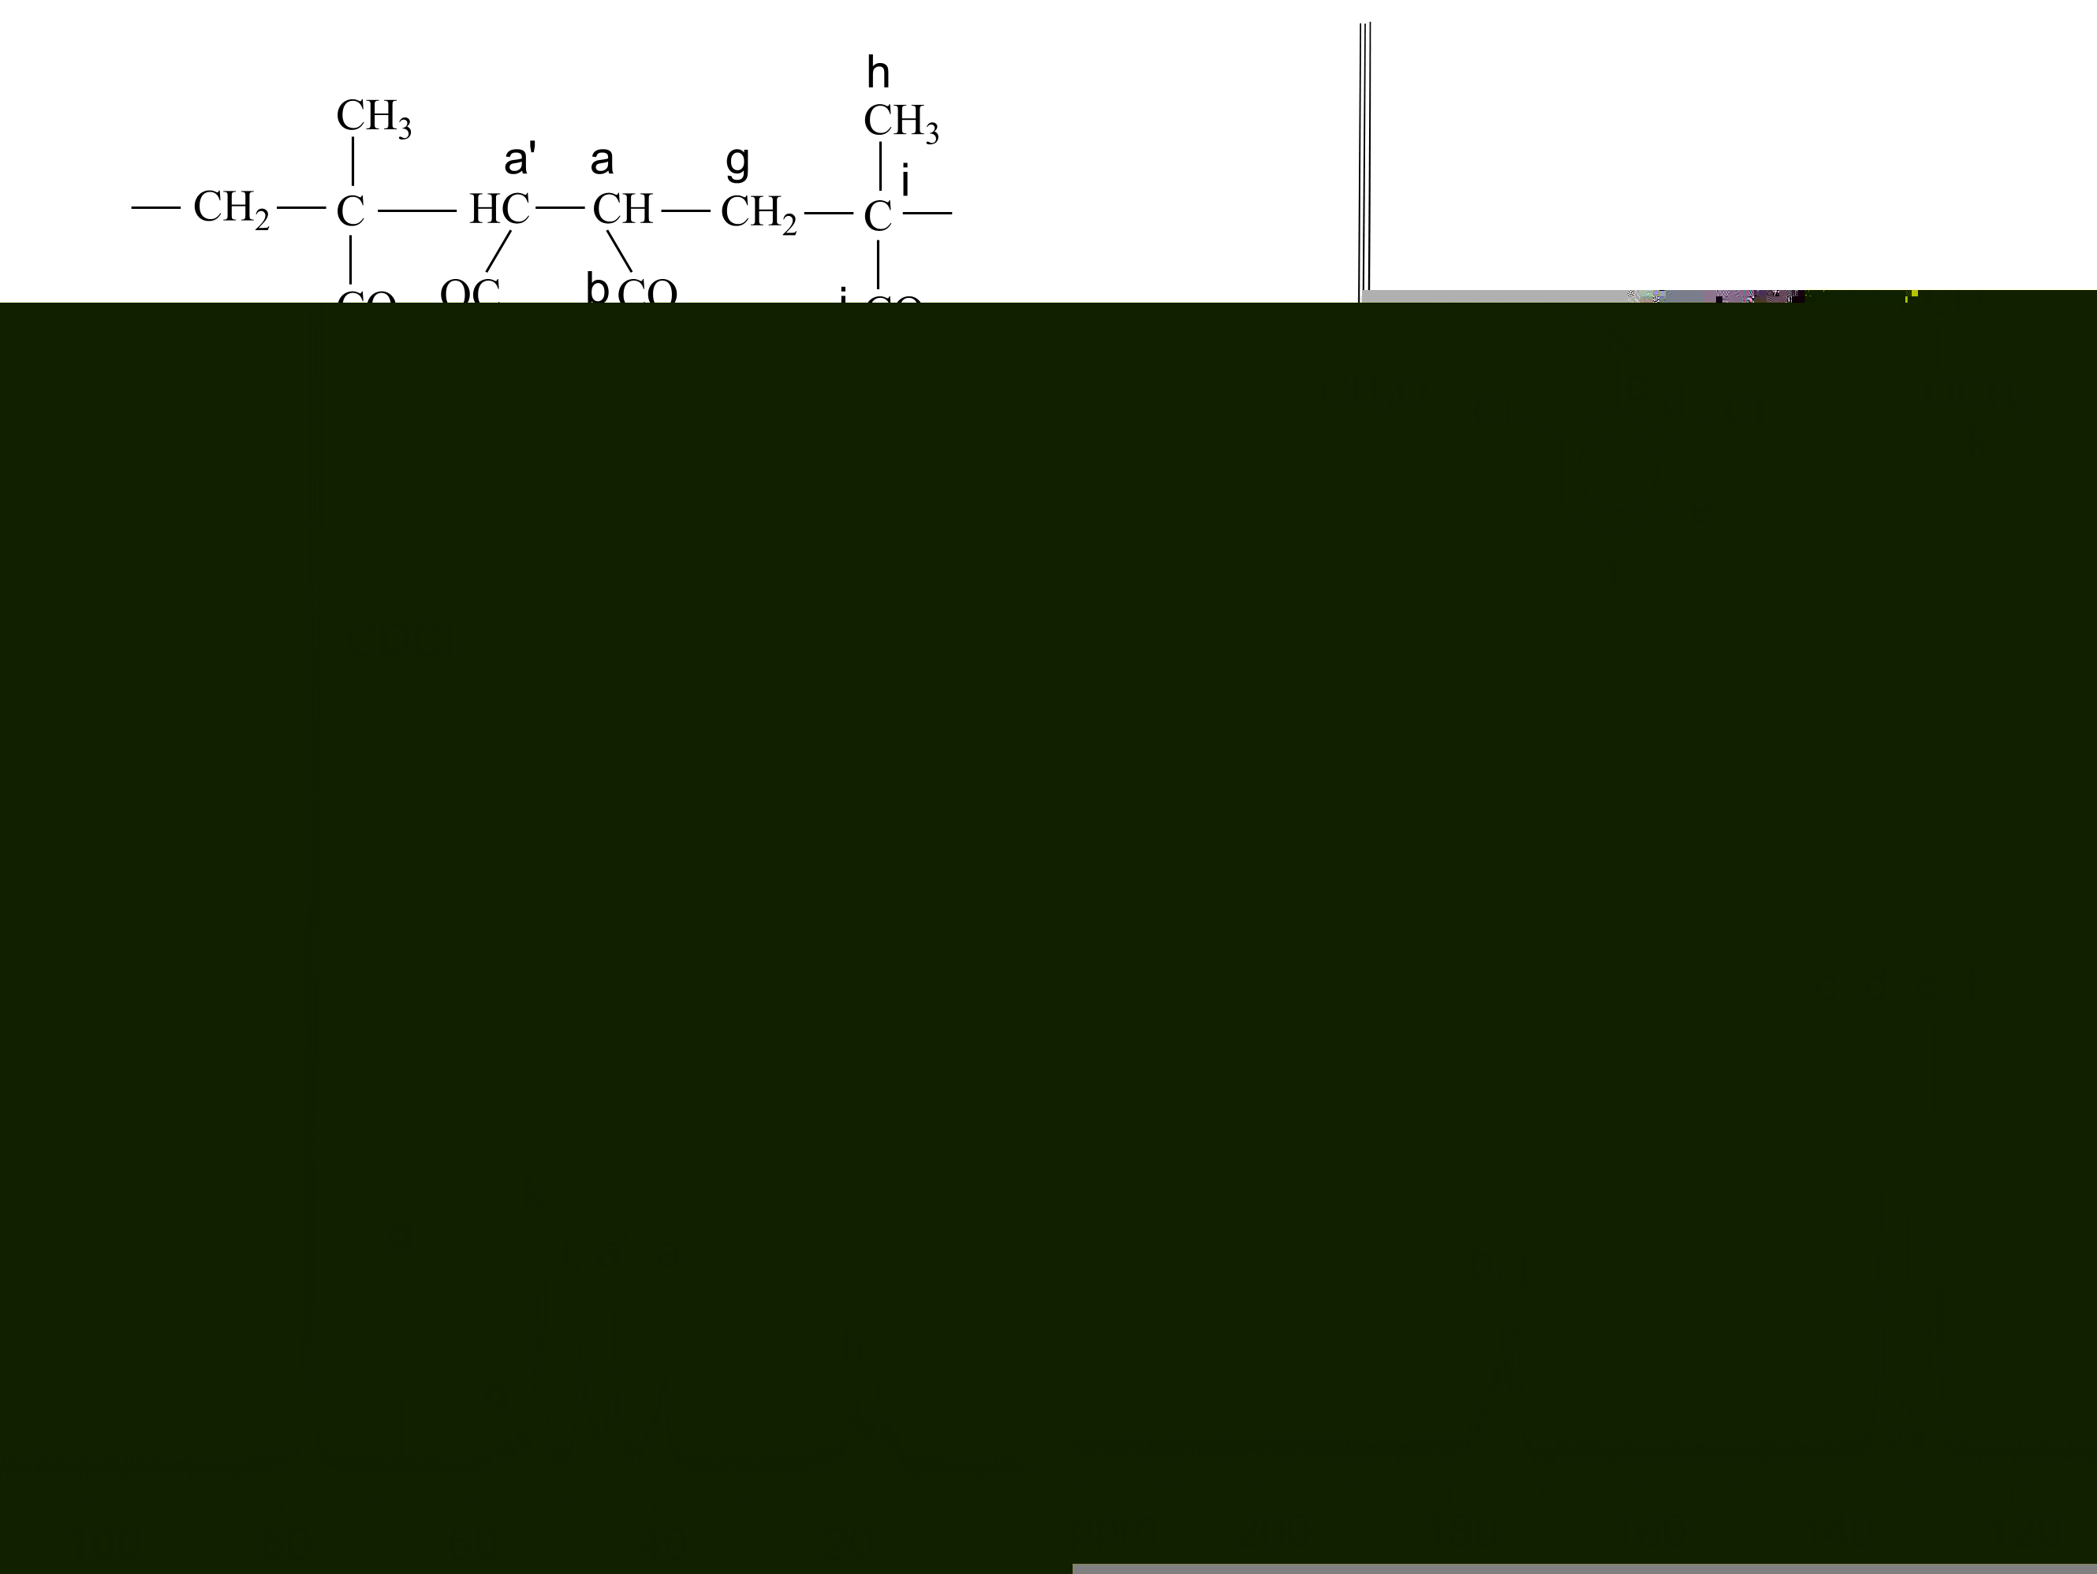
Fig. 1. ¹³C NMR spectrum of poly[(N-2,6-dichlorophenyl) maleimide-co-methyl methacrylate] containing 39.5 mol.% N-(2,6-dichlorophenyl)maleimide.

Table 3. Copolymerization of N-dichlorophenylmale-imides (M₁) with methyl methacrylate (M₂) in dioxane solution at different monomer feed ratios (C_{M} = 1.0 mol/l, T = 60ºC).
Sam-ple num-ber | DCMI (M₁) in monomer feed  mol. % |  | Con-ver-sion,  % | Poly-merization rate, R_{p}  %/min | Fraction of DCMI (M₁) in copolymer  (mol.%) |  | [η]*  dl/g
 |  |  |  |  | N | ¹H NMR | [η]*  dl/g
1 | 2,3-DCMI | 20.0 | 15.4 | 0.15 | 9.9 | 9.6 | 0.32
2 | 2,3-DCMI | 50.0 | 17.5 | 0.18 | 27.4 | 27.9 | 0.23
3 | 2,3-DCMI | 79.8 | 15.7 | 0.14 | 54.1 | 54.6 | 0.18
4 | 2,4-DCMI | 20.5 | 17.1 | 0.12 | 9.5 | 9.3 | 0.29
5 | 2,4-DCMI | 50.0 | 18.0 | 0.13 | 26.5 | 26.6 | 0.24
6 | 2,4-DCMI | 79.8 | 16.8 | 0.11 | 48.5 | 48.9 | 0.11
7 | 2,6-DCMI | 20.0 | 16.5 | 0.13 | 9.3 | 9.2 | 0.25
8 | 2,6-DCMI | 48.7 | 18.9 | 0.23 | 14.7 | 14.8 | 0.21
9 | 2,6-DCMI | 79.8 | 15.4 | 0.10 | 39.5 | 40.0 | 0.20
*η determined in 1,4-Dioxane at 25ºC (d_{k} = 0.54 mm, Ubbelode).
The experimental data showed that the copoly-merization rate (R_{p}) depends only slightly on the content of DCMI in the monomer feed. A weak kinetic maximum, shifted from the equimolar composition, was observed at higher MMA content (66–75 mol.%). This is characteristic of monomer systems with weak electron donor or electron acceptor interactions [1, 7, 16].
The monomer reactivity ratios for the copoly-merization of DCMI with MMA were determined based on the monomer feed ratios and the copolymer composition by Kelen-Tüdös (KT) method [17–18]. The dependence of the obtained copolymer composition (m₂) upon monomer feed composition (M₂ = MMA) according to experi-mental data from three series of experiments is represented in Fig. 2. The dependence curves show that the copolymerization of all the three monomer pairs lead to obtaining random copolymers. In the resulting copolymers the number of MMA units prevails over the maleimide units (see also Table 2).
The r₂ values for MMA are higher (r₂ > 1) than the r₁ values for the maleimides (r₁ << 1) for the three monomer systems (Table 4). The connection between the structure of the monomer and its reactivity in free-radical reactions is controlled by resonance, polar and steric factors. The Q-e scheme gives a quantitative evaluation of the role of resonance and polar effects. The Q₁ and e₁ values of N-(2,3-, 2,4- and 2,6-dichlorophenyl)maleimides were calculated using the Alfrey-Price Q-e scheme [19, 21] based on the reactivity ratios:
$e_{1}=e_{2}±(−\text{ln}r_{1}\text{.}r_{2})^{0\text{.}5}$ (2)
$Q_{1}=\frac{Q_{2}}{r_{2}}\text{exp}[−e_{2}(e_{2}−e_{1})]$ (3)
Values of Q₂ = 0.74 and e₂ = 0.40 for MMА were used for this purpose according to the literature data [7, 15].
V. B. Konsulov et al.: Study of the copolymerization of n-(dichlorophenyl) maleimides with methyl methacrylate
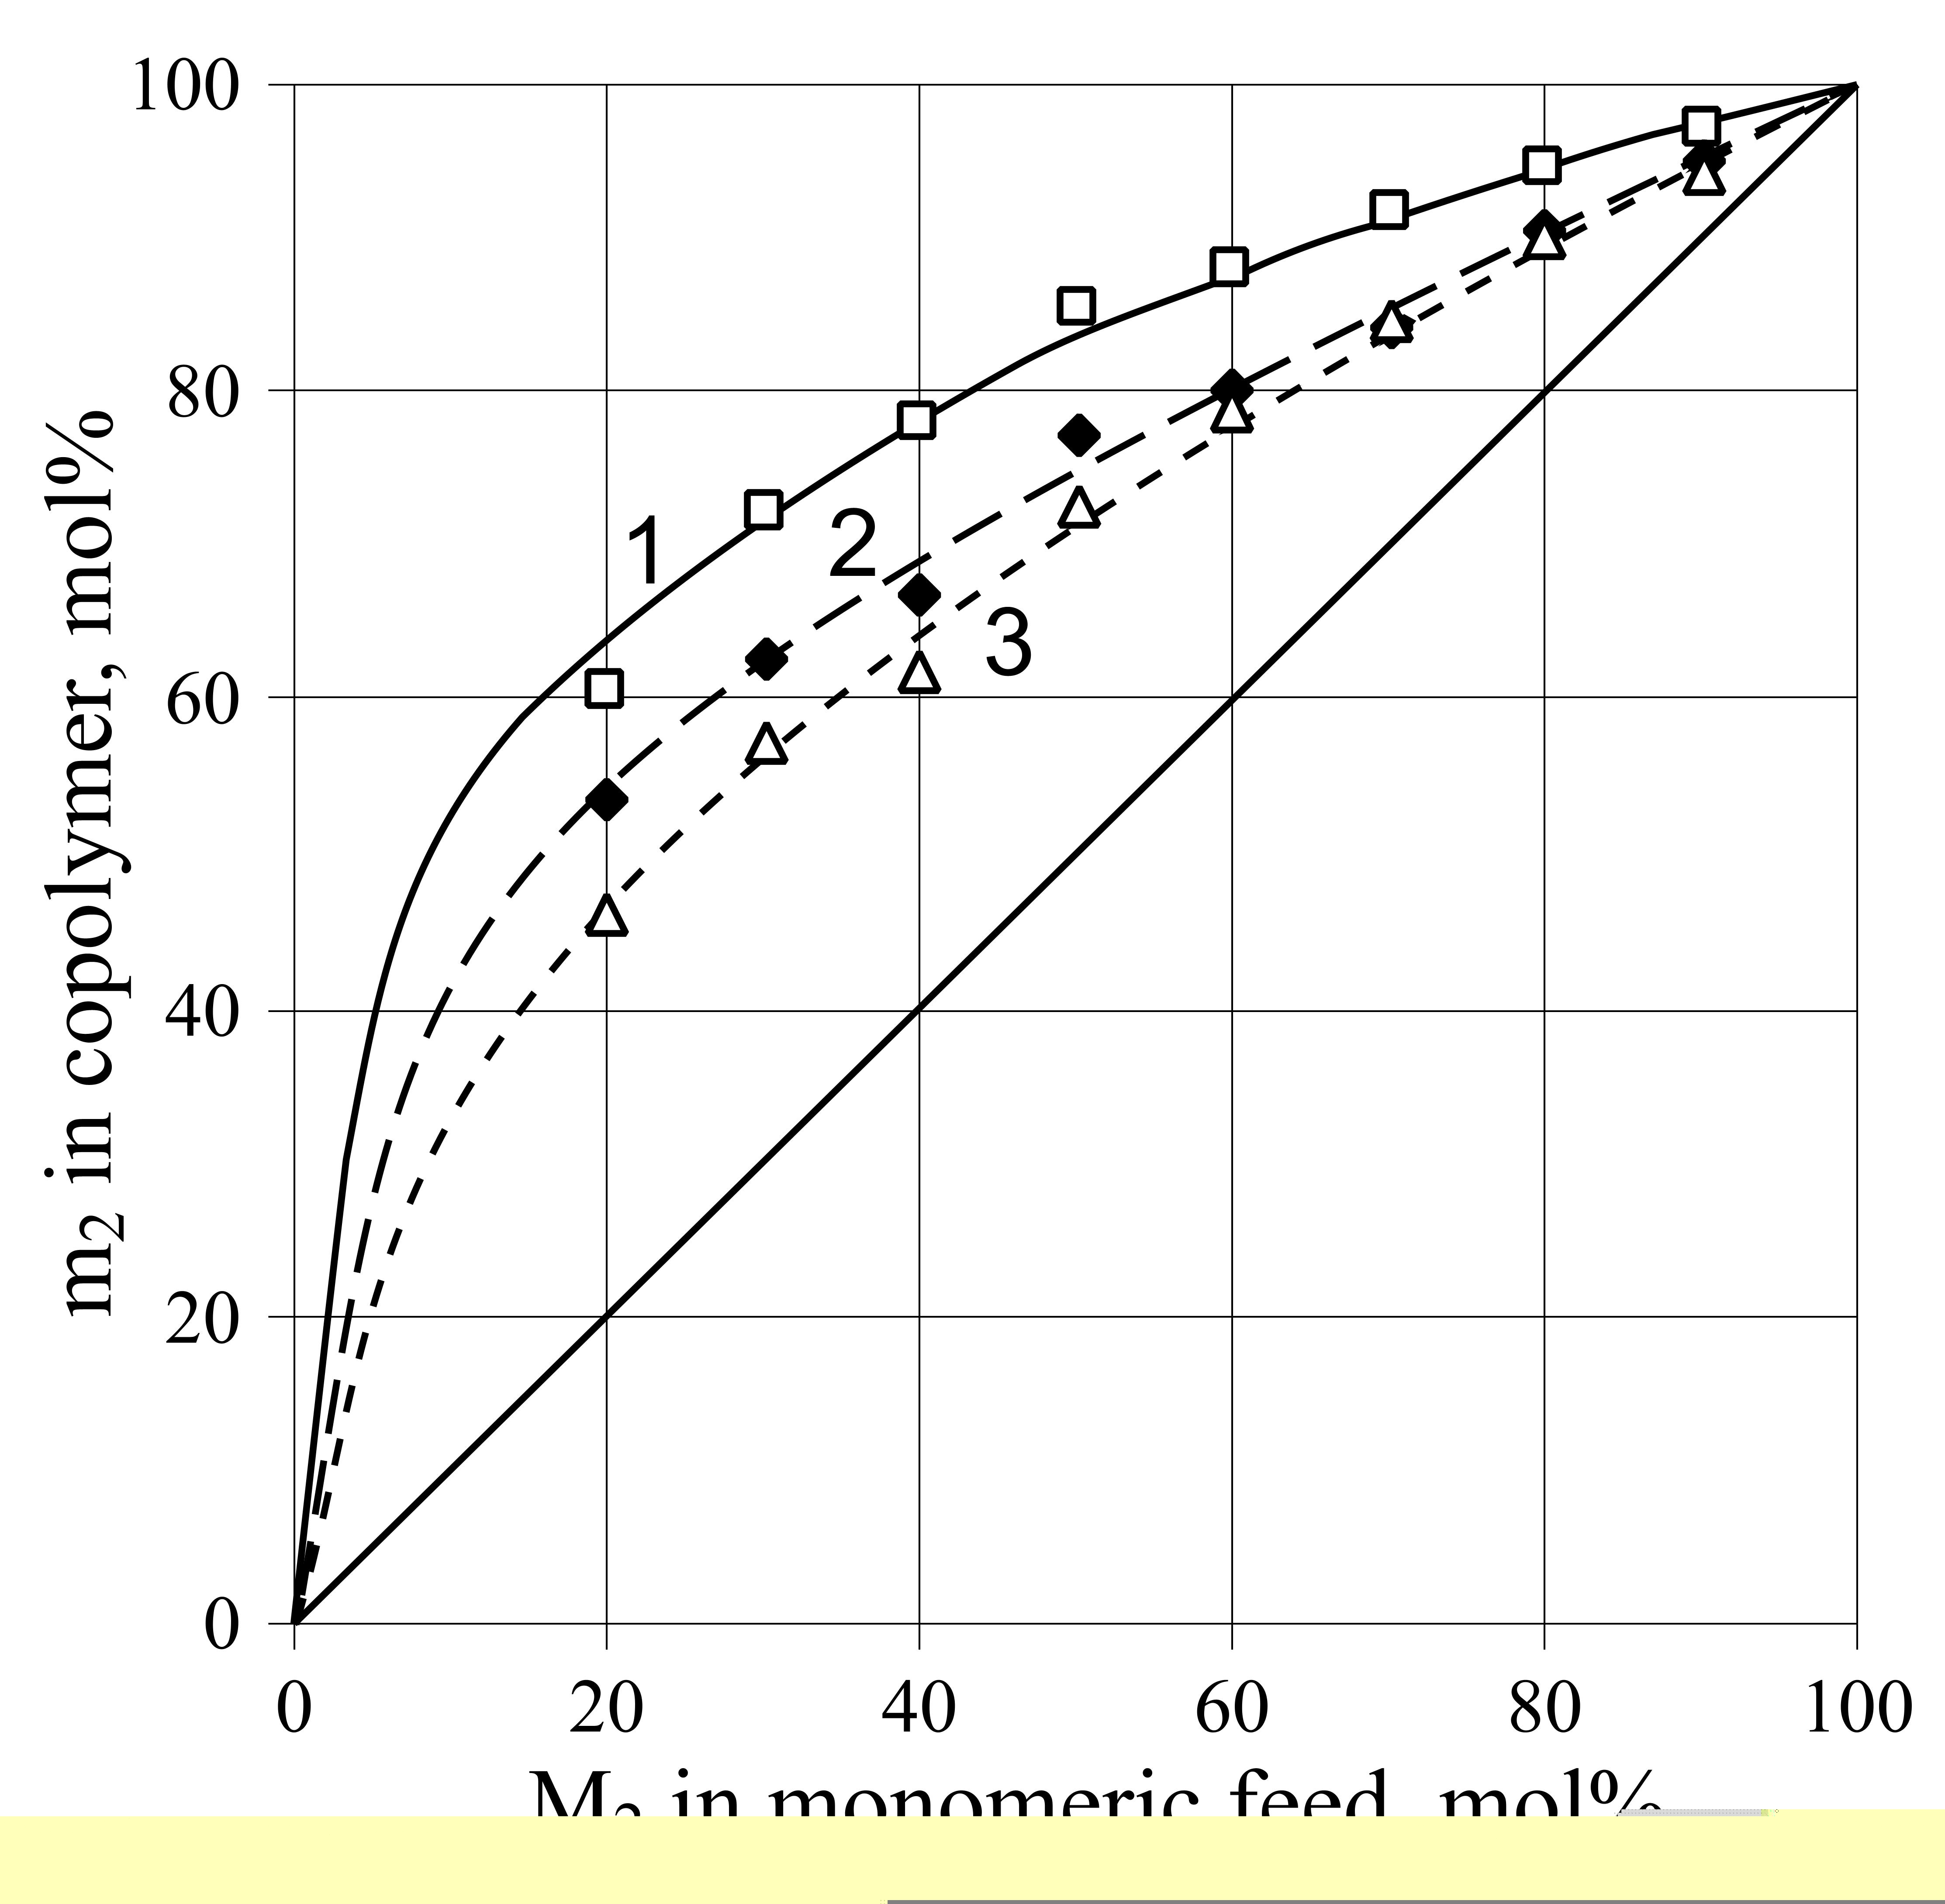
Fig. 2. Monomer-copolymer composition curves for the copolymerization of methyl metacrilate (M₂) with M₁:
N-(2,6-dichlorophenyl)maleimide (curve 1),
N-(2,4-dichlorophenyl)maleimide (curve 2) or
N-(2,3-dichlorophenyl)maleimide (curve 3).
Table 4. Monomer reactivity ratios r₁, r₂ and Q–e values for copolymerization of N-dichlorophenyl maleimides (M₁) with methyl methacrylate (M₂).
M₁ | r₁ | r₂ | 1/r₁ | 1/r₂ | r₁.r₂ | Q₁ | e₁
2,3-DCMI | 0.16 ± 0.02 | 1.97 ± 0.08 | 6.2 | 0.51 | 0.315 | 0.58 | 1.47
2,4-DCMI | 0.09 ± 0.03 | 2.23 ± 0.11 | 11.1 | 0.45 | 0.200 | 0.55 | 1.65
2,6-DCMI | 0.04 ± 0.01 | 4.19 ± 0.09 | 25.6 | 0.24 | 0.168 | 0.30 | 1,75
The resonance effect influences the reactivity of the monomer and its radical. The conjugation in the MMA molecule determines the high reactivity of the monomer, while the activity of its radical is lower. Although MMA is 1,1-disubstituted mono-mer, the steric factor does not affect its polyme-rization ability [19]. One can conclude in view of the r-values that the reactivity of the N-dichloro-phenyl maleimides decreases, when the second Cl-atom is located at a greater distance from the first one (at ortho-position in the aromatic ring). The reactivity ratios decrease in the following order: 2,3-DCMI > 2,4-DCMI > 2,6-DCMI. A possible expla-nation of these observations could be connected with the influence of the induction effect (I-effect > M-effect for Cl-atom) on the electron acceptor properties of the functional –CH=CH– group of the maleimide ring resulting in a decrease of the donor-acceptor interactions with the weak donor monomer MMA [7]. The 2,6-DCMI is about 25 times more active with respect to MMA radical in the reaction of cross propagation. (1/r₁ = k₁₂/k₁₁ ~ 25). The оrtho steric effect has a weaker influence on 2,3- and 2,4-DCMI as they have asymmetric structure. These monomers are about 6 and 11 times more active to ММА-radical, respectively.
The reactivity ratios show that the two macro-radicals in the examined systems have higher acti-vity to methacrylic monomer and the obtained copolymers are enriched in ММА-units. The MMA has high polymerization activity in the reaction of homo and cross propagation [7, 11]. The reaction of homopropagation occurs at higher rate (k₂₂ > k₂₁) and as a result in the polymer chain the number of consecutive MMA units alternate (r₁.r₂ < 1) the maleimide link or diads [5, 6, 11]. Therefore, the distribution of the monomeric links and the design of the macromolecules of the three copolymers of MMA with 2,3-, 2,4-, and 2,6- DCMI would differ. They would depend also on the monomer ratio DCMI/MMA, at which the maleimide copolymer is obtained (see Table 3, Fig. 2).
Copolymer microstructure
The microstructure in the resulting copolymers was determined using the monomer reactivity ratios. The placement probabilities P₁₁, P₁₂, P₂₁ and P₂₂ and the mean sequences length μ₁ (DCMI) and μ₂ (MMA) were calculated using the equations in references [21, 22]. The values of P₁₁, P₁₂, P₂₁, P₂₂, μ₁ and μ₂ are represented in Table 5.
Table 5. Data for the structure of copolymers of N-dichlo-rophenylmaleimide (M₁) with metylmethacrylate (M₂).
Type of DCMI | Sam-ple | P₁₁ | P₁₂ | P₂₁ | P₂₂ | Mean  sequence lenght
 |  |  |  |  |  | μ ₁ | μ ₂
2,3-DCMI | 1 | 0.0385 | 0.9615 | 0.1126 | 0.8874 | 1.04 | 8.89
2,3-DCMI | 2 | 0.1379 | 0.8621 | 0.3367 | 0.6633 | 1.16 | 2.97
2,3-DCMI | 3 | 0.3872 | 0.6128 | 0.6672 | 0.3328 | 1.63 | 1.50
2,4-DCMI | 4 | 0.0227 | 0.9773 | 0.1037 | 0.8963 | 1.02 | 9.65
2,4-DCMI | 5 | 0.0825 | 0.9174 | 0.3300 | 0.6700 | 1.09 | 3.23
2,4-DCMI | 6 | 0.2627 | 0.7373 | 0.6394 | 0.3606 | 1.36 | 1.56
2,6-DCMI | 7 | 0.0099 | 0.9901 | 0.0563 | 0.9437 | 1.01 | 17.76
2,6-DCMI | 8 | 0.0366 | 0.9634 | 0.1847 | 0.8153 | 1.04 | 5.19
2,6-DCMI | 9 | 0.1365 | 0.8635 | 0.4853 | 0.5147 | 1.16 | 2.06
The obtained data show that the probability of formation of maleimide diads (Р₁₁) is low and it depends on the mole fraction DCMI in the monomer feed. The mean sequence length μ₁ values increase from 1.04 to 1.63 in the 2,3-DCMI/MMA system, from 1.02 to 1.36 in the 2,4-DCMI/MMA system and from 1.01 to 1.16 in the 2,6-DCMI/MMA system. The Р₂₁ values are higher than P₁₁ and increase with the concentration of maleimide mono-mers. For all studied comonomer ratios the probabi-lities P₁₂ and P₂₂ are higher than Р₁₁ and P₂₁. This implies that in maleimide copolymers, diads, triads and even much longer sequences of MMA units are formed. The μ₂ values increase from 1.50 to 8.9 in the 2,3-DCMI/MMA system; from 1.56 to 9.65 in the 2,4-DCMI/MMA system and from 2.06 to 17.76 in the 2,6-DCMI/MMA system.
Thermostability of the copolymers of DCMI with MMA
The thermal properties of copolymers DCMI with MMA were determined by TGA in static air atmosphere. Data at the temperature of the initial weight loss [5, 7, 12] of a sample (T_{I}), the tempe-rature at 50% weight loss (T₅₀), the temperature of maximum decomposition rate (T_{max}) and final decomposition temperature (T_{f}), as well as the percentage of the weight loss of the samples at 350ºC and 500ºC are summarized in Table 6 and shown in Figure 3.
V. B. Konsulov et al.: Study of the copolymerization of n-(dichlorophenyl) maleimides with methyl methacrylate
Table 6. Thermal properties of copolymers of N-(dichlo-rophenyl)maleimides with metylmethacrylate (heating rate 7ºC/min in static air atmosphere).
Copo-lymer sample | T_{I},  ºC | T₅₀,  ºC | T_{max},  ºC | T_{f},  ºC | Percentage weight  loss at |  | Residue at T_{f},  %
 |  |  |  |  | 350ºC | 500ºC | Residue at T_{f},  %
1 | 316 | 373 | 378 | 530 | 28 | 93 | 7
4 | 320 | 365 | 370 | 500 | 33 | 99 | 1
7 | 325 | 375 | 380 | 520 | 16 | 98 | 2
The copolymer samples were stable up to 316ºC for 2,3-DCMI-MMA, up to 320ºC for 2,4-DCMI-MMA and up to 328ºC for 2,6-DCMI-MMA. All the samples showed a single step decomposition in the temperature region 280–420ºC, which corres-ponds to random main chain scission of MMA-MMA links (335–427ºC) of PMMA. The maximum values of the weight loss (decomposition) are at about 370–380ºC. In the case of 2,3-DCMI-MMA copolymer, the weight loss up to 350ºC was 28%, that of 2,4-DCMI-MMA – 33%, and that of 2,6-DCMI-MMA – 16%. The percentage of char yield increased upon increasing DCMI content in the maleimide copolymers.

Fig. 3. TG and DTG trace of poly(2,6-DCMI-co-MMA), poly(2,4-DCMI-co-MMA) and
poly(2,3-DCMI-co-MMA) in air atmosphere (heating rate 10ºC/min).

Conclusions
By the radical copolymerization of N-(2,3-dichlorophenyl)maleimide, N-(2,4-dichlorophenyl) maleimide, and N-(2,6-dichlorophenyl)maleimide with methyl methacrylate random maleimide copo-lymers have been obtained. The monomer reactivity ratios of N-dichlorophenylmaleimides r₁ (0.18, 0.09 and 0.04 for 2,3-, 2,4-, and 2,6- DCMI respectively) revealed the effect of molecular structure of N-substituted maleimides on their copolymerization with methyl methacrylate and on the properties of the obtained maleimide copolymers. The thermo-stability of the studied maleimide copolymers was about 80–90ºC higher compared to polymethyl-methacrylate. The role of the position of Cl-atoms in the phenyl ring of N-dichlorophenylmaleimides for the thermal properties of the copolymers was insignificant. Their thermostability increased with the molar fraction of N-dichlorophenyl maleimide units in the macromolecules.
References
V. B. Konsulov et al.: Study of the copolymerization of n-(dichlorophenyl) maleimides with methyl methacrylate
- V. B. Konsulov, in: Polymeric Materials Encyclo-pedia: Maleimide copolymers (N-substituted), vol. 6, J. C. Salamone (Ed.), CRC Press Boca Raton, New York, 1996, p.3996.
- Tz. Godjevargova, R. Nenkova, V. Konsulov, J. Mol. Catal. B: Enzym., 38, 59 (2006).
- Z. Zhu, L. Shi, J. Huang, Bioorg. Med. Chem. Lett., 12, 2843 (2002).
- B. M. Gong, J. C. W. Chien, J. Polym. Sci. Part A: Polym. Chem., 27, 1149 (1989).
- J. Borbely, T. Kelen, V. Konsulov, Z. Grozeva, Polymer Bull., 26, 253 (1991).
- V. Konsulov, Z. Grozeva, Bulg. Chem. Commun., 31, 38 (1999).
- Z. Janovič, T. Matusinovič, F. Ranogajec, Makromol. Chem., 194, 1915 (1993).
- A. Kumar, J. Macromol. Sci., A24, 711 (1987).
- V. Choudhary, A. Mishra, J. Appl. Polym. Sci., 62, 707 (1996).
- A. Mishra, T. J. M. Sinha, V. Choudhary, J. Appl. Polym. Sci., 68, 527 (1998).
- A. Ryttel, J. Appl. Polym. Sci., 74, 2924 (1999).
- A. Ryttel, J. Appl. Polym. Sci., 81, 3244 (2001).
- H. Naguib, G. Saad, M. Elsabeé, Polym. Int., 52, 1217 (2003).
- V. Konsulov, Z. Grozeva, T. Kelen, J. Borbély, Makromol. Chem., 193, 847 (1992).
- A. O. Kress, L. J. Mathias, G. Cei, Macromolecules, 22, 537 (1989).
- C. P. Yang, S. S. Wang, J. Polym. Sci. Part A: Polym. Chem., 27, 15 (1989).
- T. Kelen, F. Tűdös, J. Macromol. Sci.-Chem., A9, 1 (1975).
- T. Kelen, F. Tűdös, B.Turcsanyi, Polym. Bull., 2, 71 (1980).
- G. E. Ham (ed) in: Copolymerization, Khimia, Moscow, 1971, pp. 65–81.
- G. S. Georgiev, V. P. Zubov, Eur. Polym. J., 14, 93 (1978).
- S. Morariu, C. Hulubei, High Perform. Polym., 18, 185 (2006).
- V. Konsulov, D. Dyakova, A. Lyapova, Z. Grozeva, Bulg. Chem. Commun., 39, 72 (2007).

ИЗСЛЕДВАНЕ НА СЪПОЛИМЕРИЗАЦИЯТА НА N-(ДИХЛОРОФЕНИЛ)МАЛЕИМИДИ
С МЕТИЛМЕТАКРИЛАТ
В. Б. Консулов*, З. С. Грозева, Й. И. Тачева, К. Д. Тачев
Факултет по природни науки, Шуменски университет „Епископ Константин Преславски“,
Ул. „Университетска“ № 115, 9712 Шумен
Постъпила на 27 ноември 2007 г.; Преработена на 22 май 2008 г.
N-(2,3-дихлорофенил)малеимид (2,3-ДХМИ), N-(2,4-дихлорофенил)малеимид (2,4-ДХМИ), N-(2,6-дихлоро-фенил)малеимид (2,6-ДХМИ) са синтезирани чрез взаимодействие на малеинов анхидрид с 2,3-, 2,4- или 2,6-дихлороанилин в два стадия. Съполимеризацията на 2,3-, 2,4- и 2,6-ДХМИ (М₁) с метилметакрилат (ММА-М₂) е проведена в 1,4-диоксан (ДО) в присъствие на α,α'-азобисизобутиронитрил като инициатор при 60°С. Определени са константите на съполимеризация и Q–e стойностите: r₁ = 0.16, r₂ = 1.97, Q = 0.58, e = 1.47 за 2,3-ДХMИ-MMA; r₁ = 0.09, r₂ = 2.23, Q = 0.55, e = 1.65 за 2,4-ДХMИ-MMA; r₁ = 0.04, r₂ = 4.19, Q = 0.30, e = 1.75 за 2,6-ДХMИ-MMA. Термостабилността на получените малеимидни съполимери е изследвана чрез термо-гравиметричен анализ. Дискутира се влиянието на молекулната структура на 2,3-, 2,4- и 2,6-ДХМИ върху съполимеризацията им с ММА и свойствата на получените съполимери.

