Atomic force microscopy for the characterization of human platelets
before and after interaction with selected anticoagulant drugs
Bulgarian Chemical Communications, Volume 41, Number 1 (pp. 23–30) 2009
© 2009 Bulgarian Academy of Sciences, Union of Chemists in Bulgaria
E. Gorodkiewicz¹*, A. Sankiewicz¹, I. Sveklo², Z. A. Figaszewski^{1,3}
* To whom all correspondence should be sent:
E-mail: ewka@uwb.edu.pl
¹ Department of Electrochemistry, Institute of Chemistry, University of Bialystok,
Al. J. Pilsudskiego 11/4, 15-443 Bialystok, Poland
² Institute of Experimental Physics, University of Bialystok, Lipowa 41, 15-333 Bialystok, Poland
³ Laboratory of Electrochemical Power Sources, Faculty of Chemistry, University of Warsaw,
Pasteur St. 1, 02-093 Warsaw, Poland
Received January 16, 2008; Revised May 19, 2008
Human platelets, i.e thrombocytes are the smallest non-nucleated blood cells, which are highly reactive components of the circulatory system and play a key role in many pathophysiologic processes, such as thrombosis, hemostasis, inflammation, host defense, tumor biology, as well as in maintenance and regulation of vascular tone. The platelets aggregation process and the formation of platelet plugs are a fundamental part of the blood clotting process and prevent bleeding from capillaries, small arterioles and venules. However, thrombosis disorders are one of the reasons for complications in surgical procedures. Abciximab and Eptifibatide are efficient antiplatelet drugs used during and after coronary artery treatments, such as angioplasty, in order to prevent platelets from sticking together and causing thrombus formation inside the coronary artery.
The aim of this work was the comparison of different methods for preparation and immobilization of blood platelets on a glass or mica bedding in terms of suitability for the investigation of Abciximab or Eptifibatide interaction with platelets by Atomic Force Microscopy (AFM). AFM is a very useful tool for the observation of the topography of biological structures. The investigation was performed on dry mica, dry glass and in a buffer solution.
On mica, changes in the shape and size of inactive and activated platelets can be observed, as well as their aggregation with fibrinogen. Abciximab and Eptifibatide, deposited onto the mica sheet, form ‘twig-crystal’ structures. Surprisingly, the smaller Eptifibatide molecules form a bigger structure than that of Abciximab. This is probably caused by Eptifibatide molecular aggregation.
Platelet-inhibitor complex adhesion on mica or glass sheets was observed. The low number of activated platelets was observed after incubation of a sample with both drugs. These drugs surrounded the platelets as a result of interaction with glycoprotein GP IIb/IIIa. Frequently, whole platelets were surrounded with drugs. Each image shows the aggregation process in a different phase with a characteristic platelet filopodia. Each procedure can be used for the observation of platelets and their changes under the influence of different agents, for example drugs.
Key words: Atomic force microscopy (AFM), human blood platelets, abciximab, eptifibatide.

INTRODUCTION
Human blood platelets (PLT), i.e thrombocytes are the smallest non-nucleated blood cells. They are tiny and discoid in shape, with dimensions of approximately 2.0–4.0 μm. Platelets are produced in the bone marrow and arise from megakaryocyte. The circulating life time of a platelet is 7–10 days [1]. A normal platelet count in a healthy person is 150 000–450 000 cells/mm³ of blood (www.lab-testsonline.org). They are highly reactive com-ponents of the circulatory system and play a key role in many pathophysiologic processes, such as thrombosis, hemostasis, inflammation, host defense, tumor biology, maintenance and regulation of vascular tone [2].
Human blood platelets contain granules (alpha, dense, lysosomes), mitochondria and an endoplasm-matic reticulum [3]. Alpha and dense granules con-tribute to the very important function of platelets in hemostasis. The alpha granules play a primary role in hemostatis, while dense granules in the aggre-gation [1]. The aggregation process and the forma-tion of a platelet plug are a fundamental part of the blood clotting process and they prevent bleeding from capillaries, small arterioles, and venules. This is a two-phase process. At first, single platelets bind to the site of the wound – this is the adhesion process. Next, the platelets are activated. During activation, the platelets are drastically changing shape. They undergo change from a discoid form to a flat spread form, 7–10 μm in diameter [4]. Activation can be stimulated by substances released by these cells (for example: adenosine diphosphate, serotonin and thromboxane) and by components, which circulate in the blood (for example the Von Willebrand Factor, thrombine). The result of these two processes is the aggregation of platelets.
Platelets play an increasing role in vascular and endovascular procedures. Thrombosis disorders are one reason for complications in surgical procedures. Many agents, for example specific drugs, foods, spices and vitamins could impair platelet function [5]. Today, there is a number of drugs that inhibit platelet function [6]. The classic inhibitor of platelet function is aspirin (acetylsalicylic acid). Aspirin prevents blood from clotting by blocking the production of thromboxane A–2.
Thromboxane A-2 is produced in platelets and causes them to clump. Aspirin inhibits the enzyme cyclo-oxygenase-1 (COX-1) that produces thromb-oxane A-2 [1, 5, 6]. Clopidogrel is a potent oral antiplatelet agent often used in the medical treat-ment of coronary artery disease, peripheral vascular disease, and cerebrovascular disease. The mecha-nism of action of clopidogrel is the irreversible blockade of the adenosine diphosphate (ADP) receptor on platelet cell membranes [7]. A number of new drugs, inhibitors of fibrinogen, preventing platelet aggregation by binding to glycoprotein IIb/IIIa, has been recently studied. Three of them: abciximab (ReoPro), eptifibatide (Integrilin) and tirofiban (Aggrasrat) have been registered as effi-cient antiplatelet drugs [8, 9]. Abciximab is a human-murine chimeric Fab fragment of the mono-clonal antibody c7E3 directed against the glyco-protein IIb/IIIa [10]. Eptifibatide is a cyclic hepta-peptide containing six amino acids and one mer-captopropionyl (des-amino cysteinyl) residue [11]. Tirofiban is a synthetic, nonpeptide inhibitor acting on glycoprotein (GP) receptors, type IIb/IIIa, in human thrombocytes. These inhibitors are mainly used during and after coronary artery procedures, such as angioplasty to prevent platelets from sticking together and causing thrombus (blood clot) formation inside the coronary artery [12].
There are many methods for studying platelet properties. Platelet functions are studied by the measurement of key biochemical markers that can show changes in platelet activation. There are two principal assay systems: ELISA and flow cytometry [13–15]. Markosyan et al. [16] used a laser photo-meter to study platelet shape and aggregation. The elastic properties of cells have been measured using a mechanical indenter called a cell poker [17], optical tweezers [18], scanning acoustic microscopy [19] or fine glass needles [20]. Electron microscopy and an Atomic Force Microscope have been used [4, 21] to study the architecture of the cytoskeleton and changes in the platelet during activation [22], as well as to diagnose platelet disorders [23]. The interaction between platelet receptor and ligand (for example fibrinogen) in the presence of platelet inhibitors (abciximab, tirofiban, eptifibatide) has been studied using fluorescence laser-scan micro-scopy [24], confocal microscopy [25], laser tweezers [26], electron microscopy [27], fluor-escence and differential interference contrast micro-scopy [28].
The aim of this work was the comparison of different methods for the preparation and immobi-lization of blood platelets on a different bedding, in terms of the suitability for investigation of the interactions between anticoagulant drugs (abciximab or eptifibatide) and platelets by the Atomic Force Microscopy (AFM). More precisely, the aim was the observation of changes in platelet topography on dry mica bedding and on a glass bedding, both dry and from an aqueous buffer solution.
E. Gorodkiewicz et al.: Atomic force microscopy for the characterization of human platelets
EXPERIMENTAL
AFM measurements
The AFM measurements were performed with a commercial Ntegra Prima scanning probe micro-scope (NT-MDT, Russia) using a “Tapping mode” for “in air imaging” and a contact mode for in “liquid and air imaging”. A scanning head for mea-surements in liquid and air (100 mkm scanner) was equipped with capacitive position sensors, which allow the removal of the hysteresis of piezodrivers. CSG01 probes with a force constant of 0.01–0.08 N/m were used for the contact mode and NSG03 probes with resonance frequency 90–116 kHz were used for the tapping mode. All measurements were done at room temperature.
Chemicals
Acetone, sodium hydrogen carbonate NaHCO₃, sodium dihydrogen phosphate NaH₂PO₄, sodium chloride NaCl, potassium chloride KCl, magnesium chloride MgCl₂ (all analytical purity grade, POCH, Gliwice, Poland), Tyrode buffer (12 mM, 4 mM, 137 mM, 2.6 mM, 1 mM, pH = 7,3), abciximab (REOPRO, Centocor B.V. Holland), eptifibatide (INTEGRILIN, Glaxo Group Ltd, Great Britain). Water was deionized with a MilliQ (Millipore) apparatus.
Platelet preparation
Blood samples, taken from healthy adult subjects were supplied by the Blood Donor Centre in Bialy-stok. The blood was treated with sodium citrate as an anticoagulant.
Next, the platelet rich plasma was separated by centrifuging the blood amount 130 g for 8 min at room temperature. This platelet rich plasma was then centrifuged at 2200 g for 10 min to obtain a platelet bottom. The supernatant was removed. The platelet bottoms were washed twice with isotonic saline.
Sample preparation for AFM measurement
a). On the mica sheet. After the last washing, the platelets were resuspended in acetone to a solid concentration of ~10^{–5} g/l. 100 μl of platelet suspen- sion in acetone was dropped onto a freshly cleaved mica sheet. The mica sheet was dried in air for at least 4 h.
b). On the glass cover slip. Platelets were also prepared from the freshly drawn blood of one of the team. 100 μl of blood were deposited onto a glass cover slip. After 30 s, the sample was vigorously rinsed with Tyrode buffer to separate all blood cells from the activated platelets that had adhered strongly to the glass. The glass cover slip with platelets was left in air to dry.
For AFM measurements in the buffer solution, the glass slides with platelets were deposited in a special cell.
c). With abciximab and eptifibatide. The drugs were dissolved in acetone and immobilized on the mica in accordance with the procedure described in a) or were dissolved in aqueous buffer in accordance with the procedure described in b).
The interaction between drugs in therapeutic concentration (abciximab – 3.57 μg/ml of blood and or eptifibatide – 2.57 μg/ml of blood) and platelets was studied after incubation of blood or isolated platelets for 1 hour at 37ºC. The procedure of plate-let preparation was the same as before (see Platelet preparation). 100 μl platelet solution was deposited onto a glass cover slip or mica sheet. After vigorous rinsing, the samples were observed by AFM.
E. Gorodkiewicz et al.: Atomic force microscopy for the characterization of human platelets
RESULTS AND DISCUSSION
In order to investigate the opportunity to observe immobilized human platelets by the AFM tech-nique, platelets were immobilized on the mica sheet. This was performed by putting a suspension of platelets in acetone on the mica surface and drying. The sample contains both inactive platelets and those at different stages of activation. Both inactive and activated platelets, immobilized on mica can be
observed by the AFM. Fig. 1 shows AFM images of human platelets in different activation phases. Changes in the shape and size of inactive and activated platelets can be observed (compare Fig. 1A–C). The glycoprotein receptors located on the platelets surface change their 3D configuration under the influence of activating factors, causing them to lose their granular structure. This involved a change in platelet shape. Before these changes, platelets exhibit a regular shape and dimensions [4]. Their diameter is 2.25 µm and their thickness is 170 nm (Plot Fig. 1A). The activated platelet’s shape becomes irregular. Figure 1b shows the platelet having a diameter of 4.5 μm and a thickness of 250 nm (Plot Fig. 1B), while Fig. 1c shows the platelet having a diameter of 4.25 µm and a thickness of only 30 nm (Plot Fig. 1C). The next stage of change is filopodia formation (see Fig.1C). The filopodia formation is the morphological effect of platelet activation. Simultaneously, a release reaction occurs i.e. the platelet releases substances activating the next platelets and their GPIIb/IIIa receptors. The glycoprotein (GPIIb/IIIa) fibrinogen receptor is composed of two subunits, αII_{b} and β_{3,} which form a complex. GPIIb/IIIa is specific for platelet surfaces and binds to adsorbed protein ligands, including fibrinogen, the von Willebrand factor and fibro-nectin. The fibrinogen plays a fundamental role in forming bridges between platelets and causes aggregation. Due to receptor activation, platelets join together with fibrinogen. Fibrinogen bridges are formed between platelets (see Fig. 2A). This process is responsible for platelet aggregation. The deposi-tion procedure, of platelets from the acetone suspension on the mica sheet enables good and fast adhesion in different activation platelet phases.
Fig. 2 shows AFM pictures obtained after applying three different ways of platelet deposition: i) on the mica sheet from the acetone suspension (shown in picture A), ii) on the glass slide from the fresh unprocessed blood, after washing and drying (shown in picture B), iii) on the glass slide from an aqueous buffer solution (shown in picture C). The first two were dry probes and the third one was measured from an aqueous solution.
Each image shows the aggregation process in a different phase with a characteristic platelet filo-podia. Each procedure can be used for the obser-vation of platelets and their changes under the influence of different agents, for example drugs.

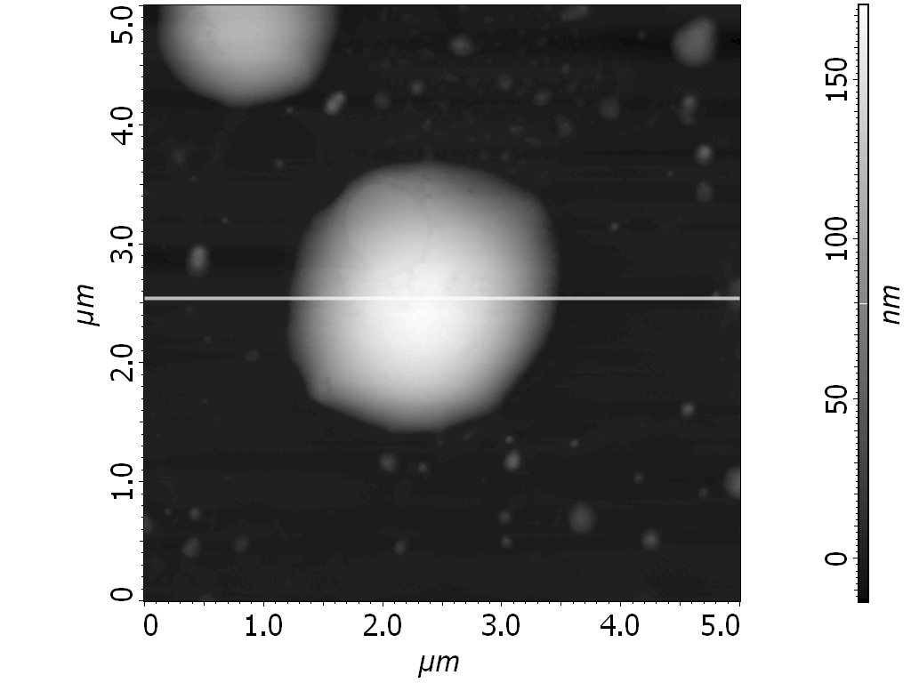 A | 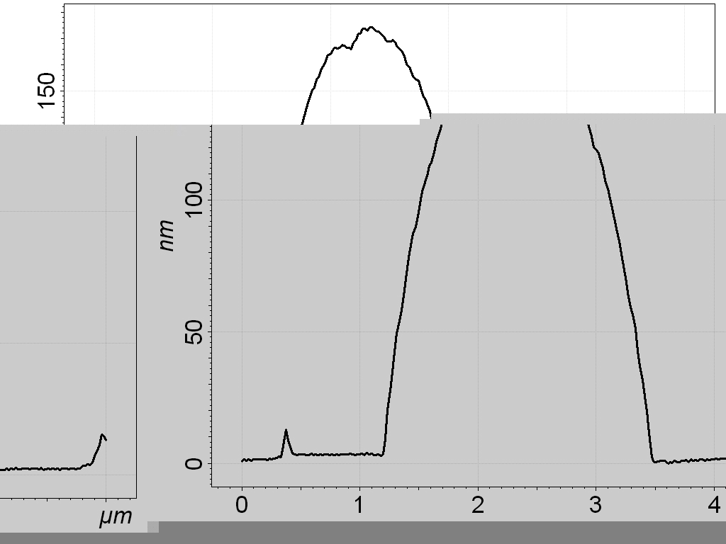 D
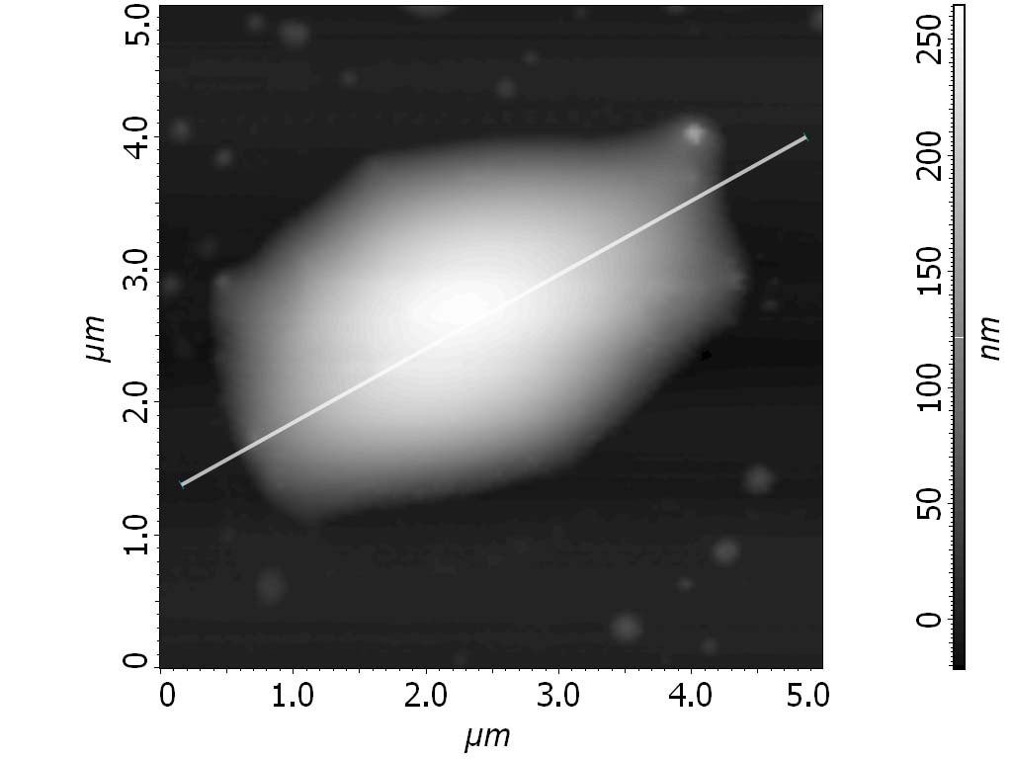 B | 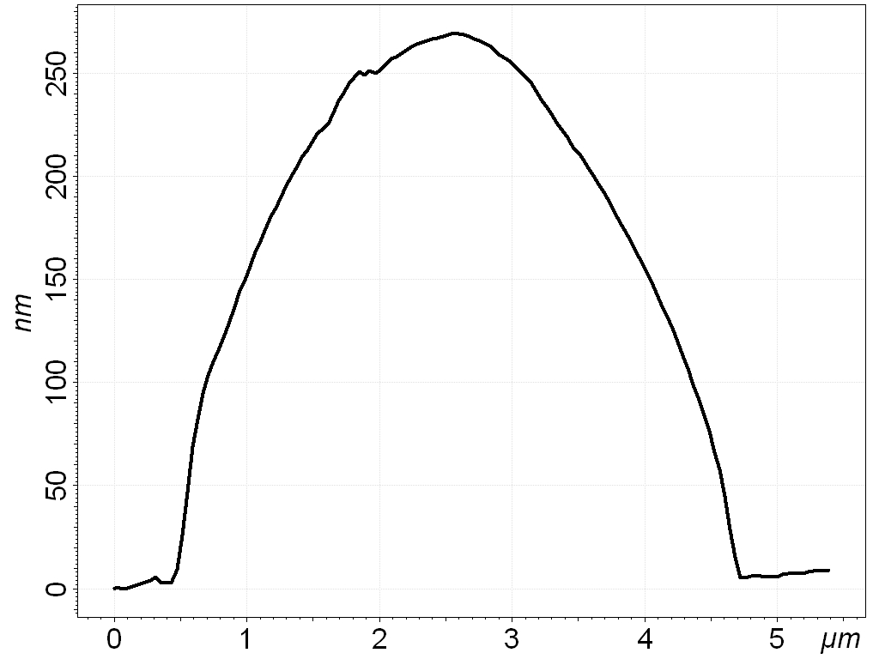E
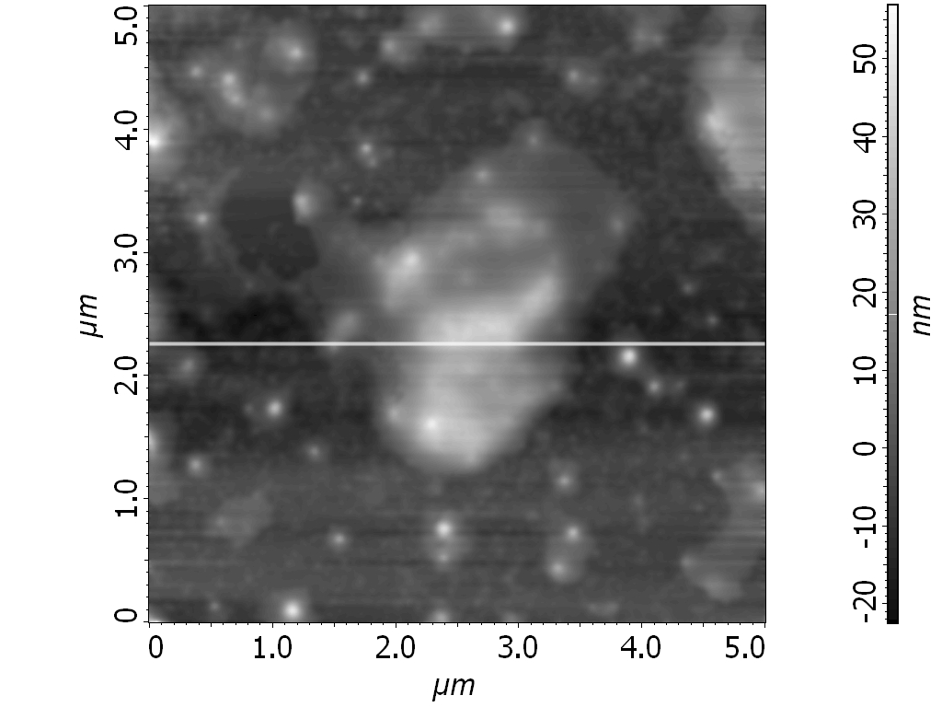 C | 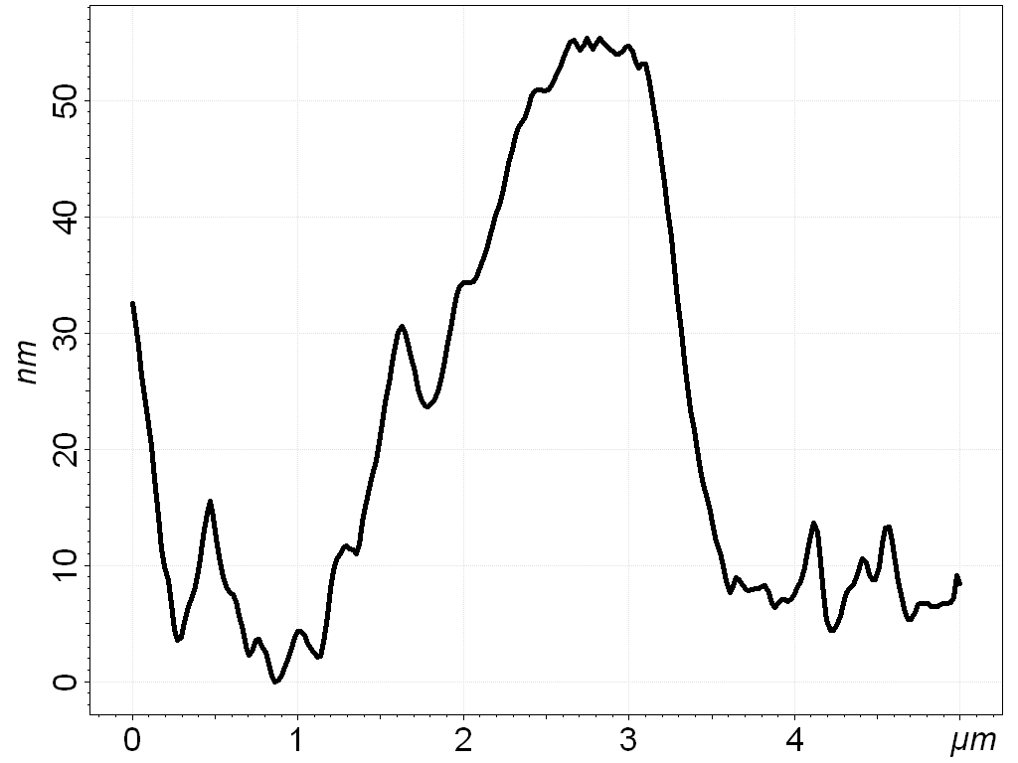 F
Fig. 1. Human platelets on the mica sheet imaged with the AFM and cross-sectional plots showing along the lines shown in images respectively (A, D) inactivity platelet; (B, E) activation process; (C, F) activated platelet.

In Fig. 3, two anticoagulant drugs, deposited onto the mica sheet, can be observed (A for abciximab and B for eptifibatide). A ‘twig-crystal’ structure is observed in both cases. Similar effects were observed with samples immobilized on a glass bedding. Abciximab is a bigger molecule and its special structure is more apparent. In the case of eptifibatide, larger structures are apparent in the pictures than in the case of abciximab, despite the fact that eptifibatide is a smaller molecule. The formation of these larger structures is probably caused by the eptifibatide molecule aggregation. Both drugs are platelet aggregation inhibitors due to fibrinogen receptor blocking. Abciximab (molecular weight of 48 kD [29]) is a human-murine chimeric Fab fragment of the monoclonal antibody c7E3. Moreover, abciximab shows a very high affinity to platelets. This molecule joins to the receptor αIIbβ3 with an antibody fragment, hindering the joining of fibrinogen, and in this manner inhibits platelet aggregation due to steric hindrance. Two amino acids sequences: RGD and KQAGDV are responsible for bonding of abciximab to this receptor [30].
E. Gorodkiewicz et al.: Atomic force microscopy for the characterization of human platelets

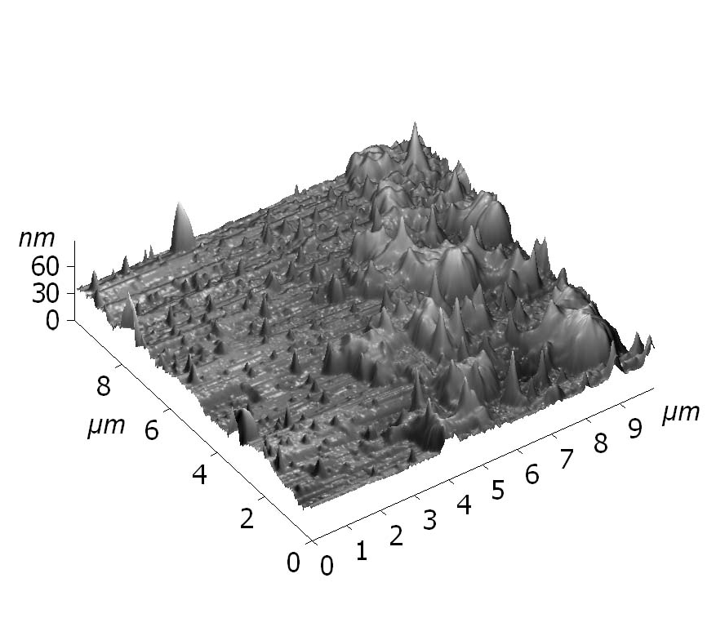 | 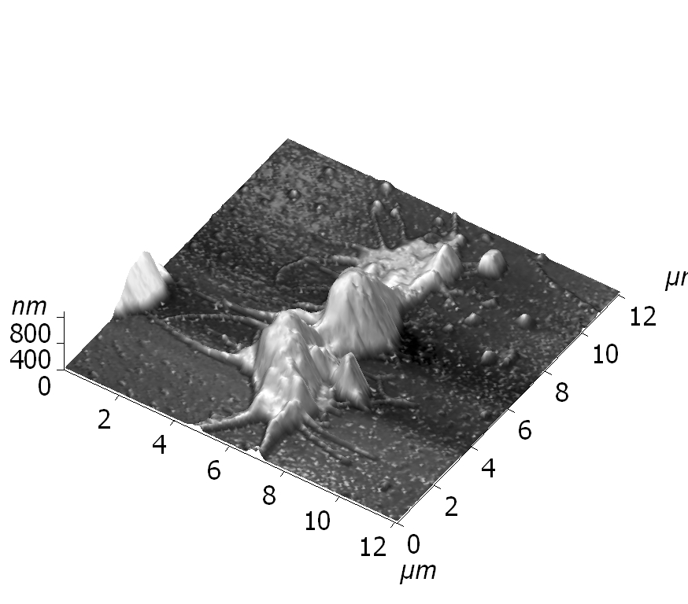 | 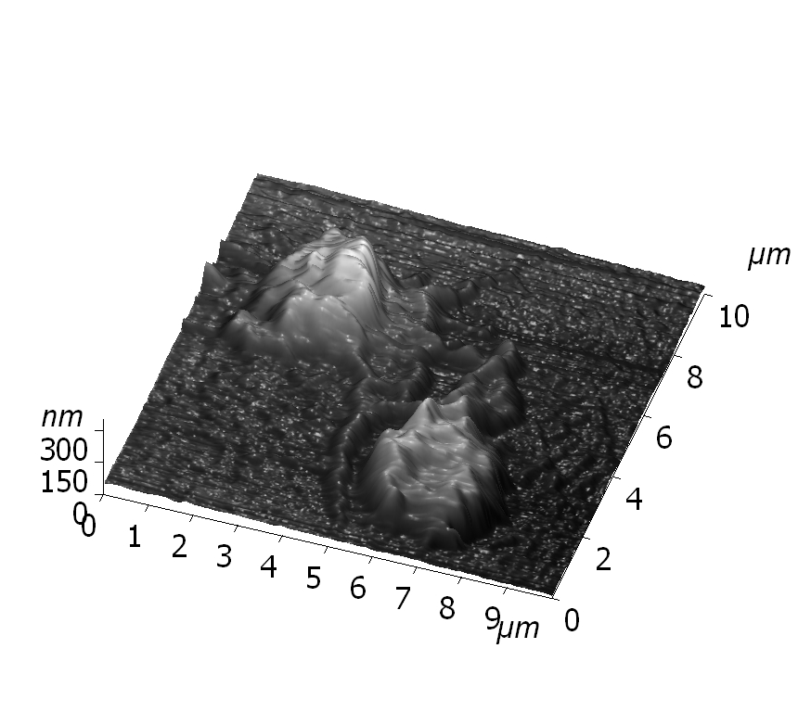
A | B | C
Fig. 2. AFM image of human platelets deposited onto mica-cluster of aggregate platelets (A), glass sheet-separate platelet (B), glass sheet in buffer solution-separate platelets (C).

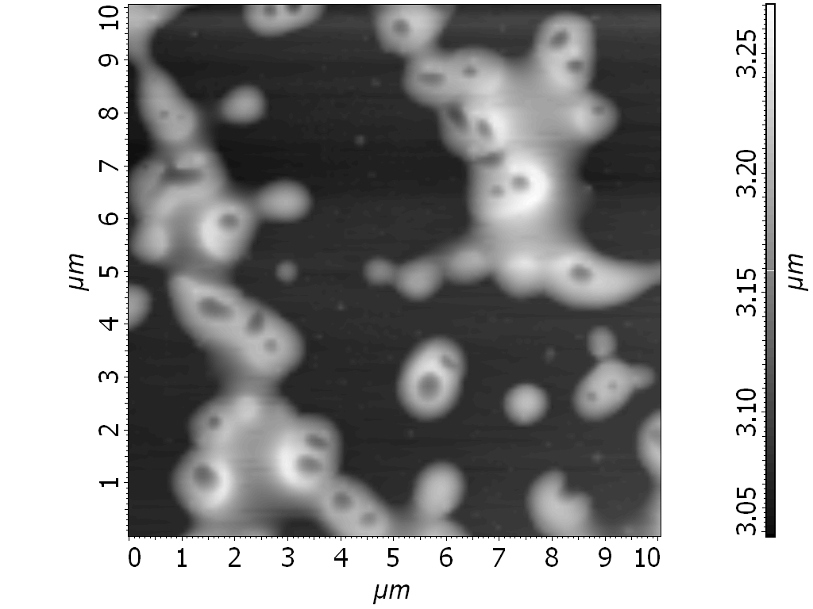 | 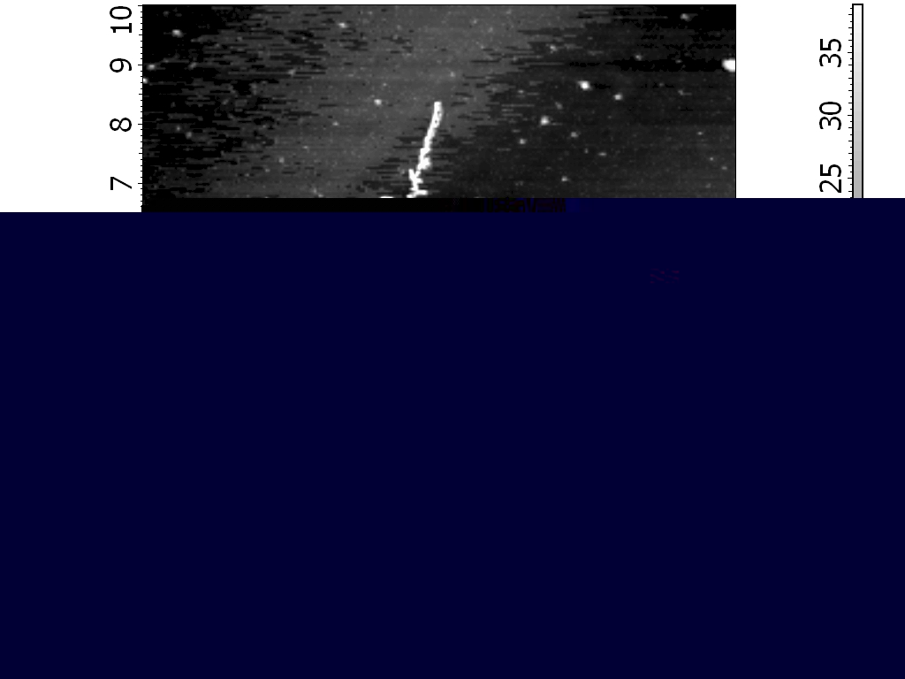
A | B
Fig. 3. AFM images of anticoagulant drugs deposited onto mica sheet: A - eptifibatide; B - abciximab.

Eptifibatide (molecular weight of < 1 kD [29] is a cyclic heptapeptide containing six amino acids with a characteristic amino acids sequence Lys-Gly-Asp (KGD). It is a specific blocker of receptor αII_{b}β₃, due to the recognition of a specific amino acid sequence (KGD) [11]. In this manner, eptifibatide blocks the fibrinogen junction to the platelet receptor. It is likely that eptifibatide forms the same steric structure as N-terminal region γ-fibrinogen chains and in this way inhibits ligand binding. On the mica sheet these drugs form “twig-crystal” structures.
These inhibitors do not influence the adhesion of platelets, as this process is caused by another plate-let receptor. This is why it is possible to observe platelet-inhibitor complex adhesion on the mica or glass sheets by AFM (see Fig. 4, picture A and B, respectively). The low number of aggregated plate-lets is observed after incubation period of a sample with both drugs. These drugs surround the platelets as a result of interaction with glycoprotein (Fig. 4).
Frequently, whole platelets are surrounded by the drug. On the surface of each platelet there are approximately 50000 GPIIb/IIIa receptors [31]. Abciximab also binds to other platelet receptors, such as the vintronectin receptor α_{V}β₃. The platelet shapes are deformed, especially those adsorbed on glass. This effect may be caused both by the inter-action with the drug, as well as by interaction with the glass surface. Abciximab and eptifibatide block the active centre in glycoprotein GPIIb/IIIa. There-fore, the interaction of the platelet with fibrinogen is impossible.
E. Gorodkiewicz et al.: Atomic force microscopy for the characterization of human platelets
The described experiments show that the fastest method for sample preparation prior to AFM measurements is the immobilization of platelets by just putting a blood drop on the glass. In spite of visible biological pollution, the best images were observed for samples immobilized on mica. On the other hand, the observation of interactions from the aqueous buffer solution, although technically difficult, enables kinetic measurements.

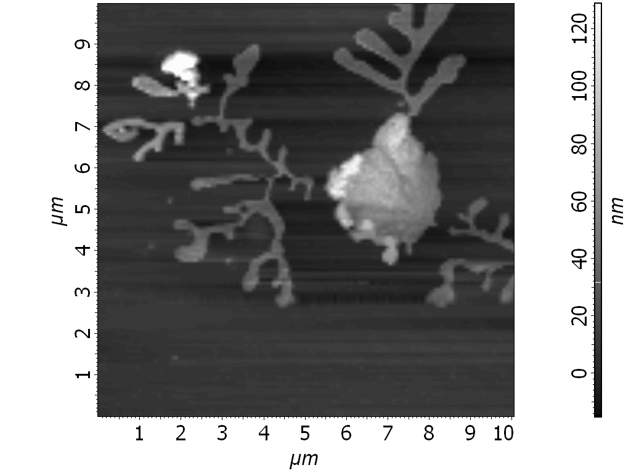 | 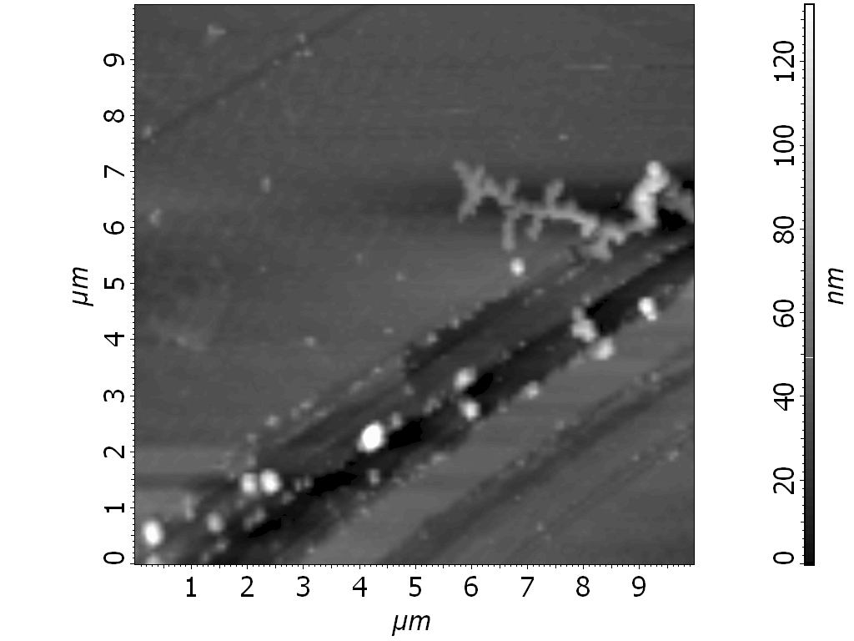
A | B
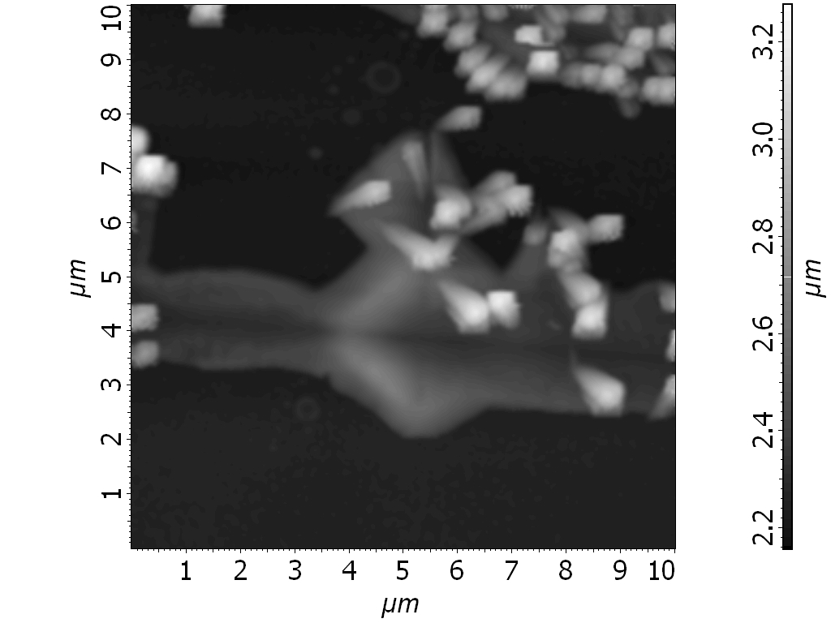 | 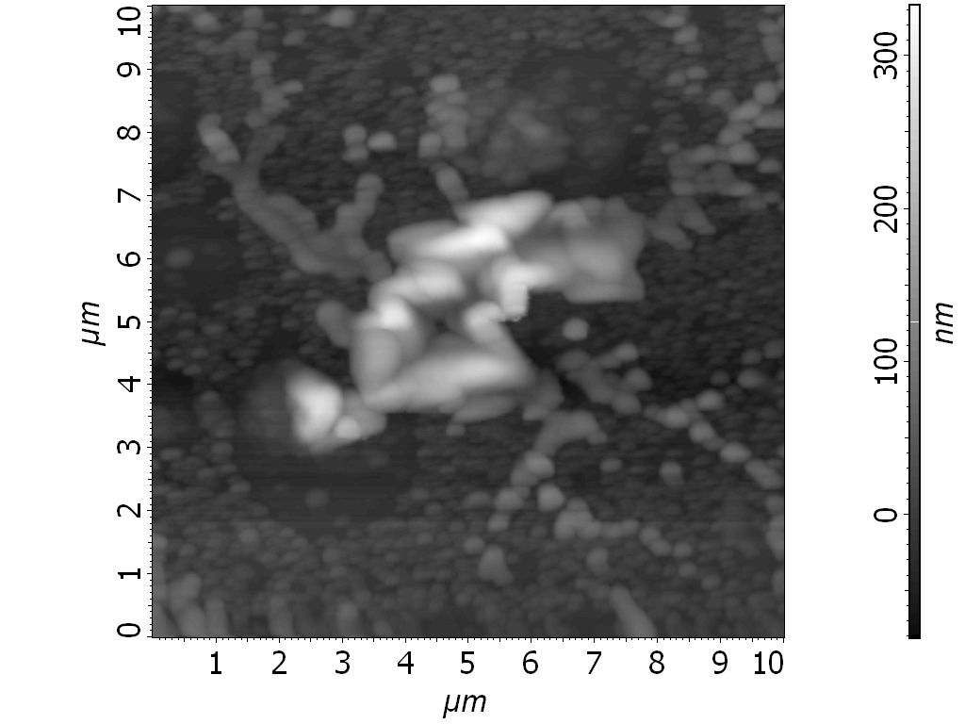
C | D
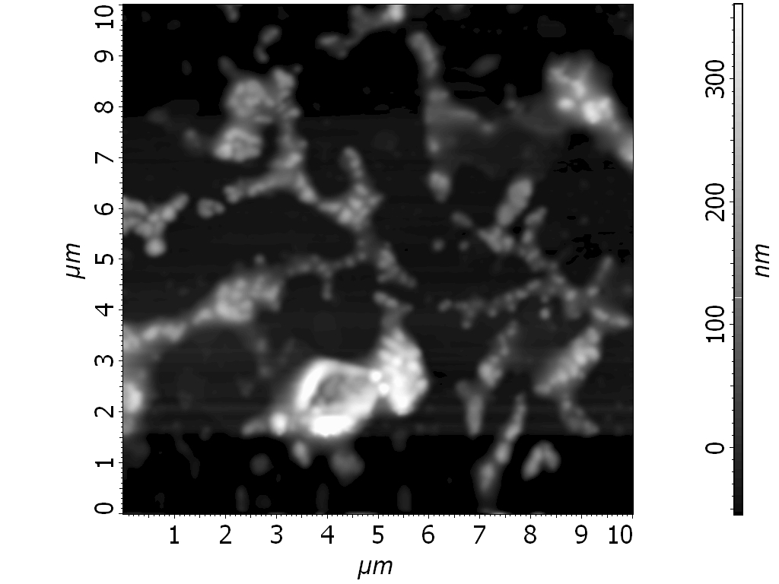 | 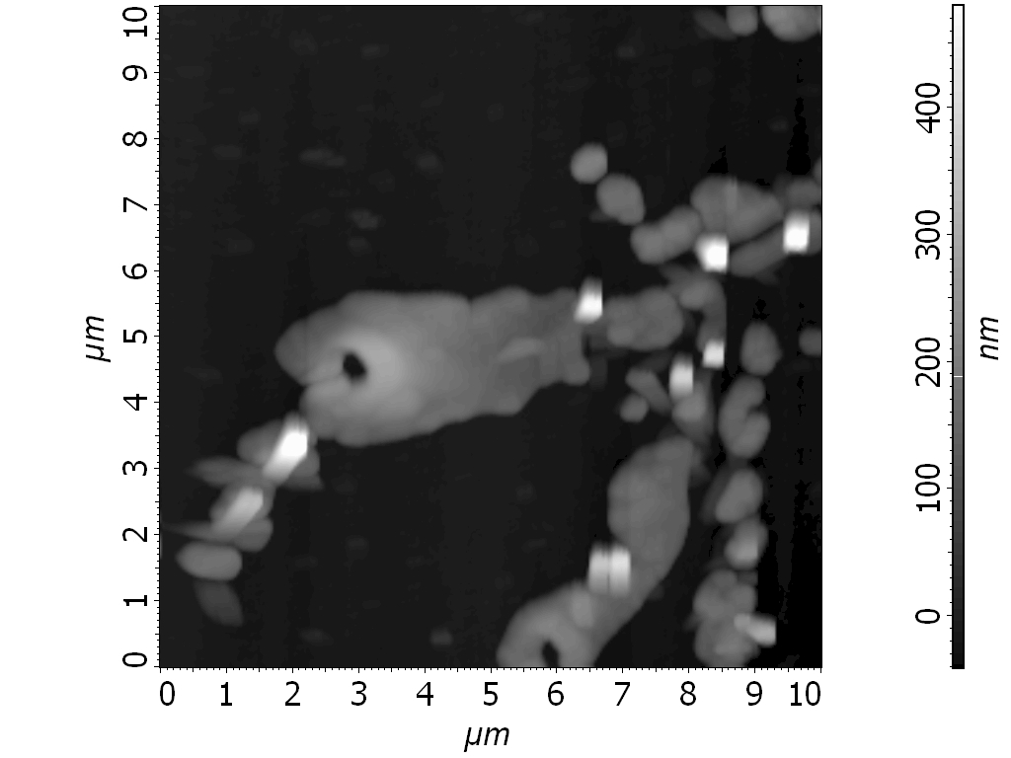
E | F
Fig. 4. AFM images of human platelets in absence anticoagulant drugs: after blood incubation with abciximab on mica and glass (A, C); after platelets incubation with abciximab on mica (B); after blood incubation with eptifibatide on mica and glass (D, F); after platelets incubation with eptifibatide on mica (E).
E. Gorodkiewicz et al.: Atomic force microscopy for the characterization of human platelets

Acknowledgements: This research was supported by the Marie Curie European Reintegration Grant (ERG) “Study of the interaction of bioactive compounds by the SPR imaging system” (MERG-6-CT-2005-516800) and by the Polish Ministry of National Education (Contract 19/6.PR UE/2006/7).
The authors are indepted Prof. A. Maziewski for his interest in and support of the present work.
References
E. Gorodkiewicz et al.: Atomic force microscopy for the characterization of human platelets
- R. A. Chaer, J. A. Graham, L. Mureebe, Vasc. Endovasc. Surgery, 40, 261 (2006).
- P. Harrison, Blood Reviews, 19, 111 (2005).
- A. D. Michelson, J. Thromb. Thrombolysis, 6, 7 (2003).
- M. Fritz, M. Radmacher, H. E. Gaub, Biophys. J., 6, 1328 (1994).
- J. N. George, The Lancet, 355, 1531 (2000).
- J. S. Bennet, Annu. Rev. Med., 52, 161 (2001).
- R. Izaguirre-Avila, A. De La Pena-Diaz, F. Barina-garrementeria-Aldatz, H. Gonzalez-Pacheco, A. E. Ramirez-Gutierrez, J. L. Ruiz-Sandoval, A. Quiroz-Martinez, C. Cantu-Brito, Clin. Appl. Thromb. Hemost., 8, 169 (2002).
- E. J. Topol, T. V. Byzova, E. F. Plow, Lancet, 353, 227 (1999).
- G. Proimos, J. Thromb. Thrombolysis, 11, 99 (2001).
- N. Chronos, A. Vahanian, A. Betriu, H. Emanuelsson, S.Goldberg, D. Gluba, B. A. van Hout, Am. Heart J., 135, 67 (1998).
- R. D. Phillips, M. R. Scarborough, Am. J. Cardiol., 80, 11B (1997).
- S. Vickers, A. D. Theoharides, B. Arison, S. K. Balani, Dan Cui, C. A. Duncan, J. D. Ellis, L. M. Gorham, S. L. Polsky, T. Prueksaritanont, H. G.
Ramjit, D. E. Slaughter, K. P. Vyas, Drug Metab. Dispos., 27, 1360 (1999).
- D. Cox , Am. Heart J. 135, 160 (1998).
- E. Tanning, Dan. Med. Bull., 39, 343 (1992).
- D. H. Hickerson, A. P. Bode, Hematol. Oncol. Clin. North Am., 16, 421 (2002).
- R. A. Markosyan, E. G. Popov, A. Y. Radin. Bull. Exp. Biol. Med., 87, 73 (1979).
- N. O. Peterson, W. B. McConnaughey, E. L. Elson, Proc. Natl. Acad. Sci. U. S. A., 79, 5327 (1982).
- A. Askin, J. M. Dziedzic, Proc. Natl. Acad. Sci. U. S. A., 86, 7914 (1989).
- J. A. Hildebrand, D. Rugar, J. Microsc., 134, 245 (1984).
- D. S. Adams, J. Cell Biol., 117, 83 (1992).
- M. Radmacher, M. Fritz, C. M. Kacher, J. P. Cleveland, P. K. Hansma, Biophys. J., 70, 556 (1996).
- J. H. Hartwing, J. Cell. Biol., 118, 1421 (1992).
- J. G. White, Semin. Thromb. Hemos., 24, 163 (1998).
- R. Loncar, U. Kalina, V. Stoldt, V. Thomas, R. E. Scharf, A. Vodovnik, Thromb. J., 4, 1 (2006).
- J. P. Collet, G. Montalescot, C. Lesty, J. Soria, Z. Mishal, D. Thomas, C. Soria, Arterioscler. Thromb. Vasc. Biol., 2, 142 (2000).
- R. I. Litvinov, H. Shuman, J. S. Bennet, J. W. Weisel, Proc. Natl. Acad. Sci. U. S. A, 99, 7426 (2002).
- J. Kawaski, N. Katori, M. Kodaka, H. Miyao, K. A. Tanaka, Anesth. Analg., 99, 1440 (2004).
- C. L. Yap, S. C. Hughan, S. L. Cranmer, W. S. Nesbitt, M. M. Rooney, S. Gouliano, S. Kulkarni, S. M. Dopheide, Y. Yuan, H. H. Salem, S. P. Jackson, J. Biol. Chem., 275, 41377 (2000).
- C. M. Dyke, Am. Heart J., 138, 307 (1999).
- K. Kawecka-Jaszcz, A. Olszanecka, M. Loster, Choroby Serca i Naczyń, 3, 91 (2006).
- M. A. Hussain, C. A. Siedlecki, Micron, 35, 565 (2004).

Атомно силова микроскопия за охарактеризиране на човешки тромбоцити преди и след взаимодействие с определени антикоагулиращи лекарства
Е. Городкиевич¹*, А. Санкиевич¹, И. Свекло², З. А. Фигашевски^{1,3}
¹ Департамент по електрохимия, Институт по химия, Университет на Бялисток,
ал. „Й. Пилсудски“ 11/4, Бялисток 15-443, Полша
² Институт по експериментална физика, Университет на Бялисток, Липова 41, Бялисток 15-333, Полша
³ Лаборатория по електрохимични източници на ток, Химически факултет, Варшавски университет,
ул. „Пастьор“ № 1, Варшава 02-093, Полша
Постъпила на 16 януари 2008 г.; Преработена на 19 май 2008 г.
(Резюме)
Тромбоцитите са най-малките безядрени кръвни клетки, които са силно реактивоспособни компоненти на системата на кръвообращението и взимат участие в много патофизиологични процеси като тромбоза, хемо-стаза, възпаление, защита, биология на туморите, в поддържането и регулирането на тонуса на кръвоносната система. Процесът на агрегиране на тромбоцитите и образуването на тромбоцитни запушалки са основна част от процеса на съсирване на кръвта и предовратяват течението от капилярите, малките артериоли и венулите. Нарушения в съсирването на кръвта обаче, са една от причините за усложнения при хирургичните процедури. Абсиксимаб и Ептифибатид са ефикасни антитромбоцитни лекарства, използвани по време или след процедури върху коронарни артерии, като ангиопластия, с цел да се предоврати събирането на тромбоцити и образуването на тромби в коронарната артерия.
Целта на настоящата работа е сравнение на различни методи за подготовка и имобилизиране на кръвни тромбоцити върху стъкло или слюда с оглед изследване на взаимодействието на тромбоцитите с Абсиксимаб и Ептифибатид чрез атомно силова микроскопия (АСМ). АСМ е много полезен инструмент за наблюдение на топографията на биологични структури. Изследването е проведено върху суха слюда, сухо стъкло и в разтвор на буфер.
Върху слюда могат да се наблюдават промени във формата и размера на неактивните и активираните тромбоцити, както и тяхното агрегиране с фибриноген. Абсиксимаб и Ептифибатид, поставени върху слюда, образуват структури “клонест кристал”. Изненадващо, по-малките молекули Ептифибатид образува по-големи структури околкото Абсиксимаб. Това, вероятно, се дължи на молекулно агрегиране на Ептифибатид.
Наблюдавана е адхезия на комплекса тромбоцит-инхибитор върху слюда или стъкло. Наблюдаван е малък брой от активирани тромбоцити след инкубация на пробата и с двата медикамента. Тези медикаменти заобикалят тромбоцитите като резултат от взаимодействие с гликопротеин GP IIb/IIIa. Често целите тромбоцити са заобиколени с медикамента. Отделните снимки показват процеса на агрегиране в различна фаза с характеристична филоподия на тромбоцита. Всяка процедура може да се използва за наблюдение на тромбоцитите и техните изменения под влияние на различни агенти, напр. лекарства.

