In Memoriam
Evgeni B. Budevski
(1922–2008)
© 2009 Bulgarian Academy of Sciences, Union of Chemists in Bulgaria

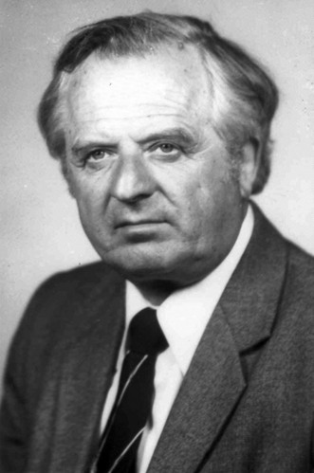 | On October 13, 2008 Academician Evgeni Budevski, the founder and pioneer of the Bulgarian Electrochemical School, passed away following a sudden illness.  Acad. Budevski started his research work in the field of electro-crystallization in 1949 immediately after graduation in Chemistry at the University of Sofia “St. Kliment Ohridski”. He was well known with the development of the original capillary method for preparation of dislocation-free faces of Ag single crystals. With his co-workers, he succeeded to confirm the 2D theory of crystal growth, introduced by Stranski and Kaischew in the 1930s and supplemented Frank’s theory with quantitatively validated theoretical calculations related to the growth of polygonized spirals.  As the first director of the Central Laboratory of Electrochemical Power Sources (CLEPS), today Institute of Electrochemistry and Energy Systems, Prof. Budevski was deeply involved in the research and development of electrochemical power sources. CLEPS electrical car on primary Zn-air batteries made its first 220-km run 6 months before that of General Motors.

In the last part of his carrier, which stopped with his death, Evgeni Budevski was one of the strong supporters (dedicated) of Hydrogen economy and renewable energy and actively worked on PEM.

Prof. Budevski left more than 150 publications and 40 patents with large impact in the scientific world. He was member of the editorial boards of Electrochimica Acta, J. Applied Electrochemistry and J. Power Sources.

During his distinguished carrier, Evgeni Budevski received national and international awards: Dimitrov State Prize (the most prestigious Bulgarian award at that time), the prize of the Electrodeposition Division of the American Electrochemical Society, Marin Drinov Medal on ribbon of the Bulgarian Academy of Sciences. He was Vice-President of the International Society for Electrochemistry (1974–1978), Foreign Member of the Saxonian Academy of Sciences (1974), member of the IUPAC Committee of Electrochemistry (1980–1987), Member of the Advisory Committee of UNESCO-EPS on Energy Saving and Storage, Member of the Advisory Committee of the President of Republic Bulgaria (1997–2001).

Evgeni Budevski will be remembered with the freshness and originality of his scientific and personal philosophy, which did not leave him till his last breath. He loved nature and camping life. A keen skier and yachtsman, he inspired the passion for his hobbies in his co-workers. He loved to spend every weekend together with his wife Lily in their mountain house and to meet there his numerous friends, which he continued to do till his last days.

