Synthesis of two peptide mimetics as markers for chemical changes of wool’s keratin during skin unhairing process and comparison of the wool quality obtained by ecological methods for skins unhairing
Bulgarian Chemical Communications, Volume 41, Number 2 (pp. 160–164) 2009
M. Koleva¹, D. Danalev²*, D. Ivanova¹, L. Vezenkov², N. Vassilev³
* To whom all correspondence should be sent:
E-mail: dancho_danalev@yahoo.com
© 2009 Bulgarian Academy of Sciences, Union of Chemists in Bulgaria
¹ Department of Textile and Leather, University of Chemical Technology and Metallurgy,
8 Kliment Ohridski Blvd., 1756 Sofia, Bulgaria
² Department of Organic Chemistry, University of Chemical Technology and Metallurgy,
8 Kliment Ohridski Blvd., 1756 Sofia, Bulgaria
³ Institute of Organic Chemistry with Centre of Phytochemistry, Bulgarian Academy of Sciences,
Acad. G. Bonchev St., Block 9, 1113 Sofia, Bulgaria
Received July 4, 2008; Revised September 18, 2008
During the last few years, a base attention is directed to improve the existing methods for unhairing of hides and skins. The major developments have been the rapid hair-saving with alkaline pretreatment and enzymatic. The sheep skins unhairing process with preliminary alkaline treatment of the wool leads to the obtaining of two unnatural dipeptide mimetics lysinoalanine (Lys*-Ala) and ornithinoalanine (Orn*-Ala). They are a result of the keratin hydrolysis process. The changes in wool keratin make it resistant to sulphide degradation. We synthesized and characterized these unnatural dipeptides under experimental conditions. The structures and mechanism of Lys*-Ala and Orn*-Ala obtaining were elucidated. The application of the newly synthesized products as markers for control of wool’s keratin changes during skin unhairing process was demonstrated.
A comparison between the data on the three samples of wool and some recommendations for the ways this secondary solid waste can be considered as a raw material due to its physical and chemical properties were done.
Keywords: Peptides mimetics, unnatural amino acids, hides’ and skins’ unhairing.

INTRODUCTION
During the application of the classical methods (alkaline conditions) for wool’s keratin unhairing two problems are raised:
- lost hair as additional material due to keratin hydrolysis;
- increasing of pollution problems related to waste water.
The highest polluted beam house liquid effluents in leather production are from unhairing and liming methods - high organic load, suspended solids, Ca(OH)₂ and Na₂S content, fats, hair wastes. There are two main directions for reducing the concen-trations of these chemicals and wastes: unhairing with alkaline pretreatment of the hair keratin and its removal and /or recycling of waste waters.
Unhairing methods used in this work are hair-saving. The surface of the received wool was damaged, but the hair maintains the fiber structure. The waste waters have lower concentrations of total nitrogen, suspended solids, Ca(OH)₂ and Na₂S content, fats, hair wastes. The results show lower pollution to the environment. Depending on the quality of the wool, after the mechanical removal, it can find different industrial applications. The main is in agriculture as a source of compost and production of animal food [1]. Improvement of quality may enlarge its putting into practice, for example in textile and building industries.
Every new technological approach aiming the solvation of the mentioned problems needs of markers for monitoring the keratin hydrolysis process. The products of keratin hydrolysis process under alkaline conditions had been studied [2, 3]. In 1976 Feairheller et al. [2] and Money later [3] suggested the compounds, which are obtained as a result of unhairing by lime-sulphide method. They both reported that the treatment of leather by this method, except natural amino acid, leads to many products, which are modified amino acids and peptides like lantionin, lysinoalanine (Lys*-Ala), ornithino-alanine (Orn*-Ala), etc. (Fig. 1). Money published a possible mechanism for the obtaining of these products as a result of decomposition of cystin residues included in leather’s hair. To characterize these products Feairheller et al. synthesized them by the methods described in [2].
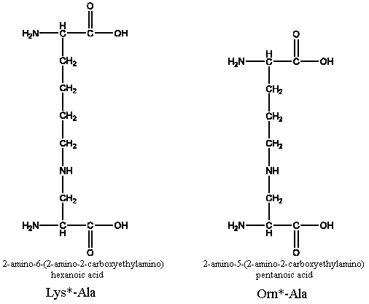
Fig. 1. Structures of published in [1] dipeptide mimetics Lys*-Ala and Orn*-Ala.
The aim of our work was the synthesis of markers to prove the above-mentioned dipeptide mimetics in wool keratin during the unhairing process by using the methods described in [2]. They are very important because their availability will allow process monitoring. On the second place, the goals are to make a comparison between the data of the three samples of wool and to give some recommendations for the ways this secondary solid waste can be considered as a raw material due to its physical and chemical properties.
EXPERIMENTAL
Procedure for preparing Lys*-Ala and Orn*-Ala
For preparation of Lys*-Ala and Orn*-Ala, methyl α-acetamidoacrylate was dissolved in 0.3 N NaOH solution with a three-fold molar excess of the appropriate protected amino acid (Zα-Lys-OH or Zα-Orn-OH) and allowed to stand at room temperature for about 6 h. The resulting solution was then evaporated to oil under vacuum. Excess 6 N HCl was then added to these residues and the resulting solution was heated at reflux for 24 h. The resulting mixture was evaporated under vacuum to dryness and until free of hydrogen chloride. The products were obtained from the residues as crystalline dihydrochlorides and were recrystralized from water-alcohol mixture [2].
M. Koleva et al.: Peptide mimetics as markers for chemical changes
The purity and synthesis of new the compounds were monitored by RP-HPLS through isocratic elution with 50% AcCN/50% K₂HPO₄:KH₂PO₄,
pH = 7, C18 column, λ = 220 nm, rate 1 ml/min, diode array detector.
The obtained products were characterized by NMR spectra recorded on a Bruker DRX-250 spectrometer, operating at 250.13 MHz for 1H, using dual 1H/13C probe head, COSY, DEPT-135 and HMQC.
Lys*-Ala: ¹H NMR (D₂O) δ (ppm): 1.41–1.64 (m, 2H, H4), 1.601 (s, 3H, CH₃), 1.67–1.82 (m, 2H, H5), 1.90–2.15 (m, 2H, H3), 3.050 (t, J = 7.5 Hz, 2H, H6), 4.183 (t, J = 6.3 Hz, 1H, H2).
¹³C NMR (D₂O) δ (ppm): 24.15 (C4), 28.06 (CH₃), 28.94 (C5), 31.85 (C3), 41.86 (C6), 55.42 (C2), 95.32 (C), 174.51 (C = O), 177.52 (C = O).
Orn*-Ala: ¹H NMR (D₂O) δ (ppm): 1.580 (s, 3H, CH₃), 1.67–1.82 (m, 2H, H4), 1.90–2.12 (m, 2H, H3), 3.072 (t, J = 7.5 Hz, 2H, H5), 4.100 (t, J = 6.3 Hz, 1H, H2).
¹³C NMR (D₂O) δ (ppm): 24.43 (C4), 25.17 (C3), 28.06 (CH₃), 41.71 (C5), 55.46 (C2), 95.57 (C), 174.81 (C = O), 177.91 (C = O).
RESULTS AND DISCUSSION
Our investigation allows us to define more accurately the preliminary structures given in literature. It was interesting that by the method described in [2] we obtained two different major products (Fig. 2).

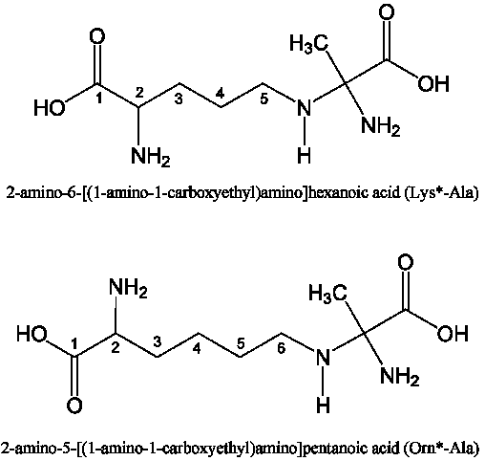
Fig. 2. Structures of dipeptide mimetics Lys*-Ala and Orn*-Ala obtained in the present study.
According to NMR data of the obtained products, the attack of the nucleofil N atom onto the quaternary C atom of methyl α-acetamidoacrylate was proven (Fig. 3).

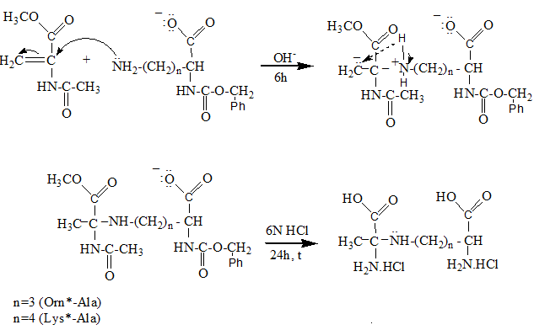
Fig. 3. Scheme of the reaction of Lys*-Ala and Orn*-Ala obtaining.

The immunization of keratin is the transfor-mation by an alkaline pretreatment (or at alkaline conditions) of part of the existing –S–S– cross-links into more stable ones. Keratin has a high stability as a consequence of the disulphide bridges of cysteine amino acid between adjacent protein chains. The possible mechanism of the immunization reaction can be associated with the alkaline transformation of disulphide bonds of cystine into other, much more stable cross-links like amino acids lantionine, lysinoalanine and ornithinoalanine.
It is possible a direct transformation of cystine cross-links into two moles of α-amino acrylic residues and H₂S generation. Possibly, they react for example with lysine and ornithine, and lysinealanine and ornithinealanine, too.
M. Koleva et al.: Peptide mimetics as markers for chemical changes
Epidermal keratinized zones, root sheaths, and follicles chemically have low cystine content and do not contain cystine cross-links in comparison with the high amount of cystine in the hard keratin. The immunization of the mature keratin is easier than that of unmature in internal root sheath and external root sheath, as well as these in the epidermis. On the basis of all observations, the differences between the solubility of the hair and roots are increasing, as well as the saving of the wool during the unhairing process. The amino acid analysis of the wool, received by both the enzyme unhairing method and unhairing method with alkaline pretreatment of the wool, shows the availability of the obtained by us dipeptide mimetics. The wool, which was immu-nizated with alkaline pretreatment, has 261.46 nmol of both Lys*-Ala and Orn*-Ala. In the wool, obtained by the enzyme unhairing method, their amount is 79.46 nmol. The wool, received by the enzyme unhairing method, is with intact fibres, not met together, clean, undestructive, with good quality. Our results show that in these concen-trations the peptide mimetics do not affect negatively the wool features and can be used for industrial purposes in different ways as a raw material.
Secondary electron micrographs (SEI) were produced using a JSM-6390 JEOL (Jeol Scanning Microscopy). Figure 4 shows the cuticle scales on a native wool fibre. There is no degradation of the scales, which can be getting in a drum unhairing process.

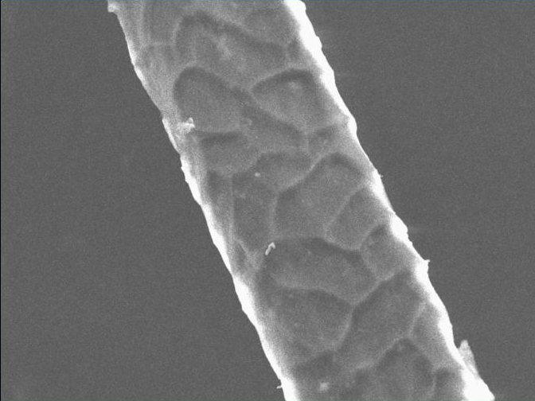
Fig. 4. The cuticle scales on a native wool fibre.
Figure 5 shows a wool fibre, obtained by the unhairing method with alkaline pretreatment of the wool. Some Ca(OH)₂ can be seen upon the opened cuticle scales. It can be caused by the poor washing of the received wool. The prior immunization does not transform the existing –S–S– cross- links into amino acid lantionine in the keratin, but in modified unnatural amino acids lysinoalanine (Lys*-Ala) and ornithinoalanine (Orn*-Ala) [4]. Occasionally, this reaction does not cause the problems of remediation. The immunization reaction made the hair resistant to –S–S– bond reduction. The alkaline solubility data showed [5] a weak damage – 10–15%. This can be explained with the hydrolysis of part of the sulphur cross-links, as well as the bonds of the peptide chains.
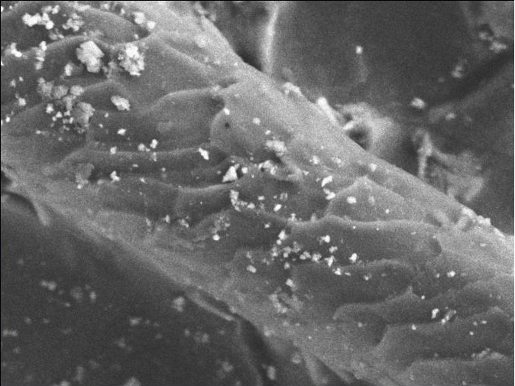
Fig. 5. Wool received after alkaline pretreatment.
The immunization reaction of wool fibres leads to little degrading intact cuticle. It can be caused by alkaline pretreatment. The wool is weakly damaged – with worsen alkaline solubility and mostly carbamid-disulfite solubility [5]. Quality by hand is for mat, weakly destructive material. The received hair is applicable in different productions, as it is whole, intact.
M. Koleva et al.: Peptide mimetics as markers for chemical changes
The wool received by the enzyme unhairing method is with little opened cuticle scales, but is still observed (Fig. 6). Probably, this is due to the alkaline pH of soaking and unhairing. This type of soak causes some immunization. The data of the amino acid analysis of wool show the availability of the obtained by us dipeptide mimetics [4]. Alkaline, acid and carbmide-disulphite solubility of the wool showed untouched peptide bonds and not damaged
hair. The wool obtained by the enzyme unhairing method is with intact fibers, not met together, clean, undestructive, with good quality. It can be used for industrial purposes in different ways as a raw material.
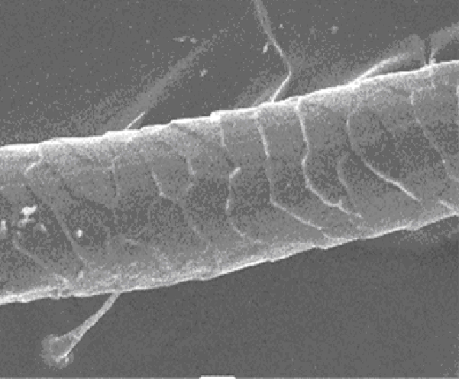
Fig. 6. Wool received from the enzyme unhairing method.
CONCLUSION
The synthesized by us markers could be used for keratin hydrolysis monitoring. For this aim some additional relationships between Lys*-Ala and Orn*-Ala concentrations and possibilities for later skins applications which will be used in practice have to be made.
Unhairing methods used in the work are hair-saving. The surface of the received wool was damaged, but the hair maintains the fibre structure. The results show lower pollution to the environment and possibilities of utilizing the received by-product (the wool of the unhairing methods) in other productions.
References
- C. S. Cantera, J. Burjan, World Leather, 10, 51, (1997).
- S. H. Feairheller, M. M. Taylor, D. G. Bailey, W. W. Windus, J. Am. Lether Chem. Ass., 71, 360 (1976).
- C. A. Money, JSLTC, 80, 175 (1996).
- D. Danalev, M. Koleva, D. Ivanova, L. Vezenkov, N. Vassilev, Protein Pept. Lett., 15, 341 (2008)
- M. Koleva, D. Ivanova, N. Pepeldjiska, L. Vezenkov, D. Danalev, JUCTM, 38, 385 (2003).

СИНТЕЗ НА ДВА ПЕПТИДНИ МИМЕТИКА КАТО МАРКЕРИ ЗА ХИМИЧНИТЕ ПРОМЕНИ НА КЕРАТИНА НА ВЪЛНАТА ПО ВРЕМЕ НА ПРОЦЕСА НА ОБЕЗКОСМЯВАНЕ И СРАВНЯВАНЕ НА КАЧЕСТВОТО НА ПОЛУЧЕНАТА ВЪЛНА ПО ДВА ЕКОЛОГИЧНИ МЕТОДА НА ОБЕЗКОСМЯВАНЕ
М. Колева¹, Д. Даналев²*, Д. Иванова¹, Л. Везенков², Н. Василев³
¹ Катедра „Текстил и Кожи“, Химикотехнологичен и металургичен университет,
бул. ,,Климент Охридски“ № 8, 1756 София
² Катедра Органична химия, Химикотехнологичен и металургичен университет,
бул. ,,Климент Охридски“ № 8, 1756 София
³ Институт по органична химия с център по фитохимия, Българска академия на науките,
ул. „Акад. Г. Бончев“, бл. 9, 1113 София
Постъпила на 4 юли 2008 г.; Преработена на 18 септември 2008 г.
(Резюме)
През последните няколко години основно внимание се обръща на подобряване на съществуващите методи за обезкосмяване на кожи. Основните разработки са насочени към намиране на бързи и ефективни методи за обезкосмяване със запазване на свойствата на получените кожи чрез предварителна алкална обработка и чрез ензимни методи. Процесът на обезкосмяване на овчи кожи с предварителна алкална обработка на вълната води до получаването на два неприродни пептидни миметици лизиноаланин (Lys*-Ala) и орнитиноаланин (Orn*-Ala). Те се получават като резултат от процеса на хидролиза на кератина. Промените в кератина на вълната го правят резистентен към сулфидно разграждане. Ние синтезирахме и охарактеризирахме тези два пептидни миметика. Показана е възможността за използването им като маркери за контрол на промените в кератина на вълната по време на процеса на обезкосмяване. Сравнението, направено между данните на трите проби добита вълна и препоръките за нейното използване показва, че този отпадък може да се счита за суровина (суров материал) съобразно неговите химични и физични показатели.

