Synthesis of model peptide substrates and investigation of the reaction
of their phenylacetyl protecting group enzyme transformation
by means of penicillin G acylase
Bulgarian Chemical Communications, Volume 41, Number 2 (pp. 122–126) 2009
D. L. Danalev¹*, L. K. Yotova²
* To whom all correspondence should be sent:
E-mail: dancho_danalev@yahoo.com
© 2009 Bulgarian Academy of Sciences, Union of Chemists in Bulgaria
H© 2009 Bulgarian Academy of Sciences, Union of Chemists in Bulgaria
¹ Department of Organic Chemistry, University of Chemical Technology and Metallurgy,
8 Kliment Ohridski Blvd., 1756 Sofia, Bulgaria
² Department of Biotechnology, University of Chemical Technology and Metallurgy,
8 Kliment Ohridski Blvd., 1756 Sofia, Bulgaria
Received July 4, 2008; Revised September 18, 2008
The development of new protective groups by means of stereospecific and selective reactions is very important for the practice especially in the synthesis of semi-synthetic antibiotics and biologically active peptides. The aim of the present investigation is to study the kinetics of enzyme hydrolysis of the Phenylacetyl (Phac) group in synthetic peptide substrates. Two model compounds with two and three Phac, respectively, were studied. The enzymatic hydrolysis by means of penicillin G acylase in pH range 6–9 was studied. The substrate concentration was between 0.4–40 mM. Maximum degree of substrate conversion 75.5% (pH 9), which is closed to the degree of conversion to pH 7.8 (74.5%), was obtained for 3 to 10 min. At pH 6.5 and 7 the degree of hydrolysis was 62.5 and 37.5%, respectively. The possibilities for the reaction of hydrolysis in the presence of salts of different complex agents CuSO₄.5H₂O, NiCl₂, Ni(NO₃)₂ and MnCl₂ were investigated, too. There was 100% degree of Phac group hydrolysis in the presence of 10% Ni(NO₃)₂ for 9 min and full shift of equilibrium to the direction of hydrolysis was monitored in the presence of 25% Ni(NO₃)₂.
Key words: enzyme kinetic; penicillin G acylase; peptide mimetics; phenylacetyl protecting group.

INTRODUCTION
Peptides and α-amino acids are widely used in the medical practice. The development of new protective groups by means of stereo specific and selective reactions is very important for the practice especially in the synthesis of semi-synthetic anti-biotics and biologically active peptides. Penicillin G acylase (PGA) is an enzyme that demonstrated high specificity on the phenyl acetyl residue. The enzyme’s hydrolase activity is of a great importance for the new substrates modifications [1–5].
The aim of the present investigation is to study the kinetics of enzyme hydrolysis of the amide function between Phenylacetyl (Phac) group and amino acid residue.
EXPERIMENTAL
Materials and Methods
PGA [E.C 3.5.1.11] from E. Coli was supplied by Fluka (Switzerland). The enzyme activity of 980 E/ml was determined according to [6]. In the reaction solution, the product was diluted to 98 E/ml. The solution with concentration 0.15 mg/ml was used. KOH, KCl, NaOH, HCl; NH₄OH, KH₂PO4; K₂HPO₄ and CH₃CN - gradient grade for HPLC were received from MERCK (Darmstadt, Germany); NiCl₂; Ni(NO₃)₂; CuSO₄.5H₂O; MnCl₂ were purchased from Reanal (Budapest , Hungary)
The IR spectra were recorded on a Perkin-Elmer Model 1600 Series FTIR instrument. The purity of the products and kinetics of the hydrolysis reactions of phenylacetyl group were checked by RP-HPLC on a Perkin-Elmer apparatus, C₁₈ column 4.6×250 mm ODS-A, S-5 micron 120 A. 50% 0.02 M KH₂PO₄:K₂HPO₄ pH = 7: 50% CH₃CN were used as eluents, rate 0.8 ml/min, λ = 220 nm and diode array detector.
The needed substrates Boc-Lys(Phac)-Val-OMe and Boc-Lys(Phac)-Lys(Phac)-Lys(Phac)-OH were obtained by conventional peptide synthesis in solution.
Boc-Lys(Phac)-Lys(Phac)-Lys(Phac)-OH was synthesized by drop-wise addition of Boc-Lys(Phac)-OH to C-terminal H-Lys(Phac)-OH by using of MA (mixed anhydrides) method:
1.00 mmol of Boc (or Z) amino acid (or peptide obtained from Boc-peptide by treatment with 10-fold excess of TFA) was dissolved in THF (10 ml) and after cooling to –10 ÷ –15°C and good stirring 1.00 mmol Et₃N and 0.98 mmol isobutyl chloro-formate were added. After 15 min 1.00 mmol of amino component without protecting groups dissolved in 1.1 mmol 2 N NaOH was added dropwise. The reaction mixture was stirred for 1 h at –10 ÷ –15°C and 24 h at room temperature. After that it was concentrated in vacuo and 2 N HCl was added to pH 2–3. The product was extracted with EtOAc (3×10 ml) and the organic layer was washed with 10% citric acid (3×10 ml) and H₂O to pH 7. The solvent was dried with Na₂SO₄ and removed in vacuo. The obtained products Boc-Lys(Phac)-Lys(Phac)-OH and Boc-Lys(Phac)-Lys(Phac)-Lys(Phac)-OH were oils.
Boc-Lys(Phac)-Val-OMe was obtained by the DCC/1-HOBt method:
1.00 mmol of HCl.H-Val-OMe was dissolved in DMF (10 ml) and after cooling to –5°C, neutralized to pH 7–7.5 with Et₃N. 1.2 mmoles of Boc-Lys(Phac)-OH; 1.20 mmol of DCC and 1.4 mmol of 1-HOBt were added. The reaction mixture was stirred for 24 h at room temperature. The obtained DC-urea was removed by filtration and then 30 ml of water were added. The product was extracted with EtOAc (3×10 ml) and the organic layer was washed with 5% NaHCO₃ (3×10 ml), H₂O (3×10 ml), 10% citric acid (3×10 ml) and H₂O to pH 7. The solvent was dried with Na₂SO₄ and removed in vacuo followed by recristalization in EtOAc/petro-leum ether.
The obtained product has the following IR spectral characteristics: [cm^{–1}] 3328 ν_{N-H}; 3067 ν_{C-H} (aromatic system); 2930 ν_{C-H} (CH₃); 2853 ν_{C-H} (CH₂); 1740 ν_{C=O} (ester); 1700 ν_{C=O} (uretan); 1680 ν_{C=O} (amide I); 1661 ν_{C=O} (amide II); 1574 δ_{N-H} (amide I); 1545 δ_{N-H} (amide II); 1390 and 1367 δ_{C-H} (isopropyl and tert-butyl groups); 1247 ν_{C-O-C} (uretan); 743 δ_{C=C} and 696 δ_{C=C} (monosubstituted aromatic system).
General procedure for the reaction of hydrolysis of Phac by means of PGA
20 ml of substrate with the needed concentration in 10% DMF/0.1 M KCl were alkalized till pH 9 with 4 M K₂HPO₄. The solution of PGA with needed concentration was added. The hydrolysis of substrate was monitored on HPLC at 0, 1, 2, 3, 5, 9, 15, 30 and 60 min after acidification. During the reaction pH of the reaction mixture was hold up by titration with solution with pH 11–12 of complex agent’s salt with needed concentration or NH₄OH.
RESULTS AND DISCUSSION
Two model reactions of hydrolysis of Phac were
studied in the presence of substrates containing one and three Phac groups, respectively. The principal scheme of the reaction is presented in Figs. 1 and 2.
Fig. 1. Reaction of hydrolysis of Phac group in dipeptide ester Boc-Lys(Phac)-Val-OMe with PGA.
Fig. 2. Reaction of hydrolysis of Phac group in tripeptide Boc-Lys(Phac)-Lys(Phac)-Lys(Phac)-OH with PGA.
It is well known that pH optimum of PGA according to its natural substrate benzylpenicillin sodium or potassium salt is 7.8–8.0 [7–9]. In our investigation the used substrates are two peptides which are not specific substrates for PGA, thus the reaction of hydrolysis was monitored at pH range 6 ÷ 9. Series of reactions were carried out with 0.4 mM substrate at different pH (Fig. 3).
D. L. Danalev and L. K. Yotova: Synthesis of model peptide substrates
Maximum degree of substrate conversion 75.5% (pH 9), which is closed to the degree of conversion at pH 7.8 (74.5%), was obtained for 3 and 10 min, respectively. At pH 6.5 and 7, the degree of hydro-lysis was 62.5 and 37.5%, respectively. By that reason, our next investigations on the reactions were carried out at the optimum value of pH 9 and at 37°C. Kinetic studies of the Phac group’s hydrolysis were done with different enzyme concentrations in the synthetic substrate Boc-Lys(Phac)-Lys(Phac)-Lys(Phac)-OH. The results are shown in Fig. 4. Maximum degree of substrate conversion 73.75% was obtained in the presence of 0.04 ml PGA for 8 min, which is closed to that obtained with 0.4 ml of PGA for 15 min (72.5%).
The obtained curves in the Figs. 3 and 4 clearly show that the reaction of Phac group hydrolysis is reversible. In order to attempt to shift the equi-librium of the reaction to the direction of full hydro-lysis of the protecting group in the model peptide substrates and to make this reaction non-reversible, the same reaction was carried out in the presence of metal ions, which are good complexing agents. Their addition to the system might lead to the formation of complex with released ε-amino function of Lys residues (Fig. 5). The obtained complex might precipitate the forming product and to shift the reaction to the right direction. The possibility of similar complex formation was dis-cussed previously by Schröder and Lubke [10].

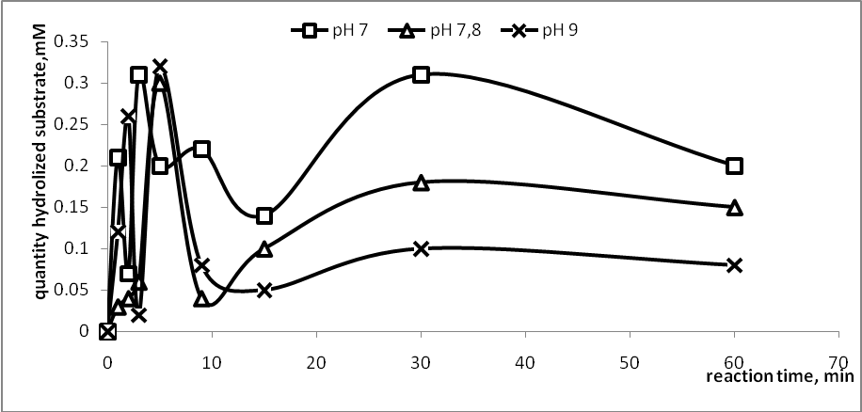
Fig. 3. Kinetics of hydrolysis of 0.4 mM synthetic substrate with 0.4 ml PGA at different pH.

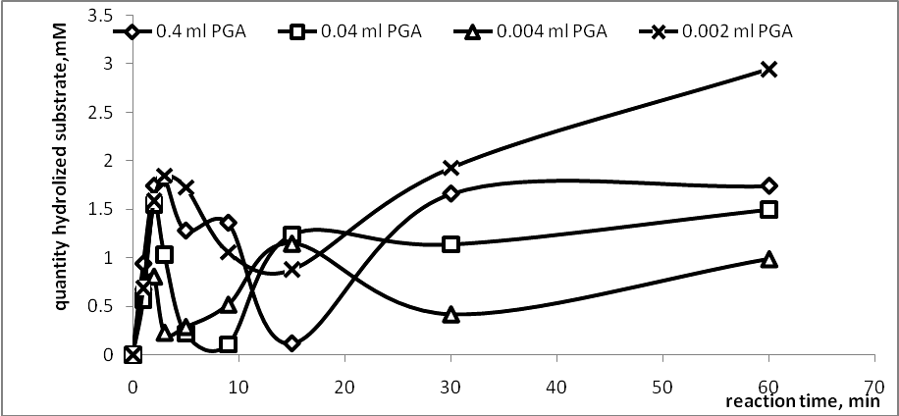
Fig. 4. Kinetics of hydrolysis of 5.0 mM synthetic substrate with different concentrations of PGA.

The kinetic results depending on the Ni(NO₃)₂ concentration, as a complex agent, are shown in Fig. 6. The figure clearly shows that the reaction equilibrium of hydrolysis of Phac group with stepwise addition of 10% Ni(NO₃)₂ was shifted to the direction of full hydrolysis of the protecting group for 9 min. In this case the substrate was 40 mM and the final concentration of Ni(NO₃)₂ – 1 M.
D. L. Danalev and L. K. Yotova: Synthesis of model peptide substrates

Fig. 5. Structure of the complex of ε-amino function of Lys residues with different metals.

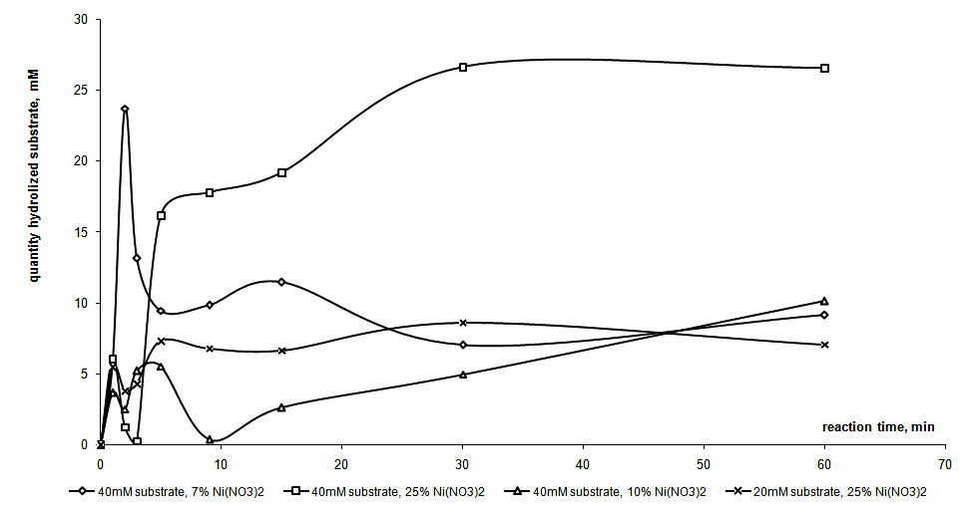
Fig. 6. Kinetics of hydrolysis of different amounts of synthetic substrate Boc-Lys(Phac)-Lys(Phac)- Lys(Phac)-OH with 0.002 ml PGA at pH = 9.0 and 37°C by stepwise addition of Ni(NO₃)₂ at different concentrations.
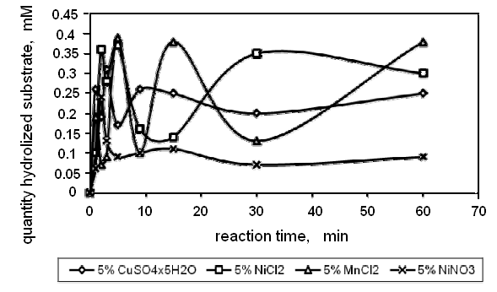
Fig. 7. Kinetics of hydrolysis of 0.4 mM synthetic substrate Boc-Lys(Phac)-Val-OH with 0.4 ml PGA in the reaction mixture at pH = 9.0 and 37°C by partial addition of different complex agents’ salts.

The possibilities for the reaction of hydrolysis in the presence of salts of different complexing agents like CuSO₄.5H₂O, NiCl₂, and MnCl₂ were investi-gated, too (Fig. 7). As it can be clearly seen from the figure, the maximum degree of conversion was achieved in the presence of Ni²⁺ in the reaction mixture. The equilibrium of the reaction is shifted to the direction of full hydrolysis of the protecting group only in the case with stepwise addition of Ni²⁺. It was revealed that the concentration of Ni²⁺ and the type of its salts are important, too. There was 100% degree of Phac group hydrolysis in the presence of 10% Ni(NO₃)₂ for 9 min and a full shift of the equilibrium to the direction of hydrolysis was monitored in the presence of 25% Ni(NO₃)₂.
D. L. Danalev and L. K. Yotova: Synthesis of model peptide substrates
CONCLUSIONS
The obtained results showed that the reaction of Phac group’s hydrolysis was reversible at defined conditions of pH, temperature range and reaction time.
Kinetic modelling studies of model peptide substrates reveal that:
- The use of metal ions as complexing agents of amino acid residues is a promising alternative for the studied enzymatic reaction.
- An acceptable approach is found to draw out the reaction of hydrolysis of phenylacetyl group with PGA in model peptide substrates to a desired direction.
- The best complex agents are Ni²⁺.
- Maximum degree of substrate conversion (100%) was obtained at pH 9 and 37°C in the presence of 10% Ni(NO₃)₂.
REFERENCES
D. L. Danalev and L. K. Yotova: Synthesis of model peptide substrates
- D. Rossi, A. Calcagni, Experientia, 35, (1985).
- R. J. Didizapetris, V. K. Svedas, Biomed. Biochem. Acta, 50, 5237 (1991).
- V. K. Svedas, A. I. Beltser, Ann. N.Y.Acad. Sci., 864, 524 (1998).
- R. Didziapetris, B. Drabnig, V. Schellenberger, H. D. Jakubke, V. Svedas, FEBS Lett., 287, 31 (1991).
- H. Waldmann, P. Braun, H. Kunz, Biomed. Biochim. Acta, 50, 243 (1991).
- L. Yotova., I. Dobrev, I. Ivanov, Practical Course in Biochemistry, Diagnosis Press, Sofia, 2001, p. 191 (in Bulgarian).
- K. Lummer, A. Rieks, B. Galunski, V. Kasche, Biochim. Biophys. Acta, 143, 327 (1999).
- M. Gololobov, U. Schellenberger, F. Schellenberger, H. D. Jakubke, V. K. Svedas, Biokhimiia, 55, 338 (1990).
- D. T. Guranda, T. S. Volovik, V. K. Svedas, Biochemistry (Moscow), 69, 1386 (2004).
- E. Schröder, K. Lubke, Methods of Peptide Synthesis I, Academic Press, New York, 1965, p. 172.

СИНТЕЗ НА МОДЕЛНИ ПЕПТИДНИ СУБСТРАТИ И ИЗСЛЕДВАНЕ НА РЕАКЦИЯТА
НА ЕНЗИМНА ТРАНСФОРМАЦИЯ НА ФЕНИЛАЦЕТИЛНА ГРУПА
С ПОМОЩТА НА ПЕНИЦИЛИН G АЦИЛАЗА
Д. Л. Даналев¹*, Л. К. Йотова²
¹ Катедра „Органична химия“, Химикотехнологичен и металургичен университет,
бул. „Климент Охридски“ № 8, 1756 София
¹ Катедра „Биотехнология“, Химикотехнологичен и Металургичен Университет,
бул. „Климент Охридски“ № 8, 1756 София
Постъпила на 4 юли 2008 г.; Преработена на 18 септември 2008 г.
(Резюме)
Откриването на нови защитни групи за органичния синтез, основани на стереоспецифични и стерео-селективни реакции, е важно за практиката, особено при синтеза на полусинтетични антибиотици и биологично активни пептиди. Целта на настоящата работа е да изследваме кинетиката на ензимна хидролиза на фенилацетилна група в синтетични пептидни субстрати. Бяха използвани два моделни пептиди, съдържащи съответно една и три фенилацетилни защитни групи. Ензимната хидролиза беше направена с помощта на Пеницилин G ацилаза в широк pH диапазон 6–9. Използваните субстратни концентрации бяха 0.4–40 mM. Максимална степен на конверсия 75.5% (pH 9), близка до тази при pH 7.8 (74.5%) беше наблюдавана за 3 до 10 минути. При pH 6.5 и 7 степента на хидролиза беше съответно 62.5 и 37.5%. Беше изследвана възможността за провеждане на реакцията в присъствие на соли на различни метални комплексообразуватели CuSO₄.5H₂O, NiCl₂, Ni(NO₃)₂ и MnCl₂. Беше постигната 100% степен на конверсия на фенилацетилната група в присъствие на 10% Ni(NO₃)₂ за 9 минути и пълно изтегляне на химичното равновесие в посока на процеса на хидролиза в присъствие на 25% Ni(NO₃)₂.

