From molecule to sexual behaviour – the role of brain neuropentapeptide proctolin in acoustic communication of the grasshopper Chorthippus biguttulus (L. 1758)
Bulgarian Chemical Communications, Volume 41, Number 2 (pp. 104–109) 2009
© 2009 Bulgarian Academy of Sciences, Union of Chemists in Bulgaria
St. R. Vezenkov¹*, H. Ralf², N. Elsner²
* To whom all correspondence should be sent:
E-mail: vezenkov_neuro@abv.bg
¹ Department of Speech Pathology, Neofit Rilski South-West University, 66 Ivan Mihailov St.,
2700 Blagoevgrad, Bulgaria
² Department of Neurobiology, Institute of Zoology, Anthropology and Developmental Biology,
28 Berliner St., 37073 Göttingen, Germany
Received July 20, 2008; Revised September 30, 2008
The acoustic communication of Chorthippus biguttulus (Ch.b.) is a suitable behavioural model system to explore the physiological effects and underlying molecular mechanisms of identified neuropeptides. Neuropentapeptide proctolin was shown to play a modulatory role in a brain neuronal circuit that controls the acoustic, respectively sexual behaviour of males Ch.b. Proctolin receptors activation triggered courtship singing, the second level of excitation in the sexual behaviour preceded by calling singing, triggered by mAChRs activation. Pharmacological studies showed that PLC pathway is involved in courtship singing since neomycine and Li⁺ showed strong inhibitory effect on the proctolin-stimulated singing. In addition, the phorbol ester, injected in proctolin sensitive sites in the brain, elicited stridulation alone. The latter showed that PKC could mediate the effects of PLC activation. The observed results suggest possible molecular mechanisms that are involved in the decision-making brain center controlling the sexual behaviour – what (by altering the context), when (by controlling the initiation) and how long (by increasing the basal excitation) should the male sing.
Key words: neuropeptide, proctolin, PKC, acoustic communication, courtship, Chorthippus biguttulus.

INTRODUCTION
Acoustic communication in orthopteran insects has become one of the favourite subjects for investigations on the neuronal basis of invertebrate behaviour. The stereotyped stridulation patterns, the relative ease of their elicitation, and the simplicity of the neuromuscular organization, which permits electrophysiological and pharmacological work in freely-moving animals, favour both an ethological and a neurophysiological approach [1]. Proctolin (RYLPT) was the first neuropeptide to be isolated and sequenced from insects [2] and was subse-quently found to have wide distribution throughout the arthropods [3]. First proctolin has been reported [4] as a “gut factor”, which caused slow graded contractions of proctodeum longitudinal muscles in the cockroach Periplaneta americana. On the other side, a G-protein coupled receptor (encoded by CG6986) for proctolin in Drosophila melanogaster has been identified and characterized [5]. Proctolin receptor immunosignals have been found in the hindgut, heart and in distinct neuronal populations of the CNS.
Previous studies have demonstrated a role for acetylcholine (ACh) and both nicotinic acetyl-choline receptors (nAChRs) and muscarinic acetyl-choline receptors (mAChRs) in the cephalic control of the singing behaviour of various grasshopper species [6, 7]. Injections of proctolin into the proto-cerebrum can elicit species-specific stridulation in both male and female grasshoppers of the species Ch.b. The stimulated behaviour is similar to the natural stridulation with respect both to the temporal structure and patterns of stridulatory movements of the hindlegs [8]. This study presents the role of intracellular signal transduction coupled to proc-tolin-stimulated singing behaviour.
EXPERIMENTAL
Animals
Adult specimen of the gomphocerine grass-hopper Chorthippus biguttulus (L. 1758) (Ch.b.) were caught in the vicinity of Göttingen, Germany, and kept in the laboratory for up to several weeks. Additional Ch. biguttulus were reared from eggs that were collected in the previous summer and kept at 4°C for > 4 months. The nymphs hatched after
~ 1 week at 26°C and were raised on wheat and supplemental food for crickets (Nekton, Pforzheim) at a 16/8 h light-dark-cycle. All pharmacological experiments were conducted with male and female adults at room temperatures of 20–25°C. Virgin females were separated as third or fourth stage nymphs kept in separation and used as adult for acoustic stimulation experiments.
Basic scheme
Small amounts (< 10 nl) of neuroactive sub-stances were pressure-injected via microcapillaries inserted dorsally into the brain. By the use of double-barrel electrodes two different substances were administered to the same location within the brain. Therefore, sequential injections of identical volumes of the same or of two different substances (excitatory, inhibitory or modulatory) could in principle influence the same set of neurons. To monitor the stridulatory behaviour, the hind leg movements and the produced sound were recorded with two opto-electronic cameras and a microphone. The animal is attached to a holder. The head is opened and the brain is exposed. The micro-capillary is attached to the mechanic micromani-pulator and is connected to the pressure-injection device through pressure resistant tubes. A three-way stopcock allows the pressed air to flow in two directions, respectively into one of the two barrels of the micro-capillary. The pump is connected to a system that continuously supplies compressed air. Two optic-electronic devices according to von Helversen [7] record the stridulatory movements of the hind legs and transform them into a voltage signal. The latter is amplified and visualized on the computer screen. The signal is stored in data format (*.dat) by the program Turbo Lab 4.2 or 4.3 for DOS.
Drugs used for injection
The neuroactive substances were usually dis-solved in grasshopper saline [9] to give concen-trations of 1 mM. Muscarine, proctolin, neomycin obtained from Sigma-Aldrich; SQ 22536 obtained from Calbiochem; phorbol-12-myristate-13-acetate (PhE, porbol ester), thapsigargin, TMB-8, ryano-dine, LiCl, purchased from Sigma-Aldrich were studied using the upper-described basic scheme. Stock solutions of proctolin (10 mM concentration in d H₂O) were preserved at –20°C. Water-soluble substances were dissolved in grasshopper saline to give concentrations of 1 to 0.1 mM. Different ions (Ba²⁺, Ni²⁺) were added to the saline to give 1 to 5 mM. Substances soluble in DMSO (thapsigargin, TMB-8, ryanodyne, obtained from Sigma-Aldrich) were dissolved in saline to give a 5% final content of DMSO. All solutions were preserved at –4°C, not longer than 1 day.
Data processing
The recorded signals were digitized on-line by means of an A/D-converter card (Real Time Devices AD3300) with the software Turbolab 4.2 (Bressner Technology, Germany) and stored as data files. The sampling rate for recording the stridulatory move-ments, the sound and the injection pulses was 5 kHz per recorded channel. The software NEUROLAB (8.2, Hedwig and Knepper) was used for visual examination and filtering of the original data. One injection of a stimulating drug usually released several song sequences separated by short pauses. The time between stimulation pulse and the begin-ning of the first stridulatory sequence was deter-mined as Latency. The sum of the durations of all individual song sequences released by one stimu-lation was calculated as the total sequence duration (S Duration) of stridulation. The duration from the beginning of the first sequence to the end of the last sequence was taken as the complete duration (C Duration) of stridulation. Latency and the durations of stridulation were normalized to the longest latency and the duration in that particular experi-ment (same volume of drug injected to the same site within the brain). The values were calculated and given in percent (%). Normalization was necessary to enable comparison between different experiments with variable efficacy of proctolin stimulations, depending on the exact site of injection and the condition of the grasshopper. Potential changes in the latency and duration of proctolin-induced stridu-lation following the injection of a test-substance were evaluated by the nonparametric Friedman test (ANOVA). “Raw” diagrams were generated with Excel 2000 and subsequently imported into graphics program CorelDraw 9 (Corel Corporation) for assembly into composite figures and labelling. Original data (hind leg movements, pressure pulse) were exported from Neurolab 8.2. and subsequently re-assembled and labelled with CorelDraw 9. All figures were stored as graphics files (*.jpg) and imported into Word 2000.
St. R. Vezenkov et al.: The role of brain neuropentapeptide proctolin in acoustic communication
RESULTS AND DISCUSSION
Proctolin alone elicits courtship singing behaviour in males Ch.b.
Injections of proctolin into the frontal part of the central complex and an adjacent neuropil anterior and dorsal to it elicited a species-specific singing behaviour in males of Ch.b (Fig. 1). Both proctolin and muscarine stimulated stridulation in a region that includes the anterior portion of the central body and the area between the central body and Proto-cerebral Bridge. However, the responses to both drugs differed in latency, duration (Fig. 2), also in internal time courses of the hind legs movements. The temporal structure of muscarine- and proctolin-stimulated stridulation were likely to respectively calling song and courtship song which correlate to two different excitation levels [8]. The proctolin-elicited singing might be the second level of excitation because the courtship singing in the natural sexual behaviour appears after the calling singing. The male produces courtship song when duets together with the responding female that shows copulatory readiness. Thus, proctolin might trigger the courtship singing of the male, respectively the higher, behavioural different, level of excitation in comparison to muscarine-stimulated calling singing.
PLC pathway and the proctolin-stimulated singing
Typically, the actions of proctolin are slow in onset and prolonged, suggesting the involvement of a second messenger activated by a metabotropic receptor or G-protein coupled receptor. An ubi-quitous cascade that is mediated through G proteins and evokes many responses is the phosphoinositide cascade or simply PLC pathway. Likewise the other cascades, it converts extracellular signals into intracellular ones. It has previously been reported that the PLC/IP₃/DAG signal transduction cascade mediates the performance of calling singing behaviour in Ch.b. following activation of mAChRs. Inhibition of PLC activity by U-73122 and neo-mycin, which act by different mechanisms, can completely suppressed muscarine-stimulated stridu-lation [10]. It was shown also that scopolamine, an inhibitor of mAChR, did not affect the proctolin-stimulated singing injected together with proctolin [8]. To investigate a possible involvement of phos-phoinositides in mediating the proctolinergic excita-tion, neomycin, a substance that reduces PLC activity by binding to the enzyme’s substrate PIP₂ was injected to site where proctolin stimulates singing. Injection of this inhibitor produced a gradual reversing reduction of proctolin-stimulated stridulation. The average duration of singing in all experiments decreased significantly (P < 0.05, n = 10) in the period of 12–16 min (Fig. 3A). In 3 other experiments, the proctolin-initiated stridulation was suppressed irreversibly and were not put into analysis. Li⁺, also known as a PLC inhibitor, was tested. In all experiments (n = 9, P < 0.05) a reversible decrease of both sequential (SD) and complete (CD) duration of proctolin-stimulated singing occurred (Fig. 3B).
St. R. Vezenkov et al.: The role of brain neuropentapeptide proctolin in acoustic communication
The robust appearance of the inhibitory effect of neomycin and Li⁺ on proctolin-stimulated singing behaviour suggested a main role for the PLC pathway mediating proctolinergic excitation in the brain of Ch.b.
PKA might mediate the proctolin-stimulated singing
Diacylglycerol (DAG) is a second messenger generated through PLC signaling and activates the proteinkinase C which phosphorilates proteins, ion channels, receptors, etc. and alters the neuronal activity. In various insect preparations, DAG has been shown to contribute to proctolin receptor-triggered excitation [11, 12].

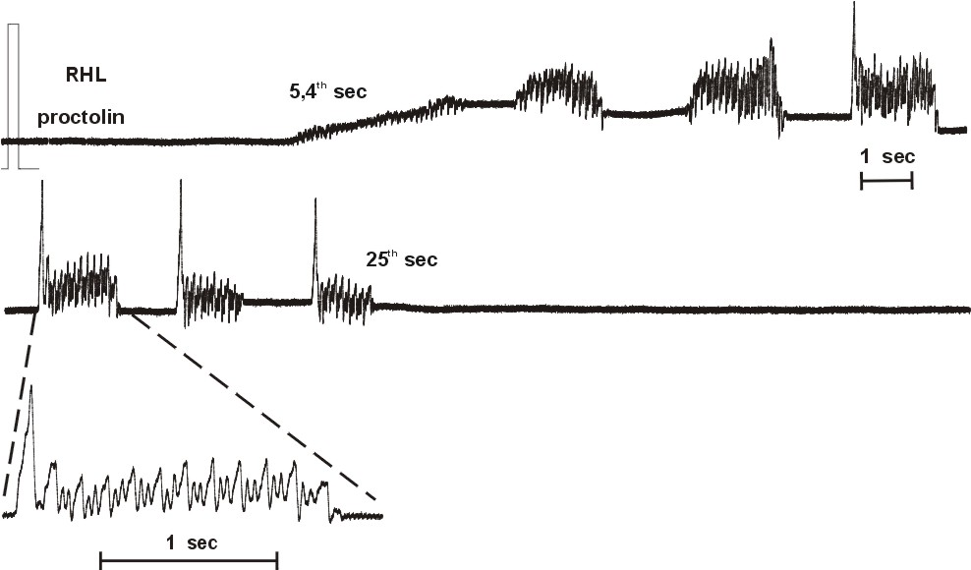
Fig. 1. Proctolin, injected inbetween the central body and Protocerebral Bridge of the brain, alone elicits
courtship singing in male Ch.b. (RHL – right hindleg).
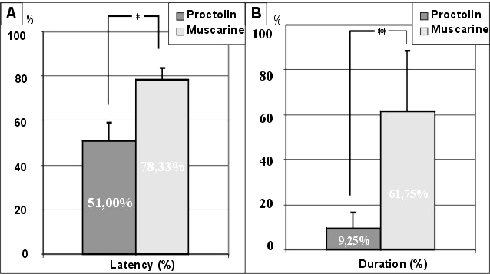
Fig. 2. Comparison between proctolin- and muscarine-stimulated stridulation induced at the same spots in the protocerebrum of males Ch.b. A. The latency of proctolin-induced stridulation was shorter (P < 0.05);
B. The duration of the proctolin produced singing was much shorter than muscarinic (P < 0.01).
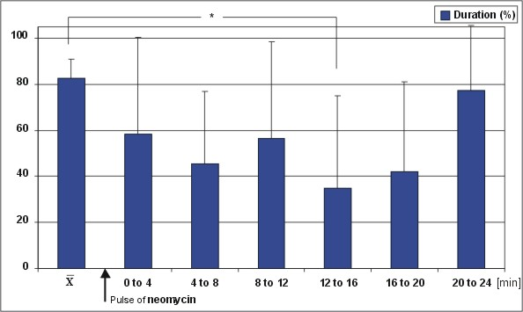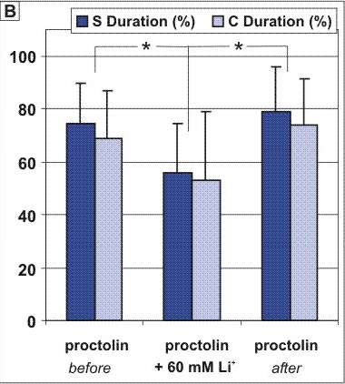
Fig. 3. Effects of the PLC inhibitors neomycin (A) and Li⁺ (B) on proctolin-stimulated singing (males, Ch.b.). A. Two phases of reversible inhibition were observed: the first one from 4th to 8th min and the second – 12th to 20th min (n = 10, P < 0.05); B. Li⁺ co-injected with proctolin reduced both S and C Duration of proctolin-induced singing (n = 9, P<0.05).
St. R. Vezenkov et al.: The role of brain neuropentapeptide proctolin in acoustic communication

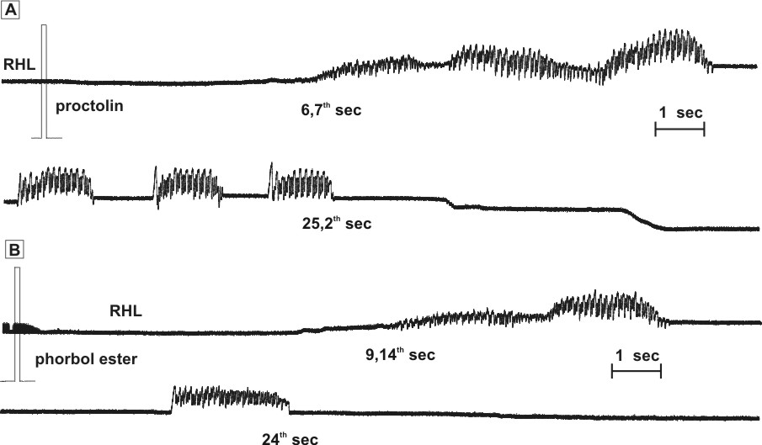
Fig. 4. Male singing (Ch.b.) induced through proctolin (A) and phorbol-12,13-dibutirate (phorbol ester, PhE) (B),
injected at the same spot in the brain.
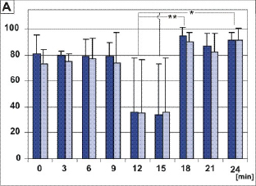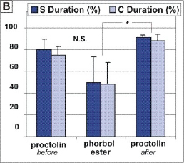
Fig. 5. S and D durations of proctolin- and phorbol ester-induced singing (males, Ch.b., n = 4).
A. 0, 3, 6 min and 18, 21, 24 min – responses to proctolin; 9, 12, 15 min – responses to PhE;
B. Average values of the S and D durations (P < 0.05).

A possible role of DAG in proctolin-stimulated singing was examined through injections of phorbol-12,13-dibutirate (phorbol ester, PhE) at the same brain areas of Ch.b., where proctolin stimu-lated singing. In the first series of experiments PhE was injected alone from the second chamber of the capillary following and preceding 3 proctolin pulses all injected with the same interval between indi-vidual stimulations. Injections of PhE into the Ch.b. brain elicited coordinated singing movements that were indistinguishable from proctolin-stimulated singing induced at the same site within the brain (Fig. 4A, B). However, the time course of the released singing differed in that the average relative duration of singing behaviour after injection of PhE was significantly shorter (from 80%, SD = 9.77% down to 50%, SD = 23.88%; P < 0.05; n = 4) than the preceding and following injections of proctolin (Fig. 5A, B), while the latency was significantly longer (data not shown). After 3 pulses PhE the durations of proctolin-elicited singing increased up to slightly higher levels than before (Fig. 5A, B), indicating a weak after-effect on the excitation due to PhE stimulation. Thus, the PKC might mediate the PLC activity triggered by proctolin and the relevant G-protein coupled receptors.
CONCLUSIONS
The proctolin-stimulated singing differed significantly from muscarine-stimulated one due to its time course and context, respectively courtship and calling singing. Additionally, the blockade of PLC through neomycine and Li⁺ showed strong inhibitory effect on the proctolin-stimulated singing in males (Ch.b.), since complete inhibition was common in most of the experiments. On the other hand, proctolin effects have been not altered by scopolamine, a mAChRs inhibitor. This suggests that the proctolin receptors, coupled to PLC pathway, play a main role in the brain control of courtship singing, triggered by proctolin in comparison to the controlled by mAChRs activation calling singing.
PKC activation (through phorbol ester) poten-tiated proctolin-stimulated responses, indicating additional level of excitation to this induced by proctolin. This may suggest a potential side entry for additional synergistic effects on singing related arousal from other receptors coupled to PLC signalling pathway. Moreover, phorbol ester injected alone to sites, where proctolin was induced singing, mimicked partly the proctolin response.
St. R. Vezenkov et al.: The role of brain neuropentapeptide proctolin in acoustic communication
The latter suggests that proctolin receptors, activated by proctolin that stimulate courtship singing behaviour in males (Ch.b.), are coupled to intracellular PLC signalling pathway and most likely uses DAG as a second messenger.
The observed results suggested possible mole-cular mechanisms that are involved in the decision-making brain centre controlling the sexual behaviour – what (by altering the context), when (by con-trolling the initiation) and how long (by increasing the basal excitation) should the male sing in presence (courtship) or absence (calling) of a female.
REFERENCES
- N. Elsner, J. Comp. Physiol., 88, 67 (1974).
- B. E. Brown, Life Sci., 17, 1241 (1975).
- D. Konopinska , G. Rosinski, J. Pept. Sci., 5, 533 (1999).
- B. E. Brown, Science, 155, 595 (1967).
- E. C. Johnson, S. F. Garczynski, D. Park, J. W. Crim, D. R. Nässel, P. H. Taghert, Proc. Nat. Acad. Sci., USA, 100, 6198 (2003).
- R. Heinrich, B. Wenzel, N. Elsner, J. Comp. Physiol., A, 187, 155 (2001).
- O. von Helversen, N. Elsner, J. Comp. Physiol., 122, 53 (1977).
- S. R. Vezenkov, PhD Thesis, GAU, Goettingen, 2004.
- A. N. Clements, T. E. May J. Exp. Biol., 61, 421 (1974).
- B. Wenzel, N. Elsner, R. Heinrich, J. Neurophysiol., 87, 876 (2001).
- J. M. Hinton, M. Nejad, J. P. Issberner, J. T. Hancock, R. H. Osborne, Insect. Biochem. Mol. Biol., 28, 331 (1998).
St. R. Vezenkov et al.: The role of brain neuropentapeptide proctolin in acoustic communication
- C. Wegener, D. R. Nässel, J. Neurophysiol., 84, 3056 (2000).

От молекулата до сексуалното поведение – ролята на мозъчния невропентапептид проктолин в акустичната комуникация
на скакалеца Chorthippus biguttulus (L.1758)
Ст. Р. Везенков¹*, Р. Хайнрих², Н. Елснер²
¹ Катедра „Логопедия“, Югозападен университет „Неофит Рилски“,
ул. „Иван Михайлов“ № 66, 2700 Благоевград,
² Департамент „Невробиология“, Институт по зоология, антропология и биология на развитието,
ул. „Берлинер“ № 28, 37073 Гьотинген, ФР Германия
Постъпила на 20 юли 2008 г.; Преработена на 30 септември 2008 г.
(Резюме)
Звуковата комуникация на скакалеца Chorthippus biguttulus (Ch.b.) е удобен поведенчески модел за изследване на неврофизиологичните ефекти на идентифицирани невропептиди и стоящите зад тях молекулярни механизми. Невропентапептидът проктолин играе модулираща роля в мозъчната невронална мрежа, която контролира звуковата комуникация (стридулация), респективно сексуалното поведение на мъжките от вида Ch.b. Активирането на проктолиновите рецептори инициира изпълнението на любовна песен (courtship song), второ ниво на сексуално поведение, предхождано от серенада (calling song), контролирано от активирането на мускариновите ацетилхолинови рецептори (mAChRs). Фармакологичните изследвания показаха, че вътре-клетъчната сигнална каскада на фосфолипаза Ц (PLC) е свързана с любовното пеене, тъй като неомицинът и литиевите йони имаха силен инхибиторен ефект върху стимулираното от проктолина пеене. Нещо повече, форболовият естер (аналог на вторичния посредник диацилглицерол), инжектиран в чувствителните към проктолин места в мозъка, предизвиква стридулация самостоятелно. Това показва, че протеинкиназа Ц медиира ефектите на активираната фосфолипаза Ц. Получените резултати показват възможните молекулярни механизми, които участват при взимането на решение в мозъчен център, контролиращ сексуалното поведение – какво (чрез промяна на контекста на изпълняваната песен), кога (чрез контрол на инициацията на продуциране на звуци) и колко продължително (чрез повишаване нивото на възбудния процес) мъжкия скакалец да произвежда видово и полово специфични звуци.

