Structure-activity relationships of new L-Valine derivatives with neuropharmacological effects
Bulgarian Chemical Communications, Volume 41, Number 2 (pp. 133–137) 2009
D. S. Tsekova¹*, E. Ts. Makakova², P. S. Alov³, G. A. Gorneva⁴, I. K. Pajeva³, L. P. Tancheva⁵,
V. V. Petkov⁵, A. R. Surleva⁶, B. Escuder⁷, J. F. Miravet⁷, E. Katz⁸
* To whom all correspondence should be sent:
E-mail: d_tsekova@abv.bg
© 2009 Bulgarian Academy of Sciences, Union of Chemists in Bulgaria
¹ Department of Organic Chemistry, University of Chemical Technology and Metallurgy,
8 Kliment Ohridski Blvd., 1756 Sofia, Bulgaria
² Faculty of Chemistry, Kliment Ohridski University of Sofia, 1 J. Bouchier Blvd., 1164 Sofia, Bulgaria
³ Center of Biomedical Engineering, Bulgarian Academy of Sciences,
Acad. G. Bonchev St., Block 105, 1113 Sofia, Bulgaria
⁴ Institute of Molecular Biology, Bulgarian Academy of Sciences,
Acad. G. Bonchev St., Block 21, 1113 Sofia, Bulgaria
⁵ Institute of Neurobiolog,y, Bulgarian Academy of Sciences,
Acad. G. Bonchev St., Block 23, 1113 Sofia, Bulgaria
⁶ Department of Analytical Chemistry, University of Chemical Technology and Metallurgy,
8 Kliment Ohridski Blvd., 1756 Sofia, Bulgaria
⁷ Department of Inorganic and Organic Chemistry, Universitat Jaume I, 12071 Castellon, Spain
⁸ Hebrew University, Jerusalem, Israel
Received July 17, 2008; Revised September 27, 2008
Four derivatives of L-Valine were studied as potential pharmacological agents. L-Valine is bound to either nicotinic (m-pyridinic) acid (M) or isonicotinic (p-pyridinic) acid (P) from N-side and to an alkyl fragment (or species) consisting of 3 or 6 methylene groups from C-side. In experiments in vivo (in albino mice) and in vitro (on cell cultures F4N) the compounds showed very low toxicity (intraperitoneal and oral toxicity over 2000 mg/kg and citotoxicity lower than vitamin C). At the same time, they demonstrated significant neuropharmacological activity. The experimental data obtained for their solubility in water and octanol, as well as with calculated logP correlate well with the results for their Central Nervous System effects.
Key words: L-Valine derivatives, neuropharmacological effect, pKa, logP, toxicity, in vivo, in vitro.

Introduction
Four compounds, derivatives of L-Valine, nico-tinic (m-pyridinic) acid (M) or isonicotinic (p-pyri-dinic) acid (P) were studied as potential pharma-cological agents. The codes M3, M6, P3 and P6, are used depending on the position and the length of the alkyl fragment (or species) consisting of 3 or 6 methylene groups. The compounds belong to the group of low-molecular gelators (LMWG) and have very high ability to form intermolecular H-bonds, involving also solvent molecules in their supra-molecular complexes formation [1, 2]. The four compounds are constructed by the natural L-α-aminoacid – Valine, connected by amide (peptide) bonds with neighbouring groups in a way different from the natural L-α-aminoacids. In this meaning, these compounds are representatives of the class of peptidomimetics. The other ingredient of the mole-cule is either nicotinic or isonicotinic acid, which are expected to determine their specific biological activities.
There are number of reports in literature for pronounced biological activities of compounds – derivatives of nicotinic and isonicotinic acids. Nicotinic acid and nicotinamide in the form of NAD+ and NADP+ participate in many enzymatic reactions [3]. Nicotinamide, known as vitamin B3 or PP is essential for normal function of the nervous system, gastrointestinal tract, normal tissue meta-bolism, it has also shown anti-anxiety anxiolytic properties similar to benzodiazepines [4] and has demonstrated anti-inflammatory actions [5]. Some isonicotinic acid derivatives are antituberculosis medications [6, 7] and others possess anti-depressant activities [8, 9].
Recently we reported that two of these compounds (M6 and P6) had neuropharmacological activities [10]. Up to this report, similar analogs have not been used as major structures for drug synthesis. Here we present additional results for M6 and P6 and two new structurally-related compounds (M3 and P3). Physicochemical properties obtained experimentally and by model calculations, in vitro and in vivo toxicity and pharmacological activities are summarized and compared.
The directions of this study include:
Defining the physicochemical characteristics of the target compounds:
- Solubility in different solvents.
- pKa .
- Partition coefficients.
Toxicity:
- In vitro toxicity (citotoxicity).
- Acute toxicity, effective doses, therapeutic index.
Analysis of structure-activity relationships.
D. S. Tsekova et al.: New L-Valine derivatives with neuropharmacological effects
Experimental
Materials and methods
Physicochemical properties were defined by:
- UV spectrophotometry - for determining of pKa and solubility concentrations. VARIAN CARY 100 Scan UV-VIS Spectrophotometre was used.
- ACD Labs.
Experimental biological activities:
Materials. 1. Male Albino mice ICR with initial body weight of 18–20g (10 in groups).
2. F4N-mouse erythro-leukimic cells, obtained by erythroidal cells, transformed by the Friend virus.
Methods. Toxicological studies. In vitro: The method is based on the ability of the live cells to extrude the blue dye (Methylene blue) which pene-trates through membranes and remains uncoloured, while the dead cells are stained blue.
In vivo: For toxicology activities estimation the following effects in the living body were defined:
1. Parameters of acute toxicity:
- Limit of acute activity (Limac).
- No observed effect level (NOEL).
- Lethal dose 50% (LD50) – according to
Bulgarian standards 15380-81.
2. Prolonged toxicity – after 5, 7 and 14 days.
3. Reversibility of the toxic damages – till the 14th day after acute administration of the compounds.
Results and discussion
Data for рКа of М3, Р3, М6 and Р6
Applying ACD Labs data for pKa were calculated and they are presented in Table 1.
The experimental values of pKa₁ and pKa₂ of P3 compound, related to both pyridine N atoms (1st and 2nd N) were determined using a well-known spectro-photometric method [11]. The analytical wave-lengths were chosen from the UV-absorption spectra of P3 (at constant concentration of 1×10^{–4} mol/l (48.3 μg/ml)) at different pH. In Fig. 1a three spectra are presented: of the neutral molecule – R that exists at pH 7, the double ionized form RH₂²⁺ existing at pH 1 and the mixture of forms that exist at pH ∼ 4, namely R, RH⁺ and RH₂²⁺.
Table 1. Calculated pKa data for the four compounds.
 | Compound
 | Р3 | Р6 | М3 | М6
pKa₁ | 3.19 | 3.08 | 3.14 | 2.93
pKa₂ | 3.8 | 3.71 | 3.74 | 3.62
pKa₃ | 11.33 | 11.35 | 11.76 | 11.78
pKa₄ | 11.94 | 11.95 | 12.37 | 12.38
pKa₅ | 15.73 | 15.96 | 15.75 | 15.97
pKa₆ | 16.64 | 16.58 | 16.65 | 16.59
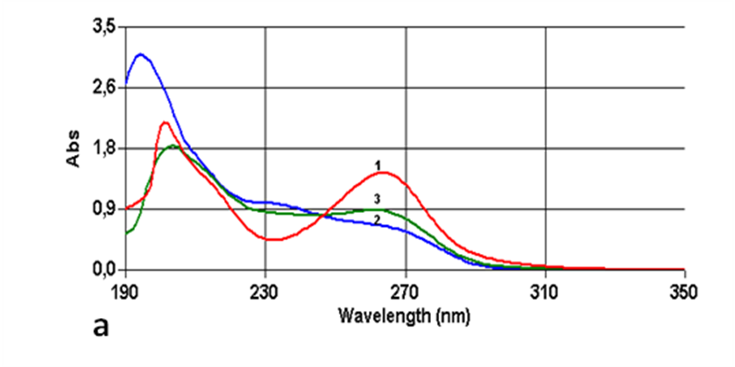
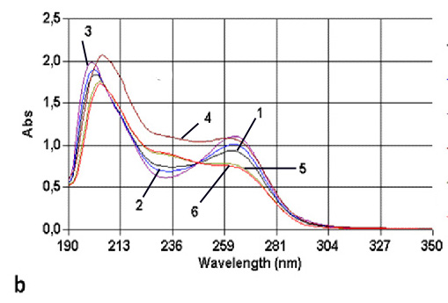
Fig. 1. Absorption of compound P3 in the UV range at different рH: a) 1– pH = 7; 2 – pH = 1; 3 – pH=3,8;
b) 1 – pH = 3.64; 2 – pH = 3.47; 3 – pH = 3.16;
4 – pH = 4.02; 5 – pH = 4.19; 6 – pH = 4.33.
As it is seen from the figure, the differences in the absorption (A) of both states R and RH₂²⁺ at λ = 231 and 264 nm have analytical values. Using the data for the absorption at these wavelengths and applying equation (1) approximated pKa were calculated:
$\text{pKa}=\text{pH}+\text{log}\frac{A−A_{R}}{A_{{\text{RH}}_{2}^{2+}}−A}$
or
$\text{pKa}=\text{pH}+\text{log}\frac{A_{R}−A}{A−A_{{\text{RH}}_{2}^{2+}}}$ (1)
where A_{R} is the absorption of unionized molecule (at pH 7), $A_{{\text{RH}}_{2}^{2+}}$ – the absorption of the double ionized molecule (at pH = 1) and A is the absorption at pH, which is between 1 and 7.
Results obtained show that:
- at pH 7, solution contains 99.99% R and 0.01% of the mixture RH⁺ + RH₂²⁺:
- at pH 1, 99.99% of the compound P3 exist in the fully ionized form RH₂²⁺;
- pKa₁ is higher than 3.2;
- pKa₂ is lower than 4.3.
Both values of pKa are very close. The condi-tions where only the monoionized form RH⁺ exists in a solution at concentrations higher than 99% can not be created experimentally and thus its absorp-tion can not be measured. In such cases, the absorp-tion of RH⁺ can be calculated by an extrapolation of the absorption values of the other two forms (R and RH₂²⁺) at different pH. The absorption of P3 has been measured in the pH range between 3.16 and 4.33 and the resulting UV-spectra are presented in Fig. 1b. The values of pKa₁ and pKa₂ were calcu-lated using the method of consecutive approxima-tions: pKa₁ = 3.23 ± 0.15 and pKa₂ = 4.16 ± 0.10
(n = 3, p = 95%) at 20°C.
As the experimentally established values of pKa were close enough to the theoretically calculated ones, we accepted theoretically the found data as applicable for all four substances.
Data for logP
One of the very important physicochemical characteristic of the drugs is their partition coeffi-cient logP that characterizes their distribution between water and lipid phase in the body. In the experimental model systems lipids are usually presented by octanol and logP is defined by the following equation:
D. S. Tsekova et al.: New L-Valine derivatives with neuropharmacological effects
(2)
where C is concentration of the unionized solute in both solvents, octanol and water. The pKa data of the four compounds, (Table 1), show that all they exist in unionized form at the physiologically active pH 7.4 (the physiological pH of blood serum), which means that logP and logD (the apparent logP) do not differ.
In order to define logP experimentally, we needed information for solubility of the compounds in both solvents. Experiments were performed to define the standard calibration lines for absorption in both solvents. The absorption bands in the region 190–310 nm for compound P3 are presented in Fig. 2. Concentrations used for water solutions were between 0.1 and 0.0025 mg/ml, and those used for octanol solutions – between 0.15 and 0.02 mg/ml.

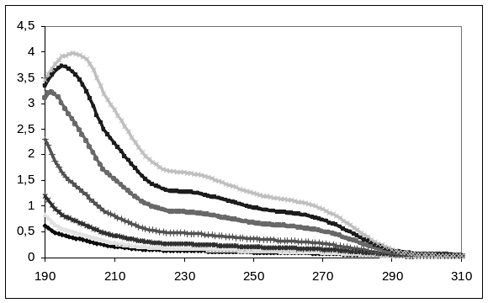
a | b
Fig. 2. a. Bands of absorbance in the UV range for compound P3 in water. Used concentrations of Р3 in water (mg/ml) were: 0.1; 0.075; 0.05; 0.025; 0.01; 0.0075; 0.005; b. Bands of absorbance in the UV range for compound P3 in octanol. Used concentrations of Р3 in octanol (mg/ml) were: 0.15; 0.12; 0.09 0.06 0.003.
On the abscissas is the wavelength, λ nm, and on the ordinates is the absorbance, А.

The spectra presented in Fig. 2 display two main bands. It turned out that the lower one is more sensitive to variation in concentrations and its maximum appears at constant wavelength (λ), while the maximum of the higher one appears at different wavelengths with exchanging of concentrations, namely upon increase in concentration this taller maximum shifts to higher values of λ. Using data for the absorptions of the compounds in water solutions at 261 nm, and in octanol at 248 nm, standard lines concentration/absorption were drawn. In the course of the experiment an interesting fact was detected: in water solutions the same substance shows different molar absorptions depending on the starting concentration. Figure 3 illustrates one of the sets of calibration lines obtained for compound P3. This result shows that after dissolving at high temperatures and subsequent cooling each com-pound forms stable supramolecular complexes of different size depending on the initial concentration obtained in hot solution. That finding restricted the exact experimental log P measurement. On the other hand, comparison of the solubility of four com-pounds in water and in octanol shows that the solubilities in octanol are in orders higher than those in water, namely for M6 and P6 about 80–100 times, for M3 and P3 – 30–50 times, which results agree with data obtained by theoretical calculations (Table 2).
Fig. 3. Calibrating lines obtained for P3 in water with starting concentrations of 3.1, 2.07 and 1.24×10^{–4} M P3. On the abscissas is the molar concentration and on the ordinates is А at λ = 261 nm.
Table 2. Data calculated for logP for the four compounds.
Substance | LogP (Theoretical data)
M3 | 1.14 ± 0.76
P3 | 0.33 ± 0.67
M6 | 2.20 ± 0.68
P6 | 1.4 ± 0.67

Biological activities
Toxicity in vitro (citotoxicity): The four peptido-mimetics were found as nontoxic at concentrations equal or lower than 250 μМ. For purpose of comparison we tested Vitamin C at the same experimental conditions and established that it revealed toxicity at 200 μМ, i.e. our compounds were less toxic than Vit. C.
D. S. Tsekova et al.: New L-Valine derivatives with neuropharmacological effects
Toxicity in vivo: As a result of the experiments performed, a low acute effect and lack of prolonged toxicity were observed. At doses over 2000 mg/kg each of the tested compounds (applied in both modes: intraperitoneal (i.p.) and oral (p.os)) did not provoke any symptoms of intoxication, i.e. LD50 is over 2000 mg/kg (p.os and i.p.).
No observed effect level (NOEL) was estimated as 40 mg/kg i.p. and limit of acute toxicity (Limac) was found at 80 mg/kg i.p.
Dissection of the animals at the 5, 7 and 14 day of the treatment did not show any changes or irreversible toxic damages in the organs which points to the lack of prolonged toxicity.
In most of the experiments the effective doses (ED50) of the compounds were about 250 mg/kg b.w. i.p. Bearing in mind that LD50 is over 2000 mg/kg, a therapeutic index (LD50/ED50) higher than 8 could be expected.
Preliminary data showed that some of the compounds (M6 and P6) had pronounced analgesic effect as well as good dose-dependent effect on learning and memory [10].
Conclusions
The four compounds are nontoxic at concen-trations ≤ 250 μМ. They show citotoxicity even lower than that of Vit C.
High therapeutic index > 8 can be expected.
At physiological рН 7.4 the four compounds exist mainly in their unionized form.
Their solubility in octanol is much higher than in water (for M6 and P6 about 80–100 times, for M3 and P3 – 30–50 times), which could be related to the differences in the observed neuropharmacological effects.
In water solutions each compound shows different molar absorptions that points to formations of stable supramolecular complexes with sizes depending on the concentration of the compound.
The above data will be further used for pur-poseful synthesis and molecular modelling studies of structure-activity relationships of this new class of peptidomimetics.
Acknowledgements: We thank for the funding provided by the University of Chemical Technology and Metallurgy (Research Contract 10508).
References
- D. S. Tsekova, B. Escuder, J. F. Miravet, Cryst. Growth Des., 8, 11 (2008).
- J. F. Miravet, B. Escuder, Chem. Commun., 5796 (2005).
D. S. Tsekova et al.: New L-Valine derivatives with neuropharmacological effects
- P. Belenky, K. L. Bogan, C. Brenner, Trends Biochem. Sci., 32, 12 (2007).
- J. F. Tallman, S. M. Paul, P. Skolnick, D. W. Gallager, Science, 207, 274 (1980).
- N. M. Niren, Cutis, 77 (1 Suppl), 11 (2006).
- A. Dömling, S. Achatz, B. Beck, Bioorg. Med. Chem. Lett., 17, 5483 (2007).
- G. S. Timmins, V. Deretic, Mol. Microbiol., 62, 1220 (2006).
- M. Kobayashi, E. Arai, Psychopharmacology, 46, 317 (1976).
- P. O. Ganrot, E. Rosengren, C. G. Gottfries, Cell. Mol. Life Sci., 18, 260 (1962).
- L. Tantcheva, V. V. Petkov, G. Karamukova, S. Abarova, Y. Chekalarova, D. Tsekova, B. Escuder, J. Miravet, K. Lyubomirova, Bulg. Chem. Comm., 38, 54 (2006).
- A. Albert, E. Sergeant, Ionization Constants of Acids and Bases, Khimiya,. Moscow-Leningrad, 1964, р. 64 (in Russian).

ВРЪЗКА СТРУКТУРА-АКТИВНОСТ ПРИ НОВИ ПРОИЗВОДНИ НА L-ВАЛИНА
ПРОЯВЯВАЩИ НЕВРОФИЗИОЛОГИЧНИ ЕФЕКТИ
Д. С. Цекова¹*, Е. Ц. Макакова², П. С. Алов³, Г. А. Горнева⁴, И. К. Пъжева³, Л. П. Танчева⁵,
В. В. Петков⁵, А. Р. Сурлева⁶, Б. Ескюдер⁷, Х. Ф. Миравет⁷, Е. Катц⁸
¹ Катедра „Органична химия“, Химикотехнологичен и металургичен университет,
бул. „Климент Охридски“ № 8, 1756 София
² Химически факултет, Софийски университет „Климент Охридски“,
бул. „Дж. Баучър“ № 1, 1164 София
³ Център по биомедицинско инженерство, Българска академия на науките,
ул. „Акад. Г. Бончев“, бл. 105, 1113 София
⁴ Институт по молекулярна биология, Българска академия на науките,
ул. „Акад. Г. Бончев“, бл. 21, 1113 София
⁵ Институт по невробиология, Българска академия на науките,
ул. „Акад. Г. Бончев“, бл. 23, 1113 София
⁶ Катедра „Аналитична химия“, Химикотехнологичен и металургичен университет,
бул. „Климент Охридски“ № 8, 1756 София
⁷ Департамент по неорганична и органична химия, Университет „Хайме I“,
12071 Кастелон, Испания
⁸ Еврейски университет, Йерусалим, Израел
Постъпила на 17 юли 2008 г., Преработена на 27 септември 2008. г.
(Резюме)
Изследвани бяха четири производни на L-валина като потенциални фармакологични агенти. От N-края си α-аминокиселината е свързана с никотинова (m-пиридинова) киселина или с изоникотинова (р-пиридинова) киселина и от С-края си – с алкилов остатък съдържащ 3 или 6 метиленови групи. В in vivo (бели мишки) и in vitro (клетъчни култури F4N) експерименти и четирите съединения показаха много ниска токсичност (интра-перитонеално и орално въведени веществата проявяваха токсичност над 2000 мг/кг, a при клетъчните култури токсичността бе по-ниска от тази на витамин С). Същевременно бе отчетена значима неврофармакологична активност при доста по-ниски дози на изследваните вещества. Експериментално получените данни, отнасящи се до тяхната разтворимост във вода и октанол (logР), както и изчислените данни за logР, са в добра корелация с резултатите свързани с техните ефекти върху цетралната нервна система.

