In Memoriam
Professor Dimitar Petkov

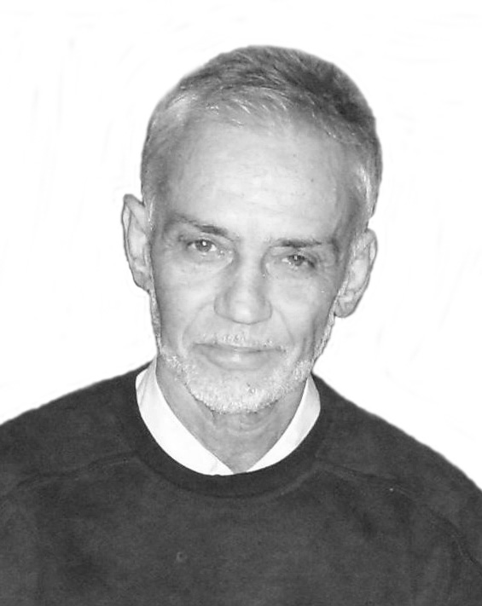 | Professor Dimitar D. Petkov, D.Sci., Ph.D., died on March 8, 2008 at the age of 66 after a short and bitter fight with cancer. By sheer strong will, he supervised his Ph.D. students to the last.  Born in 1941 in the village of Sushica, VelikoTarnovo District, Petkov graduated chemistry at Sofia University in 1967. His Master’s Thesis with N. Tyutyulkov was in the field of quantum chemistry. Petkov joined the Institute of Organic Chemistry, Bulgarian Academy of Sciences (1967–2007), first in D. Shopov’s Laboratory of Organic Catalysis doing theoretical work, soon after went over (1969) to the Laboratory “Proteins” headed by M. Karadjova, where his main interest was enzyme catalysis by proteinases. He spent six months (1976) in Cornell University with Hames. He became Head of the Spin-off Laboratory BIOCATALYSIS (1988). The last decade of his life was dedicated to the intriguing field of ribosome catalysis.

Being Docent (1984) in Sofia University he taught there Bioorganic Chemistry and related courses in the Chemical and the Biological Faculties.

The scientific legacy of Dimitar Petkov comprises 85 papers cited more than 400 times, a text book “Biorganic Chemistry” (1996), several patents on peptide synthesis. He was a Member of the American Peptide Society and the European Peptide Society and co-founding Member of the Bulgarian Peptide Society.

Even the first studies of D. Petkov (coauthored with A. Andreev and D. Shopov) provoked already keen interest. One of the papers (J. Catalysis, 1969) treating the quantum chemical estimation of the modes of hydrogen adsorption on nickel was cited 55 times.

Moving to the Protein Laboratory headed by Maria Karadjova, Petkov’s research work focused on the chemistry of serine proteinases: urokinase, trypsin, chymotrypsin covering a wide range of problems: from enzyme-catalysed synthesis of peptides, methods of assay of activity to the mechanism of enzymatic action. Highlights issues from a practical point of view are his papers “Nucleophilic specificity in chymotrypsin peptide synthesis” (Biochem. Biophys. Res. Commun. 1984, most cited paper 82 times), “Enzyme peptide synthesis and semisynthesis – kinetic and thermodynamic aspects” defining the best conditions for in vitro synthesis nicely demonstrated by the development of an iterative procedure of peptide synthesis in a nucleophile pool. Structure-activity relationships helped to elucidate the transition state in urokinase aided peptide hydrolysis. Most of the peptide work was carried out in collaboration with Senior Research Fellow Dr. Ivanka Stoineva. The recognition of these achievements is materialized in the foundation of a commercial laboratory for conversion of swine into human insulin, the activity of which was unfortunately discontinued because of market considerations.

As it was already mentioned, the last decade of the research efforts of Petkov and his numerous associates were dedicated to the fascinating field of the catalytic action of ribosomes during protein biosynthesis. Using model substrates complex enough to mimic credibly the nucleoside structure and aprotic solvents, imitating the anhydrous environment of the active site of the ribosome, the catalytic role of neighbouring sugar hydroxyl and the modes of proton transfer were established using the experimental methods of physical organic and computational chemistry. The publication of these results in JACS and Angewandte Chemie proves convincingly the quality of these results.

Science dominated his life and his emotions. He would come early in the morning on his bicycle and work the whole day. Dominating in his research work and teaching was his keen interest in modern science, which drew the best young scientists to work or do Ph.D. with him. Many of them are now scattered in renowned labs in the world. Over the years, he corresponded and collaborated with top scientists in the field.

The way Petkov treated science reminds of a story told about the Nobel Prize-winner biochemist Albert Szent-Gyorgi, discoverer of vitamin C. He was fishing in the lake of Balaton when a fellow fisherman noticed: Why are you using such large hooks – there are no such large fish in the lake?! Szent-Gyorgi answered: I have no time for small fish.

The memory of Professor D. D. Petkov will be revered by the traces he left in the world of science, by his many former students whom he introduced to the frontiers of scientific endeavour and by his friends for his stimulating personality.

Ivan Pojarlieff
Corresponding Member of the Bulgarian Academy of Sciences

