Materials used for organic light-emitting diodes – organic electroactive compounds
Bulgarian Chemical Communications, Volume 41, Number 3 (pp. 211–225) 2009
P. Petrova*, R. Tomova
* To whom all correspondence should be sent:
E-mail: petia@clf.bas.bg
© 2009 Bulgarian Academy of Sciences, Union of Chemists in Bulgaria
H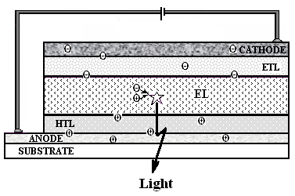
H
H
H
H
Acad. J. Malinowski Central Laboratory of Photoprocesses, Bulgarian Academy of Sciences,
Acad. G. Bonchev St., Block 109, 1113 Sofia, Bulgaria
Received April 24, 2008; Revised February 10, 2009
This paper introduces the readers into the great variety organic electroactive compounds suitable for the preparation of organic light-emitting diodes (OLED). Some of our results on successful usage of new Zn complexes as light-emitting layers in OLED are presented.
Key words: organic light-emitting diodes (OLEDs), electroluminescence, organic electroactive materials, thin films, organometallic compounds, conducting polymers.

INTRODUCTION
In the past decades, an enormous amount of research work as well as commercial interest has focused on the new field of conjugated organic electronics materials. This interest, which has recently received a new impulse thanks to the Nobel Prize in chemistry of Shirakawa, MacDiarmid and Heeger for year 2000, is due to the fact that these materials combine a number of interesting pro-perties, which give rise to a broad variety of new applications. Probably the most important feature of conjugated organic electronics materials is their ability to transport charges, i.e. they can be con-ductors or semiconductors. On the other hand, these materials are organic molecules or polymers and thus offer the possibility they to be designed in such a way as to fit perfectly the desired requirements.
The search for polymers and small organic molecules as the active layer in light emitting diodes has made rapid advance. Organic light-emitting diodes (OLEDs) are energy converting devices (electricity-to-light) based on electroluminescence (EL) of organic compounds and are considered as next generation full-colour flat panel display.
Even though the display market is still dominated by Cathode-Ray-Tubes (CRT) and Liquid-Crystal-Displays (LCD) the impact of organic light emitting diodes (OLEDs) is getting stronger, so that the first mass products are hitting the market.
In this paper, an overview of the different organic compounds used as electroluminescent materials in the organic light emitting devices is presented. Besides some of our results on developing of OLED on the basis of Zn complexes will be discussed.
Typical OLED structure
OLED devices contain the substrate materials, electrodes and functional organic substances. Two types of electrodes are used. A layer of indium - tin oxide (extremely thin, because it has to be optically transparent), is used as anode. Low work-function metals such as Mg, Ca, Al, Li and their alloys with Ag are commonly used as cathodes. Several types of organic materials are used as the functional layers: polymers or small molecules transporting the injected charges to the recombination zone, fluorescent or more efficient phosphorescent materials emitting the light.
Fig. 1. Scheme of a typical multi-layer OLED with electron transporting layer (ETL), emitting layer (EL), and hole transporting layer (HTL).
When an electric field is applied, electrons are injected from the cathode and holes from the anode into the organic layers. The electron moves through the layers by a hopping process from one molecule to another until it meets an “electronical hole” (a defect formed by the abstraction of an electron at the anode). This abstraction leads to a radical cation, which is neutralized again by receiving an electron from a neighbour molecule, thus drifting in the direction of the cathode. In this way, charges can combine, forming excited molecular species, e.g. excitons, some of which decay to their ground state emitting the light (Fig. 1).
“Small molecular” organic compounds and con-jugated oligomers or polymers with precise chain length, and defined electrical and optical qualities are used as organic light-emitting materials. Dendri-mers is the newest class investigated materials.
The light emission colour of the polymers strongly depends on their chemical composition. By chemical modification of the polymer structure, a range of soluble light-emitting polymers emitting in the range from 400 nm to 800 nm is made available. This means that any colour in the visible spectrum can be obtained. Important for the emission colour of the light-emitting polymers are the type of polymer and the nature of the side-groups (which are also important for the solubility of the polymer). Well-known examples of light-emitting polymers are poly(p-phenylenevinylene), and poly(fluorene) (Fig. 2).
The use of emissive additives (known also as dyes) is an interesting option for influencing the emission colour of light-emitting polymers. By adding a small amount of a suitable dye to a polymer, energy can be transferred from the polymer to the dye and the light will only be emitted from the dye. The colour from the device can be tuned using different dyes. For example, a green dye in a blue polymer will give green light, while a red dye in a blue polymer will give red light.
Industrial challenges
The industrial methods for deposition of organic materials depend on the type of the device produced. Four industrial methods for deposition of organic materials are known:
Thermal vacuum evaporation – used for manu-facture of “Small Molecular” Organic Light-Emit-ting Device (OLED). The small molecules are deposited by vapour deposition.
Spin-coating – used for deposition of soluble polymers. Monochrome displays (PLED) are produced by this method. Conjugated polymers can be applied to a surface either through dip-coating or spin-coating. The thickness of the layers is dependent on the composition of the polymer and the concentration of the polymer solution.
Ink-jet printing – used for manufacture of full-colour display (PLED). Patterning of pixels could be done through ink-jet printing, but the pixel pitch at 28 μm obtained by this method is considered too large for microdisplays.
Laser induced thermal image – used for manu-facture of high resolution full-colour display (OLED & PLED).
The materials can be deposited in many separate layers or mixed into one or several layers.
P. Petrova and R. Tomova: Organic electroactive compounds used for OLED
Also, an extremely uniform thickness of each layer is necessary for device fabrication. Non uniformities may lead to localized surges of electric current, localized overheating, and gradual destruc-tion of the device. The complexity makes the fabrication of OLEDs difficult and slows down testing of new materials.
Polymeric OLEDs have the advantage that the active layers can be deposited from solution, thus allowing large-area devices preparation, while in “small molecular” OLEDs, the active layers are typically deposited by vapor deposition technique. Vacuum deposition is limited to vaporizable low molecular weight materials and can only be applied to compounds, which endure thermal stress without decomposition. On the other hand, by vacuum tech-nique the complicated multilayer device architecture can be constructed without any serious problems. This technology is relatively expensive and can only be applied for smaller devices with high quality.
However, multi-layer preparation from solution is far from trivial. It is of crucial importance that previously deposited layers are absolutely resistant against the solvent used for deposition of the subsequent layer(s). Yet the most elegant strategy is the application of precursors containing polymeriz-able groups, which are converted into an insoluble network by an additional crosslinking step.

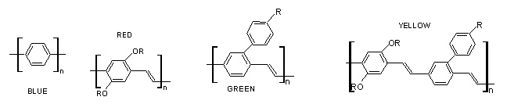
Fig. 2. Light-emitting polymers based on poly(p-phenylene) and poly(p-phenylenevinylene).

Requirements to the materials used in OLED
The materials need to have a good thermal stability because of the heat generated in the device, low turn-on voltages, high conductivity and high electroluminescence efficiency. The conducting polymers have to be soluble, with good mechanical properties, high resistance to acids and bases and high conductivity.
The glass transition temperature Tg, of the polymer materials is also an important issue in the choice of the material for the device. In OLEDs the conjugated polymers have a very high Tg approxi-mately 90–95°C that results in a hard glasslike structure in usage at room temperature. At tempe-ratures over Tg the display does not obtain a proper functionality and the lifetime is reduced. The upper limit of the temperature range can be improved finding the polymer materials with a higher Tg [1].
P. Petrova and R. Tomova: Organic electroactive compounds used for OLED
The study of the variety of organic materials as active components is determined by the necessity to optimize the characteristics of the devices.
Electro-conducting and/or luminescent organic materials
“Small molecular” organic compounds
Low-molecular weight materials such as metal chelates (organometallic compounds), simple oxadi-azole compounds, triarylamines, porphines, and phthalocyanines are used for OLED [2]. Organome-
tallic compounds are successfully applied in OLEDs as the emitters or electron transporters.
The substituted “small” molecules with aromatic amines are used for hole transport (Fig. 3a), while a variety of polynuclear aromatic complexes with high electron affinity and the oxadiazoles (Fig. 3b) are used for electron transport. The porphines and the phthalocyanines [3, 4] are used as dopant emit-ters (dyes) and photo-conducting materials. In some cases, the charge transporting “small” molecules (or polymers) themselves assume the role of emitters.
One of the most widely used materials because of its excellent luminescent, electron transporting, and film-forming properties is tris(8-quinolinolato) aluminium, commonly referred to as Alq₃ (Fig. 4) [5–9]. The compound Alq₃ is one of the typical examples for amorphous films that can be prepared by vacuum vapour deposition. Two geometric isomers can be formulated for Alq₃, the meridianal (mer) and the facial (fac) form [10, 11], which may even be interconverted into each other at high temperatures. The 4-methyl-8-quinolinolato ligand also could be used successfully [12].
The efforts with small organometallic com-pounds (SOC) are directed to design and prepare various electrolumophores (chromophores that are electroluminescent). This is very important area of research, because of the main use of electro-lumophores in the fabrication of Organic Light-Emitting Diodes (OLEDs) for full-colour displays.

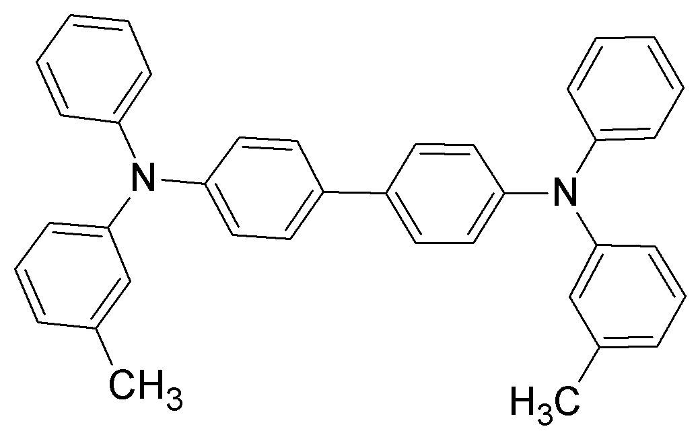 | 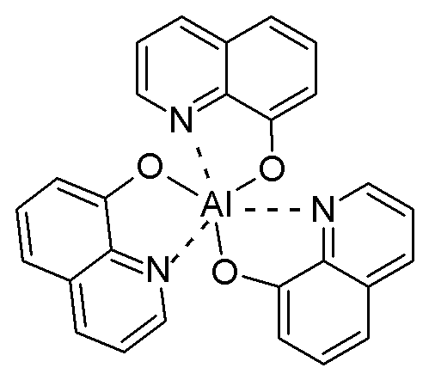
Fig. 3a. N,N’-diphenyl-N,N’-bis(3-methylphenyl)(1,1’-biphenyl)-4,4’-diamine (TPD) is preferred as a hole transporting material. | Aluminum(III) tris(8-hydroxyquinoline) Alq₃  Green Emitter.
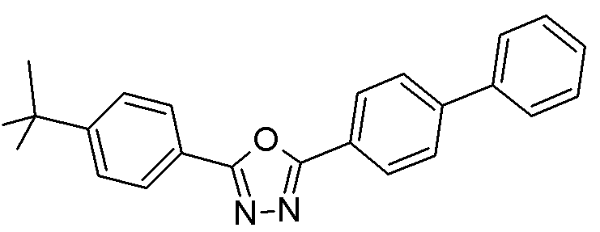 | 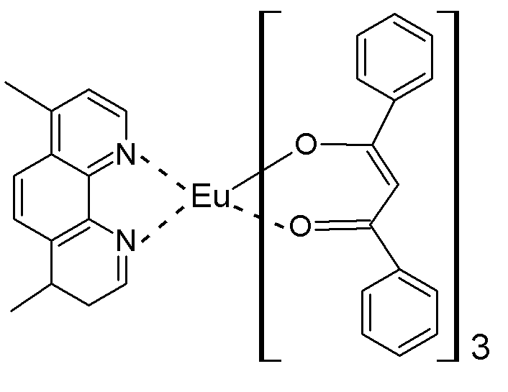
Fig. 3b. 2-(4-Biphenylyl)-5-(p-tert-butylphenyl)-1,3,4-oxadiazole (PBD) is used as an electron transporting layer. | Europium (III) 4,7-Dimethylphenanthroline-  tris(1,3-diphenyl-1,3-propadione) Red Emitter-Dopant.  Fig. 4. Organometallic compounds.

A broad range of metal ions have been used for the complexation of functional ligands, including beryllium [13], zinc, boron [14], transition metals [15] such as iridium [16–19], and the lanthanide metals introduced by Kido [20], especially europium [21] and terbium. Common ligands are phenanthro-line (phen) (Fig. 4), bathophenanthroline (bath),
2-phenylpyridine (ppy), acetylacetonate (acac), dibenzoylmethanate (dbm), anthracene [22] and thenoyltrifluoroacetonate (TTFA). A frequently used complex is the volatile Eu(TTFA)₃(phen) [23]. In general, these complexes tend to crystallize and require the use of a stabilizing matrix. By incorpo-rating larger ligands, the glass forming tendency is increased.
Electroactive polymers
The electroactive polymers fulfil multiple functions: both electron and hole transport and light emission, even though dopant emitters can be used to tune the colour.
Conjugated polymers. Conjugated polymers (CPs) are organic semiconductors with delocalized π-molecular orbitals along the polymeric chain.
Conjugated polymers have a framework of alter-nating single and double carbon–carbon (sometimes carbon–nitrogen) bonds. Single bonds are referred to as σ-bonds, and double bonds contain a σ-bond and a π-bond. All conjugated polymers have a σ-bond backbone of overlapping sp² hybrid orbitals.
The remaining out-of-plane p_{z} orbitals on the carbon (or nitrogen) atoms overlap with neighbouring p_{z} orbitals to give π-bonds. Electron movement within delocalized π-molecular orbitals is the source of conductivity. In CPs (Fig. 5), conductivity within one polymer chain is based on the conjugated nature of the polymer molecules and the resulting mobility of p-electrons.
With the discovery of electrical conductivity of electroactive polymers began a period of intense theoretical and experimental research into the physical and chemical properties of these materials. Polyacetylene (PA) was the first organic conducting polymer, synthesized in 1971 by a co-worker of Shirakawa, who accidentally used an excess of Ziegler-Natta catalyst [24]. This was followed in 1977 by the discovery of Heeger, MacDiarmid and Shirakawa that polyacetylene doped with iodide demonstrated a much higher conductivity than with other dopants, with conductivities reaching as high as 10⁶ S·cm^{–1} under appropriate conditions [25, 26]. Following these discoveries, research in the field of conducting polymers began in earnest.
P. Petrova and R. Tomova: Organic electroactive compounds used for OLED
Different types of conjugated polymers such as polyacetylene (PA), poly(p-phenylene) (PPP), poly(p-phenylenevinylene) (PPV), poly(phenylene ethynylene) (PPE), polyfluorene (PF), polyaniline (PAni), polypyrrole (PPy), polythiophene (PT), poly(3,4-ethylenedioxythiophene) (PEDOT) have been developed and intensively investigated.

Fig. 5. Basic structures of common conducting polymers.

Linear π-conjugated polymers are not only known as electrically conductive materials but also have recently been found to function as electro-chromic [27, 28], photovoltaic [29, 30], and organic EL device materials [31, 32].
Most conjugated polymers have semiconductor band gaps of 1.5–3 eV, which means that they are ideal for optoelectronic devices that emit visible light. They can also be chemically modified in a variety of ways, and a lot of efforts have been put into finding materials that can be processed easily from solution – either as directly soluble polymers, or as “precursor” polymers that are first processed in solution and then converted in situ to form the semiconducting structure.
Fine tuning of polymers chemical structures is achieved via copolymerization variation of different conjugated units into the polymer backbone. Thus high purity, ease of processability, control of the band-gap and the emission colour of the polymer are achieved [33, 34].
The varieties, excellent optical and electronic properties, and high thermal and chemical stability of polyfluorenes (PFs) make them an attractive class of materials for polymer light-emitting diodes (PLEDs) [35–39]. The polyfluorene copolymers are of high molecular weight, highly photoluminescent, and their emissive colours can be qualitatively correlated to the extent of delocalization in the co-monomers. For example, the thiophene copolymer emits bluish-green light, the cyanostilbene copolymer emits green light, and the bithiophene copolymer emits yellow light [40]. Thus, the choice of co-monomer in the fluorene-based polymer family has served as an excellent synthetic tool for designing polymers with well-balanced hole- and electron-transport properties and fine colour control [41, 42]. No other polymer class offers the full range of colours with high efficiency, low operating voltage, and high lifetime when applied in a device configuration. Thus, the polyfluorene-based mole-cules are the most viable LEPs for comercialization.
Oligomers. Main chain conjugated polymers inevitably contain random dispersed defects leading to a statistical distribution of lumophore lengths [43, 46]. In contrast, well-defined conjugated oligomers allow strict control of the effective conjugation length. Initially, they have been synthesized as model compounds in order to gain more insight into the structural and electronic peculiarities of the corresponding polymers [44, 45]. However, on account of their controllable and rigorously defined structure, conjugated oligomers have also been used as novel materials and potential alternative in electrooptical applications.
Like the corresponding polymers, the conjugated oligomers can be deposited from solution or, since they are molecular materials, by sublimation. The method of choice depends mainly on molecular weight and solubility of the material.
Solution processing demands sufficient solubility which is typically ensured by introduction of solu-bilizing side chains. Pursuing this concept, a wide range of oligo(p-phenylenevinylene)s with alkyl [47–50] (Fig. 6а) or alkoxy [51–56] (Fig. 6b) substituents have been synthesized. Oligo(p-phe-nylene)s have been used as blue emitters [57–64] (Fig. 7) in electroluminescent devices. Тhey exhibit high-fluorescence quantum yields. Oligothiophenes [65–68] (Fig. 8) with various number of thiophene rings in the molecular chain [69] and end-capping group have been synthesized. Oligothiophenes are intrinsically electron-rich compounds exhibiting low electron affinity. Oligomers have been incorporated into OLEDs as spincast films [50, 70] and in polymeric blends [51, 54].
P. Petrova and R. Tomova: Organic electroactive compounds used for OLED

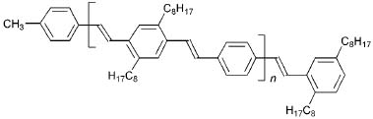a
b
Fig. 6. Substituted oligo(p-phenylenevinylene)s.

Fig. 7. Oligo(p-phenylene).

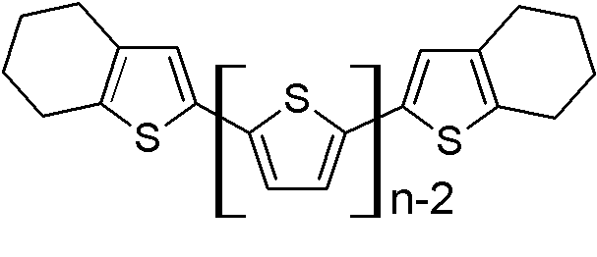
Fig. 8. End-capped oligothiophenes, n = 5, 6, 7.
Oligomers are very often used as side chain in non-conjugated polymers with pendant π-electron systems. For example, series of non-conjugated vinyl and methacrylate polymers containing pendant unsubstituted and substituted oligothiophenes have been synthesized [71].
Substituted conjugated polymers. The variety of polymer materials synthesized with the aim to be used for the production of OLED is enormous. One of the main trends is the modification of conjugated polymers.
The most widely used polymer is poly(phenylene vinylene) or “PPV”, which has a band gap of about 2.5 eV and emits yellow-green light. PPV is insoluble in common solvents, and as such requires special processing steps to produce a conjugated thin film necessary for EL device application. The researchers often modify PPV by attaching alkyls side-chains to the phenylene rings. The introduction of substituents into the PPV skeleton on one hand allows the modification of the electronic properties (e.g. band gap, electron affinity, and ionization potential) and on the other hand it enables the generation of PPVs that are soluble in organic solvents.
In 1991, Heeger and Braun reported a red-orange emitting OLED based on the asymmetrically sub-stituted soluble PPV derivative poly[2-methoxy-5-(2-ethylhexyloxy)-p-phenylenevinylene] (MEH-PPV has an energy gap of about 2.2 eV) (Fig. 9) in a simple single-layer device configuration (ITO/MEH-PPV/Ca) with an external quantum yield of 1% [72].
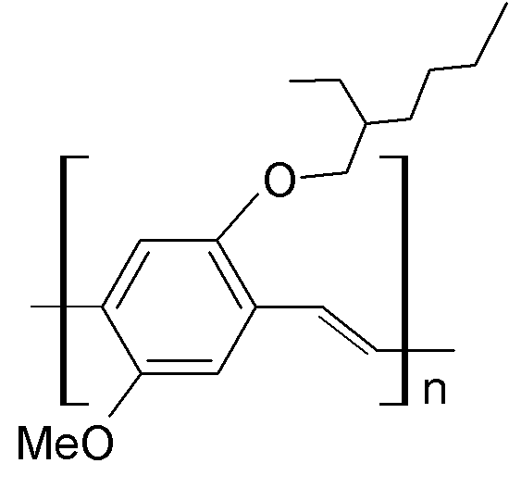
Fig. 9. Poly[2-methoxy-5-(2-ethylhexyloxy)-
p-phenylenevinylene] (MEH-PPV).
A variety of PPV derivatives containing long alkyl [73–75] and alkoxy [73, 74, 76–81] side chains, and oligoethenyloxy [82–84] substituents have been synthesized by polycondensation. PPV derivatives with at least one long solubilizing alkoxy side chain are soluble in organic solvents such as chloroform or THF providing sufficient processability with respect to electrooptical applications [85]. Further-more, long side chains separate the polymeric chains from each other and hence impede the formation of non-emissive relaxation sites. This effect seems to be advantageous with regard to the fluorescence and electroluminescence efficiencies of the corres-ponding polymers.
The introduction of silyl substituents, as realized for PPV derivative, (see Fig. 10), gave an increase in solubility and a widening of the band gap with respect to PPV, enabling the emission of green light [82, 86–90].
P. Petrova and R. Tomova: Organic electroactive compounds used for OLED
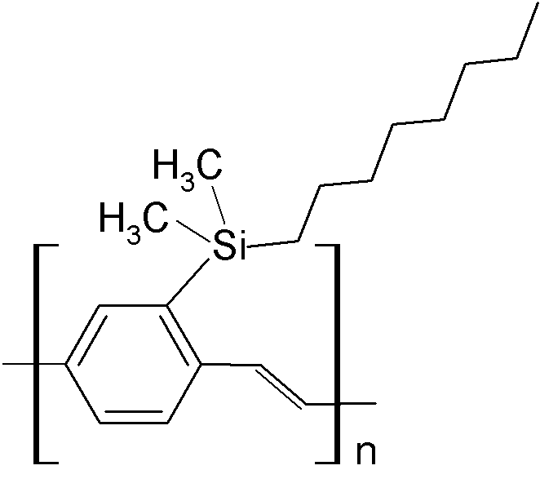
Fig. 10. Silyl substituted poly(p-phenylenevinylene).
An orange colour became accessible using copolymers with unsubstituted phenylene and statistically distributed alkoxy-substituted phenylene segments [91, 92].
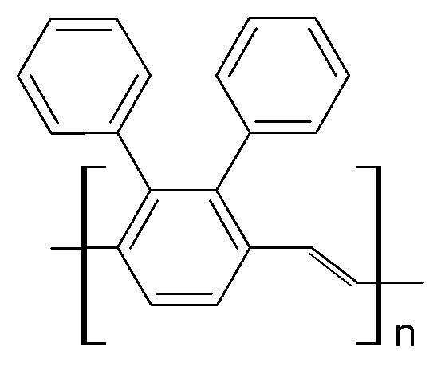 1

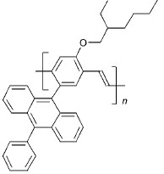 2
Fig. 11. Aryl substituted poly(p-phenylenevinylene)s.
Other successful approaches to tune the band gap were the introduction of oligo(p-phenylene) moieties [93, 94] as well as the incorporation of m-phenylene segments [95–97].
The most important example, poly(2,3-diphenyl-p-phenylenevinylene) Compound 1 (Fig. 11), [98, 99] exhibits EL in a single-layer configuration (ITO/Comp.1/Al) with an external quantum efficiency of 0.04% [98, 100] similar to the values obtained for simple PPV-diodes [101].
Pendent phenylanthryl substituents have proven to increase the EL efficiency of single-layer devices based on polymer Comp. 2 (Fig. 11) by a factor of 10 in comparison to LEDs based on PPV [102, 103]. This improvement was interpreted based on both increased interchain distance and an intrachain electronic energy transfer between the main chain and the pendants. The latter effect was expected to slow down the decay of the excited state.
Organic compounds in general, and conjugated polymers in particular, tend to have low electron affinities rendering electron injection more difficult than hole injection. One strategy to overcome this problem is the use of metals with lower work functions for the cathodes. The more perspective strategy is to improve the electron affinity of the inserted polymer. This concept was first used by Friend, Holmes et al. in 1993 [104]. They attached electron-withdrawing cyano groups to the vinylene bonds of a dihexyloxy-substituted PPV (Fig. 12), which was synthesized by a Knoevenagel conden-sation polymerization of suitable monomers. A bright red fluorescent material was obtained (CN-PPV, Fig. 12, Comp. 3). Internal efficiencies of 0.2% were reported for a single-layer configuration Al/CN-PPV/metal, independent of the type of cathode material (Al or Ca).

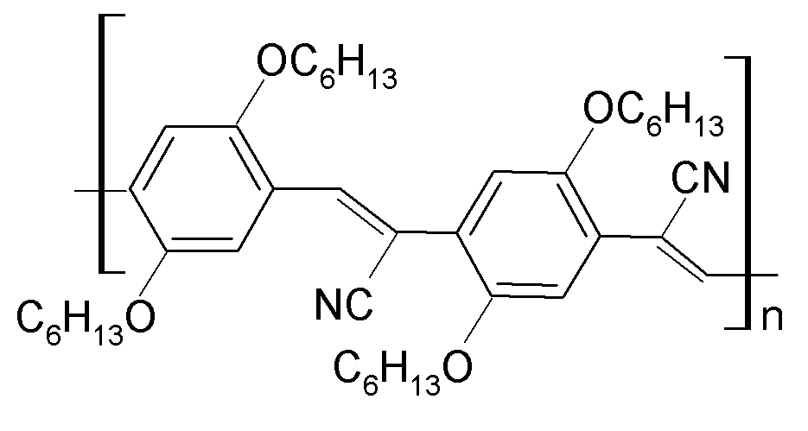 3
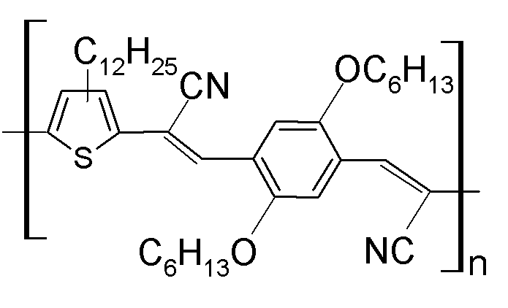 4
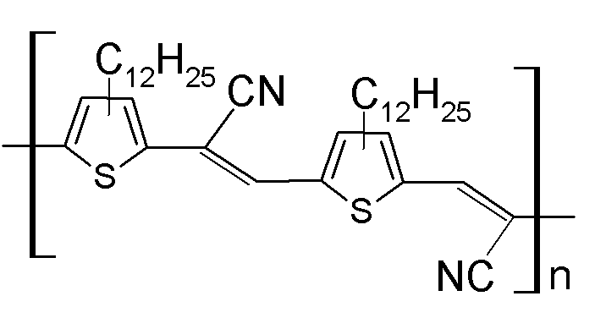 5
Fig. 12. Polymers with electron-withdrawing substituents.
Following this initial report, a series of other CN-PPV derivatives [105, 106], and thiophene analogues Comp. 4 and Comp. 5 (Fig. 12) [105] have been synthesized by Knoevenagel method. The PLEDs with blue, red and near-IR emission have been fabricated with these polymers.
Polymer OLEDs emitting in the blue region are therefore an attractive target for research. Blue emission from the active luminescent material requires a HOMO-LUMO energy gap of approxi-mately 2.7–3.0 eV [107]. In 1992, Leising et al. for the first time reported on blue electroluminescence from OLEDs containing poly(p-phenylene) (PPP) [108]. They observed external quantum efficiencies for simple single-layer devices (ITO/PPP/Al) of 0.05%. Like PPV, PPP is also insoluble and infusible and has to be incorporated into an electrooptical device via a soluble precursor polymer [109].
P. Petrova and R. Tomova: Organic electroactive compounds used for OLED
In an effort to improve processability, PPP derivatives bearing solubilizing alkyl, aryl, alkoxy, or perfluoralkyl side chains have been synthesized by transition metal-catalyzed polymerization of appropriate monomers and have been utilized as active organic materials in OLEDs [110–117].
On account of their good solubility and chemical stability poly(3-alkylthiophene)s (PATs) have attracted considerable interest. The properties of polythiophene derivatives (PTs) in general can easily be altered by structural modification, which allows the control of the torsion of the main chain and thus the adjustment of the effective conjugation length. PATs and other PT derivatives are attractive electroluminescent materials due to their ease of tunability [118–125]. Although simple PATs [126, 127] usually exhibit red emission, all other colours from blue to near infrared have been realized in OLED applications. Although PTs tend to exhibit fluorescence intensities smaller than PPVs and PPP derivatives they have frequently been used as active layers in electrooptical applications [118–123, 128].
Non-conjugated polymers containing pendant
π-electron system. Non-conjugated polymers con-taining pendant π-electron systems are of interest for the following reasons: the variety of possible pendant molecules, chemical stability, ease of processability, possibility to form morphologically stable system, photoconductivity of pendant π-elec-tron systems, and invariance of the standard redox potential with the degree of doping.
The concept of attaching chromophoric groups to or as the side chain of a non-conjugated polymer was found to be of great advantage for the transfor-mation of crystalline electroluminescent materials to amorphous derivatives. Thus, blue electrolumi-nescence from perylene-containing poly(methyl-acrylamide) was reported Comp. 6 (Fig. 13) [129].
Side group polymers with laterally fixed charge transport units have proven to provide a homo-geneous, amorphous morphology essential for device stability. The oxadiazole moieties, including the PBD, were introduced as pendant groups in many non-conjugated polymers in order to reduce the electron-injection barrier and improve the EL efficiency of the device. To avoid phase separation and molecular PBD crystallization several groups introduced the PBD moieties as pendant groups in polymetacrylate [130–132] and polyethylene [133] chains. Polymers (Comp. 7–9, Fig. 14) have been studied as materials for PLEDs [130, 131], both in a single-layer devices and in combination with PPV hole transporting layer. The authors mention that the device instability is a great problem for these systems, and creating a more robust polymer back-bone would be necessary. Later, Register et al. [134] synthesized and studied related polymers (Comp. 10 and Comp. 11) based on polystyrene backbone. Observing the immiscibility of oxadi-azole polymer (Comp. 10) with PVK, the authors designed the co-polymer Comp. 11 containing both electron- and hole-transporting units. The device ITO/Comp. 11/Mg:Al showed improved external quantum efficiency of 0.3%, although the turn-on voltage was still high (16 V). Doping the polymer with different molecular dyes, the emission colour was tuned from blue to orange [134].
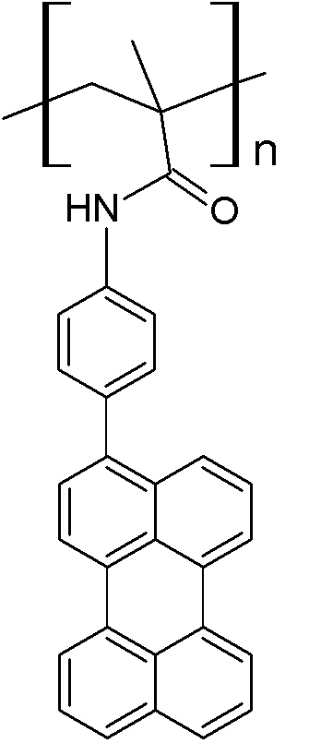 6
Fig. 13.
Polystyrenes with quaterphenylene segments in the side chain (Fig. 15a) were utilized as electron transporting material [135]. Polyacrylate with
pendant triphenylene segments (Fig. 15b) was used as an efficient hole transporting material in a two-layer configuration with Alq₃ (ITO/ polyacrylate/ Alq₃/Al) [136].
P. Petrova and R. Tomova: Organic electroactive compounds used for OLED
A high hole mobility and excellent photocon-ductive properties of carbazole-containing polymers, such as poly(N-vinylcarbazole) (PVK) (Fig. 15c) [3] and poly(N-epoxyprolylcarbazole) (PEPK, Fig. 15d) rate them among the most studied polymers for optoelectronic application. Generally, the electrolu-minescent properties of non-conjugated carbazoles are quite poor. On the other hand, being an excellent hole-transporting material, PVK has been extens-ively used as a HTL [137–144] or as a hole-trans-porting material in blends with other conjugated EL materials in PLEDs [145–149], and host material in host / guest systems [150].
In an effort to simplify device fabrication and restrict all functions to a single layer, a series of copolymers containing both charge transport and emissive chromophores on pendant side chains has been synthesized [151–154].
High-efficiency red, green and blue phospho-rescent polymer light-emitting devices based on phosphorescent polymers involving carbazole units and iridium-complex units (Fig. 16) have been reported by Tokito еt аl. [155]. Many other com-pounds may be associated with this polymer groups.
Dendrimers
Light-emitting dendrimers generally consist of a light-emitting core, to which one or more branched dendrones are attached. Surface groups are attached to the distal end of the dendrons to provide the solubility necessary for solution processing. The dendritic structure allows independent modification of the core (light emission), branching groups (charge transport) and surface groups (processing properties).

7 8 9 10 11
Fig. 14. Non-conjugated polymers containing pendant oxadiazoles as π-electron system.
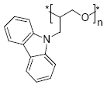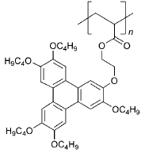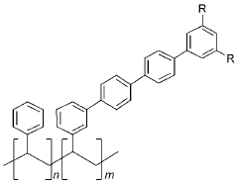

а) R = CF₃ or t-Bu b) c) d)
Fig. 15. Non-conjugated polymers containing pendant phenylene segments or carbazole units as π-electron system.
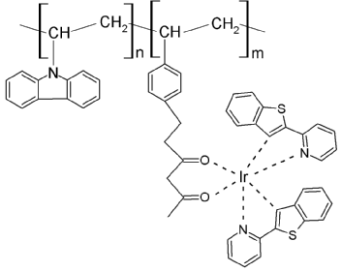 | 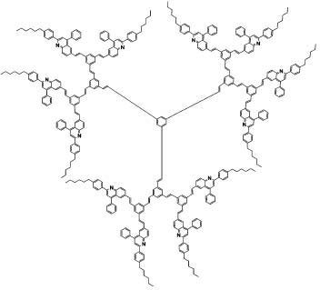
Fig. 16. Synthesized molecular structures of red phosphorescent polymers (RPP) | Fig. 17. n-Type conjugated dendrimer [G2–12Q].

Dendrimers possess a number of potential advantages over the conjugated polymers and small molecule light-emitting materials. First, their key electronic properties, such as light emission, can be finely tuned by picking out among a wide range of luminescent chromophores, including phospho-rescent groups. Second, solubility of the molecules can be adjusted by selecting the appropriate surface groups to optimize the materials to meet different processing and application requirements. Finally, the level of intermolecular interaction of the electro-active chromophores can be controlled by the type and generation of the dendrons employed, a vital element in the performance of OLEDs. This makes it possible to adapt dendrimers to various processing systems without compromising the quality of light emission.
These design principles have been illustrated in the development of green-light-emitting phospho-rescent dendrimers that contained fac-tris(2-phenyl-pyridyl)iridium(III) cores, biphenyl based dendrons and 2-ethylhexyloxy surface groups. The solution processable green phosphorescent dendrimers have been used to fabricate highly efficient single layer [156, 157] devices, as well as bi-layer OLEDs giving efficiencies of up to 16% and 40 lm·W^{–1} at 400 cd·m^{–2} [158]. Anthopoulos et al. [159] reported two new solution processable red phosphorescent dendrimers for use in OLEDs. Kwon et al. [160] reported three new electron-acceptor and light-emitting conjugated dendrimers, based on a benzene core, poly(phenylenevinylene) dendrons, and diphe-nylquinoline peripheral groups (Fig. 17). As the emissive materials in light-emitting diodes, these dendrimers showed yellow electroluminescence, the brightness and efficiency of which increased with generation and number of electron-acceptor peripheral groups.
P. Petrova and R. Tomova: Organic electroactive compounds used for OLED
OLEDs with Zn complexes
It was one of our aims to test the new Zn organometallic compounds bis(2-methyl-8-hydroxy-quinoline)zinc (Znq₂), bis(2-(2-hydroxyphenyl) benzothiazole)zinc (Zn(BTz)₂), and bis(2-(2-hydroxynaphthyl)benzothiazole)zinc (Zn(NBTz)₂) as light-emitting materials (Fig. 18). The presented Zn complexes were investigated in electroluminescent devices with conventional structure: ITO/HTL/EL/M, where ITO is a transparent anode of In₂O₃:SnO₂, HTL – a hole-transporting layer, EL – an emitting layer, and M – a metallic cathode of Al. We demonstrated earlier, that the composite film of N,N’-bis(3-methylphenyl)-N,N’-diphenylbenzi-dine (TPD) incorporated in poly(N-vinylcarbazole) (PVK) matrix [161] was a promising HTL for OLED. More details about device preparation and measure-ments are published in our previous paper [162].
The electrical and optical properties of the OLED are complicated linked to molecular organization of layers, such as morphology, and chain arrangement in polymer. The surface morphology of the com-posite film PVK:TPD, spin coated on PET substrate covered with ITO, is shown in Fig. 19a. SEM micrographs of the vacuum deposited Znq₂ and Zn(BTz)₂ in the case of both investigated OLED structures ITO/PVK:TPD/Zn complex are presented in Figs. 19b, c. The images show very smooth and homogeneous surfaces of the deposited films. It is a substantial prerequisite for developing of OLED with good characteristics.
The present metal complexes showed bright emission as emitting layers. Fig. 20 represents the current/voltage (I–V) (a) and luminance/voltage (L–V) (b) characteristics of the three type identical devices with different EL at two concentrations (x = 10 and 20 wt.%) of TPD in PVK:TPD_{x} composite HT film. All devices emit from yellow-green for Znq₂ to pure green for Zn(BTz)₂ and Zn(NBTz)₂ spectrum of visible light.
P. Petrova and R. Tomova: Organic electroactive compounds used for OLED
The current densities (I) of the all devices are similar, while the luminances (L) at the same current densities (I) are quite different. It was established that the luminance of the devices with Zn(BTz)₂ is 2.5 times higher than those with Znq₂ and 3 times higher than those with Zn(NBTz)₂ (at 15 V DC). Besides Zn(BTz)₂ shows the lowest “turn-on voltage” and the best electroluminescent efficiency – 2 times higher than that of Znq₂ and 6x higher than that of Zn(NBTz)₂ at luminance of 250 cd/m² (Fig. 21).
The current density and the luminance of the devices with Znq₂ increase with the concentration (x) of TPD in composite PVK:TPD_{x} while the “turn-on voltage” becomes lower. Just the opposite are the results in the cases of Zn(BTz)₂ and Zn(NBTz)₂.

Znq₂ Zn(BTz)₂ Zn(NBTz)₂
Fig. 18. Chemical structures of the investigated Zn complexes.

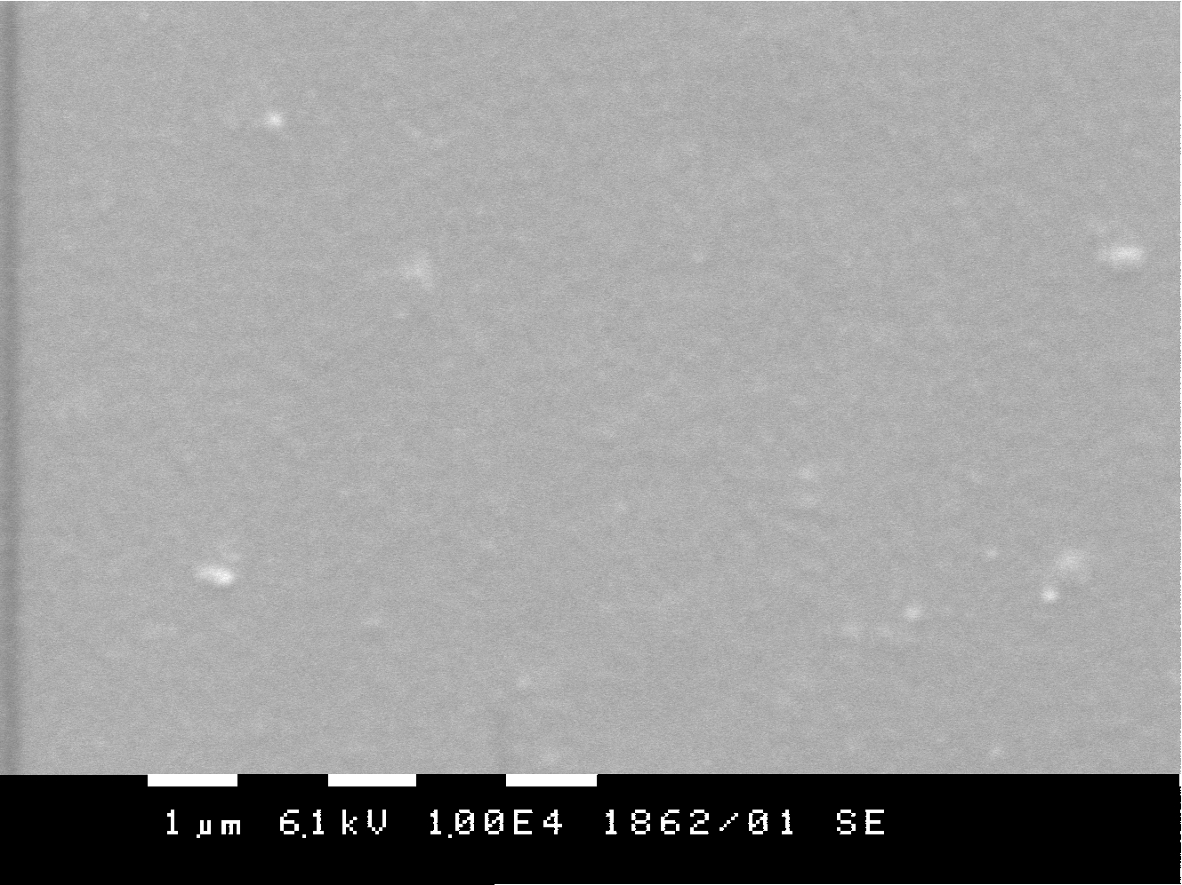 | 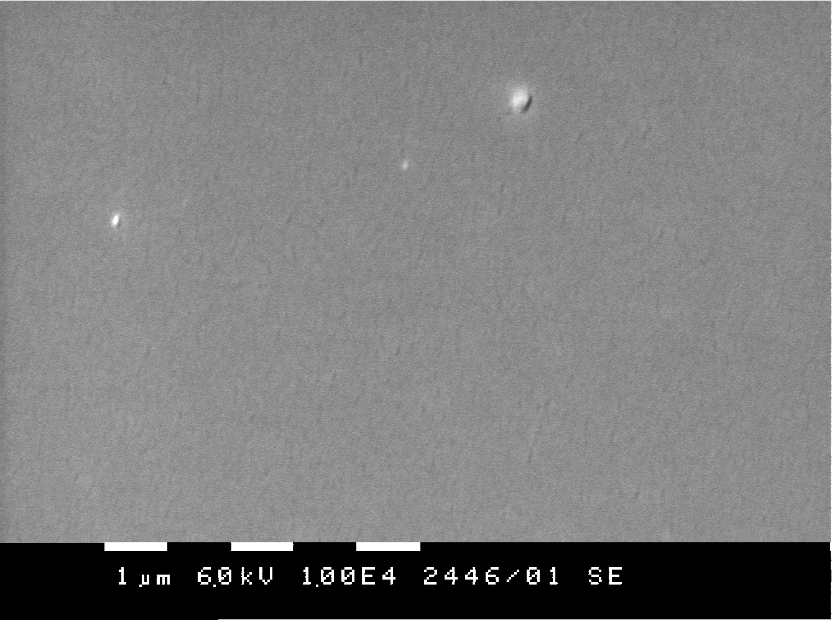 | 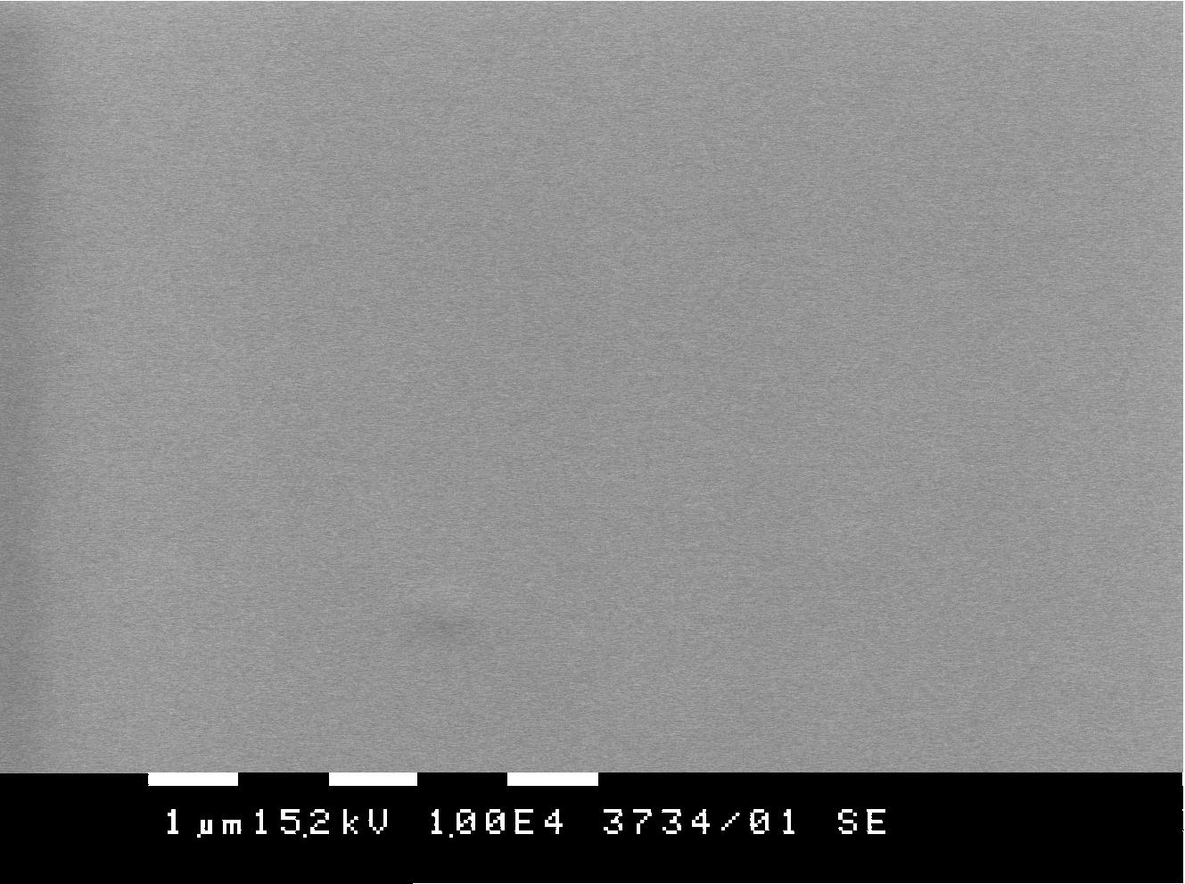
a) PET/ITO/ PVK:TPD | b) PET/ITO/ PVK:TPD/ Znq₂ | c) PET/ITO/ PVK:TPD/ Zn(BTz)₂
Fig. 19. SEM micrographs of PET/ITO/PVK:TPD, PET/ITO/PVK:TPD/Znq₂, and PET/ITO/PVK:TPD/ Zn(BTz)₂ surfaces.

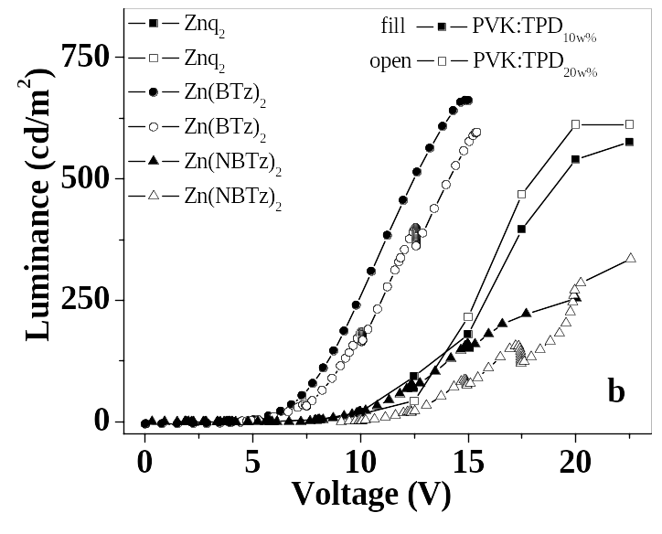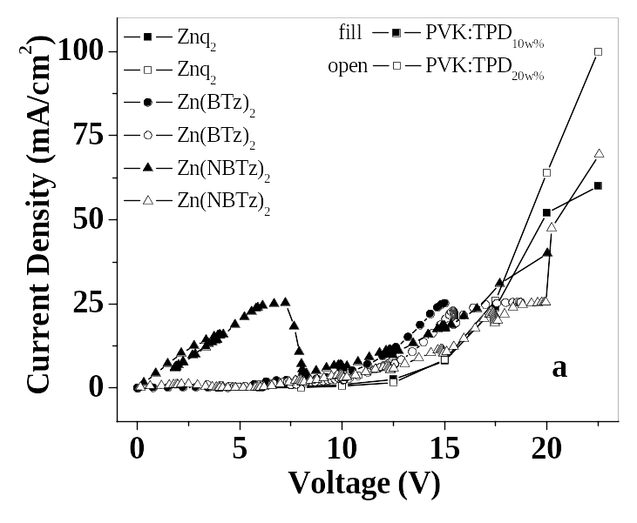
Fig. 20. Current/voltage (I-V) (a) and luminance/voltage (L-V) (b) characteristics of the three types of identical devices with different EL at two concentrations (x = 10 and 20wt.%) of TPD in PVK:TPD_{x} composite HT film.

Fig. 21. Electroluminescent efficiency of devices with HTL of PVK:TPD_{10wt.%} and different EL.
The results presented in this paper show that the studied Zn complexes can be successfully used as emitters and electron transporting layers for OLED. The best characteristics are shown by the devices on the basis of Zn(BTz)₂ (Fig. 22). It could be empha-sized that the efficiency of the devices with Zn(BTz)₂ is 6.3 cd/A at luminance 250 cd/m² and 4.1 cd/A at luminance 100 cd/m². It is one of the best reported up to now in the literature for the devices with similar structure. Sano [163] reported efficiency 1.39 cd/A at luminance 100 cd/m² for ITO/TPD/Zn(BTz)₂/Mg:In device. Maximum quan-tum efficiency of 0.3% was found for ITO/PVK/Zn(BTz)₂/Al device by Wu [164]. Zheng et al. [165] showed maximum quantum efficiency 0.63% and the corresponding luminance efficiency 4.05 cd/A and luminance 4048 cd/m² for the white device on the basis of Zn(BTz)₂ doped with rubrene.
P. Petrova and R. Tomova: Organic electroactive compounds used for OLED
Studying the molecular structure of Zn(BTz)₂ Wu et al. [164] showed that as disturbed by Zn²⁺, the complex molecular rigidity and planar structure were strengthened and enlarged greatly. Moreover, augmented conjugative effect of π electron made the transition π --- π * more easily, which results in high fluorescence of Zn(BTz)₂, eventually. Probably it is a reason for the best characteristics of the devices on the basis of Zn(BTz)₂.

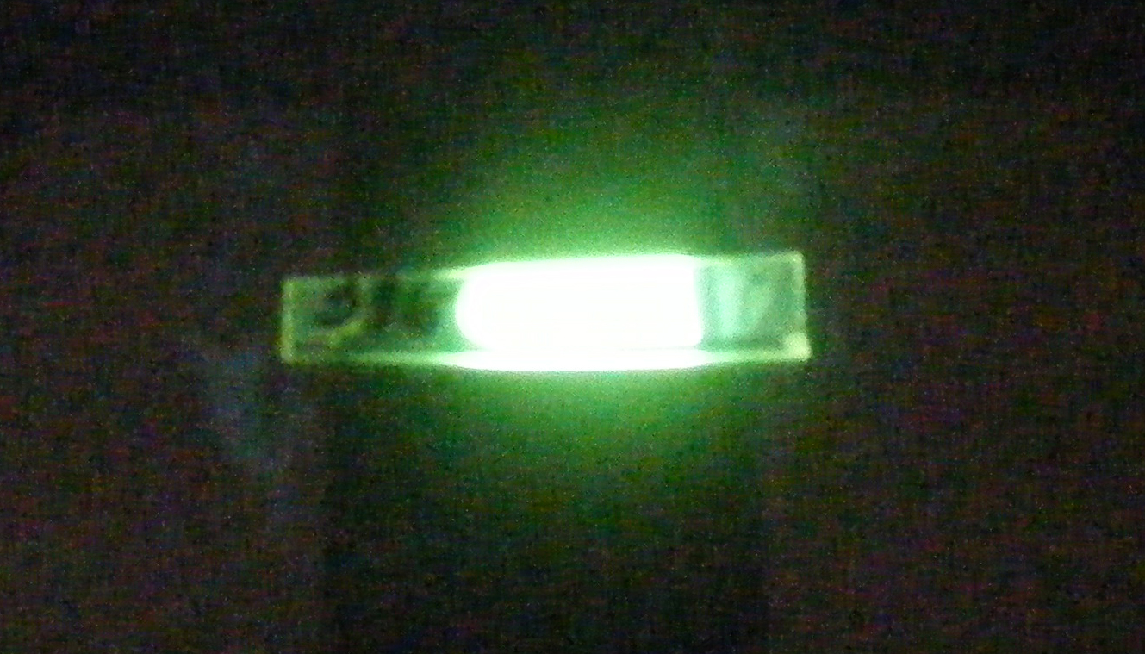
Fig. 22. Picture of our luminous OLED device with structure ITO/(PVK:TPD₂₀)/Zn(BTz)₂/Al at 15 V DC.
It was established that Zn complexes synthesized by T. Deligeorgiev [166] are useful for the develop-ment of OLED and further improvement of their characteristics is in progress. Besides some other Zn and Al organometallic complexes are under investi-gations.
CONCLUSION
Although this review is not exhaustive, it does illustrate some recent developments of organic materials used in OLED.
The use of π-conjugated materials is not limited to their application in OLEDs. Organic chemistry offers an endless variety of structures, and therefore, the choices of charge transporters, emitters and other dopants are virtually unlimited.
For highly stable and efficient materials of such applications semi-conducting materials with smart designed and optimized properties are greatly desired. The toolbox of organic chemistry hereby opens a broad variety of suitable reactions and easily accessible target compounds. The optimiza-tion of the target structures results therefore in smart materials with finely-tuned optical and electronic properties.
The advantages of polymeric materials compared with other “classic” materials like glass, ceramic or metal are the low specific weight, high corrosion stability and good process ability. The addition of additives opens furthermore the option of fine-tuning of properties.
P. Petrova and R. Tomova: Organic electroactive compounds used for OLED
Acknowledgements: The authors are grateful to the Ministry of Education and Science of Bulgaria for financial support through the project FSI-Ch-1516.
REFERENCES
- T. P. Nguyen, P. Molinie, P. Destruel, in: Organic and Polymer-Based Light Emitting Diodes. Handbook of Advanced Electronic and Photonic Materials and Devices, H. Sing Nalwa (ed), vol. 10, Academic Press, San Diego, 2001, p. 3.
- T. Fuhrmann, J. Salbeck in: Funnctional Molecular Glasses: Building Blocks for Future Optoelectronics. Advances in Photochemistry, D. C. Neckers, G. von Bünau, W. S. Jenks (eds), vol. 27, John Wiley & Sons Inc. 2002, p. 83.
- S. K. Kim, T. G. Chung, D. H. Chung, H. S. Lee, M. J. Song, J. W. Park, J. U. Lee, T. W. Kim, Opt. Mater., 21, 159 (2002).
- P.-C. Kao, S.-Y. Chu, Z. X. You, S. J. Liou, C.-A. Chuang, Thin Solid Films, 498, 249 (2006).
- H. Tang, H. Liao, K. Xu, Z. Zhou, L. Zhu, J. Lumin., 118, 39 (2006).
- J.-S. Kim, H. Kajii, Y. Ohmori, Thin Solid Films, 499, 343 (2006).
- Y. Iwama, T, Itoh, T. Mori, T. Mizutani, Thin Solid Films, 499, 364 (2006).
- C. Y.Kwong, A. B. Djurišić, W. C. H. Choy, D. Li, M. H. Xie, W. K. Chan, K. W. Cheah, P. T. Lai, P. C. Chui, Mater. Sci. Eng. B, 116, 75 (2005).
- C.-Y Yang, Y. S. Tsai, F.-S. Juang, Y.-K. Su, D. Lin, C.-H. Chu, Y.-T. Chiu, Jpn. J. Appl. Phys., 44, (4B), 2833 (2005).
- C. H. Chen, J. Shi, J. Coord, Chem. Rev., 171, 161 (1998).
- M. Brinkmann, G. Gadret, M. Muccini, C. Taliani, N. Masciocchi, A. Sironi, J. Am. Chem. Soc., 122, 5147 (2000).
- J. Kido, Y. Iizumi, Appl. Phys. Lett., 73, 2721 (1998).
- Y. Hamada, H. Kanno, T. Sano, H. Fujii, Y. Nishio, H. Takahashi, T. Usuki, K. Shibata, Chem. Lett., 905 (1993).
- T.-R. Chen, R.-H. Chien, M.-S. Jan, A. Yeh, J.-D. Chen, J. Organomet. Chem., 691, 799 (2006).
- J. Yang, K. C. Gordon, Y. Zidon, Y. Shapira, J. Appl. Phys., 94, 6391 (2003).
- M. A. Baldo, S. Lamansky, P. E. Burrows, M. E. Thompson, S. R. Forrest, Appl. Phys. Lett., 75, 4 (1999).
- M.-L. Xu, T.-L. Li, W.-L. Li, Z.-R. Hong, Z. -W. An, Q. Zhou, Thin Solid Films, 497, 239 (2006).
- K.-H. Fang, L.-L. Wu, Y.-T. Huang, C.-H. Yang, I.-W. Sun, Inorg. Chim. Acta, 359, 441 (2006).
- J. H. Kim, E. J. Nam, S. Y. Hong, B. O. Kim, S. M. Kim, S. S. Yoon, J. H. Suh, Y. Ha, Y. K. Kim, Mater. Sci. Eng. C, 24, 167 (2004).
- J. Kido, H. Hayase, K. Hongawa, K. Nagai, K. Okuyama, Appl. Phys. Lett., 65, 2124 (1994).
- H. Xin, F. Y. Li, M. Guan, C. H. Huang, M. Sun, K. Z. Wang, Y. A. Zhang, L. P. Jin, J. Appl. Phys., 94, 4729 (2003).
- K.-Y. Lai, T.-M. Chu, F. C.-N. Hong, A. Elangovan, K.-M. Kao, S.-W. Yang, T.-I. Ho, Surf. Coat. Technol., 200, 3283 (2006).
- T. Sano, M. Fujita, T. Fujii, Y. Hamada, K. Shibata, K. Kuroki, Jpn. J. Appl. Phys., 34, 1883 (1995).
- H. Shirakawa, E. J. Louis, A. G. MacDiarmid, C. K. Chiang, A. J. Heeger, J. Chem. Soc., Chem. Commun., 578 (1977).
- C. K. Chiang, C. R. Fincher, Y. W. Park, A. J. Heeger, H. Shirakawa, E. J. Louis, S. C. Gau, A. G. MacDiarmid, Phys. Rev. Lett., 39, 1098 (1977).
- T. Schimmel, M. Schwoerer, H. Naarmann, Synth. Met., 1, 1 (1990).
- S. A. Sapp, G. A. Sotzing, J. R. Reynolds, Chem. Mater., 10, 2101 (1998).
- F. Garnier, G. Tourillon, M. Gazard, J. C. Dubois, J. Electrochem. Anal. Chem., 148, 299 (1983).
- G. Yu, A. J. Heeger, J. Appl. Phys., 78, 4510 (1995).
- G. Yu, J. Gao, J. C. Hummelen, F. Wudl, A. J. Heeger, Science, 270, 1789 (1995).
- A. Kraft, A. C. Grimsdale, A. B. Holmes, Angew. Chem., Intern. Ed., 37, 402 (1998).
- R. H. Friend, R. W. Gymer, A. B. Holmes, J. H. Burroughes, R. N. Marks, C. Taliani, D. D. C. Bradley, D. A. Dos Santos, J. L. Brédas, M. Lögdlung, W. R. Salaneck, Nature, 397, 121 (1999).
- Y. Zou, S. Tan, Z. Yuan, Z. Yu, J. Mater. Sci. 40, 3561 (2005).
- Y. -H. Niu, Q. Hou, Y. Cao, Appl. Phys. Lett., 82, 2163 (2003).
- D. Fujishima, T. Mori, T. Mizutani, T. Yamamoto, N. Kitamura, Jpn. J. Appl. Phys., 44, 546 (2005).
- M. Bernius, M. Inbasekaran, E. Woo, W. Wu, L. Wujkòwski, J. Mater. Sci.: Mater. Electron., 11, 111 (2000).
- M. T. Bernius, M. Inbasekaran, J. O'Brien, W. Wu, Adv. Mater., 12, 1737 (2000).
- M. Leclerc, J. Polym. Sci. Part A: Polym. Chem. 39, 2867 (2001).
- D. Y. Kim, H. N. Cho, C. Y. Kim, Prog. Polym. Sci., 25, 1089, (2000).
- M. T. Bernius, M. Inbasekaran, J. O'Brien, W. Wu, Adv. Mater., 12, 1737 (2000).
- J. H. Kim, P. Herguth, M.-S. Kang, A. K.-Y. Jen,
Y.-H. Tseng, C.-F. Shu, Appl. Phys. Lett., 85, 1116 (2004).
- D.-H. Hwang, M.-J. Park, J.-H. Lee, Mater. Sci. Eng. C, 24, 201 (2004).
- J. Roncali, Chem. Rev., 97, 173 (1997).
- W. J. Feast, J. Tsibouklis, K. L. Pouwer, L. Groenendaal, E. W. Meijer, Polymer, 37, 5017 (1996).
- H. S. O. Chan, S. C. Ng, Prog. Polym. Sci., 23, 1167 (1998).
- L. Pu, Acta Polym., 48, 116 (1997).
- D. Oelkrug, A. Tompert, H.-J. Egelhaaf, M. Hanack, E. Steinhuber, M. Hohloch, H. Meier, U. Stalmach, Synth. Met., 83, 231 (1996).
- E. Thorn-Csányi, P. Kraxner, Macromol. Chem. Phys., 198, 3827 (1997).
- R. E. Gill, A. Meetsma, G. Hadziioannou, Adv. Mater., 8, 212 (1996).
- M. Halim, J. N. G. Pillow, I. D. W. Samual, P. L. Burn, Adv. Mater., 11, 371 (1999).
- V. Gebhardt, A. Bacher, M. Thelakkat, U. Stalmach, H. Meier, H.-W. Schmidt, D. Haarer, Adv. Mater., 11, 119 (1999).
- V. Gebhardt, A. Bacher, M. Thelakkat, U. Stalmach, H. Meier, H. -W. Schmidt, D. Haarer, Synth. Met., 90, 123 (1997).
- J. L. Segura, N. Martin, M. Hanack, Eur. J. Org. Chem., 643 (1999).
- P. Frederiksen, T. Bjornholm, H. G. Madsen, K. Bechgaard, J. Mater. Chem., 4, 675 (1994).
- М. Era, J. -I. Koganemaru, T. Tsutsui, A. Watakabe, T. Kunitake, Synth. Met., 91, 83 (1997).
- S. Pfeiffer, H.-H. Hörhold, H. Boerner, H. Nikol, W. Busselt, Proc. SPIE Intern. Soc. Opt. Eng., 3476, 258 (1998).
- G. Leising, E. J. W. List, S. Tasch, C. Brandstätter, W. Graupner, P. Markart, F. Meghdadi, G. Kranzelbinder, A. Niko, R. Resel, E. Zojer, P. Schlichting, U. Rohr, Y. Geerts, U. Scherf, K. Müllen, R. Smith, D. Gin, Proc. SPIE Intern. Soc. Opt. Eng., 3476, 76 (1998).
- G. Leising, S. Tasch, F. Meghdadi, L. Athouel, G. Froyer, U. Scherf, Synth. Met., 81, 185 (1996).
- N. Koch, A. Pogantsch, E. J. W. List, G. Leising, R. I. R. Blyth, M. G. Ramsey, F. P. Netzer, Appl. Phys. Lett., 74, 2909 (1999).
- F. Meghdadi, S. Tasch, B. Winkler, W. Fischer, F. Stelzer, G. Leising, Synth. Met., 85, 1441 (1997).
- B. Winkler, F. Meghdadi, S. Tasch, R. Müllner, R. Resel, R. Saf, G. Leising, F. Stelzer, Opt. Mater., 9, 159 (1998).
- J. Salbeck, N. Yu, J. Bauer, F. Weissörtel, H. Bestgen, Synth. Met., 91, 209 (1997).
- K. -H. Weinfurtner, F. Weissörtel, G. Harmgarth, J. Salbeck, Proc. SPIE Intern. Soc. Opt. Eng., 3476, 40 (1998).
- N. Johansson, J. Salbeck, J. Bauer, F. Weissörtel, P. Bröms, A. Andersson, W. R. Salaneck, Adv. Mater., 10, 1136 (1998).
P. Petrova and R. Tomova: Organic electroactive compounds used for OLED
- F. Geiger, M. Stoldt, H. Schweizer, P. Bäuerle, E. Umbach, Adv. Mater., 5, 922 (1993).
- H. Neureiter, W. Gebauer, C. Väterlein, M. Sokolowski, P. Bäuerle, E. Umbach, Synth. Met., 67, 173 (1994).
- C. Väterlein, H. Neureiter, W. Gebauer, B. Ziegler, M. Sokolowski, P. Bäuerle, E. Umbach, J. Appl. Phys., 82, 3003 (1997).
- P. Bäuerle, U. Mitschke, E. Mena-Osteritz, M. Sokolowski, D. Müller, M. Groβ, K. Meerholz, Proc. SPIE Intern. Soc. Opt. Eng., 3476, 32 (1998).
- G. Gigli, O. Inganäs, M. Anni, M. De Vittorio, R. Cingolani, G. Barbarella, L. Favaretto, Appl. Phys. Lett., 78, 1493 (2001).
- T. Goodson III, W. Li, A. Gharavi, L. Yu, Adv. Mater., 9, 639 (1997).
- Y. Shirota, J. Mater. Chem., 10, 1 (2000).
- D. Braun, A. J. Heeger, Appl. Phys. Lett., 58, 1982 (1991).
- M. R. Andersson, G. Yu, A. J. Heeger, Synth. Met., 85, 1275 (1997).
- B. J. Schwartz, F. Hide, M. R. Andersson, A. J. Heeger, Chem. Phys. Lett., 265, 327 (1997).
- E. G. J. Staring, R. C. J. E. Demandt, D. Braun, G. L. J. Rikken, Y. A. R. R. Kessener, T. H. J. Venhuizen, H. Wynberg, W. T. Hoeve, K. J. Spoelstra, Adv. Mater., 6, 934 (1994).
- J. Salbeck, Ber. Bunsenges. Phys. Chem., 100, 1666 (1996).
- H. F. M. Schoo, R. C. J. E. Demandt, J. J. M. Vleggaar, C. T. H. Liedenbaum, Macromol. Symp., 125, 165 (1997).
- M. Hamaguchi, K. Yoshino, Jpn. J. Appl. Phys., 34, L712 (1995).
- K. L. Brandon, P. G. Bentley, D. D. C. Bradley, D. A. Dunmur, Synth. Met., 91, 305 (1997).
- C. T. Wong, W. K. Chan, Adv. Mater., 11, 455 (1999).
- M. S. Jang, S. Y. Song, J.-I. Lee, H.-K. Shim, T. Zyung, Macromol. Chem. Phys., 200, 1101 (1999).
- B. S. Chuah, D. -H. Hwang, S. T. Kim, S. C. Moratti, A. B. Holmes, J. C. de Mello, R. H. Friend, Synth. Met., 91, 279 (1997).
- B. Winkler, L. Dai, A. W.-H. Mau, Chem. Mater., 11, 704 (1999).
- R. O. Garay, B. Mayer, F. E. Karasz, R. W. Lenz, J. Polym. Sci., Part A: Polym. Chem., 33, 525 (1995).
- A. Kraft, A. C. Grimsdale, A. B. Holmes, Angew. Chem., Intern. Ed., 37, 402 (1998).
- D.-H. Hwang, I.-N. Kang, M.-S. Jang, H.-K. Shim, T. Zyung, Polym. Bull., 36, 383 (1996).
- D.-H. Hwang, S. T. Kim, H.-K. Shim, A. B. Holmes, S. C. Moratti, R. H. Friend, Synth. Met., 84, 615 (1997).
- S. Höger, J. J. McNamara, S. Schricker, F. Wudl, Chem. Mater., 6, 171 (1994).
- Z.-K.Chen, L.-H. Wang, E.-T. Kang, Y.-H. Lai, W. Huang, Bull. Chem. Soc. Jpn., 72, 1941 (1999).
- Z.-K. Chen, L.-H. Wang, E.-T. Kang, W. Huang, Phys. Chem. Chem. Phys., 1, 3789 (1999).
- E. G. J. Staring, R. C. J. E. Demandt, D. Braun, G. L. J. Rikken, Y. A. R. R. Kessener, A. H. J. Venhuizen, M. M. F. van Knippenberg, M. Bouwmans, Synth. Met., 71, 2179 (1995).
- E. Z. Faraggi, H. Chayet, G. Cohen, R. Neumann, Y. Avny, D. Davidov, Adv. Mater., 7, 742 (1995).
- M. Remmers, D. Neher, J. Grüner, R. H. Friend, G. H. Gelinck, J. M. Warmann, C. Quattrocchi, D. A. Dos Santos, J. L. Brédas, Macromolecules, 29, 7432 (1996).
- Y. Liu, M. S. Liu, X.-C. Li, A. K.-Y. Jen. Chem. Mater., 10, 3301 (1998).
- D. D. C. Bradley, M. Grell, A. Grice, A. R. Tajbakhsh, D. F. O’Brien, A. Bleyer, Opt. Mater., 9, 1 (1998).
- M. Baumgarten, T. Yüksel, Phys. Chem. Chem. Phys., 1, 1699 (1999).
- T. Ahn, M. S. Jang, H.-K. Shim, D.-H. Hwang, T. Zyung, Macromolecules, 32, 3279 (1999).
- H. Antoniadis, D. Roitman, B. Hsieh, W. A. Feld, Polym. Adv. Technol., 8, 392 (1997).
- B. R. Hsieh, W. C. Wan, Y. Yu, Y. Gao, T. E. Goodwin, S. A. Gonzalez, W. A. Feld, Macromolecules, 31, 631 (1998).
- W. C. Wan, H. Antoniadis, V. E. Choong, H. Razafitrimo, Y. Gao, W. A. Feld, B. R. Hsieh, Macromolecules, 30, 6567 (1997).
- J. H. Burroughes, D. D. C. Bradley, A. R. Brown, R. N. Marks, K. Mackay, R. H. Friend, P. L. Burns, A. B. Holmes, Nature, 347, 539 (1990).
- S.-J. Chung, J.-I. Jin, C.-H. Lee, C.-E. Lee, Adv. Mater., 10, 684 (1998).
- J.-I. Jin, S.-J. Chung, S.-H. Yu, Macromol. Symp., 128, 79 (1998).
- N. C. Greenham, S. C. Moratti, D. D. C. Bradley, R. H. Friend, A. B. Holmes, Nature, 365, 628 (1993).
- S. C. Moratti, R. Cervini, A. B. Holmes, D. R. Baigent, R. H. Friend, N. C. Greenham, J. Grüner, P. J. Hamer, Synth. Met., 71, 2117 (1995).
- Y. Liu, G. Yu, Q. Li, D. Zhu, Synth. Met., 122, 401 (2001).
- J. L. Segura, Acta Polym., 49, 319 (1998).
- G. Grem, G. Leditzky, B. Ullrich, G. Leising, Adv. Mater., 4, 36 (1992).
- U. Mitschke, P, Bäuerle, J. Mater. Chem., 10, 1471 (2000).
P. Petrova and R. Tomova: Organic electroactive compounds used for OLED
- M. Grell, D. D. C. Bradley, Adv. Mater., 11, 895 (1999).
- G. LuÈssem, J. H. Wendorff, Polym. Adv. Technol., 9, 443 (1998).
- R. H. Friend, R. W. Gymer, A. B. Holmes, J. H. Burroughes, R. N. Marks, C. Taliani, D. D. C. Bradley, D. A. Dos Santos, J. L. Breädas, M. LoÈgdlund, W. R. Salaneck, Nature, 397, 121 (1999).
- J. L. Segura, Acta Polym., 49, 319 (1998).
- J. Kido, Phys. World, 12, 27 (1999).
- H. S. O. Chan, S. C. Ng, Prog. Polym. Sci., 23, 1167 (1998).
- Y. Liu, M. S. Liu, X.-C. Li, A. K.-Y. Jen, Chem. Mater., 10, 3301 (1998).
- J. W. Baur, S. Kim, P. B. Balanda, J. R. Reynolds, M. F. Rubner, Adv. Mater., 10, 1452 (1998).
- M. Pomerantz, Y. Cheng, R. K. Kasim, R. L. Elsenbaumer, J. Mater. Chem., 9, 2155 (1999).
- S.-D. Jung, D.-H. Hwang, T. Zyung, W. H. Kim, K. G. Chittibabu, S. K. Tripathy, Synth. Met., 98, 107 (1998).
- S.-D. Jung, T. Zyung, W. H. Kim, C. J. Lee, S. K. Tripathy, Synth. Met., 100, 223. (1999).
- M. R. Andersson, O. Thomas, W. Mammo, M. Svensson, M. Theander, O. Inganäs, J. Mater. Chem., 9, 1933 1999.
- P. Barta, J. Sanetra, M. Zagórska, Synth. Met., 94, 119 (1998).
- P. Barta, F. Cacialli, R. H. Friend, M. Zagórska, J. Appl. Phys., 84, 6279 (1998).
- A. Bolognesi, C. Botta, L. Cecchinato, Synth. Met., 111–112, 187 (2000).
- S.-H. Ahn, M.-Z. Czae, E.-R. Kim, H. Lee, S.-H. Han, J. Noh, M. Hara, Macromolecules, 34, 2522, (2001).
- H. Spreitzer, H. Becker, E. Kluge, W. Kreuder, H. Schenk, R. Demandt, H. Schoo, Adv. Mater., 10, 1340 (1998).
- P. K. H. Ho, M. Granstroèm, R. H. Friend, N. C. Greenham, Adv. Mater., 10, 769, (1998).
- S. H. Jin, B, U. Yoo, S. Y. Kang, Y. S. Gal, D. K. Moon, Opt. Mater., 21, 153 (2003).
- C. H. Lee, S. H. Ryu, S. Y. Oh, J. Polym. Sci. B, Polym. Phys. 41, 2733 (2003).
- F. Cacialli, X. -C. Li, R. H. Friend, S. C. Moratti, A. B. Holmes, Synth. Met., 75, 161, (1995).
- X. -C. Li, F. Cacialli, M. Giles, J. Grüner, R. H. Friend, A. B. Holmes, S. C. Moratti, T. M. Yong, Adv. Mater. 7, 898 (1995).
- M. Strukelj, T. M. Miller, F. Papadimitrakopoulos, S. Son, J. Am. Chem. Soc. 117, 11976, (1995).
- S. Dailey, W. J. Feast, R. J. Peace, I. C. Sage, S. Till, E. L. Wood, J. Mater. Chem. 11, 2238 (2001).
- X. Jiang, R. A. Register, K. A. Killeen, M. E. Thompson, F. Pschenitzka, J. C. Sturm, Chem. Mater., 12, 2542 (2000).
- J. Pommerehne, A. Selz, K. Book, F. Koch, U. Zimmermann, C. Unterlechner, J. H. Wendorff, W. Heitz, H. Bässler, Macromolecules, 30, 8270 (1997).
- A. Bacher, I. Bleyl, C. H. Erdelen, D. Haarer, W. Paulus, H. -W. Schmidt, Adv. Mater., 9, 1031 (1997).
- T. Ahn, S. Ko, J. Lee, H. Shim, Macromolecules, 35, 3495 (2002).
- M. R. Robinson, S. Wang, A .J. Heeger, G. C .Bazan, Adv. Funct. Mater., 11, 413 (2001).
- J. Pei, W.-L. Yu, W. Huang, A. J. Heeger, J. Chem. Soc. Chem. Commun., 33, 1631 (2000).
- B. Liu, W.-L. Yu, Y.-H. Lai, W. Huang, Macromolecules, 33, 8945 (2000).
- J. Pei, W. L. Yu, J. Ni, Y. H. Lai, W. Huang, A. J. Heeger, Macromolecules, 34, 7241 (2001).
- X. Chen, M. Liu, Z. Xu, Y. Hou, F. Teng, X. Xu, J. Phys. D: Appl. Phys., 37, 1007 (2004).
- A. P. Kulkarni, A. P. Gifford, C. J. Tonzola, S. A. Jenekhe, Appl. Phys. Lett., 86, 061106 (2005).
- M. Jin, Y. J. Liang, R. Lu, X. H. Chuai, Z. H. Yi, Y. Y. Zhao, H. J. Zhang, Synth. Met., 140, 37 (2004).
- X. Zhan, S. Wang, Y. Liu, X. Wu, D. Zhu, Chem. Mater., 15, 1963 (2003).
- S. Destri, U. Giovanella, A. Fazio, W. Porzio, B. Gabriele, G. Zotti, Org. Electron., 3, 149 (2002).
- G. Gigli, M. Ani, G. Barbarella, L. Favaretto, F. Cacialli, R. Cingolani, Phys. E, 7, 612 (2000).
- J. Yang, K. C. Cordon, A. J. McQuillan, Y. Zidon, Y. Shapira, Phys. Rev. B, 71, 155209 (2005).
- X. Chen, Z. Xu, Y. Hou, S. Liu, F. Teng, X. Xu, J. Phys. D: Appl. Phys., 36, 2054 (2003).
- K. M. Vaeth, C. W. Tang, J. Appl. Phys., 92, 3447 (2002).
- F. Cacialli, X.-C. Li, R. H. Friend, S. C. Moratti, A. B. Holmes, Synth. Met., 75, 161 (1995).
- X.-C. Li, F. Cacialli, M. Giles, J. Grüner, R. H. Friend, A. B. Holmes, S. C. Moratti, T. M. Yong, Adv. Mater., 7, 898 (1995).
- Y. Heischkel, H.-W. Schmidt, Macromol. Chem. Phys., 199, 869 (1998).
- X.-C. Li, T.-M. Yong, J. Grüner, A. B. Holmes, S. C. Moratti, F. Cacialli, R. H. Friend, Synth. Met., 84, 437 (1997).
- S. Tokito, M. Suzuki, F. Sato, M. Kamachi, K. Shirane, Org. Electron., 4, 105 (2003).
P. Petrova and R. Tomova: Organic electroactive compounds used for OLED
- J. P. J. Markham., S. -C. Lo, S. W. Magennis, P. L. Burn, I. D. W. Samuel, Appl. Phys. Lett., 80, 2645 (2002).
- T. D. Anthopoulos, J. P. J. Markham, E. B. Namdas, I. D. W. Samuel, S.-C. Lo, P. L. Burn, Appl. Phys. Lett., 82, 4824 (2003).
- S.-C. Lo, N. A. H. Male, J. P. J. Markham, S. W. Magennis, P. L. Burn, O. V. Salata, I. D. W. Samuel, Adv. Mater., 14, 975 (2002).
- T. D. Anthopoulos, M. J. Frampton, E. B. Namdas, P. L. Burn, I. D. W. Samuel, Adv. Mater., 16, 557 (2004).
- T. W. Kwon, M. M. Alam, S. A. Jenekhe, Chem. Mater., 16, 4657 (2004).
- R. Tomova, P. Petrova, A. Buroff, R. Stoycheva-Topalova, J. Chem. Soc. Chem. Commun., 39, 247 (2007).
- R. Tomova, P. Petrova, R. Stoycheva-Topalova, A. Buroff, A. Vassilev, T. Deligeorgiev, J. Nanosci. Nanotechnol., in press.
- T. Sano,Y. Nishio, Y. Hamada, H. Takahashi, T. Usuki, K. Shibata, J. Mater. Chem., 10, 157, (2000).
- X. Wu, Y. Hua, Z. Wang, J. Zheng, X. Feng, Y. Sun, Chin. Phys. Lett., 22, 1797, (2005).
- J. Zheng, Y. Hua, S. Yin, X. Feng, X. Wu, Y. Sun, Y. Li, Ch. Yang, Z. Shuai, Chin. Sci. Bull., 50, 509, (2005).
- T. Deligeorgiev, http://www.chem.unisofia.bg/
UNIDYES/oled.html.

МАТЕРИАЛИ ИЗПОЛЗВАНИ ЗА ОРГАНИЧНИ СВЕТОИЗЛЪЧВАЩИ ДИОДИ – ОРГАНИЧНИ ЕЛЕКТРОАКТИВНИ СЪЕДИНЕНИЯ
П. К. Петрова*, Р. Л. Томова
Централна лаборатория по фотопроцеси „Акад. Й. Малиновски“, Българска академия на науките,
ул. „Акад. Г. Бончев“, Блок 109, 1113 София
Постъпила на 24 април 2008 г.; Преработена на 10 февруари 2009 г.
(Резюме)
Тази статия въвежда читателя в голямото разнообразие от органични електроактивни съединения подходящи за направата на органични светоизлъчващи диоди (OLED). Представени са наши резултати за успешно използване на нови Zn органометални съединения като електролуминесцентни слоеве в OLED.

